Supplementary Information
The following items are of a procedural/illustrative nature and are provided as supplementary material; they are not required to interpret the analytical results reported in the main text.
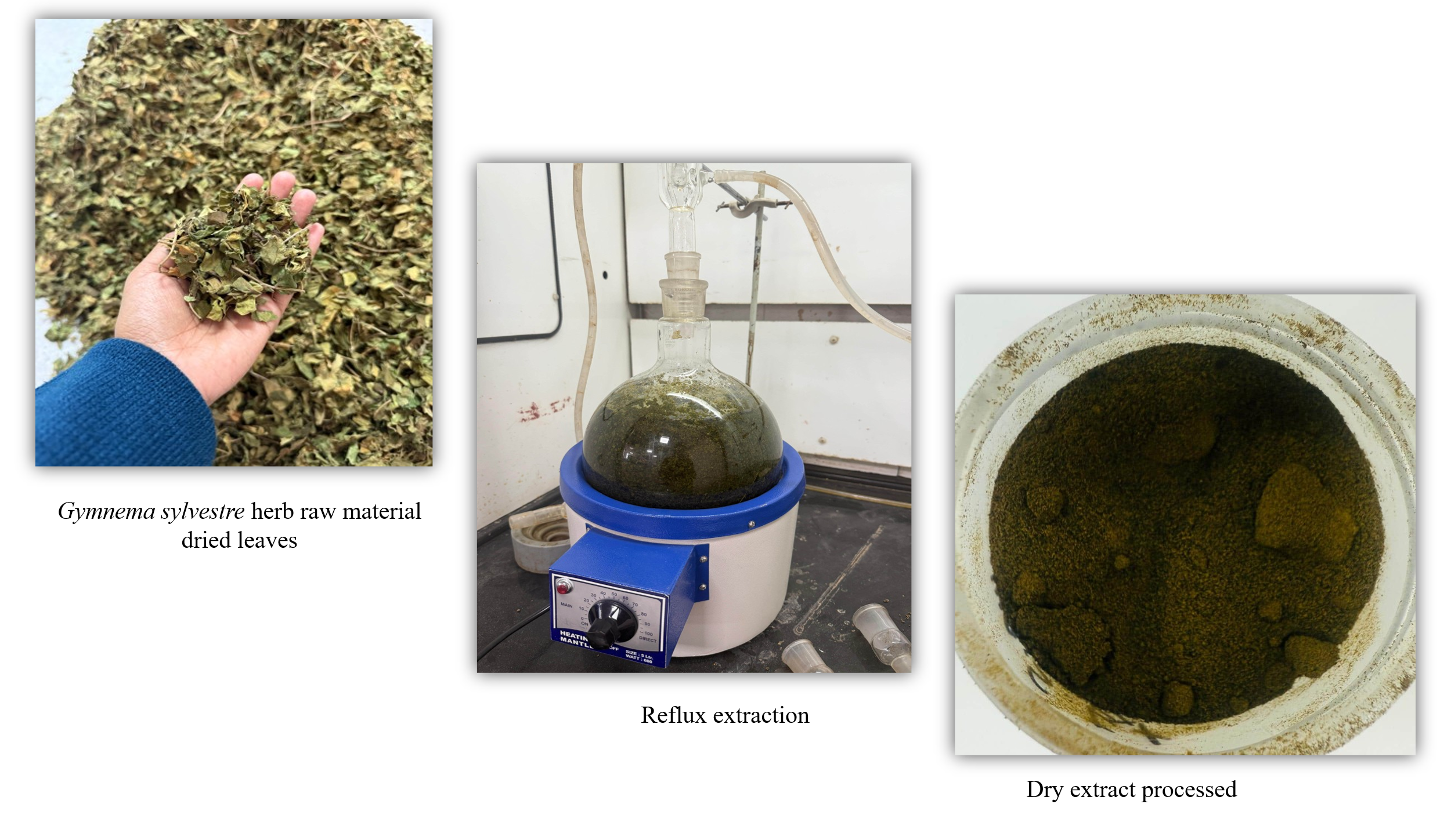
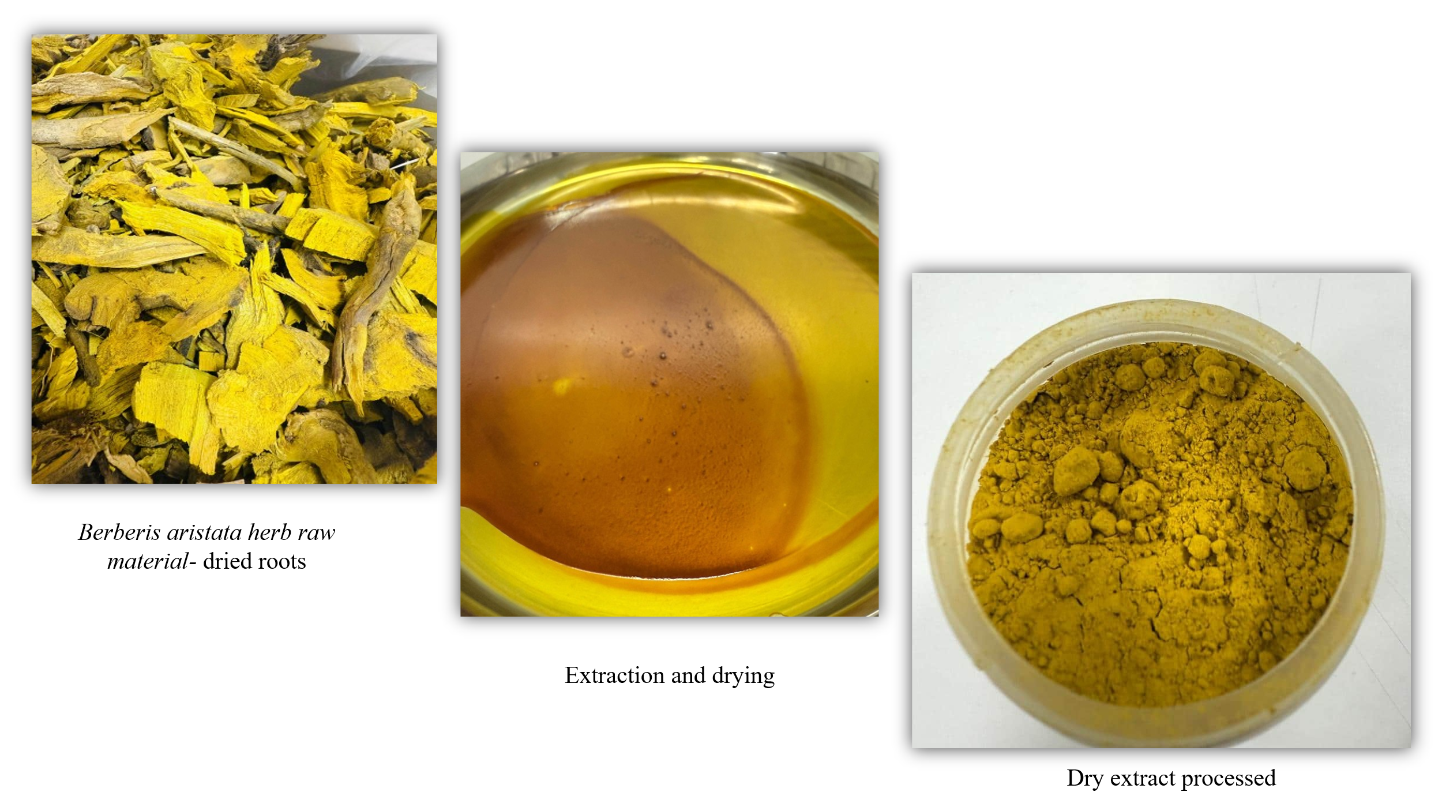
Online Resource 1 Hydroalcoholic extraction procedure for Gymnema sylvestre and Berberis aristata (schematic)
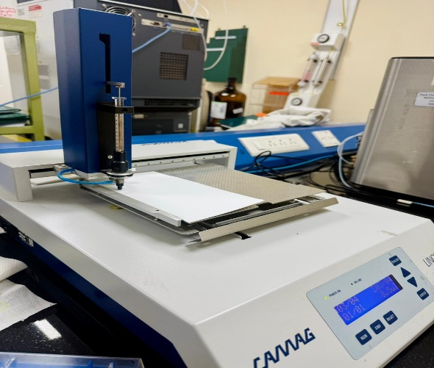
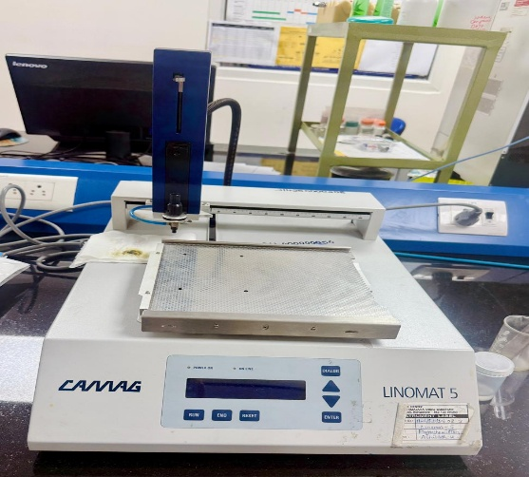
Online Resource 2 CAMAG Linomat 5 semi-automatic sample applicator used for band application

