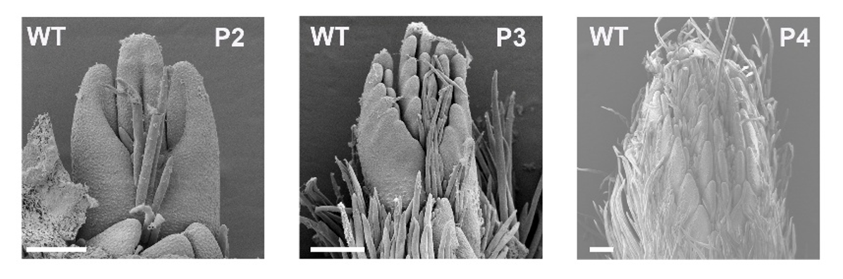
Supplementary Figure S1. Morphology of P2-P4 leaves in wild-type woodland strawberry.
Images showing the morphology of P2-P4 leaves in WT woodland strawberry. Scale bars: 50 μm.

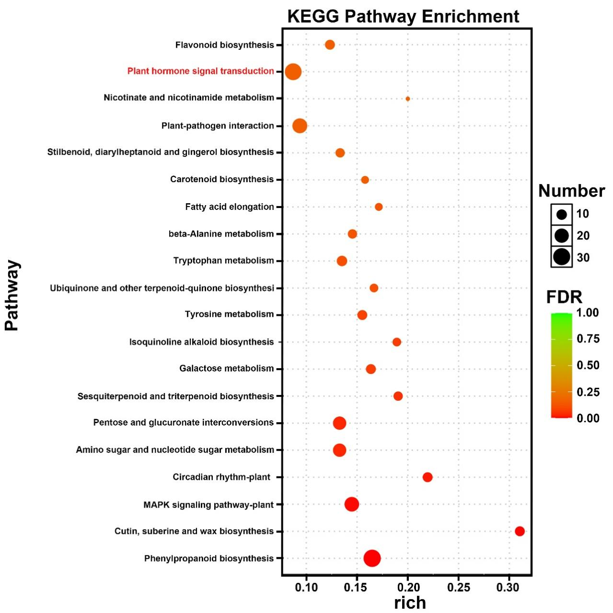
Supplementary Figure S2. KEGG analysis of genes downregulated in young leaves of fvemyb117a-1 relative to WT.
KEGG pathway enrichment analysis of downregulated genes in young leaves of the fvemyb117a-1 versus WT (P < 0.05). The X‑axis represents the enrichment factor.

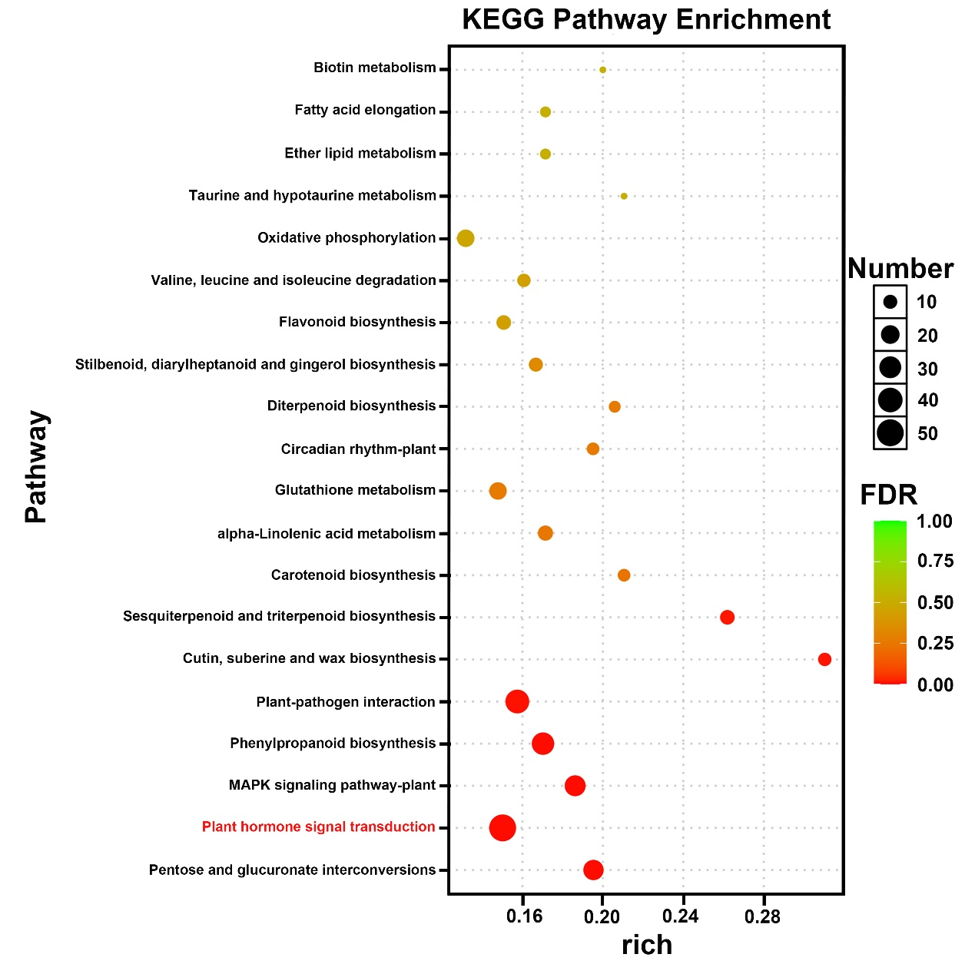
Supplementary Figure S3. KEGG analysis of genes downregulated in young leaves of sl1-1 relative to WT.
KEGG pathway enrichment analysis of downregulated genes in young leaves of the sl1-1 versus WT (P < 0.05). The X‑axis represents the enrichment factor.

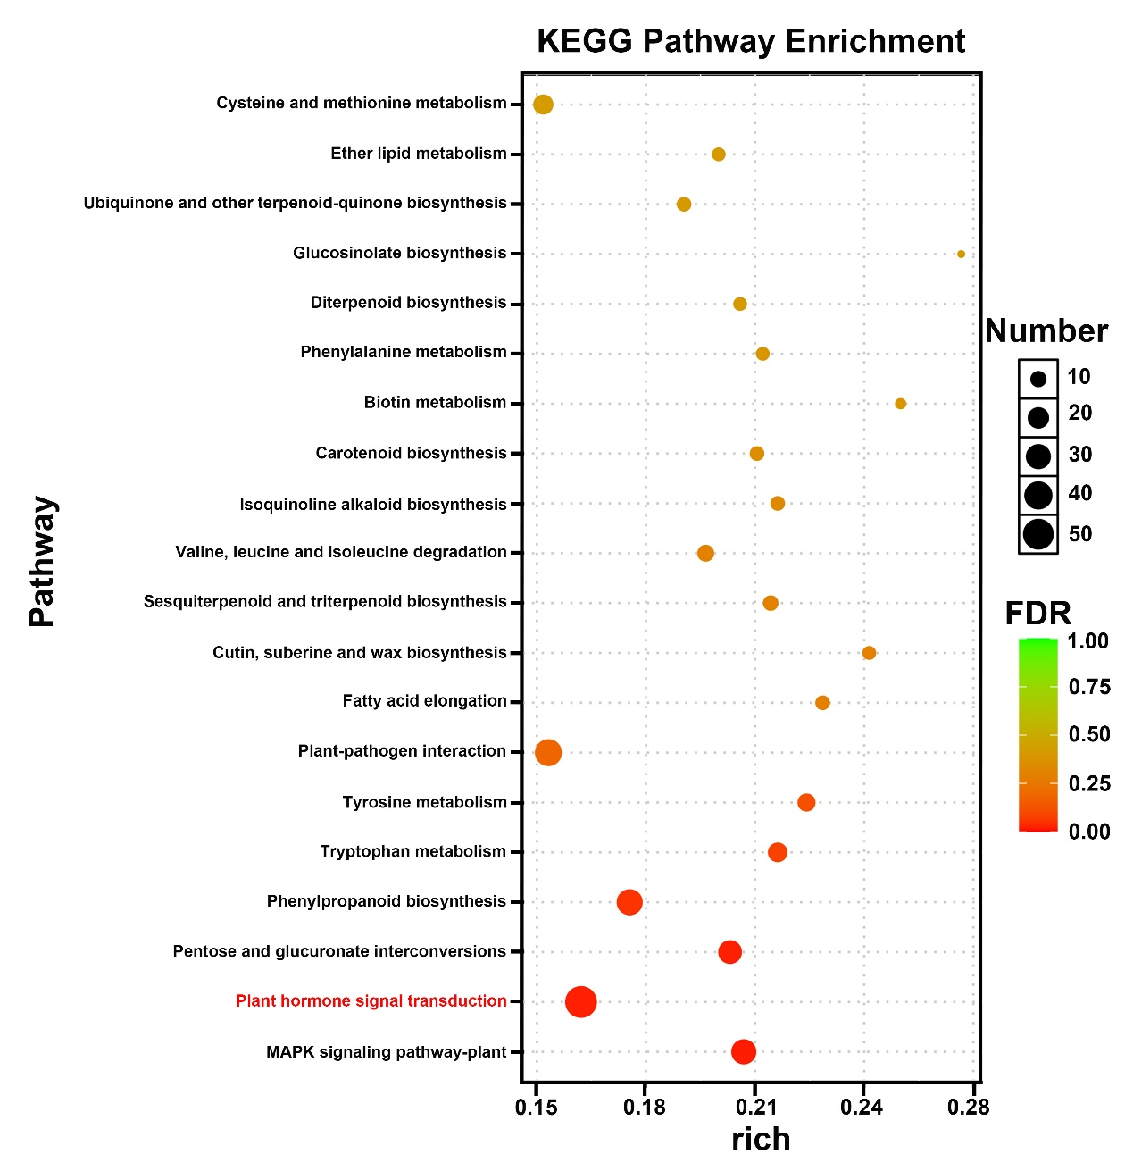
Supplementary Figure S4. KEGG analysis of genes downregulated in young leaves of fvemyb117a-1 sl1-1 relative to WT.
KEGG pathway enrichment analysis of downregulated genes in young leaves of the fvemyb117a-1 sl1-1 versus WT (P < 0.05). The X‑axis represents the enrichment factor.

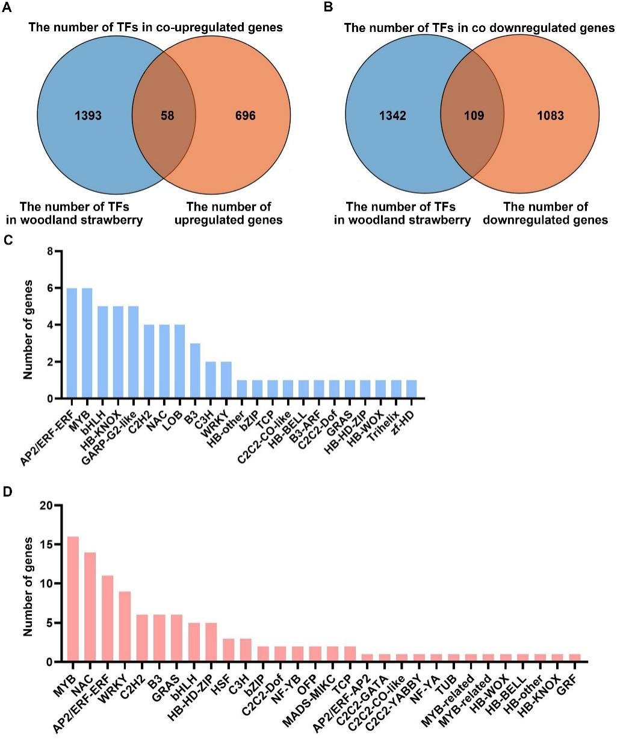
Supplementary Figure S5. Classification of TF types among genes that are commonly upregulated or downregulated in young leaves of the three mutants.
A-B, The Venn diagram shows the number of transcription factors that are commonly upregulated or downregulated in fvemyb117a-1, sl1-1 and fvemyb117a-1 sl1-1 compared to WT. C-D, Analysis of the types of transcription factors in the commonly upregulated or downregulated genes.

Supplementary Table S1. Summary of the RNA-seq reads.
Sample  name | Number of raw  reads | Number of uniquely  mapped reads | %  mapped
WT-2 | 42,472,380 | 41,860,778 | 98.56%
WT-2 | 47,496,244 | 46,821,797 | 98.58%
WT-3 | 50,684,544 | 49,954,687 | 98.56%
fvemyb117a-1-1 | 51,327,786 | 50,650,259 | 98.68%
fvemyb117a-1-2 | 52,062,830 | 51,365,188 | 98.66%
fvemyb117a-1-3 | 47,593,900 | 46,970,420 | 98.69%
sl1-1-1 | 48,593,324 | 47,995,626 | 98.77%
sl1-1-2 | 52,447,170 | 51,791,580 | 98.75%
sl1-1-3 | 48,562,826 | 47,970,360 | 98.78%
fvemyb117a-1 sl1-1-1 | 43,170,972 | 42,601,115 | 98.68%
fvemyb117a-1 sl1-1-2 | 52,088,376 | 51,411,227 | 98.70%
fvemyb117a-1 sl1-1-3 | 46,583,306 | 45,977,723 | 98.70%
Average |  |  | 98.68%

Supplementary Table S2. Primers used in this study.
Primer name | Sequence (5'-3')
Primers used for genotyping of the mutant included in this articl
fvemyb117a-1-SNP-F | ATGGCTAATCACAATGCTAGTGCT
fvemyb117a-1-SNP-R | TCCTTGGGTCCAGCTGGTTAAACC
sl1-1-SNP-F | AGACCCTTCCGTTTGCTGAATC
sl1-1-SNP-R | ACACAGGACTAGGGCTTTCAGTCT
Primers used for making the constructs in yeast one hybrid
pHIS2-SL1-P1-F | GACTCACTATAGGGCGAATTACTGTGGTGCTACTGTCAGAATATGATTGC
pHIS2-SL1-P1-R | CGGATCGATTCGCGAACGCGCTTTTCTTATTACTTTCGAAGACTCAACCGTAGTTTTATAA
pGADT7-FveMYB117a-F | CCCATACGACGTACCAGATTACGCTCATATGAAGGGCATGATGGCTAATCACAATGCTAGTGCTA
pGADT7-FveMYB117a-R | TTCAGTATCTACGATTCATCTGCAGCTCGAGTCATGTGGCTCCAACCCCAAGAAAATCAA
Primers used for making the constructs in dual luciferase assay
pCambia1302-FveMYB117a-F | TGGAGAGAACACGGGGGACTCTTGACCATGAAGGGCATGATGGCTAATCACAATGCTAGTGCTATTTAT
pCambia1302-FveMYB117a-R | CTCCAGTGAAAAGTTCTTCTCCTTTACTAGTTGTGGCTCCAACCCCAAGAAAATCAATGAAGGATGACG
pGreenII0800-SL1-F | ATACGACTCACTATAGGGCGAATTGGGTACCACACTCTTTCAGAAAGGGAT
pGreenII0800-SL1-R | GCCTTTCTTTATGTTTTTGGCGTCTTCCATGGACTCTCTCAAAATGGCCCAGAAG
Primers used for Electrophoretic mobility shift assays
FveMYB117a-His-F | CAGCAAATGGGTCGCGGATCCATGAAGGGCATGATGGC
FveMYB117a-His-R | TTGTCGACGGAGCTCGAATTCTGTGGCTCCAACCCCAAG
FAM-SL1-P1-F | GATTTGTTATTTACCAACCAGAATTAACCTA
FAM-SL1m-P1-F | GATTTGTTATTTTTTTTTTAGAATTAACCTA
SL1-P1-F | GATTTGTTATTTACCAACCAGAATTAACCTA
SL1-P1-R | TAGGTTAATTCTGGTTGGTAAATAACAAATC
SL1m-P1-R | TAGGTTAATTCTAAAAAAAAAATAACAAATC
Primers used for RT-qPCR
SL1-qRT-F | ATGCCTCCATGGGAGTTTCA
SL1-qRT-R | TTTCCGGAGTGGAAATCGGA
FveActin-qRT-F | AGCCTAACGCAGAGGTTCCAAA
FveActin-qRT-R | GCAGCCCACATTGAAGGGTCTATAGT
FveTCP4-qRT-F | CCACCGGCCGGAAAGACCGC
FveTCP4-qRT-R | ACGGAAATTGAGTTCGGGTT
FveTCP14-qRT-F | AAGAAGACGAAGCCGCATCC
FveTCP14-qRT-R | CGCCCGCGGCCGTCGACTTT
FveWOX1-qRT-F | ACTCTACTTCCAACACGACG
FveWOX1-qRT-R | TTAAGCCAGATCGATACAGCT
FveKNAT5La-qRT-F | ACCAACCCGACCCGAATTCCA
FveKNAT5La-qRT-R | TGGTTGGAGGCCTGGGAGGC
FveJAG-qRT-F | GGAGACAGAGACACTAAACCG
FveJAG-qRT-R | GTATGAGTTGTGTGGAAGGAG
FveLOG8-qRT-F | GTTATAAAACTGCTGCTACA
FveLOG8-qRT-R | GCATGTCGGTTACACGTATT
FveYUC7-qRT-F | CCAGGAGATGTGTATGGGTG
FveYUC7-qRT-R | AAGGGAAGTTGGGTAACTGG
FveYUC6-qRT-F | GATTCACAAAATGAATAACC
FveYUC6-qRT-R | TGAAGGCGGAGGCGATCGTAG
FveGH3.6-qRT-F | TTCTGAGTGAAATCCTAGCTC
FveGH3.6-qRT-R | TCCCAGAGCTTGTCAAAAACTC
FveGH3.2-qRT-F | TTCTGAGTGAAATCCTAGCT
FveGH3.2-qRT-R | CAGAGCTTGTCAAAAACTCC

