Supplemental Tables
Table S1 Demographics and medications of all patients in this study.
Patient No. | Gender | Age (years) | Disease duration (years) | SLEDAI
1 | F | 26 | 2.2 | 15
2 | F | 53 | 3 | 20
3 | F | 40 | 5 | 24
4 | F | 33 | 4.7 | 18
5 | F | 40 | 5.2 | 24
6 | F | 21 | 4.6 | 20
7 | F | 40 | 2.4 | 5
8 | F | 22 | 2.2 | 18
9 | F | 52 | 3.2 | 3
10 | F | 53 | 1 | 8
11 | F | 20 | 2.8 | 17
12 | F | 55 | 3.9 | 22
13 | F | 44 | 1.7 | 3
14 | F | 40 | 2.7 | 20
15 | F | 45 | 5.3 | 3
16 | F | 27 | 2.3 | 17
17 | F | 42 | 5.2 | 14
18 | F | 32 | 2.9 | 14
19 | F | 44 | 2.7 | 6
20 | F | 50 | 1.2 | 13
21 | F | 45 | 2.2 | 9
22 | M | 23 | 2.3 | 14
23 | M | 30 | 2.8 | 6
24 | M | 20 | 1.2 | 22
25 | M | 36 | 1.1 | 14
26 | M | 41 | 2 | 7
27 | M | 47 | 4.8 | 4
28 | M | 45 | 3.7 | 6
29 | M | 46 | 1 | 18
30 | M | 30 | 2.2 | 13
SLEDAI: Systemic Lupus Erythematosus Disease Activity Index, F: female, M: male.

Table S2 Gene-specific primer sets used in this study
Gene name | Primer Sequence (5’-3’)
Human NLRC5-F | GCTCGGCAACAAGAACCTGT
Human NLRC5-R | GGTCCAAGGTCTCGTTCCT
Human CIITA-F | CCTGGAGCTTCTTAACAGCGA
Human CIITA-R | TGTGTCGGGTTCTGAGTAGAG
Human HLA-B-F | CATCGTGGGCATTGTTGCTG
Human HLA-B-R | ACGCAGCCTGAGAGTAGC
Human TAP1-F | CCTGTGGCACAAACTCGGG
Human TAP1-R | ATCTCCCCAAGAGAGGAGAGGA
Human HLA-DPB1-F | ATTCTGCCCGGAGTAAGACAT
Human HLA-DPB1-R | TCGTTGAACTTTCTTGCTCCTC
Human HLA-DRB1-F | CGGGGTTGGTGAGAGCTTC
Human HLA-DRB1-R | AACCACCTGACTTCAATGCTG
Human GAPDH-F | ATGGGGAAGGTGAAGGTCG
Human GAPDH-R | GGGGTCATTGATGGCAACAATA
Mouse Nlrc5-F | GTGCCAAACGTCCTTTTCAGA
Mouse Nlrc5-R | AGTGAGGAGTAAGCCATGCTC
Mouse Ciita-F | TGCGTGTGATGGATGTCCAG
Mouse Ciita-R | CCAAAGGGGATAGTGGGTGTC
Mouse H2-D1-F | AGTGGTGCTGCAGAGCATTACAA
Mouse H2-D1-R | GGTGACTTCACCTTTAGATCTGGG
Mouse H2-K1-F | GCTGGTGAAGCAGAGAGACTCAG
Mouse H2-K1-R | GGTGACTTTATCTTCAGGTCTGCT
Mouse Tap1-F | AGTCTGGAGCCCACGATTTCATC
Mouse Tap1-R | GGGTGATAAGAAGAACCGTCCG
Mouse Cd74-F | AGTGCGACGAGAACGGTAAC
Mouse Cd74-R | CGTTGGGGAACACACACCA
Mouse H2-Eb1-F | TCCAGTGGCTTTGGTCAGAGAC
Mouse H2-Eb1-R | CAGGTTCTCCTCCAGGTTGTAG
Mouse H2-Dmb1-F | AGAGCCTTCTCCAGCGTTTGCA
Mouse H2-Dmb1-R | TGTGGTTTGGGCTACTCGGACA
Mouse β-actin - F | ATGCTCCCCGGGCTGTAT
Mouse β-actin - R | CATAGGAGTCCTTCTGACCCATTC

Table S3: List of antibodies and reagents.
Antibodies | Source | Cat#
Anti-mouse CD4-FITC | BioLegend | 100406
Anti-mouse CD21-APC | BioLegend | 123412
Anti-mouse MHCⅡ-BV510 | BioLegend | 107636
Anti-mouse CD11c-percpcy5.5 | BioLegend | 136504
Anti-mouse CD11c-FITC | BioLegend | 117306
Anti-mouse CD3-APC | BioLegend | 100236
Anti-mouse SiglecH-PE | BioLegend | 12-0333-82
Goat Anti-Rabbit IgG H&L | Abcam | ab150083
Donkey polyclonal Secondary Antibody to Goat IgG H&L | Abcam | ab150129
Anti-mouse IFNγ-APC | BD | 562018
Anti-mouse IL-17A-PE | BD | 561020
DAPI | BD | 564907
β-Actin (13E5) Rabbit mAb | Cell Signaling Technology | #4970
Anti-rabbit IgG, HRP-linked Antibody | Cell Signaling Technology | #7074
Anti-mouse IgG, HRP-linked Antibody | Cell Signaling Technology | #7076
Phospho-p47phox (Ser370) Polyclonal Antibody | Thermo Fisher | PA5-36863
InVivoMAb anti-mouse CD317 | Bio X Cell | BE0311
InVivoMAb rat IgG2b isotype control | Bio X Cell | BE0090
APC anti-human Lineage Cocktail (CD3, CD14, CD16, CD19, CD20, CD56) | Biolegend | 348803
Anti-human CD24-BV711 | BD | 563401
Anti-human CD11c-BUV395 | BD | 563787
Anti-human CD3-BV786 | BD | 563799
Anti-human CD4-BUV496 | BD | 564651
APC anti-human Lineage Cocktail (CD3, CD14,  CD16, CD19, CD20, CD56) | Biolegend | 348803
Anti-human CD11c-percpcy5.5 | BD | 565227
Anti-human HLA-DR-FITC | BD | 555811
Anti-human AXL-APC | R&D | FAB154A
Anti-human CD27-APC-EF780 | eBioscience | 47-0279
Anti-human CD45RA-PE-CY7 | eBioscience | 25-0458-73
Fc block | BioLegend | 422301
LIVE/DEAD® Stain Kit Green Fluorescent | Invitrogen | L23101

Supplemental Figures
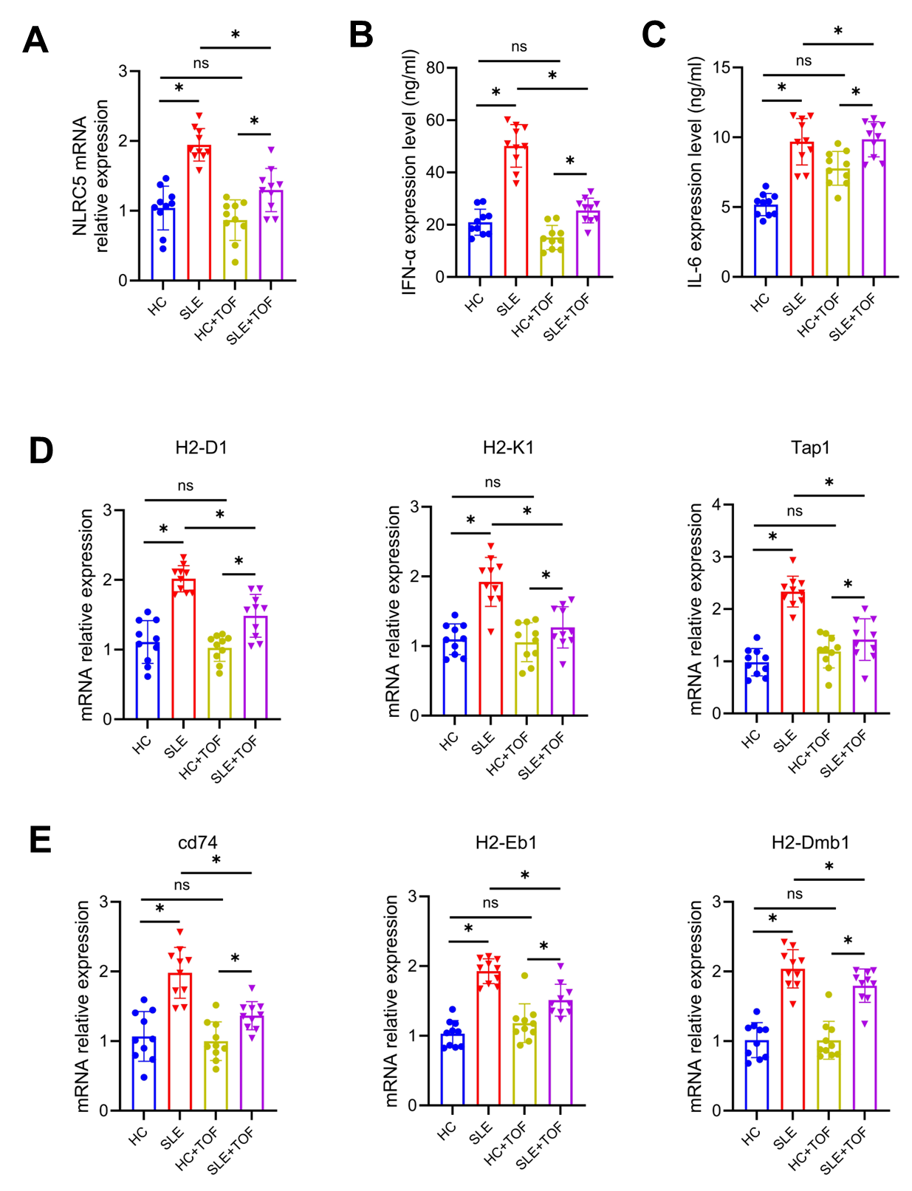
Figure S1: TOF suppressed the expression of IFN-α and IL-6 in SLE pDCs in vitro. (A) RT-qPCR analysis of the mRNA levels of NLRC5 in pDCs (n=10). (B, C) Levels of IFN-α (B) and IL-6 (C) in the supernatant of the culture medium (n=10). (D, E) RT-qPCR analysis of the mRNA levels of MHC-I (D) and MHC-II (E) in pDCs (n=10). Data shown are representatives of three independent experiments. Data were presented as mean ± SEM, *P < 0.05. The P values were calculated using paired t-test.

