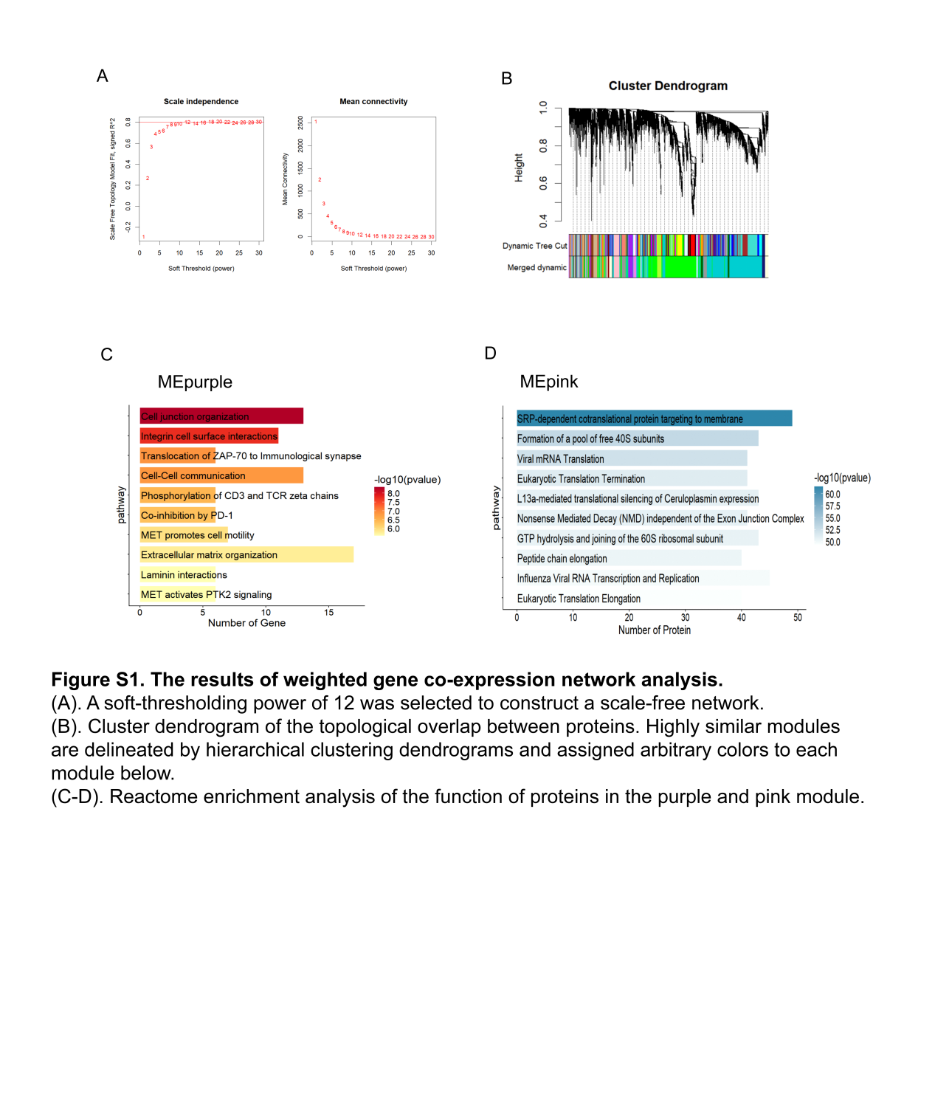

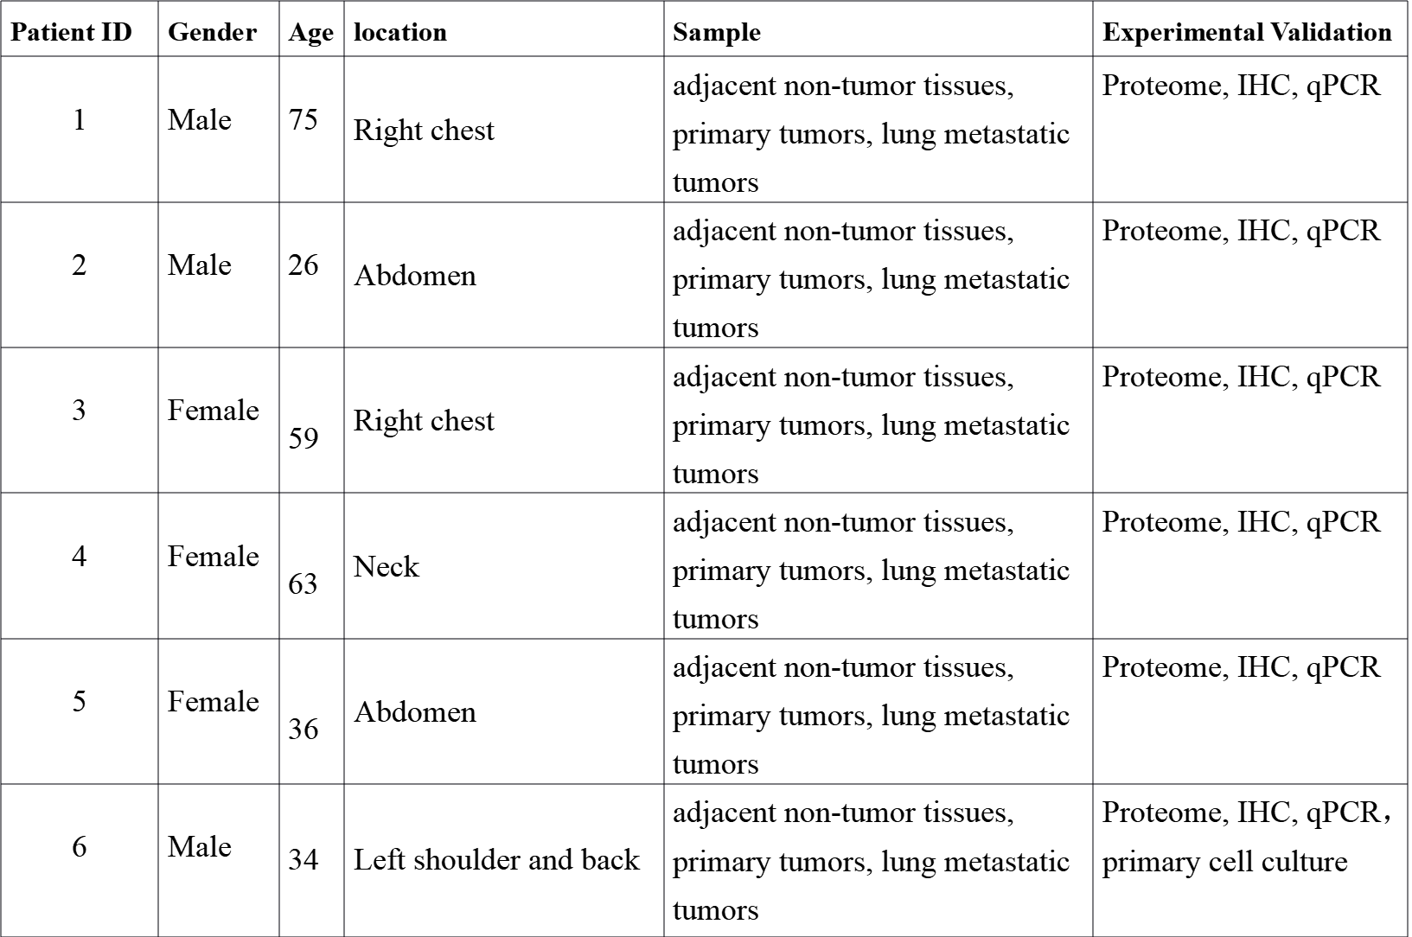
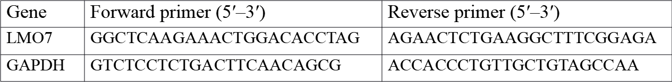
Table S2. Primers for RT-qPCR.
Table S1. Clinical information of patients with dermatofibrosarcoma protuberans.

