Appendix B. Proofs
The calculation process of equilibrium outcomes under the NC strategy.
First, find the first and second derivatives of the profit function of the platform with respect to the ride price, denoted as $\frac{dπ_{r}^{NC}}{dp}=λ\left(1-β\right)\left(1-2p\left(1-sαβ\right)+αρ\left(n_{p}+n_{q}\right)\right)$ and $\frac{d^{2}π_{r}^{NC}}{dp^{2}}=-2λ\left(1-β\right)\left(1-sαβ\right)$. It is required that $\frac{d^{2}π_{r}^{NC}}{dp^{2}}<0$, which means $1-sαβ>0$. Given $\frac{dπ_{r}^{NC}}{dp}=0$, the optimal response function for the platform can be obtained as $p^{NC}=\frac{1+αρ\left(n_{p}+n_{q}\right)}{2\left(1-sαβ\right)}$.
Furthermore, substitute $p^{NC}$ into the profit functions of the provider-c and provider-f. Then, the results for the first-order partial derivatives and second-order partial derivatives of the profit functions for both entities with respect to the decision variables are as follows:
$\frac{dπ_{c}^{NC}}{dn_{c}}=-2n_{c}+\frac{e_{0}ρ\left(2-sαβ\right)\left(m+e-τ-△\right)}{4m\left(1-sαβ\right)}$, and $\frac{d^{2}π_{c}^{NC}}{d{n_{c}}^{2}}=-2<0$; $\frac{∂π_{f}^{NC}}{∂n_{f}}=-2kn_{f}+\frac{ρ\left(e+e_{0}\right)\left(2-sαβ\right)\left(τ+△+m-e\right)}{4\left(1-sαβ\right)}$, and $\frac{∂^{2}π_{f}^{NC}}{∂{n_{f}}^{2}}=-2k<0$, $\frac{∂^{2}π_{f}^{NC}}{∂n_{f}∂e}=\frac{ρ\left(2-sαβ\right)\left(m+τ+△-2e-e_{0}\right)}{4m\left(1-sαβ\right)}$, $\frac{∂π_{f}^{NC}}{∂e}=\frac{\left(sβ+ρ\left(n_{c}+n_{f}\right)\left(2-sαβ\right)\right)\left(τ+m+△-2e-e_{0}\right)}{4\left(1-sαβ\right)}$, $\frac{∂^{2}π_{f}^{NC}}{∂e^{2}}=-\frac{sβ+\left(n_{c}+n_{f}\right)\left(2-sαβ\right)ρ}{2m\left(1-sαβ\right)}<0$, and $\frac{∂^{2}π_{f}^{NC}}{∂e∂n_{f}}=\frac{ρ\left(2-sαβ\right)\left(m+τ+△-2e-e_{0}\right)}{4m\left(1-sαβ\right)}$. Since the provider-f makes decisions involving two variables, it is required that the Hessian matrix $\left|H_{1}\right|$ is greater than 0, i.e., $\left|H_{1}\right|=\frac{∂^{2}π_{f}^{NC}}{∂{n_{f}}^{2}}\frac{∂^{2}π_{f}^{NC}}{∂e^{2}}-{\left(\frac{∂^{2}π_{f}^{NC}}{∂n_{f}∂e}\right)}^{2}=\left(\frac{k\left(sβ+ρ\left(n_{c}+n_{f}\right)\left(2-sαβ\right)\right)}{m\left(1-sαβ\right)}-\frac{ρ^{2}{\left(2-sαβ\right)}^{2}{\left(m+τ+△-2e-e_{0}\right)}^{2}}{16m^{2}{\left(1-sαβ\right)}^{2}}\right)>0$.
By simultaneously setting $\frac{dπ_{c}^{NC}}{dn_{c}}=0$, $\frac{∂π_{f}^{NC}}{∂n_{f}}=0$, and $\frac{∂π_{f}^{NC}}{∂e}=0$, the equilibrium decisions for the provider-c and provider-f can be obtained as $n_{c}^{NC*}=\frac{e_{0}ρ\left(2-sαβ\right)\left(3m-e_{0}-τ-△\right)}{16m\left(1-sαβ\right)}$, $e^{NC*}=\frac{1}{2}\left(m+τ+△-e_{0}\right)$ and $n_{f}^{NC*}=\frac{ρ\left(2-sαβ\right){\left(e_{0}+τ+△+m\right)}^{2}}{32km\left(1-sαβ\right)}$. It should be noted that there are three sets of equilibrium decisions, but only this set of solutions satisfies the requirement that the Hessian matrix is greater than 0. The result for the Hessian matrix is $\left|H_{1}\right|=\frac{32kmsβ\left(1-sαβ\right)+ρ^{2}{\left(2-sαβ\right)}^{2}\left(2e_{0}k\left(3m-\left(e_{0}+τ+△\right)\right)+{\left(e_{0}+τ+△+m\right)}^{2}\right)}{32m{\left(1-sαβ\right)}^{2}}>0$. Based on this set of equilibrium decisions, all equilibrium outcomes in Table 2 can be obtained.
Proof of Proposition 1.
By taking the first derivatives of all equilibrium outcomes under the three subsidy strategies with respect to the network externality coefficient $α$ and the sensitivity coefficient of drivers to the number of charging stations $ρ$, Proposition 1 can be derived.

Proof of Proposition 2.
The proof process for the three subsidy strategies is similar. We take the case of usage subsidy strategy as an example for the proof.
The derivative of the equilibrium decisions and outcomes with respect to the difference in charging time costs is as follows:
(1) $\frac{∂e^{NU*}}{∂Δ}=\frac{1}{2}>0$; $\frac{∂n_{c}^{NU*}}{∂Δ}=-\frac{e_{0}ρ\left(2-sαβ\right)}{16m\left(1-sαβ\right)}<0$; $\frac{∂n_{f}^{NU*}}{∂Δ}=\frac{ρ\left(2-sαβ\right)\left(e_{0}+μ+△+m\right)}{16km\left(1-sαβ\right)}>0$.
(2) $\frac{∂Q_{f}^{NU*}}{∂Δ}=\frac{1}{256km^{2}{\left(1-sαβ\right)}^{2}}\left(3{\left(2-sαβ\right)}^{2}ρ^{2}{\left(e_{0}+μ+△+m\right)}^{2}+4k\left(e_{0}ρ^{2}{\left(2-sαβ\right)}^{2}\left(m-\left(e_{0}+μ+△\right)\right)+8msβ\left(1-sαβ\right)\right)\right)$, when $△≤\frac{8msβ\left(1-sαβ\right)}{e_{0}ρ^{2}{\left(2-sαβ\right)}^{2}}+m-e_{0}-μ$, we have $\frac{∂Q_{f}^{NU*}}{∂Δ}>0$; when $△>\frac{8msβ\left(1-sαβ\right)}{e_{0}ρ^{2}{\left(2-sαβ\right)}^{2}}+m-e_{0}-μ$, if $k≥\frac{-3ρ^{2}{\left(2-sαβ\right)}^{2}{\left(e_{0}+μ+△+m\right)}^{2}}{4\left(e_{0}ρ^{2}{\left(2-sαβ\right)}^{2}\left(m-\left(e_{0}+μ+△\right)\right)+8msβ\left(1-sαβ\right)\right)}$, then $\frac{∂Q_{f}^{NU*}}{∂Δ}≤0$; otherwise, $\frac{∂Q_{f}^{NU*}}{∂Δ}>0$.
$\frac{∂Q_{c}^{NU*}}{∂Δ}=\frac{1}{256km^{2}{\left(1-sαβ\right)}^{2}}\left(\begin{aligned}&{\left(2-sαβ\right)}^{2}ρ^{2}\left(e_{0}+μ+△+m\right)\left(5m-3\left(e_{0}+μ+△\right)\right) \\ &-4k\left(e_{0}ρ^{2}{\left(2-sαβ\right)}^{2}\left(5m-\left(e_{0}+μ+△\right)\right)+8msβ\left(1-sαβ\right)\right)\end{aligned}\right)$, when $\frac{5m}{3}≤e_{0}+μ+△<3m$, we have $\frac{∂Q_{c}^{NU*}}{∂Δ}<0$. When $0<e_{0}+μ+△<\frac{5m}{3}$, if $k≥\frac{ρ^{2}{\left(2-sαβ\right)}^{2}\left(e_{0}+μ+△+m\right)\left(5m-3\left(e_{0}+μ+△\right)\right)}{4e_{0}ρ^{2}{\left(2-sαβ\right)}^{2}\left(3m-\left(e_{0}+μ+△\right)\right)+32msβ\left(1-sαβ\right)}>1$, then $\frac{∂Q_{c}^{NU*}}{∂Δ}<0$; otherwise, $\frac{∂Q_{c}^{NU*}}{∂Δ}≥0$.
$\frac{∂π_{f}^{NU*}}{∂Δ}=\frac{\left(e_{0}+μ+△+m\right)}{256km^{2}{\left(1-sαβ\right)}^{2}}\left({\left(2-sαβ\right)}^{2}ρ^{2}{\left(e_{0}+μ+△+m\right)}^{2}+k\left(e_{0}ρ^{2}{\left(2-sαβ\right)}^{2}\left(5m-3\left(e_{0}+μ+△\right)\right)+32msβ\left(1-sαβ\right)\right)\right)$, when $△≤\frac{32msβ\left(1-sαβ\right)}{3e_{0}ρ^{2}{\left(2-sαβ\right)}^{2}}+\frac{5m}{3}-e_{0}-μ$, we have $\frac{∂π_{f}^{NU*}}{∂Δ}>0$. When $△>\frac{32msβ\left(1-sαβ\right)}{3e_{0}ρ^{2}{\left(2-sαβ\right)}^{2}}+\frac{5m}{3}-e_{0}-μ$, if $k>\frac{-ρ^{2}{\left(2-sαβ\right)}^{2}{\left(e_{0}+μ+△+m\right)}^{2}}{e_{0}ρ^{2}{\left(2-sαβ\right)}^{2}\left(5m-3\left(e_{0}+μ+△\right)\right)+32msβ\left(1-sαβ\right)}$, then $\frac{∂π_{f}^{NU*}}{∂Δ}≤0$; otherwise, $\frac{∂π_{f}^{NU*}}{∂Δ}≥0$.
$\frac{∂π_{c}^{NU*}}{∂Δ}=\frac{e_{0}}{256km^{2}{\left(1-sαβ\right)}^{2}}\left(\begin{aligned}&{\left(2-sαβ\right)}^{2}ρ^{2}\left(e_{0}+μ+△+m\right)\left(5m-3\left(e_{0}+μ+△\right)\right) \\ &-2k\left(e_{0}ρ^{2}{\left(2-sαβ\right)}^{2}\left(3m-\left(e_{0}+μ+△\right)\right)+16msβ\left(1-sαβ\right)\right)\end{aligned}\right)$, when$\frac{5m}{3}-e_{0}-μ≤△<3m-e_{0}-μ$, we have $\frac{∂π_{c}^{NU*}}{∂Δ}<0$. When $△<\frac{5m}{3}-e_{0}-μ$, if $k≥\frac{ρ^{2}{\left(2-sαβ\right)}^{2}\left(e_{0}+μ+△+m\right)\left(5m-3\left(e_{0}+μ+△\right)\right)}{2e_{0}ρ^{2}{\left(2-sαβ\right)}^{2}\left(3m-\left(e_{0}+μ+△\right)\right)+32msβ\left(1-sαβ\right)}>1$, then $\frac{∂π_{c}^{NU*}}{∂Δ}<0$; otherwise, $\frac{∂π_{c}^{NU*}}{∂Δ}≥0$.
(3) $\frac{∂p^{NU*}}{∂Δ}=\frac{α\left(2-sαβ\right)ρ^{2}\left(μ+△+m-e_{0}\left(k-1\right)\right)}{32km{\left(1-sαβ\right)}^{2}}$, if $1<k<\frac{μ+△+m}{e_{0}}+1$, we have $\frac{∂p^{NU*}}{∂Δ}>0$; otherwise, $\frac{∂p^{NU*}}{∂Δ}≤0$.
$\frac{∂S^{NU*}}{∂Δ}=\frac{{\left(2-sαβ\right)}^{2}ρ^{2}\left(μ+△+m-e_{0}\left(k-1\right)\right)}{32km{\left(1-sαβ\right)}^{2}}$, similar to $\frac{∂p^{NU*}}{∂Δ}$.
$\frac{∂D^{NU*}}{∂Δ}=\frac{α\left(2-sαβ\right)λρ^{2}\left(μ+△+m-e_{0}\left(k-1\right)\right)}{32km\left(1-sαβ\right)}$, similar to $\frac{∂p^{NU*}}{∂Δ}$.
$\frac{∂π_{r}^{NU*}}{∂Δ}=\frac{αλρ^{2}\left(1-β\right)\left(2-sαβ\right)}{1024k^{2}m^{2}{\left(1-sαβ\right)}^{3}}\left(μ+△+m-e_{0}\left(k-1\right)\right)\left(\begin{aligned}&α\left(2-sαβ\right)ρ^{2}{\left(e_{0}+μ+△+m\right)}^{2} \\ &+2k\left(\begin{aligned}16m\left(1-sαβ\right)+ \\ αe_{0}ρ^{2}\left(2-sαβ\right)\left(3m-\left(e_{0}+μ+△\right)\right)\end{aligned}\right)\end{aligned}\right)$, similar to $\frac{∂p^{NU*}}{∂Δ}$.

Proof of Proposition 3.
(1) The proof process for the charging subsidy strategy is similar to the usage subsidy strategy. We take the case of usage subsidy strategy as an example to prove the impact of subsidy increase on the optimal outcome.
$\frac{∂e^{NU*}}{∂μ}=-\frac{1}{2}$. $\frac{∂n_{c}^{NU*}}{∂μ}=-\frac{e_{0}ρ\left(2-sαβ\right)}{16m\left(1-sαβ\right)}<0$. $\frac{∂n_{f}^{NU*}}{∂μ}=\frac{ρ\left(2-sαβ\right)\left(e_{0}+μ+△+m\right)}{16km\left(1-sαβ\right)}>0$. $\frac{∂p^{NU*}}{∂μ}=\frac{αρ^{2}\left(2-sαβ\right)\left(μ+△+m-e_{0}\left(k-1\right)\right)}{32km{\left(1-sαβ\right)}^{2}}$, if $μ>μ_{1}$, then $\frac{∂p^{NU*}}{∂μ}>0$; otherwise, $\frac{∂p^{NU*}}{∂μ}≤0$.
$\frac{∂S^{NU*}}{∂μ}=\frac{ρ^{2}{\left(2-sαβ\right)}^{2}\left(μ+△+m-e_{0}\left(k-1\right)\right)}{32km{\left(1-sαβ\right)}^{2}}$, similar to $\frac{∂p^{NU*}}{∂μ}$.
$\frac{∂D^{NU*}}{∂μ}=\frac{αλρ^{2}\left(2-sαβ\right)\left(μ+△+m-e_{0}\left(k-1\right)\right)}{32km\left(1-sαβ\right)}$, similar to $\frac{∂p^{NU*}}{∂μ}$.
$\frac{∂Q_{f}^{NU*}}{∂μ}=sign\left(k\left(4e_{0}ρ^{2}{\left(2-sαβ\right)}^{2}\left(m-\left(e_{0}+μ+△\right)\right)+32msβ\left(1-sαβ\right)\right)+3ρ^{2}{\left(2-sαβ\right)}^{2}{\left(e_{0}+μ+△+m\right)}^{2}\right)$, when $μ≤μ_{2}$, we have $\frac{∂Q_{f}^{NU*}}{∂μ}>0$. When $μ>μ_{2}$, if $k>k_{1}$, then $\frac{∂Q_{f}^{NU*}}{∂μ}<0$; otherwise, $\frac{∂Q_{f}^{NU*}}{∂μ}>0$.
$\frac{∂Q_{c}^{NU*}}{∂μ}=sign\left(\begin{aligned}&ρ^{2}{\left(2-sαβ\right)}^{2}\left(e_{0}+μ+△+m\right)\left(5m-3\left(e_{0}+μ+△\right)\right) \\ &-k\left(4e_{0}ρ^{2}{\left(2-sαβ\right)}^{2}\left(3m-\left(e_{0}+μ+△\right)\right)+32msβ\left(1-sαβ\right)\right)\end{aligned}\right)$, when$μ_{3}≤μ<3m-e_{0}-△$, we have $\frac{∂Q_{c}^{NU*}}{∂μ}<0$. When $0<μ<μ_{3}$, if $k≥k_{2}>1$, then $\frac{∂Q_{c}^{NU*}}{∂μ}<0$; otherwise, $\frac{∂Q_{c}^{NU*}}{∂μ}≥0$.
(2) $\frac{∂e^{NB*}}{∂η}=0$. $\frac{∂n_{c}^{NB*}}{∂η}=0$. $\frac{∂n_{f}^{NB*}}{∂η}=\frac{1}{2k}>0$. $\frac{∂p^{NB*}}{∂η}=\frac{αρ}{4k\left(1-sαβ\right)}>0$. $\frac{∂S^{NB*}}{∂η}=\frac{ρ\left(2-sαβ\right)}{4k\left(1-sαβ\right)}>0$. $\frac{∂D^{NB*}}{∂η}=\frac{αλρ}{4k}>0$. $\frac{∂Q_{f}^{NB*}}{∂η}=\frac{ρ\left(2-sαβ\right)\left(e_{0}+△+m\right)}{16km\left(1-αβ\right)}>0$. $\frac{∂Q_{c}^{NB*}}{∂η}=\frac{\left(2-sαβ\right)ρ\left(3m-e_{0}-△\right)}{16km\left(1-sαβ\right)}>0$.
Proof of Proposition 4.
(1) The proof process for the charging subsidy strategy is similar to the usage subsidy strategy. We take the case of usage subsidy strategy as an example to prove the impact of subsidy increase on the optimal profit and surplus.
$\frac{∂π_{f}^{NU*}}{∂μ}=\frac{\left(e_{0}+μ+△+m\right)}{256km^{2}{\left(1-sαβ\right)}^{2}}\left(ρ^{2}{\left(2-sαβ\right)}^{2}\left({\left(e_{0}+μ+△+m\right)}^{2}+ke_{0}\left(5m-3\left(e_{0}+μ+△\right)\right)\right)+32kmsβ\left(1-sαβ\right)\right)$, when $μ≤μ_{4}$, we have $\frac{∂π_{f}^{NU*}}{∂μ}>0$. When $μ>μ_{4}$, if $k>k_{3}$, then $\frac{∂π_{f}^{NU*}}{∂μ}<0$; otherwise, $\frac{∂π_{f}^{NU*}}{∂μ}>0$.
$\frac{∂π_{c}^{NU*}}{∂μ}=sign\left(ρ^{2}{\left(2-sαβ\right)}^{2}\left(e_{0}+μ+△+m\right)\left(5m-3\left(e_{0}+μ+△\right)\right)-2k\left(e_{0}ρ^{2}{\left(2-sαβ\right)}^{2}\left(3m-\left(e_{0}+μ+△\right)\right)+16msβ\left(1-sαβ\right)\right)\right)$, when $μ_{3}≤μ<3m-e_{0}-△$, we have $\frac{∂π_{c}^{NU*}}{∂μ}<0$. When $0<μ<μ_{3}$, if $k≥k_{4}>1$, then $\frac{∂π_{c}^{NU*}}{∂μ}<0$; otherwise, $\frac{∂π_{c}^{NU*}}{∂μ}≥0$.
$\frac{∂π_{r}^{NU*}}{∂μ}=\frac{α\left(1-β\right)\left(2-sαβ\right)λρ^{2}}{1024k^{2}{\left(1-sαβ\right)}^{3}}\left(αρ^{2}\left(2-sαβ\right)\left(\begin{aligned}{\left(e_{0}+μ+△+m\right)}^{2} \\ +2ke_{0}\left(3m-\left(e_{0}+μ+△\right)\right)\end{aligned}\right)+32km\left(1-sαβ\right)\right)=sign\left(μ+△+m-e_{0}\left(k-1\right)\right)$, similar to $\frac{∂p^{NU*}}{∂μ}$.
$\frac{∂CS^{NU*}}{∂μ}=\frac{α\left(2-sαβ\right)λρ^{2}\left(μ+△+m-e_{0}\left(k-1\right)\right)\left(\begin{aligned}&αρ^{2}\left(2-sαβ\right){\left(e_{0}+μ+△+m\right)}^{2} \\ &+2k\left(16m\left(1-sαβ\right)+αe_{0}ρ^{2}\left(2-sαβ\right)\left(3m-\left(e_{0}+μ+△\right)\right)\right)\end{aligned}\right)}{2048k^{2}m^{2}{\left(1-sαβ\right)}^{2}}$, similar to $\frac{∂p^{NU*}}{∂μ}$.
$\frac{∂DS^{NU*}}{∂μ}=sign\left(\begin{aligned}&\frac{4}{k{\left(1-sαβ\right)}^{2}}\left(4k{\left(1-sαβ\right)}^{2}\left(e_{0}+μ+△-m\right)+m{\left(2-sαβ\right)}^{2}ρ^{2}\left(m+μ+△-e_{0}\left(k-1\right)\right)\right) \\ &\left(2k\left(4e_{0}ρ^{2}{\left(2-sαβ\right)}^{2}\left(3m-\left(e_{0}+μ+△\right)\right)+16msβ\left(1-sαβ\right)\right)+{\left(2-sαβ\right)}^{2}ρ^{2}{\left(e_{0}+m+μ+△\right)}^{2}\right) \\ &+2{\left(2-sαβ\right)}^{2}ρ^{2}\left(m+μ+△-e_{0}\left(k-1\right)\right)\left(4{\left(3m-\left(e_{0}+μ+△\right)\right)}^{2}+4{\left(e_{0}+m+μ+△\right)}^{2}\right)\end{aligned}\right)$, if $μ<μ_{5}$, we have $\frac{∂DS^{NU*}}{∂μ}<0$. If $μ≥μ_{1}$, then $\frac{∂DS^{NU*}}{∂μ}>0$, where $μ_{5}<μ_{1}$.
(2) $\frac{∂π_{f}^{NB*}}{∂η}=\frac{\left(2-sαβ\right)ρ{\left(e_{0}+△+m\right)}^{2}}{32km\left(1-sαβ\right)}+\frac{η}{2k}>0$. $\frac{∂π_{c}^{NB*}}{∂η}=\frac{e_{0}ρ\left(2-sαβ\right)\left(3m-e_{0}-△\right)}{16km\left(1-sαβ\right)}>0$.
$\frac{∂π_{r}^{NB*}}{∂η}=\frac{α\left(1-β\right)λρ\left(\begin{aligned}&αρ\left(16m\left(1-sαβ\right)η+\left(2-sαβ\right)ρ{\left(e_{0}+△+m\right)}^{2}\right) \\ &+2k\left(16m\left(1-sαβ\right)+αe_{0}ρ^{2}\left(2-sαβ\right)\left(3m-\left(e_{0}+△\right)\right)\right)\end{aligned}\right)}{128k^{2}m{\left(1-sαβ\right)}^{2}}>0$.
$\frac{∂CS^{NB*}}{∂η}=\frac{αλρ\left(αρ\left(16m\left(1-sαβ\right)η+\left(2-sαβ\right)ρ{\left(e_{0}+△+m\right)}^{2}\right)+2k\left(16m\left(1-sαβ\right)+αe_{0}ρ^{2}\left(2-sαβ\right)\left(3m-\left(e_{0}+△\right)\right)\right)\right)}{256k^{2}m\left(1-sαβ\right)}>0$.
$\frac{∂DS^{NB*}}{∂η}=\frac{\left(2-sαβ\right)ρ}{256k^{2}m^{2}{\left(1-sαβ\right)}^{3}}\left(\begin{aligned}&\left(2-sαβ\right)mρ\left(16m\left(1-sαβ\right)η+ρ\left(2-sαβ\right){\left(e_{0}+△+m\right)}^{2}\right)+ \\ &2k\left(\begin{aligned}&2{\left(1-sαβ\right)}^{2}\left(4m^{2}+{\left(m-\left(e_{0}+△\right)\right)}^{2}\right)+ \\ &e_{0}mρ^{2}{\left(2-sαβ\right)}^{2}\left(3m-\left(e_{0}+△\right)\right)+16m^{2}sβ\left(1-sαβ\right)\end{aligned}\right)\end{aligned}\right)>0$.
Proof of Proposition 5.
(1) $e^{NC*}-e^{NU*}=\frac{μ+τ}{2}>0$, $e^{NC*}-e^{NB*}=\frac{τ}{2}>0$, $e^{NU*}-e^{NB*}=-\frac{μ}{2}<0$, therefore, $e^{NC*}>e^{NB*}>e^{NU*}$.
(2) By observing the equilibrium outcomes under the charging subsidy strategy and the usage subsidy strategy, it can be concluded that charging subsidies and usage subsidies have a substitution effect. Therefore, usage subsidies and charging subsidies have the same impact on various aspects such as the scale of conventional and fast charging stations, ride price, supply and demand on the ride-hailing platform, as well as charging market demand.
Due to the similar effects of charging subsidies and usage subsidies, the subsequent analysis only compares the usage subsidy strategy and the building subsidy strategy.
(3) $n_{c}^{NU*}-n_{c}^{NB*}=-\frac{e_{0}μρ\left(2-sαβ\right)}{16m\left(1-sαβ\right)}<0$.
(4) $n_{f}^{NU*}-n_{f}^{NB*}=\frac{16ηm\left(1-sαβ\right)-μρ\left(2-sαβ\right)\left(2m+2e_{0}+μ+2△\right)}{-32km\left(1-sαβ\right)}$, if $η>η_{1}$, $n_{f}^{NB*}>n_{f}^{NU*}$; otherwise, $n_{f}^{NB*}≤n_{f}^{NU*}$.
(5) $p^{NU*}-p^{NB*}=\frac{αρ\left(-16ηm\left(1-sαβ\right)+\left(2-sαβ\right)μρ\left(μ+2m+2△-2e_{0}\left(k-1\right)\right)\right)}{64km{\left(1-sαβ\right)}^{2}}$, if $η>η_{2}$, then $p^{NB*}>p^{NU*}$; otherwise, $p^{NB*}≤p^{NU*}$.
$S^{NU*}-S^{NB*}=\frac{ρ\left(2-sαβ\right)\left(-16ηm\left(1-sαβ\right)+μρ\left(2-sαβ\right)\left(μ+2m+2△-2e_{0}\left(k-1\right)\right)\right)}{64km{\left(1-sαβ\right)}^{2}}$, similar to $p^{NU*}-p^{NB*}$.
$D^{NU*}-D^{NB*}=\frac{αλρ\left(-16ηm\left(1-sαβ\right)+μρ\left(2-sαβ\right)\left(μ+2m+2△-2e_{0}\left(k-1\right)\right)\right)}{64km\left(1-sαβ\right)}$, similar to $p^{NU*}-p^{NB*}$.
(6) $Q_{c}^{NU*}-Q_{c}^{NB*}=\frac{1}{256km^{2}{\left(1-sαβ\right)}^{2}}\left(\begin{aligned}&μ\left(\begin{aligned}&ρ^{2}{\left(2-sαβ\right)}^{2}\left(\left(3m-e_{0}-△\right)\left(2\left(e_{0}+m+△\right)+μ\right)-{\left(e_{0}+m+μ+△\right)}^{2}\right) \\ &-2k\left(16msβ\left(1-sαβ\right)+e_{0}ρ^{2}{\left(2-sαβ\right)}^{2}\left(2\left(3m-e_{0}-△\right)-μ\right)\right)\end{aligned}\right) \\ &-16ηmρ\left(2-sαβ\right)\left(1-sαβ\right)\left(3m-e_{0}-△\right)\end{aligned}\right)$, if $η>η_{3}$, then $Q_{c}^{NB*}>Q_{c}^{NU*}$; otherwise, $Q_{c}^{NB*}≤Q_{c}^{NU*}$.
(7) $Q_{f}^{NU*}-Q_{f}^{NB*}=\frac{1}{256km^{2}{\left(1-sαβ\right)}^{2}}\left(\begin{aligned}&μ\left(ρ^{2}{\left(2-sαβ\right)}^{2}\left(\begin{aligned}&m\left(4ke_{0}+3\left(m+μ+2e_{0}+2△\right)\right)+ \\ &{e_{0}}^{2}\left(3-4k\right)+μ^{2}+3△\left(μ+△\right)+ \\ e_{0}\left(3-2k\right)\left(μ+2△\right)\end{aligned}\right)+32mksβ\left(1-sαβ\right)\right) \\ &-16mρη\left(1-sαβ\right)\left(2-sαβ\right)\left(m+e_{0}+△\right)\end{aligned}\right)$, if $η>η_{4}$, then $Q_{f}^{NB*}>Q_{f}^{NU*}$; otherwise, $Q_{f}^{NB*}≤Q_{f}^{NU*}$.
Proof of Proposition 6.
(1) Similar to Proposition 5, charging subsidies and usage subsidies have the same effect on the optimal profits of various entities. Therefore, in the subsequent analysis, only the usage subsidy strategy and the building subsidy strategy are compared.
(2) $π_{c}^{NU*}-π_{c}^{NB*}=\frac{e_{0}}{256km^{2}{\left(1-sαβ\right)}^{2}}\left(\begin{aligned}&\left(3m-e_{0}-μ-△\right)\left(\begin{aligned}&ρ^{2}{\left(2-sαβ\right)}^{2}{\left(e_{0}+m+μ+△\right)}^{2}+ \\ &k\left(32msβ\left(1-sαβ\right)+e_{0}ρ^{2}{\left(2-sαβ\right)}^{2}\left(3m-e_{0}-μ-△\right)\right)\end{aligned}\right) \\ &-\left(3m-e_{0}-△\right)\left(\begin{aligned}&k\left(32msβ\left(1-sαβ\right)+e_{0}ρ^{2}{\left(2-sαβ\right)}^{2}\left(3m-e_{0}-△\right)\right) \\ &+ρ^{2}{\left(2-sαβ\right)}^{2}{\left(m+e_{0}+△\right)}^{2}+16mηρ\left(2-sαβ\right)\left(1-sαβ\right)\end{aligned}\right)\end{aligned}\right)$, if $η>η_{5}$, then $π_{c}^{NB*}>π_{c}^{NU*}$; otherwise, $π_{c}^{NB*}≤π_{c}^{NU*}$.
(3) By calculating the outcome of $π_{f}^{NU*}-π_{f}^{NB*}$, it is found that this outcome is a quadratic function with respect to the building subsidy $η$ and exhibits convexity. Specifically:
${\left.π_{f}^{NU*}-π_{f}^{NB*}\right|}_{η=0}=\frac{1}{1024km^{2}{\left(1-sαβ\right)}^{2}}\left(\begin{aligned}&μρ^{2}{\left(2-sαβ\right)}^{2}\left(2{\left(e_{0}+m+△\right)}^{2}+μ\left(2\left(e_{0}+m+△\right)+μ\right)\right)\left(2\left(e_{0}+m+△\right)+μ\right)+ \\ &4k\left(\begin{aligned}&μ\left(2\left(e_{0}+m+△\right)+μ\right)\left(16msβ\left(1-sαβ\right)+e_{0}ρ^{2}{\left(2-sαβ\right)}^{2}\left(3m-e_{0}-μ-△\right)\right) \\ &-μe_{0}ρ^{2}{\left(2-sαβ\right)}^{2}{\left(e_{0}+m+△\right)}^{2}\end{aligned}\right)\end{aligned}\right)>0$.
Through solving the equation, it is discovered that there exists a unique positive value $η_{6}$ for which $π_{f}^{NU*}=π_{f}^{NB*}$.
Therefore, if $η>η_{6}$, we have $π_{f}^{NB*}>π_{f}^{NU*}$; otherwise, $Q_{f}^{NB*}≤Q_{f}^{NU*}$.
(4) $π_{r}^{NU*}-π_{r}^{NB*}=sign\left(\left(μαρ^{2}\left(2-sαβ\right)\left(2\left(m+△-e_{0}\left(k-1\right)\right)+μ\right)\right)-16mηαρ\left(1-sαβ\right)\right)$, if $η>η_{2}$, then $π_{r}^{NB*}>π_{r}^{NU*}$; otherwise, $π_{r}^{NB*}≤π_{r}^{NU*}$.
Proof of Proposition 7.
This proposition compares three subsidy strategies in terms of the efficiency gains of marginal subsidies on the profits of the ride-hailing platform and the two charging providers and user surplus, i.e., $μ_{1}<μ<μ_{3}$，$τ_{1}<τ<τ_{3}$ and $η>0$ are required.
(1) Under the charging subsidy strategy and the usage subsidy strategy, the driver surplus are as follows:
$\frac{∂DS^{NC*}}{∂τ}=\frac{\left(\begin{aligned}&\left(16k{\left(1-sαβ\right)}^{2}\left(e_{0}+m+3τ+△\right)+4ρ^{2}{\left(2-sαβ\right)}^{2}\left(m+τ+△-e_{0}\left(k-1\right)\right)\right) \\ &\left(ρ^{2}{\left(2-sαβ\right)}^{2}{\left(e_{0}+m+τ+△\right)}^{2}+2k\left(16msβ\left(1-sαβ\right)+e_{0}ρ^{2}{\left(2-sαβ\right)}^{2}\left(3m-\left(e_{0}+τ+△\right)\right)\right)\right)+ \\ &16kρ^{2}{\left(1-sαβ\right)}^{2}{\left(2-sαβ\right)}^{2}\left(m+τ+△-e_{0}\left(k-1\right)\right)\left(\begin{aligned}&4m\left(4\left(v-rt_{f}\right)-3\left(△+m+e_{0}\right)+τ\right) \\ &+{\left(m+τ-e_{0}-△\right)}^{2}+4\left(m^{2}-2mτ-τ^{2}\right)\end{aligned}\right)\end{aligned}\right)}{8192k^{2}m^{3}{\left(1-sαβ\right)}^{4}}$ and $\frac{∂DS^{NU*}}{∂μ}=\frac{\left(\begin{aligned}&\left(16k{\left(1-sαβ\right)}^{2}\left(e_{0}+μ+△-m\right)+4ρ^{2}{\left(2-sαβ\right)}^{2}\left(m+μ+△-e_{0}\left(k-1\right)\right)\right) \\ &\left(ρ^{2}{\left(2-sαβ\right)}^{2}{\left(e_{0}+m+μ+△\right)}^{2}+2k\left(16msβ\left(1-sαβ\right)+e_{0}ρ^{2}{\left(2-sαβ\right)}^{2}\left(3m-e_{0}-μ-△\right)\right)\right) \\ &+16kρ^{2}{\left(1-sαβ\right)}^{2}{\left(2-sαβ\right)}^{2}\left(m+μ+△-e_{0}\left(k-1\right)\right)\left(4m\left(4\left(v-rt_{f}\right)-3\left(e_{0}+△\right)-2m+μ\right)+{\left(m-e_{0}-μ-△\right)}^{2}\right)\end{aligned}\right)}{8192k^{2}m^{3}{\left(1-sαβ\right)}^{4}}$. It is evident that there are two sub-formulas that differ, namely: $A=\left(4m\left(4\left(v-rt_{f}\right)-3\left(△+m+e_{0}\right)+τ\right)+{\left(m+τ-e_{0}-△\right)}^{2}+4\left(m^{2}-2mτ-τ^{2}\right)\right)$ and $B=\left(4m\left(4\left(v-rt_{f}\right)-3\left(m+e_{0}+μ+△\right)+\left(m+4μ\right)\right)+{\left(m-e_{0}-μ-△\right)}^{2}\right)$. Since $B-A=8\left(μ^{2}+3τ^{2}+2\left(μ+τ\right)\left(e_{0}+m+△\right)\right)>0$, we can conclude that the usage subsidy strategy is more effective in terms of driver surplus. Furthermore, we have validated this result through numerical simulations. As observed in Fig. B.1, usage subsidies for driver surplus are more effective than charging subsidies. Additionally, when comparing the impact of increasing unit subsidies on the marginal profits of various entities and passenger surplus, there is still a substitutive relationship between charging subsidies and usage subsidies.
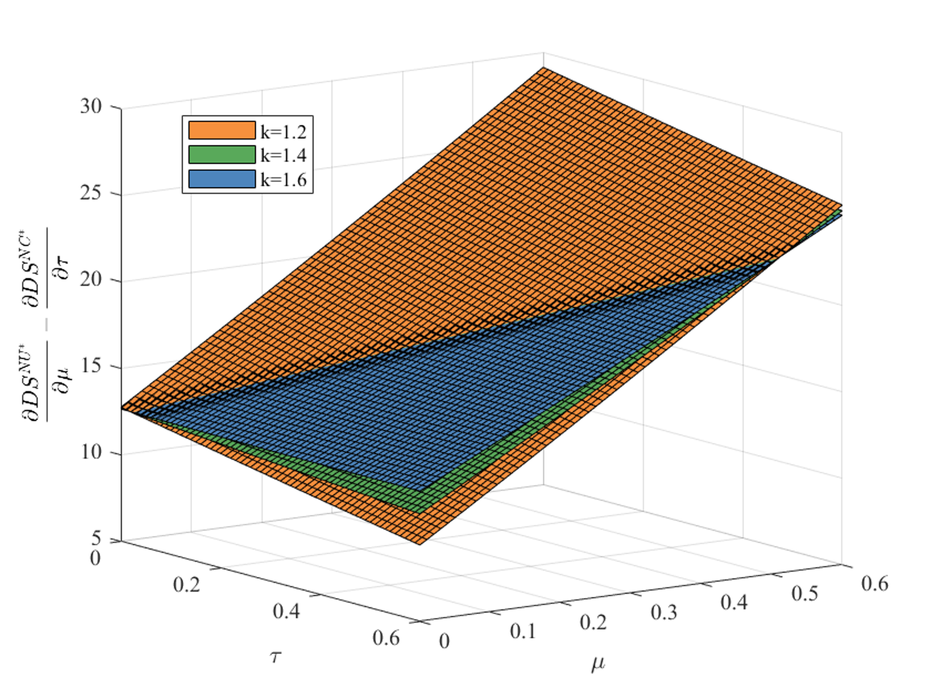
Fig. B.1. A comparison of the changes in driver surplus due to marginal subsidies under the NU strategy and the NC strategy

Note. $s=6$, $α=0.2$, $β=0.75$, $ρ=0.4$, $m=0.6$, $Δ=0.4$, $e_{0}=0.3$, $v=1.5$, r=0.4, $t_{f}$=0.5
(2) $\frac{∂π_{r}^{NU*}}{∂μ}-\frac{∂π_{r}^{NB*}}{∂η}=\frac{α\left(1-β\right)λρ}{1024k^{2}m^{2}{\left(1-sαβ\right)}^{3}}\left(\begin{aligned}&\left(2-sαβ\right)ρ\left(e_{0}+μ+△+m-ke_{0}\right)\left(\begin{aligned}&α\left(2-sαβ\right)ρ^{2}{\left(e_{0}+μ+△+m\right)}^{2} \\ &+2k\left(\begin{aligned}&16m\left(1-sαβ\right)+ \\ &αe_{0}ρ^{2}\left(2-sαβ\right)\left(3m-\left(e_{0}+μ+△\right)\right)\end{aligned}\right)\end{aligned}\right) \\ &-8m\left(1-sαβ\right)\left(\begin{aligned}&αρ\left(16m\left(1-sαβ\right)η+ρ\left(2-sαβ\right){\left(e_{0}+△+m\right)}^{2}\right) \\ &+2k\left(16m\left(1-sαβ\right)+αe_{0}ρ^{2}\left(2-sαβ\right)\left(3m-\left(e_{0}+△\right)\right)\right)\end{aligned}\right)\end{aligned}\right)$.
Define $\overline{η}$ as a solution to the equation $\frac{∂π_{r}^{NU*}}{∂μ}-\frac{∂π_{r}^{NB*}}{∂η}=0$.
When $η<\overline{η}$, increasing unit usage subsidy can generate greater profits for the platform. When $η≥\overline{η}$, increasing unit building subsidy becomes more advantageous for the platform’s profitability.
$\frac{∂CS^{NU*}}{∂μ}-\frac{∂CS^{NB*}}{∂η}=\frac{αλρ}{2048k^{2}m^{2}{\left(1-sαβ\right)}^{2}}\left(\begin{aligned}&\left(2-sαβ\right)ρ\left(e_{0}+μ+△+m-ke_{0}\right)\left(\begin{aligned}&α\left(2-sαβ\right)ρ^{2}{\left(e_{0}+μ+△+m\right)}^{2} \\ &+2k\left(\begin{aligned}&16m\left(1-sαβ\right) \\ &+αe_{0}ρ^{2}\left(2-sαβ\right)\left(3m-\left(e_{0}+μ+△\right)\right)\end{aligned}\right)\end{aligned}\right) \\ &-8m\left(1-sαβ\right)\left(\begin{aligned}&αρ\left(16m\left(1-sαβ\right)η+ρ\left(2-sαβ\right){\left(e_{0}+△+m\right)}^{2}\right) \\ &+2k\left(16m\left(1-sαβ\right)+αe_{0}ρ^{2}\left(2-sαβ\right)\left(3m-\left(e_{0}+△\right)\right)\right)\end{aligned}\right)\end{aligned}\right)$, similar to $\frac{∂π_{r}^{NU*}}{∂μ}-\frac{∂π_{r}^{NB*}}{∂η}$.
$\frac{∂π_{f}^{NU*}}{∂μ}-\frac{∂π_{f}^{NB*}}{∂η}=\frac{\left(\begin{aligned}&\left(e_{0}+μ+△+m\right)\left(\begin{aligned}&{\left(2-sαβ\right)}^{2}ρ^{2}{\left(e_{0}+μ+△+m\right)}^{2} \\ &+k\left(\begin{aligned}&e_{0}ρ^{2}{\left(2-sαβ\right)}^{2}\left(2m-3\left(e_{0}+μ+△\right)\right) \\ &+32msβ\left(1-sαβ\right)\end{aligned}\right)\end{aligned}\right) \\ &-8m\left(1-sαβ\right)\left(16m\left(1-sαβ\right)η+\left(2-sαβ\right)ρ{\left(e_{0}+△+m\right)}^{2}\right)\end{aligned}\right)}{256km^{2}{\left(1-sαβ\right)}^{2}}$. Define $\hat{η}$ as a solution to the equation $\frac{∂π_{f}^{NU*}}{∂μ}-\frac{∂π_{f}^{NB*}}{∂η}=0$.
When $η<\hat{η}$, increasing unit usage subsidy can bring greater profits for the provider-f. When $η≥\hat{η}$, increasing unit building subsidy becomes more advantageous for the profitability of the provider-f.
(3) $\frac{∂π_{c}^{NU*}}{∂μ}-\frac{∂π_{c}^{NB*}}{∂η}=\frac{e_{0}\left(\begin{aligned}&{\left(2-sαβ\right)}^{2}ρ^{2}\left(m+e_{0}+μ+△\right)\left(5m-3\left(e_{0}+μ+△\right)\right)-16m\left(2-sαβ\right)\left(1-sαβ\right)ρ\left(3m-\left(e_{0}+△\right)\right) \\ &-2k\left(e_{0}ρ^{2}{\left(2-sαβ\right)}^{2}\left(3m-\left(e_{0}+μ+△\right)\right)+16msβ\left(1-sαβ\right)\right)\end{aligned}\right)}{256km^{2}{\left(1-sαβ\right)}^{2}}$, only if $k≤\frac{{\left(2-sαβ\right)}^{2}ρ^{2}\left(e_{0}+μ+△+m\right)\left(5m-3\left(e_{0}+μ+△\right)\right)-16m\left(2-sαβ\right)\left(1-sαβ\right)ρ\left(3m-\left(e_{0}+△\right)\right)}{2\left(e_{0}ρ^{2}{\left(2-sαβ\right)}^{2}\left(3m-\left(e_{0}+μ+△\right)\right)+16msβ\left(1-sαβ\right)\right)}$, we can get $\frac{∂π_{c}^{NU*}}{∂μ}-\frac{∂π_{c}^{NB*}}{∂η}≥0$, but $\frac{{\left(2-sαβ\right)}^{2}ρ^{2}\left(e_{0}+μ+△+m\right)\left(5m-3\left(e_{0}+μ+△\right)\right)-16m\left(2-sαβ\right)\left(1-sαβ\right)ρ\left(3m-\left(e_{0}+△\right)\right)}{2\left(e_{0}ρ^{2}{\left(2-sαβ\right)}^{2}\left(3m-\left(e_{0}+μ+△\right)\right)+16msβ\left(1-sαβ\right)\right)}<0$. Therefore, concerning the profitability of the provider-c, building subsidies are consistently more effective than usage subsidies.
(4) $\frac{∂DS^{NU*}}{∂μ}-\frac{∂DS^{NB*}}{∂η}=sign\left(\begin{aligned}&ρ\left(2-sαβ\right)\left(m+μ+△-e_{0}\left(k-1\right)\right)\left(\begin{aligned}&4m+{\left(3m-e_{0}-μ-△\right)}^{2}+{\left(e_{0}+m+μ+△\right)}^{2}+ \\ &\left(\frac{sβ}{1-sαβ}+\frac{{\left(2-sαβ\right)}^{2}ρ^{2}\left(\begin{aligned}&2ke_{0}\left(3m-e_{0}-μ-△\right) \\ &+{\left(e_{0}+m+μ+△\right)}^{2}\end{aligned}\right)}{32km{\left(1-sαβ\right)}^{2}}\right)\end{aligned}\right) \\ &-4m\left(\begin{aligned}&2\left(1-sαβ\right)\left({\left(3m-e_{0}-△\right)}^{2}+{\left(e_{0}+m+△\right)}^{2}\right)+\frac{\left(2ksβ+\left(2-sαβ\right)ηρ\right)}{k} \\ &+\frac{{\left(2-sαβ\right)}^{2}ρ^{2}\left(2ke_{0}\left(3m-e_{0}-△\right)+{\left(e_{0}+m+△\right)}^{2}\right)}{16km\left(1-sαβ\right)}\end{aligned}\right)\end{aligned}\right)$.
Define $\tilde{η}$ as a solution to the equation $\frac{∂DS^{NU*}}{∂μ}-\frac{∂DS^{NB*}}{∂η}=0$.
When $η<\tilde{η}$, increasing unit usage subsidy can generate a greater surplus for the drivers. When $η≥\tilde{η}$, increasing unit building subsidy becomes more advantageous for the driver surplus.
Proof of Proposition 8.
In the scenario where the ride-hailing platform invests in fast charging stations through equity control, the platform’s profit is derived from both ride-hailing services and charging services. The platform’s profit from ride-hailing services is higher than its profit in the situation where it does not participate in building charging stations.
The difference in profit under the usage subsidy strategy is:
$\frac{\left(8k\left(1-sαβ\right)-λα^{2}ρ^{2}\left(1-β\right)\right){\left(αλρ\left(1-β\right)\left(\begin{aligned}αρ^{2}\left(2-sαβ\right){\left(e_{0}+m+μ+△\right)}^{2}+ \\ 2k\left(16m\left(1-sαβ\right)+e_{0}αρ^{2}\left(2-sαβ\right)\left(3m-e_{0}-μ-△\right)\right)\end{aligned}\right)\right)}^{2}}{4096k^{2}m^{2}{\left(1-sαβ\right)}^{3}{\left(4k\left(1-sαβ\right)+λα^{2}ρ^{2}\left(1-β\right)\right)}^{2}}>0$;
The difference under the building subsidy strategy is:
$\frac{\left(8k\left(1-sαβ\right)-λα^{2}ρ^{2}\left(1-β\right)\right){\left(αλρ\left(1-β\right)\left(\begin{aligned}&2k\left(16m\left(1-sαβ\right)+e_{0}αρ^{2}\left(2-sαβ\right)\left(3m-e_{0}-△\right)\right) \\ &+αρ\left(\left(2-sαβ\right)ρ{\left(m+e_{0}+△\right)}^{2}+16mη\left(1-sαβ\right)\right)\end{aligned}\right)\right)}^{2}}{4096k^{2}m^{2}{\left(1-sαβ\right)}^{3}{\left(4k\left(1-sαβ\right)-λα^{2}ρ^{2}\left(1-β\right)\right)}^{2}}>0$.
Therefore, under both subsidy strategies, the platform benefits from investing in building charging stations and can obtain higher profits.

Appendix C. Supporting outcomes
(1) The equilibrium outcomes in Section 6.1
Table C.1. Equilibrium decisions in the CU and CB strategy
CU strategy | CB strategy
$$n_{c}^{CU*}=\frac{e_{0}ρ\left(2-sαβ\right)\left(e+m-△\right)}{8m\left(1-sαβ\right)}$$ | $$n_{c}^{CB*}=\frac{e_{0}ρ\left(2-sαβ\right)\left(e+m-△\right)}{8m\left(1-sαβ\right)}$$
$$n_{f}^{CU*}=\frac{ρ\left(2-sαβ\right)\left(e_{0}+e+μ\right)\left(△+m-e\right)}{8km\left(1-sαβ\right)}$$ | $$n_{f}^{CB*}=\frac{ρ\left(2-sαβ\right)\left(e+e_{0}\right)\left(m+△-e\right)}{8km\left(1-sαβ\right)}+\frac{η}{2k}$$
$$p^{CU*}=\frac{1}{2\left(1-sαβ\right)}\left(\begin{aligned}&1+\frac{sβδ\left(e+e_{0}+μ\right)\left(m+△-e\right)}{2λm\left(1-β\right)}+ \\ &\frac{αρ^{2}\left(2-sαβ\right)\left(\begin{aligned}&\left(e+μ\right)\left(m+△-e\right) \\ &+e_{0}\left(\begin{aligned}\left(e-△\right)\left(k-1\right) \\ +m\left(k+1\right)\end{aligned}\right)\end{aligned}\right)}{8km\left(1-sαβ\right)}\end{aligned}\right)$$ | $$p^{CB*}=\frac{1}{2\left(1-sαβ\right)}\left(\begin{aligned}&1+\frac{sβδ\left(\left(e+e_{0}\right)\left(m+△-e\right)\right)}{2m\left(1-β\right)λ} \\ &+\frac{αρ\left(\begin{aligned}&4m\left(1-sαβ\right)η+ \\ &ρ\left(2-sαβ\right)\left(\begin{aligned}\left(e+e_{0}\right)\left(m+△-e\right) \\ +e_{0}k\left(m-△+e\right)\end{aligned}\right)\end{aligned}\right)}{8km\left(1-sαβ\right)}\end{aligned}\right)$$
Substituting the above equilibrium decisions into the demand, supply, and profit functions of each entity, we can obtain equilibrium outcomes. To ensure that the above results are all positive, the following conditions must be met: $e+m-△>0$ and $1-sαβ>0$.
(2) The equilibrium outcomes in Section 6.2
Table C.2. Equilibrium decisions in the $NU_{ρ}$ and $NB_{ρ}$ strategy
$NU_{ρ}$ strategy | $NB_{ρ}$ strategy
$$e^{NU_{ρ}^{*}}=\frac{1}{2}\left(△+m-e_{0}-μ\right)$$ | $$e^{NB_{ρ}^{*}}=\frac{1}{2}\left(△+m-e_{0}\right)$$
$$n_{c}^{NU_{ρ}^{*}}=\frac{e_{0}ρ_{2}\left(2-sαβ\right)\left(3m-Φ_{2}\right)}{16m\left(1-sαβ\right)}$$ | $$n_{c}^{NB_{ρ}^{*}}=\frac{e_{0}ρ_{2}\left(2-sαβ\right)\left(3m-Φ_{3}\right)}{16m\left(1-sαβ\right)}$$
$$n_{f}^{NU_{ρ}^{*}}=\frac{ρ_{1}\left(2-sαβ\right){\left(m+Φ_{2}\right)}^{2}}{32km\left(1-sαβ\right)}$$ | $$n_{f}^{NB_{ρ}^{*}}=\frac{ρ_{1}\left(2-sαβ\right){\left(m+Φ_{3}\right)}^{2}}{32km\left(1-sαβ\right)}+\frac{η}{2k}$$
$$p^{NU_{ρ}*}=\frac{1}{2\left(1-sαβ\right)}+\frac{α\left(2-sαβ\right)\left(\begin{aligned}2ke_{0}{ρ_{2}}^{2}\left(3m-Φ_{2}\right) \\ +{ρ_{1}}^{2}{\left(m+Φ_{2}\right)}^{2}\end{aligned}\right)}{64km{\left(1-sαβ\right)}^{2}}$$ | $$p^{NB_{ρ}^{*}}=\frac{k+αρ_{1}η}{2k\left(1-sαβ\right)}+\frac{α\left(2-sαβ\right)\left(\begin{aligned}2ke_{0}{ρ_{2}}^{2}\left(3m-Φ_{3}\right) \\ +{ρ_{1}}^{2}{\left(m+Φ_{3}\right)}^{2}\end{aligned}\right)}{64km{\left(1-sαβ\right)}^{2}}$$
By substituting the equilibrium decisions into the demand, supply, profit functions of each entity, passenger surplus, and driver surplus, the equilibrium outcomes can be obtained.

Appendix D. Extension: The platform invests in fast charging stations through equity control
During the equity control investment process in fast charging stations, the platform places greater emphasis on charging efficiency, consequently diminishing the competitiveness of other fast charging stations in the market. To simplify the model, we exclude provider-f from the competition model, focusing solely on the competition between the fast-charging stations invested in by the platform and conventional charging stations. In reality, cooperative or competitive relationships may exist between platforms and fast-charging service providers. For instance, a platform might collaborate with fast-charging service providers to build fast charging stations, but the platform may lack decision-making authority. Our focus is on understanding the decision-making process when a platform invests in fast charging stations. Without loss of generality, the government provides either usage subsidies or building subsidies for the platform, while normalising the government’s subsidy for conventional charging stations to 0. The subsidy strategy is denoted as the “IU strategy”, and the building strategy is denoted as the “IB strategy”.
This subsection is divided into two decision stages. In the first stage, the platform aims to maximise its overall profit (including both charging services and ride-hailing services) while making decisions regarding the additional fare and the number of fast charging stations to build. Meanwhile, provider-c determines the number of charging stations to build to maximise profit. In the second stage, the platform aims to maximise its profit from ride-hailing services while deciding on the ride price. This decision process mirrors real-world scenarios, the case of the charging service company Xiaoju Charging, invested in by Didi Chuxing. As a subsidiary, the decision-making for Xiaoju Charging should prioritize the entire ecosystem, encompassing both ride-hailing and charging services, whereas Didi Chuxing itself remains more focused on ride-hailing services.
Under the IU strategy, the profit functions for the platform and provider-c are as follows:
$π_{r}^{IU}=\left(1-β\right)pD+S\overline{x}\left(e_{0}+e+μ\right)-k{n_{f}}^{2}$ (D.1)
$π_{c}^{IU}=Q_{c}e_{0}-{n_{c}}^{2}=S\left(1-\overline{x}\right)e_{0}-{n_{c}}^{2}$ (D.2)
Under the IB strategy, the profit functions for the platform and provider-c are as follows:
$π_{r}^{IB}=\left(1-β\right)pD+S\overline{x}\left(e_{0}+e\right)-k{n_{f}}^{2}+ηn_{f}$ (D.3)
$π_{c}^{IB}=Q_{c}e_{0}-{n_{c}}^{2}=S\left(1-\overline{x}\right)e_{0}-{n_{c}}^{2}$ (D.4)
The equilibrium decisions and related outcomes for the IU strategy and the IB strategy are provided in Tables D.1 and D.2. While the obtained outcomes affirm the substitution relationship between $μ$ and $Δ$, as well as the positive effect of $η$, a direct comparison of the equilibrium outcomes under the two subsidy strategies is challenging. To address this complexity, we employ numerical simulations for analysis and derive Claim D.1.
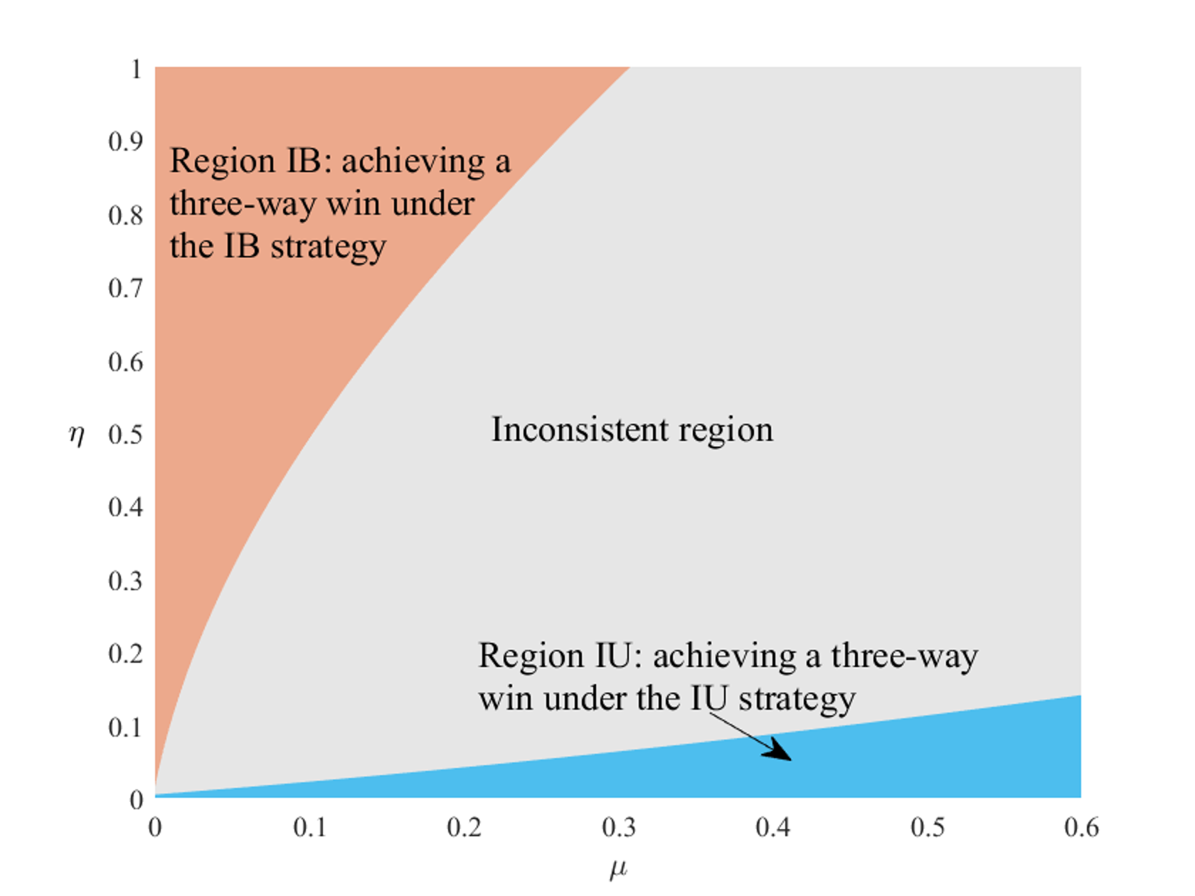
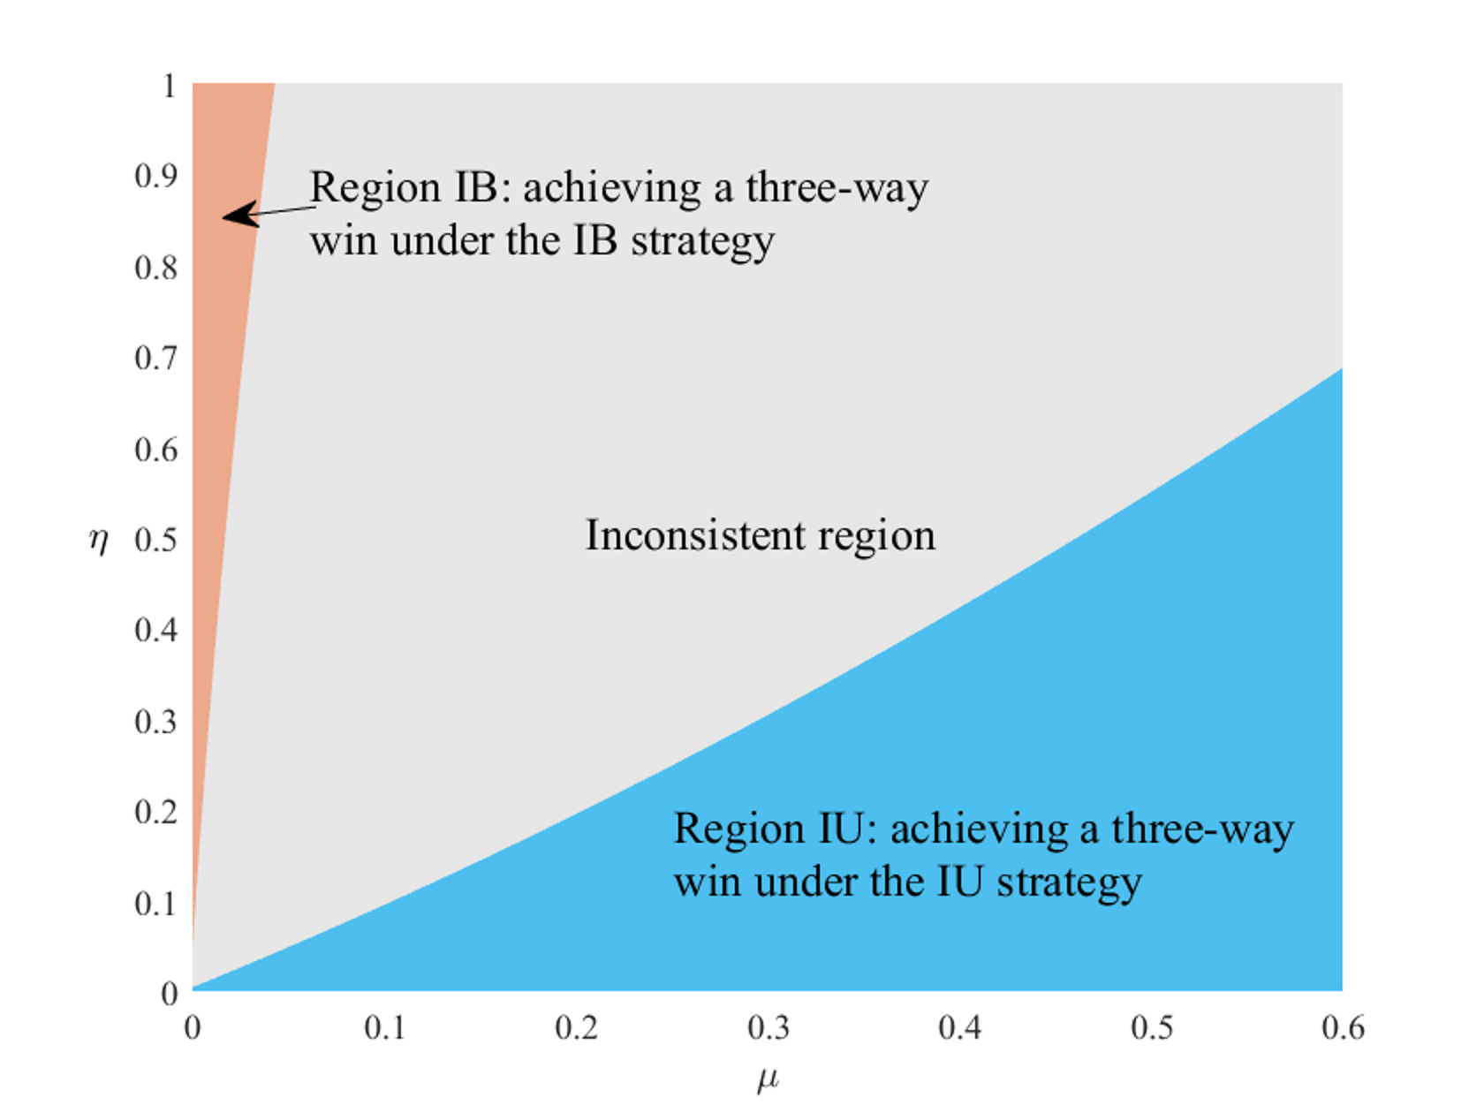
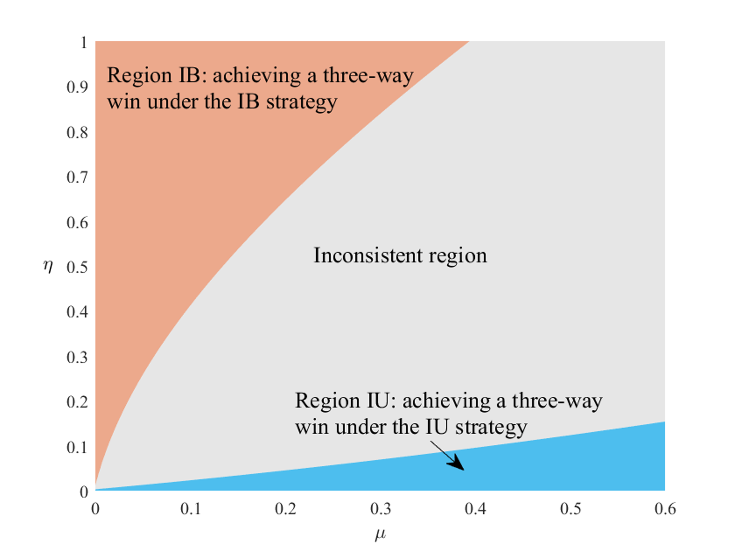
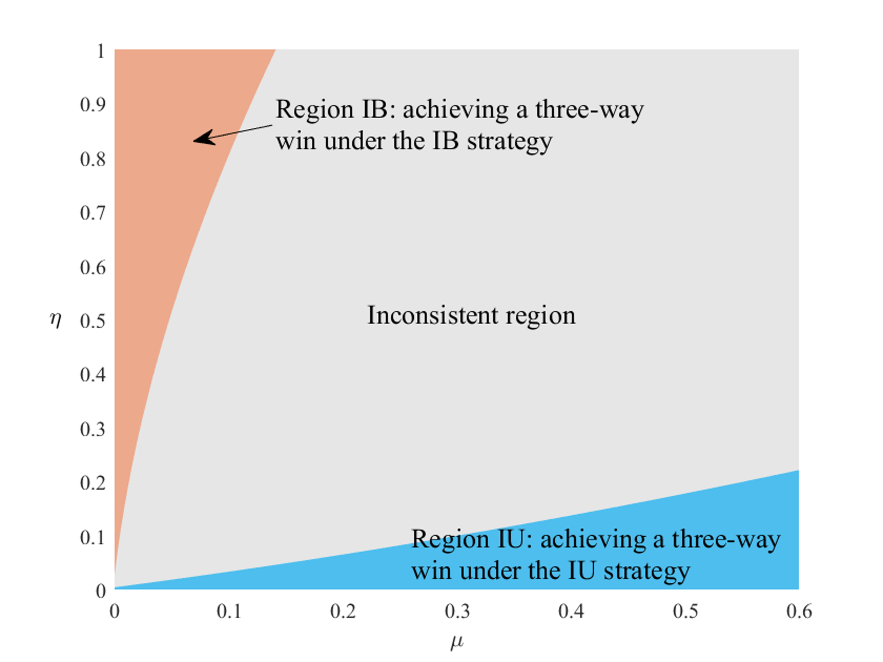
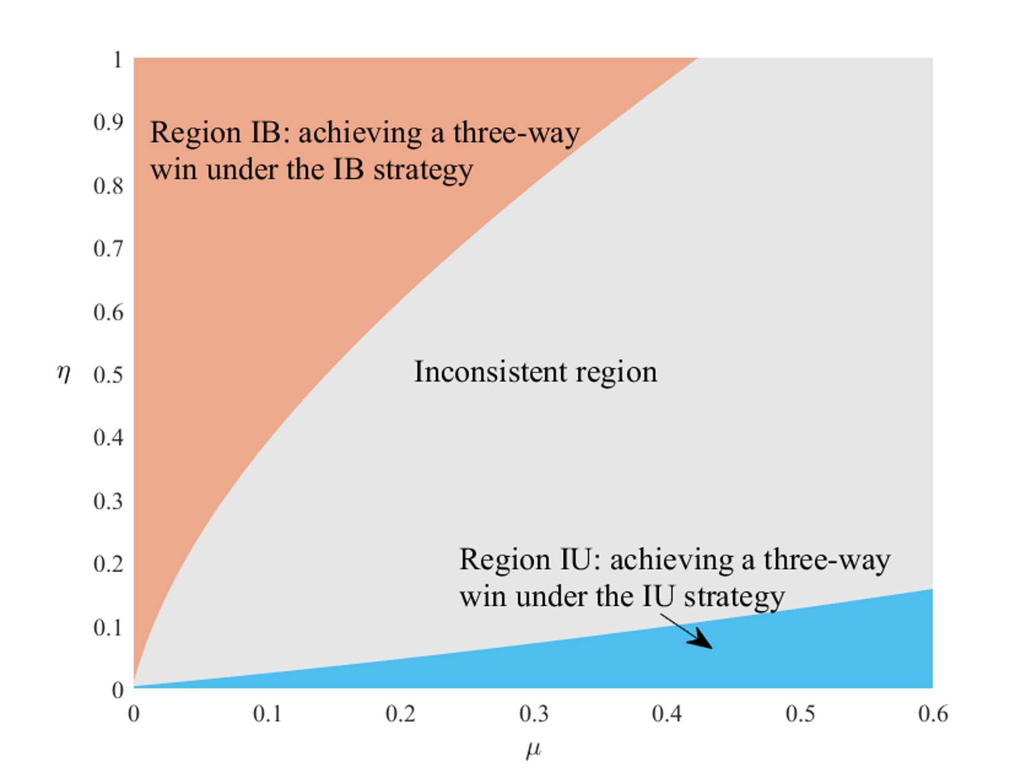
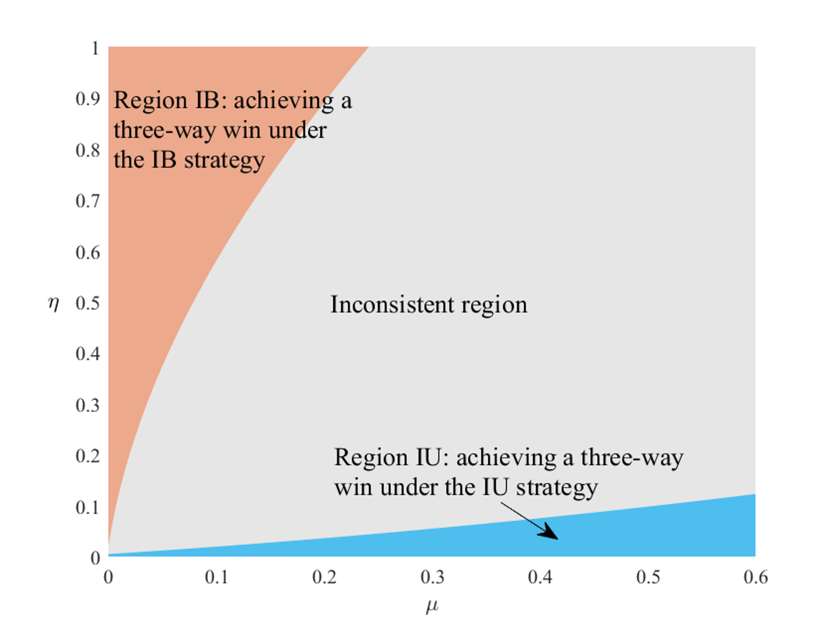
Claim D.1. (1) The likelihood of achieving a three-way win scenario for the platform, passengers, and drivers is higher under the IB (IU) strategy when the usage (building) subsidy is small and the building (usage) subsidy is large; (2) As the service rate $s$ increases, the region of achieving a three-way win scenario shrinks under the IB strategy but expands under the IU strategy; (3) As the building cost coefficient $k$ increases, the regions of achieving a three-way win scenario under both the IB strategy and the IU strategy will shrink.
Note. $β=0.75$, $α=0.2$, $ρ=0.4$, $m=0.6$, $Δ=0.4$, $e_{0}=0.3$, $λ=1.2$, $v=1.5$, $r=0.4$, $t_{f}=0.5$
Fig.D.1. The impact of market environment on government implementation of subsidy strategies
a. $s=2$, $k=1.2$
b. $s=4$, $k=1.2$
c. $s=6$, $k=1.2$
d. $s=2$, $k=1.1$
e. $s=2$, $k=1.6$
f. $s=2$, $k=2.1$
Fig. D.1 illustrates the three-way win regions for the platform, passengers, and drivers under both the IU strategy and the IB strategy, highlighting the impact of changes in market environment factors such as service rate and building cost coefficient. Firstly, in the region IB where the usage subsidy is smaller than the building subsidy, the platform consistently achieves higher profits under the IB strategy. Consumers and drivers, as users of the platform, also experience greater surplus under this strategy, fostering a three-way win scenario within the region IB. Notably, provider-c consistently benefits under the IB strategy, indicating a four-way win within this region. Consumers, being the least sensitive to strategy variations, can attain more surplus under the IU strategy only within the region IU where the building subsidy is smaller than the usage subsidy. The platform and drivers, as direct and indirect beneficiaries of the IU strategy, also benefit more in this region. Secondly, observations from Fig. D.1a-c reveal that, with an increase in the service rate, the region IB shrinks while the region IU expands. An elevated service rate signifies increased demand for the platform, indicating higher economic levels. This attracts more drivers to the platform and amplifies the demand for charging services, resulting in more subsidies for the platform and increased profits from both ride-hailing and charging services. However, as the service rate reaches very high levels, achieving higher revenue under the IB strategy needs substantial support for this approach. Simultaneously, higher service rates in practice imply escalated electricity consumption and charging frequency, allowing the platform to gain more usage subsidies. Finally, Fig. D.1d-f demonstrate that an increase in the building cost coefficient results in the narrowing of both the regions IB and IU, which places heightened requirements on the government’s subsidy strategy. In this case, regardless of implementing the IB or IU strategy, the government must provide more substantial subsidies to facilitate the construction of charging stations, thus prompting economic and social welfare. In summary, the findings provide valuable managerial insights for the government. In economically developed cities, the government should concentrate on implementing the usage subsidy strategy to support platforms in building fast charging stations. Conversely, in less developed areas, adopting the building subsidy strategy can be an effective measure. Moreover, when the economic burden of building fast charging stations for platforms is substantial, the government should consider intensifying its subsidy efforts to ensure the success of such infrastructure projects.
By comparing the optimal profits of the platform in section 4 and this subsection, we delve into the question of whether the platform should invest in fast charging stations.
Proposition D.1. Under both the usage subsidy strategy and the building subsidy strategy, the platform should select to invest in fast charging stations.
Proposition D.1 asserts that under both subsidy strategies, the platform has the incentive to invest in fast charging stations. On one hand, this action extends the platform’s presence into the charging market, enabling it to generate profits from the charging business. On the other hand, building fast charging stations improves the charging efficiency for drivers, thereby enhancing the quality of ride-hailing services, which directly contributes to the platform’s profitability. Therefore, the platform should invest in fast charging stations, regardless of its focus on current ride-hailing services or future charging services. As shown in Fig. D.2, under both subsidy strategies, the platform’s inclination to invest in fast charging stations strengthens with an increase in the service rate $s$. This is attributed to the higher probability of individuals in economically developed cities selecting the platform, resulting in a larger driver pool and a heightened potential for both ride-hailing and charging services industries in such scenarios. Conversely, an increase in the building cost coefficient $k$ diminishes the profitability of the platform, a trend more pronounced under the building subsidy strategy. However, the negative impact of the building cost coefficient $k$ on this profit difference is considerably smaller than the positive effect of the service rate $s$. In other words, in economically developed cities, even if high costs lead to significant construction expenses for fast charging stations, the platform should prioritize the market potential of the city.
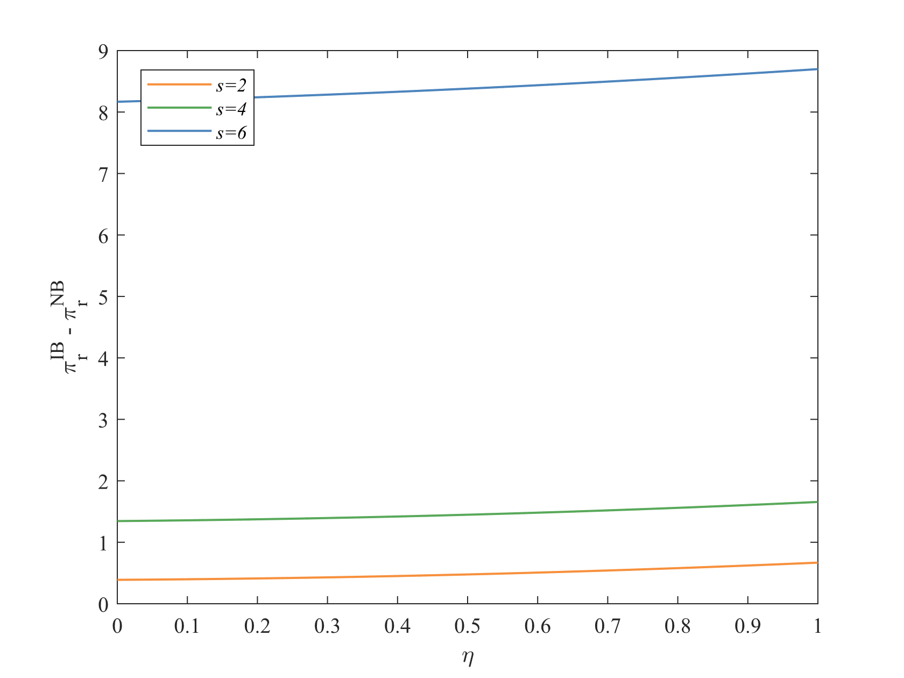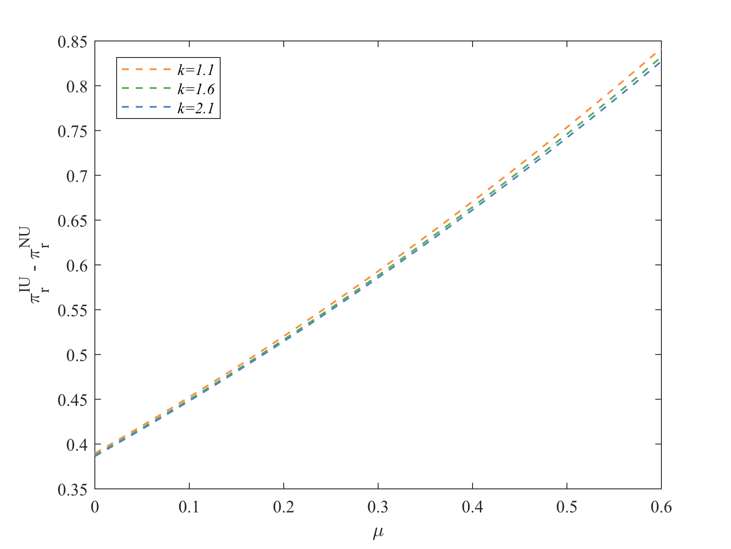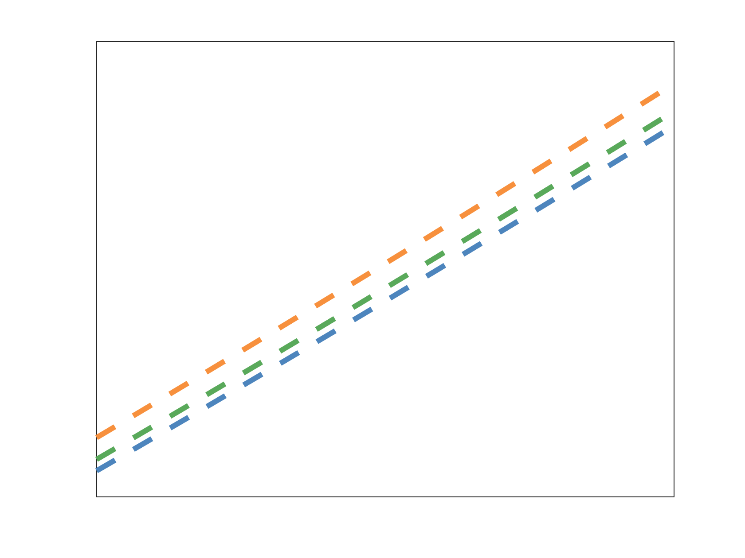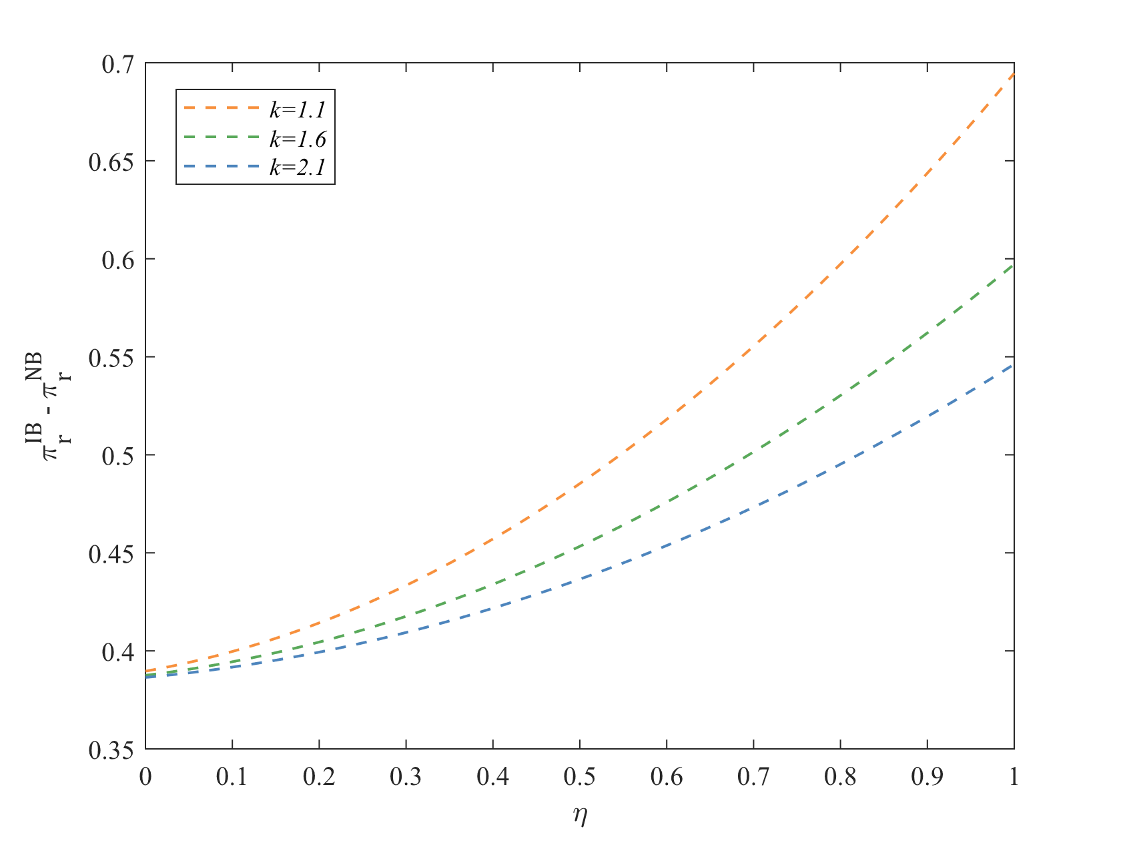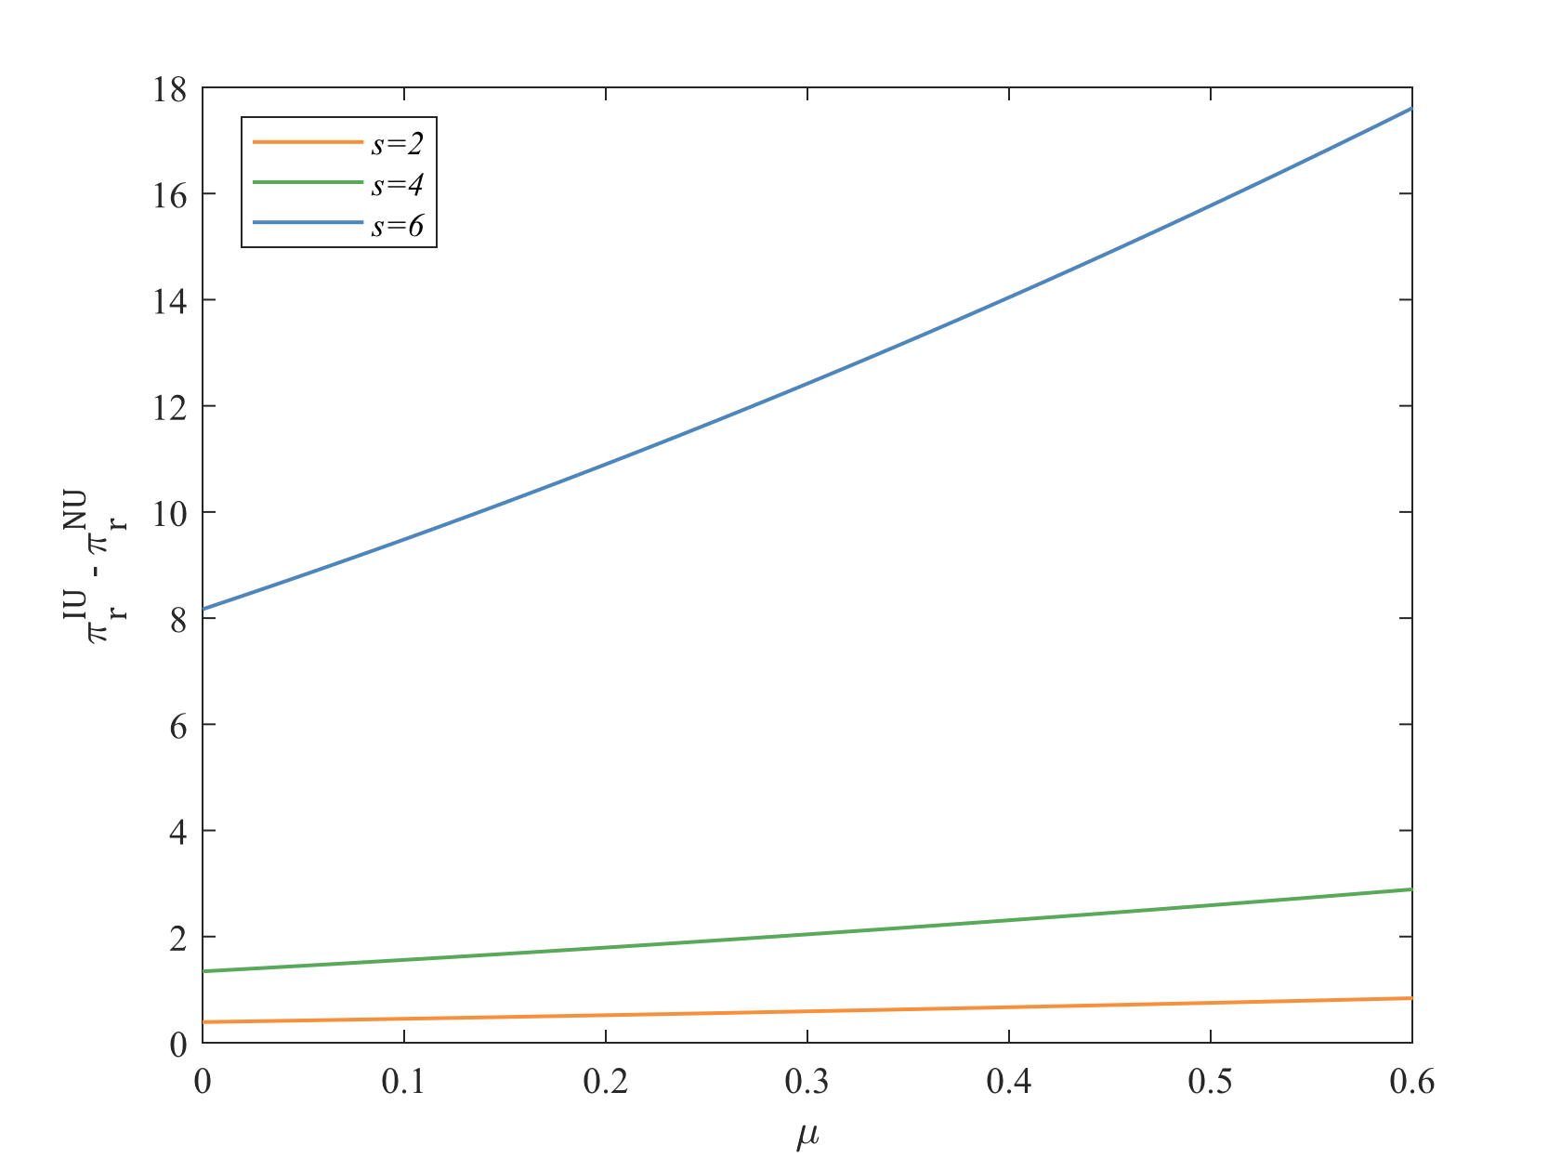
Fig.D.2. The impact of market environment on profit difference
before and after investment for the platform under IU or IB strategies
a. IU strategy: $k=1.2$
b. IU strategy: $s=2$
c. IB strategy: $k=1.2$
d. IB strategy: $s=2$
Note. $β=0.75$, $α=0.2$, $ρ=0.4$, $m=0.6$, $Δ=0.4$, $e_{0}=0.3$, $λ=1.2$

(1) The equilibrium decisions and related outcomes for the IU strategy
Using reverse induction, with the given additional fare and the number of charging stations decided by the ride-hailing platform in the first stage, the ride price in the second stage is given by $p^{IU}=\frac{1+\left(n_{f}+n_{c}\right)αρ}{2\left(1-sαβ\right)}$. Substituting $p^{IU}$ into the profit functions of both the ride-hailing platform and the provider-c, making simultaneous decisions yields the equilibrium decisions, consequently obtaining optimal ride price, driver supply, and market demand, as shown in Table D.1.
Table D.1. Equilibrium decisions and outcomes in the IU strategy
IU strategy
$$e^{IU*}=\frac{1}{2}\left(△+m-e_{0}-μ\right)$$ | $$n_{f}^{IU*}=\frac{ρ\left(e_{0}λα^{2}ρ^{2}\left(1-β\right)\left(2-sαβ\right)\left(3m-Φ_{2}\right)+2\left(1-sαβ\right)\left(\left(2-sαβ\right){\left(m+Φ_{2}\right)}^{2}+8αλm\left(1-β\right)\right)\right)}{16m\left(1-sαβ\right)\left(4k\left(1-sαβ\right)-λα^{2}ρ^{2}\left(1-β\right)\right)}$$
$$n_{c}^{IU*}=\frac{e_{0}ρ\left(2-sαβ\right)\left(3m-Φ_{2}\right)}{16m\left(1-sαβ\right)}$$ |  | $$p^{IU*}=\frac{αρ^{2}\left(2-sαβ\right)\left({\left(m+Φ_{2}\right)}^{2}+2ke_{0}\left(3m-Φ_{2}\right)\right)+32km\left(1-sαβ\right)}{16m\left(1-sαβ\right)\left(4k\left(1-sαβ\right)-α^{2}\left(1-β\right)λρ^{2}\right)}$$
$$S^{IU*}=\frac{\left(\begin{aligned}&ρ^{2}{\left(2-sαβ\right)}^{2}\left({\left(m+Φ_{2}\right)}^{2}+2ke_{0}\left(3m-Φ_{2}\right)\right) \\ &+16m\left(1-sαβ\right)\left(2ksβ+αλρ^{2}\left(1-β\right)\right)\end{aligned}\right)}{16m\left(1-sαβ\right)\left(4k\left(1-sαβ\right)-λα^{2}ρ^{2}\left(1-β\right)\right)}$$ |  |  | $$D^{IU*}=\frac{λ\left(\begin{aligned}αρ^{2}\left(2-sαβ\right)\left({\left(m+Φ_{2}\right)}^{2}+2ke_{0}\left(3m-Φ_{2}\right)\right) \\ +32km\left(1-sαβ\right)\end{aligned}\right)}{16m\left(4k\left(1-sαβ\right)-λα^{2}ρ^{2}\left(1-β\right)\right)}$$ | $$Q_{f}^{IU*}=\frac{\left(m+Φ_{2}\right)S^{IU*}}{4m}$$ | $$Q_{c}^{IU*}=\frac{\left(3m-Φ_{2}\right)S^{IU*}}{4m}$$
By substituting the aforementioned equilibrium outcomes into the profit of the ride-hailing platform and the provider-c, as well as into the passenger surplus and driver surplus, the corresponding equilibrium outcomes can be obtained. To ensure the existence of equilibrium outcomes, the following conditions must be satisfied: $△+m-e_{0}-μ>0$, $3m-Φ_{2}>0$, and $k>\frac{λα^{2}ρ^{2}\left(1-β\right)}{4\left(1-sαβ\right)}$. These requirements also apply to the IB strategy.
(2) The equilibrium decisions and related outcomes for the the IB strategy
Using reverse induction, in the IB strategy, the ride price in the second stage is the same as in the IU strategy, that is, $p^{IB}=p^{IU}=\frac{1+\left(n_{f}+n_{c}\right)αρ}{2\left(1-sαβ\right)}$. Similar to the IU strategy, we can derive the equilibrium decisions and outcomes, as shown in Table D.2.
Table D.2. Equilibrium decisions and outcomes in the IB strategy
IB strategy
$$n_{f}^{IB*}=\frac{\left(\begin{aligned}&ρ\left(2-sαβ\right)\left(2\left(1-sαβ\right){\left(m+Φ_{3}\right)}^{2}+e_{0}λα^{2}ρ^{2}\left(1-β\right)\left(3m-Φ_{3}\right)\right) \\ &+16m\left(1-sαβ\right)\left(2\left(1-sαβ\right)η+λαρ\left(1-β\right)\right)\end{aligned}\right)}{16m\left(1-sαβ\right)\left(4k\left(1-sαβ\right)-λα^{2}ρ^{2}\left(1-β\right)\right)}$$ | $$e^{IB*}=\frac{1}{2}\left(m+△-e_{0}\right)$$ | $$n_{c}^{IB*}=\frac{e_{0}ρ\left(2-sαβ\right)\left(3m-Φ_{3}\right)}{16m\left(1-sαβ\right)}$$
$$p^{IB*}=\frac{αρ^{2}\left(2-sαβ\right)\left({\left(m+Φ_{3}\right)}^{2}+2ke_{0}\left(3m-Φ_{3}\right)\right)+32m\left(1-sαβ\right)\left(k+η\right)}{16m\left(1-sαβ\right)\left(4k\left(1-sαβ\right)-λα^{2}ρ^{2}\left(1-β\right)\right)}$$ | $$D^{IB*}=\frac{λ\left(\begin{aligned}&αρ^{2}\left(2-sαβ\right)\left({\left(m+Φ_{3}\right)}^{2}+2ke_{0}\left(3m-Φ_{3}\right)\right) \\ &+16m\left(1-sαβ\right)\left(2k+αρη\right)\end{aligned}\right)}{16m\left(4k\left(1+sαβ\right)-λα^{2}ρ^{2}\left(1-β\right)\right)}$$
$$S^{IB*}=\frac{\left(\begin{aligned}&16m\left(1-sαβ\right)\left(2ksβ+ρ\left(αλρ\left(1-β\right)+\left(2-sαβ\right)η\right)\right) \\ &ρ^{2}{\left(2-sαβ\right)}^{2}\left({\left(m+Φ_{3}\right)}^{2}+2ke_{0}\left(3m-Φ_{3}\right)\right)\end{aligned}\right)}{16m\left(1-sαβ\right)\left(4k\left(1-sαβ\right)-λα^{2}ρ^{2}\left(1-β\right)\right)}$$ | $$Q_{f}^{IB*}=\frac{\left(m+Φ_{3}\right)S^{IB*}}{4m}$$ | $$Q_{c}^{IB*}=\frac{\left(3m-Φ_{3}\right)}{4m}S^{IB*}$$
By substituting the above equilibrium outcomes into the profit of the ride-hailing platform and the provider-c, as well as into the passenger surplus and driver surplus, we can obtain the corresponding equilibrium outcomes.

