S1 Fig. Leave-one-out sensitivity analysis forest plot. Each row represents the inverse-variance-weighted estimate obtained when the corresponding SNP was excluded; the bottom row ('All') shows the full estimate across all six instruments.
S2 Fig. Funnel plot. Each point represents a single instrumental variable; point size reflects precision (1/SE). The black line is the inverse-variance-weighted regression fit.

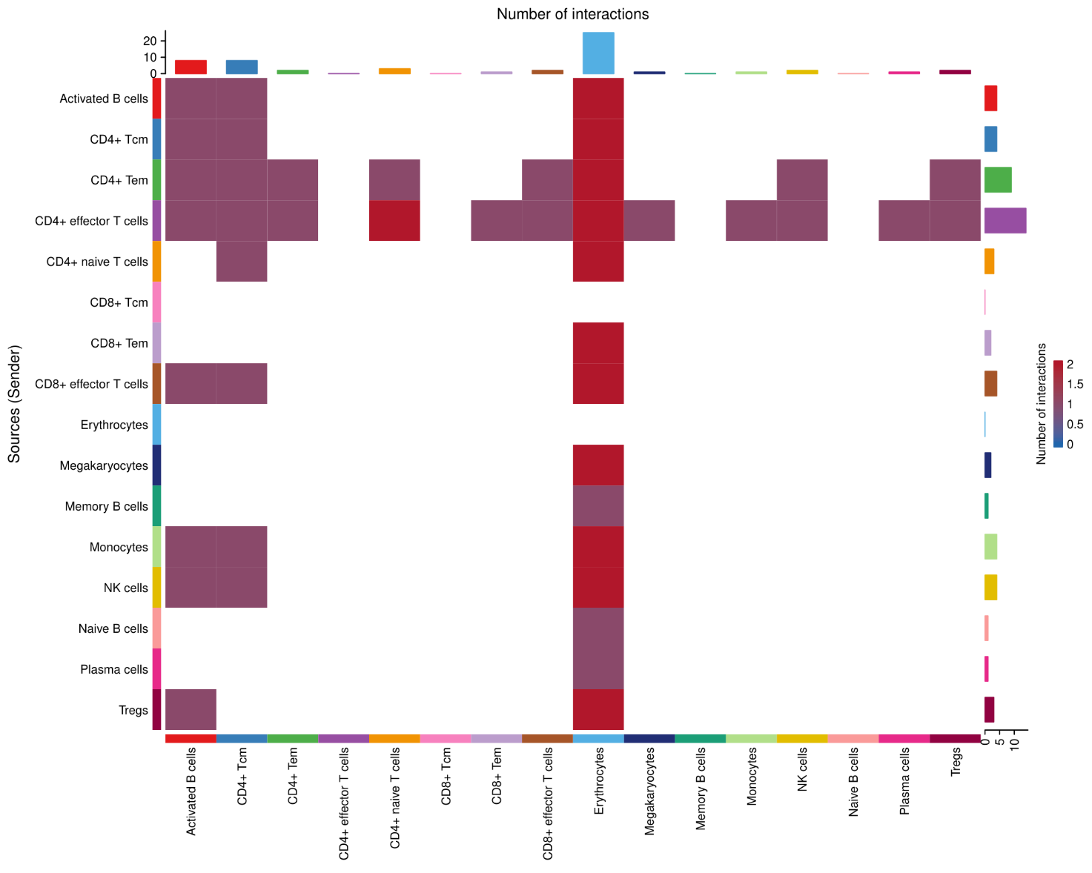
S3 Fig.Example CellChat communication heatmap. Example CellChat communication heatmap for one GSE163558 sample, illustrating the per-sample ligand-receptor probability matrix underlying the aggregated tumor→stroma analysis. Data source: GEO GSE163558.

Excluded SNP | β (SE) | OR (95% CI) | P-value
rs2978977 | −0.0417 (0.0090) | 0.959 (0.942–0.976) | 3.32 × 10⁻⁶
rs3805495 | −0.0324 (0.0115) | 0.968 (0.947–0.990) | 4.64 × 10⁻³
rs3997848 | −0.0278 (0.0069) | 0.973 (0.960–0.986) | 4.99 × 10⁻⁵
rs72690905 | −0.0326 (0.0110) | 0.968 (0.947–0.989) | 3.00 × 10⁻³
rs7542186 | −0.0317 (0.0117) | 0.969 (0.947–0.991) | 6.67 × 10⁻³
rs760077 | −0.0285 (0.0145) | 0.972 (0.945–1.000) | 5.01 × 10⁻²
All (6 IVs) | −0.0324 (0.0098) | 0.968 (0.950–0.987) | 9.51 × 10⁻⁴
S1 Table. Leave-one-out sensitivity analysis of the Mendelian randomization estimate for gastric cancer on appendicular lean mass. Shown are the per-omission inverse-variance-weighted natural-log odds ratio (β), standard error (SE), odds ratio (OR) with 95% confidence interval, and P-value for each excluded SNP and for all six instruments combined.

