Supplementary Information

High-performance electroluminescent LEDs via structural engineering of ultrasound-assisted carbon quantum dots
Ziyi Liu¹, Xu Li^{1*}, Jiayun Li¹, Binghan Liu¹, Longxue Zheng¹, Li Guan^{1*}, Zhan’ao Tan^{2*}, Jinxing Zhao^{1*}

¹Hebei Key Laboratory of Optic-electronic Information and Materials, College of Physics Science and Technology, Hebei University, Baoding, China.
²State Key Laboratory of Chemical Resource Engineering, Beijing Advanced Innovation Center for Soft Matter Science and Engineering, Beijing University of Chemical Technology, Beijing, China.

E-mail: lixcn@sina.com; lguan@hbu.edu.cn; tanzhanao@mail.buct.edu.cn; jxzhao@hbu.edu.cn

Supplementary Methods 2
Supplementary Figures 4
Supplementary Tables 38
Supplementary References 41

Supplementary Methods

Materials
4,4'-diformyltriphenylamine, 2-naphthylacetonitrile, 4-biphenylacetonitrile, Sodium hydroxide (NaOH), Cesium carbonate (Cs₂CO₃), and poly(sodium 4-styrenesulfonate) (PSSNa) were purchased from Adamas-beta, Titan Scientific Co., Ltd, Shanghai, China. Ethanol, dichloromethane (CH₂Cl₂), 1,4-dioxane, and chlorobenzene (CB) were purchased from Tianjin Kermel Chemical Reagent Co., Ltd. Poly(3,4-Ethylenedioxythiophene): poly(styrene sulfonate) (PEDOT:PSS), 1.3~1.7 wt% dispersion in H₂O, was purchased from Vizuchem, Shanghai, China. 10-(4-(4-(9H-Carbazol-9-yl)phenylsulfonyl)phenyl)-9,9-dimethyl-9,10-dihydroacridine (CzAcSF) was purchased from Beijing Mreda Technology Co., Ltd. 2,4,6-tris[3-(diphenylphosphinyl)phenyl]-1,3,5-triazine (PO-T2T) was procured from Volt-Amp Optoelectronics Tech. Co., Ltd, Dongguan, China. All chemicals were used as received unless otherwise specified.
Characterization of UA-CQDs
To observe the morphology of UA-CQDs, Transmission electron microscopy (TEM) tests were performed using a JEOL JEM 2100. High-resolution TEM (HRTEM) characterization was subsequently conducted with a JEOL JEM-ARM200F. X-ray diffraction (XRD) measurements were conducted using a Bruker D8 Discovery 2D X-ray diffractometer equipped with a Vantec 500 2D area detector operating on Cu K𝛼 radiation. The molecular weights of UA-CQDs were detected through Gel Permeation Chromatography (GPC) using THF as the mobile phase. Fourier transform infrared (FT-IR) spectroscopy involved a Perkin-Elmer Spectrum Two. X-ray photoelectron spectroscopy (XPS) measurements used a Thermo Fisher ESCALAB 250Xi surface analysis system. Nuclear magnetic resonance (NMR) (¹H NMR & ¹³C NMR, 600 MHz) spectra were recorded on an Avance NEO 600 MHz at room temperature. The high-resolution mass (HR-MS) measurements were performed on a Bruker ApexUltra instrument equipped with an electrospray ionization (ESI) source in positive ion mode.
The photoluminescence (PL) spectra and temperature-dependent PL spectra were measured on an F-7000 (HITACHI) spectrofluorometer. UV-vis absorption spectra were measured using a Perkin Elmer Lambda 950 spectrophotometer. The absolute quantum yield (QY) was measured using an Edinburgh Instruments FLS980 spectrometer. Time-resolved PL (TRPL) spectra of UA-CQDs in solid states and films were recorded using an Edinburgh FLS1000. femtosecond transient absorption (fs-TA) spectroscopy measurements were performed using a fiber laser (1030 nm, 100kHz repetition rate, 9.5 μJ/pulse, YF-FL-10-100-IR, Yacto-Technology, China) as the laser source and a femto-TA100 spectrometer (Time-Tech Spectra, China). The pump beam was generated using an optical parametric amplifier (YactoOPA). Atomic force microscopy (AFM) images were taken using MFP-3D Infinity (Asylum Research). Mott-Schottky (M-S) curves were completed by using a multi-channel electrochemical workstation (Biologic VMP3).
Density functional theory (DFT) calculations
The specific calculation process is as follows: the initial structure is generated using the Gauss program package [1]; subsequently, the ground state (S₀) is optimized via the DFT method to obtain a structure without imaginary frequencies, and the excited state (S₁) is optimized using the time-dependent DFT method, both employ the B3LYP exchange-correlation functional and the 6-31g* basis set [2-4], with D3 dispersion correction using the Becke-Johnson damping to describe dispersion forces [5], and all calculations are performed in a solid-state environment. Finally, the excited-state properties of all structures are analyzed using the Multiwfn software package [6], and all isosurfaces are visualized via the VMD visualization program [7].
Device characterizations
The electrical performance of the system test equipment programmed by Suzhou Rona Nano Technology Co., Ltd. was evaluated, including the relationship between current density, luminance, and voltage (Current density-Luminance-Voltage, J-L-V), as well as the relationship between external quantum efficiency, current efficiency, and luminance (EQE-CE-Luminance, EQE-CE-L). The Keithley 2400 source meter provided a power supply for driving components, while the Keithley 6485 picoammeter detected photocurrent using a calibrated silicon photodiode probe. After assembly, the entire system was calibrated using stable blue, green, and red light chips via the Photo Research-735. EL spectra were acquired using the Ocean Optics USB 2000 spectrometer.
Space-charge limited current (SCLC) measurements
The measurements were performed on two types of single-carrier devices. For a hole-only device with a multilayer structure of ITO/PEDOT:PSS/UA-CQDs/MoO3/Al, and for an electron-only device with a multilayer structure of ITO/Al/ UA-CQDs/Al. The J-V curves of the devices were collected in a forward scan (0 V to 6 V, step: 0.05 V) using a Keithley 2400 under dark conditions.

Supplementary Figures
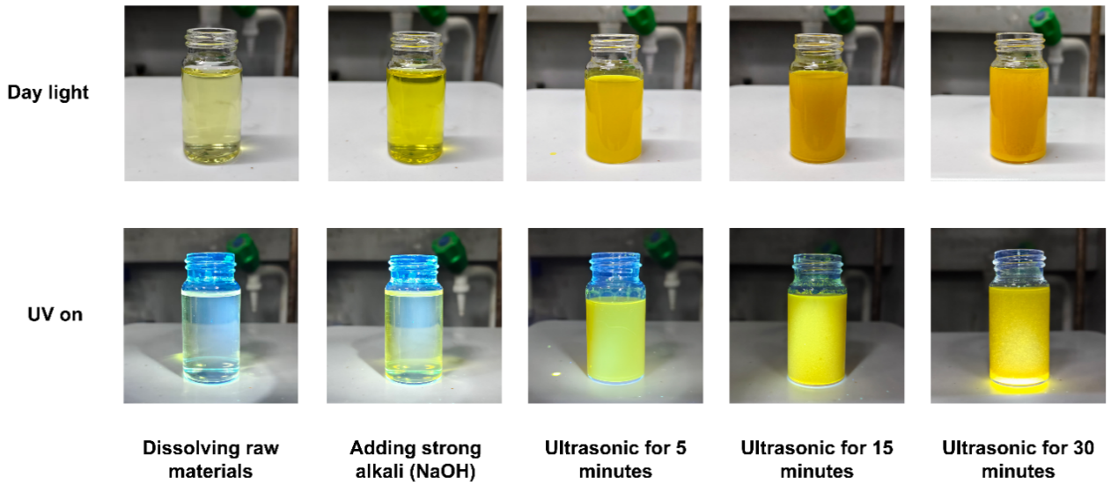
Supplementary Figure 1. Schematic illustration of the synthesis process for UA-CQDs. UA-CQDs under daylight and 365 nm UV excitation.
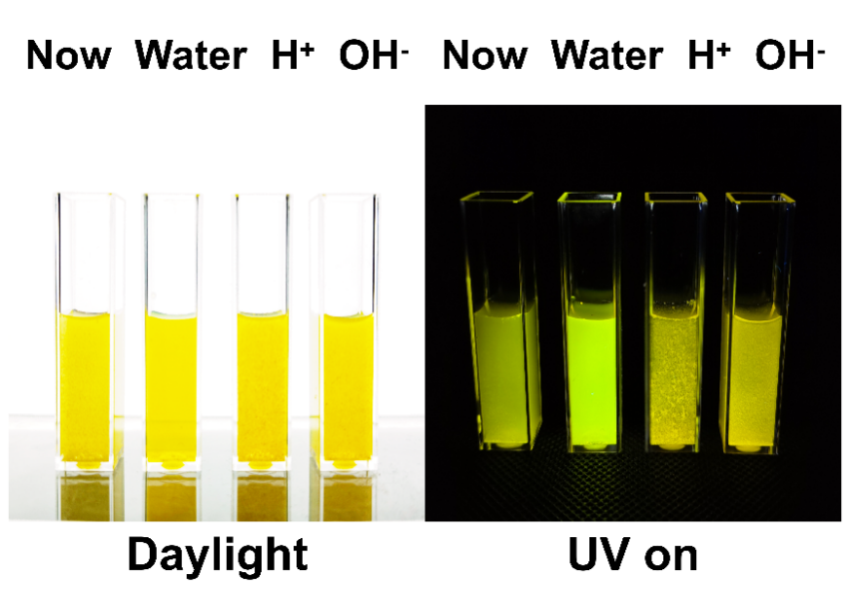
Supplementary Figure 2. The stability test of UA-CQDs. UA-CQDs were dispersed in different solutions and photographed under daylight and 365 nm UV excitation. The solution with NOW and Water is deionized water, the solution with H⁺ is dilute hydrochloric acid, and the solution with OH⁻ is dilute sodium hydroxide solution.
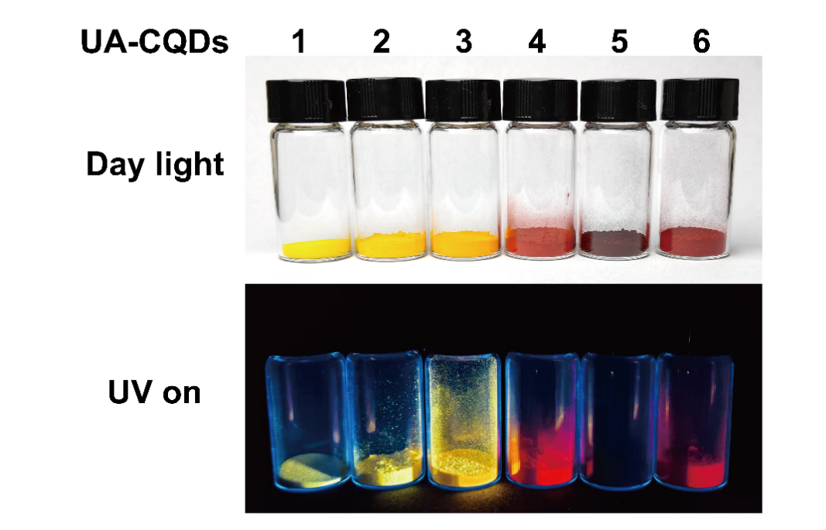
Supplementary Figure 3. Photographs of UA-CQDs synthesized from different precursors (denoted as UA-CQDs 1–6). Photographs show UA-CQDs 1-6 under daylight and 365 nm UV excitation.
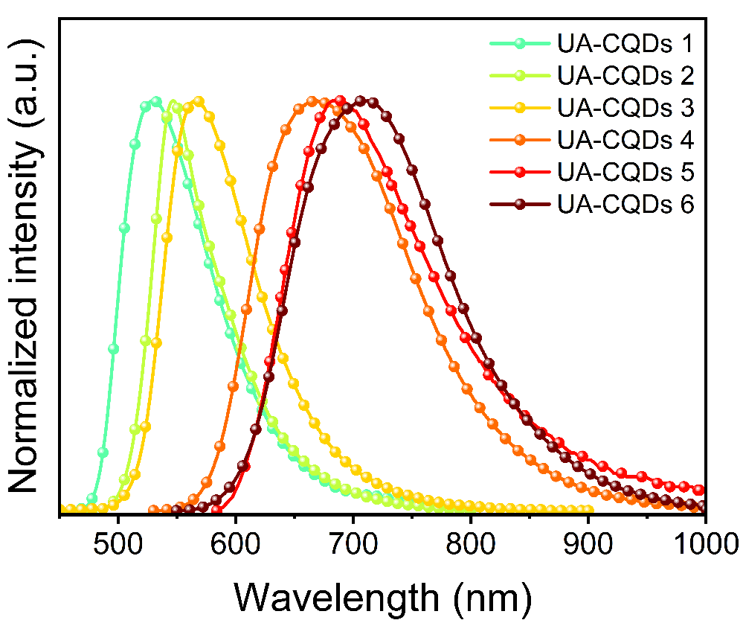
Supplementary Figure 4. Normalized PL spectra of UA-CQDs 1-6 in the solid state.
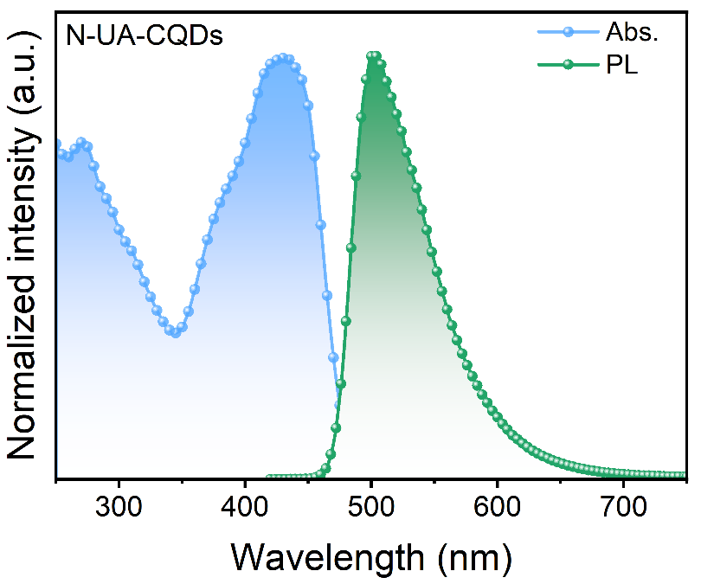
Supplementary Figure 5. Normalized absorption, PL spectra of N-UA-CQDs in solution.
Supplementary Figure 6. TEM characterization of UA-CQDs. TEM image of (a) N-UA-CQDs. Inserts present the corresponding High-resolution TEM images. (b) Diameter histogram of N-UA-CQDs. Line profile of the FFT reciprocal lattice of (c) B-UA-CQDs and (d) N-UA-CQDs.
Supplementary Figure 7. AFM images and corresponding height profiles of (a) B-UA-CQDs and (b) N-UA-CQDs.
Supplementary Figure 8. Dialysis experiments. Rhodamine B and UA-CQDs were dialyzed using membranes with MWCO of 5000 Da and 20,000 Da, respectively. Images were taken under UV excitation after 1 h (up) and 12 h (down) of dialysis.
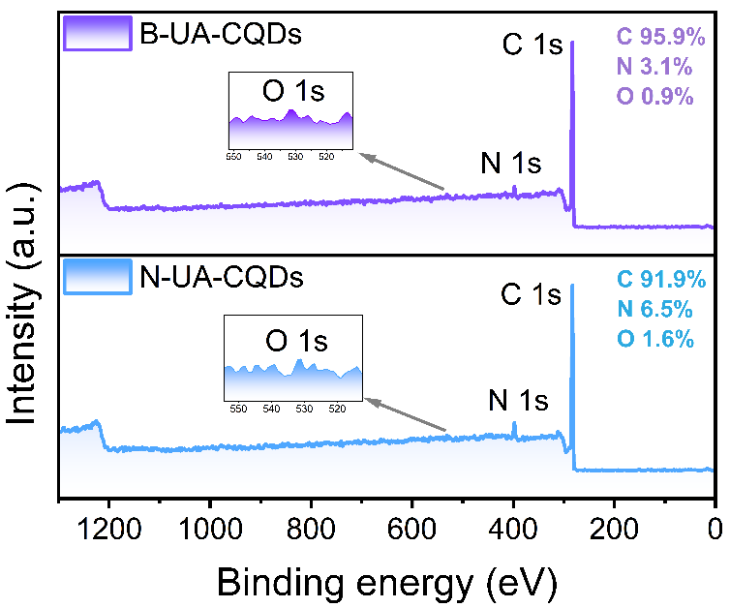
Supplementary Figure 9. Full-survey XPS spectra of B-UA-CQDs and N-UA-CQDs.
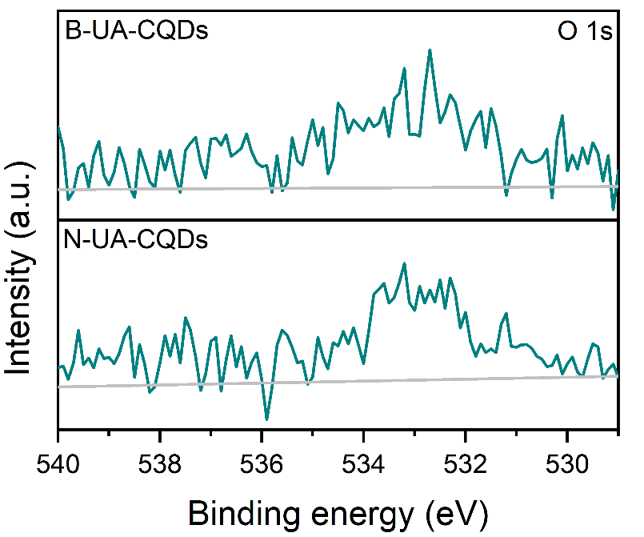
Supplementary Figure 10. High-resolution O 1s spectra of B-UA-CQDs and N-UA-CQDs.
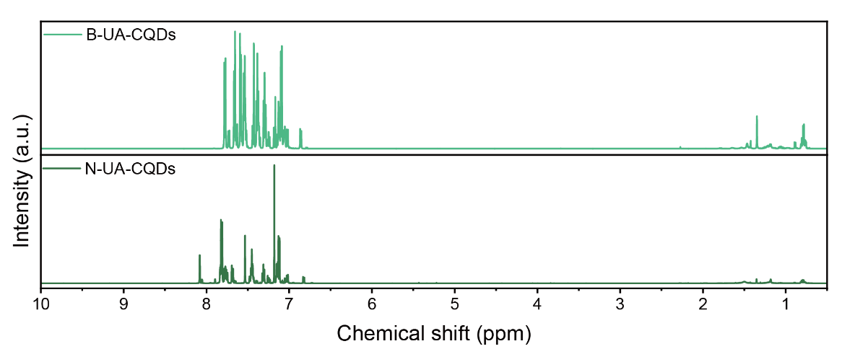
Supplementary Figure 11. ¹H NMR spectra of B-UA-CQDs and N-UA-CQDs.
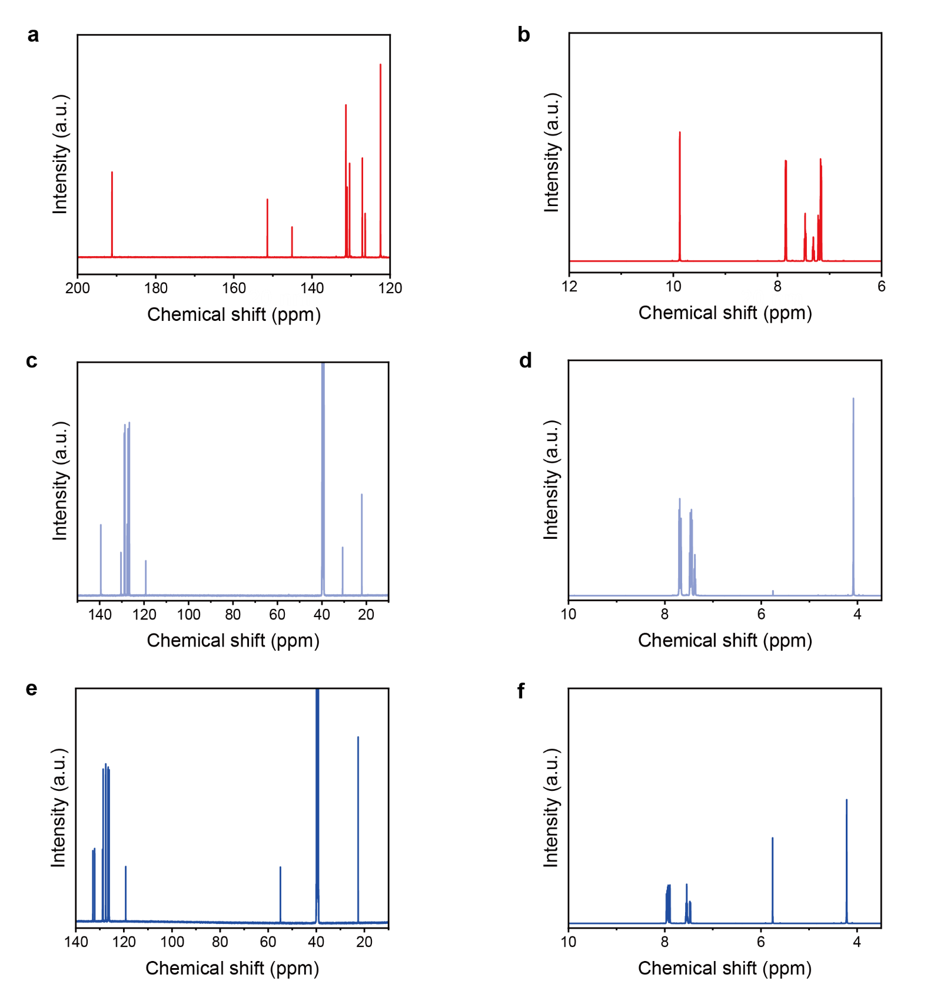
Supplementary Figure 12. ¹³C NMR and ¹H NMR spectra of precursors. (a, b) 4,4'-diformyltriphenylamine; (c, d) 4-biphenylacetonitrile; (e, f) 2-naphthylacetonitrile.
Supplementary Figure 13. The HR-MS spectra of (a) N-UA-CQDs and (b) B-UA-CQDs.
Supplementary Figure 14. Possible reaction mechanisms for the formation of N-UA-CQDs and B-UA-CQDs.
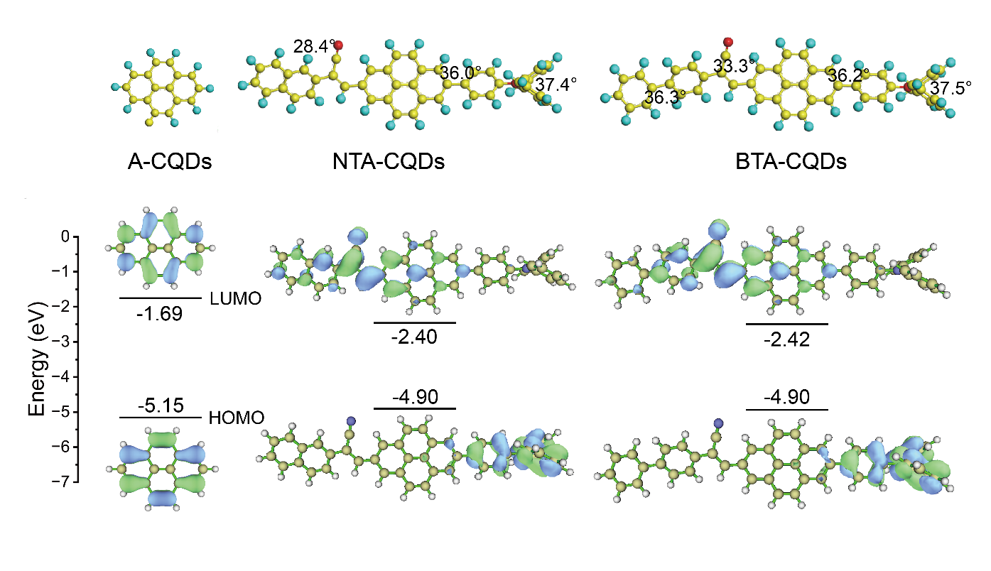
Supplementary Figure 15. DFT calculations of single CQDs. Calculated highest occupied molecular orbital (HOMO)/lowest unoccupied molecular orbital (LUMO) distributions and optimized structures of A-CQDs, NTA-CQDs, and BTA-CQDs, respectively.
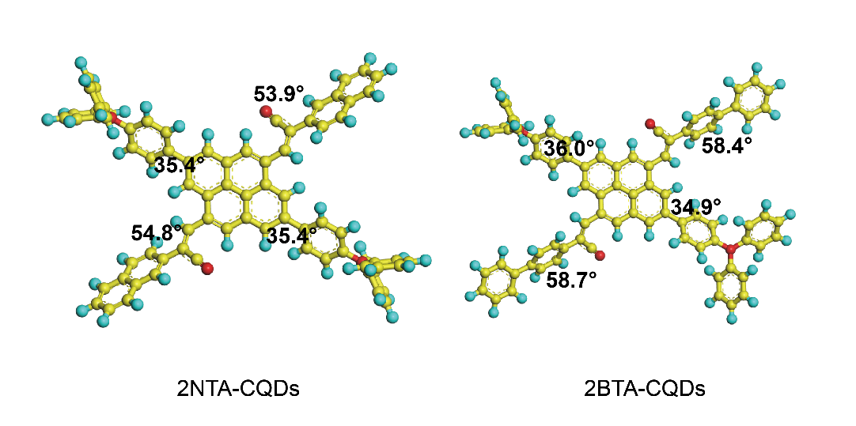
Supplementary Figure 16. Computationally optimized structures of 2NTA-CQDs and 2BTA-CQDs. 2NTA-CQDs are composed of A-CQDs passivated with two triphenylamine units and (naphthalene)-C(CN)=CH- units, while 2BTA-CQDs are composed of A-CQDs passivated with two triphenylamine units and (biphenyl)-C(CN)=CH- units.
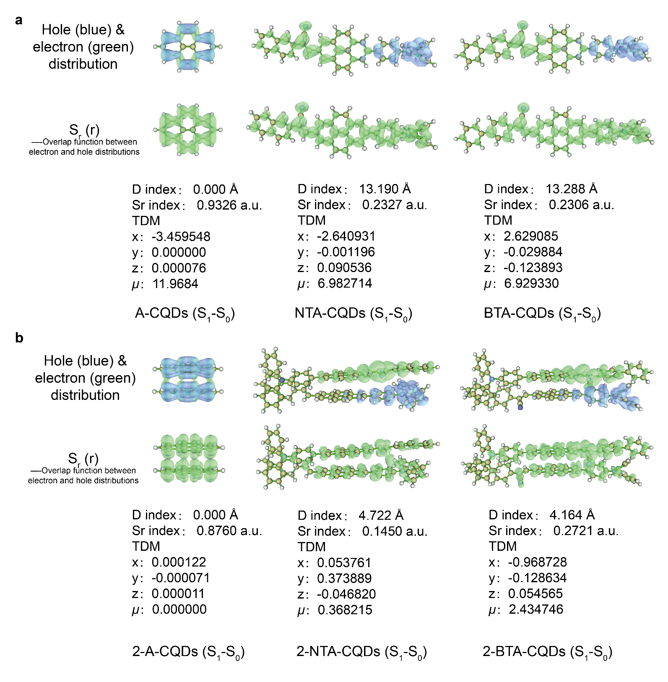
Supplementary Figure 17. DFT calculation results. Hole (blue) and electron (green) distributions, the spatial overlap integral (S_{r}) and centroid distance (D) between hole and electron, transition dipole moment (TDM) of (a) A-CQDs, NTA-CQDs, and BTA-CQDs; (b) 2-A-CQDs, 2-NTA-CQDs, and 2-BTA-CQDs.
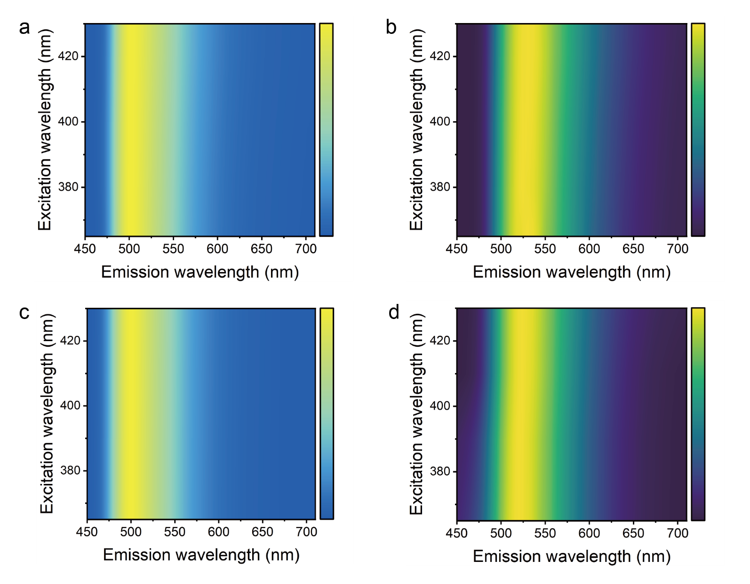
Supplementary Figure 18. Two-dimensional pseudocolor maps of normalized excitation-dependent PL spectra. PL spectra of B-UA-CQDs in (a) 1,4-dioxane and (b) dichloromethane; N-UA-CQDs in (c) 1,4-dioxane and (d) dichloromethane.
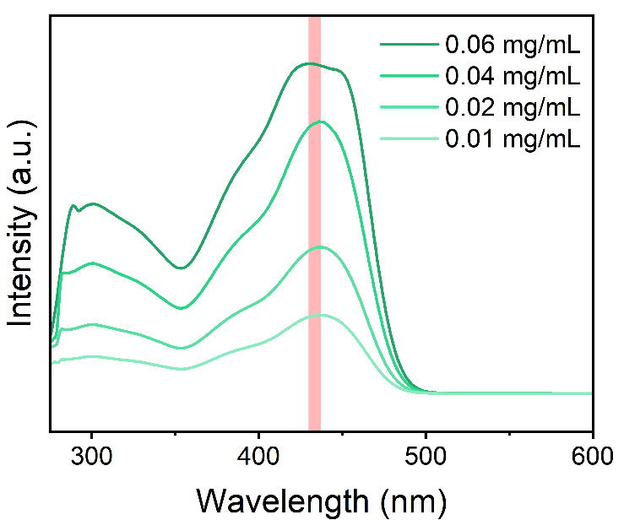
Supplementary Figure 19. PL spectra of (a) B-UA-CQDs and (b) N-UA-CQDs, both in different solvents with varying polarity.
Supplementary Figure 20. Concentration-dependent UV-vis absorption spectra of B-UA-CQDs in solution.
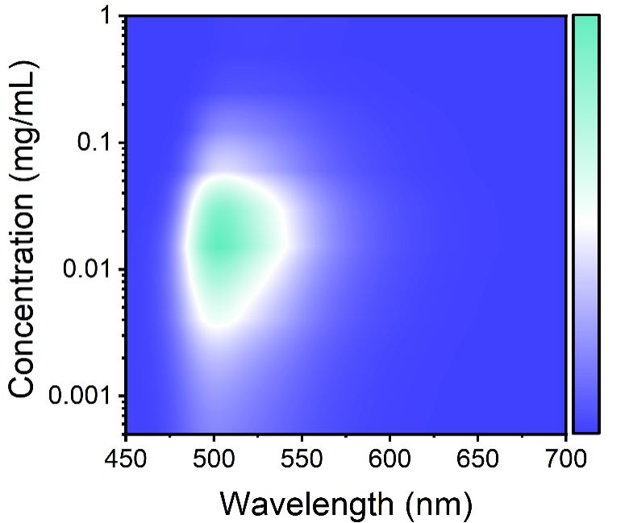
Supplementary Figure 21. Two-dimensional pseudocolor map of concentration-dependent PL spectra of B-UA-CQDs in solution.
Supplementary Figure 22. PLQYs of (a) N-UA-CQDs and (b) B-UA-CQDs.
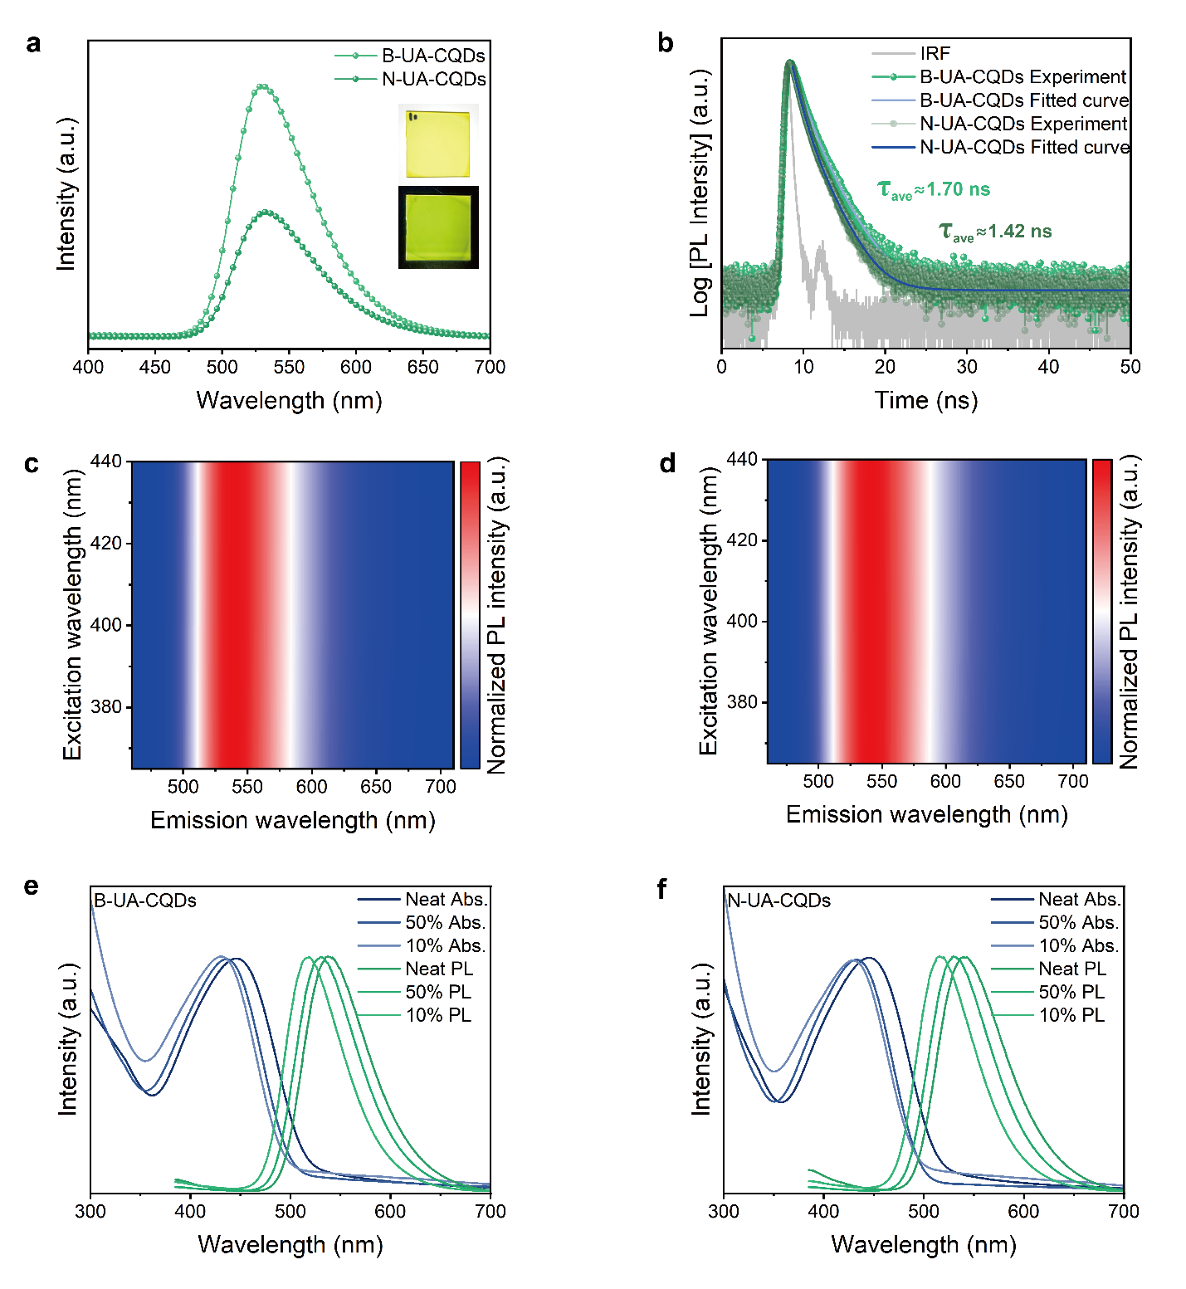
Supplementary Figure 23. Optical properties of UA-CQDs in the film state. (a) Normalized PL spectra of UA-CQDs in films with photographs of the B-UA-CQDs under daylight (up) and UV light (down); (b) Time-resolved PL spectra of UA-CQDs in films; Two-dimensional pseudocolor maps of normalized excitation-dependent PL spectra of (c) B-UA-CQDs and (d) N-UA-CQDs in films; Normalized absorption and PL spectra of (e) B-UA-CQDs and (f) N-UA-CQDs in films at different doping concentrations.
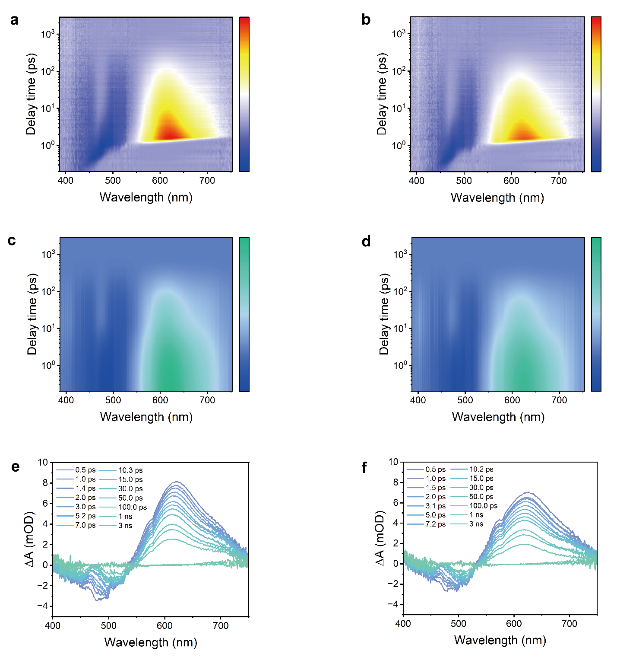
Supplementary Figure 24. fs-TA spectra of UA-CQDs. (a) B-UA-CQDs and (b) N-UA-CQDs: two-dimensional pseudocolor maps of as-measured TA spectra as a function of delay time and probe wavelength; (c) B-UA-CQDs and (d) N-UA-CQDs: corresponding maps after chirp correction; (e) B-UA-CQDs and (f) N-UA-CQDs: TA spectra at indicated delay times from 0.5 ps to 3 ns.
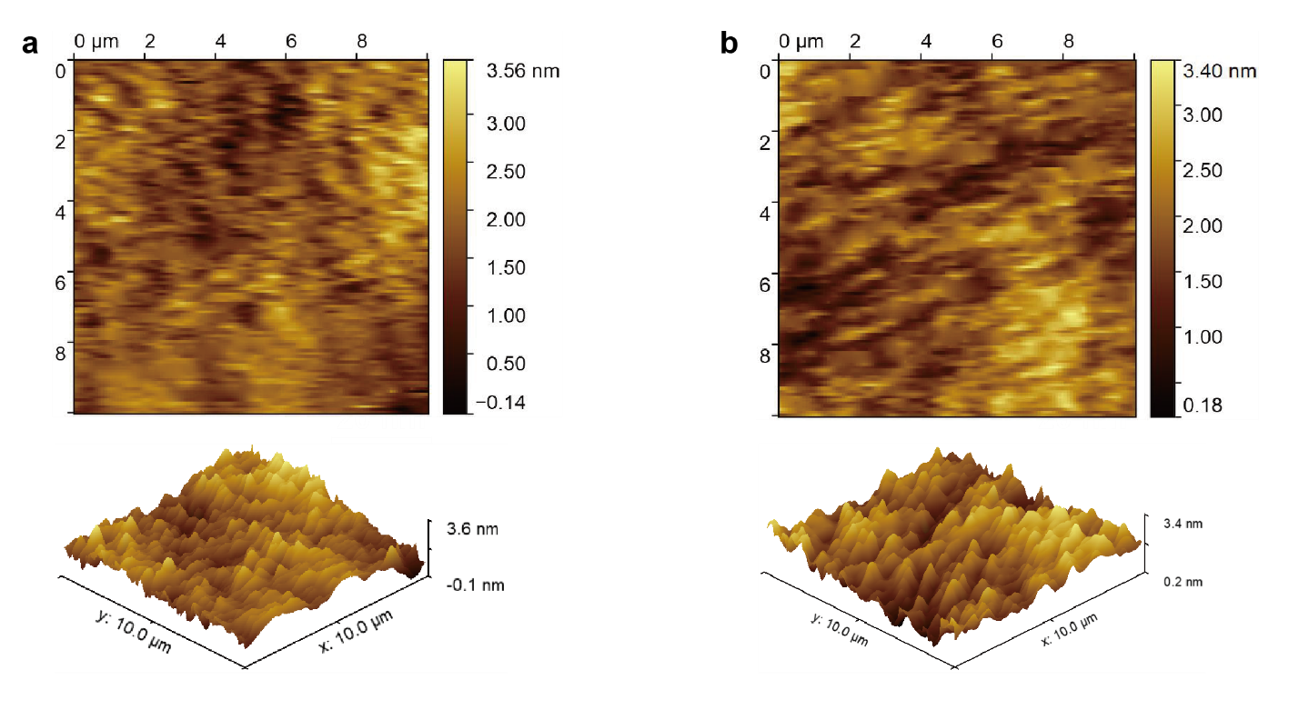
Supplementary Figure 25. AFM surface topographies of (a) B-UA-CQDs and (b) N-UA-CQDs.
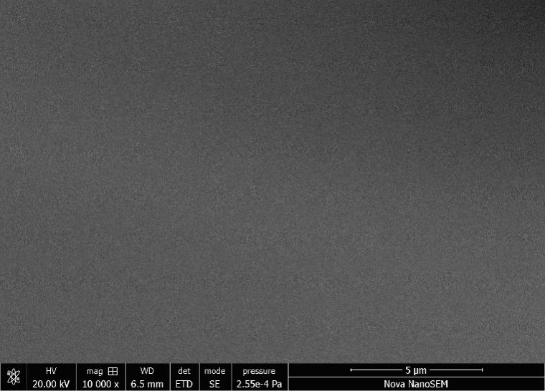
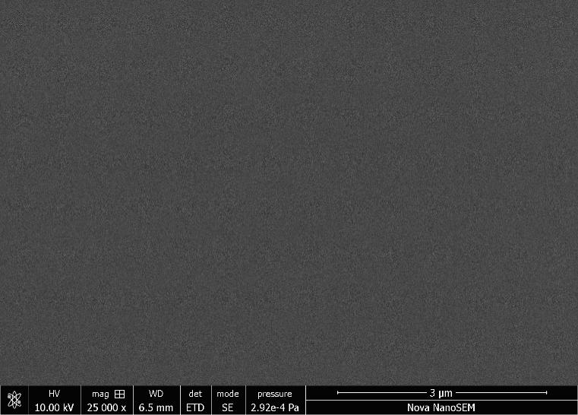
Supplementary Figure 26. SEM surface topographies of B-UA-CQDs (up) and N-UA-CQDs (down).
Supplementary Figure 27. Tauc plots of (a) B-UA-CQDs and (b) N-UA-CQDs in solution.
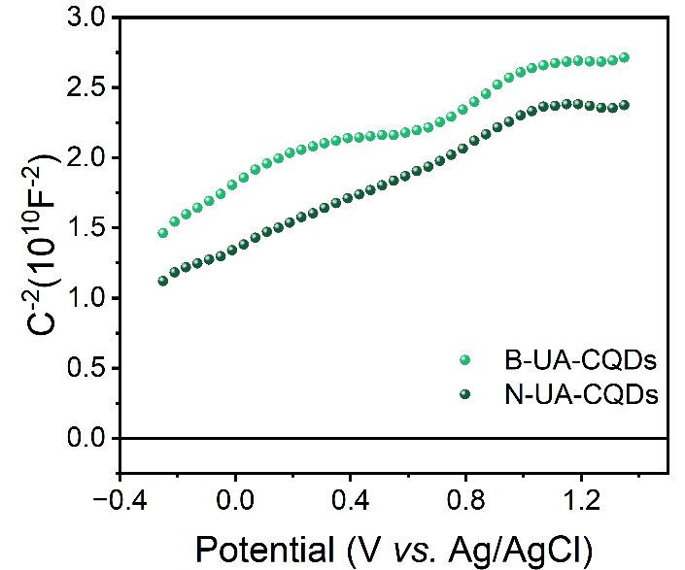
Supplementary Figure 28. M-S curves of UA-CQDs.
Supplementary Figure 29. Performance of devices using pristine B-UA-CQDs directly as the emissive layer. (a) J-V-L characteristics; (b) EQE and current efficiency as functions of current density; (c) Two-dimensional pseudocolor map of EL spectra and photograph of the device during operation; (d) Two-dimensional pseudocolor map of normalized EL spectra.
Supplementary Figure 30. J-V characteristics of hole-only and electron-only devices using (a) B-UA-CQDs and (b) N-UA-CQDs as the emissive layer.
Figure Supplementary Figure 31. Performance of devices with UA-CQDs blended with CzAcSF as the emissive layer. For B-UA-CQDs: (a) Two-dimensional pseudocolor map of normalized EL spectra. For N-UA-CQDs: (b) Two-dimensional pseudocolor map of normalized EL spectra; (c) Two-dimensional pseudocolor map of EL spectra.
Supplementary Figure 32. EL spectra of devices using CzAcSF as the emissive layer, and photograph of devices during operation.
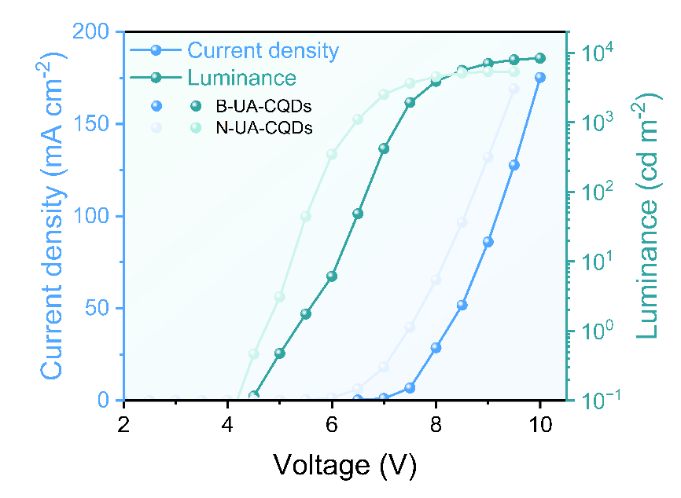
Supplementary Figure 33. J-V-L characteristics of UA-CQD-based LEDs.
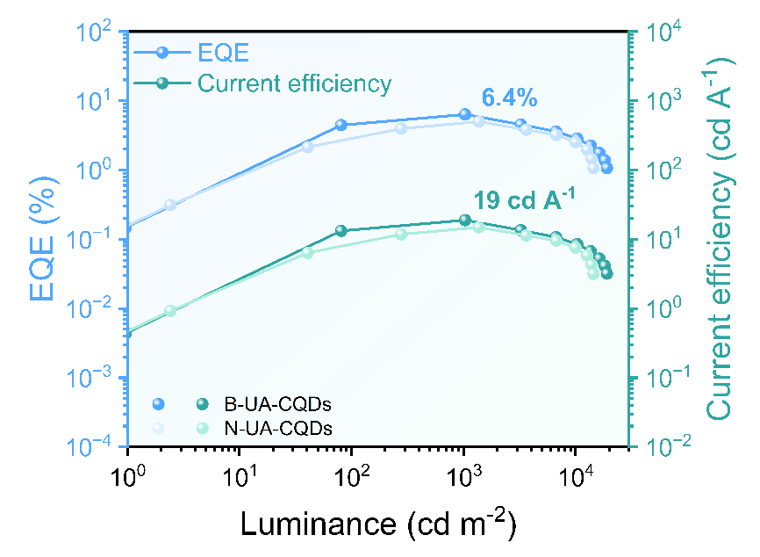
Supplementary Figure 34. EQE and current efficiency as functions of luminance for UA-CQD-based LEDs using m-PEDOT:PSS as the hole injection layer.
Supplementary Table
UA-CQDs | Aldehyde-containing precursor &  active methylene-containing precursor |  | Solid-state emission color | Emission peak (nm)
1 | 4,4′-Diformyltriphenylamine | 2-Naphthylacetonitrile | Green | 529
2 | 4,4′-Diformyltriphenylamine | 3,4-(Methylenedioxy)phenylacetonitrile | Yellow-green | 546
3 | 4,4′-Diformyltriphenylamine | 4-Biphenylacetonitrile | Yellow | 570
4 | 4,4′-Diformyltriphenylamine | 2-(Benzo[d]thiazol-2-yl)Acetonitrile | Red | 668
5 | 2,5-Furandicarboxaldehyde | 1,4-Phenylenediacetonitrile | Deep-red | 690
6 | 2,5-Dimethoxybenzene-1,4-Dicarboxaldehyde | 1,4-Phenylenediacetonitrile | Near-infrared | 714

Supplementary Table 1. Synthesis of UA-CQDs from different precursors.

Supplementary Table 2. Device performance comparison of B-UA-CQD-based electroluminescent LEDs between this work and reported results.
Materials & LEDs | Emission peak (nm) | Luminance (cd m⁻²) | Current efficiency (cd A⁻¹) | EQE (%) | Ref.
B-LEDs | 476 | 1882 | 1.22 | / | Nat Commun. 9, 2249 (2018)
G-LEDs | 510 | 4762 | 5.11 | / | Nat Commun. 9, 2249 (2018)
Y-LEDs | 540 | 2784 | 2.31 | / | Nat Commun. 9, 2249 (2018)
R-LEDs | 602 | 2344 | 1.73 | / | Nat Commun. 9, 2249 (2018)
HCP-DB-CDs | 433 | 5240 | / | 4.04 | Nat. Photonics 14, 171–176 (2020)
H-CQDs | 521 | 11615 | 15.55 | 4.6 | Angew. Chem. Int. Ed.  62, e202218568 (2023)
G-LEDs | 520 | 4236 | 2.34 | / | Angew. Chem. Int. Ed.  62, e202301651 (2023)
O-LEDs | 580 | 9450 | 1.57 | / | Angew. Chem. Int. Ed.  62, e202301651 (2023)
R-SSCQDs | 535 | 15834 | 10.3 | 3 | Angew. Chem. Int. Ed.  64, e202419983 (2024)
R-SSCQDs | 640 | 4824 | 1.25 | 1.02 | Angew. Chem. Int. Ed.  64, e202419983 (2024)
O-CQDs | 523 | 16000 | 31 | 10 | Angew. Chem. Int. Ed.  64, e202508650 (2025)
O-CQDs | 625 | 5356 | / | / | Angew. Chem. Int. Ed.  64, e202508650 (2025)
MIE-CQDs | 510 | 10219 | 20 | 7 | Adv. Funct. Mater.  36, e24329 (2025)
MIE-CQDs | 603 | 8366 | 0.64 | 0.3 | Adv. Funct. Mater.  36, e24329 (2025)
TADF CDs | 560 | / | / | 5.68 | Nano Lett. 24, 2904−2911 (2024)
CDs | 445 | 1550 | / | 7.21 | Adv. Funct. Mater.  34, 2404437 (2024)
CDs | 445 | 1290 | / | 7.07 | Adv. Funct. Mater.  34, 2404437 (2024)
CDs | 450 | 2500 | / | 10.8 | Nano Lett. 25, 2996–3001 (2025)
CDs | 453 | / | 2.14 | 2.04 | Nano Lett. 23, 8794−8800 (2023)
CDs | / | / | 4.18 | 2.62 | Nano Lett. 23, 8794−8800 (2023)
CDs | 515 | 2023 | 5.51 | 2.04 | Nano Lett. 23, 8794−8800 (2023)
B-LEDs | 444 | 3785 | / | 7.2 | Nat Commun. 15, 3043 (2024)
G-LEDs | 494 | 6130 | / | 9.9 | Nat Commun. 15, 3043 (2024)
Y-LEDs | 523 | 7550 | / | 8.7 | Nat Commun. 15, 3043 (2024)
O-LEDs | 574 | 5580 | / | 7.8 | Nat Commun. 15, 3043 (2024)
R-LEDs | 620 | 4190 | / | 6 | Nat Commun. 15, 3043 (2024)
R-LEDs | 625 | 1818 | 4 | 5.6 | J. Am. Chem. Soc.  143, 18941-18951 (2021)
HCP-RCQDs | 645 | 18535 | / | / | Angew. Chem. Int. Ed.  64, e202513847 (2025)
CDs | 452 | 648 | / | 2.11 | Laser Photonics Rev.  15, 2000412 (2021)
DR-NBE-CDs | 679 | 579 | / | 0.57 | Adv. Mater. 35, 2302275 (2023)
Ch-CDs | 660 | 332 | 0.9 | 1.98 | Adv. Mater. 36, 2410094 (2024)
G-LEDs | 544 | 8373 | 6.41 | / | Adv. Mater. 38, e73773 (2026)
Y-LEDs | 556 | 8401 | 13.04 | / | Adv. Mater. 38, e73773 (2026)
R-LEDs | 592 | 12287 | 6.73 | / | Adv. Mater. 38, e73773 (2026)
RT-CDs | 576 | 2967 | 1.38 | / | Small 19, 192206715 (2023)
B,N-CDs | 440 | / | / | 6.98 | Chem. Eng. J. 514, 163146 (2025)
B-UA-CQDs  (Pristine) | 538 | 7774 | 1.16 | 0.33 | This work
B-UA-CQDs  (TADF Host) | 505 | 8368 | 37.54 | 12.23 | This work
B-UA-CQDs  (TADF Host and m-PEDOT:PSS) | 506 | 19034 | 18.93 | 6.36 | This work

Supplementary References

1. M. J. Frisch, G. W. Trucks, H. B. Schlegel, et al., Wallingford, CT 2016.
2. P. J. Stephens, F. J. Devlin, C. F. Chabalowski, M. J. Frisch, “Ab Initio Calculation of Vibrational Absorption and Circular Dichroism Spectra Using Density Functional Force Fields,” The Journal of Physical Chemistry 98 (1994): 11623-11627, http://doi.org/10.1021/j100096a001.
3. F. Furche, R. Ahlrichs, “Adiabatic time-dependent density functional methods for excited state properties,” The Journal of Chemical Physics 117 (2002): 7433-7447, http://doi.org/10.1063/1.1508368.
4. R. Krishnan, J. S. Binkley, R. Seeger, J. A. Pople, “Self-consistent molecular orbital methods. XX. A basis set for correlated wave functions,” The Journal of Chemical Physics 72 (1980): 650-654, http://doi.org/10.1063/1.438955.
5. S. Grimme, S. Ehrlich, L. Goerigk, “Effect of the damping function in dispersion corrected density functional theory,” Journal of Computational Chemistry 32 (2011): 1456-1465,
6. T. Lu, F. Chen, “Multiwfn: A multifunctional wavefunction analyzer,” Journal of Computational Chemistry 33 (2011): 580-592, http://doi.org/10.1002/jcc.22885.
7. W. Humphrey, A. Dalke, K. Schulten, “VMD: visual molecular dynamics,” Journal of Molecular Graphics & Modelling 14 (1996): 33-38, http://doi.org/10.1016/0263-7855(96)00018-5.

