Additional file 1
Crude co-mention trends and standardized observed-to-expected ratios can move in opposite directions: a decomposition, with an application to US multiple-cause-of-death data.
This supplementary material contains estimator-sensitivity analyses and additional displays supporting the main manuscript.

Supplementary Table S1. IE slopes under alternative estimators
Annual change (%/yr, 95% CI) for the infective endocarditis × CKD pair. HAC is the primary specification reported in Table 1 of the main text.
Era | Statistic | HAC (corrected) | HC3 | AR(1) GLS | DW
2013–2019 | C | +0.93 (+0.40, +1.46) | +0.93 (+0.36, +1.50) | +0.88 (−0.39, +2.17) | 2.30
2013–2019 | Q | +3.55 (+3.23, +3.87) | +3.55 (+3.14, +3.96) | +3.53 (+2.74, +4.32) | 1.83
2013–2019 | ER | −2.53 (−3.29, −1.76) | −2.53 (−3.37, −1.68) | −2.55 (−4.47, −0.59) | 1.97
1999–2010 | ER | −0.85 (−1.26, −0.43) | −0.85 (−1.53, −0.16) | −0.97 (−1.44, −0.51) | 1.76
Stable years | ER | −1.46 (−1.74, −1.18) | −1.46 (−1.74, −1.18) | −1.64 (−2.03, −1.25) | 1.15
The estimated ER slope is negative under every specification in every window, and in 2013–2019 the three estimators agree to within 0.05 percentage points on all three statistics, using the rounded estimates reported in Supplementary Table S1.
AR(1) GLS is interpretable only where the residual diagnostics support it. For the 1999–2010 and pooled C and Q series Durbin–Watson is 0.33–0.72; iterative GLS then drives ρ toward unity and quasi-differences away the trend being estimated, returning implausible values — for 1999–2010 Q, −2.12%/yr against +1.33%/yr under HAC. Those unstable C and Q fits are excluded from Supplementary Table S1 and are not used in the main text.
A preliminary multinomial bootstrap over the four-cell decomposition of each stratum preserves the nesting constraints and the shared deaths but captures only sampling error in the counts, which is negligible at this scale — sepsis has 199,628 index deaths in 2019, while the residual SD of log C about its trend is 0.053 — so it returns intervals far narrower than HAC. The bootstrap is retained as a preliminary sampling-only diagnostic; it was not rerun with the bounded allocation and does not quantify allocation uncertainty. Table S1 uses t-based inference for HAC, HC3 and AR(1) GLS. The post-transition crude AR(1) interval includes zero, so agreement in estimated directions does not imply significance under every estimator.

Bounded-allocation sensitivity. The primary allocation is the least-squares projection of the proportional residual target onto the jointly feasible set, preserving reported cells, exact year totals and non-negative four-cell counts, with each unreported cell in [0, 9]. The bounded uniform allocation is a secondary target under the same constraints. Both bounded constructions were feasible for all 88 condition-years (1999–2020). For IE, sepsis and pneumonia, all index-condition cells are reported, so E is linear in the unknown co-mention cells and linear programming gives exact extrema over the continuous feasible set. Where CDI index cells are also unknown, coordinate-wise feasible bounds give a conservative enclosure; its endpoints need not be jointly attainable. Annual bounds propagate to OLS log-slope bounds using the signed centered-year weights. For IE in 2013–2019, the standardized slope remains between −2.5292 and −2.5281%/yr. These coefficient bounds describe allocation uncertainty separately from the conditional sampling/model confidence intervals and do not establish significance for every allocation.

Supplementary Figure S1. Crude, standardized and background slopes, four pairs
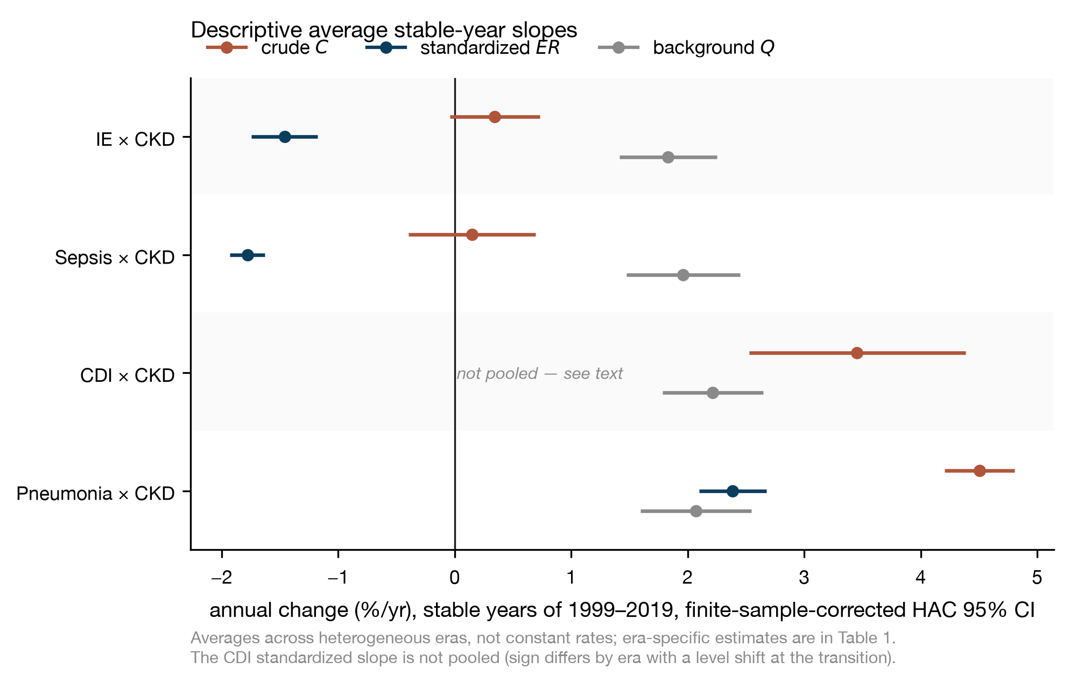
The three slopes for each of the four CKD pairs, stable years. C. difficile’s standardized slope is omitted because it fails the pooling check (main text, Table 2 footnote).

Supplementary Figure S2. Literature audit
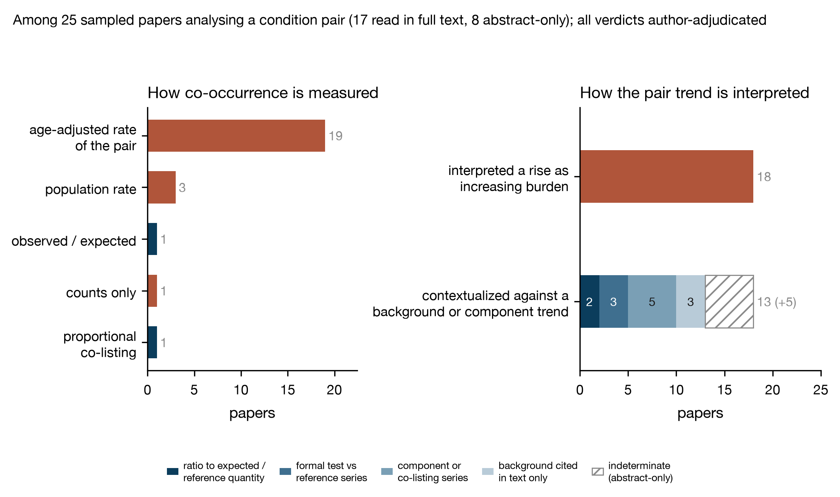
Left: how the 25 pair analyses measure co-occurrence. Right: how they interpret and contextualize the pair trend, with the contextualization bar segmented by what was actually computed. All verdicts author-adjudicated; counts are Table 4 of the main text.

Provenance
Every number above is reproducible offline from the archived CDC WONDER responses. The audit verdicts, both preliminary and adjudicated, are in the archived audit_verdicts.json file; each of the 25 pair analyses carries its machine_* classification alongside the final one, and the papers whose adjudication reversed a preliminary verdict carry the supporting sentence under adjudication_evidence.

