Multi‑Sensor Deep Learning for Smallholder Paddy Rice Mapping with Sentinel‑1 SAR and Sentinel‑2 Optical Imagery
Alex Okiemute Onojeghuo ^{1, *} and Ajoke Ruth Onojeghuo ¹
¹ Research and Development Unit, Jolexy Environmental Services Limited, Edmonton, AB, Canada
*Corresponding author: alex.onojeghuo@jolexyenviro.com
Supplementary Information

Graphic Abstract
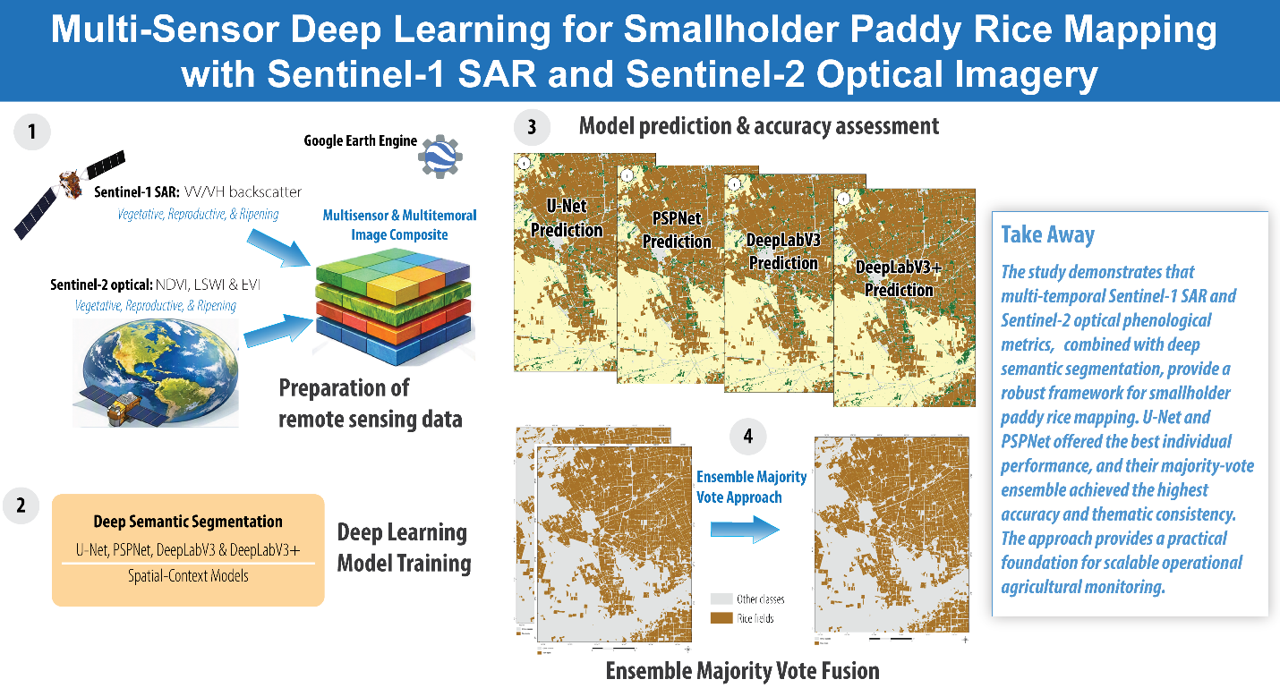

Interactive Map of paddy rice distribution generated in the study:
To facilitate visualization of the upscaled paddy rice map product, an interactive map application was developed for external stakeholders. This can be accessed using the link: https://experience.arcgis.com/experience/dc91e8b0ecea41a49b6d8ba1f91fba82.
Figure A.1. Map showing spatial extent of training/testing data used to build deep learning models assessed in the study (adopted from Onojeghuo, et al. [1]).
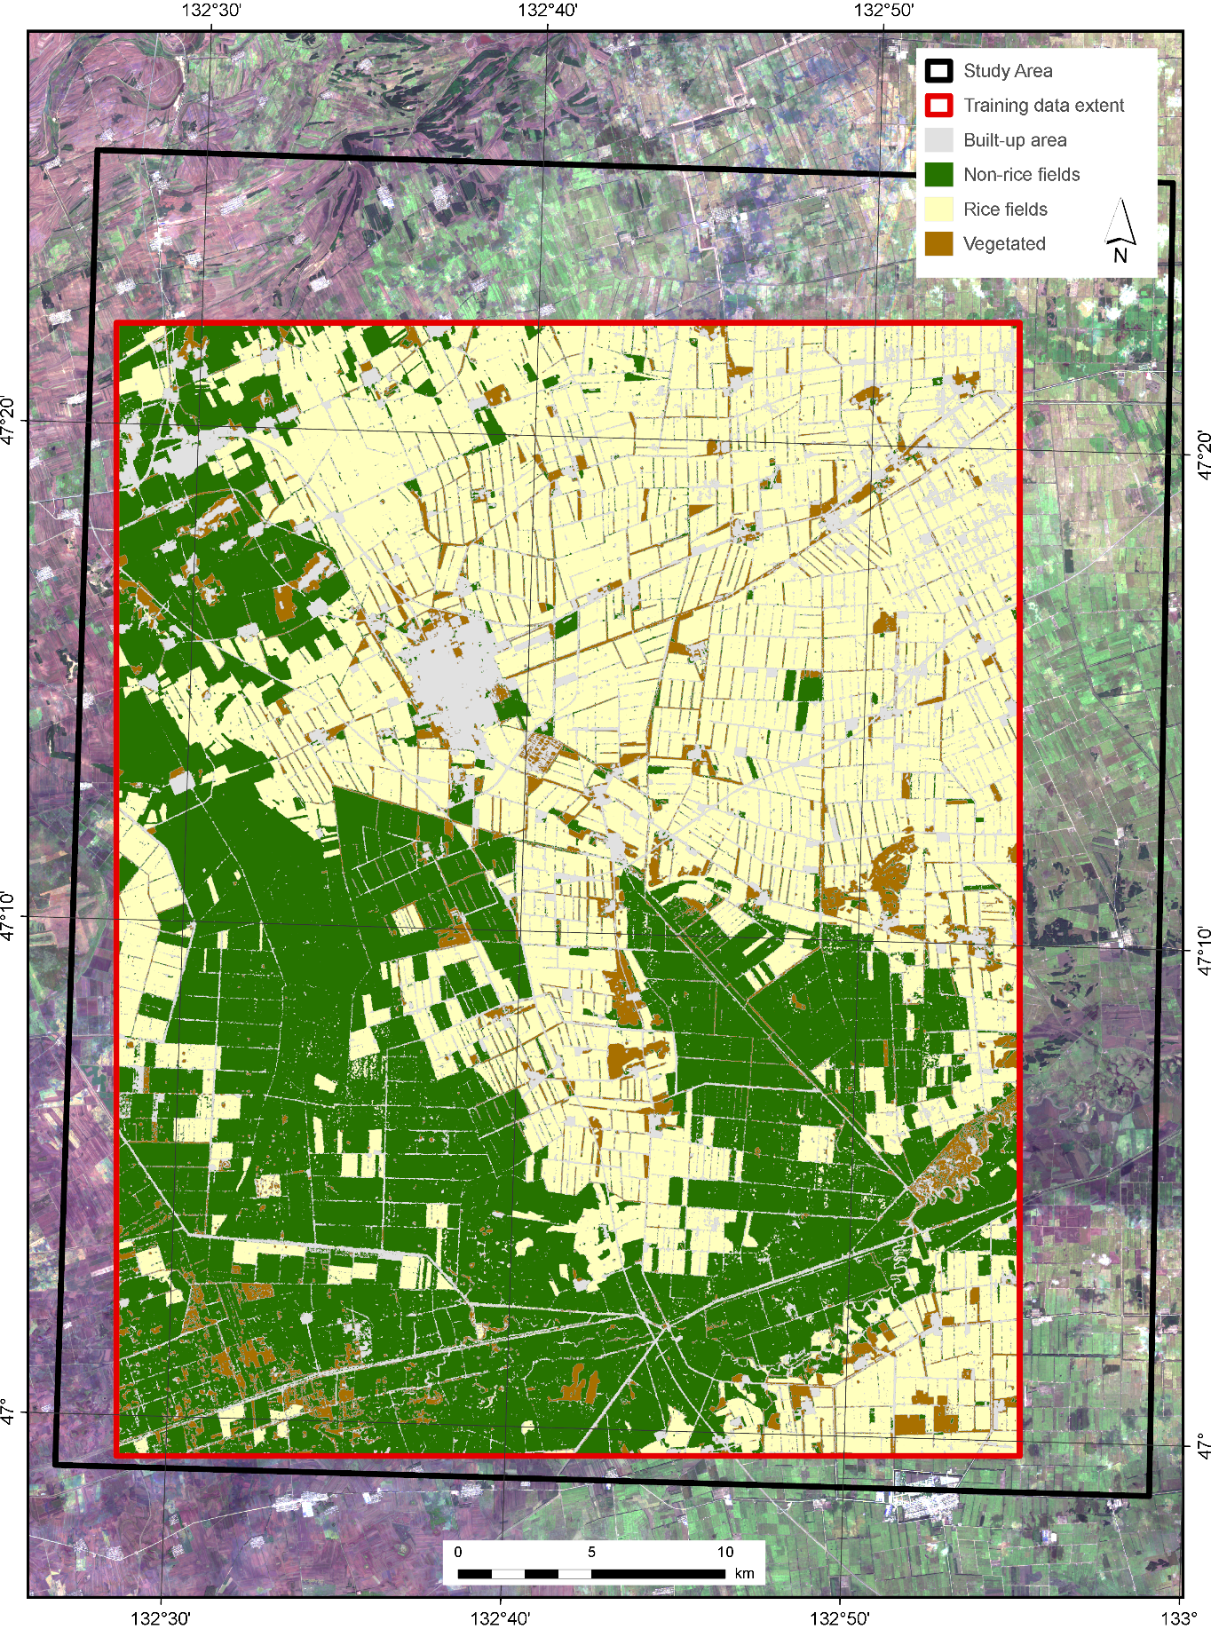
Figure A.2. Map showing spatial distribution of ground validation points used for an independent assessment of the paddy rice binary products.
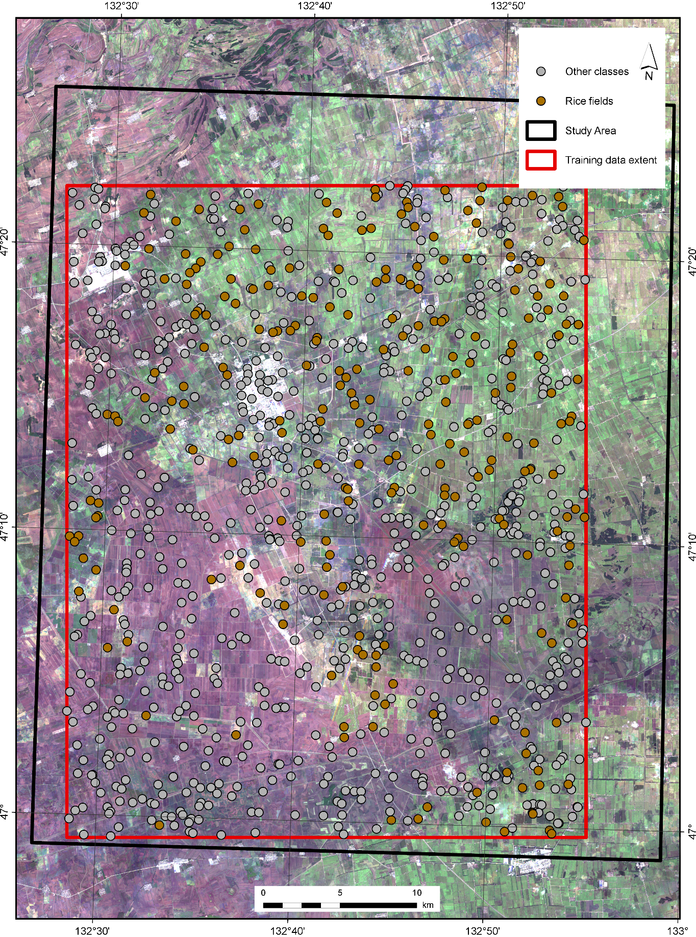

Table A.1. Error matrix of paddy rice binary products generated in the study. The evaluated architectures included U-Net, PSPNet, DeepLabV3, DeepLabV3+, and an ensemble majority-vote product based on U-Net and PSPNet.
DL Model: PSPNet |  |  |  |  |  | DL Model: U-Net
Class | Non-rice | Rice | Total | Precision |  | Class | Non-rice | Rice | Total | Precision
Non-rice | 683 | 9 | 692 | 0.99 |  | Non-rice | 696 | 12 | 708 | 0.98
Rice | 67 | 241 | 308 | 0.78 |  | Rice | 54 | 238 | 292 | 0.82
Total | 750 | 250 | 1000 |  |  | Total | 750 | 250 | 1000
Recall | 0.91 | 0.96 |  |  |  | Recall | 0.93 | 0.95
FI-Score | 0.95 | 0.86 |  |  |  | FI-Score | 0.95 | 0.88
Overall Kappa | 0.81 |  |  |  |  | Overall Kappa | 0.83
Overall Accuracy | 0.92 |  |  |  |  | Overall Accuracy | 0.93
Mean F1-Score | 0.91 |  |  |  |  | Mean F1-Score | 0.92
DL Model: DeepLabV3 |  |  |  |  |  | DL Model: DeepLabV3+
Class | Non-rice | Rice | Total | Precision |  | Class | Non-rice | Rice | Total | Precision
Non-rice | 652 | 13 | 665 | 0.98 |  | Non-rice | 660 | 8 | 668 | 0.99
Rice | 98 | 237 | 335 | 0.71 |  | Rice | 90 | 242 | 332 | 0.73
Total | 750 | 250 | 1000 |  |  | Total | 750 | 250 | 1000
Recall | 0.87 | 0.95 |  |  |  | Recall | 0.88 | 0.97
FI-Score | 0.92 | 0.81 |  |  |  | FI-Score | 0.93 | 0.83
Overall Kappa | 0.73 |  |  |  |  | Overall Kappa | 0.76
Overall Accuracy | 0.89 |  |  |  |  | Overall Accuracy | 0.90
Mean F1-Score | 0.87 |  |  |  |  | Mean F1-Score | 0.88

Table A.1. Error matrix of paddy rice binary products generated in the study. The evaluated architectures included U-Net, PSPNet, DeepLabV3, DeepLabV3+, and an ensemble majority-vote product based on U-Net and PSPNet.
Ensemble (U-Net & PSPNet)
Class | Non-rice | Rice | Total | Precision
Non-rice | 703 | 13 | 716 | 0.98
Rice | 47 | 237 | 284 | 0.83
Total | 750 | 250 | 1000
Recall | 0.94 | 0.95
FI-Score | 0.96 | 0.89
Overall Kappa | 0.85
Overall Accuracy | 0.94
Mean F1-Score | 0.92

References
1. Onojeghuo, A.O.; Miao, Y.; Blackburn, G.A. Deep ResU-Net Convolutional Neural Networks Segmentation for Smallholder Paddy Rice Mapping Using Sentinel 1 SAR and Sentinel 2 Optical Imagery. Remote Sensing 2023, 15, 1517.

