Emerging Asymmetry in Drought Timescales under High-Emission Scenarios
Md Rayhan ^{1,}*
¹Water Resources Engineering, Bangladesh University of Engineering
*Correspondence: rayhan.nkr11@gmail.com;

Suplimentary Document
- Dinajpur
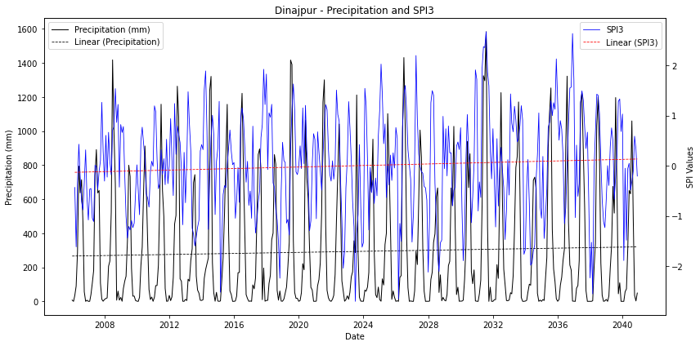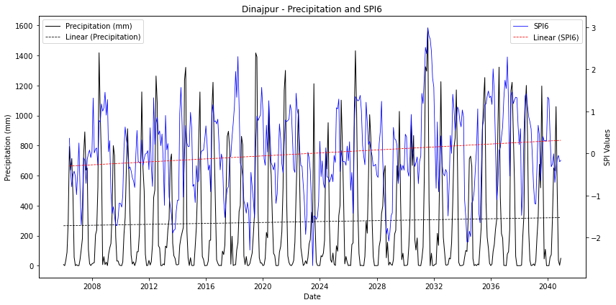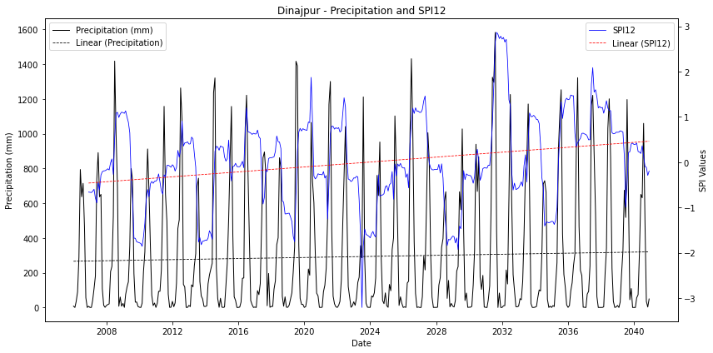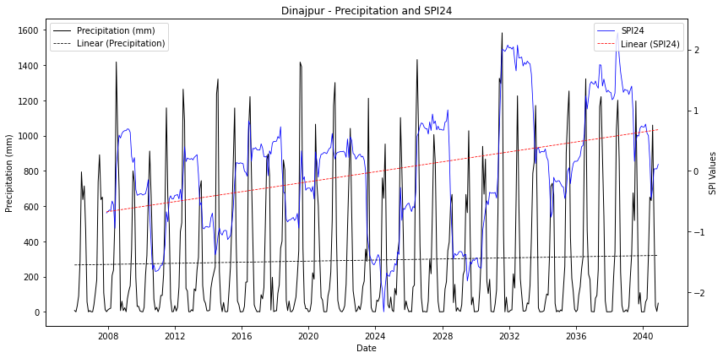
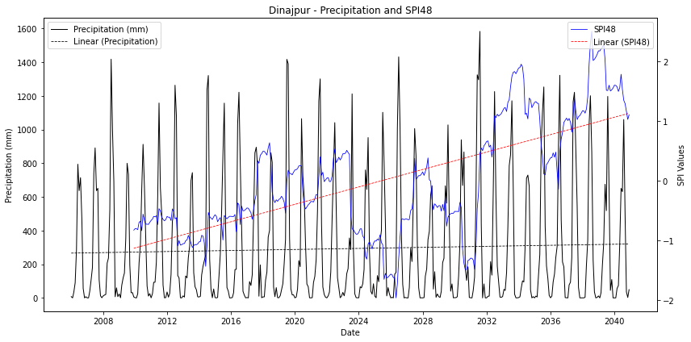

- Satkhira
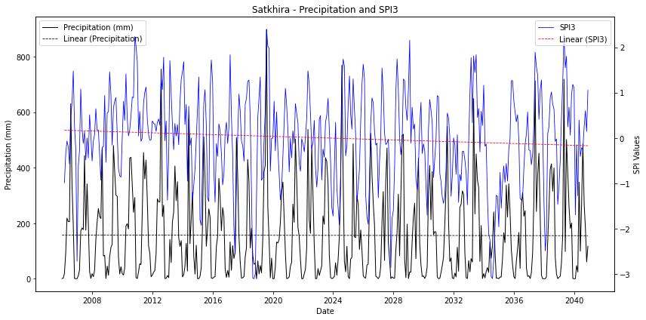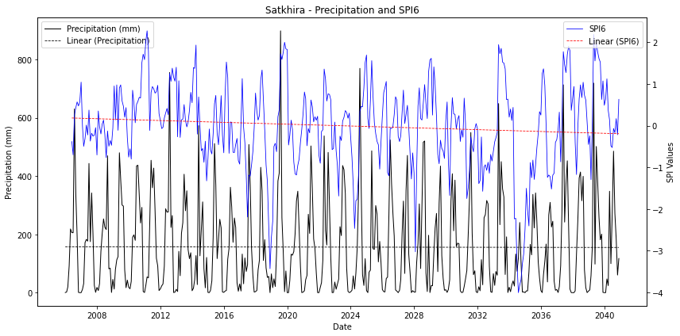
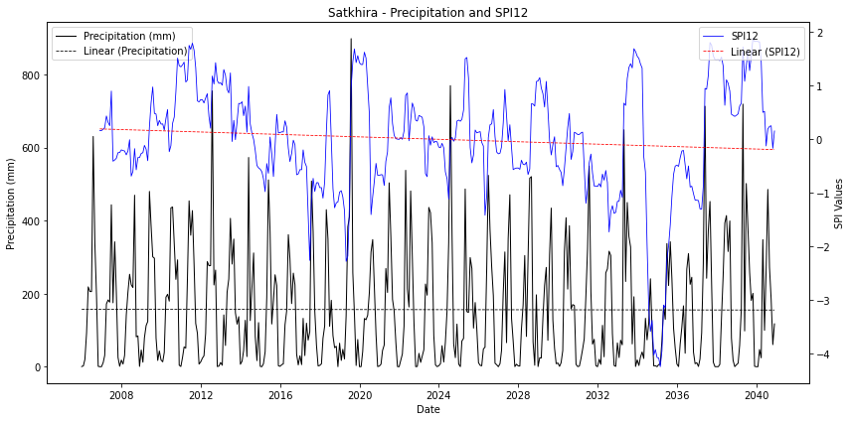
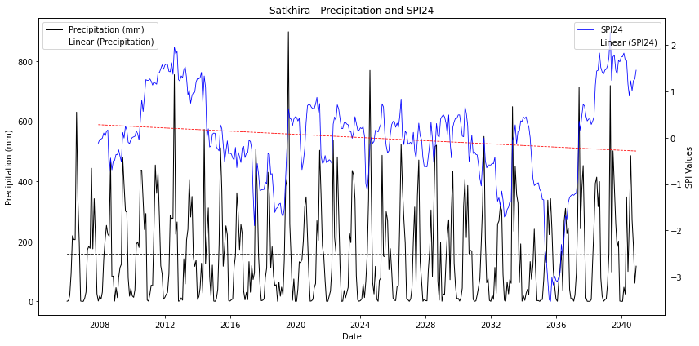
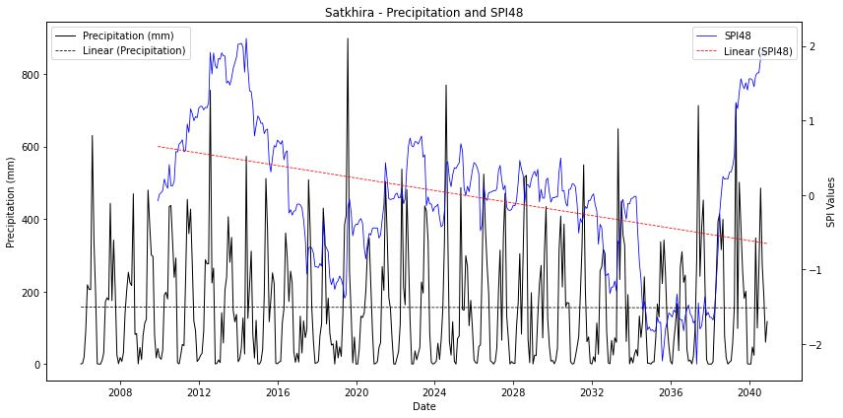

- Bogra
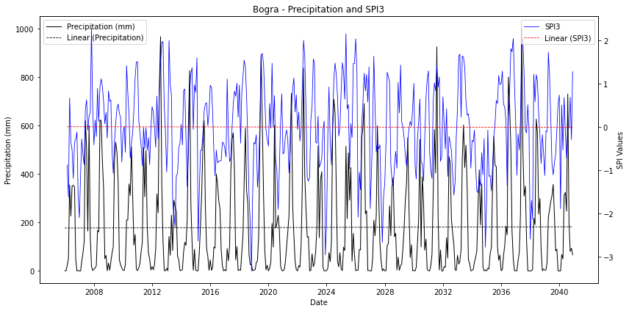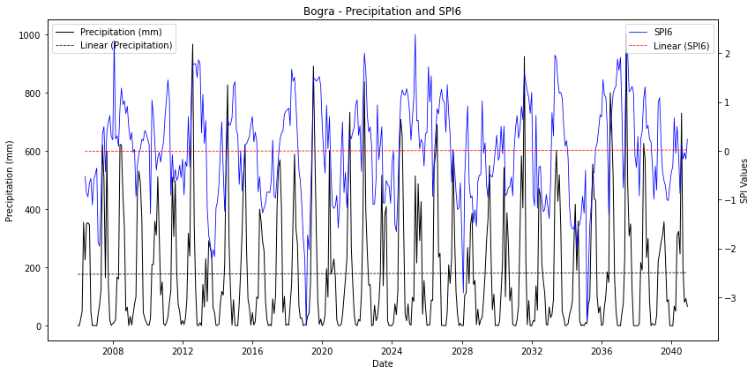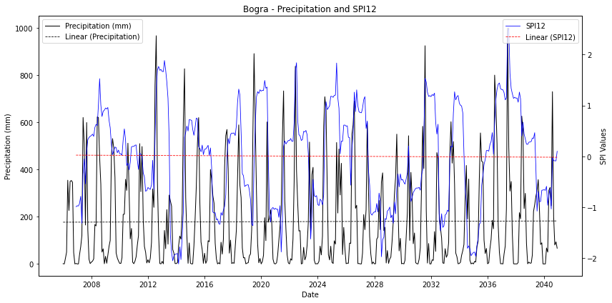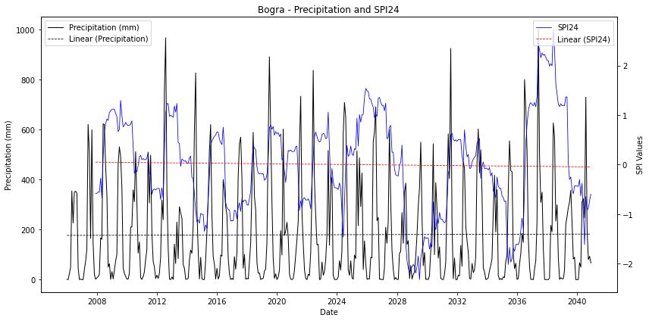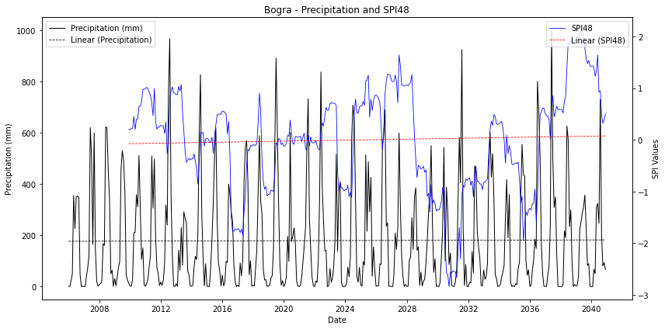

- Ishurdi
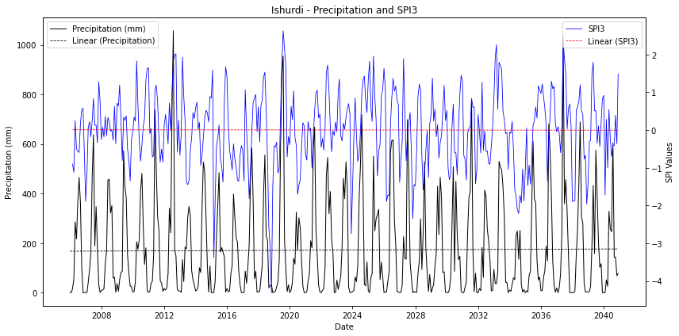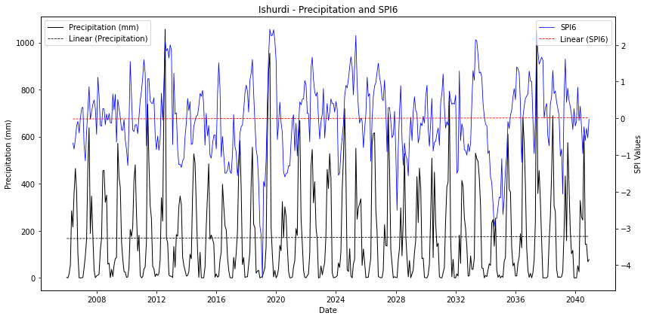
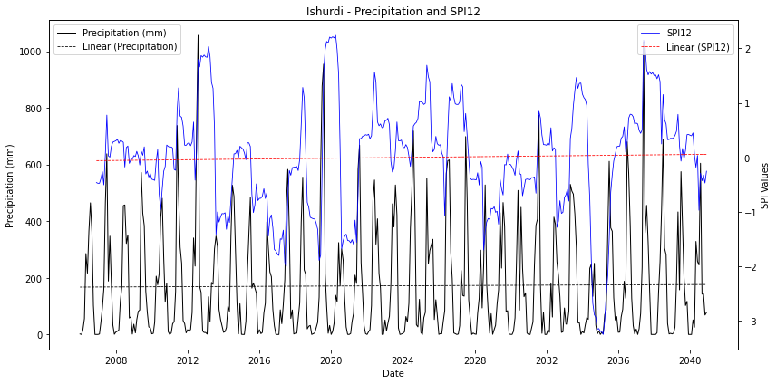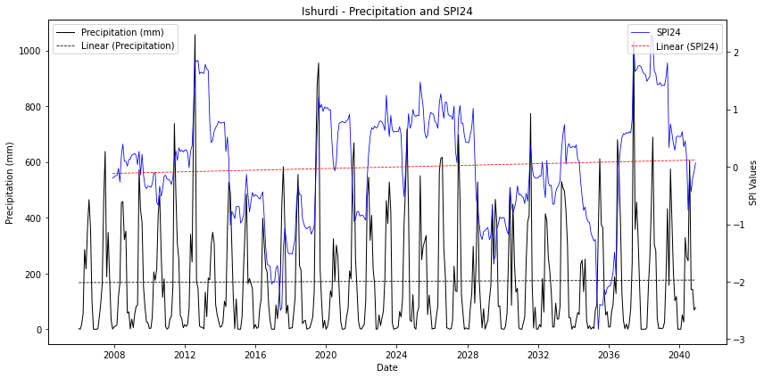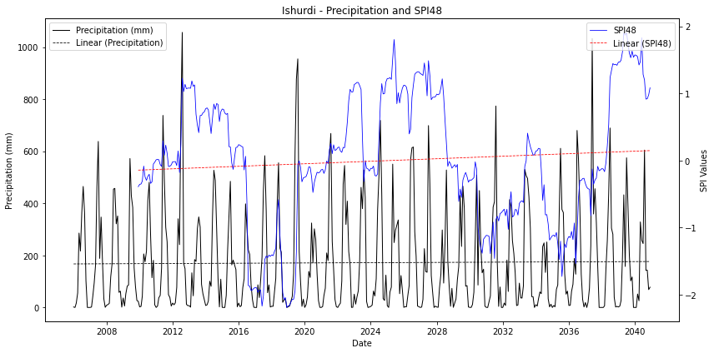

- Jessore
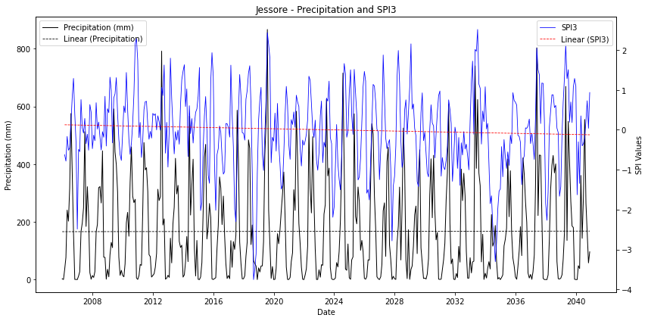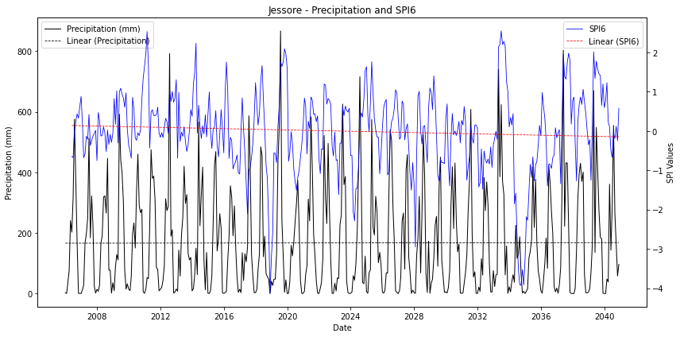
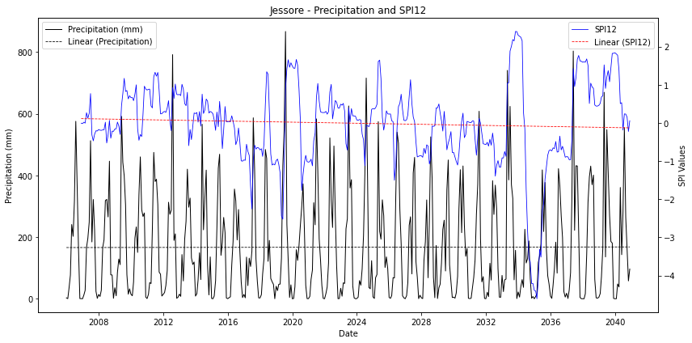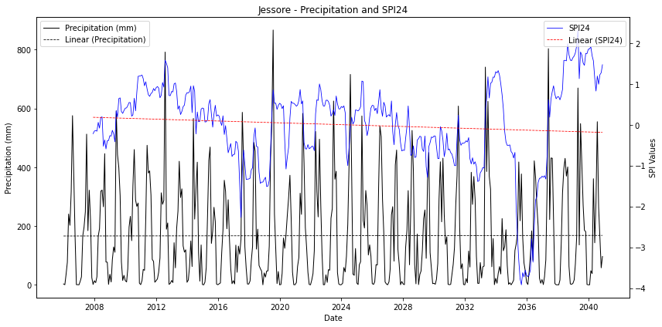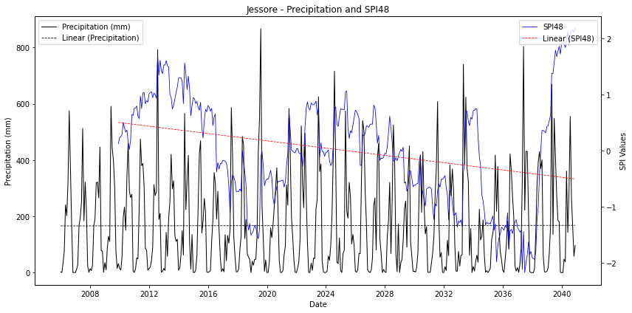
- Khulna
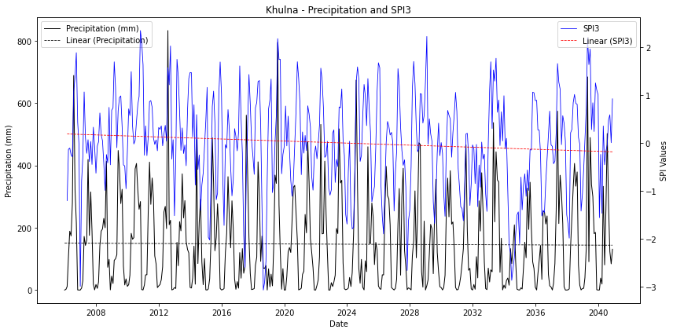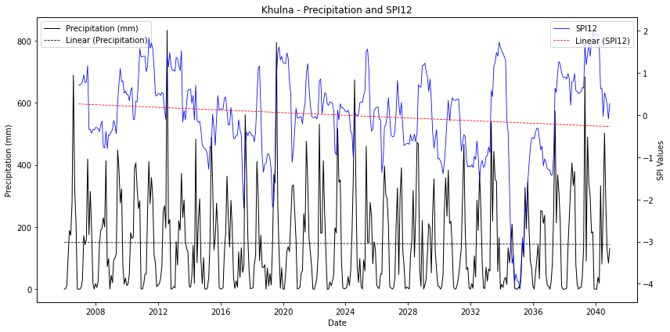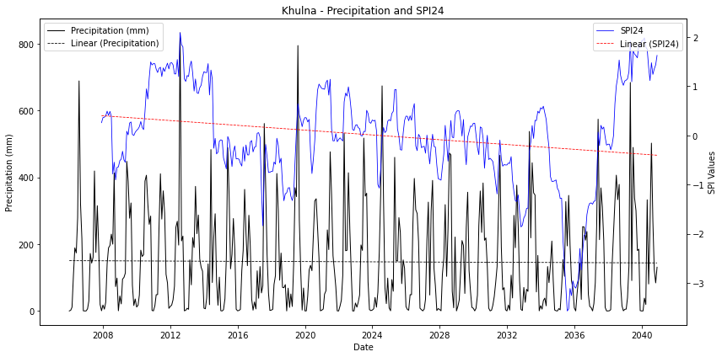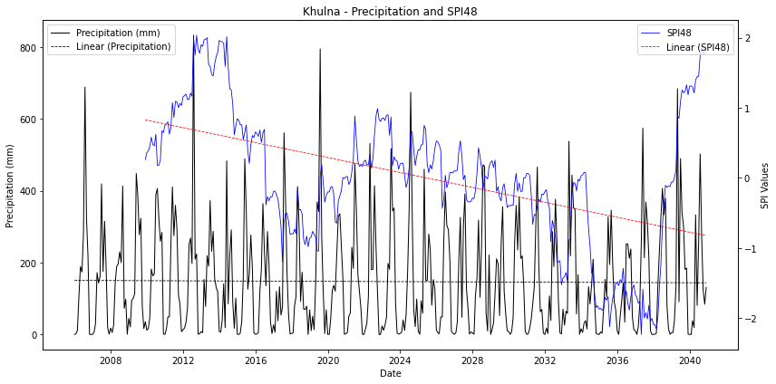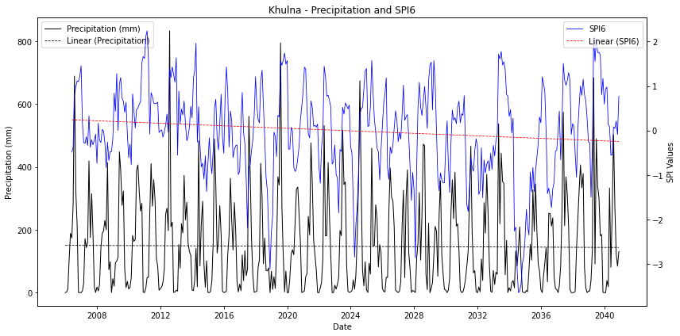

- Mongla
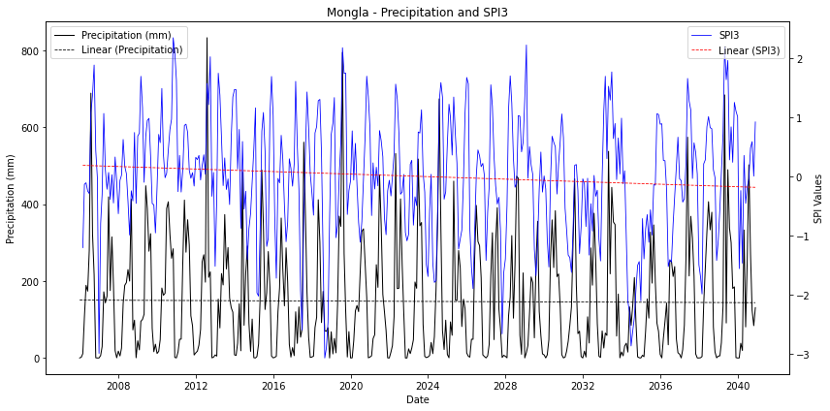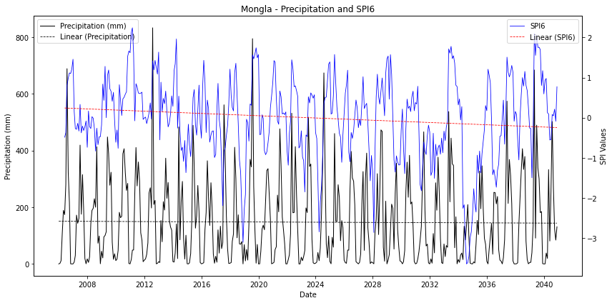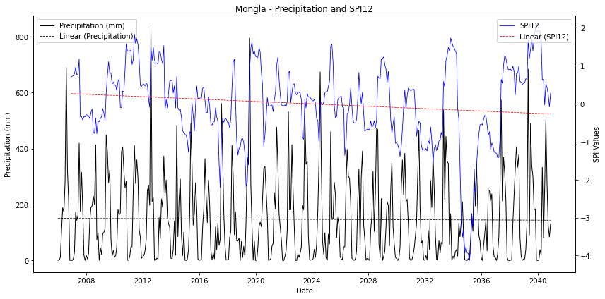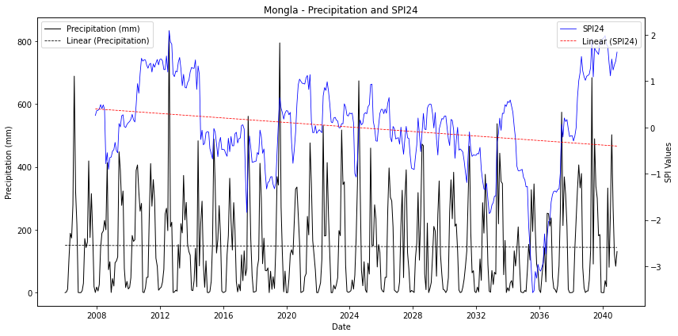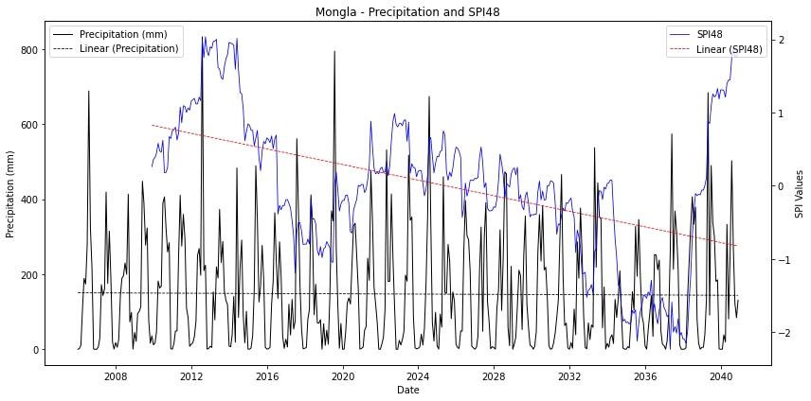
- Rangpur
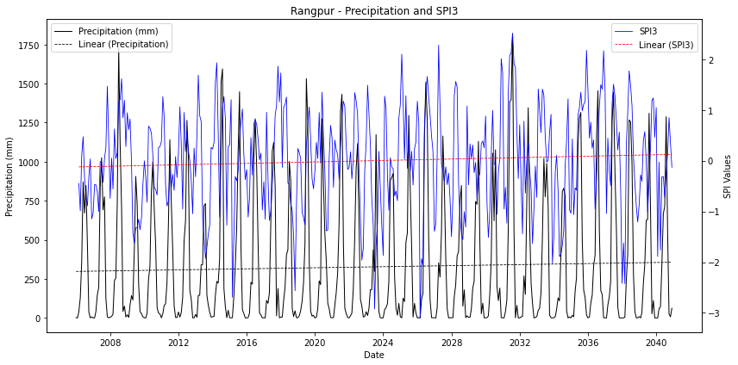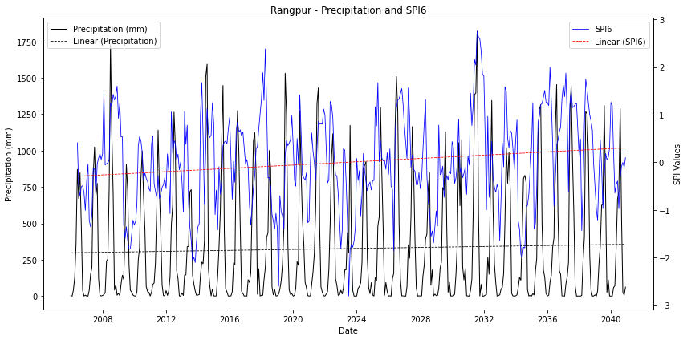
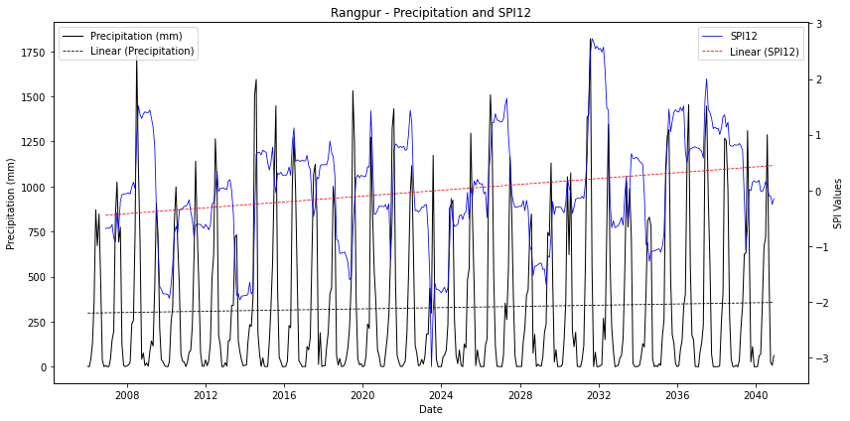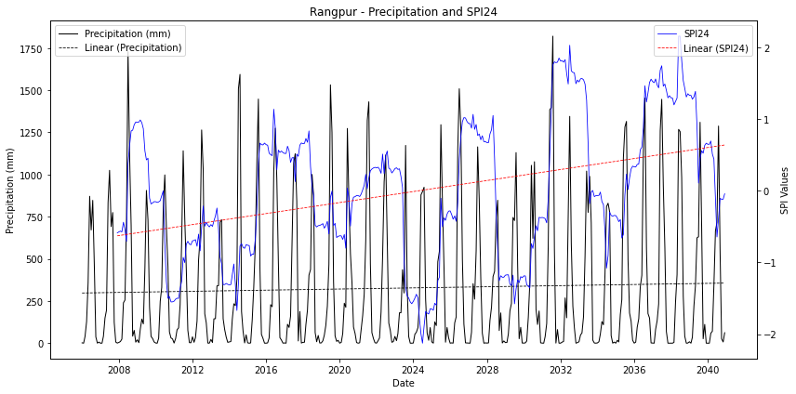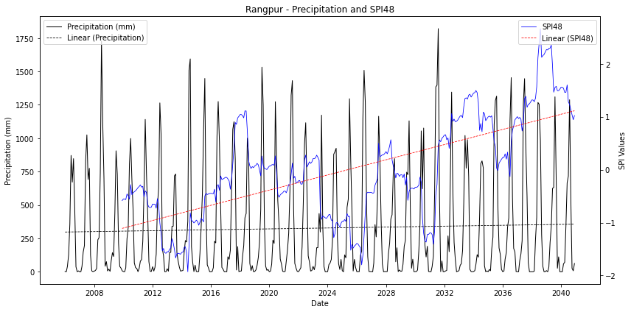
Figure S1: Precipitation and SPI (SPI3–SPI48) trends for selected BMD station under different climate scenarios: 2020s (2006–2040) (a) Dinajpur (b) Satkhira (c) Bogra (d) Ishurdi (e) Jessore (f) Khulna (g) Mongla (h) Rangpur
- Dinajpur
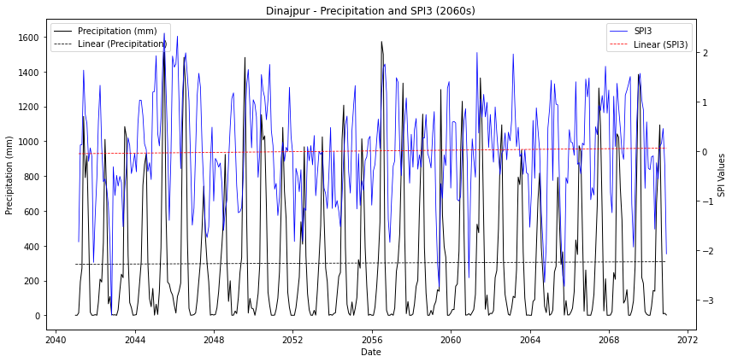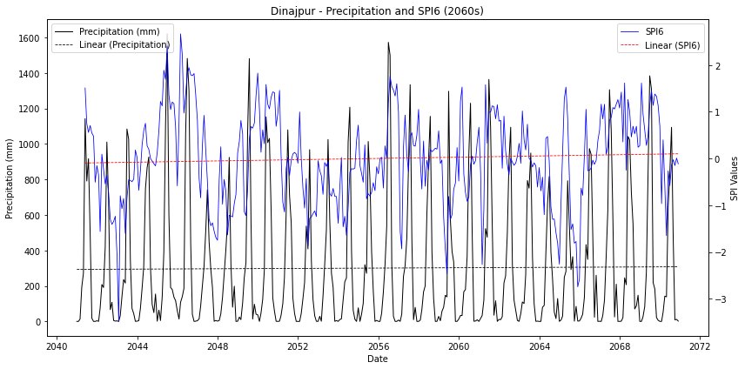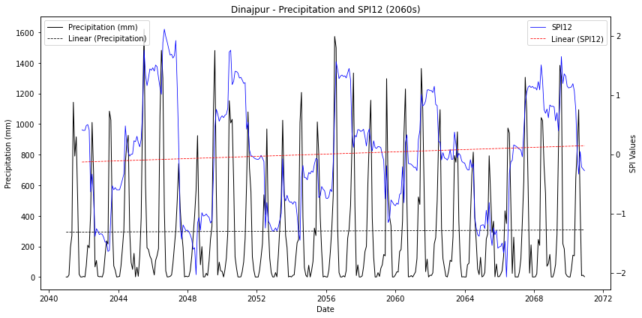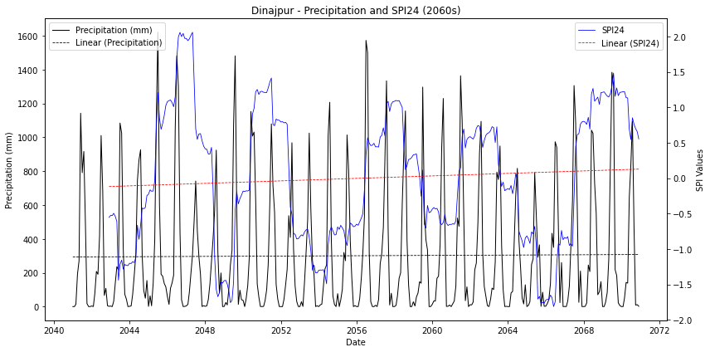
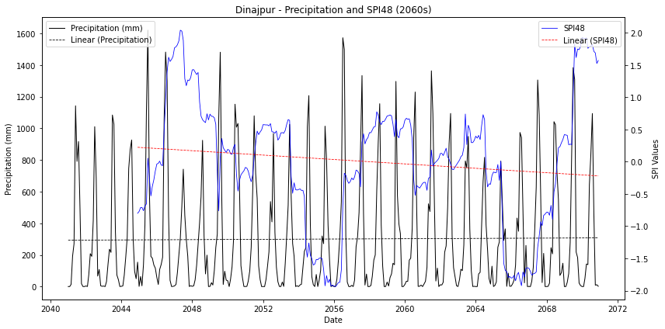
- Satkhira
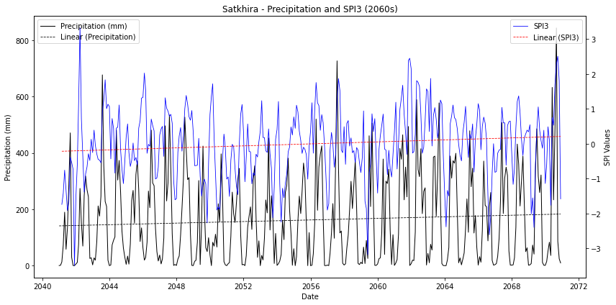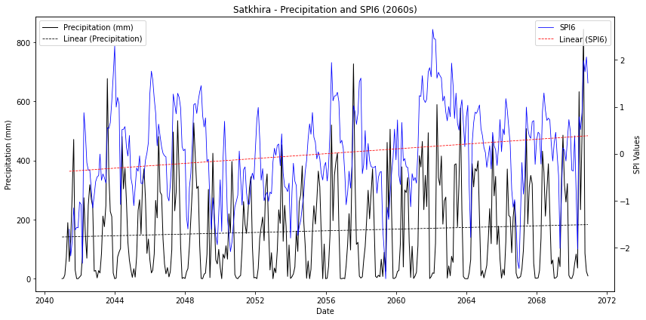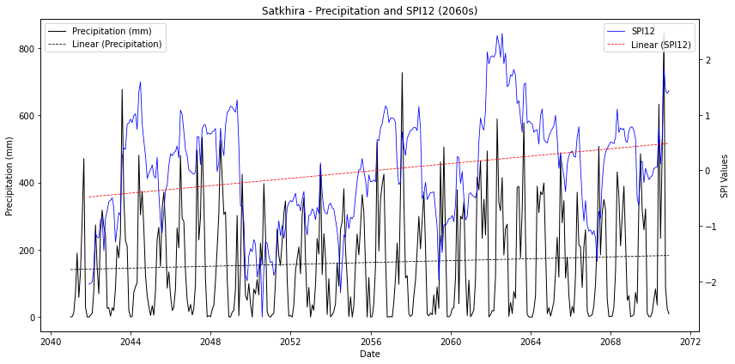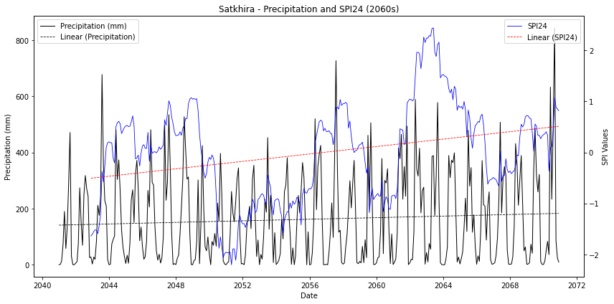
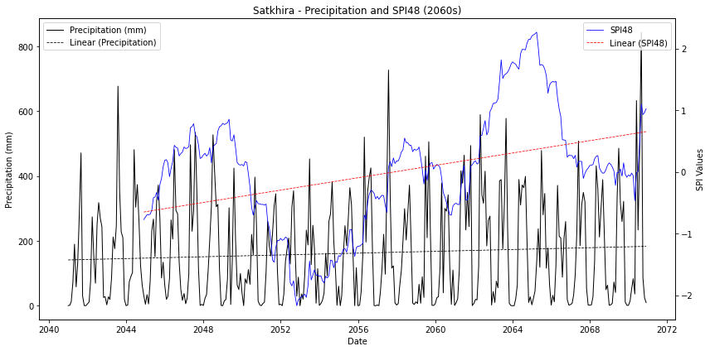

- Bogra
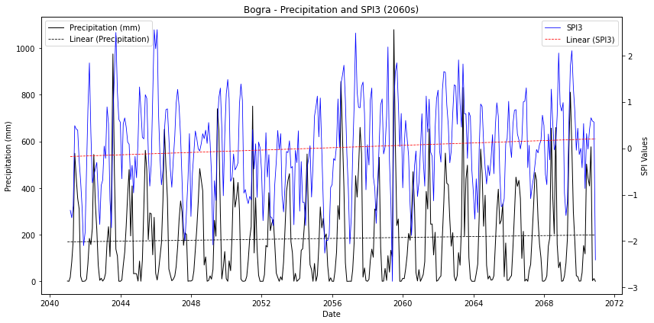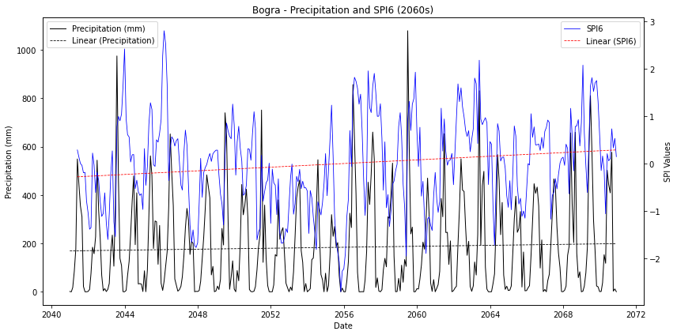
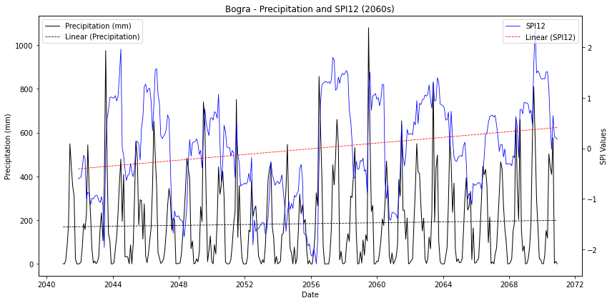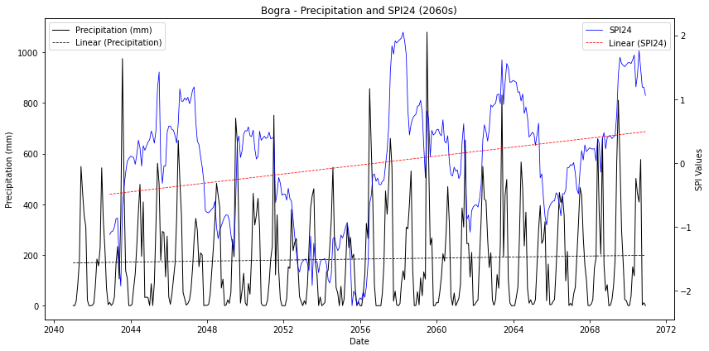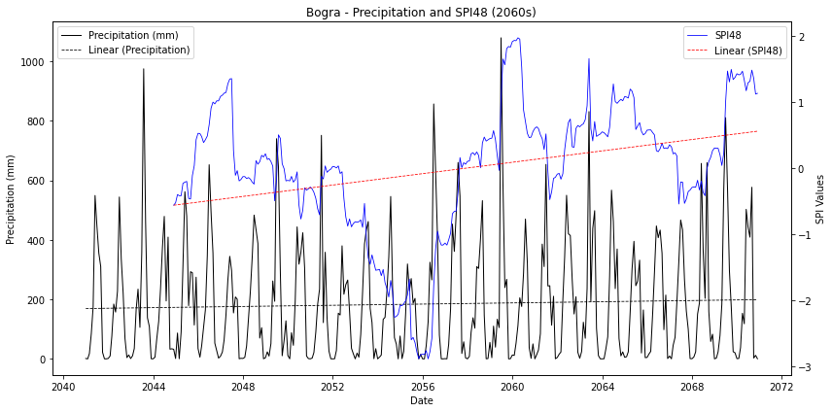
- Ishurdi
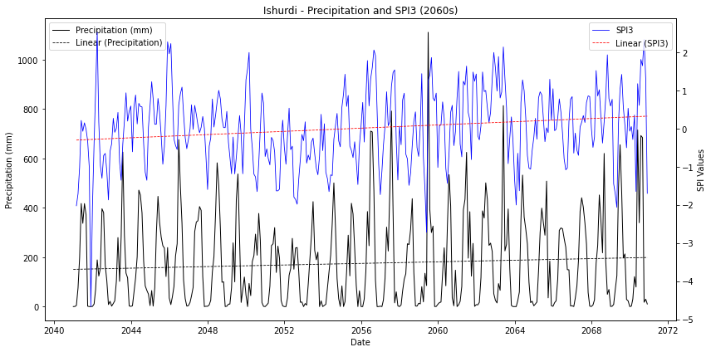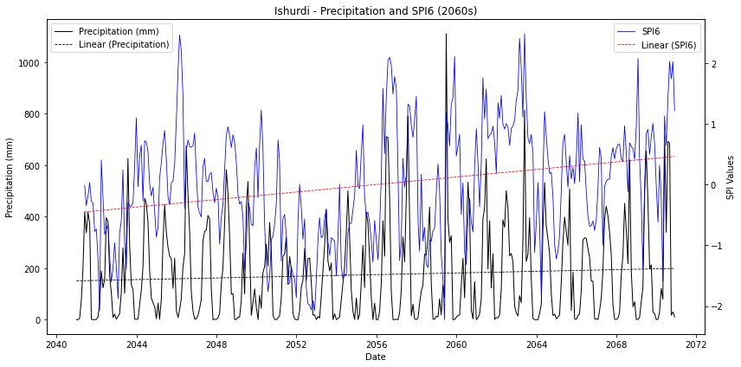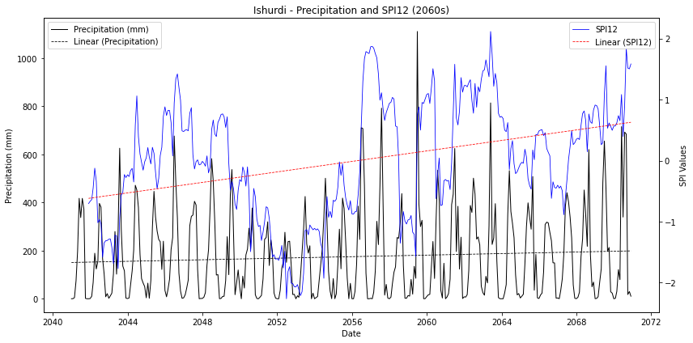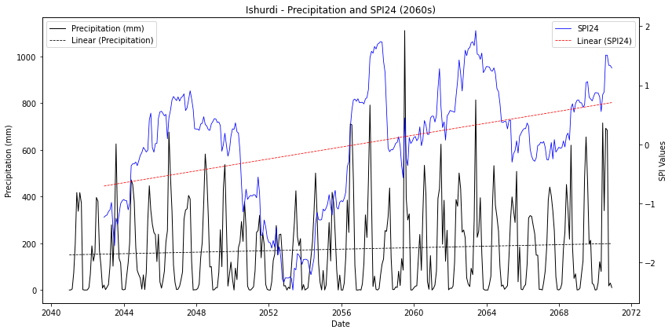
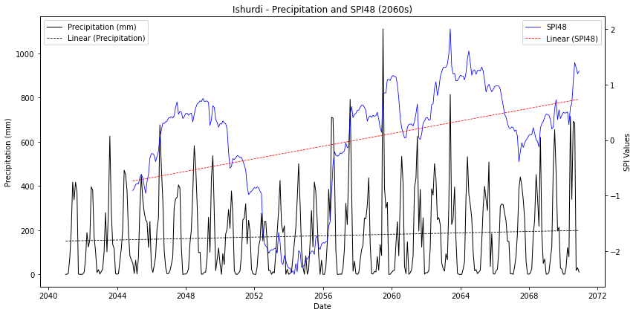

- Jessore
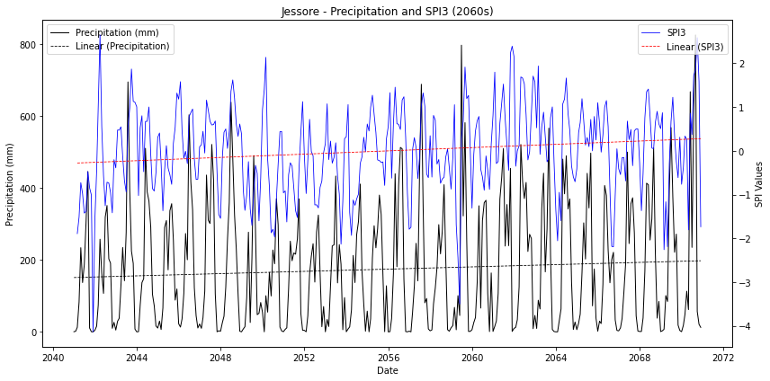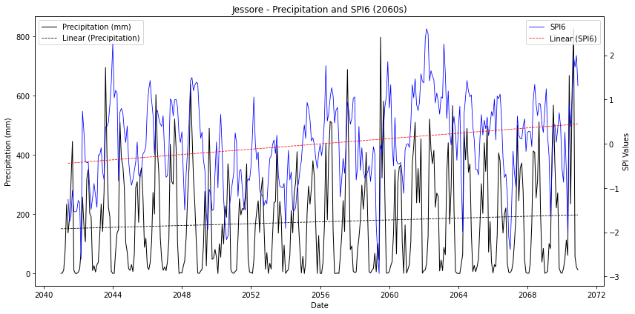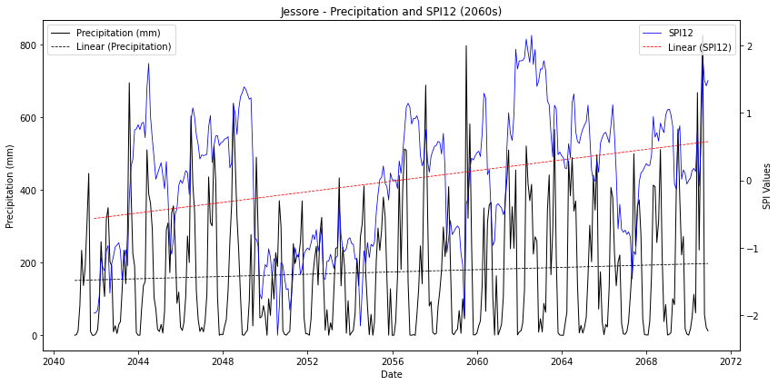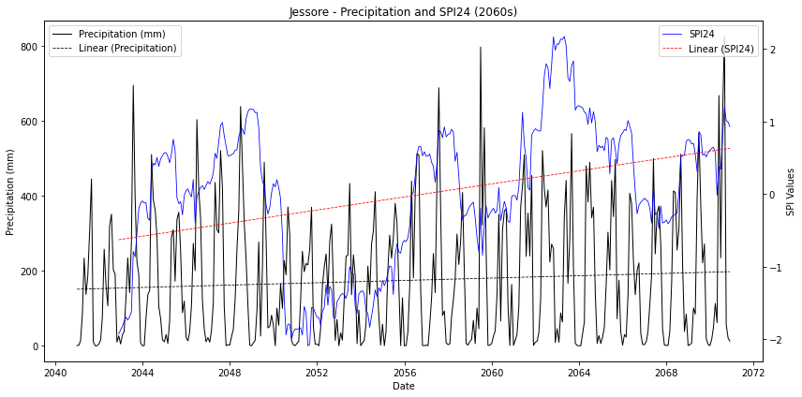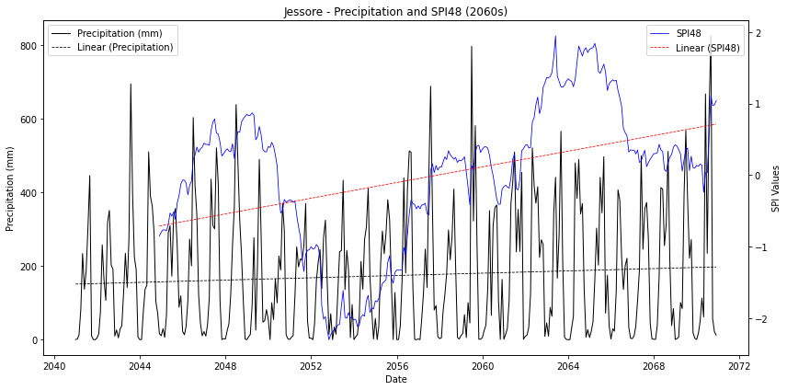
- Khulna
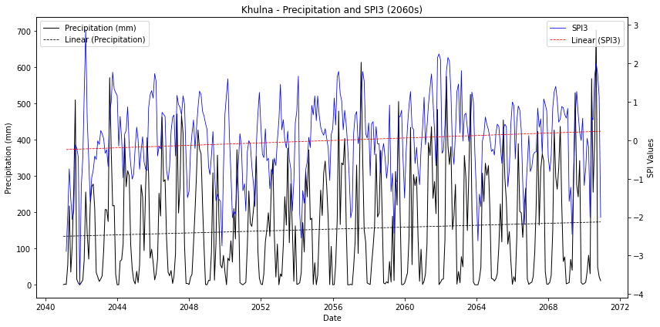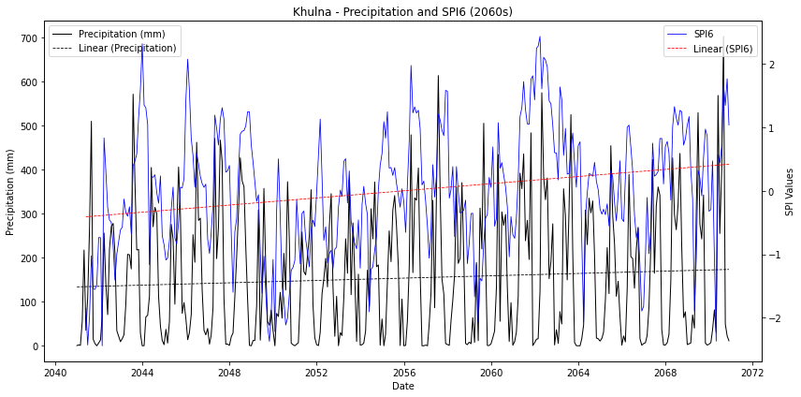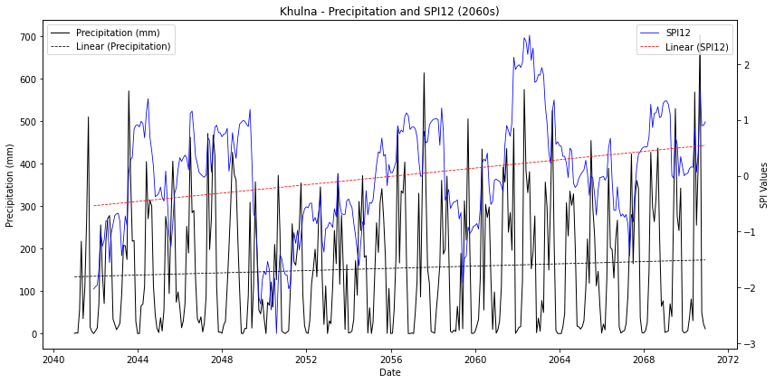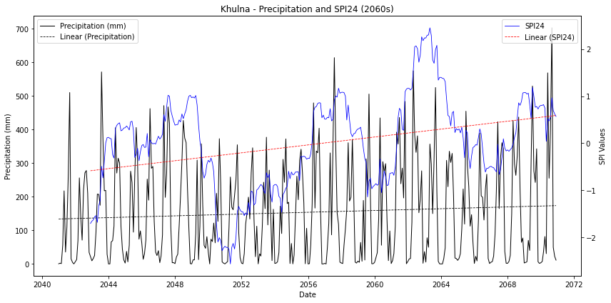
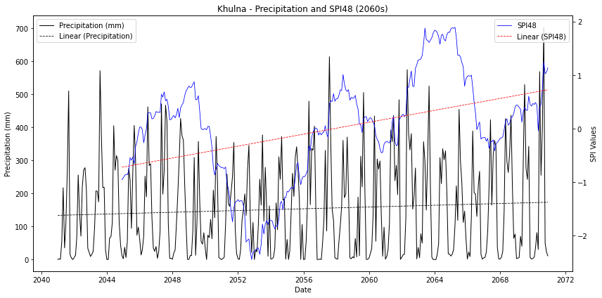
- Mongla
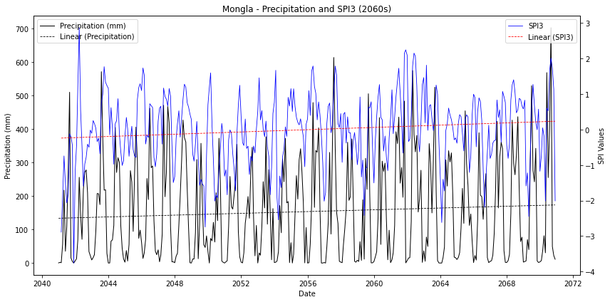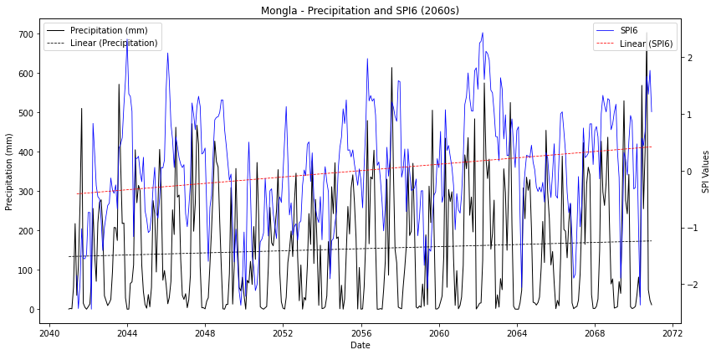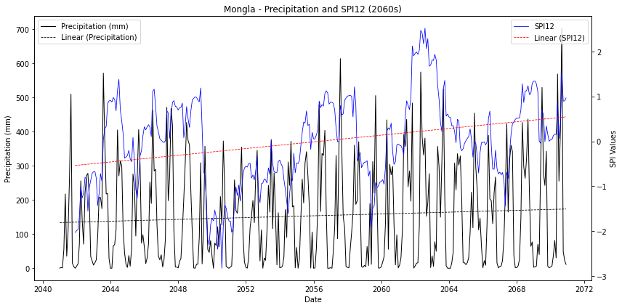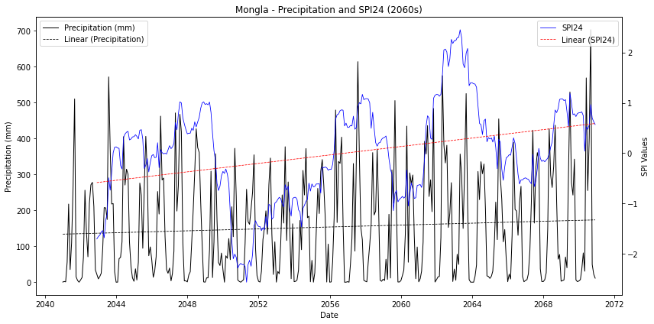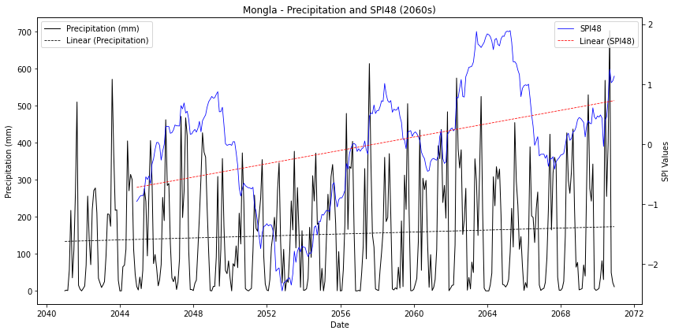
- Rangpur
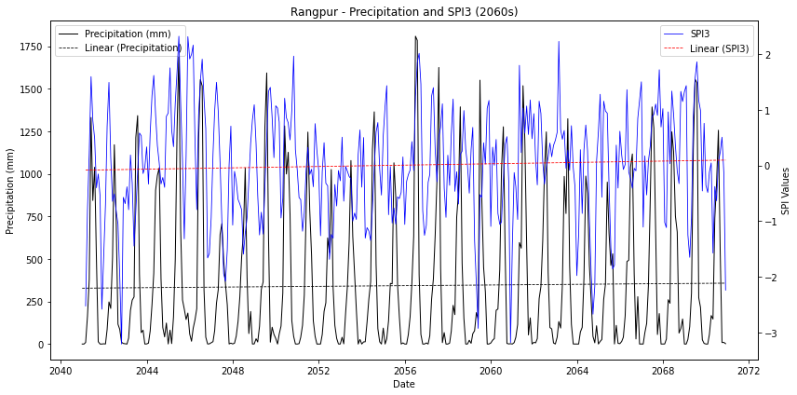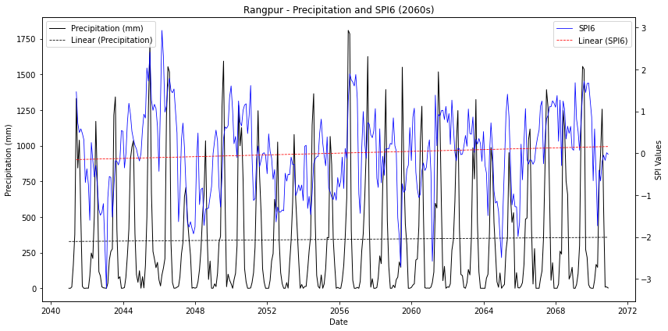
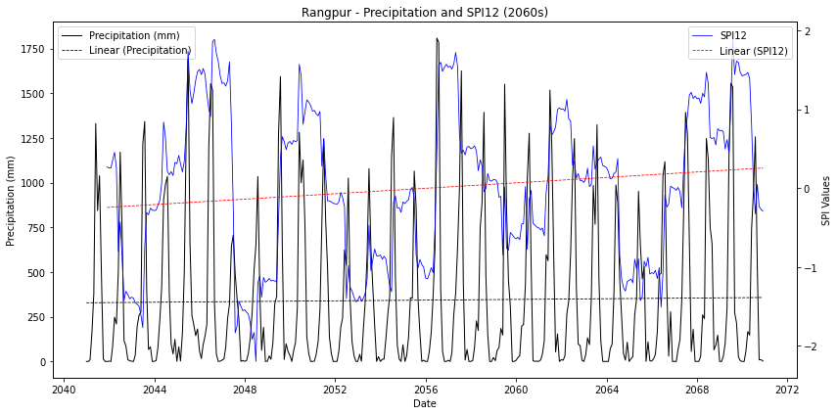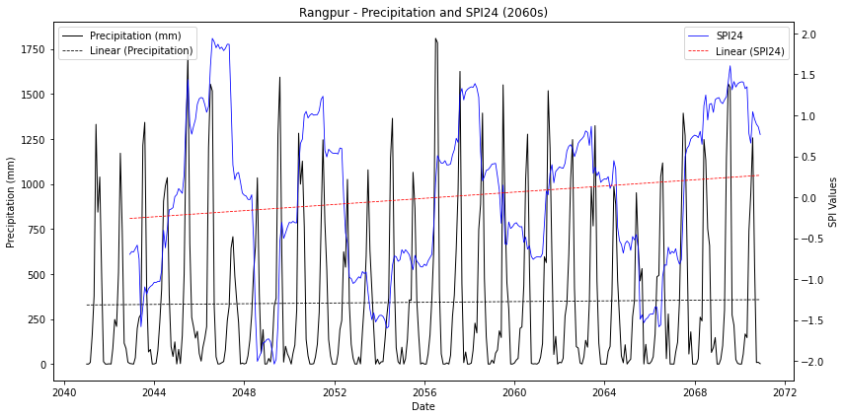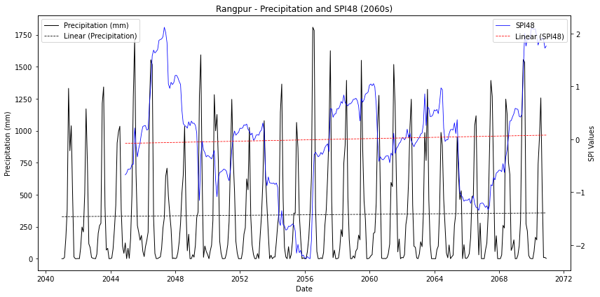
Figure S2: Precipitation and SPI (SPI3–SPI48) trends for selected BMD station under different climate scenarios: 2060s (2041–2070) (a) Dinajpur (b) Satkhira (c) Bogra (d) Ishurdi (e) Jessore (f) Khulna (g) Mongla (h) Rangpur
- Dinajpur
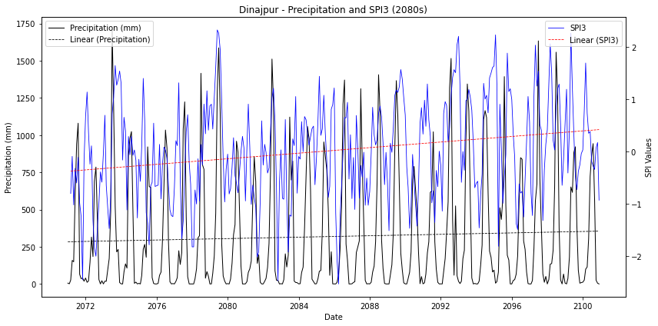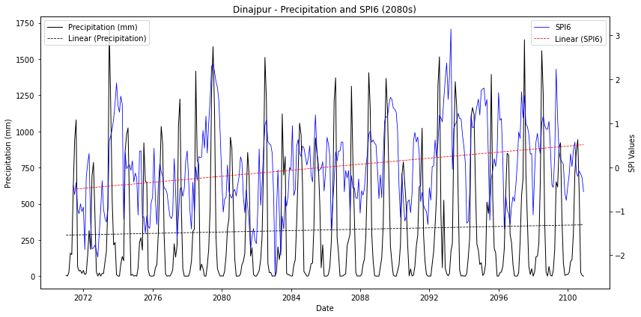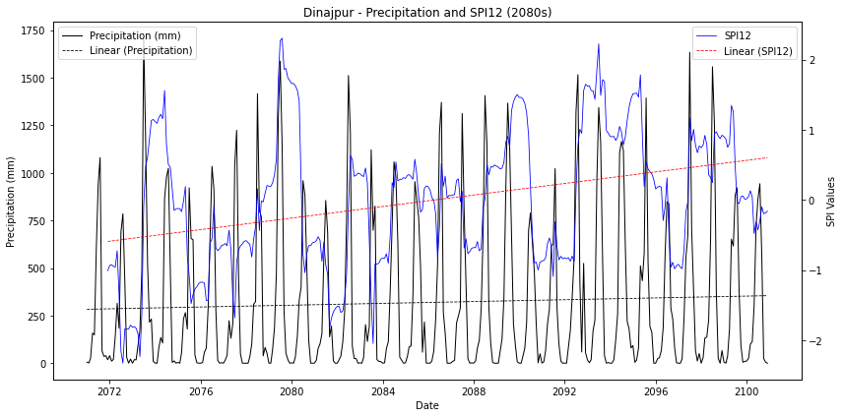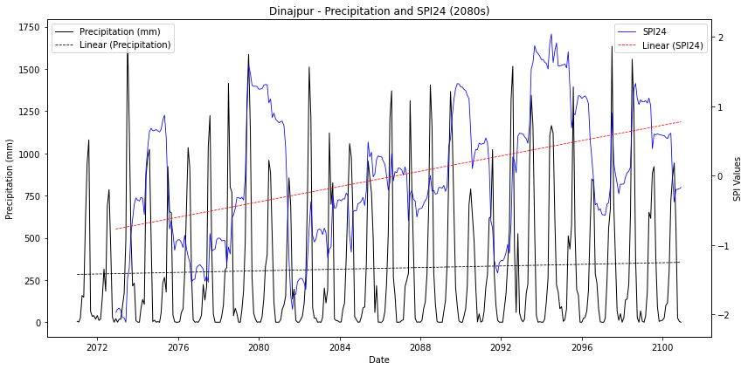
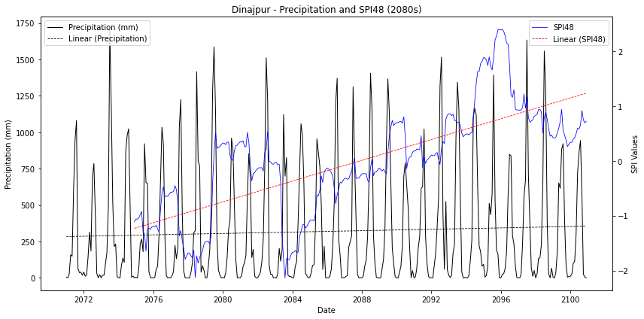
- Satkhira
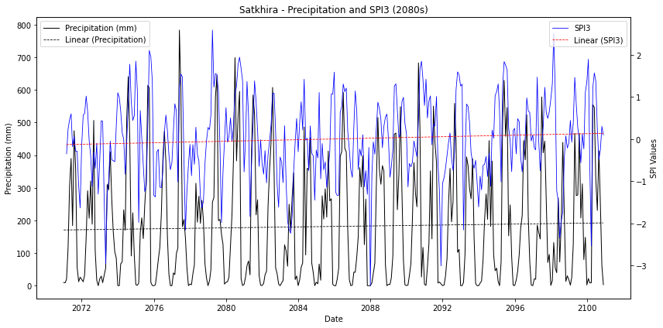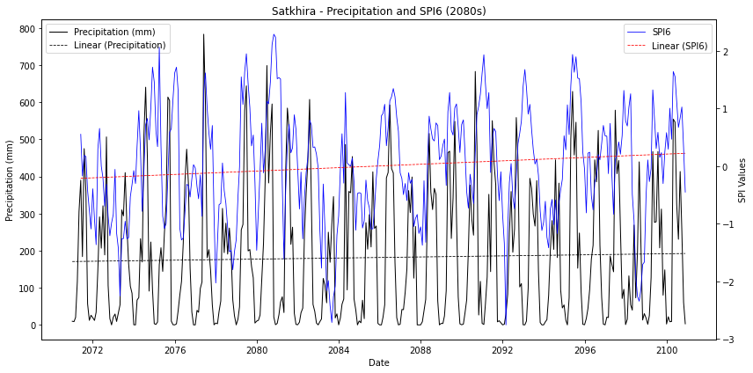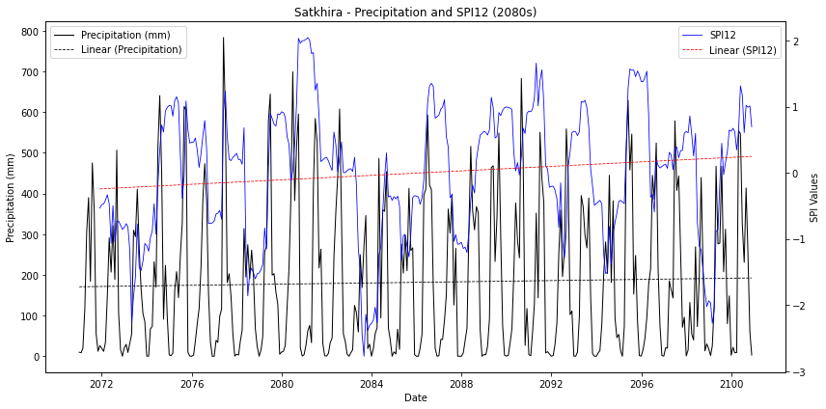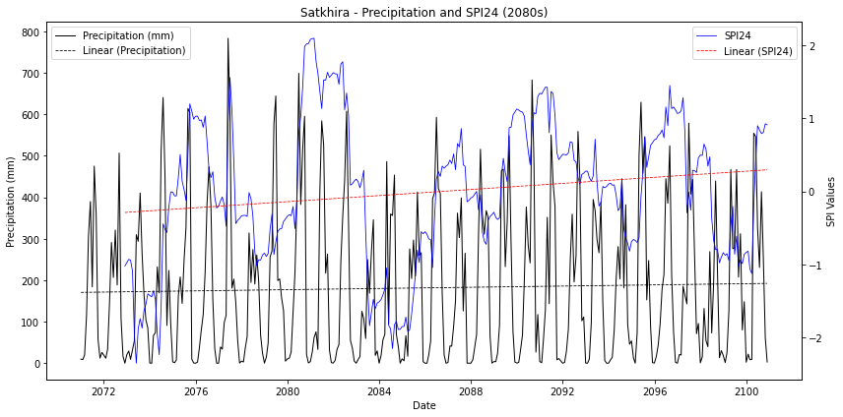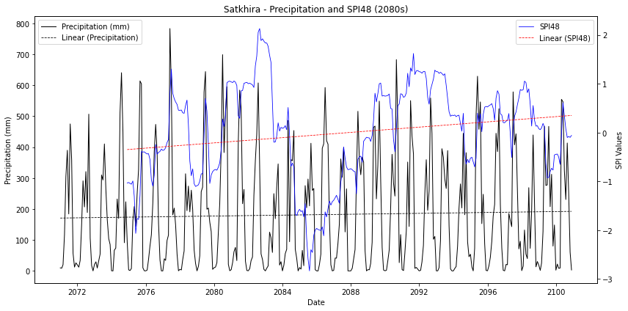
- Bogra
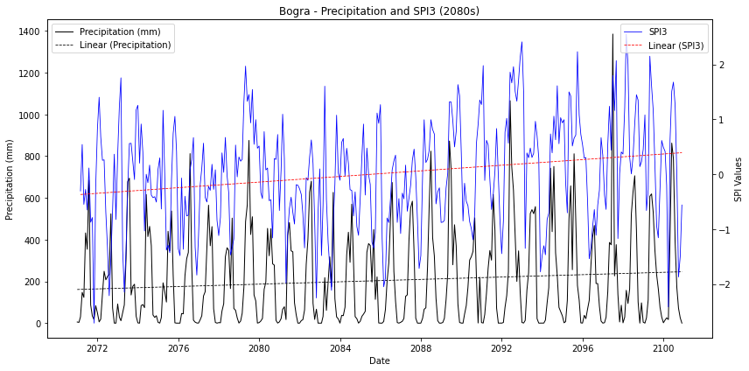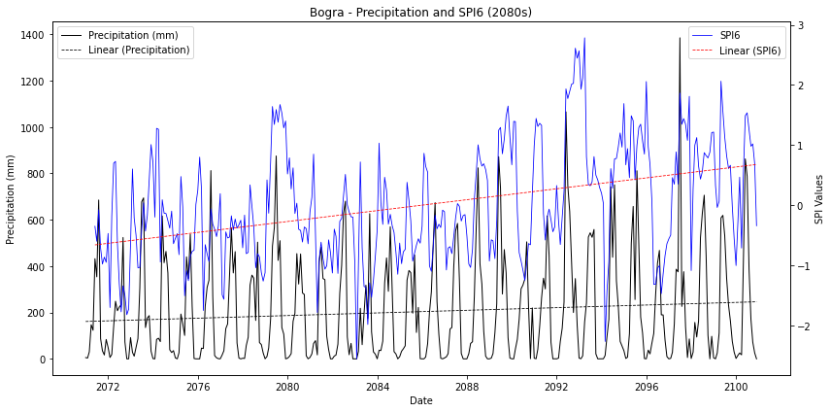
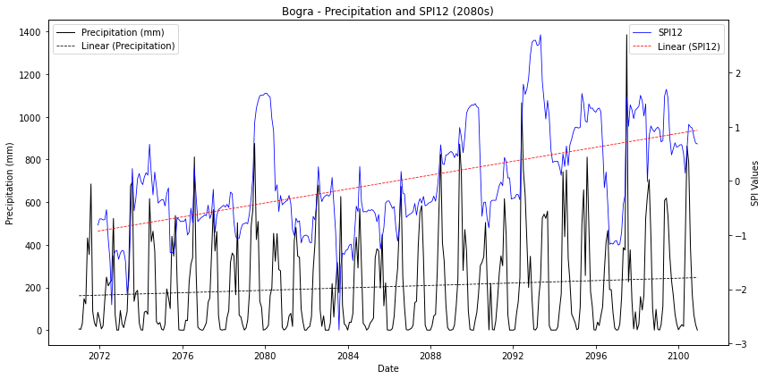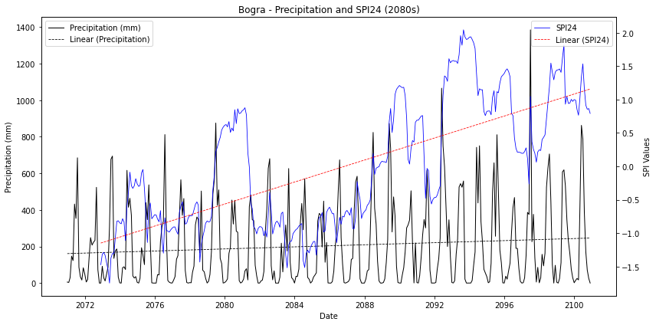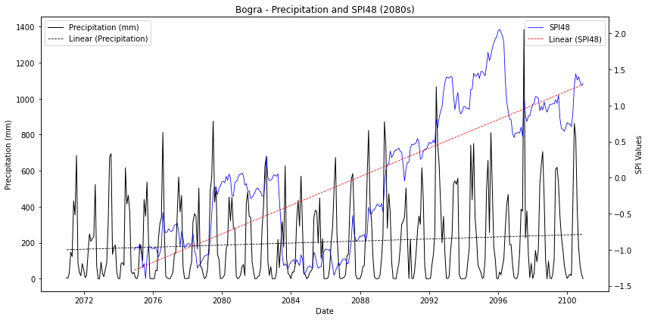
- Ishurdi
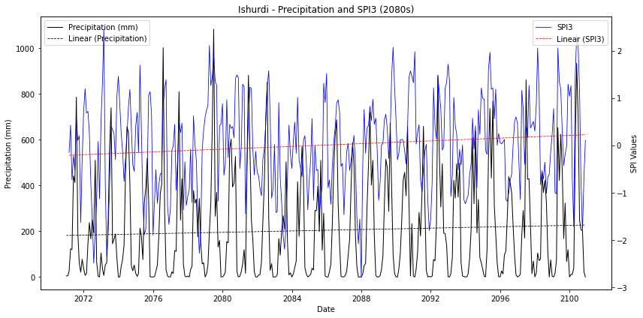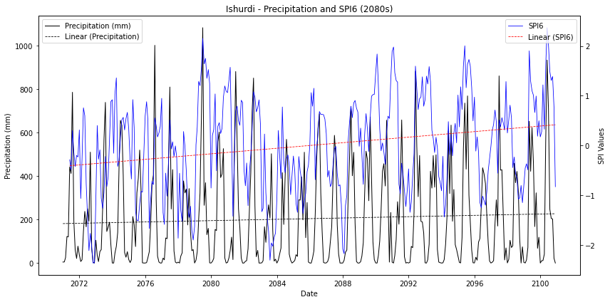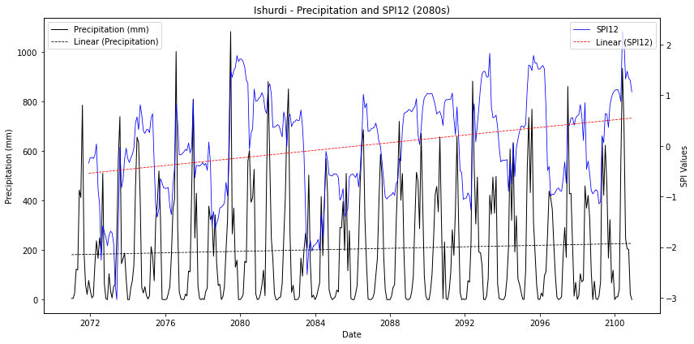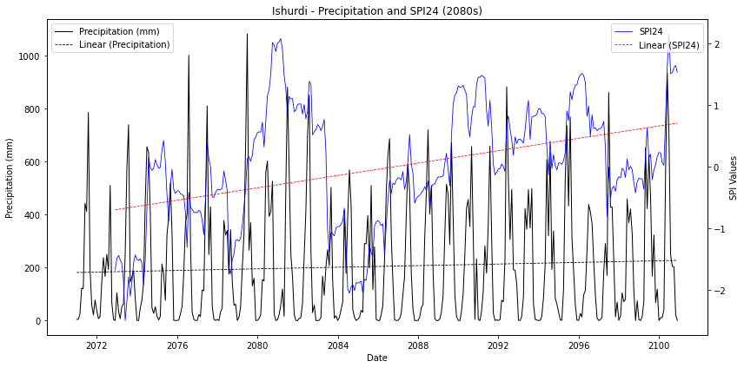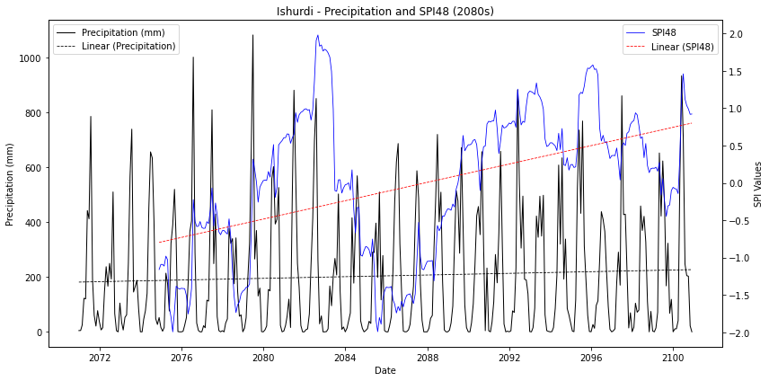

- Jessore
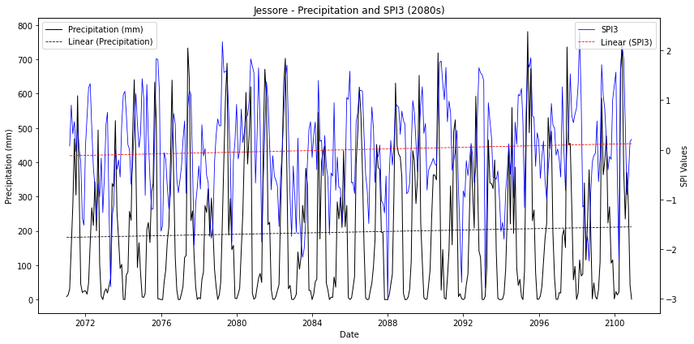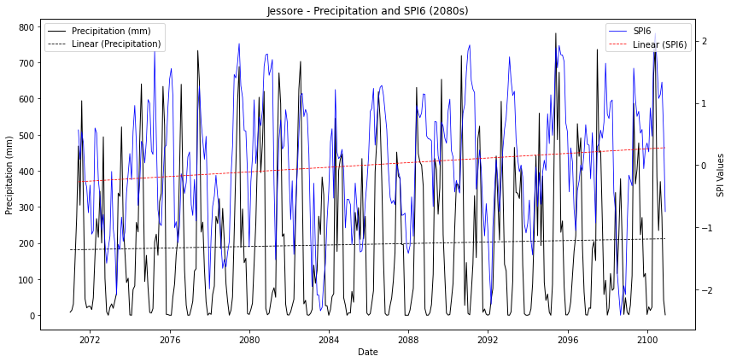
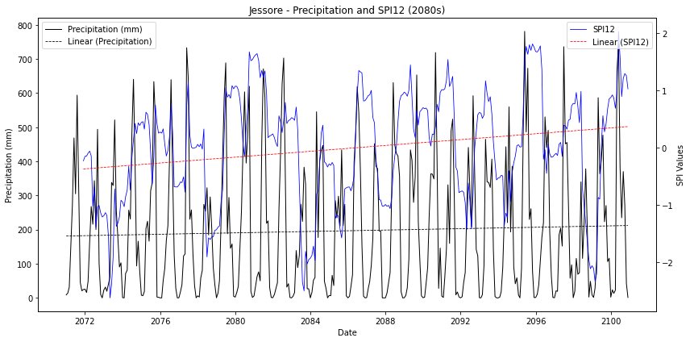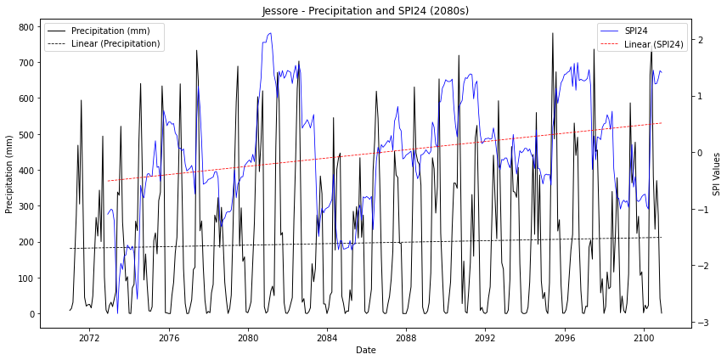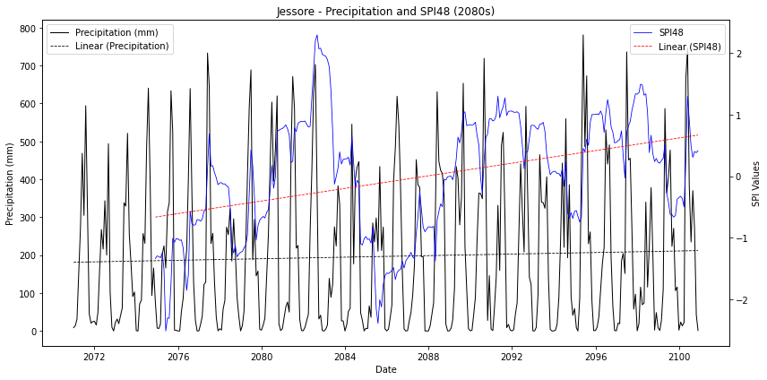

- Khulna
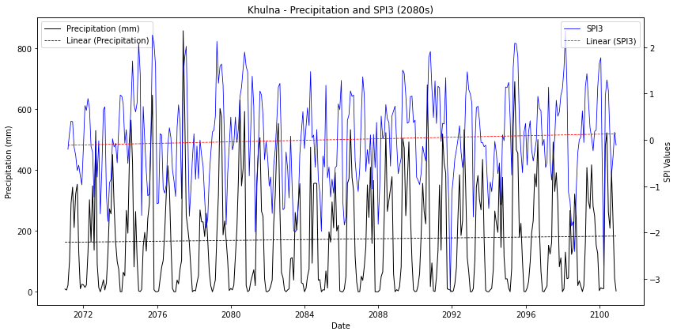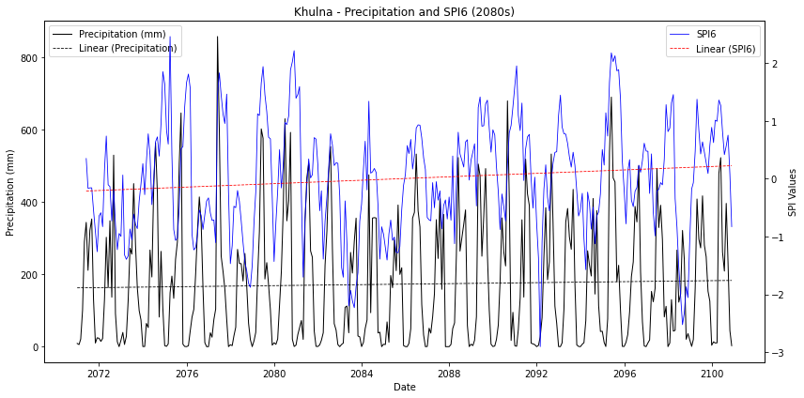
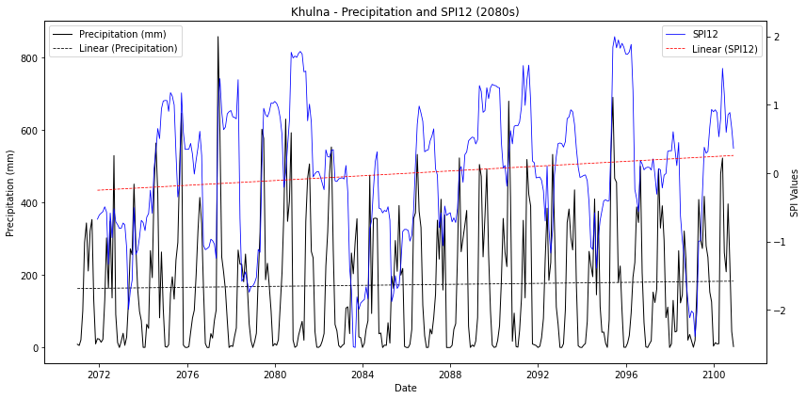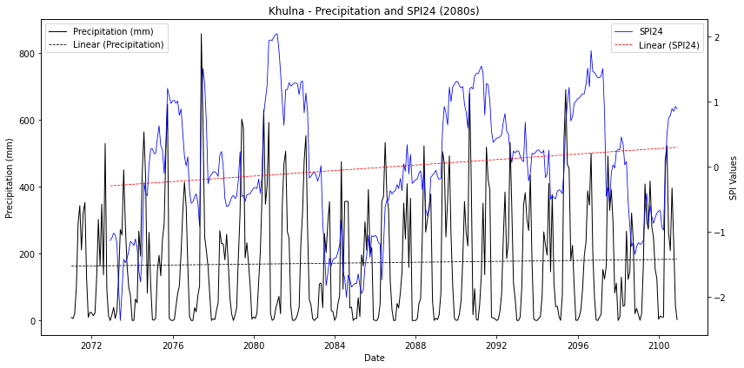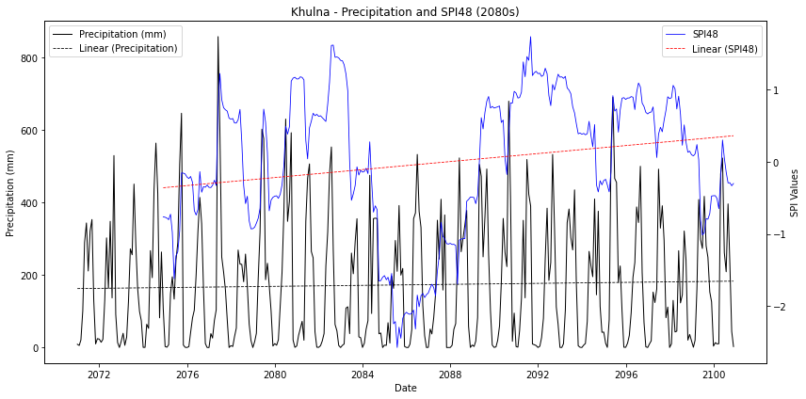
- Mongla
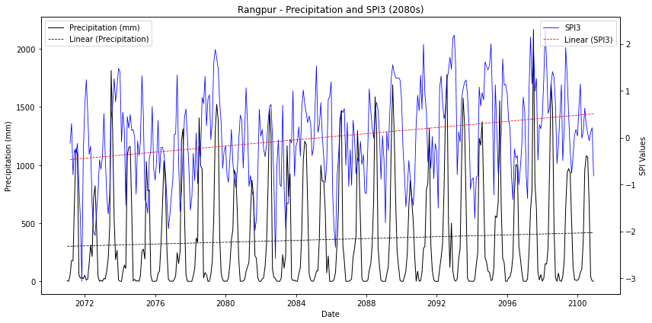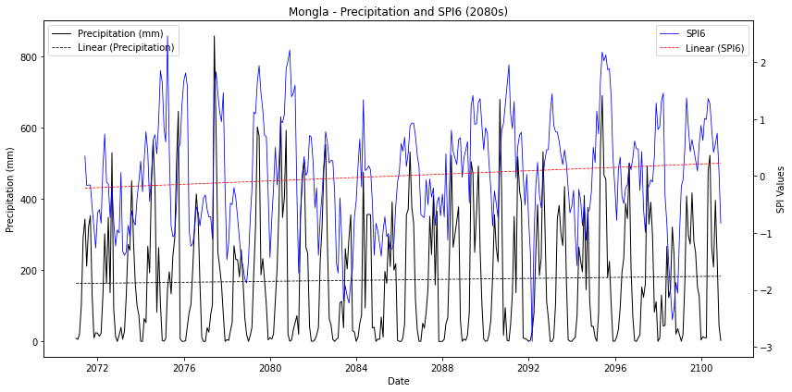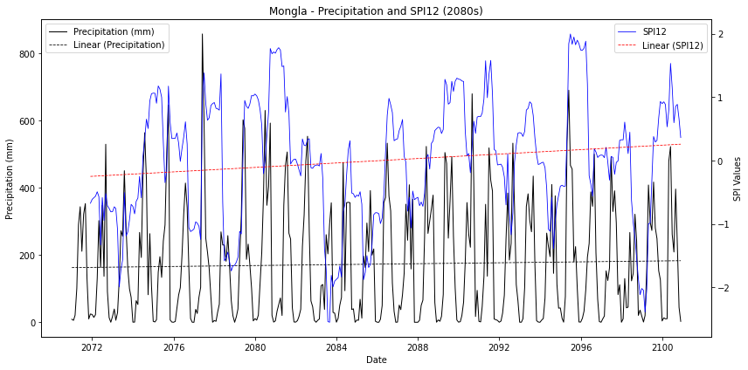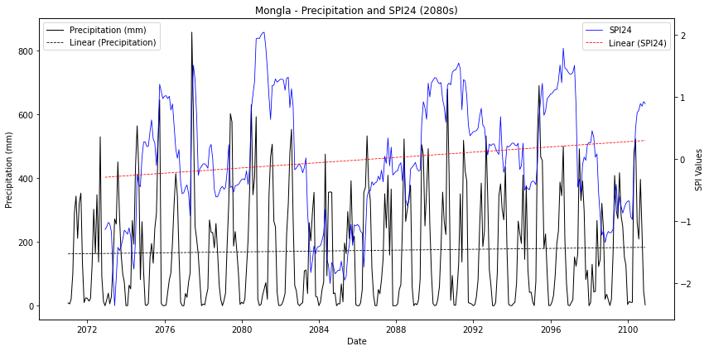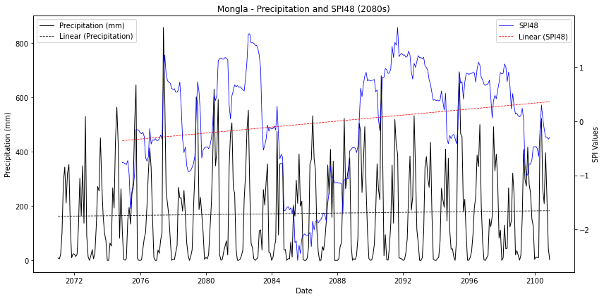

- Rangpur
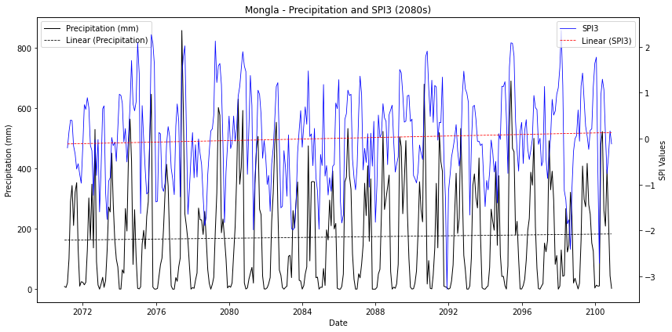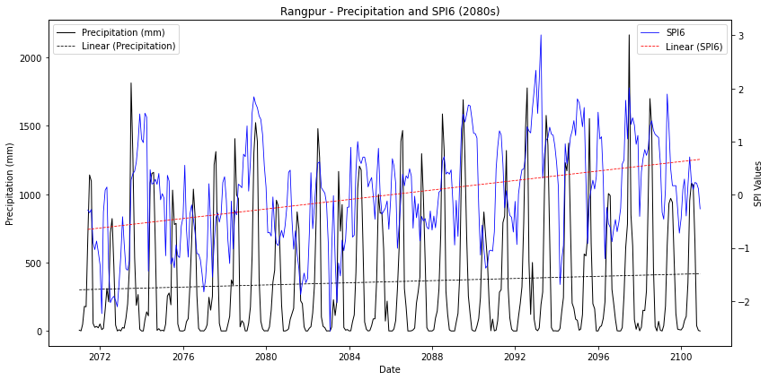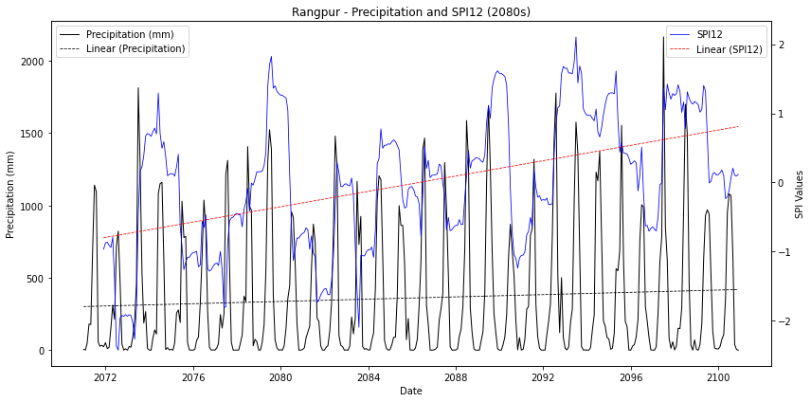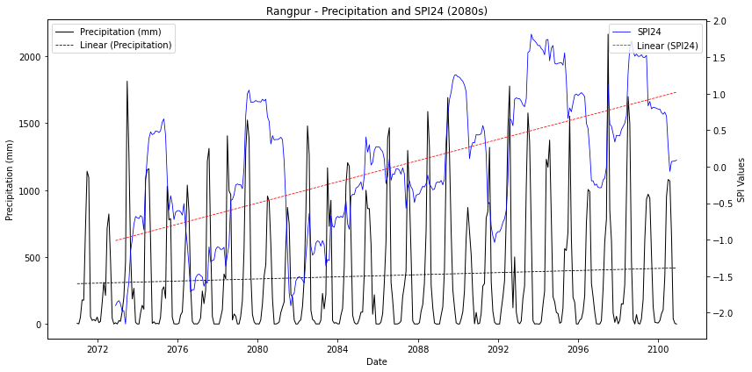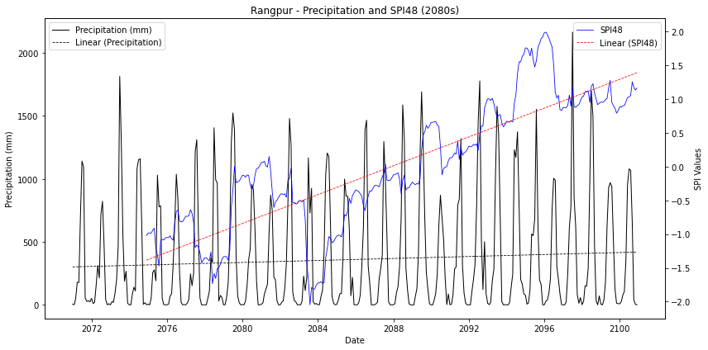
Figure S3: Precipitation and SPI (SPI3–SPI48) trends for selected BMD stations under different climate scenarios: 2080s (2071–2100) (a) Dinajpur (b) Satkhira (c) Bogra (d) Ishurdi (e) Jessore (f) Khulna (g) Mongla (h) Rangpur

Table S1: Statistical trend parameters of SPI values for all stations under the 2020s, 2060s, and 2080s scenarios.
- Dinajpur
District | SPI | Trend | Mann-Kendall p-value | Sen's Slope | Spearman R | Spearman p-value
 | 2020s
Dinajpur | SPI3 | Increasing | 0.082 | 0.001 | 0.086 | 0.08
Dinajpur | SPI6 | Increasing | 0 | 0.001 | 0.177 | 0
Dinajpur | SPI12 | Increasing | 0 | 0.002 | 0.272 | 0
Dinajpur | SPI24 | Increasing | 0 | 0.003 | 0.401 | 0
Dinajpur | SPI48 | Increasing | 0 | 0.006 | 0.653 | 0
Dinajpur | 2060s
Dinajpur | SPI3 | Increasing | 0.224 | 0.001 | 0.058 | 0.274
Dinajpur | SPI6 | Increasing | 0.078 | 0.001 | 0.087 | 0.102
Dinajpur | SPI12 | Increasing | 0.081 | 0.001 | 0.084 | 0.117
Dinajpur | SPI24 | Increasing | 0.053 | 0.001 | 0.092 | 0.091
Dinajpur | SPI48 | Decreasing | 0.009 | -0.002 | -0.129 | 0.022
Dinajpur | 2080s
Dinajpur | SPI3 | Increasing | 0 | 0.002 | 0.236 | 0
Dinajpur | SPI6 | Increasing | 0 | 0.003 | 0.312 | 0
Dinajpur | SPI12 | Increasing | 0 | 0.004 | 0.35 | 0
Dinajpur | SPI24 | Increasing | 0 | 0.005 | 0.462 | 0
Dinajpur | SPI48 | Increasing | 0 | 0.008 | 0.775 | 0

- Satkhira
District | SPI | Trend | Mann-Kendall p-value | Sen's Slope | Spearman R | Spearman p-value
 | 2020s
Satkhira | SPI3 | Decreasing | 0.062 | -0.001 | -0.092 | 0.061
Satkhira | SPI6 | Decreasing | 0.084 | -0.001 | -0.08 | 0.105
Satkhira | SPI12 | Decreasing | 0.07 | -0.001 | -0.062 | 0.21
Satkhira | SPI24 | Decreasing | 0.016 | -0.001 | -0.086 | 0.086
Satkhira | SPI48 | Decreasing | 0 | -0.004 | -0.365 | 0
Satkhira | 2060s
Satkhira | SPI3 | Increasing | 0.006 | 0.001 | 0.142 | 0.007
Satkhira | SPI6 | Increasing | 0 | 0.002 | 0.24 | 0
Satkhira | SPI12 | Increasing | 0 | 0.003 | 0.268 | 0
Satkhira | SPI24 | Increasing | 0 | 0.003 | 0.287 | 0
Satkhira | SPI48 | Increasing | 0 | 0.004 | 0.314 | 0
Satkhira | 2080s
Satkhira | SPI3 | Increasing | 0.095 | 0.001 | 0.086 | 0.103
Satkhira | SPI6 | Increasing | 0.003 | 0.002 | 0.156 | 0.003
Satkhira | SPI12 | Increasing | 0.002 | 0.002 | 0.165 | 0.002
Satkhira | SPI24 | Increasing | 0.002 | 0.002 | 0.175 | 0.001
Satkhira | SPI48 | Increasing | 0 | 0.002 | 0.207 | 0

- Bogra
District | SPI | Trend | Mann-Kendall p-value | Sen's Slope | Spearman R | Spearman p-value
 | 2020s
Bogra | SPI3 | Decreasing | 0.996 | 0 | -0.003 | 0.957
Bogra | SPI6 | Increasing | 0.909 | 0 | 0.007 | 0.892
Bogra | SPI12 | Decreasing | 0.854 | 0 | -0.012 | 0.807
Bogra | SPI24 | Decreasing | 0.238 | -0.001 | -0.051 | 0.311
Bogra | SPI48 | Increasing | 0.349 | 0.001 | 0.048 | 0.359
Bogra | 2060s
Bogra | SPI3 | Increasing | 0.023 | 0.001 | 0.127 | 0.016
Bogra | SPI6 | Increasing | 0.002 | 0.002 | 0.187 | 0
Bogra | SPI12 | Increasing | 0 | 0.002 | 0.247 | 0
Bogra | SPI24 | Increasing | 0 | 0.003 | 0.286 | 0
Bogra | SPI48 | Increasing | 0 | 0.003 | 0.385 | 0
Bogra | 2080s
Bogra | SPI3 | Increasing | 0 | 0.002 | 0.22 | 0
Bogra | SPI6 | Increasing | 0 | 0.004 | 0.397 | 0
Bogra | SPI12 | Increasing | 0 | 0.005 | 0.568 | 0
Bogra | SPI24 | Increasing | 0 | 0.007 | 0.698 | 0
Bogra | SPI48 | Increasing | 0 | 0.008 | 0.763 | 0

- Ishurdi
District | SPI | Trend | Mann-Kendall p-value | Sen's Slope | Spearman R | Spearman p-value
 | 2020s
Ishurdi | SPI3 | Increasing | 0.915 | 0 | 0.003 | 0.944
Ishurdi | SPI6 | Increasing | 0.517 | 0 | 0.039 | 0.43
Ishurdi | SPI12 | Increasing | 0.057 | 0.001 | 0.113 | 0.022
Ishurdi | SPI24 | Increasing | 0.144 | 0.001 | 0.082 | 0.101
Ishurdi | SPI48 | Increasing | 0.359 | 0 | 0.037 | 0.482
Ishurdi | 2060s
Ishurdi | SPI3 | Increasing | 0.001 | 0.002 | 0.189 | 0
Ishurdi | SPI6 | Increasing | 0 | 0.003 | 0.287 | 0
Ishurdi | SPI12 | Increasing | 0 | 0.004 | 0.378 | 0
Ishurdi | SPI24 | Increasing | 0 | 0.004 | 0.408 | 0
Ishurdi | SPI48 | Increasing | 0 | 0.004 | 0.438 | 0
Ishurdi | 2080s
Ishurdi | SPI3 | Increasing | 0.034 | 0.001 | 0.108 | 0.042
Ishurdi | SPI6 | Increasing | 0 | 0.002 | 0.228 | 0
Ishurdi | SPI12 | Increasing | 0 | 0.003 | 0.307 | 0
Ishurdi | SPI24 | Increasing | 0 | 0.004 | 0.425 | 0
Ishurdi | SPI48 | Increasing | 0 | 0.005 | 0.479 | 0

- Jessore
District | SPI | Trend | Mann-Kendall p-value | Sen's Slope | Spearman R | Spearman p-value
 | 2020s
Jessore | SPI3 | Decreasing | 0.199 | 0 | -0.066 | 0.18
Jessore | SPI6 | Decreasing | 0.171 | -0.001 | -0.06 | 0.221
Jessore | SPI12 | Decreasing | 0.115 | -0.001 | -0.042 | 0.392
Jessore | SPI24 | Decreasing | 0.031 | -0.001 | -0.05 | 0.322
Jessore | SPI48 | Decreasing | 0 | -0.004 | -0.345 | 0
Jessore | 2060s
Jessore | SPI3 | Increasing | 0.001 | 0.002 | 0.173 | 0.001
Jessore | SPI6 | Increasing | 0 | 0.003 | 0.274 | 0
Jessore | SPI12 | Increasing | 0 | 0.004 | 0.328 | 0
Jessore | SPI24 | Increasing | 0 | 0.004 | 0.349 | 0
Jessore | SPI48 | Increasing | 0 | 0.004 | 0.383 | 0
Jessore | 2080s
Jessore | SPI3 | Increasing | 0.175 | 0.001 | 0.07 | 0.184
Jessore | SPI6 | Increasing | 0.001 | 0.002 | 0.179 | 0.001
Jessore | SPI12 | Increasing | 0 | 0.002 | 0.234 | 0
Jessore | SPI24 | Increasing | 0 | 0.003 | 0.29 | 0
Jessore | SPI48 | Increasing | 0 | 0.005 | 0.419 | 0

- Khulna
District | SPI | Trend | Mann-Kendall p-value | Sen's Slope | Spearman R | Spearman p-value
 | 2020s
Khulna | SPI3 | Decreasing | 0.048 | -0.001 | -0.095 | 0.052
Khulna | SPI6 | Decreasing | 0.023 | -0.001 | -0.107 | 0.029
Khulna | SPI12 | Decreasing | 0.01 | -0.001 | -0.102 | 0.039
Khulna | SPI24 | Decreasing | 0 | -0.002 | -0.18 | 0
Khulna | SPI48 | Decreasing | 0 | -0.005 | -0.467 | 0
Khulna | 2060s
Khulna | SPI3 | Increasing | 0.007 | 0.001 | 0.142 | 0.007
Khulna | SPI6 | Increasing | 0 | 0.003 | 0.255 | 0
Khulna | SPI12 | Increasing | 0 | 0.003 | 0.295 | 0
Khulna | SPI24 | Increasing | 0 | 0.004 | 0.33 | 0
Khulna | SPI48 | Increasing | 0 | 0.005 | 0.405 | 0
Khulna | 2080s
Khulna | SPI3 | Increasing | 0.077 | 0.001 | 0.091 | 0.087
Khulna | SPI6 | Increasing | 0.001 | 0.002 | 0.17 | 0.001
Khulna | SPI12 | Increasing | 0.005 | 0.002 | 0.152 | 0.004
Khulna | SPI24 | Increasing | 0.001 | 0.002 | 0.178 | 0.001
Khulna | SPI48 | Increasing | 0.001 | 0.002 | 0.224 | 0

- Mongla
District | SPI | Trend | Mann-Kendall p-value | Sen's Slope | Spearman R | Spearman p-value
 | 2020s
Mongla | SPI3 | Decreasing | 0.048 | -0.001 | -0.095 | 0.052
Mongla | SPI6 | Decreasing | 0.023 | -0.001 | -0.107 | 0.029
Mongla | SPI12 | Decreasing | 0.01 | -0.001 | -0.102 | 0.039
Mongla | SPI24 | Decreasing | 0 | -0.002 | -0.18 | 0
Mongla | SPI48 | Decreasing | 0 | -0.005 | -0.467 | 0
Mongla | 2060s
Mongla | SPI3 | Increasing | 0.007 | 0.001 | 0.142 | 0.007
Mongla | SPI6 | Increasing | 0 | 0.003 | 0.255 | 0
Mongla | SPI12 | Increasing | 0 | 0.003 | 0.295 | 0
Mongla | SPI24 | Increasing | 0 | 0.004 | 0.33 | 0
Mongla | SPI48 | Increasing | 0 | 0.005 | 0.405 | 0
Mongla | 2080s
Mongla | SPI3 | Increasing | 0.077 | 0.001 | 0.091 | 0.087
Mongla | SPI6 | Increasing | 0.001 | 0.002 | 0.17 | 0.001
Mongla | SPI12 | Increasing | 0.005 | 0.002 | 0.152 | 0.004
Mongla | SPI24 | Increasing | 0.001 | 0.002 | 0.178 | 0.001
Mongla | SPI48 | Increasing | 0.001 | 0.002 | 0.224 | 0

- Rangpur
District | SPI | Trend | Mann-Kendall p-value | Sen's Slope | Spearman R | Spearman p-value
 | 2020s
Rangpur | SPI3 | Increasing | 0.101 | 0.001 | 0.079 | 0.107
Rangpur | SPI6 | Increasing | 0.001 | 0.001 | 0.169 | 0.001
Rangpur | SPI12 | Increasing | 0 | 0.002 | 0.256 | 0
Rangpur | SPI24 | Increasing | 0 | 0.003 | 0.378 | 0
Rangpur | SPI48 | Increasing | 0 | 0.006 | 0.667 | 0
Rangpur | 2060s
Rangpur | SPI3 | Increasing | 0.155 | 0.001 | 0.07 | 0.189
Rangpur | SPI6 | Increasing | 0.034 | 0.001 | 0.103 | 0.052
Rangpur | SPI12 | Increasing | 0.001 | 0.002 | 0.151 | 0.005
Rangpur | SPI24 | Increasing | 0 | 0.002 | 0.18 | 0.001
Rangpur | SPI48 | Increasing | 0.674 | 0 | 0.03 | 0.595
Rangpur | 2080s
Rangpur | SPI3 | Increasing | 0 | 0.003 | 0.28 | 0
Rangpur | SPI6 | Increasing | 0 | 0.004 | 0.389 | 0
Rangpur | SPI12 | Increasing | 0 | 0.005 | 0.463 | 0
Rangpur | SPI24 | Increasing | 0 | 0.006 | 0.609 | 0
Rangpur | SPI48 | Increasing | 0 | 0.009 | 0.865 | 0

- Dinajpur
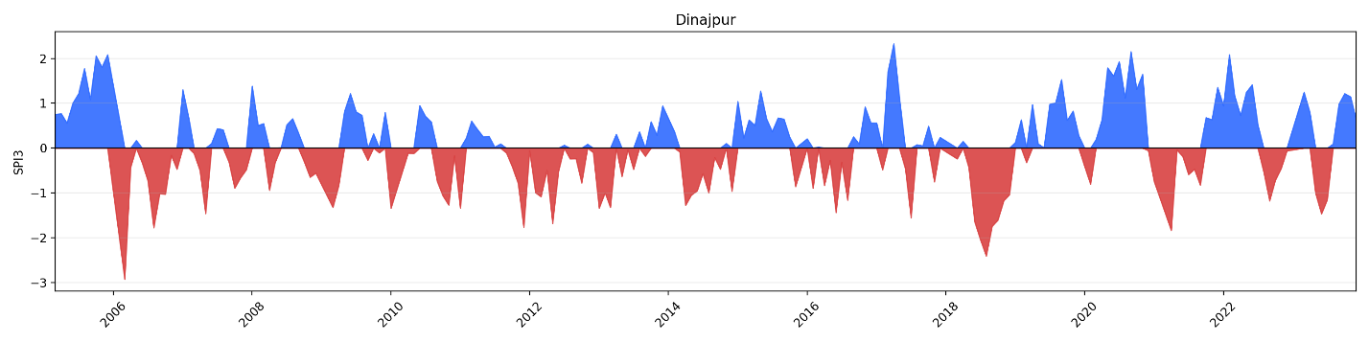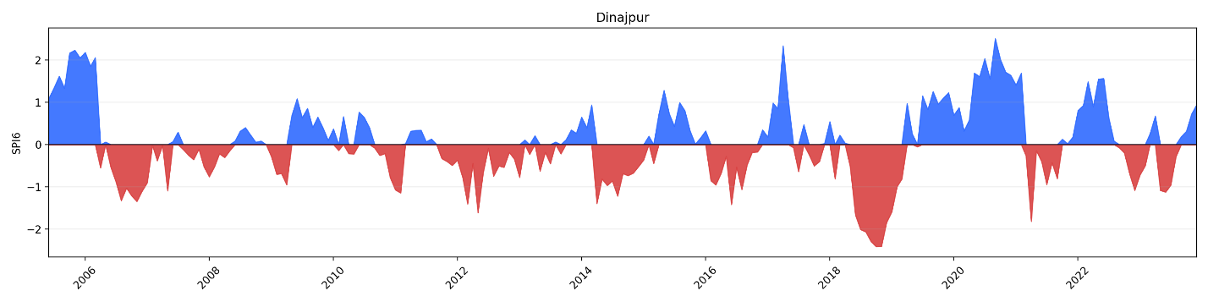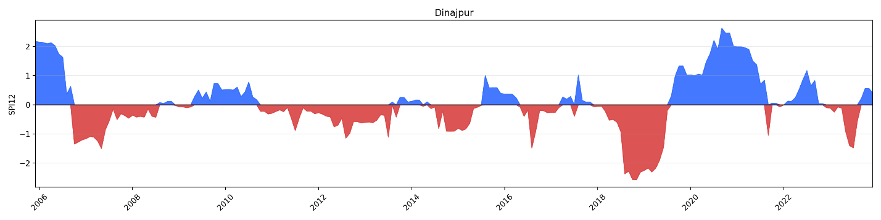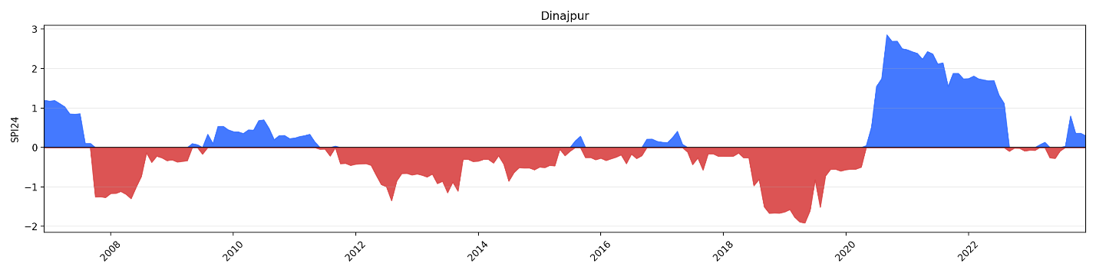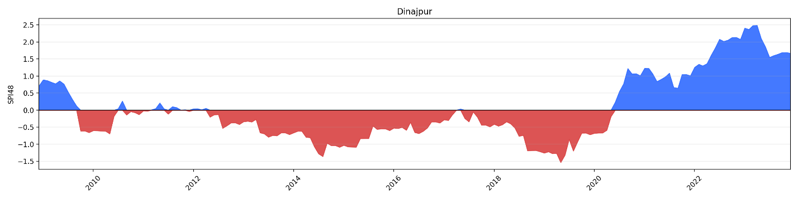
- Satkhira
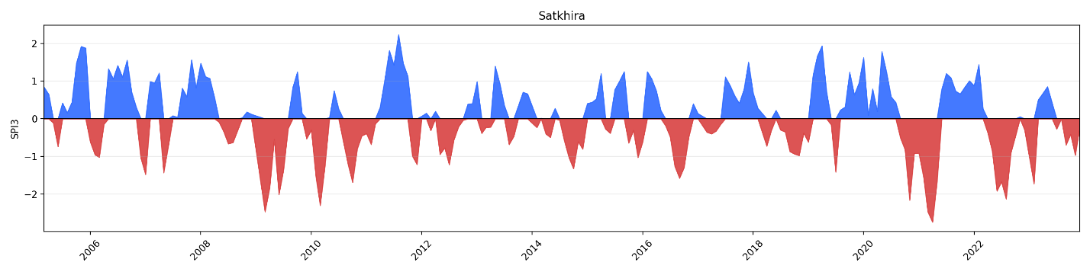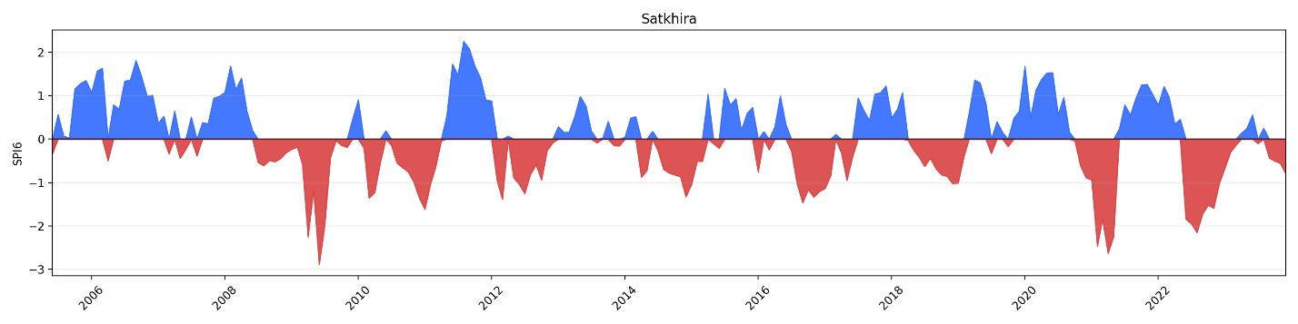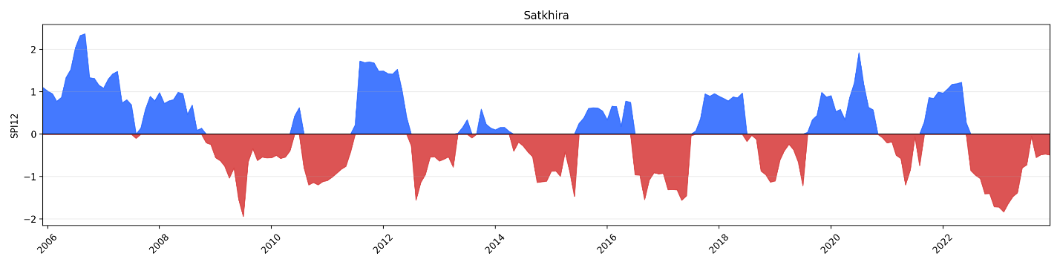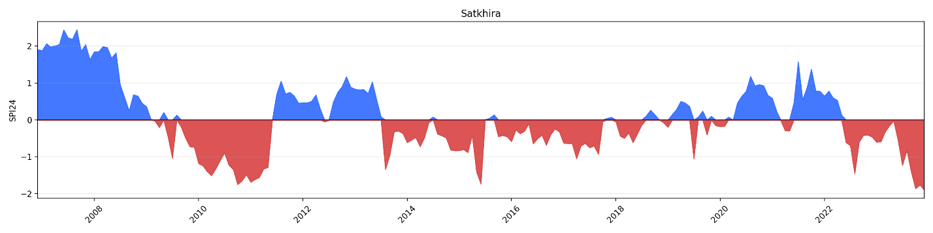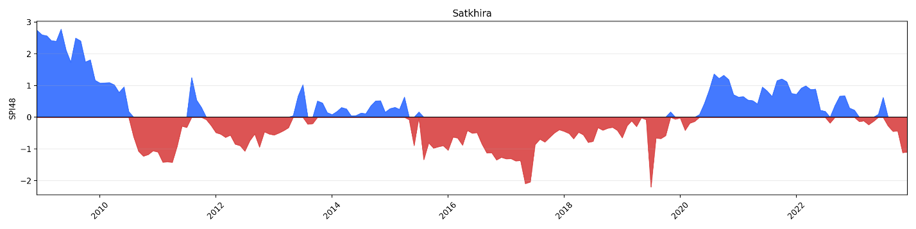
- Bogra
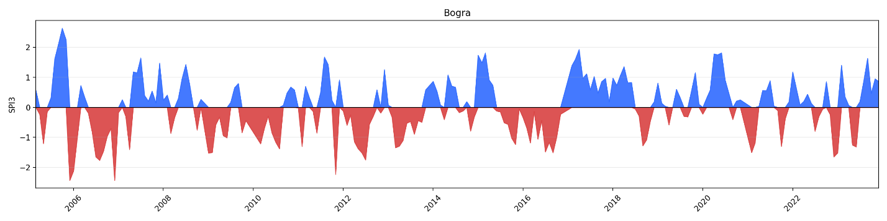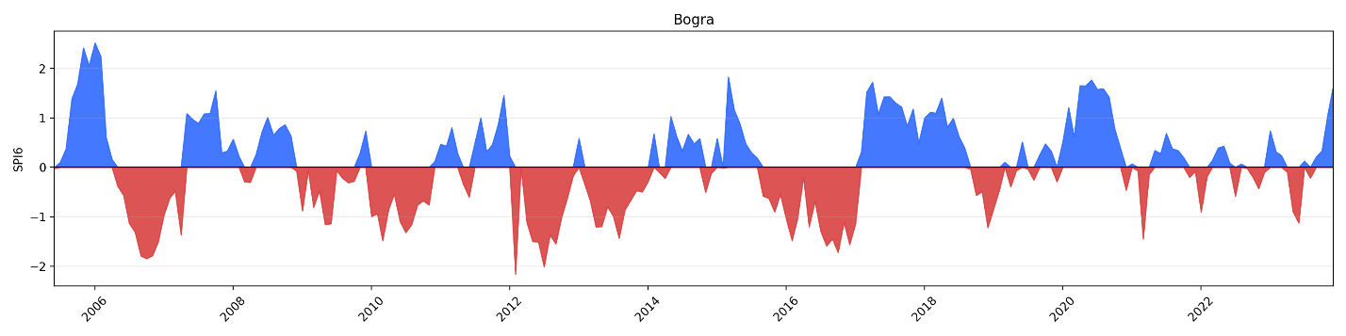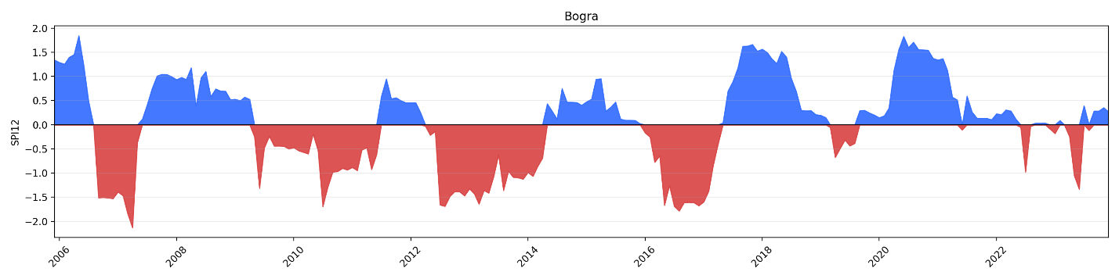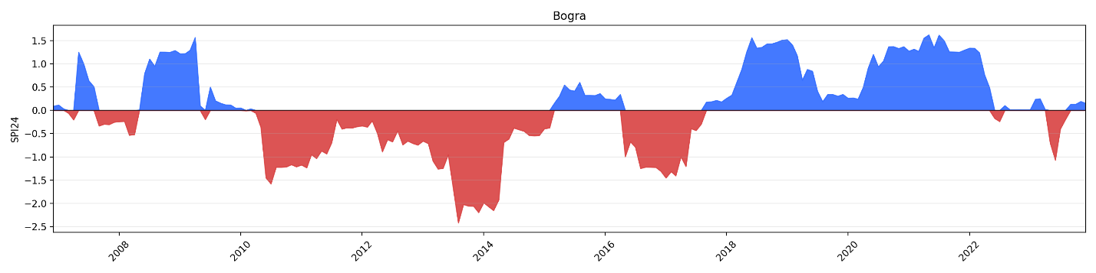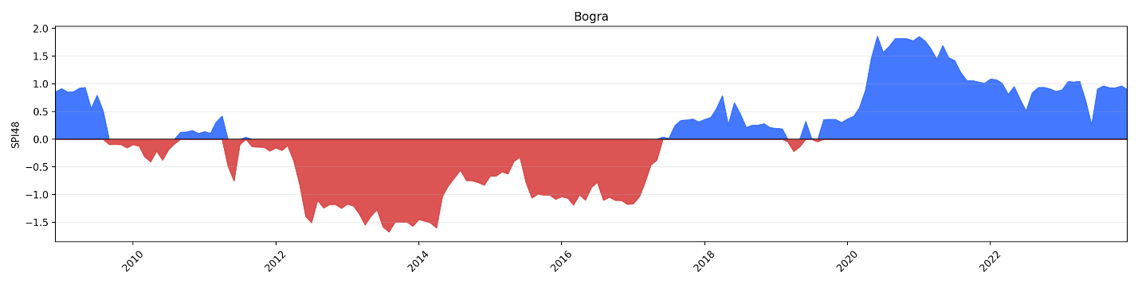
- Ishurdi
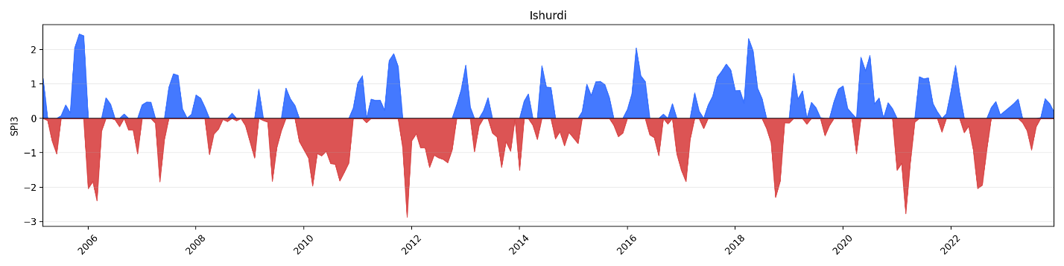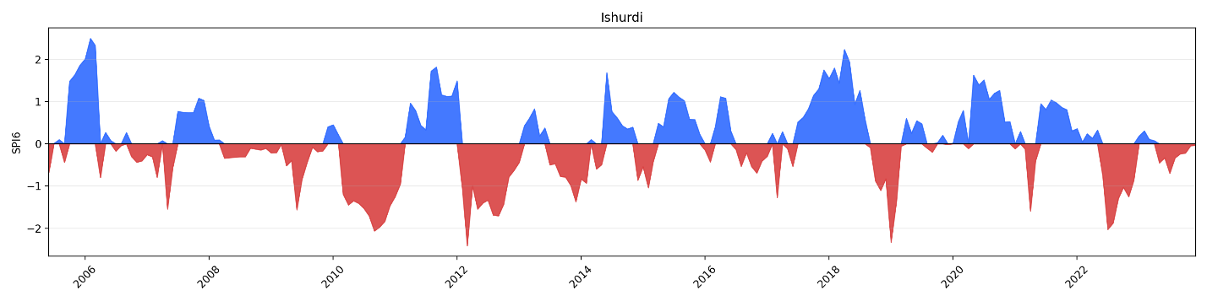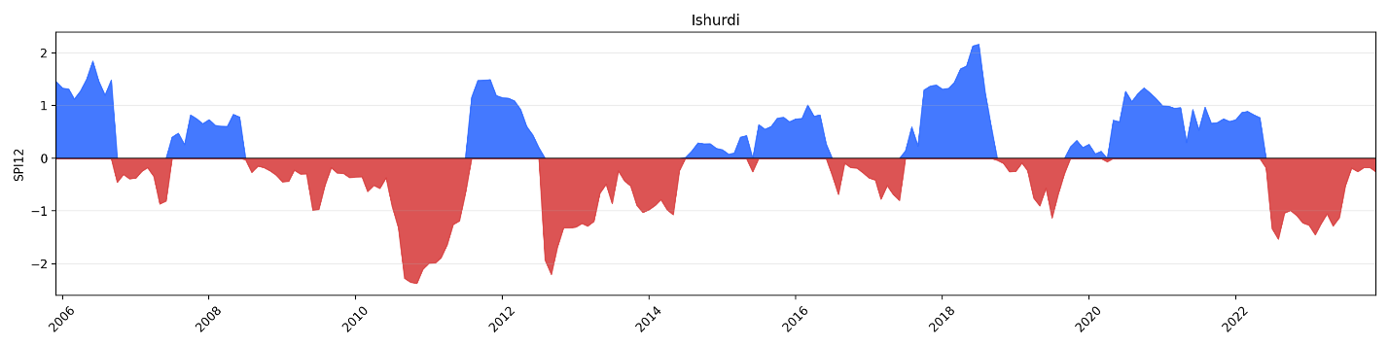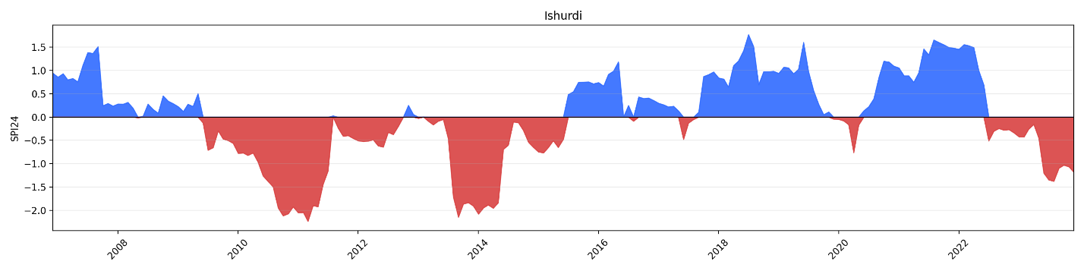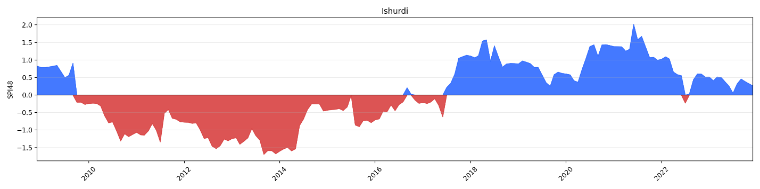
- Jessore
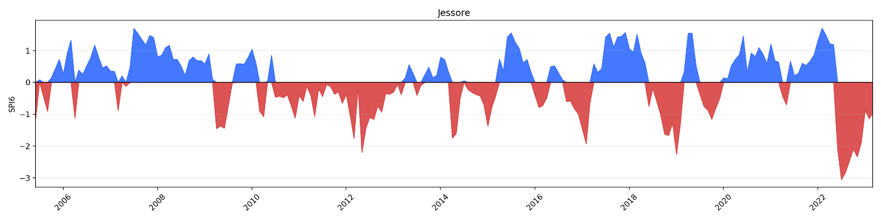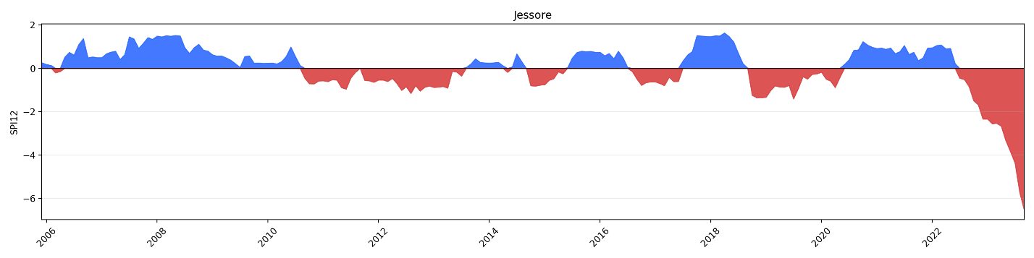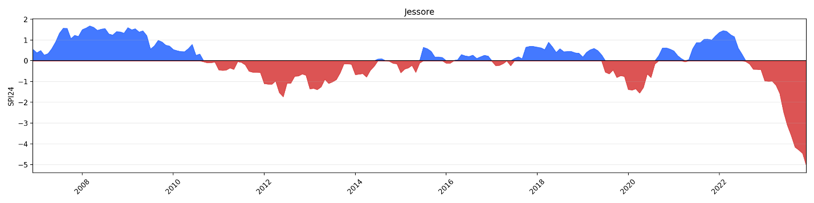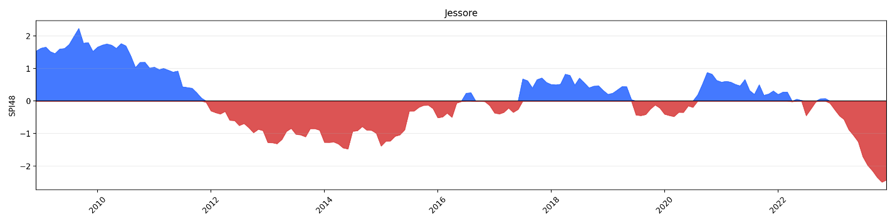
- Khulna
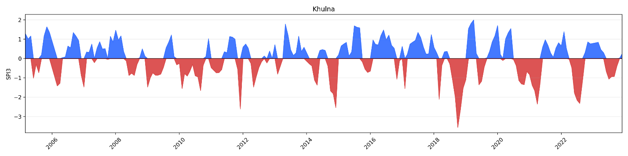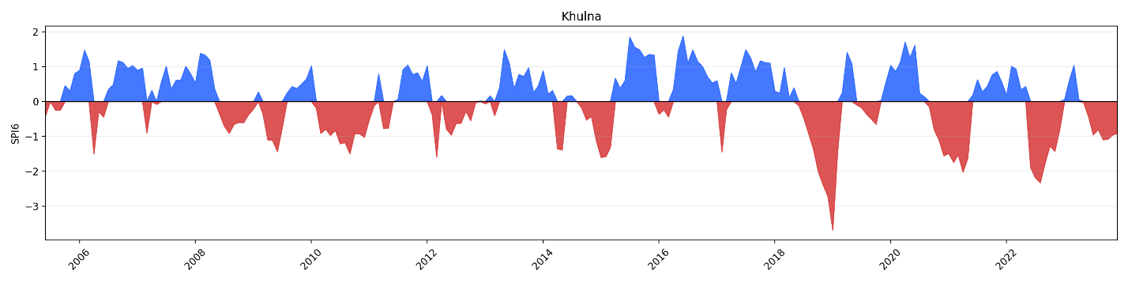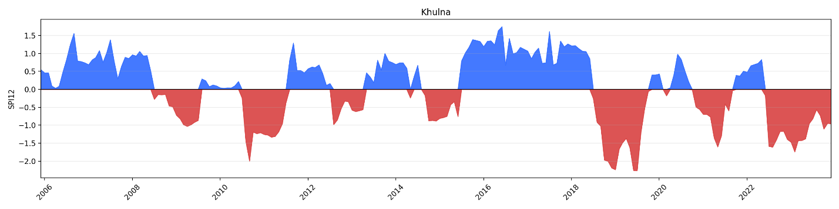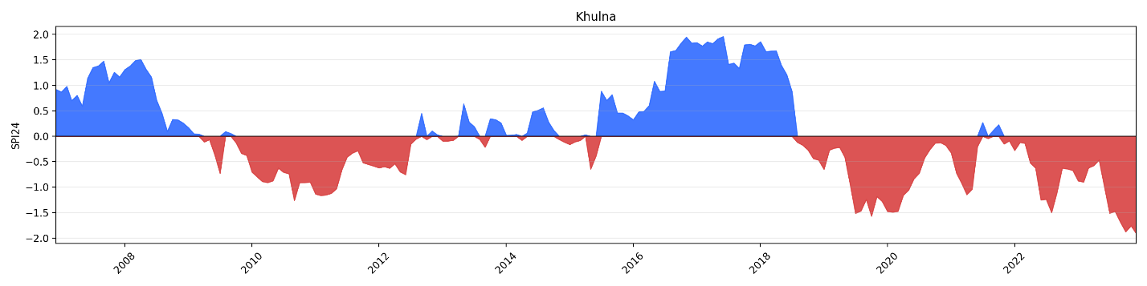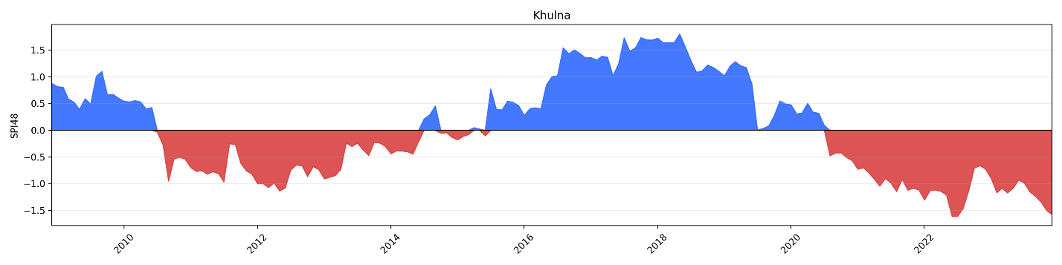
- Mongla
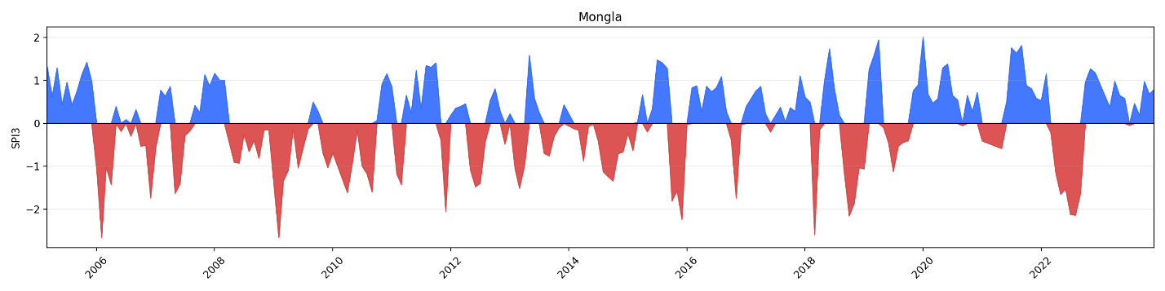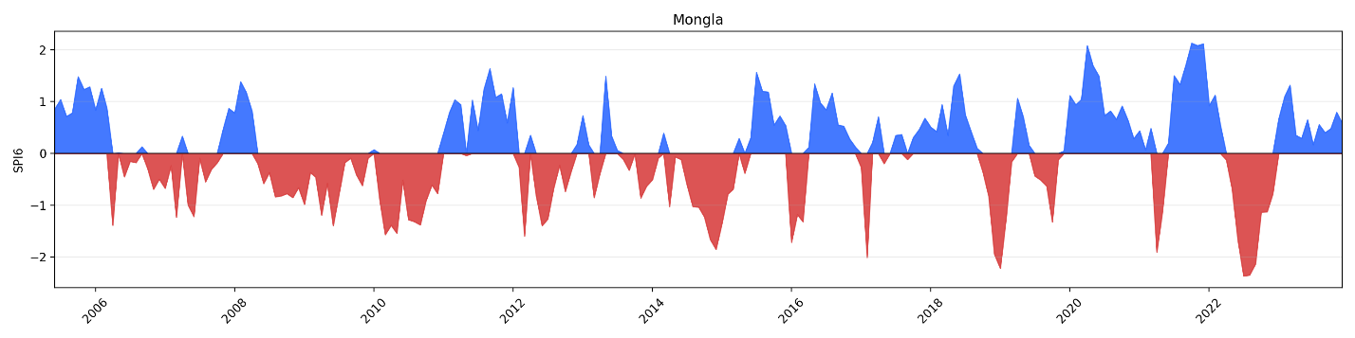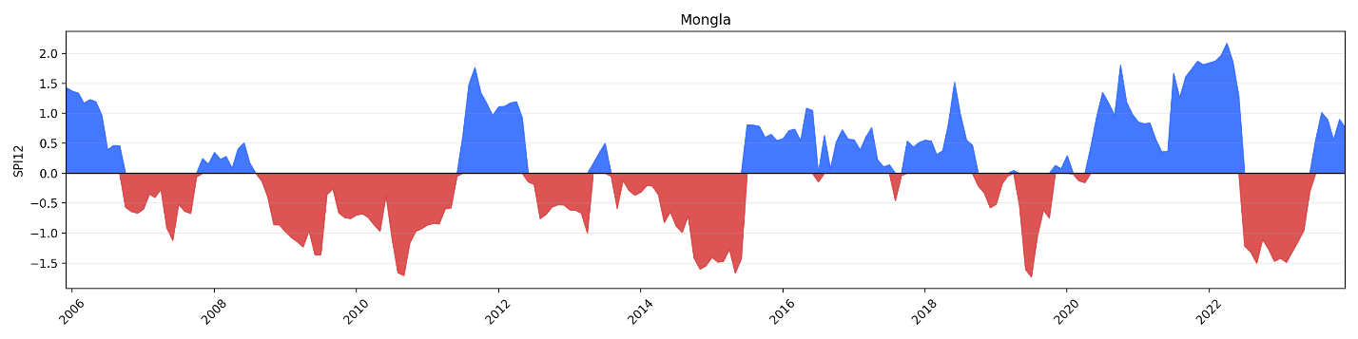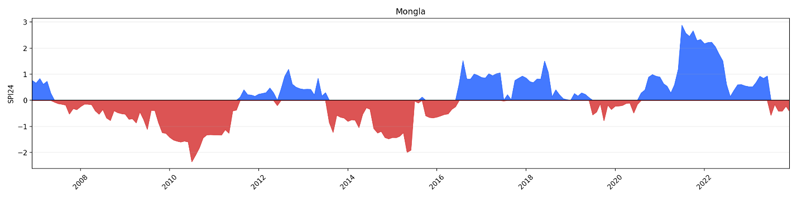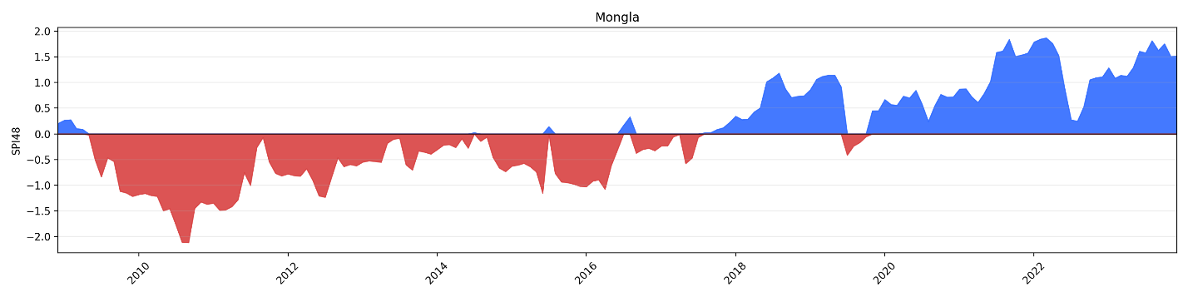
- Rangpur
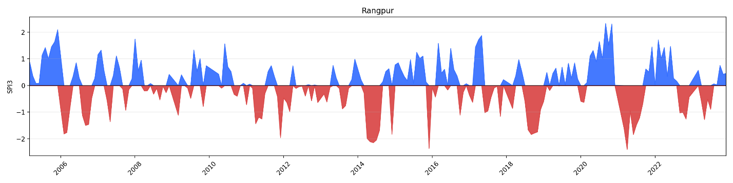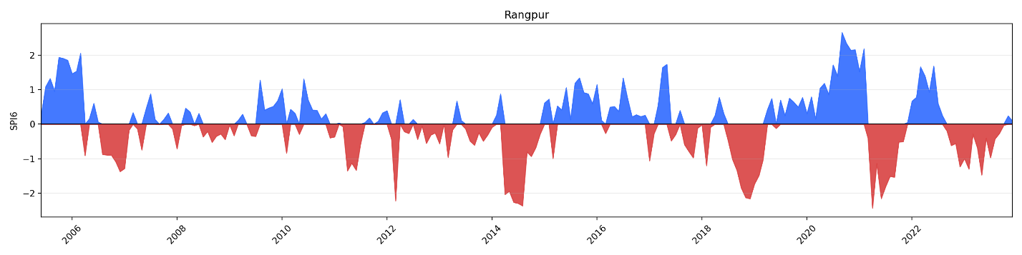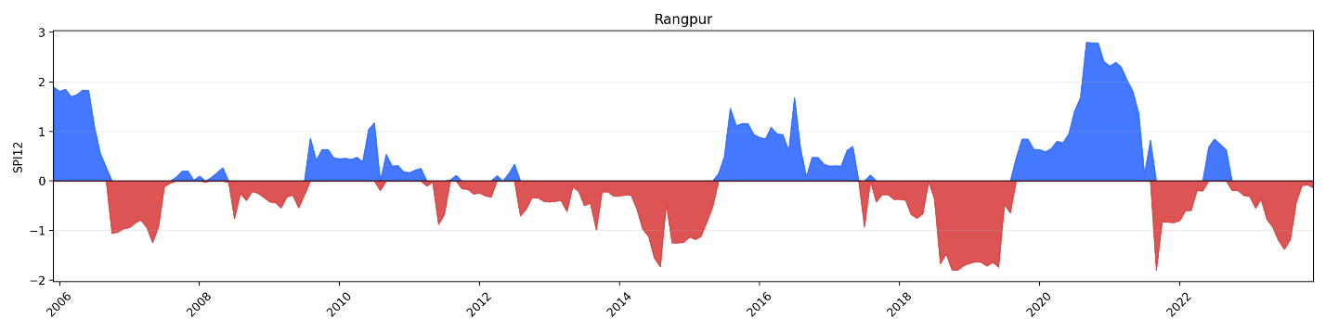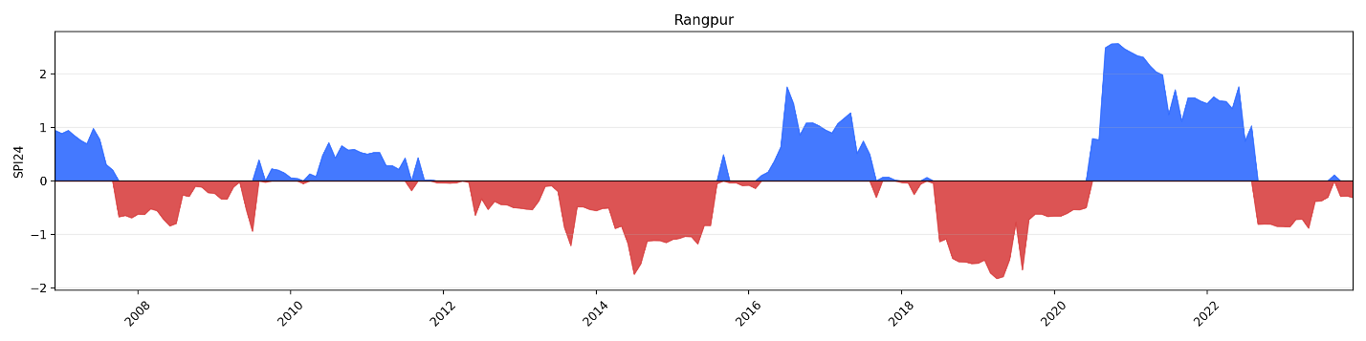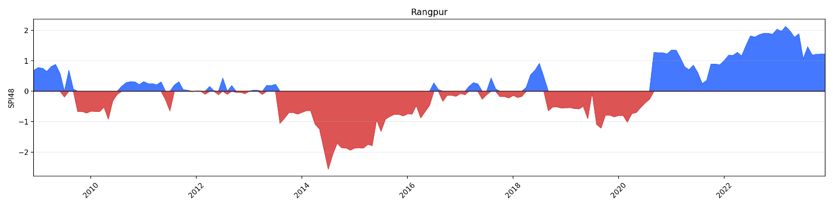
Figure S4. Standardized Precipitation Index (SPI3–SPI48) variability for selected BMD stations in Bangladesh during 2005–2023.

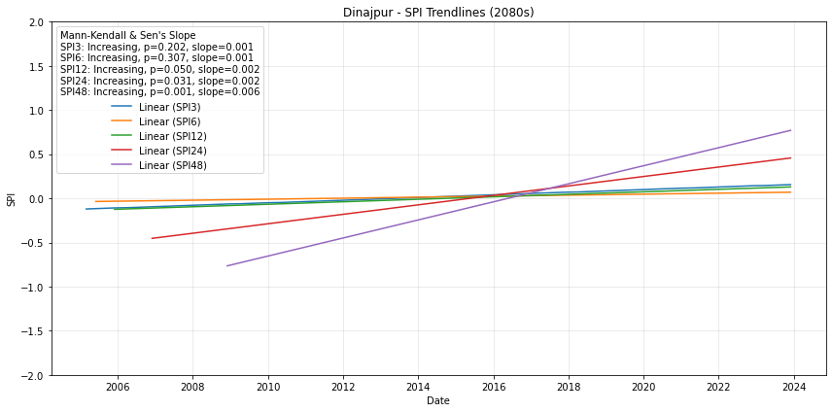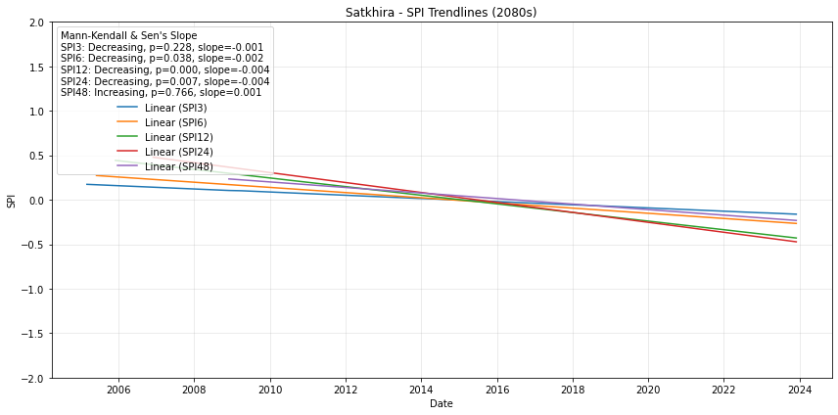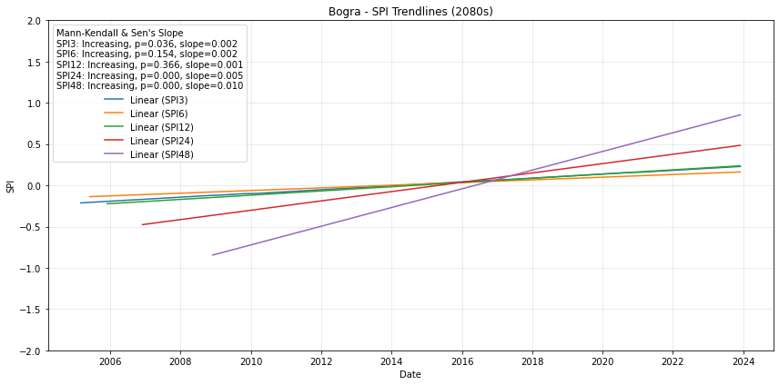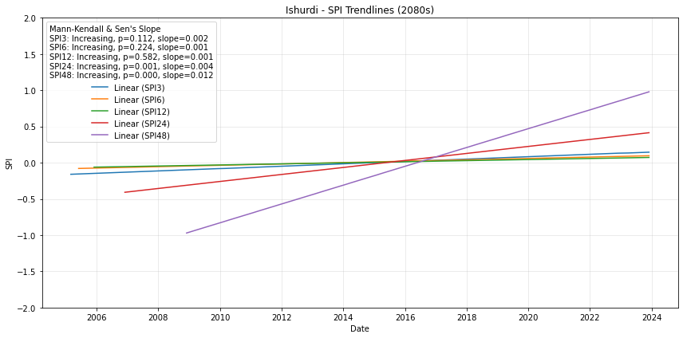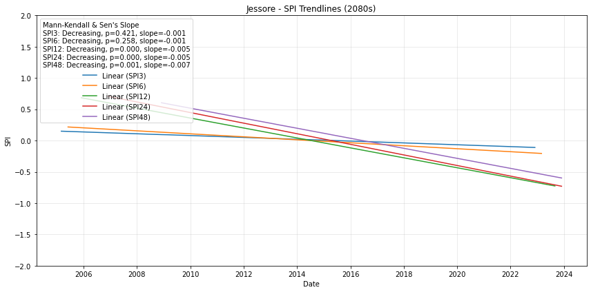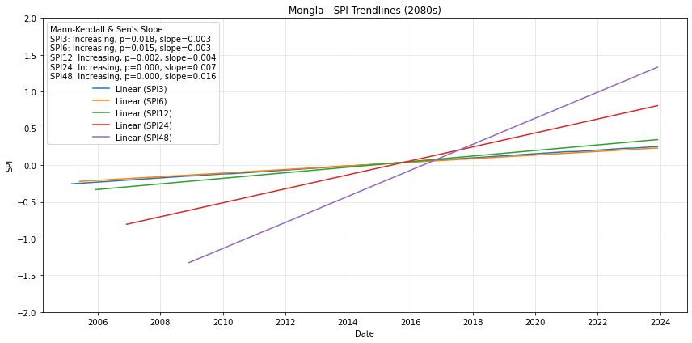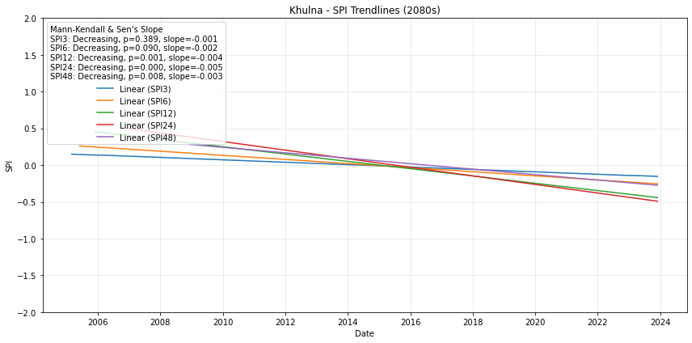
Figure S5: Observed SPI trendlines (2005–2023) for selected BMD stations at different timescales (SPI3, SPI6, SPI12, SPI24, SPI48).

