Supplements
Supplementary Tables 2
Supplementary Table 1 Associations between median LLM surprisal and demographic and syntactic confounders, before and after residualization. 2
Supplementary Table 2 Clinical and cognitive correlations with residualized median LLM surprisal before and after control for medication load 3
Supplementary Table 3 Group difference in median LLM surprisal across language models (unadjusted and residualized) 7
Supplementary Table 4 Associations between median LLM surprisal and clinical, cognitive, and language measures 8
Supplementary Table 5 Clinical correlations with median LLM surprisal after additionally residualizing for verbal IQ ( ρ | uncorrected P | n | FDR-corrected q) 10
Supplementary Table 6 Clinical and cognitive correlations with median LLM surprisal across diagnostic cohorts 12
Supplementary Table 7 Incremental predictive value of median LLM surprisal for patient–control classification 14
Supplementary Table 8 Incremental diagnostic classification performance of LLM surprisal over clinician-rated FTD scales in SSD vs. HC 17
Supplementary Table 9 System-prompt configurations used in the cross-prompt validation analysis 18
Supplementary Table 10 Robustness of group discrimination in median LLM surprisal across four system-prompt configurations 19
Supplementary Table 11 Distributional (tail) features of sentence-level surprisal versus thought-and-language measures 21
Supplementary Table 12 Tail features of sentence-level surprisal versus thought-and-language measures, controlling for the participant median 22
Supplementary Table 13 Distributional (tail) surprisal features within each diagnostic cohort. 23
Supplementary Table 14 Clinical correlations under a healthy-control reference (sensitivity analysis) 24
Supplementary Table 15 Quadratic (U-shaped) relationship between verbal IQ and median LLM surprisal. 26
Supplementary Table 16 Sensitivity of the patient-level quadratic verbal IQ term to influential observations. 26
Supplementary Figures 27
Supplementary Figure 1 Correlation with average sentence length of participants before and after residualization 27
Supplementary Figure 2 Antipsychotic dose vs. median LLM surprisal (SSD only) 28
Supplementary Figure 3 Polypharmacy Index vs. median LLM surprisal (all Patients) 29
Supplementary Figure 4 Associations between residualized LLM surprisal and clinical and cognitive measures 30
Supplementary Figure 5 Incremental value of median LLM surprisal for patient–control classification across diagnostic cohorts 31
Supplementary Figure 6 Cross model correlation of LLM surprisal 32
Supplementary Figure 7 Cross model correlation for clinical variables 33
Supplementary Figure 8 Ablation Analysis: Base vs. Instruction-Tuned Weights 34
Supplementary Figure 9 Cross prompt correlation of LLM surprisal 35
Supplementary Figure 10 Cross prompt correlation for clinical variables 36
Supplementary Figure 11 Sensitivity analysis of patient-level clinical correlations under first-word token trimming for median surprisal 37
Supplementary Figure 12 Sensitivity analysis of patient-level clinical correlations under first-word token trimming for highest 95th percentile - Surprisal 38

Supplementary Tables

Supplementary Table 1 Associations between median LLM surprisal and demographic and syntactic confounders, before and after residualization.

Confounder | ρ (unadjusted) | P (unadjusted) | ρ (residualized) | P (residualized)
Sex | -0.140 | 0.007 | -0.011 | 0.84
Age | +0.156 | 0.003 | -0.004 | 0.95
ASL | -0.556 | < 0.001 | +0.027 | 0.61
YoE | -0.304 | < 0.001 | +0.002 | 0.97
Spearman correlations between participant-level median surprisal and four candidate confounders across the full sample (N = 371), shown for the unadjusted metric and after residualizing out age, sex, YoE, and ASL by OLS. Note: Spearman for sex is effectively a rank-biserial coefficient. ρ Spearman’s rank correlation coefficient; P, corresponding p-value

Supplementary Table 2 Clinical and cognitive correlations with residualized median LLM surprisal before and after control for medication load
Cohort | Clinical Variable | n | Control Variable | resid. ρ | resid. P | Meds corrected ρ | Meds corrected P
All Patients | GAF | 187 | MedIndex Sum | -0.158 | 0.031 | -0.176 | 0.016
All Patients | HAMD-17 Total | 188 | MedIndex-Sum | 0.095 | 0.196 | 0.104 | 0.156
All Patients | Lexical Fluency | 189 | MedIndex-Sum | -0.225 | 0.002 | -0.238 | 0.001
All Patients | Abulia / Apathy | 188 | MedIndex-Sum | 0.205 | 0.005 | 0.211 | 0.004
All Patients | Affective Flattening | 136 | MedIndex-Sum | 0.104 | 0.229 | 0.11 | 0.203
All Patients | Alogia | 189 | MedIndex-Sum | 0.175 | 0.016 | 0.177 | 0.015
All Patients | Anhedonia | 187 | MedIndex-Sum | 0.093 | 0.208 | 0.096 | 0.19
All Patients | Bizarre Behavior | 187 | MedIndex-Sum | 0.187 | 0.011 | 0.154 | 0.036
All Patients | Hallucinations | 188 | MedIndex-Sum | 0.113 | 0.124 | 0.088 | 0.232
All Patients | Formal Thought Disorder | 189 | MedIndex-Sum | 0.227 | 0.002 | 0.237 | 0.001
All Patients | SAPS Total | 187 | MedIndex-Sum | 0.221 | 0.002 | 0.212 | 0.004
All Patients | Delusions | 188 | MedIndex-Sum | 0.131 | 0.073 | 0.091 | 0.214
All Patients | Semantic Fluency | 188 | MedIndex-Sum | -0.137 | 0.06 | -0.153 | 0.036
All Patients | TLI Disorganization | 182 | MedIndex-Sum | 0.152 | 0.04 | 0.149 | 0.044
All Patients | TLI Impoverished | 182 | MedIndex-Sum | 0.112 | 0.133 | 0.089 | 0.234
All Patients | TLI Non-specific | 182 | MedIndex-Sum | 0.032 | 0.663 | 0.076 | 0.31
All Patients | YMRS Total | 189 | MedIndex-Sum | 0.22 | 0.002 | 0.175 | 0.016
All Patients | Verbal IQ | 185 | MedIndex-Sum | -0.247 | 0.001 | -0.25 | 0.001
SSD | GAF | 45 | CPZ-Sum | -0.229 | 0.131 | -0.172 | 0.258
SSD | HAMD-17 Total | 45 | CPZ-Sum | 0.04 | 0.794 | -0.006 | 0.971
SSD | Lexical Fluency | 46 | CPZ-Sum | -0.197 | 0.19 | -0.183 | 0.223
SSD | Abulia / Apathy | 46 | CPZ-Sum | 0.12 | 0.427 | 0.071 | 0.639
SSD | Affective Flattening | 43 | CPZ-Sum | 0.035 | 0.824 | -0.004 | 0.98
SSD | Alogia | 46 | CPZ-Sum | -0.012 | 0.939 | -0.039 | 0.797
SSD | Anhedonia | 45 | CPZ-Sum | 0.061 | 0.692 | -0.023 | 0.881
SSD | Bizarre Behavior | 45 | CPZ-Sum | 0.192 | 0.206 | 0.134 | 0.38
SSD | Hallucinations | 45 | CPZ-Sum | 0.22 | 0.146 | 0.269 | 0.074
SSD | Formal Thought Disorder | 46 | CPZ-Sum | 0.228 | 0.128 | 0.266 | 0.074
SSD | SAPS Total | 45 | CPZ-Sum | 0.253 | 0.093 | 0.269 | 0.073
SSD | Delusions | 45 | CPZ-Sum | 0.181 | 0.233 | 0.153 | 0.317
SSD | Semantic Fluency | 46 | CPZ-Sum | 0.03 | 0.846 | 0.02 | 0.896
SSD | TLI Disorganization | 48 | CPZ-Sum | 0.164 | 0.265 | 0.171 | 0.245
SSD | TLI Impoverished | 48 | CPZ-Sum | 0.205 | 0.163 | 0.259 | 0.076
SSD | TLI Non-specific | 48 | CPZ-Sum | -0.136 | 0.358 | -0.057 | 0.699
SSD | YMRS Total | 47 | CPZ-Sum | 0.209 | 0.16 | 0.232 | 0.117
SSD | Verbal IQ | 46 | CPZ-Sum | -0.232 | 0.121 | -0.255 | 0.088
Partial Spearman correlations in patients. For the full patient sample the control variable was the general polypharmacy index (MedIndex-Sum); within the SSD subgroup it was the chlorpromazine-equivalent antipsychotic dose (CPZ-Sum). Resid. ρ / resid. P give the residualized correlation and P before medication control; Meds corrected ρ / P give the partial correlation after additionally controlling for the medication variable; n, available observations per variable. p-values are uncorrected

Supplementary Table 3 Group difference in median LLM surprisal across language models (unadjusted and residualized)
Comparison | Metric | Qwen-2.5-32B-Instruct | Qwen-2.5-7B-Instruct | LeoMistral-Hessianai- 7b
HC vs. All Patients | Unadjusted | β=0.32 [0.11, 0.52], P=0.002 | β=0.30 [0.09, 0.50], P=0.004 | β=0.33 [0.13, 0.53], P=0.001
HC vs. All Patients | Residualized | β=0.15 [-0.02, 0.33], P=0.09 | β=0.14 [-0.04, 0.33], P=0.13 | β=0.12 [-0.01, 0.25], P=0.08
HC vs. SSD | Unadjusted | β=0.80 [0.49, 1.11], P=< 0.001 | β=0.88 [0.58, 1.19], P=< 0.001 | β=0.73 [0.42, 1.05], P=< 0.001
HC vs. SSD | Residualized | β=0.49 [0.21, 0.76], P=0.002 | β=0.61 [0.32, 0.90], P=< 0.001 | β=0.32 [0.11, 0.53], P=0.009
HC vs. MDD | Unadjusted | β=0.08 [-0.14, 0.31], P=0.48 | β=0.03 [-0.19, 0.26], P=0.76 | β=0.13 [-0.10, 0.35], P=0.27
HC vs. MDD | Residualized | β=-0.02 [-0.21, 0.18], P=0.87 | β=-0.05 [-0.26, 0.15], P=0.61 | β=0.00 [-0.14, 0.15], P=0.97
HC vs. BD | Unadjusted | β=0.50 [0.10, 0.90], P=0.02 | β=0.41 [0.01, 0.80], P=0.07 | β=0.50 [0.09, 0.90], P=0.02
HC vs. BD | Residualized | β=0.39 [0.04, 0.73], P=0.04 | β=0.30 [-0.05, 0.66], P=0.14 | β=0.34 [0.08, 0.60], P=0.01
MDD vs BD | Unadjusted | β=0.42 [0.01, 0.83], P=0.07 | β=0.37 [-0.04, 0.78], P=0.07 | β=0.37 [-0.05, 0.78], P=0.12
MDD vs BD | Residualized | β=0.40 [0.05, 0.75], P=0.04 | β=0.36 [-0.01, 0.73], P=0.08 | β=0.34 [0.07, 0.61], P=0.02
MDD vs SSD | Unadjusted | β=0.72 [0.39, 1.04], P=< 0.001 | β=0.85 [0.53, 1.17], P=< 0.001 | β=0.61 [0.28, 0.93], P=< 0.001
MDD vs SSD | Residualized | β=0.50 [0.22, 0.79], P=0.002 | β=0.66 [0.37, 0.96], P=< 0.001 | β=0.32 [0.10, 0.53], P=0.01
BD vs SSD | Unadjusted | β=0.30 [-0.16, 0.76], P=0.21 | β=0.48 [0.02, 0.94], P=0.06 | β=0.24 [-0.23, 0.70], P=0.31
BD vs SSD | Residualized | β=0.10 [-0.30, 0.50], P=0.62 | β=0.31 [-0.11, 0.73], P=0.15 | β=-0.02 [-0.33, 0.28], P=0.89
Standardized beta β coefficients, 95% confidence intervals [in brackets], and P-values derived from OLS regression models comparing group differences in unadjusted and residualized median surprisal. Values are unadjusted or residualized median surprisal; residualized values were obtained by regressing out age, sex, YoE, and ASL. Positive β values denote higher residualized surprisal (lower text predictability). Estimates are shown for the primary model (Qwen2.5-32B-Instruct) and two validation models: a smaller same-family model (Qwen2.5-7B) and a German-language model (LeoMistral-Hessianai-7b). Significant results (P < 0.05) are indicated in bold. n = 178 HC, 48 SSD, 26 BD, 119 MDD. HC, healthy controls; SSD, schizophrenia spectrum disorder; BD, bipolar disorder; MDD, major depressive disorder.

Supplementary Table 4 Associations between median LLM surprisal and clinical, cognitive, and language measures

Domain | Clinical Variable | Unadjusted (ρ) | Residualized (ρ)
Mood
 | YMRS Total (Mania) | +0.34*** | +0.22**
 | HAMD-17 Total (Depression) | +0.14 | +0.09
Positive Symptoms
 | SAPS Total | +0.31*** | +0.22**
 | Formal Thought Disorder | +0.28*** | +0.23**
 | Delusions | +0.20* | +0.13
 | Hallucinations | +0.15 | +0.11
 | Bizarre Behavior | +0.12 | +0.19*
Negative Symptoms
 | Abulia / Apathy | +0.25** | +0.20*
 | Alogia | +0.24** | +0.17*
 | Affective Flattening | +0.22* | +0.10
 | Anhedonia | +0.19* | +0.09
Cognition & Language
 | Verbal IQ | -0.30*** | -0.25**
 | Lexical Fluency | -0.28*** | -0.22**
 | Semantic Fluency | -0.25** | -0.14
 | TLI Impoverished | +0.27*** | +0.11
 | TLI Disorganization | +0.08 | +0.15
 | TLI Non-specific | +0.09 | +0.03
Functioning
 | GAF | -0.24** | -0.16
Values are Spearman rank correlation coefficients (ρ) between median surprisal and each measure, computed within patients. Unadjusted, unadjusted median surprisal; Residualized, median surprisal adjusted for age, sex, YoE, and log-transformed ASL. Positive ρ indicates that higher surprisal is associated with a higher score on the measure. Significance is based on Benjamini–Hochberg FDR-corrected q values within each column: *q < 0.05, **q < 0.01, ***q < 0.001. FTD, formal thought disorder; TLI, Thought and Language Index; GAF, Global Assessment of Functioning; YMRS, Young Mania Rating Scale; HAMD-17, 17-item Hamilton Depression Rating Scale; SAPS, Scale for the Assessment of Positive Symptoms; SANS, Scale for the Assessment of Negative Symptoms.

Supplementary Table 5 Clinical correlations with median LLM surprisal after additionally residualizing for verbal IQ ( ρ | uncorrected P | n | FDR-corrected q)
Variable | Whole Cohort (unadjusted) | Whole Cohort (Residualized) | Diagnosis Main Effect | MDD Subgroup | SSD Subgroup | BD Subgroup
YMRS total | 0.34 | <0.001 | 189 | <0.001 | 0.20 | 0.007 | 181 | 0.030 | 0.09 | 0.208 | 181 | 0.535 | 0.09 | 0.339 | 112 | 0.508 | 0.14 | 0.344 | 45 | 0.620 | 0.15 | 0.491 | 24 | 0.692
SAPS total | 0.31 | <0.001 | 187 | <0.001 | 0.23 | 0.002 | 179 | 0.027 | 0.12 | 0.117 | 179 | 0.350 | 0.14 | 0.154 | 112 | 0.308 | 0.24 | 0.122 | 43 | 0.592 | 0.14 | 0.500 | 24 | 0.692
Verbal IQ | -0.30 | <0.001 | 185 | <0.001 | -0.05 | 0.467 | 185 | 0.494 | -0.06 | 0.420 | 185 | 0.630 | -0.07 | 0.450 | 115 | 0.623 | -0.10 | 0.514 | 46 | 0.737 | 0.20 | 0.345 | 24 | 0.675
SAPS positive FTD | 0.28 | <0.001 | 189 | <0.001 | 0.22 | 0.003 | 181 | 0.027 | 0.14 | 0.064 | 181 | 0.350 | 0.15 | 0.124 | 113 | 0.279 | 0.19 | 0.220 | 44 | 0.592 | 0.13 | 0.544 | 24 | 0.700
Lexical verbal fluency | -0.28 | <0.001 | 189 | <0.001 | -0.15 | 0.037 | 185 | 0.094 | -0.12 | 0.090 | 185 | 0.350 | -0.17 | 0.076 | 115 | 0.253 | -0.23 | 0.125 | 46 | 0.592 | 0.29 | 0.163 | 24 | 0.675
TLI impoverished | 0.27 | <0.001 | 182 | <0.001 | 0.10 | 0.172 | 174 | 0.248 | 0.07 | 0.372 | 174 | 0.630 | 0.16 | 0.098 | 104 | 0.253 | 0.21 | 0.169 | 46 | 0.592 | -0.43 | 0.036 | 24 | 0.650
Semantic verbal fluency | -0.25 | <0.001 | 188 | 0.001 | -0.10 | 0.183 | 184 | 0.248 | -0.03 | 0.712 | 184 | 0.712 | -0.12 | 0.218 | 114 | 0.362 | 0.03 | 0.839 | 46 | 0.920 | 0.22 | 0.313 | 24 | 0.675
SANS abulia/apathy | 0.25 | <0.001 | 188 | 0.001 | 0.20 | 0.006 | 180 | 0.030 | 0.12 | 0.099 | 180 | 0.350 | 0.25 | 0.008 | 112 | 0.136 | 0.12 | 0.442 | 44 | 0.724 | -0.19 | 0.375 | 24 | 0.675
GAF | -0.24 | <0.001 | 187 | 0.002 | -0.15 | 0.049 | 179 | 0.097 | -0.05 | 0.475 | 179 | 0.658 | -0.06 | 0.517 | 112 | 0.664 | -0.18 | 0.253 | 43 | 0.592 | 0.02 | 0.937 | 24 | 0.937
SANS alogia | 0.24 | 0.001 | 189 | 0.002 | 0.17 | 0.021 | 181 | 0.064 | 0.12 | 0.112 | 181 | 0.350 | 0.18 | 0.056 | 113 | 0.250 | 0.02 | 0.920 | 44 | 0.920 | 0.19 | 0.369 | 24 | 0.675
SAPS delusions | 0.20 | 0.007 | 188 | 0.012 | 0.14 | 0.064 | 180 | 0.115 | 0.03 | 0.682 | 180 | 0.712 | 0.05 | 0.613 | 113 | 0.690 | 0.17 | 0.263 | 43 | 0.592 | 0.07 | 0.757 | 24 | 0.802
SANS anhedonia | 0.19 | 0.009 | 187 | 0.013 | 0.07 | 0.382 | 180 | 0.430 | 0.04 | 0.639 | 180 | 0.712 | 0.00 | 0.992 | 113 | 0.992 | 0.09 | 0.573 | 43 | 0.737 | 0.12 | 0.589 | 24 | 0.707
SANS affective flattening | 0.22 | 0.010 | 136 | 0.014 | 0.11 | 0.206 | 131 | 0.248 | 0.04 | 0.651 | 131 | 0.712 | -0.01 | 0.936 | 69 | 0.991 | 0.02 | 0.886 | 42 | 0.920 | 0.30 | 0.196 | 20 | 0.675
SAPS hallucinations | 0.15 | 0.038 | 188 | 0.049 | 0.15 | 0.045 | 180 | 0.097 | 0.08 | 0.285 | 180 | 0.570 | -0.19 | 0.048 | 113 | 0.250 | 0.24 | 0.128 | 43 | 0.592 | 0.31 | 0.144 | 24 | 0.675
HAMD-17 total | 0.14 | 0.064 | 188 | 0.077 | 0.09 | 0.206 | 180 | 0.248 | 0.06 | 0.400 | 180 | 0.630 | 0.16 | 0.092 | 113 | 0.253 | 0.05 | 0.757 | 43 | 0.909 | -0.23 | 0.272 | 24 | 0.675
SAPS bizarre behaviour | 0.12 | 0.110 | 187 | 0.124 | 0.18 | 0.016 | 179 | 0.058 | 0.09 | 0.255 | 179 | 0.570 | 0.19 | 0.042 | 112 | 0.250 | 0.16 | 0.298 | 43 | 0.596 | -0.15 | 0.470 | 24 | 0.692
TLI non-specific | 0.09 | 0.226 | 182 | 0.239 | 0.02 | 0.822 | 174 | 0.822 | 0.04 | 0.616 | 174 | 0.712 | 0.12 | 0.221 | 104 | 0.362 | -0.09 | 0.574 | 46 | 0.737 | -0.10 | 0.643 | 24 | 0.723
TLI disorganization | 0.08 | 0.281 | 182 | 0.281 | 0.11 | 0.133 | 174 | 0.218 | 0.15 | 0.054 | 174 | 0.350 | 0.05 | 0.584 | 104 | 0.690 | 0.19 | 0.214 | 46 | 0.592 | 0.35 | 0.089 | 24 | 0.675
Replicates the primary correlation analysis with verbal IQ added to the deconfounding model (age, sex, YoE, ASL, verbal IQ). Cell format: ρ | uncorrected P | n | FDR-corrected q. Columns: unadjusted and residualized whole-cohort correlations, the diagnosis-adjusted main effect, and within-subgroup correlations for MDD, SSD, and BD. FDR correction was applied within each column across the 18 clinical variables (Benjamini–Hochberg). Significant correlations using FDR-corrected q in bold.

Supplementary Table 6 Clinical and cognitive correlations with median LLM surprisal across diagnostic cohorts
Variable | All Patients (Unadj.) | All Patients (Resid.) | Diagnosis Main Effect | MDD Subgroup | SSD Subgroup | BD  Subgroup
YMRS total | 0.34 | <0.001 | 189 | <0.001 | 0.22 | 0.002 | 189 | 0.009 | 0.10 | 0.192 | 189 | 0.385 | 0.08 | 0.399 | 116 | 0.479 | 0.21 | 0.160 | 47 | 0.411 | 0.13 | 0.534 | 26 | 0.951
SAPS total | 0.31 | <0.001 | 187 | <0.001 | 0.22 | 0.002 | 187 | 0.009 | 0.11 | 0.147 | 187 | 0.346 | 0.14 | 0.134 | 116 | 0.234 | 0.25 | 0.093 | 45 | 0.411 | 0.02 | 0.941 | 26 | 0.951
Verbal IQ | -0.30 | <0.001 | 185 | <0.001 | -0.25 | <0.001 | 185 | 0.009 | -0.24 | <0.001 | 185 | 0.017 | -0.29 | 0.002 | 115 | 0.035 | -0.23 | 0.121 | 46 | 0.411 | 0.03 | 0.884 | 24 | 0.951
SAPS positive FTD | 0.28 | <0.001 | 189 | <0.001 | 0.23 | 0.002 | 189 | 0.009 | 0.15 | 0.042 | 189 | 0.191 | 0.15 | 0.115 | 117 | 0.234 | 0.23 | 0.128 | 46 | 0.411 | 0.06 | 0.763 | 26 | 0.951
Lexical verbal fluency | -0.28 | <0.001 | 189 | <0.001 | -0.22 | 0.002 | 189 | 0.009 | -0.19 | 0.008 | 189 | 0.073 | -0.25 | 0.005 | 118 | 0.044 | -0.20 | 0.190 | 46 | 0.411 | 0.06 | 0.785 | 25 | 0.951
TLI impoverished | 0.27 | <0.001 | 182 | <0.001 | 0.11 | 0.130 | 182 | 0.170 | 0.08 | 0.257 | 182 | 0.463 | 0.13 | 0.197 | 108 | 0.272 | 0.20 | 0.163 | 48 | 0.411 | -0.30 | 0.141 | 26 | 0.951
Semantic verbal fluency | -0.25 | <0.001 | 188 | 0.001 | -0.14 | 0.060 | 188 | 0.100 | -0.06 | 0.377 | 188 | 0.576 | -0.17 | 0.070 | 117 | 0.210 | 0.03 | 0.846 | 46 | 0.895 | 0.17 | 0.430 | 25 | 0.951
SANS abulia/apathy | 0.25 | <0.001 | 188 | 0.001 | 0.20 | 0.005 | 188 | 0.010 | 0.12 | 0.087 | 188 | 0.262 | 0.25 | 0.007 | 116 | 0.044 | 0.12 | 0.427 | 46 | 0.591 | -0.27 | 0.181 | 26 | 0.951
GAF | -0.24 | <0.001 | 187 | 0.002 | -0.16 | 0.030 | 187 | 0.060 | -0.06 | 0.416 | 187 | 0.576 | -0.09 | 0.361 | 116 | 0.464 | -0.23 | 0.131 | 45 | 0.411 | 0.15 | 0.462 | 26 | 0.951
SANS alogia | 0.24 | 0.001 | 189 | 0.002 | 0.17 | 0.020 | 189 | 0.040 | 0.13 | 0.079 | 189 | 0.262 | 0.18 | 0.051 | 117 | 0.184 | -0.01 | 0.939 | 46 | 0.939 | 0.13 | 0.542 | 26 | 0.951
SAPS delusions | 0.20 | 0.007 | 188 | 0.010 | 0.13 | 0.070 | 188 | 0.110 | 0.01 | 0.890 | 188 | 0.890 | 0.05 | 0.611 | 117 | 0.651 | 0.18 | 0.233 | 45 | 0.419 | -0.06 | 0.759 | 26 | 0.951
SANS anhedonia | 0.19 | 0.009 | 187 | 0.010 | 0.09 | 0.210 | 187 | 0.230 | 0.06 | 0.454 | 187 | 0.584 | 0.05 | 0.614 | 117 | 0.651 | 0.06 | 0.692 | 45 | 0.890 | 0.06 | 0.780 | 25 | 0.951
SANS affective flattening | 0.22 | 0.010 | 136 | 0.010 | 0.10 | 0.230 | 136 | 0.240 | 0.04 | 0.638 | 136 | 0.717 | -0.01 | 0.926 | 71 | 0.926 | 0.03 | 0.824 | 43 | 0.895 | 0.19 | 0.397 | 22 | 0.951
SAPS hallucinations | 0.15 | 0.040 | 188 | 0.050 | 0.11 | 0.120 | 188 | 0.170 | 0.03 | 0.714 | 188 | 0.756 | -0.20 | 0.033 | 117 | 0.147 | 0.22 | 0.146 | 45 | 0.411 | -0.01 | 0.945 | 26 | 0.951
HAMD-17 total | 0.14 | 0.060 | 188 | 0.080 | 0.09 | 0.200 | 188 | 0.230 | 0.06 | 0.400 | 188 | 0.576 | 0.15 | 0.118 | 117 | 0.234 | 0.04 | 0.794 | 45 | 0.895 | -0.21 | 0.302 | 26 | 0.951
SAPS bizarre behaviour | 0.12 | 0.110 | 187 | 0.120 | 0.19 | 0.010 | 187 | 0.030 | 0.10 | 0.154 | 187 | 0.346 | 0.16 | 0.082 | 116 | 0.211 | 0.19 | 0.206 | 45 | 0.411 | -0.14 | 0.506 | 26 | 0.951
TLI non-specific | 0.09 | 0.230 | 182 | 0.240 | 0.03 | 0.660 | 182 | 0.660 | 0.05 | 0.505 | 182 | 0.606 | 0.13 | 0.183 | 108 | 0.272 | -0.14 | 0.358 | 48 | 0.537 | -0.01 | 0.951 | 26 | 0.951
TLI disorganization | 0.08 | 0.280 | 182 | 0.280 | 0.15 | 0.040 | 182 | 0.070 | 0.17 | 0.020 | 182 | 0.122 | 0.14 | 0.143 | 108 | 0.234 | 0.16 | 0.265 | 48 | 0.433 | 0.28 | 0.161 | 26 | 0.951
Clinical correlations with median LLM surprisal across diagnostic cohorts. Data within cells are presented as Spearman’s ρ | uncorrected P | n | FDR-adjusted q. All Patients (Unadj.) represents unadjusted correlations. All Patients (Residualized) represents partial correlations controlling for age, sex, YoE, and log-transformed ASL. Diagnosis Main Effect further adjusts for the categorical diagnostic group. Subgroup columns (MDD, SSD, BD) denote within-group correlations using the residualized LLM surprisal metric. FDR correction was applied across all clinical variables independently within each column using the Benjamini-Hochberg procedure. Unadj., unadjusted; Resid., residualized; MDD, Major Depressive Disorder, SSD, Schizophrenia Spectrum Disorder, BD, Bipolar Disorder, FDR, False Discovery Rate.

Analyses with regard to the Supplementary Table: To test whether these baseline associations were independent of broad diagnostic categories, we evaluated a secondary multivariate regression model adjusting simultaneously for demographic covariates and diagnosis. In this fully adjusted model, the unique relationship between LLM surprisal and verbal IQ remained highly robust and significant (r = -0.24, q = 0.017). All symptom-based correlations, however, were attenuated below the significance threshold when accounting for diagnostic group membership.

Finally, to isolate disease-specific effects, exploratory correlations were examined within each independent diagnostic patient subgroup utilizing the residualized metrics. Within the MDD cohort (n = 119), higher residualized LLM surprisal remained significantly associated with lower verbal IQ (r = -0.29, q = 0.035), reduced lexical verbal fluency (r = -0.25, q = 0.044), and greater negative symptom severity (SANS abulia/apathy: r = 0.25, q = 0.044). Within the smaller SSD (n = 48) and BD (n = 26) cohorts, no clinical or cognitive variables survived FDR correction for the diagnostic subgroups.

Supplementary Table 7 Incremental predictive value of median LLM surprisal for patient–control classification
Cohort | Model Specification | AIC | CV-AUC [95% DeLong CI] | Reference Base Model | LRT p-value | DeLong p-value
All Patients vs. HC | Length Only | 512.3 | 0.556 [0.497, 0.614] | — | — | —
 | Coherence Only | 515.5 | 0.538 [0.479, 0.597] | — | — | —
 | Median LLM surprisal Only | 508.2 | 0.580 [0.521, 0.638] | — | — | —
 | Confounders Only | 502.5 | 0.603 [0.546, 0.661] | — | — | —
 | Confounders + Semantic Coherence | 499.3 | 0.610 [0.553, 0.667] | — | — | —
 | Length + Median LLM surprisal | 509.5 | 0.569 [0.511, 0.627] | Length Only | 0.029 | 0.524
 | Confounders + Median LLM surprisal | 501.6 | 0.614 [0.557, 0.672] | Confounders Only | 0.089 | 0.324
 | Confounders + Semantic Coherence + Median LLM surprisal | 496.7 | 0.627 [0.571, 0.684] | Confounders + Semantic Coherence | 0.033 | 0.133
SSD vs. HC | Length Only | 225.9 | 0.638 [0.546, 0.731] | — | — | —
 | Coherence Only | 237.2 | 0.501 [0.409, 0.592] | — | — | —
 | Median LLM surprisal Only | 215.2 | 0.676 [0.584, 0.767] | — | — | —
 | Confounders Only | 208.2 | 0.736 [0.656, 0.816] | — | — | —
 | Confounders + Semantic Coherence | 212.4 | 0.706 [0.622, 0.789] | — | — | —
 | Length + Median LLM surprisal | 216.5 | 0.671 [0.580, 0.762] | Length Only | < 0.001 | 0.379
 | Confounders + Median LLM surprisal | 201.1 | 0.753 [0.672, 0.834] | Confounders Only | 0.003 | 0.374
 | Confounders + Semantic Coherence + Median LLM surprisal | 203.6 | 0.744 [0.665, 0.824] | Confounders + Semantic Coherence | < 0.001 | 0.059
BD vs. HC | Length Only | 159.0 | 0.476 [0.360, 0.593] | — | — | —
 | Coherence Only | 155.6 | 0.616 [0.493, 0.739] | — | — | —
 | Median LLM surprisal Only | 152.8 | 0.622 [0.502, 0.741] | — | — | —
 | Confounders Only | 161.9 | 0.442 [0.326, 0.559] | — | — | —
 | Confounders + Semantic Coherence | 158.5 | 0.590 [0.464, 0.715] | — | — | —
 | Length + Median LLM surprisal | 154.5 | 0.597 [0.471, 0.724] | Length Only | 0.010 | 0.110
 | Confounders + Median LLM surprisal | 158.4 | 0.555 [0.428, 0.682] | Confounders Only | 0.019 | 0.023
 | Confounders + Semantic Coherence + Median LLM surprisal | 155.1 | 0.622 [0.495, 0.749] | Confounders + Semantic Coherence | 0.021 | 0.252
MDD vs. HC | Length Only | 402.5 | 0.494 [0.426, 0.561] | — | — | —
 | Coherence Only | 405.5 | 0.520 [0.452, 0.588] | — | — | —
 | Median LLM surprisal Only | 403.4 | 0.476 [0.409, 0.544] | — | — | —
 | Confounders Only | 401.3 | 0.497 [0.428, 0.565] | — | — | —
 | Confounders + Semantic Coherence | 401.6 | 0.558 [0.493, 0.624] | — | — | —
 | Length + Median LLM surprisal | 404.5 | 0.465 [0.397, 0.533] | Length Only | 0.873 | < 0.001
 | Confounders + Median LLM surprisal | 403.3 | 0.483 [0.414, 0.551] | Confounders Only | 0.886 | < 0.001
 | Confounders + Semantic Coherence + Median LLM surprisal | 403.5 | 0.550 [0.484, 0.615] | Confounders + Semantic Coherence | 0.730 | 0.011
Nested logistic regression models predicting patient versus healthy control status, fitted separately for each cohort. The LRT P value tests whether adding median LLM surprisal improves fit over the corresponding base model without surprisal (Length + Surprisal vs Length; Confounders + Surprisal vs Confounders; Confounders + Coherence + Surprisal vs Confounders + Coherence). Length, ASL; Confounders, age, sex, YoE, and ASL; Coherence, semantic Coherence. AIC, Akaike information criterion (lower indicates better fit); CV-AUC, leave-one-out cross-validated area under the receiver operating characteristic curve; LRT, likelihood-ratio test; HC, healthy controls; BD, bipolar disorder; MDD, major depressive disorder; SSD, schizophrenia spectrum disorder.

Supplementary Table 8 Incremental diagnostic classification performance of LLM surprisal over clinician-rated FTD scales in SSD vs. HC
Clinical Baseline | Sample Size (N) | Rating-Scale Baseline AUC | Standalone LLM surprisal AUC | Combined Model AUC | ∆AUC | DeLong p-value
TLI | 190 (48 SSD, 142 HC) | 0.506 [0.405, 0.607] | 0.614 [0.514, 0.713] | 0.615 [0.514, 0.716] | +0.109 | 0.058
SAPS Positive FTD | 220 (46 SSD, 174 HC) | 0.637 [0.506, 0.768] | 0.608 [0.508, 0.709] | 0.752 [0.659, 0.846] | +0.115 | 0.003
Combined (TLI + SAPS) | 184 (46 SSD, 138 HC) | 0.665 [0.541, 0.789] | 0.604 [0.502, 0.706] | 0.737 [0.639, 0.836] | +0.072 | 0.051
Logistic regression models classify diagnostic status (SSD vs. HC). Standalone LLM surprisal represents median sentence cross-entropy loss residualized for age, sex, education, and sentence length. Brackets indicate 95% confidence intervals [95% CI]. ∆AUC improvement denotes the absolute difference in AUC between the Combined Model and the Rating-Scale Baseline (Combined − Baseline). Two-tailed p-values are computed via DeLong’s test for nested ROC curves; bold values indicate significance at α = 0.05. The higher performance of the SAPS + LLM surprisal model (AUC = 0.752) compared to the SAPS + TLI + LLM surprisal model (AUC = 0.737) is consistent with the interpretation that the TLI baseline (AUC = 0.506) functions as noise for the discrimination of HC vs. SSD. During cross-validation, incorporating this non-informative feature may drive training-fold overfitting, resulting in a predictable drop in out-of-sample classification accuracy. Abbreviations: AUC, Area Under the Curve; CI, Confidence Interval; FTD, Formal Thought Disorder; HC, Healthy Controls; LLM, Large Language Model; SAPS, Scale for the Assessment of Positive Symptoms; SSD, Schizophrenia Spectrum Disorder; TLI, Thought Language Index.

Supplementary Table 9 System-prompt configurations used in the cross-prompt validation analysis
Condition | System prompt (Translated to English from German original prompt)
Healthy | A mentally healthy person describes a TAT picture. The description is predominantly structured and shows no typical psychopathological abnormalities. (Eine psychisch gesunde Person beschreibt ein TAT-Bild. Die Beschreibung ist überwiegend strukturiert und weist keine typischen psychopathologischen Auffälligkeiten auf.)
Patient | A person with a mental illness describes a TAT picture. The description may show abnormalities such as formal thought disorder, incoherence, or unusual associations. (Eine Person mit einer psychischen Erkrankung beschreibt ein TAT-Bild. Die Beschreibung kann Auffälligkeiten wie formale Denkstörungen, Inkohärenz oder ungewöhnliche Assoziationen zeigen.)
Neutral | A person describes a TAT picture. (Eine Person beschreibt ein TAT-Bild.)
No prompt | —
All prompts were provided in German in brackets. The healthy and patient prompts provided diagnostic context, the neutral prompt gave no clinical information, and the no prompt condition used no system prompt.

Supplementary Table 10 Robustness of group discrimination in median LLM surprisal across four system-prompt configurations
Comparison | Metric | Healthy | Patient | Neutral | No prompt
HC vs. All Patients | Unadjusted | β=0.32 [0.11, 0.52], P=0.002 | β=0.31 [0.11, 0.51], P=0.003 | β=0.31 [0.11, 0.51], P=0.003 | β=0.27 [0.07, 0.48], P=0.008
HC vs. All Patients | Residualized | β=0.15 [-0.02, 0.33], P=0.09 | β=0.14 [-0.03, 0.31], P=0.11 | β=0.16 [-0.03, 0.34], P=0.09 | β=0.09 [-0.08, 0.26], P=0.30
HC vs. SSD | Unadjusted | β=0.80 [0.49, 1.11], P=< 0.001 | β=0.78 [0.47, 1.09], P=< 0.001 | β=0.76 [0.45, 1.07], P=< 0.001 | β=0.80 [0.49, 1.11], P=< 0.001
HC vs. SSD | Residualized | β=0.49 [0.21, 0.76], P=0.002 | β=0.45 [0.18, 0.72], P=0.004 | β=0.49 [0.20, 0.78], P=0.003 | β=0.45 [0.19, 0.72], P=0.003
HC vs. MDD | Unadjusted | β=0.08 [-0.14, 0.31], P=0.48 | β=0.08 [-0.14, 0.31], P=0.47 | β=0.09 [-0.14, 0.31], P=0.46 | β=0.04 [-0.19, 0.26], P=0.73
HC vs. MDD | Residualized | β=-0.02 [-0.21, 0.18], P=0.87 | β=-0.02 [-0.21, 0.17], P=0.87 | β=-0.00 [-0.21, 0.20], P=0.96 | β=-0.07 [-0.26, 0.12], P=0.47
HC vs. BD | Unadjusted | β=0.50 [0.10, 0.90], P=0.02 | β=0.50 [0.10, 0.89], P=0.02 | β=0.49 [0.09, 0.89], P=0.02 | β=0.37 [-0.02, 0.77], P=0.10
HC vs. BD | Residualized | β=0.39 [0.04, 0.73], P=0.04 | β=0.38 [0.04, 0.71], P=0.04 | β=0.39 [0.03, 0.75], P=0.05 | β=0.25 [-0.08, 0.58], P=0.21
MDD vs BD | Unadjusted | β=0.42 [0.01, 0.83], P=0.07 | β=0.41 [-0.00, 0.82], P=0.08 | β=0.41 [-0.00, 0.82], P=0.08 | β=0.34 [-0.08, 0.75], P=0.11
MDD vs BD | Residualized | β=0.40 [0.05, 0.75], P=0.04 | β=0.39 [0.05, 0.74], P=0.04 | β=0.39 [0.02, 0.76], P=0.06 | β=0.32 [-0.02, 0.66], P=0.10
MDD vs SSD | Unadjusted | β=0.72 [0.39, 1.04], P=< 0.001 | β=0.69 [0.37, 1.02], P=< 0.001 | β=0.67 [0.35, 1.00], P=< 0.001 | β=0.76 [0.44, 1.09], P=< 0.001
MDD vs SSD | Residualized | β=0.50 [0.22, 0.79], P=0.002 | β=0.46 [0.18, 0.74], P=0.004 | β=0.49 [0.19, 0.79], P=0.004 | β=0.52 [0.25, 0.80], P=< 0.001
BD vs SSD | Unadjusted | β=0.30 [-0.16, 0.76], P=0.21 | β=0.28 [-0.18, 0.75], P=0.23 | β=0.27 [-0.20, 0.73], P=0.26 | β=0.43 [-0.04, 0.89], P=0.11
BD vs SSD | Residualized | β=0.10 [-0.30, 0.50], P=0.62 | β=0.07 [-0.32, 0.46], P=0.74 | β=0.10 [-0.32, 0.52], P=0.65 | β=0.21 [-0.18, 0.59], P=0.29
Group differences in median LLM surprisal across the four system-prompt configurations (healthy persona, patient persona, neutral, and no prompt), estimated with the primary model (Qwen2.5-32B-Instruct). Each cell reports the OLS beta with its 95% confidence interval and p-value, for both the unadjusted and the residualized metric (residualized for age, sex, YoE, and ASL). The SSD elevation over controls was robust across all four prompts; the BD elevation was significant under the healthy, patient, and neutral prompts but attenuated under the no-prompt condition; MDD never differed from controls. Between-patient contrasts were mostly consistent across prompts, with SSD and BD each separating from MDD while not differing from one another. n = 178 HC, 48 SSD, 26 BD, 119 MDD. HC, healthy controls; SSD, schizophrenia spectrum disorder; BD, bipolar disorder; MDD, major depressive disorder.

Supplementary Table 11 Distributional (tail) features of sentence-level surprisal versus thought-and-language measures
Distributional surprisal metric | TLI Disorganization | SAPS positive FTD | TLI Impoverished | TLI Non-specific
Standard deviation | 0.16 (0.142) | −0.01 (0.985) | 0.05 (0.771) | 0.04 (0.804)
90th percentile | 0.16 (0.142) | 0.11 (0.321) | 0.10 (0.415) | 0.00 (0.985)
95th percentile | 0.22 (0.021) | 0.13 (0.237) | 0.03 (0.858) | 0.06 (0.752)
High-surprisal  sentence rate | 0.23 (0.021) | 0.08 (0.558) | 0.01 (0.984) | 0.05 (0.771)
Spearman correlations between four distributional features of the residualized sentence-level surprisal and clinician-rated thought-and-language measures, computed within patients. The features summarize the spread and upper tail of each participant's sentence-level surprisal distribution: its standard deviation, the 90th and 95th percentiles, and the high-surprisal-sentence rate (the proportion of a participant's sentences whose surprisal exceeds the healthy-control 90th percentile). Cell entries are Spearman's ρ with the Benjamini–Hochberg FDR-corrected q-value in parentheses; significance was defined as q < 0.05. SAPS, Scale for the Assessment of Positive Symptoms; FTD, formal thought disorder; TLI, Thought and Language Index.

Supplementary Table 12 Tail features of sentence-level surprisal versus thought-and-language measures, controlling for the participant median

Distributional surprisal metric | TLI Disorganization | SAPS positive FTD | TLI Impoverished | TLI Non-specific
95th percentile | 0.18 (0.015) | 0.00 (0.975) | −0.07 (0.375) | 0.04 (0.618)
High-surprisal-sentence rate | 0.19 (0.009) | −0.06 (0.417) | −0.08 (0.268) | 0.03 (0.707)
Partial Spearman correlations between the upper-tail surprisal features (95th percentile and high-surprisal-sentence rate) and thought-and-language measures, computed within patients while controlling for the residualized participant-level median surprisal. Cell entries are partial Spearman's ρ with the Benjamini–Hochberg FDR-corrected q-value in parentheses; significance was defined as q < 0.05. Values indicate that the upper tail carries information about disorganization beyond central tendency. SAPS, Scale for the Assessment of Positive Symptoms; FTD, formal thought disorder; TLI, Thought and Language Index.

Supplementary Table 13 Distributional (tail) surprisal features within each diagnostic cohort.

Distributional surprisal metric | SSD | BD | MDD
Standard deviation | 0.08 (0.643) | 0.18 (0.400) | −0.02 (0.868)
90th percentile | 0.38 (0.021) | 0.27 (0.207) | −0.06 (0.634)
95th percentile | 0.28 (0.084) | 0.20 (0.340) | −0.06 (0.639)
High-surprisal-sentence rate | 0.29 (0.072) | 0.09 (0.672) | 0.14 (0.249)
Between-group comparison of distributional (tail) surprisal features. Each cell reports the OLS standardized beta (with p-value in parentheses) for the patient group relative to HC, on the residualized sentence-level surprisal features; positive values indicate a heavier upper tail than controls. P values are uncorrected. SSD, schizophrenia spectrum disorder; BD, bipolar disorder; MDD, major depressive disorder.

Supplementary Table 14 Clinical correlations under a healthy-control reference (sensitivity analysis)
Variable | n | Un-  adjusted | Resid (HC) | +Diag-  nosis | MDD | SSD | BD
YMRS total | 189 | 0.34*** | 0.33*** | 0.22*** | 0.20 | 0.32 | 0.22
SAPS total | 187 | 0.31*** | 0.29*** | 0.16 | 0.19 | 0.29 | 0.10
Verbal IQ | 185 | -0.30*** | -0.35*** | -0.34*** | -0.35*** | -0.41 | -0.09
SAPS positive FTD | 189 | 0.28*** | 0.25** | 0.17 | 0.20 | 0.15 | 0.15
Lexical verbal fluency | 189 | -0.28*** | -0.26** | -0.23*** | -0.25** | -0.24 | 0.07
TLI impoverished | 182 | 0.27*** | 0.30*** | 0.26*** | 0.35** | 0.28 | -0.17
Semantic verbal fluency | 188 | -0.25** | -0.26*** | -0.18* | -0.26** | -0.10 | -0.05
SANS abulia/apathy | 188 | 0.25** | 0.25** | 0.15 | 0.28** | -0.01 | -0.05
GAF | 187 | -0.24** | -0.23** | -0.14 | -0.12 | -0.14 | -0.13
SANS alogia | 189 | 0.24** | 0.21** | 0.12 | 0.24* | -0.04 | -0.01
SAPS delusions | 188 | 0.20* | 0.21** | 0.05 | 0.15 | 0.23 | -0.11
SANS anhedonia | 187 | 0.19* | 0.14 | 0.08 | 0.07 | -0.02 | 0.40
SANS affective flattening | 136 | 0.22* | 0.19* | 0.08 | 0.19 | -0.06 | 0.31
SAPS hallucinations | 188 | 0.15* | 0.19* | 0.09 | -0.12 | 0.28 | 0.16
HAMD-17 total | 188 | 0.14 | 0.13 | 0.09 | 0.16 | -0.01 | -0.17
SAPS bizarre behaviour | 187 | 0.12 | 0.09 | 0.00 | -0.03 | 0.15 | -0.07
TLI non-specific | 182 | 0.09 | 0.10 | 0.09 | 0.16 | 0.09 | -0.19
TLI disorganization | 182 | 0.08 | 0.05 | 0.07 | -0.01 | 0.19 | 0.12
Values are Spearman's ρ between median LLM surprisal and each clinical variable; bold indicates FDR-corrected q < 0.05 (Benjamini–Hochberg, within column). LLM surprisal was residualized with a covariate model (age, sex, YoE and ASL) estimated in HC only and applied to all participants. Unadjusted surprisal; Resid (HC), healthy-control-residualized surprisal; + Diagnosis, additionally adjusted for diagnostic group; MDD/SSD/BD, within-subgroup correlations on the residualized metric. n is the whole-patient sample per variable; subgroup n ranges MDD 108–118, SSD 43–48, BD 22–26.

Supplementary Table 15 Quadratic (U-shaped) relationship between verbal IQ and median LLM surprisal.

Sample | n | Linear β (×10³) | Quadratic β (×10³) | LR χ²(1) | P | ΔR² | Vertex (verbal IQ)
Pooled | 355 | -5.6 | 0.29 | 14.9 | <0.001 | 0.039 | 125.0
Healthy controls | 170 | -4.3 | 0.35 | 8.2 | 0.004 | 0.047 | 121.5
Patients | 185 | -6.6 | 0.22 | 5.0 | 0.027 | 0.024 | 130.5
Quadratic regression of unadjusted median LLM surprisal on verbal IQ, fitted in the pooled sample and separately within healthy controls and patients. Verbal IQ was mean-centered; a positive quadratic term indicates a U-shaped relationship, with surprisal rising toward both extremes of verbal ability. Linear and quadratic β are unstandardized coefficients (shown ×10³); LR χ²(1) and its P value test the improvement of the quadratic over the linear model; ΔR² is the additional variance explained by the quadratic term; the vertex gives the verbal IQ value of minimum surprisal on the raw scale. The quadratic term was significant in the pooled sample and within controls, and weaker within patients, where it did not survive robustness checks (Supplementary Table 16). n, participants with available verbal IQ.

Supplementary Table 16 Sensitivity of the patient-level quadratic verbal IQ term to influential observations.
Model | n | Quadratic β (×10³) | P
OLS (reference) | 185 | 0.22 | 0.027
Influential removed | 171 | 0.17 | 0.143
Top 5% IQ trimmed | 175 | 0.21 | 0.088
Sensitivity of the patient-level quadratic verbal IQ term to influential observations. The reference row is the OLS quadratic fit within patients (as in Supplementary Table 15); the remaining rows refit the model after excluding high-influence observations (Cook's distance > 4/n) and after trimming the upper 5% of verbal IQ scores. Quadratic β is the unstandardized coefficient (shown ×10³) with its P value. The term did not remain significant under either check, indicating that the within-patient curvature is driven substantially by a small number of high-verbal-IQ observations and should be interpreted with caution.

Supplementary Figures

Supplementary Figure 1 Correlation with average sentence length of participants before and after residualization
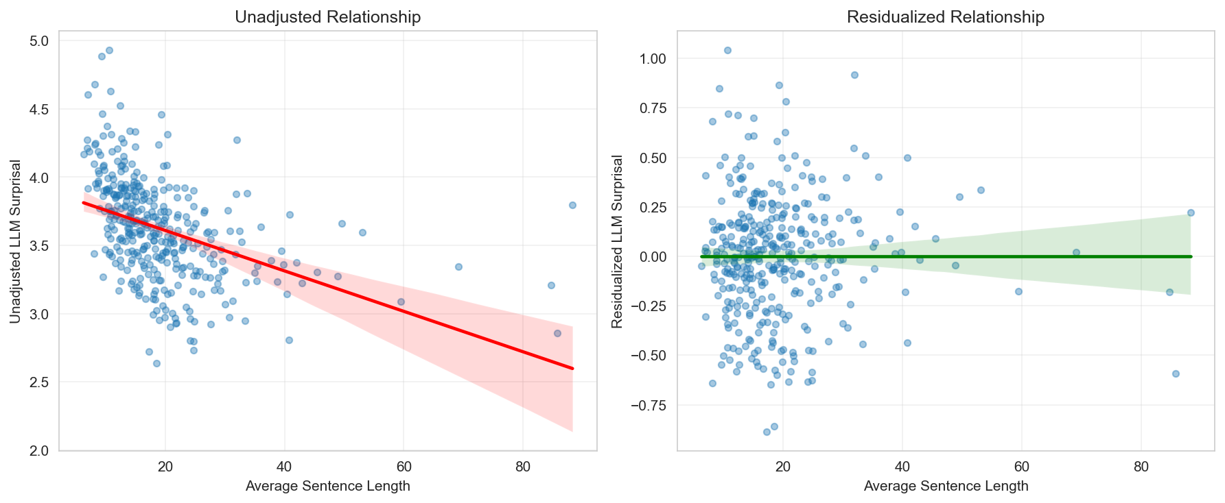
ASL Spearman correlation with LLM surprisal before and after residualization.

Supplementary Figure 2 Antipsychotic dose vs. median LLM surprisal (SSD only)
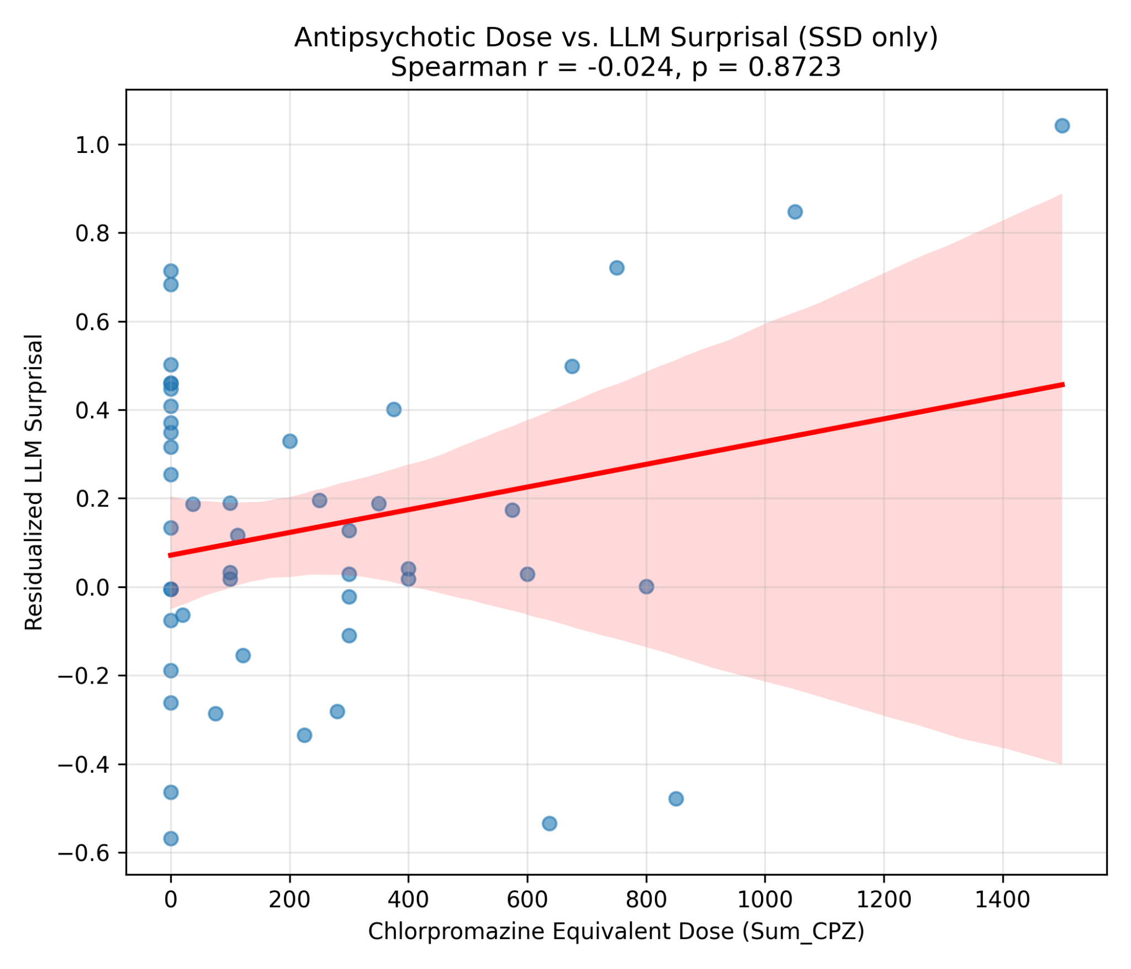
Spearman correlation: ρ = -0.024, P = 0.87

Supplementary Figure 3 Polypharmacy Index vs. median LLM surprisal (all Patients)
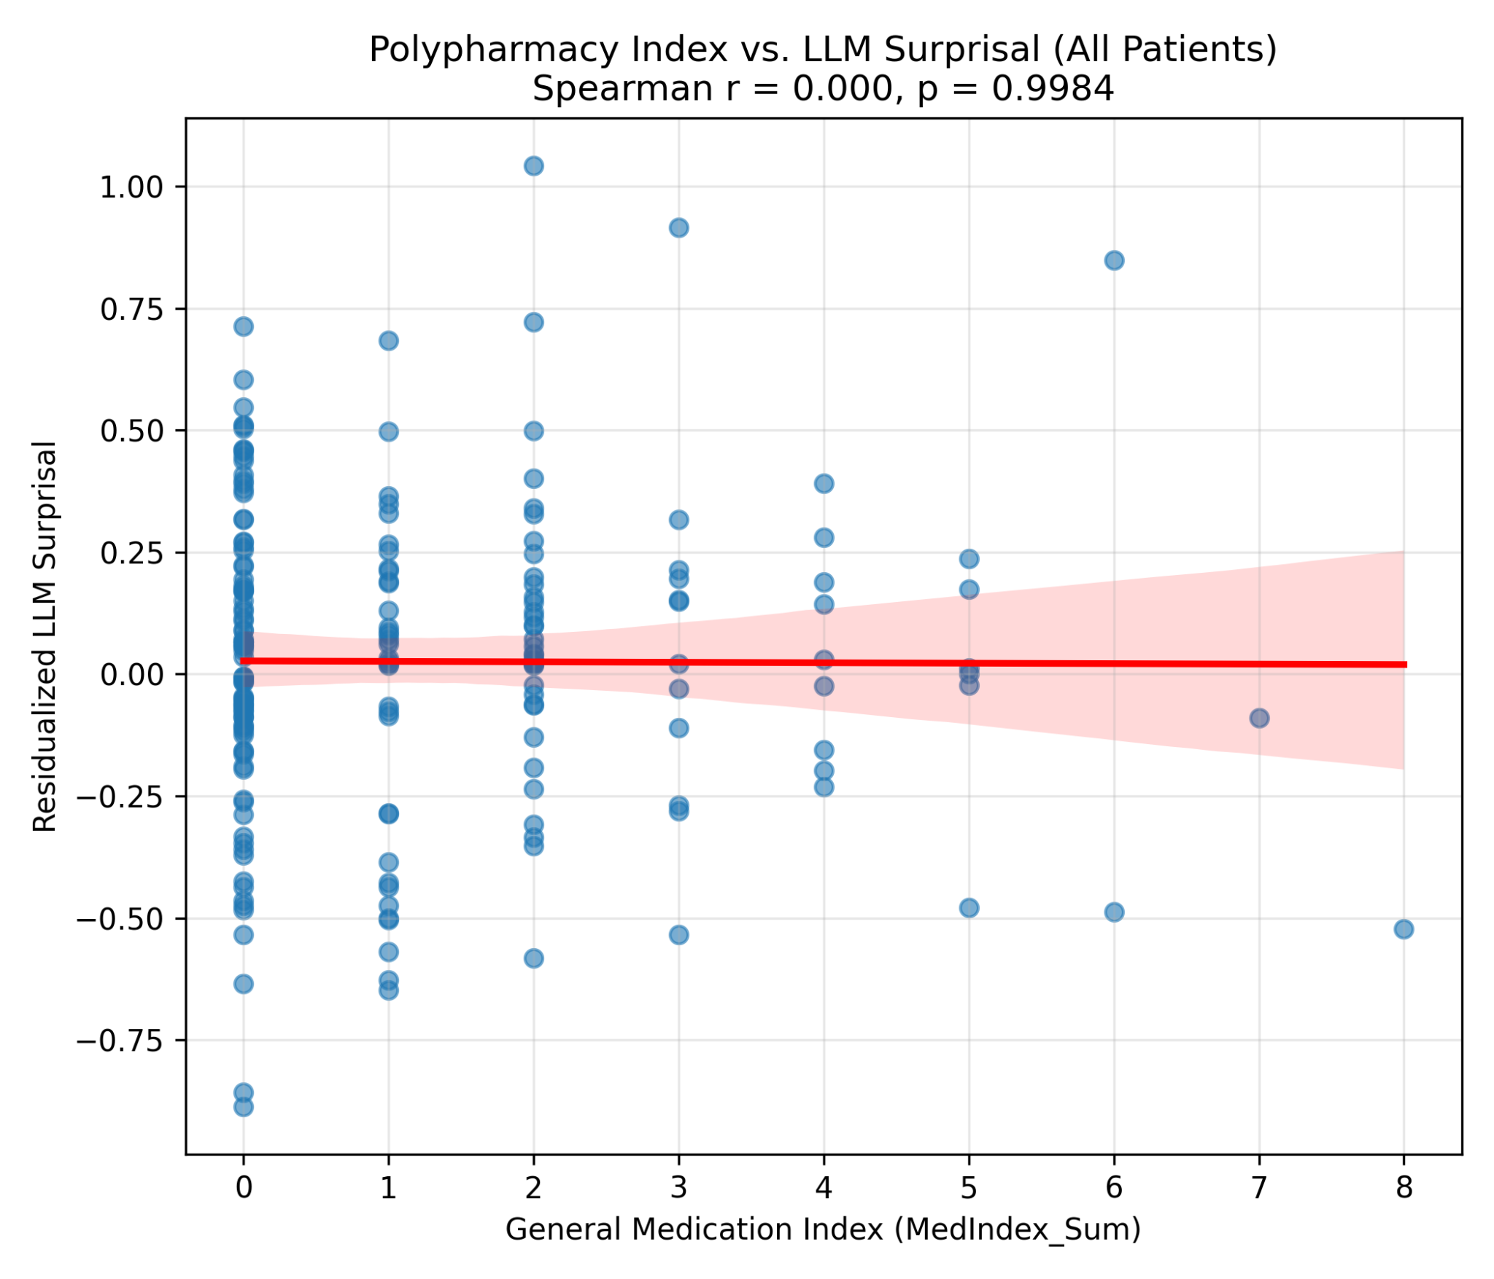
Spearman-Correlation: ρ = 0.000, P = 0.99

Supplementary Figure 4 Associations between residualized LLM surprisal and clinical and cognitive measures

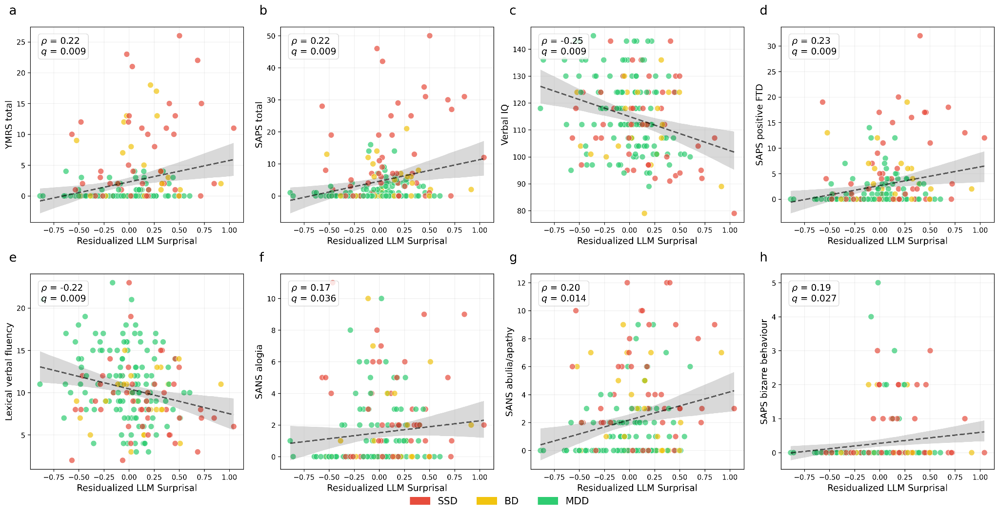
Scatter plots of participant-level residualized median loss (x-axis)/surprisal against clinical and cognitive variables (y-axis),pooled across the patient sample and colored by diagnosis. Each panel reports the Spearman correlation coefficient (ρ) and its FDR-corrected-p-value (q); the dashed line is the linear regression fit and the shaded band its 95% confidence interval. Point color denotes diagnostic group.

Supplementary Figure 5 Incremental value of median LLM surprisal for patient–control classification across diagnostic cohorts

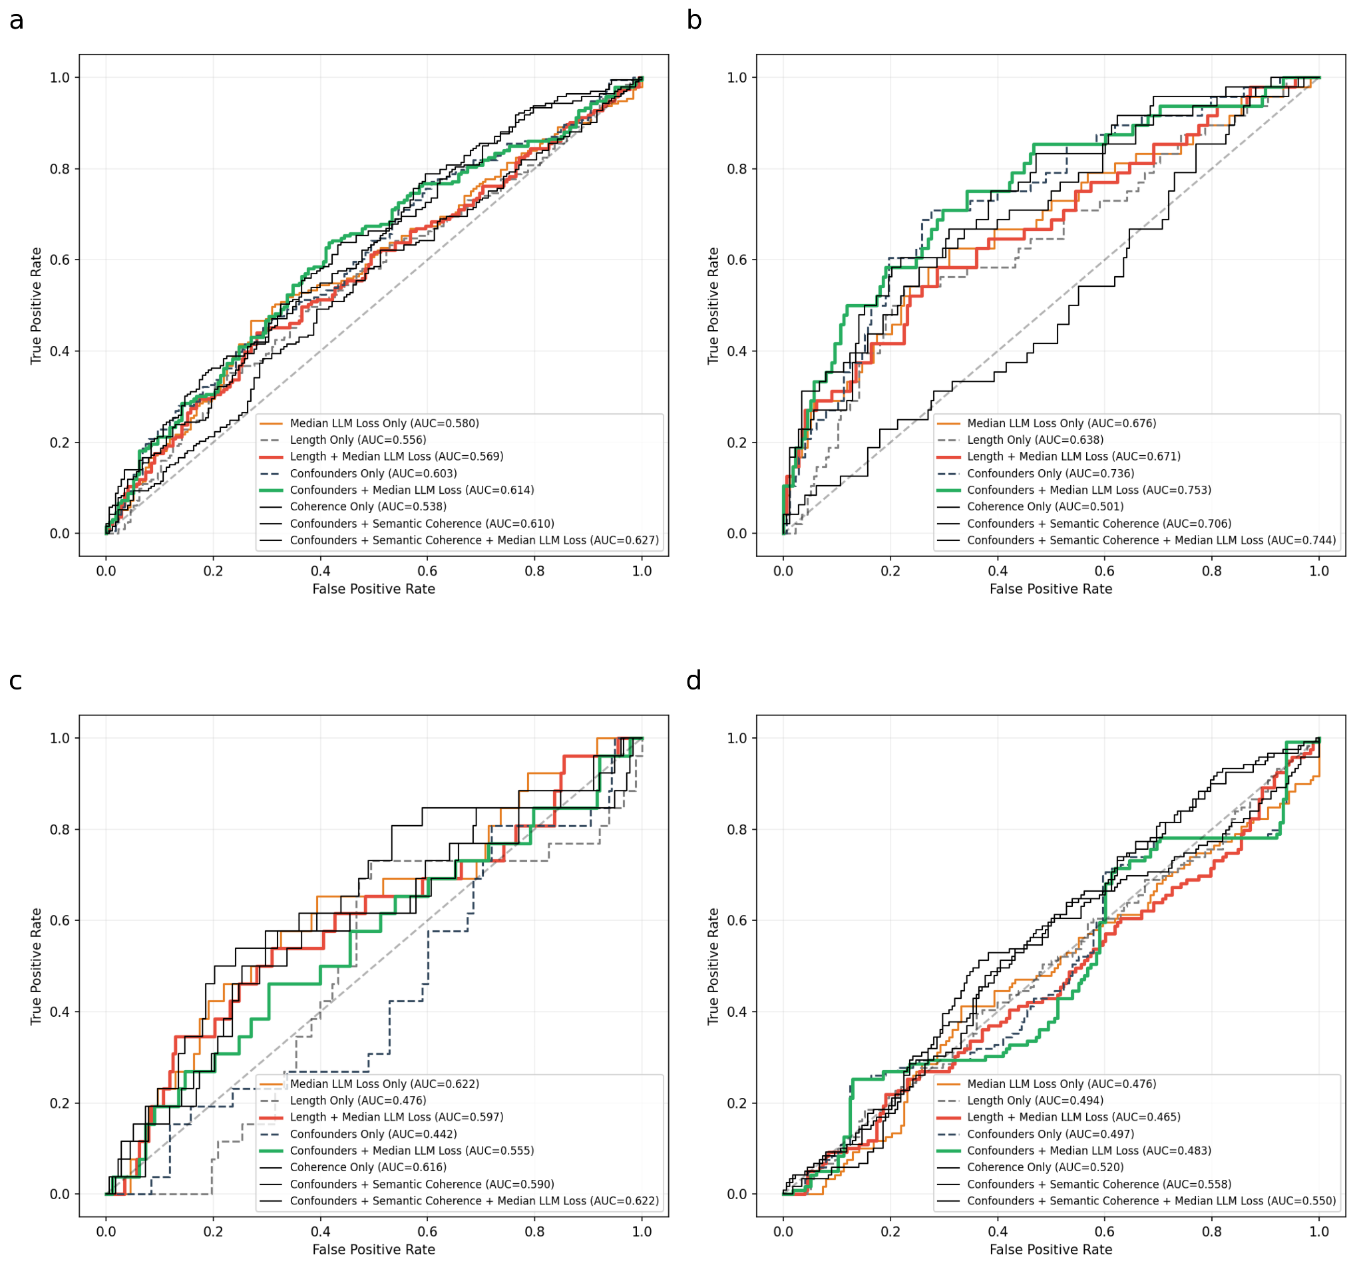
Receiver operating characteristic (ROC) curves for logistic-regression models classifying patients versus HC, with leave-one-out cross-validated AUC (CV-AUC) in each panel legend. (a) Full mixed-diagnosis patient cohort, (b) SSD, (c) BD, and (d) MDD, each versus HC. Eight nested models are compared per panel: median LLM surprisal/loss alone; ASL alone; length plus surprisal; the full confounder model (age, sex, YoE and ASL); confounders plus surprisal; confounders plus semantic Coherence (mean cosine similarity between consecutive utterances); and confounders plus Coherence plus surprisal/loss. The dashed diagonal denotes chance (AUC = 0.50).
AUC, area under the ROC curve; CV-AUC, leave-one-out cross-validated AUC; LLM, large language model; HC, healthy controls; SSD, schizophrenia spectrum disorder; BD, bipolar disorder; MDD, major depressive disorder.

Supplementary Figure 6 Cross model correlation of LLM surprisal
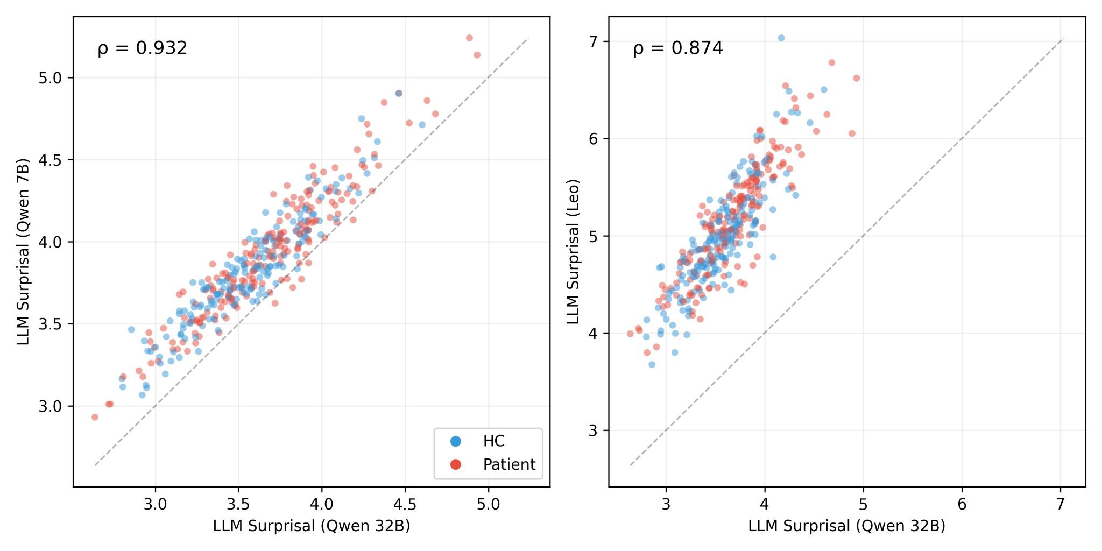
Spearman-Correlation ρ; both P < 0.001

Supplementary Figure 7 Cross model correlation for clinical variables
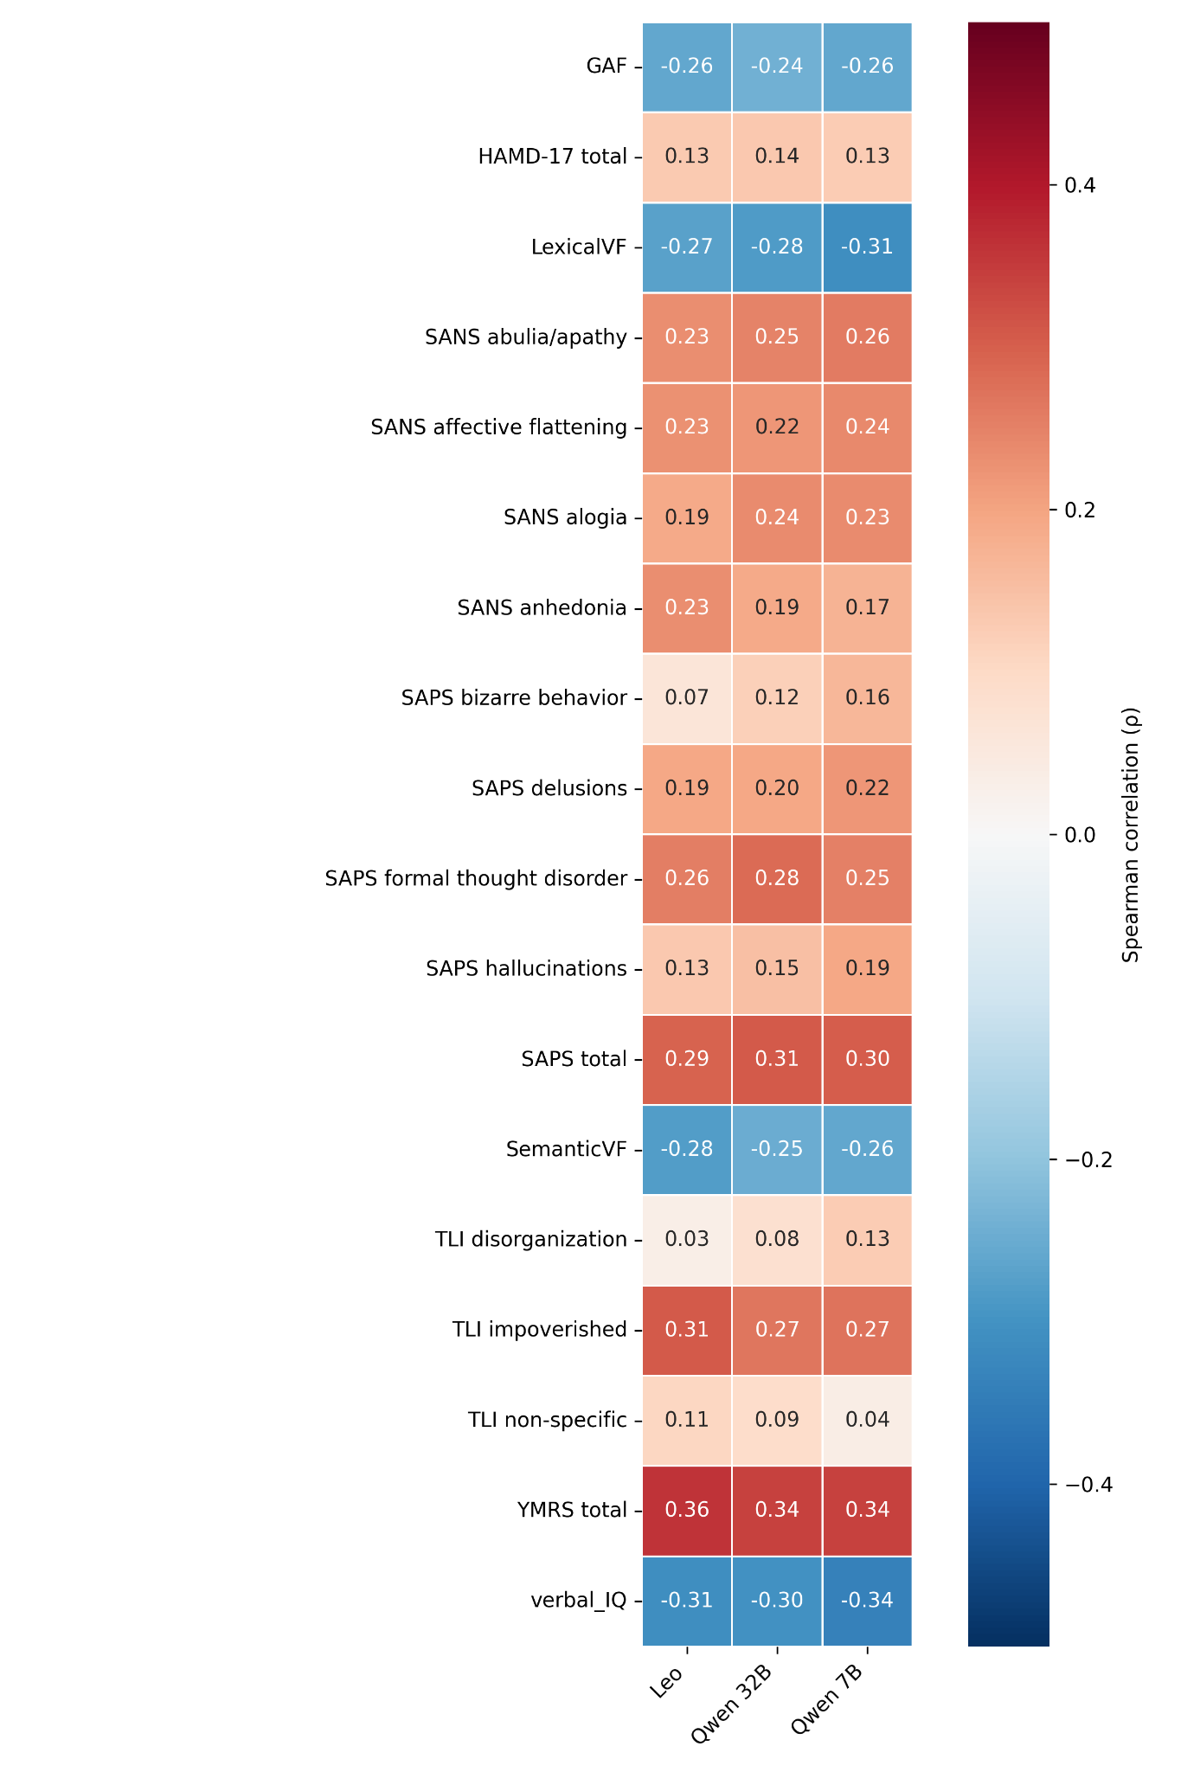
Spearman correlation (ρ) with unadjusted median LLM surprisal for different models.

Supplementary Figure 8 Ablation Analysis: Base vs. Instruction-Tuned Weights
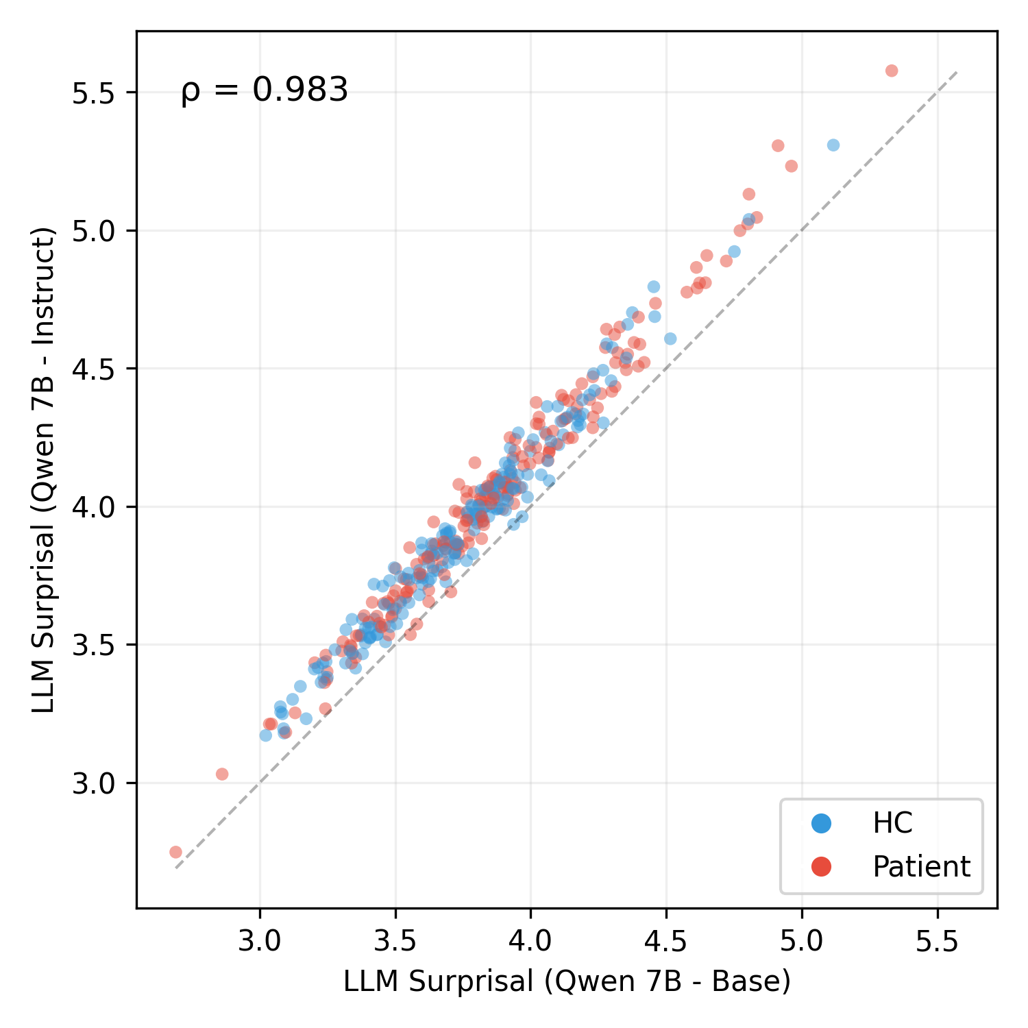
Spearman-Correlation ρ; P < 0.001.

Supplementary Figure 9 Cross prompt correlation of LLM surprisal
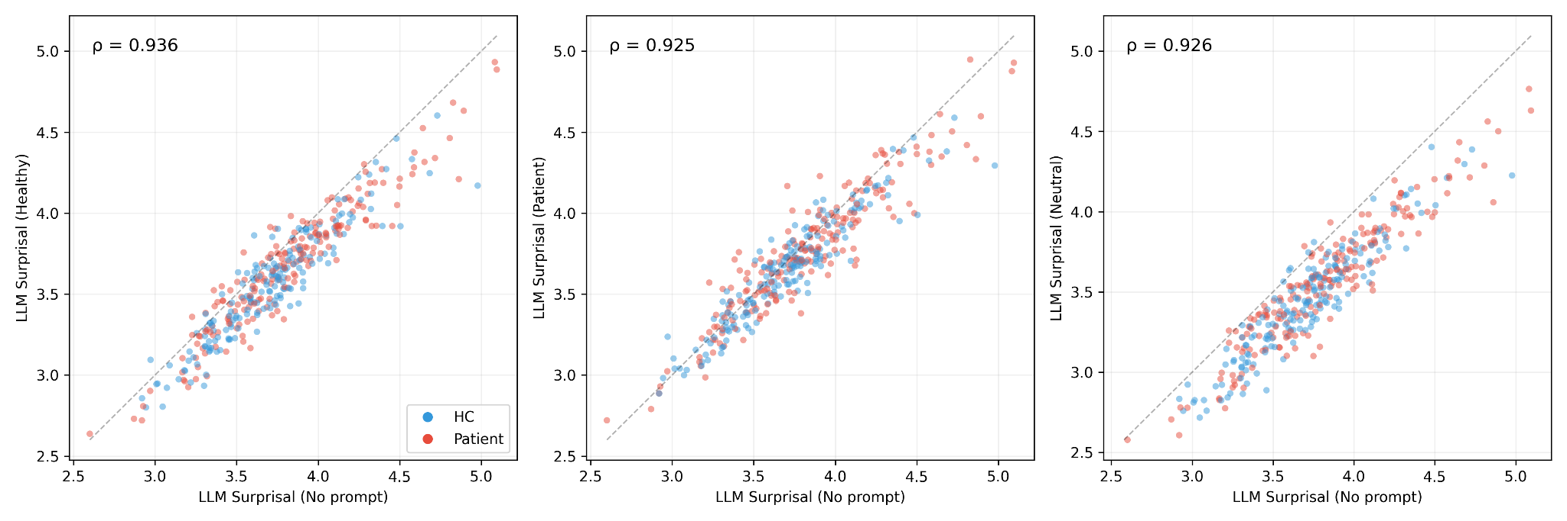
Spearman-Correlation ρ; all P < 0.001.

Supplementary Figure 10 Cross prompt correlation for clinical variables
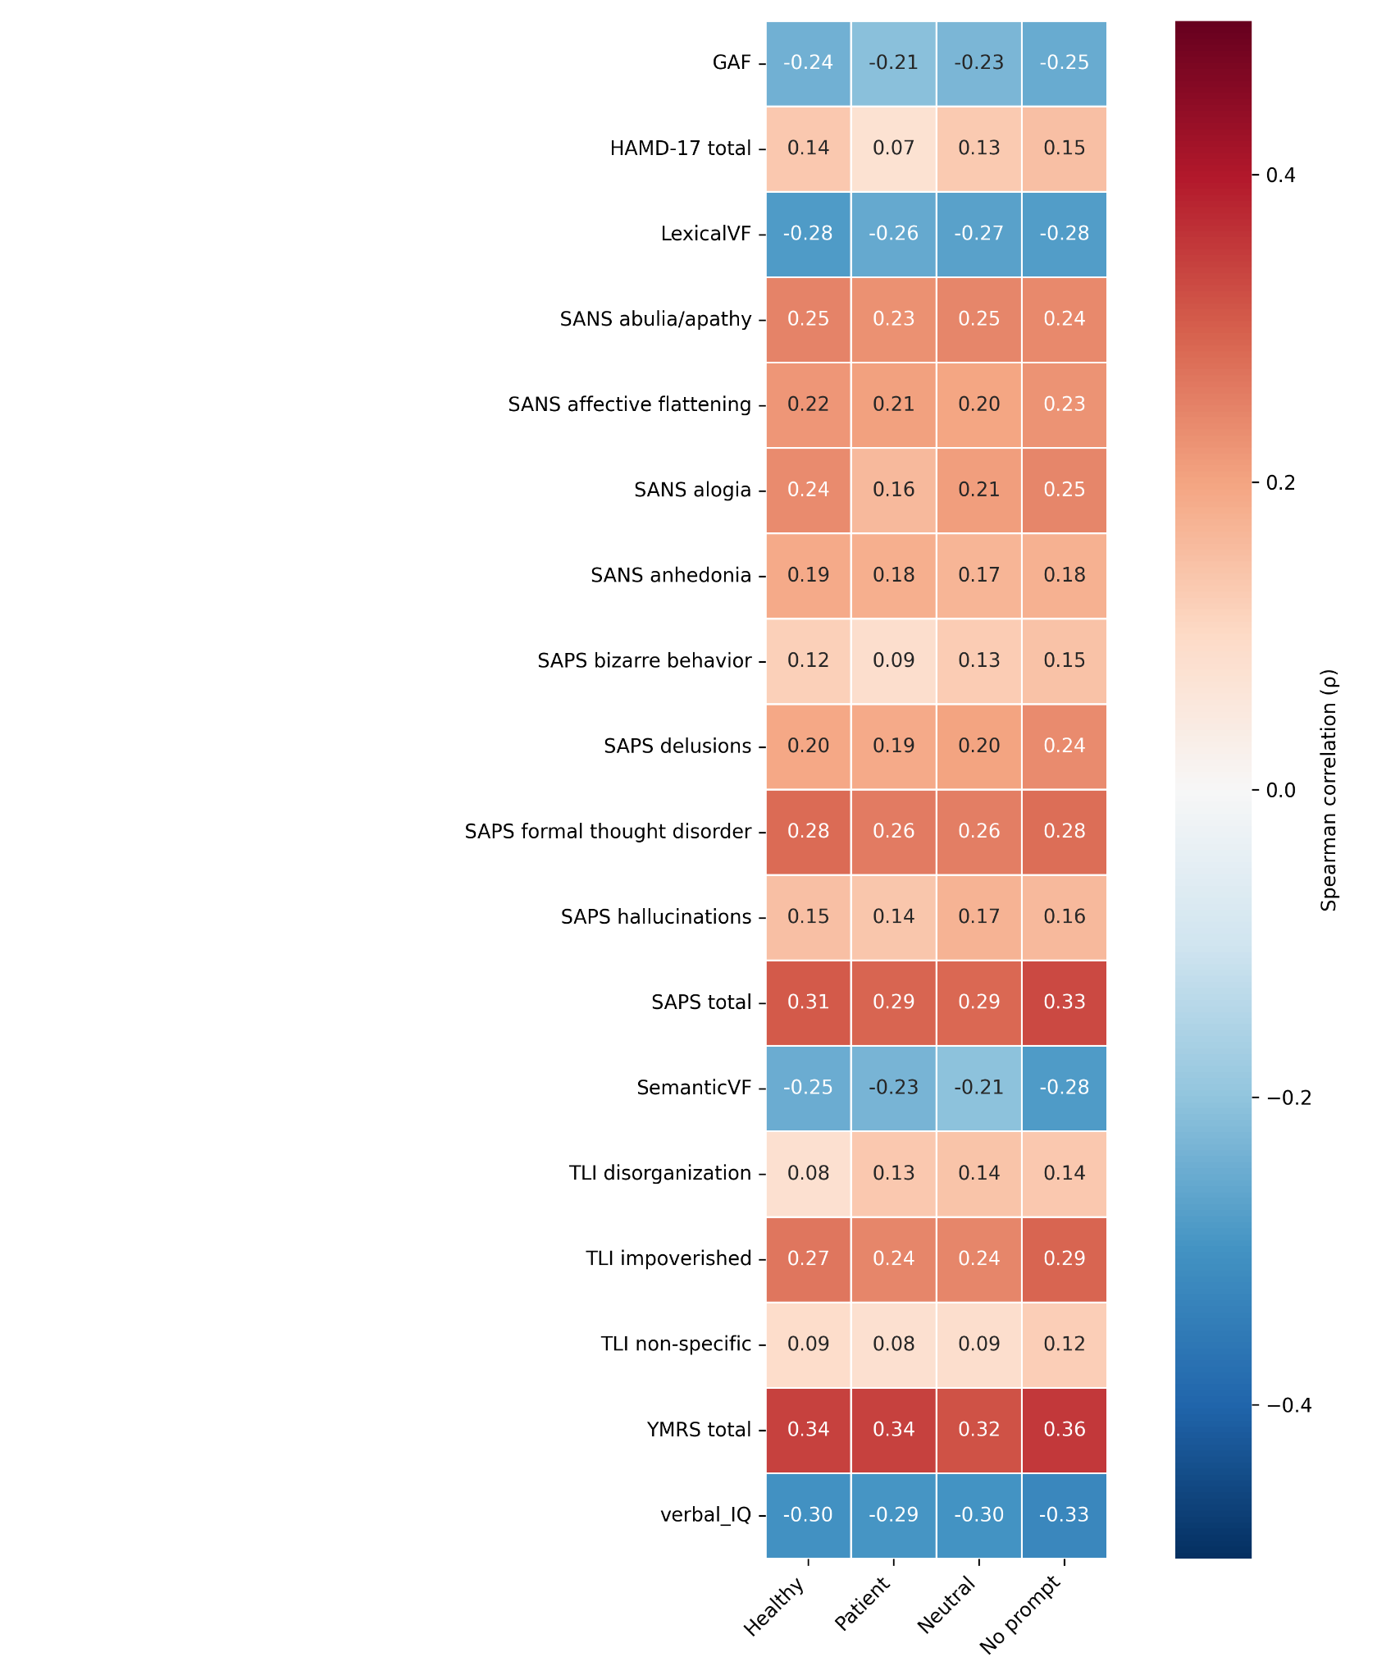
Spearman-Correlation ρ for different prompts across clinical metrics.

Supplementary Figure 11 Sensitivity analysis of patient-level clinical correlations under first-word token trimming for median surprisal
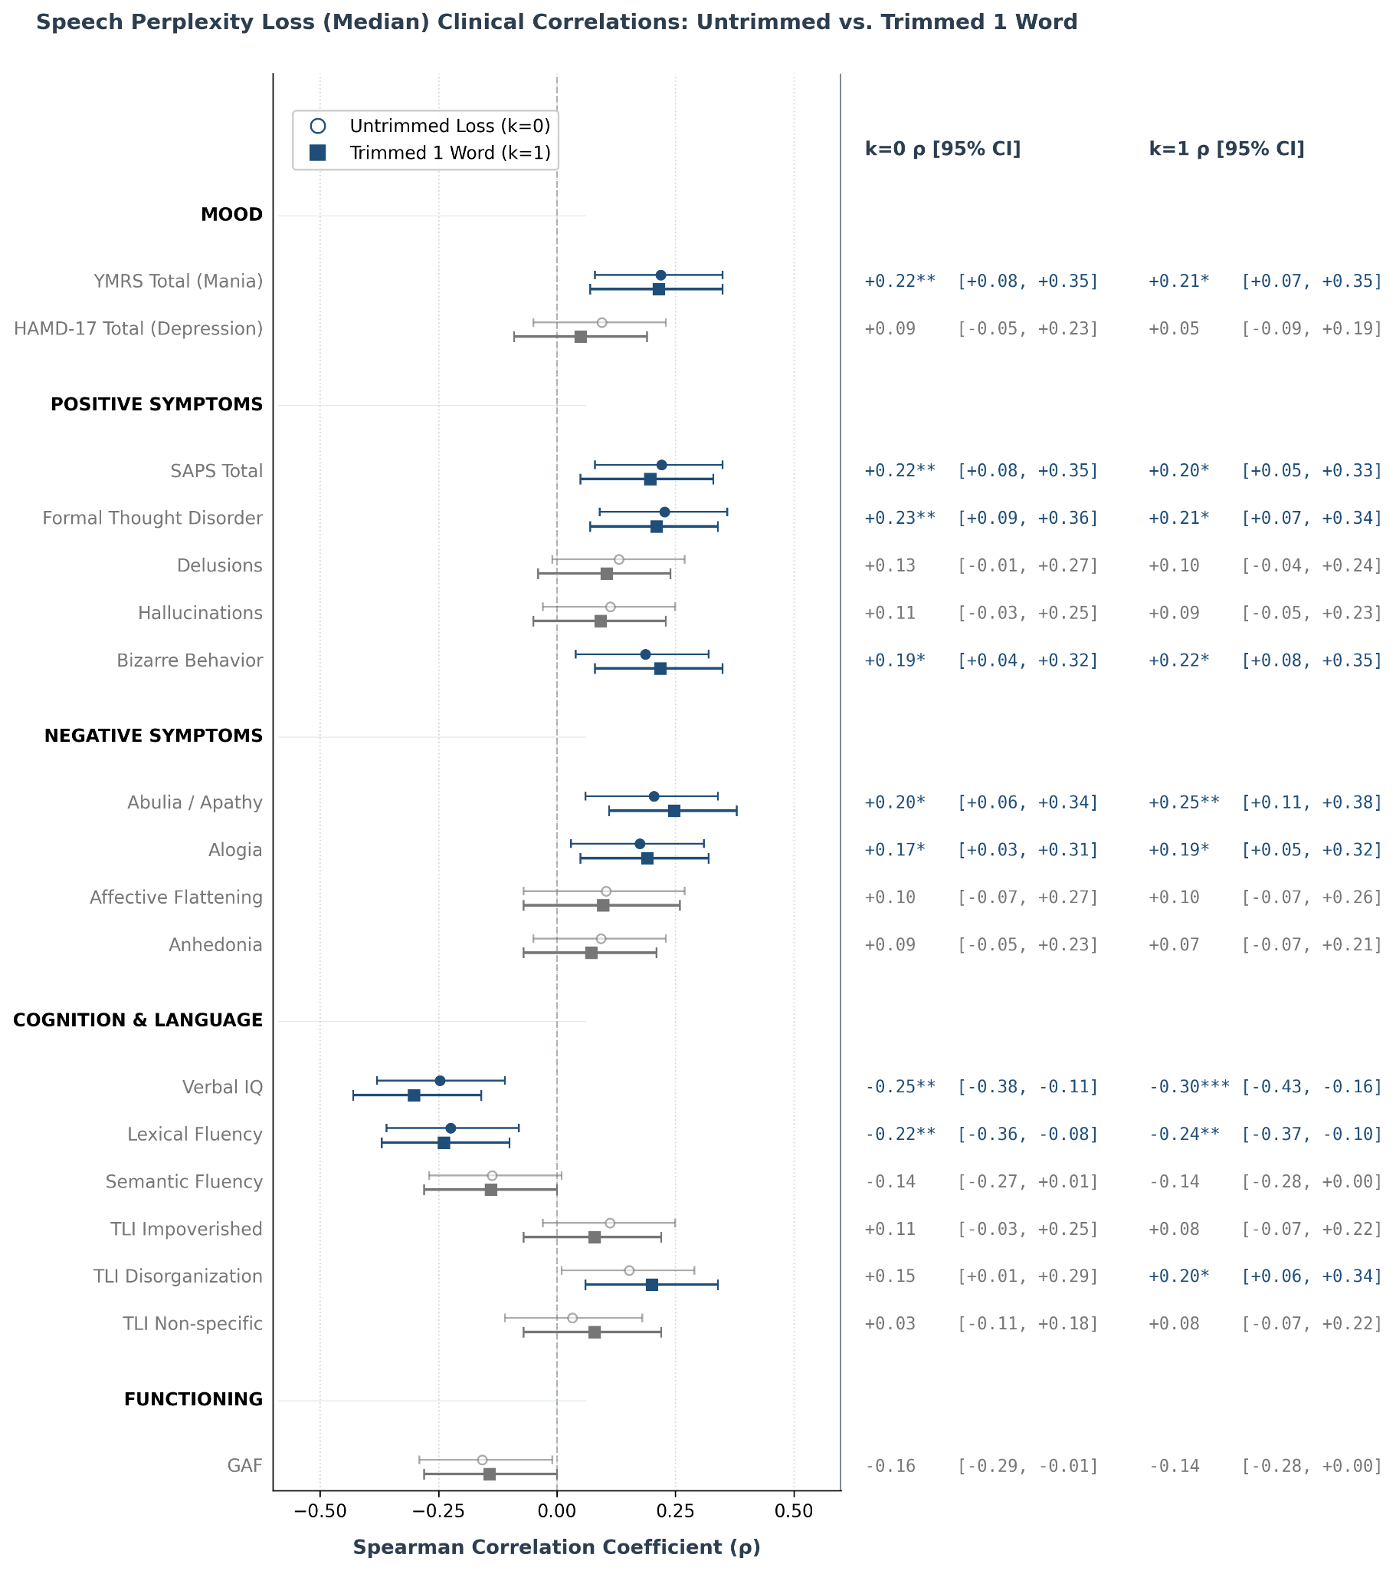
Trimming (k=1) denotes removing the first word of each utterance, which lacks preceding context and acts as structural noise. Compared to the untrimmed baseline (k=0). Overlapping 95% confidence intervals reveal an overall robust and stable correlation pattern (∆⍴ ≤ ±0.05)

Supplementary Figure 12 Sensitivity analysis of patient-level clinical correlations under first-word token trimming for highest 95th percentile - Surprisal
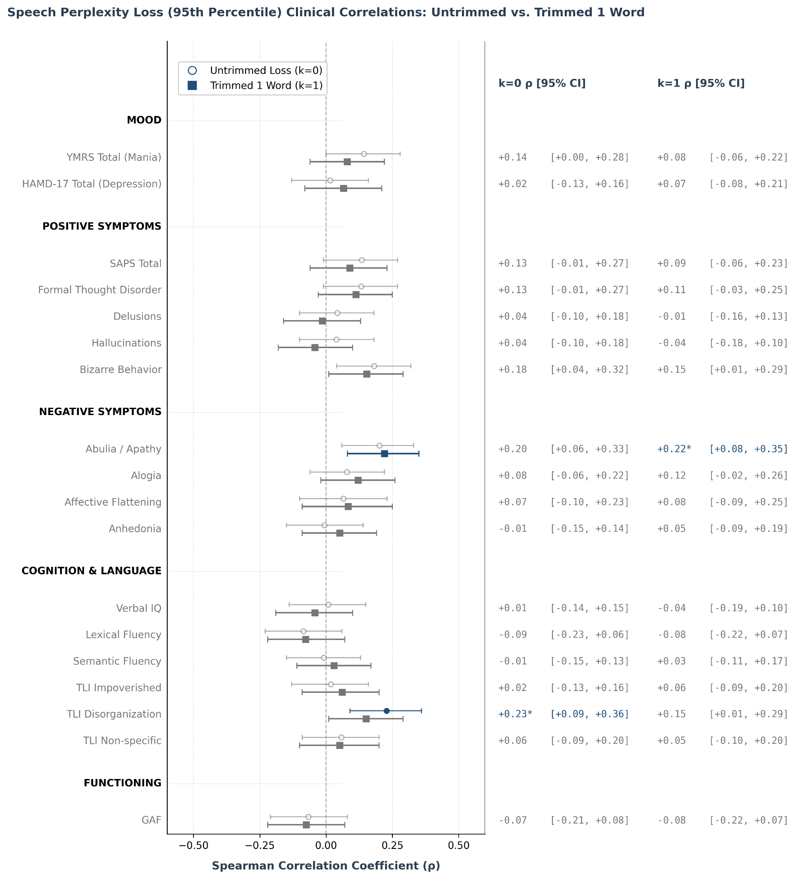
Trimming (k=1) denotes removing the first word of each utterance, which lacks preceding context and acts as structural noise. Compared to the untrimmed baseline (k=0). Overlapping 95% confidence intervals reveal an overall robust and stable correlation pattern (∆⍴ ≤ ±0.05)

