Supporting information (SI)
Leveraging Metabolic Synergy for Scaled-up and Cost-effective Upcycling of Organic Wastewater into High-value Chemicals
Min Yang^{1,3#}, Xin Wang^{2#}, Tan Ke¹, Menghan Tian¹, Wenjun Yang², Weixiang Chao¹, Guifeng Li¹, Haitao Hu², Xinyue He¹, Xiang Gao²*, Lu Lu¹*

¹ State Key Laboratory of Urban-rural Water Resources and Environment, School of Ecology and Environment, Harbin Institute of Technology, Shenzhen, Shenzhen 518055, China
² State Center for Materials Synthetic Biology, Shenzhen Institute of Synthetic Biology, Shenzhen Institutes of Advanced Technology, Chinese Academic of Science, Shenzhen 518000, China
³ Chaohu Regional Collaborative Technology Service Center for Rural Revitalization, School of Biological and Environmental Engineering, Chaohu University, Hefei, 238000, China

* Corresponding author E-mail: gaoxiang@siat.ac.cn; lulu@hit.edu.cn

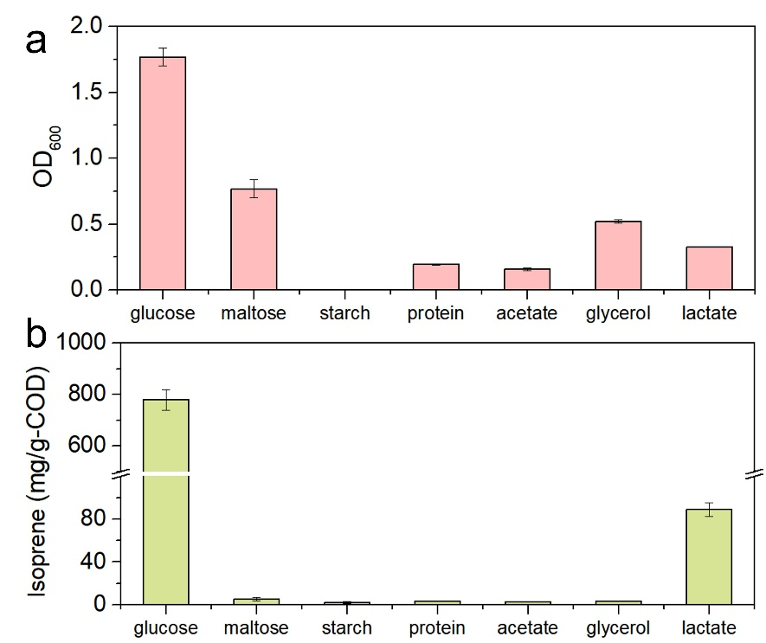
Fig. S1. Efficiency of engineered E.coli to utilize different substrates. a, The OD600 and b, the isoprene production after 24h with different substrates.

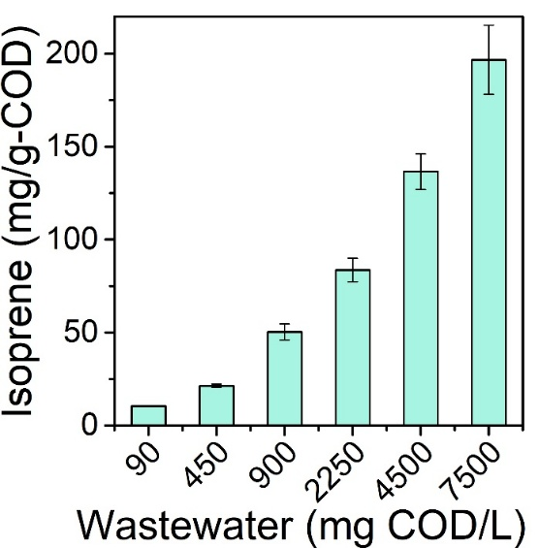
Fig. S2. Isoprene production from wastewater with different COD concentrations (90~7500 mg/L) and a lactate-to-glycerol mole ratio of approximately 1:1.

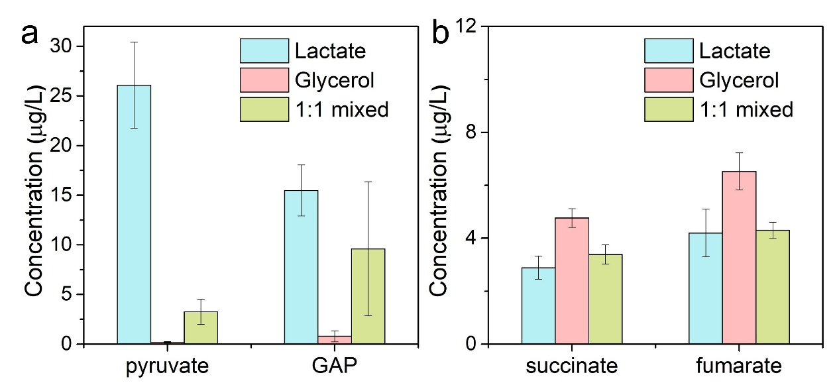
Fig. S3. Concentrations of (a) key precursors and (b) intermediate metabolites of the TCA cycle when lactate alone as substrate, glycerol alone as substrate and mixture of lactate and glycerol as substrate, respectively.

Table S1. The significance test for comparisons of lactate alone as substrate, glycerol alone as substrate and mixture of lactate and glycerol as substrate in terms of key enzyme activity during isoprene production.
 | Lactate vs. Glycerol |  | Lactate vs. Mixed |  | Glycerol vs. Mixed
 | T Statistic | p-value | T Statistic | p-value | T Statistic | p-value
HMGR | 7.3 | 0.016* | 0.2 | 0.84 | -5.9 | 0.006**
DXPS | -4.5 | 0.024* | -0.24 | 0.82 | 3.6 | 0.023*
IDI | 6.9 | 0.0024** | 1.6 | 0.18 | -1.8 | 0.15
IspS | 6.2 | 0.0043** | -1.5 | 0.21 | -8.6 | 0.001**

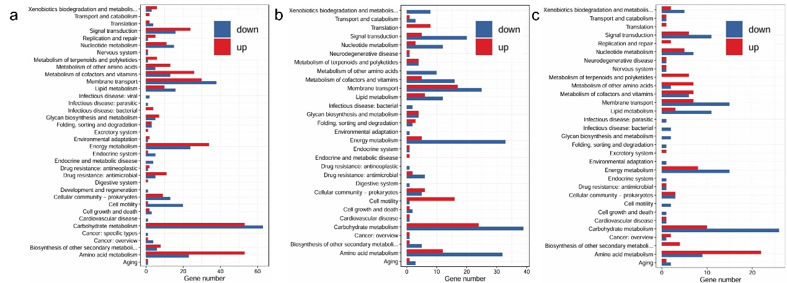
Fig. S4. Kyoto Encyclopedia of Genes and Genomes (KEGG) enrichment analysis of differentially expressed genes between (a) lactate and glycerol, (b) glycerol and mixture and (c) lactate and mixture with p-value < 0.05.

Table S2. The significance test for comparisons of lactate alone as substrate, glycerol alone as substrate and mixture of lactate and glycerol as substrate in terms of the expression of key genes in the MEP and MVA pathways.
 | Lactate vs. Glycerol |  | Lactate vs. Mixed |  | Glycerol vs. Mixed
 | T Statistic | p-value | T Statistic | p-value | T Statistic | p-value
mvaS | 2.92 | 0.043* | 1.35 | 0.29 | -1.19 | 0.30
mvaE | 3.06 | 0.038* | -0.53 | 0.62 | -2.98 | 0.041*
PMK | 3.74 | 0.020* | 2.03 | 0.11 | -1.72 | 0.22
PMD | 0.13 | 0.91 | -0.51 | 0.64 | -0.75 | 0.50
dxs | -3.11 | 0.036* | -3.37 | 0.028* | -0.86 | 0.44
dxr | -2.95 | 0.042* | -0.81 | 0.46 | 1.45 | 0.22
ispG | -2.82 | 0.048* | -2.62 | 0.059 | -0.27 | 0.80
ispH | -1.76 | 0.15 | -0.52 | 0.63 | 0.95 | 0.40

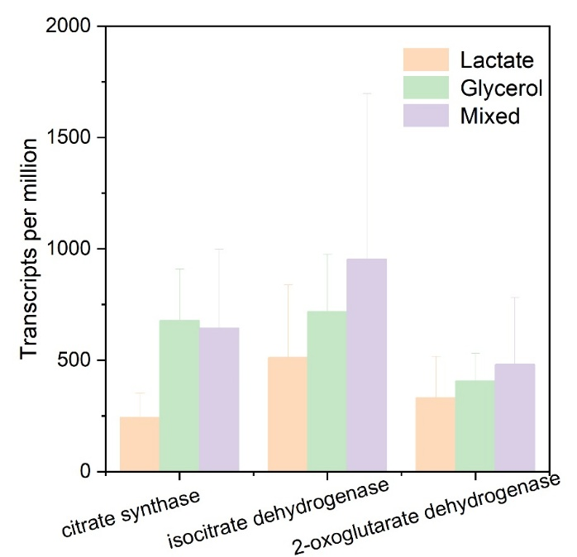
Fig. S5. The expression of key genes in TCA cycle for lactate, glycerol and their 1:1 mix as mediums, respectively

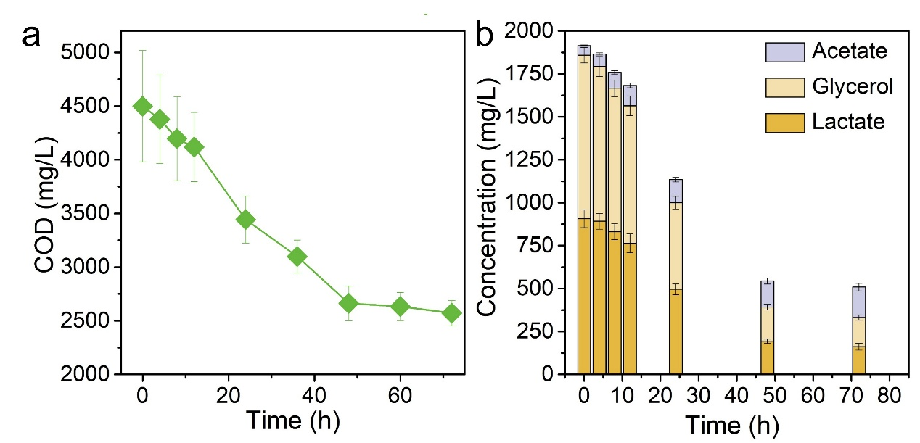
Fig. S6. The COD removal (a) and the changes in concentration of each organic component in wastewater (b) in scaled-up bioreactor over culture time.

Table S3. The properties of two kinds of industrial wastewater generated during corn starch and biodiesel production used in this study.
 | Corn starch production wastewater | Biodiesel production wastewater
COD (mg/L) | 4553±519 | 4500±350
TN (mg/L) | 321±38 | 12±1.4
NH₃-N (mg/L) | 173±25 | -
pH | 6.0±0.5 | 6.9±0.5
Lactic acid (mg C/L) | 655±23.1 | --
Glycerol (mg C/L) | 21±2.5 | 1340±102
Protein (mg C/L) | 86±12.8 | --
Acetic acid (mg C/L) | 20±1.3 | --
Butyric acid (mg C/L) | 22±3.6 | --

Strains construction and preservation
Construction of recombinant E.coli to synthesize isoprene follows previous research ¹. To be briefly, replacing the DXPS, DXR, and IDI gene endogenic promoter on E.coli chromosome with strong mobilizer PGI or PL**. Used the IDI from Sacchromycess Cerevisiae to replace the endogenic IDI to strengthen the MEP pathway in E.Coli itself. In addition, two genes mvaE and mvaS from Enterococcus Faecalis, as well as PMK, PMD and IDI from S. Cerevisiae were integrated into E.coli chromosomes. And then introduce two grains, PES and PSK, to expresses IspS and MK on the upstream routes of MVA, respectively. Eventually, engineered E. coli that can efficiently synthesize isoprene through both MEP and MVA pathways was obtained. Strains and plasmids used in this study was shown in Table S4 and schematic diagram of the construction process was shown in Figure S5.
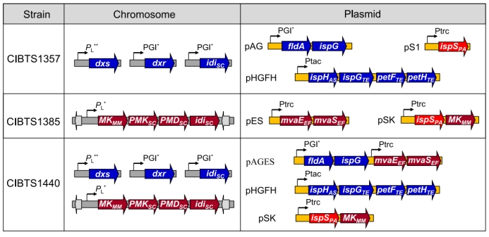
Fig. S7. Construction of the isoprene production strains overexpressing the MEP pathway and the MVA pathway simultaneously or individually. Genes of the MEP pathway are denoted by the blue arrows while the genes of the MVA pathway are denoted by the violet red arrows.
Table S4. Strains and plasmids used in this study.
Strain | Genotype
BL21 | F⁻dcm ompT hsdS(rB⁻mB⁻) gal λ^{S}
CIBTS1756 | BL21, glmS-pstS: P_{L}* MK_{MM} PMK_{SC} PMD_{SC} idi_{SC}
CIBTS1757 | BL21, Δidi: PGI* idi_{SC}, P_{L}** dxs, PGI* dxr
CIBTS1758 | BL21, glmS-pstS: P_{L}* MK_{MM} PMK_{SC} PMD_{SC} idi_{SC}, Δidi: PGI* idi_{SC}, P_{L}** dxs, PGI* dxr
CIBTS1357 | CIBTS1757/pAG+pHGFH+pTrcS1
CIBTS1384 | CIBTS1756/pSK
CIBTS1385 | CIBTS1756/pES+pSK
CIBTS1439 | CIBTS1758/pAG+ pHGFH+pSK
CIBTS1440 | CIBTS1758/pAGES+ pHGFH+pSK
CIBTS1557 | CIBTS1757/pAG+pHGFH+pEBI
CIBTS1558 | CIBTS1756/pES+pEBIK
CIBTS1559 | CIBTS1758/pAGES+pHGFH+pEBIK
Plasmids
pCL1920 | pSC101 origin, Spec^{r}
pTrcHis2B | pBR322 origin, Amp^{r}
pSU2718 | P15A origin, Cm^{r}
pS1 | Ptrc ispS_{PA}, pTrcHis2B ori, Amp^{r}
pSK | Ptrc ispS_{PA}, MK_{MM}, pTrcHis2B ori, Amp^{r}
pAG | PGI* fldA ispG, pCL1920 ori, Spec^{r}
pHGFH | Ptac ispH_{AS} ispG_{TE} petF_{TE} petH_{TE}, pSU2718 ori, Cm^{r}
pES | Ptrc mvaE_{EF} mvaS_{EF}, pCL1920 ori, Spec^{r}
pAGES | PGI* fldA ispG, Ptrc mvaE_{EF} mvaS_{EF}, pCL1920 ori, Spec^{r}
pEBI | Ptrc crtE_{PAN} crtB_{PAN} crtl_{PAN}, pTrcHis2B ori, Amp^{r}
pEBIK | Ptrc crtE_{PAN} crtB_{PAN} crtl_{PAN} MK_{MM}, pTrcHis2B ori, Amp^{r}
The economic and ecological effect evaluation
We compared single and synergetic microbial metabolisms for isoprene production from wastewater in a scaled-up bioreactor. The performance of these systems was further evaluated against established routes for hydrogen and methane production, which used the same mixed-substrate wastewater and bioreactor (Fig. 4a). A cradle-to-gate life cycle assessment (LCA) was conducted, excluding utility construction and end-of-life disposal, to analyze greenhouse gases (GHG) emissions (CO₂ equivalent) and economic costs. The emission factors and life-cycle inventories corresponding to a functional unit of 1 kg of product from different wastewater bio-fermentation routes were obtained from the Ecoinvent database and a model adapted from Argonne National Laboratory^{2, 3}. This study employs a modified industrial modeling framework that integrates laboratory data to comprehensively assess the environmental and economic impacts of lab-scale operations with reduced uncertainty. The LCA boundary primarily includes wastewater pretreatment, biosynthesis in the bioreactor, product separation, and system operational inputs (e.g., acid/alkali, heat, electricity etc.). Monte Carlo simulations were conducted for 20 input parameters subject to uncertainty to evaluate the influence of uncertainties from statistical data and calibrated industrial models. 10,000 trials with triangular distributions bounded by ±20% of base-case values, and results were shown in error bars of Fig 5. The supplementary information provides a life cycle inventory and detailed calculation parameters, including material and energy consumption for the production of hydrogen, methane and isoprene. The Intergovernmental Panel on Climate Change (IPCC) 2021 impact assessment method⁴ and its categories were applied to quantify GHG emissions. Additionally, a life cycle costing (LCC) analysis, adopting the same goal and scope as the LCA, was performed to calculate the total economic burden of the process⁵.
Route 1. Isoprene production from single/mixed wastewater.
For isoprene production by synergetic metabolism, a mixture of lactate wastewater and glycerol wastewater was used as substrate and inoculated with engineered E. coli in the scaled-up bioreactor. And only lactate wastewater (Lactate WW) or glycerol wastewater (Glycerol WW) was added for single metabolism. Similarly, the single/mixed wastewater streams first blended and pH-adjusted in a pretreatment unit before being fed into the bioreactor. The cultivation temperature is maintained constant at 35°C with a neutral pH. An isoprene yield of 67.3~79.1, 34.4~40.0 and 100.1~119.5 mg/g COD was obtained for Lactate WW, Glycerol WW and their 1:1 mixture, respectively. The resulting gas streams are directed to a fractionation column for the final separation of isoprene. In the fractionator, the gas is first heated to 50°C and then cooled to 25°C, condensing the liquid isoprene fraction. Tap water is used as the cooling medium in the condenser. Fig. S8 exhibits the schematic of isoprene production by single and synergetic microbial metabolisms and Table S5 summarizes the energy and chemicals consumption.
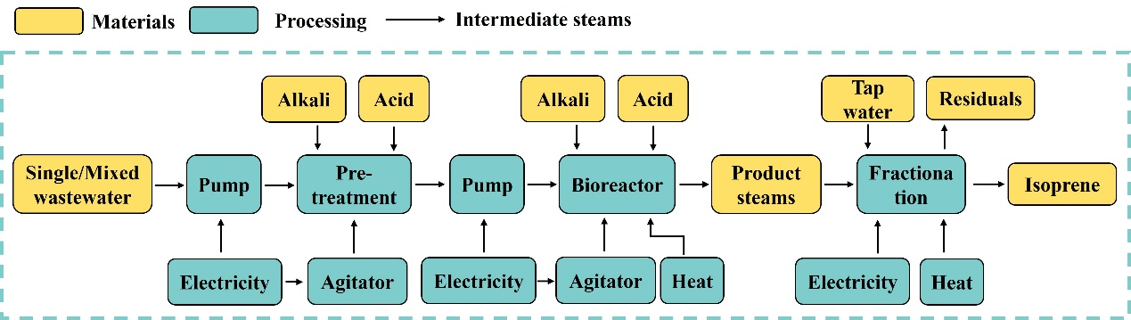
Fig. S8. Schematic and system boundary of isoprene recovery from single wastewater and mixed wastewater based on the metabolic synergy.
Table. S5. Energy and material inventory of isoprene recovery from single wastewater and mixed wastewater.
Inputs | Wastewater1 | Wastewater 2 | Mixed wastewater | Units | Description
Heat | 277.9-325.4 | 308.2-360.1 | 135.8-158.9 | MJ/kg | Heat, district or industrial, natural gas
Electricity | 192.5-221.3 | 216.4-251.5 | 94.6-108.5 | MJ/kg | Electricity, high voltage
Hydrochloric acid | 2.6-3.5 | 7.6-9.0 | 2.4-3.2 | kg/kg | Hydrochloric acid, without water, in 30% solution state
Sodium hydroxide | 2.4-3.4 | 5.1-6.4 | 1.4-2.6 | kg/kg | Sodium hydroxide, without water, in 50% solution state
Tap water | 0.003-0.005 | 0.006-0.008 | 0.002-0.004 | m³/kg | Cooling water for fractionation, waste
Route 2. Hydrogen production from mixed wastewater.
To facilitate further comparison, we use the same pretreated mixed wastewater in the same reactor for bio-H₂ production and collect experimental data. The fermentation condition follows a previous ethanol-H₂-coproducing dark fermentation study⁶ and the inoculumn collected from a wastewater treatment plant in Shenzhen. The two wastewater streams are conveyed to a pretreatment unit via pumping, where they are thoroughly mixed. The mixture is then fed into a stirred bioreactor for hydrogen fermentation. The fermentation is maintained at a constant temperature of 35°C, with acid and alkali supplementation as needed to sustain the optimal pH, and a H₂ yield of 12.1~15.1 mg/g COD was obtained. Then the collected biogas, containing a large amount of by-products primarily composed of carbon dioxide, is transported to the separation unit. While multiple methods, including water washing, alkaline solvent absorption, pressure swing adsorption, and membrane separation, are viable for carbon dioxide removal from biogas, solvent-based chemical absorption is noted for yielding higher purity hydrogen⁷. Given the high purity of the isoprene recovered in this study and to ensure a consistent basis for comparison, mono ethanol amine (MEA) solution (1mol/L) is conducted to remove CO₂ under atmospheric pressure. The mass-flow rate of adsorbent is assumed as 1.2 times than the CO₂ in biogas streams from bioreactor and the wastage is assumed to be 3%. Fig. S9 exhibits the schematic of hydrogen recovery from wastewater. Table S6 summarizes the energy and chemicals consumed during the recovery of hydrogen.
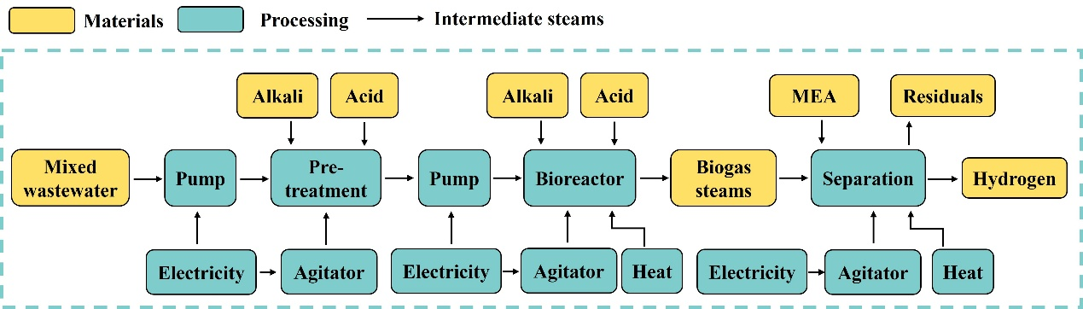
Fig. S9. Schematic and system boundary of hydrogen recovery from mixed wastewater.

Table. S6. Energy and material inventory of hydrogen recovery from mixed wastewater.
Inputs | Usage amount | Units | Description
Heat | 160.2-175.8 | MJ/kg | Heat, district or industrial, natural gas
Electricity | 61.8-73.5 | MJ/kg | Electricity, high voltage
Hydrochloric acid | 3.5-4.8 | kg/kg | Hydrochloric acid, without water, in 30% solution state
Sodium hydroxide | 2.6-3.7 | kg/kg | Sodium hydroxide, without water, in 50% solution state
Mono ethanol amine | 13.2-18.6 | kg/kg | Separation,1.2 times of CO₂ in biogas
Mono ethanol amine | 0.40-0.56 | kg/kg | 3% wastage

Route 3. Methane production from mixed wastewater.
Bio-CH₄ was likewise produced using the same pretreated mixed wastewater in the same reactor following an anaerobic fermentation under reported conditions using the same inoculumn⁸. Before the formal experiment begins, a low-load, stepwise-increase strategy was employed to acclimate methanogenic bacteria for one week. The two wastewater streams are conveyed to a pretreatment unit via pumping, where they are thoroughly mixed. The mixture is then fed into a bioreactor without stirring for methane fermentation. The pH was maintained at neutral using sodium hydroxide and the temperature was also kept constant at 35℃, and a CH₄ yield of 115.7~140.3 mg/g COD was obtained. The biogas is collected and transferred to the separation unit. And for the similar reason, an absorption purification by mono ethanol amine (MEA) is conducted here to remove CO₂. Fig. S10 exhibits the schematic of methane production from wastewater and Table S7 summarizes the energy and chemical consumption.
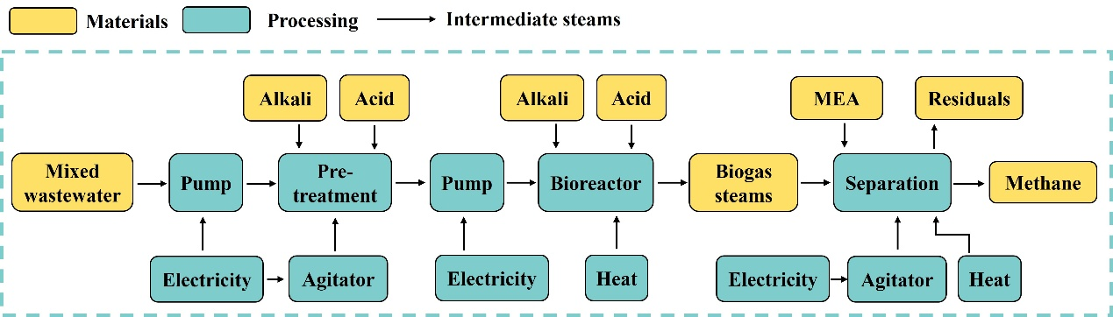
Fig. S10. Schematic and system boundary of methane recovery from mixed wastewater.

Table. S7. Energy and material inventory of methane production from mixed wastewater.
Inputs | Usage amount | Units | Description
Heat | 16.1-23.6 | MJ/kg | Heat, district or industrial, natural gas
Electricity | 13.7-20.4 | MJ/kg | Electricity, high voltage
Hydrochloric acid | 0.8-1.2 | kg/kg | Hydrochloric acid, without water, in 30% solution state
Sodium hydroxide | 0.6-0.9 | kg/kg | Sodium hydroxide, without water, in 50% solution state
Mono ethanol amine | 2.0-3.2 | kg/kg | Separation,1.2 times of CO₂ in biogas
Mono ethanol amine | 0.06-0.10 | kg/kg | 3% wastage

Potential offset of economic cost and GHG emissions
Productions of isoprene, methane and hydrogen from wastewater all avoid potential GHG emissions and the economic cost from wastewater treatment. Given that the COD of both wastewater streams and their mixed effluent are similar in this study, it is assumed that the same typical wastewater treatment process is employed: an anaerobic-anoxic-aerobic (A²O) system for secondary treatment, integrated with primary treatment upstream to remove organic matter, and the residual sludge is transferred to a landfill after undergoing concentration and dewatering⁹. The influent flow rate for the wastewater treatment unit is set to be 1 m³. The wastewater treatment system features a complex structure, yet the environmental and economic burdens associated with utility construction are negligible compared to the operational phase—where electricity and chemical consumption account for approximately 90% of the environmental impact^{10, 11}. Therefore, this study focuses solely on the operational phase of sewage treatment, with the system boundary defined as shown in Fig. S11. Table S8 summarizes the energy and material consumption of wastewater treatment.

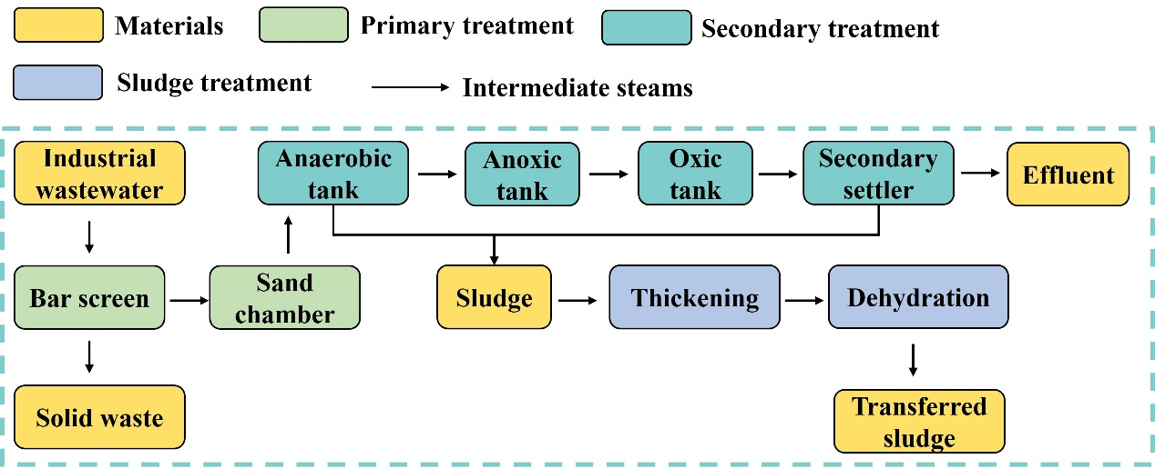
Fig. S11. Schematic and system boundary of wastewater treatment.

Table. S8. Energy and material inventory of conventional industrial wastewater treatment.
Primary treatment
Inputs | Usage amount | Units | Outputs | Emission amount | Units
TSS | 1.2-1.5E-01 | kg/m³ | Grid slag | 6.5-6.9E-02 | kg/m³
COD | 4.0-5.0 | kg/m³ | Sanding | 3.8-4.6E-02 | kg/m³
BOD₅ | 3.6-4.6 | kg/m³ | H₂S | 2.6-3.4E-06 | kg/m³
TP | 2.8-3.6E-03 | kg/m³ | NH₃ | 1.4-1.6E-05 | kg/m³
TN | 3.0-3.4E-01 | kg/m³
Electricity | 5.2-5.6E-02 | kWh/m³
Secondary treatment
Inputs | Usage amount | Units | Outputs | Emission amount | Units
Acetic acid | 3.2-3.5E-03 | kg/m³ | H₂S | 5.5-5.8E-06 | kg/m³
Electricity | 2.2-2.7E-01 | kg/m³ | NH₃ | 2.7-3.0E-05 | kg/m³
Sludge treatment
Inputs | Usage amount | Units | Outputs | Emission amount | Units
Aluminum chloride | 8.2-8.6E-02 | kg/m³ | Biochemical sludge | 3.7-3.9E-01 | kg/m³
Polyacrylamide | 8.2-8.9E-04 | kg/m³ | H₂S | 6.6-7.0E-07 | kg/m³
Electricity | 5.6-6.1E-03 | kWh/m³ | NH₃ | 4.1-4.5E-06 | kg/m³

Energy and chemical consumption
The heat consumption mainly comes from fermentation and separation processes, and it is calculated as follows:
$Q_{total}=Q_{fermentation}+Q_{separation}$ equation S1
$Q_{fermentation}= m_{wastewater}×C_{w}×(T_{fer}-T_{in})×(1+L_{heat})$ equation S2
$Q_{separation}=m_{product steam}×C_{p,s}×(T_{sep}-T_{fer}) ×(1+L_{heat})$ equation S3
Where Q_{total} is total heat consumption for 1kg product production, Q_{fermentation} and Q_{separation} are the heat consumption during fermentation and separation process, m_{wastewater} is the mass of wastewater consumption, m_{product steam} is the mass of gas steam for 1kg product production and it is calculated by adding product flow mass and carbon dioxide flow mass (assumed that carbon dioxide was the only gaseous byproduct, apart from the target product), C_{w} is the specific heat capacity of wastewater, C_{p,s} is the specific heat capacity of product steams, T_{in}, T_{fer} and T_{sep} is the initial temperature (15℃), fermentation temperature (35℃) and product separation temperature(50℃ for isoprene separation), respectively, and L_{heat} is heat waste rate (assumed to be 0.15).
The electricity consumption is mainly used for wastewater or cooling water pumping and bioreactor agitation, and it is calculated as follows:
$E_{total}=E_{pump}+E_{stir}+E_{sep}$ equation S4
$E_{pump}=\frac{ρ_{wastewater}×g×H_{pump}×V_{wastewater}}{η_{pump}}$ equation S5
$E_{stir}=P_{stir}×t$ equation S6
$E_{sep}=\frac{ρ_{tapwater}×g×H_{sep}×V_{w}}{η_{pump}}$ equation S7
Where E_{total} is total electricity consumption for 1kg product production, E_{pump}, E_{stir} and E_{sep} are the electricity consumption during pumping, fermentation stirring and separation process, ρ_{wastewater} is the wastewater density, g is acceleration due to gravity, H_{pump} is the pumping head, V_{wastewater} represents the amount of wastewater, η_{pump} is pump efficiency (assumed to be 0.7), P_{stir} is the blender power (assumed to be 0.3kW), t is the fermentation retention time, ρ_{tapwater} is the tap water density, H_{sep} is the pumping head for separation process, V_{w} is volume flow of tap water for 1kg product production and is separately calculated as below.
Hydrochloric acid and sodium hydroxide are primarily used for two purposes: first, in the pretreatment process to neutralize incoming wastewater (pH 5.5-7.4) to approximately 7.0; and second, to maintain the optimal pH during fermentation by offsetting fluctuations from metabolic processes or operational variances. The dosage for pretreatment is calculated based on the required H⁺/OH⁻ equivalents, whereas the amount for pH maintenance is estimated from pH changes measured during the fermentation.
Tap water, as the cooling medium for the isoprene separation process, is mainly consumed due to evaporation losses, and it is calculated as follows:
$V_{tapwater}=L_{tapwater}×V_{w}$ equation S8
$V_{w}=\frac{m_{product steam}×C_{p,s}×(T_{sep}-T_{fin})}{C_{tap}×∆T_{w}}$ equation S9
Where V_{tapwater} is the tap water consumption (m³), L_{tapwater} is the tap water evaporation loss rate (assumed to be 0.03), V_{w} is volume flow of tap water, m_{product steam} is the mass of gas steam for 1kg product production, C_{p,s} is the specific heat capacity of product steams, T_{sep} and T_{fin} is the product separation temperature (50℃ for isoprene separation) and final temperature (15℃), C_{tap} is the specific heat capacity of tap water, $∆T_{w}$is the cooling water temperature rise (assumed to be 5℃).
The amount of MEA consumption is calculated as follows:
$M_{MEA,total}=R_{MEA/{CO}_{2}}×(1+L_{MEA})×R_{{CO}_{2}/product}×\frac{{MW}_{{CO}_{2}}}{{MW}_{product}}$ equation S10
Where M_{MEA,total} represents the total consumption of MEA for 1kg product production, $R_{MEA/{CO}_{2}}$ is the mass flow ratio of MEA to CO₂ (assumed to be 1.2 in this study), L_{MEA} is the MEA waste rate (assumed to be 0.03), $R_{{CO}_{2}/product}$ is the molar ratio of carbon to product, ${MW}_{{CO}_{2}}$ is the molecular weight of carbon and MW_{product} is the molecular weight of product, Y_{product} is the products yield.

Potential offset of GHG emissions and economic cost.
The potential offset of GHG emissions and economic cost were calculated as follows:
$∆COD=V_{wastewater}×{COD}_{influent}-V_{wastewater}×{COD}_{effluent}$ equation S11
${Offset}_{GHG}=(V_{wastewater}×{GHG}_{WWT}+C_{{CH}_{4}-{CO}_{2}}×∆COD×{EF}_{S-{CH}_{4}}+C_{N_{2}O-{CO}_{2}}×∆TN×{EF}_{S-N_{2}O})/V_{wastewater}$ equation S12
${Offset}_{cost}={Cost}_{WWT}×V_{wastewater}$ equation S13
where ${COD}_{influent}$and${COD}_{effluent}$ are the concentrations of COD (kg/m³) in the influent and effluent of industrial wastewater, ${Offset}_{GHG}$(kg CO₂-eq/m³) is the offset of GHG (CO₂, CH₄, and N₂O) emission from wastewater treatment, $V_{wastewater}$(m³) is the treated volume of wastewater, ${GHG}_{WWT}$(kg CO₂-eq/m³) is the GHG emission of wastewater treatment, $∆COD$(kg) is the removal amount of COD before and after wastewater treatment, $∆TN$(kg) is the removal amount of total-nitrogen before and after wastewater treatment, ${EF}_{S-{CH}_{4}}$(10⁻³ kg CH₄/kg COD removal) and ${EF}_{S-N_{2}O}$ (10⁻³ kg N₂O/kg TN removal) are the emission factors of CH₄ (generated from anaerobic zone) and N₂O (generated from aerobic zone) during A²O treatment, $C_{{CH}_{4}-{CO}_{2}}$(~25, dimensionless) and $C_{N_{2}O-{CO}_{2}}$(~298, dimensionless) are the constant of GHG effects of CH₄ and N₂O compared against CO₂ according to the reports of Intergovernmental Panel on Climate Change, ${Offset}_{cost}$($/m³) is the offset of economic burdens from wastewater treatment, ${Cost}_{WWT}$($/m³) is the economic expense of wastewater treatment.
Carbon emissions and composite cost
Environmental emissions such as carbon emissions and composite costs are calculated as follows:
$EI=\sum_{i=1}^{n}{{(CA}_{i}×{EF}_{i})}-{Offset}_{GHG}$ equation S14
$Cost=\sum_{i=1}^{n}{{(CA}_{i}×{UP}_{i})-{Offset}_{cost}}$ equation S15
Where EI represents the emission impacts, kg CO₂-eq per process of production of 1 kg product. CA_{i} indicates the consumption amount (CA, mass or energy unit per 1 kg products) of items i (e.g., materials, chemicals, energy) as shown in specific energy and material inventories. EF_{i} refers to the emission factor (EF, kg CO₂-eq per consumable items) of i consumed for production, which is assessed by IPCC-2021, while the EF of electricity (kg CO₂-eq/kWh) is used the emission factor of thermal power type since that nearly three-quarters of China’s power generation capacity comes from thermal power generation¹². Cost represents the overall cost of production of 1 kg product. UP_{i} refers to the unit price of items i.

Table S8. Major economic assumptions evaluating the composite cost.
Items | Units | Numerical range
Natural gas | $/MJ | 0.0027 - 0.0051
Electricity | $/kWh | 0.073 - 0.143
Tap water | $/kg | 0.00071 - 0.00141
Hydrochloric acid | $/kg | 0.5 - 0.7
Sodium hydroxide | $/kg | 0.6 - 0.8
Mono ethanol amine | $/kg | 0.53 – 1.38
Hydrogen | $/kg | 1.06 - 1.63
Methane | $/kg | 0.28 - 0.70
Isoprene | $/kg | 1.25 - 1.81
Aluminum chloride | $/kg | 0.06-0.07
Polyacrylamide | $/kg | 1.8-2.2
Notes: The thermal power price is used as electricity item since nearly three-quarters of China’s power generation capacity comes from thermal power generation¹².

Reference
1. Yang C, Gao X, Jiang Y, Sun B, Gao F, Yang S. Synergy between methylerythritol phosphate pathway and mevalonate pathway for isoprene production in Escherichia coli. Metabolic engineering 37, 79-91 (2016).
2. Wernet G, Bauer C, Steubing B, Reinhard J, Moreno-Ruiz E, Weidema B. The ecoinvent database version 3 (part I): overview and methodology. The International Journal of Life Cycle Assessment 21, 1218-1230 (2016).
3. Dunn JB, et al. Life-cycle analysis of bioproducts and their conventional counterparts in GREET.). Argonne National Lab.(ANL), Argonne, IL (United States) (2015).
4. IPCC. Climate change 2021: The physical science basis. Contribution of Working Group I to the Sixth Assessment Report of the Intergovernmental Panel on Climate Change. Cambridge University Press. https://www.ipcc.ch/report/ar6/wg1/.) (2021).
5. Jiang H, Jin Q, Cheng P, Hua M, Ye Z. How are typical urban sewage treatment technologies going in China: from the perspective of life cycle environmental and economic coupled assessment. Environmental Science and Pollution Research 28, 45109-45120 (2021).
6. Lu L, Ren N, Xing D, Logan B. Hydrogen production with effluent from an ethanol–H2-coproducing fermentation reactor using a single-chamber microbial electrolysis cell. Biosensors and Bioelectronics 24, 3055-3060 (2009).
7. Maile O, Muzenda E, Tesfagiorgis H. Chemical absorption of carbon dioxide in biogas purification. Procedia Manufacturing 7, 639-646 (2017).
8. Song Y, Ma M, Su Q, Du Y, Du D. The new strategy of using pine-cone biochar to enhance anaerobic digestion of liquor wastewater for methane production. Journal of Cleaner Production 438, 140748 (2024).
9. Xu H, Fu G, Ye Q, Lyu M, Yan X. Life cycle environmental impacts of urban water systems in China. Water Research 266, 122350 (2024).
10. Lin C, Sun F, Gao J, Wu J, Guo F. Scenario Setting in Life Cycle Assessments for Wastewater Treatment: A Comprehensive Review. Current Pollution Reports 11, 23 (2025).
11. Lu Y, An H, Li C, Liu C. Environmental Impact Analysis and Carbon Emission Reduction Pathways by Upgrading Wastewater Treatment Plant: A Case Study of Upgrading Project at a Wastewater Treatment Plant in Dongguan, China. Water 16, 596 (2024).
12. Feng Y, Lu C-C, Lin I-F, Yang A-C, Lin P-CJS. Total factor energy efficiency of China’s thermal power industry. 14, 504 (2022).

