Structural basis of periplasmic bridge protein docking and nucleotide-dependent remodelling in lipopolysaccharide transport
Yi Wang¹, Matteo Cervoni², Hayden W. Tucker³, Keyi Wei⁴, Corinne A Lutomski^{5,6}, Tarick J. El-Baba^{5,6}, Francesco Imperi², Phillip J. Stansfeld⁴, Carol V. Robinson^{5,6}, Francesco Fiorentino^{7,*}, Chih-Chia Su^{3,*}, Jani R. Bolla^{1,*}
¹Department of Biochemistry, University of Oxford, South Parks Road, Oxford, OX1 3QU, UK.
²Department of Science, Roma Tre University, Viale Marconi 446, 00146, Rome, Italy.
³Department of Pharmacology, Case Western Reserve University School of Medicine, Cleveland, OH 44106, USA.
⁴School of Life Sciences, Gibbet Hill Campus, The University of Warwick, Coventry, CV4 7AL, UK.
⁵Department of Chemistry, University of Oxford, South Parks Road, Oxford, OX1 3QZ, UK.
⁶Kavli Institute for Nanoscience Discovery, University of Oxford, Dorothy Crowfoot Hodgkin Building, University of Oxford, South Parks Road, Oxford, OX1 3QU, UK.
⁷Department of Biochemical Sciences, Sapienza University of Rome, Piazzale Aldo 5, 00185, Rome, Italy.

*Correspondence: Francesco Fiorentino (f.fiorentino@uniroma1.it), Chih-Chia Su (cxs670@case.edu), and Jani R Bolla (jani.bolla@bioch.ox.ac.uk)

Running title: LptH docking and ATP binding orchestrate bridge assembly in LPS transport

Materials and Methods
Protein purification
LptB₂FG(C) and LptH were purified exactly as described before^{1,2}.
Native MS experiments
Purified LptB₂FG(C) was buffer-exchanged into MS Buffer (200 mM ammonium acetate + 0.04% (w/v) [G1]-OGD) and LptH into 200 mM ammonium acetate using a centrifugal buffer exchange device (Micro Bio-Spin 6, Bio-Rad) as previously described^{1,2}. LptB₂FGCH complex reconstruction was performed by mixing LptH (3 μM) with exchanged LptB2FG(C) (3 μM) after buffer exchange into the relevant native MS buffer. The samples were loaded into a gold-coated capillary Clark borosilicate capillary (Harvard Apparatus) prepared in the laboratory. The experiments were performed using a Q Exactive UHMR Hybrid Quadrupole-Orbitrap mass spectrometer (Thermo Fisher Scientific). The instrument parameters used for data collection were: capillary voltage 1.1 kV, S-lens RF 100%, quadrupole selection from 1,000 to 20,000 m/z range, HCD collision energy 200-300 V, source fragmentation 0 V, in-source trapping 200-300 V in negative mode. The ion transfer optics was set as follows: injection flatapole -5 V, inter-flatapole lens -4 V, bent flatapole -2 V, transfer multipole 0 V. The resolution of the instrument was 8,750 at m/z = 200 (transient time of 64 ms), argon pressure in the HCD cell was maintained at approximately at 8 × 10–10 mbar and source temperature was kept at 200°C. The noise level was set at 3 rather than the default value of 4.64. Where required, baseline subtraction was performed to achieve a better-quality mass spectrum. Data were analysed using the Xcalibur 3.0 (Thermo Scientific), and UniDec (www.unidec.chem.ox.ac.uk) software packages.
Nanodisc preparation
To assemble LptB2FG(C) into nanodiscs, a mixture containing 10 μM LptB2FG(C), 30 μM membrane scaffold protein (MSP; 1D1), and 300 μM E. coli total extract lipid was incubated for 15 min at room temperature. After, 0.8 mg/ml prewashed Bio-Beads (Bio-Rad) was added. The resultant mixture was incubated for 1 h on ice, followed by overnight incubation at 4°C. The protein-nanodisc solution was filtered through 0.22-μm nitrocellulose filter tubes to remove the Bio-Beads. To separate free nanodiscs from LptB2FG(C)-loaded nanodiscs, the filtered protein-nanodisc solution was purified using a Superdex 200 column (GE Healthcare) equilibrated with 20 mM Tris-HCl (pH 7.5) and 100 mM NaCl. Fractions corresponding to the size of the LptB2FG(C)-nanodisc complex were collected for cryo-EM.
Electron microscopy sample preparation and data collection
The LptB₂FG(C) nanodisc sample was concentrated to 1 mg/ml and mixed with purified LptH at a 1:2 molar ratio. A 2.5-μl aliquot of the sample was applied to glow-discharged holey carbon grids (Quantifoil Cu R1.2/1.3, 300 mesh), blotted for 5 s, and plunge-frozen in liquid ethane using a Vitrobot (Thermo Fisher Scientific). The vitrified grids were subsequently transferred into cartridges for cryo-EM data collection.
For high-resolution data collection, grids were loaded into a Titan Krios cryo-electron microscope operated at 300 kV and equipped with a Gatan BioQuantum energy filter and a K3 Summit direct electron detector (Gatan). Micrographs were recorded using Latitude software (Gatan) in counting mode at a nominal magnification of ×81,000. The calibrated physical pixel sizes were 1.08 Å/pixel (0.54 Å/pixel in super-resolution mode) for the nucleotide-free (apo) LptB₂FGC–LptH dataset and 1.12 Å/pixel (0.56 Å/pixel in super-resolution mode) for the AMP-PNP-bound LptB₂FGC–LptH dataset (Table S1). Images were collected over a defocus range of −1.0 to −2.5 μm. To remove inelastically scattered electrons, the energy-filter slit width was set to 20 eV. Each micrograph was acquired with a 2-s exposure and a total electron dose of 50 e⁻/Å², fractionated into 40 frames.
Cryo-EM data processing
The LptB₂FGC-LptH datasets were processed using the Build-and-Retrieve (BaR) workflow³. Super-resolution movie stacks were motion-corrected and Fourier-cropped by a factor of two using patch motion correction in cryoSPARC⁴, resulting in final physical pixel sizes of 1.08 Å/pixel for the apo dataset and 1.12 Å/pixel for the AMP-PNP dataset. Contrast transfer function (CTF) parameters were estimated using patch CTF estimation in cryoSPARC.
Following manual inspection to remove poor-quality micrographs and estimate particle dimensions, particles were initially picked from subsets of micrographs using the blob picker in cryoSPARC. The resulting particles were subjected to several rounds of 2D classification, and well-defined class averages were selected as templates for template-based particle picking. The template-picked particle sets were further cleaned through iterative rounds of 2D classification using different circular mask diameters to accommodate variations in particle size. Featureless and poorly defined classes were discarded at each step, yielding cleaned heterogeneous particle stacks for subsequent processing. High-quality 2D class averages displaying clear structural features were then selected to train a Topaz particle-picking model⁵. The trained model was subsequently applied to the complete datasets using Topaz within cryoSPARC.
Particles from the resulting heterogeneous datasets were further classified and reconstructed using the BaR workflow. Briefly, initial 3D references were generated from selected particle subsets using 2D classification, ab initio reconstruction, and heterogeneous refinement. These initial 3D classes were then used to retrieve corresponding particles from the Topaz-picked particle stacks. Three-dimensional heterogeneous refinement using the ab initio classes generated during the build phase of BaR was applied to the cleaned heterogeneous particle sets. The retrieved particle subsets were subsequently cleaned through additional rounds of 2D classification, ab initio reconstruction, and heterogeneous refinement.
Final 3D reconstructions were obtained using non-uniform refinement in cryoSPARC. Soft masks encompassing the LptB₂FGC-LptH complex were used for local refinement. The resulting maps exhibited well-resolved structural features suitable for atomic model building. The processing workflow for the nucleotide-free LptB₂FGC–LptH dataset is summarized in Fig. S1. A similar processing strategy was applied to the AMP-PNP-bound LptB₂FGC–LptH dataset (Fig. S6).
Model building and refinement
Atomic models of apo LptB₂FGCH and AMP-PNP-bound LptB₂FGCH were constructed using cryo-EM maps at resolutions of 3.24 Å and 3.05 Å, respectively. Previously determined structures of LptB₂FGC¹ and LptH⁶ were used as initial models and rigid-body fitted into the corresponding cryo-EM density maps using UCSF Chimera⁷. The models were subsequently rebuilt and manually adjusted in Coot, followed by iterative real-space refinement using phenix.real_space_refine in the PHENIX suite⁸. The quality and stereochemistry of the final atomic models were evaluated using MolProbity⁹. Detailed statistics for cryo-EM data collection, 3D reconstruction, and atomic model refinement are provided in Table S1.
Generation of plasmids and recombinant strains, and complementation assays
The DNA fragments for cloning were amplified by PCR using the genomic DNA of P. aeruginosa PAO1 as the template, or in vitro synthesised by IDTDNA. All constructs generated in this work were verified by DNA sequencing.
The arabinose-dependent P. aeruginosa PAO1 lptC conditional mutant was generated using a previously described strategy¹⁰. Briefly, the coding sequence of the lptC was cloned into mini-CTX1-araCParaBAD, downstream of the arabinose-dependent araCParaBAD regulatory element¹¹, and then the araCParaBAD lptC construct was introduced into the attB neutral site of the P. aeruginosa PAO1 chromosome. The deletion of the endogenous copy of lptC was obtained by homologous recombination using the pDM4ΔlptC construct, generated by directionally cloning two DNA regions upstream and downstream of the lptC coding sequence into the suicide vector pDM4¹². The arabinose-dependent P. aeruginosa PAO1 lptH conditional mutant was generated in a previous study¹³.
The plasmid constructs to express LptC and LptH protein variants were generated by directionally cloning the coding sequence of each gene of interest or its mutant variant into the shuttle vector pME6032¹⁴, downstream of the IPTG-inducible Ptac promoter. The pME6032 derivatives were introduced into P. aeruginosa strains by transformation using chemically competent cells.
Complementation assays were performed by pre-culturing the strains of interest in Mueller-Hinton broth supplemented with 0.5% arabinose until late-exponential phase. Cells were collected by centrifugation and resuspended in saline at an OD₆₀₀ = 1, and 5-µL aliquots of serial ten-fold dilutions in saline were plated onto Mueller-Hinton agar plates supplemented or not with 0.5% arabinose or 0.5 mM IPTG. Images were taken after 16 h of incubation at 37°C.
Model Prediction and Molecular Simulation setup
Experimental cryo-EM structures were used as starting templates for the full LptB₂FGC–LptH simulations; unresolved segments were completed using AlphaFold 3¹⁵. All simulations were performed with GROMACS¹⁶. The LptB₂FGCH complexes were embedded in a membrane using the Martini 3 coarse-grained (CG) force field¹⁷ and solvated with water and 0.15 M NaCl to neutralize the system. Membranes were constructed using insane with a 7:2:1 ratio of PE:PG:CDL lipids, following the MemProtMD pipeline^{18,19}. The systems were first energy-minimized using the steepest descent algorithm until the maximum force reached 1000 kJ mol⁻¹ nm⁻¹, and were then simulated for a total of 1 μs. Temperature and pressure were maintained at 310 K and 1 bar, respectively. Protein, lipids, and water/ions were coupled separately to temperature baths using the V-rescale thermostat²⁰, while pressure was controlled with a semi-isotropic Parrinello–Rahman barostat. The final snapshots from the CG simulations were subsequently converted back to atomistic representations using CG2AT²¹. The LptCH, LptHH, and LptH–thanatin complexes did not contain membranes and were therefore solvated directly in water with 0.15 M NaCl to neutralize the systems. All full-length and truncated systems were energy-minimized using the steepest descent algorithm and subjected to 10 ns of NPT equilibration with V-rescale temperature coupling at 310 K under positional restraints.
Converted all-atom simulations of the LptB₂FGCH complexes, as well as the truncated complexes, were performed without positional restraints for a total of 500 ns and run in triplicate. For all full LptB₂FGCH systems, a 2 fs timestep was used in the NPT ensemble with V-rescale temperature coupling at 310 K and semi-isotropic Parrinello–Rahman pressure coupling at 1 bar. Protein, water/ions, and, where present, lipids were coupled separately. For the truncated complexes, an isotropic Parrinello–Rahman barostat at 1 bar was used. Electrostatic interactions were treated using the particle mesh Ewald method with a cut-off of 1.2 nm, and van der Waals interactions were shifted between 1.0 and 1.2 nm. The TIP3P water model was used, with water bond lengths and angles constrained by SETTLE. Hydrogen bonds were constrained using the LINCS algorithm. Trajectory analysis was performed using MDAnalysis²², and molecular structures were visualized in PyMOL.
References:
1 Fiorentino, F. et al. Structural snapshots of Pseudomonas aeruginosa LptB(2)FG and LptB(2)FGC reveal insights into lipopolysaccharide recognition and transport. Nat Commun 16, 11384 (2025). https://doi.org/10.1038/s41467-025-66182-0
2 Fiorentino, F., Rotili, D., Mai, A., Bolla, J. R. & Robinson, C. V. Mass spectrometry enables the discovery of inhibitors of an LPS transport assembly via disruption of protein-protein interactions. Chem Commun (Camb) 57, 10747–10750 (2021). https://doi.org/10.1039/d1cc04186j
3 Su, C. C. et al. A 'Build and Retrieve' methodology to simultaneously solve cryo-EM structures of membrane proteins. Nat Methods 18, 69–75 (2021). https://doi.org/10.1038/s41592-020-01021-2
4 Punjani, A., Rubinstein, J. L., Fleet, D. J. & Brubaker, M. A. cryoSPARC: algorithms for rapid unsupervised cryo-EM structure determination. Nat Methods 14, 290–296 (2017). https://doi.org/10.1038/nmeth.4169
5 Bepler, T. et al. Positive-unlabeled convolutional neural networks for particle picking in cryo-electron micrographs. Nat Methods 16, 1153–1160 (2019). https://doi.org/10.1038/s41592-019-0575-8
6 Bollati, M. et al. Crystal structure of LptH, the periplasmic component of the lipopolysaccharide transport machinery from Pseudomonas aeruginosa. FEBS J 282, 1980–1997 (2015). https://doi.org/10.1111/febs.13254
7 Pettersen, E. F. et al. UCSF Chimera--a visualization system for exploratory research and analysis. J Comput Chem 25, 1605–1612 (2004). https://doi.org/10.1002/jcc.20084
8 Liebschner, D. et al. Macromolecular structure determination using X-rays, neutrons and electrons: recent developments in Phenix. Acta Crystallogr D Struct Biol 75, 861–877 (2019). https://doi.org/10.1107/S2059798319011471
9 Williams, C. J. et al. MolProbity: More and better reference data for improved all-atom structure validation. Protein Sci 27, 293–315 (2018). https://doi.org/10.1002/pro.3330
10 Lo Sciuto, A., Spinnato, M. C., Pasqua, M. & Imperi, F. Generation of Stable and Unmarked Conditional Mutants in Pseudomonas aeruginosa. Methods Mol Biol 2548, 21–35 (2022). https://doi.org/10.1007/978-1-0716-2581-1_2
11 Lo Sciuto, A. et al. The periplasmic protein TolB as a potential drug target in Pseudomonas aeruginosa. PLoS One 9, e103784 (2014). https://doi.org/10.1371/journal.pone.0103784
12 Milton, D. L., O'Toole, R., Horstedt, P. & Wolf-Watz, H. Flagellin A is essential for the virulence of Vibrio anguillarum. J Bacteriol 178, 1310–1319 (1996). https://doi.org/10.1128/jb.178.5.1310-1319.1996
13 Fernandez-Pinar, R. et al. In vitro and in vivo screening for novel essential cell-envelope proteins in Pseudomonas aeruginosa. Sci Rep 5, 17593 (2015). https://doi.org/10.1038/srep17593
14 Heeb, S., Blumer, C. & Haas, D. Regulatory RNA as mediator in GacA/RsmA-dependent global control of exoproduct formation in Pseudomonas fluorescens CHA0. J Bacteriol 184, 1046–1056 (2002). https://doi.org/10.1128/jb.184.4.1046-1056.2002
15 Abramson, J. et al. Addendum: Accurate structure prediction of biomolecular interactions with AlphaFold 3. Nature 636, E4 (2024). https://doi.org/10.1038/s41586-024-08416-7
16 Pronk, S. et al. GROMACS 4.5: a high-throughput and highly parallel open source molecular simulation toolkit. Bioinformatics 29, 845–854 (2013). https://doi.org/10.1093/bioinformatics/btt055
17 de Jong, D. H. et al. Improved Parameters for the Martini Coarse-Grained Protein Force Field. J Chem Theory Comput 9, 687–697 (2013). https://doi.org/10.1021/ct300646g
18 Stansfeld, P. J. et al. MemProtMD: Automated Insertion of Membrane Protein Structures into Explicit Lipid Membranes. Structure 23, 1350–1361 (2015). https://doi.org/10.1016/j.str.2015.05.006
19 Parrag, M. & Stansfeld, P. J. MemPrO: A Predictive Tool for Membrane Protein Orientation. J Chem Theory Comput 22, 638–652 (2026). https://doi.org/10.1021/acs.jctc.5c01433
20 Bussi, G., Donadio, D. & Parrinello, M. Canonical sampling through velocity rescaling. J Chem Phys 126, 014101 (2007). https://doi.org/10.1063/1.2408420
21 Vickery, O. N. & Stansfeld, P. J. CG2AT2: an Enhanced Fragment-Based Approach for Serial Multi-scale Molecular Dynamics Simulations. J Chem Theory Comput 17, 6472–6482 (2021). https://doi.org/10.1021/acs.jctc.1c00295
22 Michaud-Agrawal, N., Denning, E. J., Woolf, T. B. & Beckstein, O. MDAnalysis: a toolkit for the analysis of molecular dynamics simulations. J Comput Chem 32, 2319–2327 (2011). https://doi.org/10.1002/jcc.21787

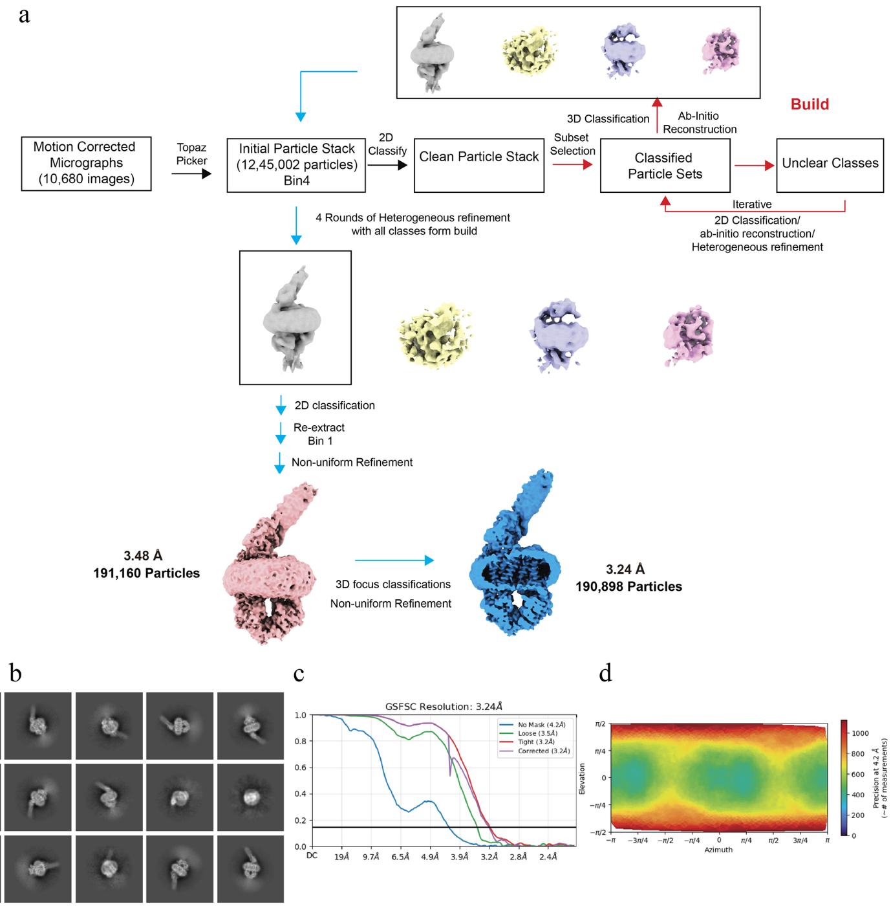
Figure S1. Cryo-EM processing of apo LptB₂FGCH. (a) Workflow for apo LptB₂FGCH cryo-EM data processing. (b) Representative 2D class averages of apo LptB₂FGCH. (c) Gold-standard FSC curve of the final reconstruction, showing an overall resolution of 3.24 Å by the 0.143 criterion. (d) Angular distribution plot for the final particle set.

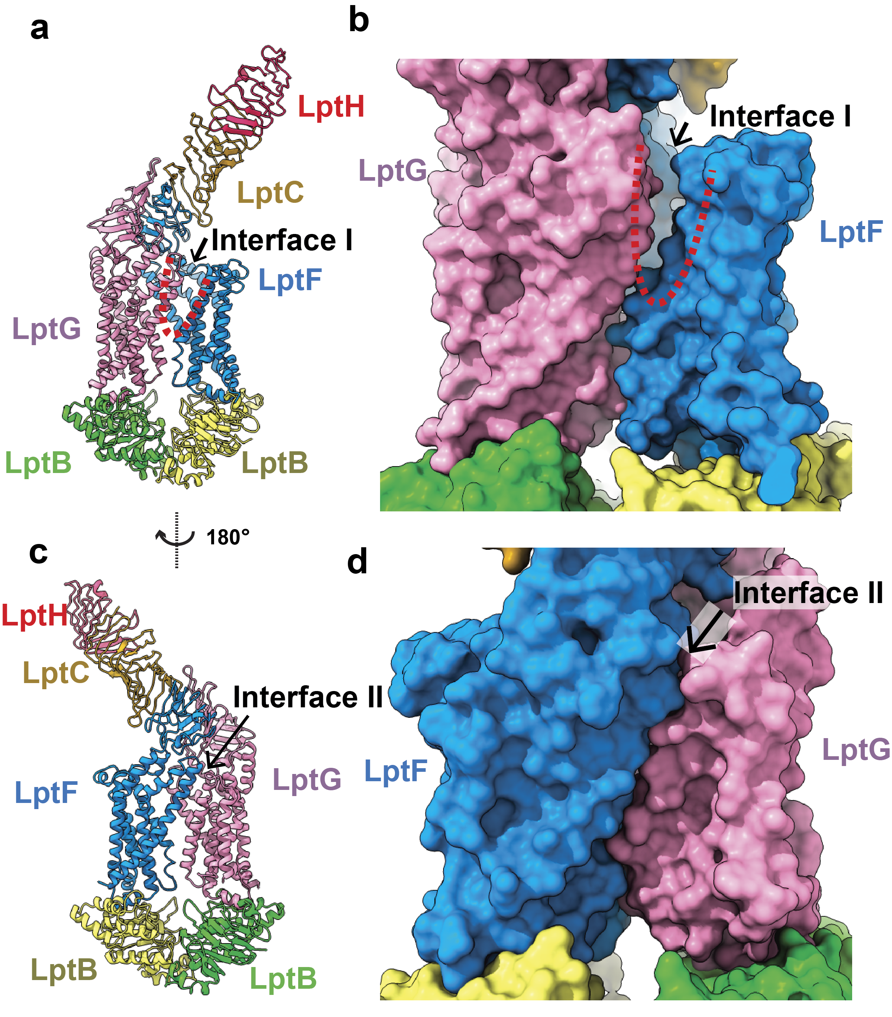
Figure S2. apo LptB₂FGCH displays an asymmetric open–sealed architecture at the LptF–LptG interface. (a) Overall cryo-EM structure of apo LptB₂FGCH, with LptB, LptF, LptG, LptC, and LptH colored green/yellow, blue, pink, gold, and red, respectively. Interface I between LptF and LptG is indicated by a red dashed line. (b) Surface view of Interface I showing an open cleft between LptF and LptG. (c) View of the complex rotated 180° relative to panel a, showing the opposite side of the transporter and the position of Interface II. (d) Surface view of Interface II showing tight packing between LptF and LptG, consistent with a sealed conformation. These data show that apo LptB₂FGCH adopts an asymmetric gate arrangement, with one LptF–LptG interface open and the opposite interface sealed.

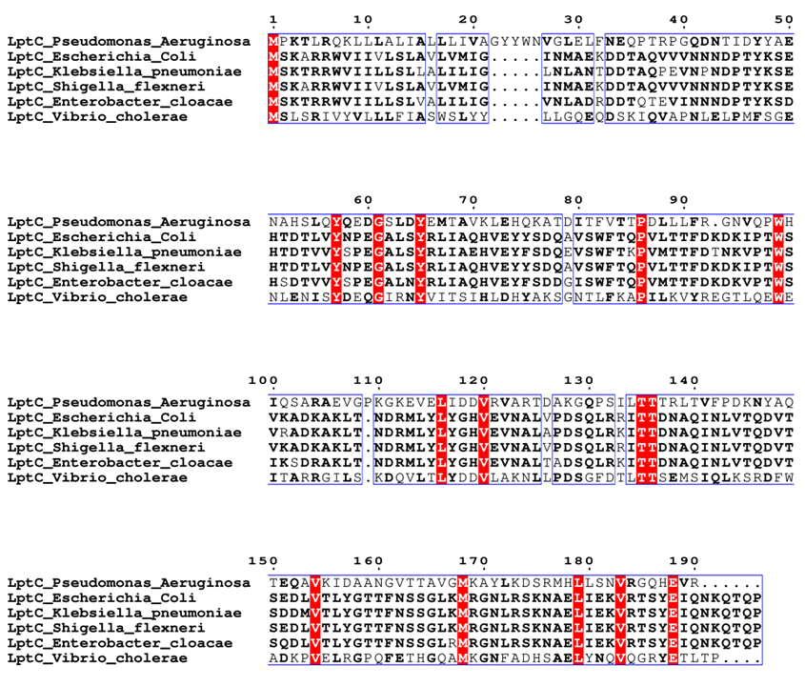
Figure S3. Sequence alignment of P. aeruginosa LptC with its orthologues from E. coli, K. pneumoniae, S. flexneri, E. cloacae, and V. cholerae. Red colour indicates conserved residues, highly similar residues are shown in bold. Cyan circles and arrows indicate the residues chosen for the preparation of conditional mutants. Alignments generated with NPS@ClustalW and ESPript 3.0.
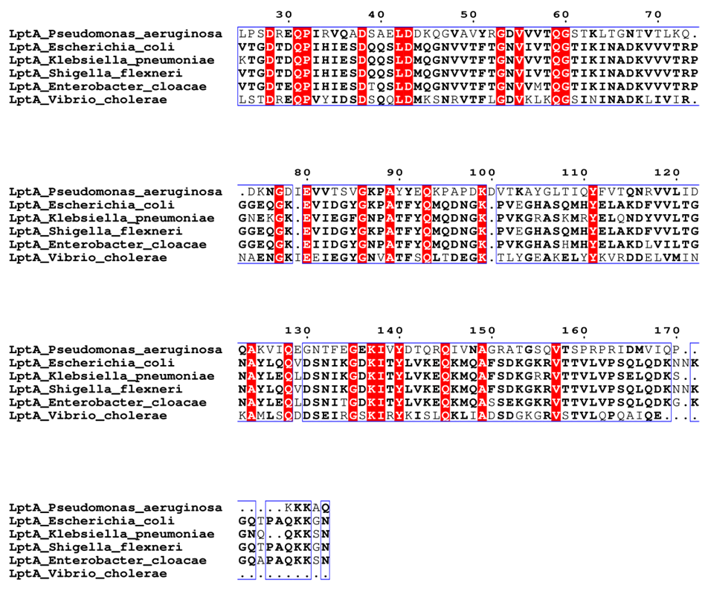
Figure S4. Sequence alignment of P. aeruginosa LptH with its orthologues from E. coli, K. pneumoniae, S. flexneri, E. cloacae, and V. cholerae. Red colour indicates conserved residues, highly similar residues are shown in bold. Cyan circles and arrows indicate the residues chosen for the preparation of conditional mutants. Only the sequence of LptA following removal of the periplasm-targeting peptide has been considered. Alignments generated with NPS@ClustalW and ESPript 3.0.

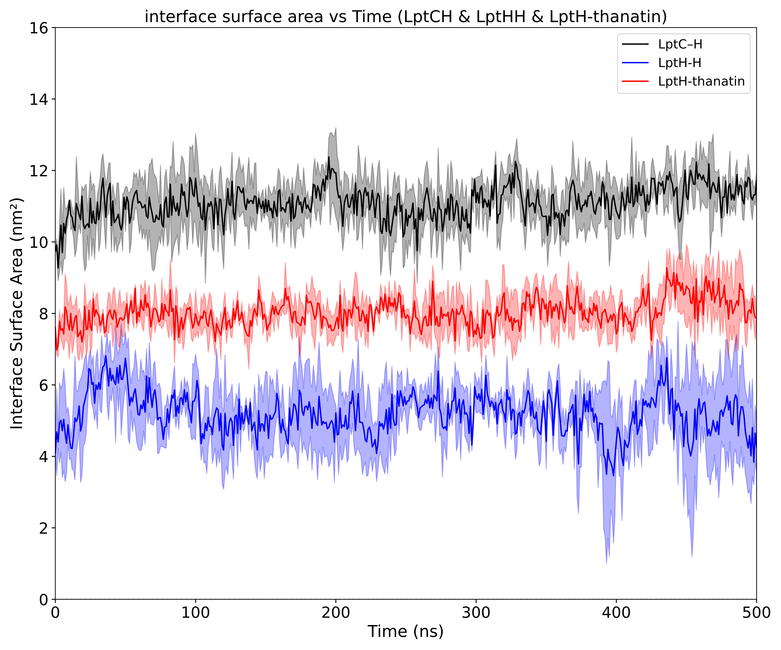
Figure S5. Buried interface surface area profiles for LptC-LptH, LptH-LptH, and LptH-thanatin systems. The black line represents the LptC-LptH interface in the LptC-LptH system, the blue line represents the LptH-LptH interface in the LptH-LptH dimer system, and the red line represents the LptH-thanatin interface in the LptH-thanatin system. The LptH-LptH interface exhibits the smallest buried surface area, whereas the LptC-LptH interface shows the largest buried surface area.

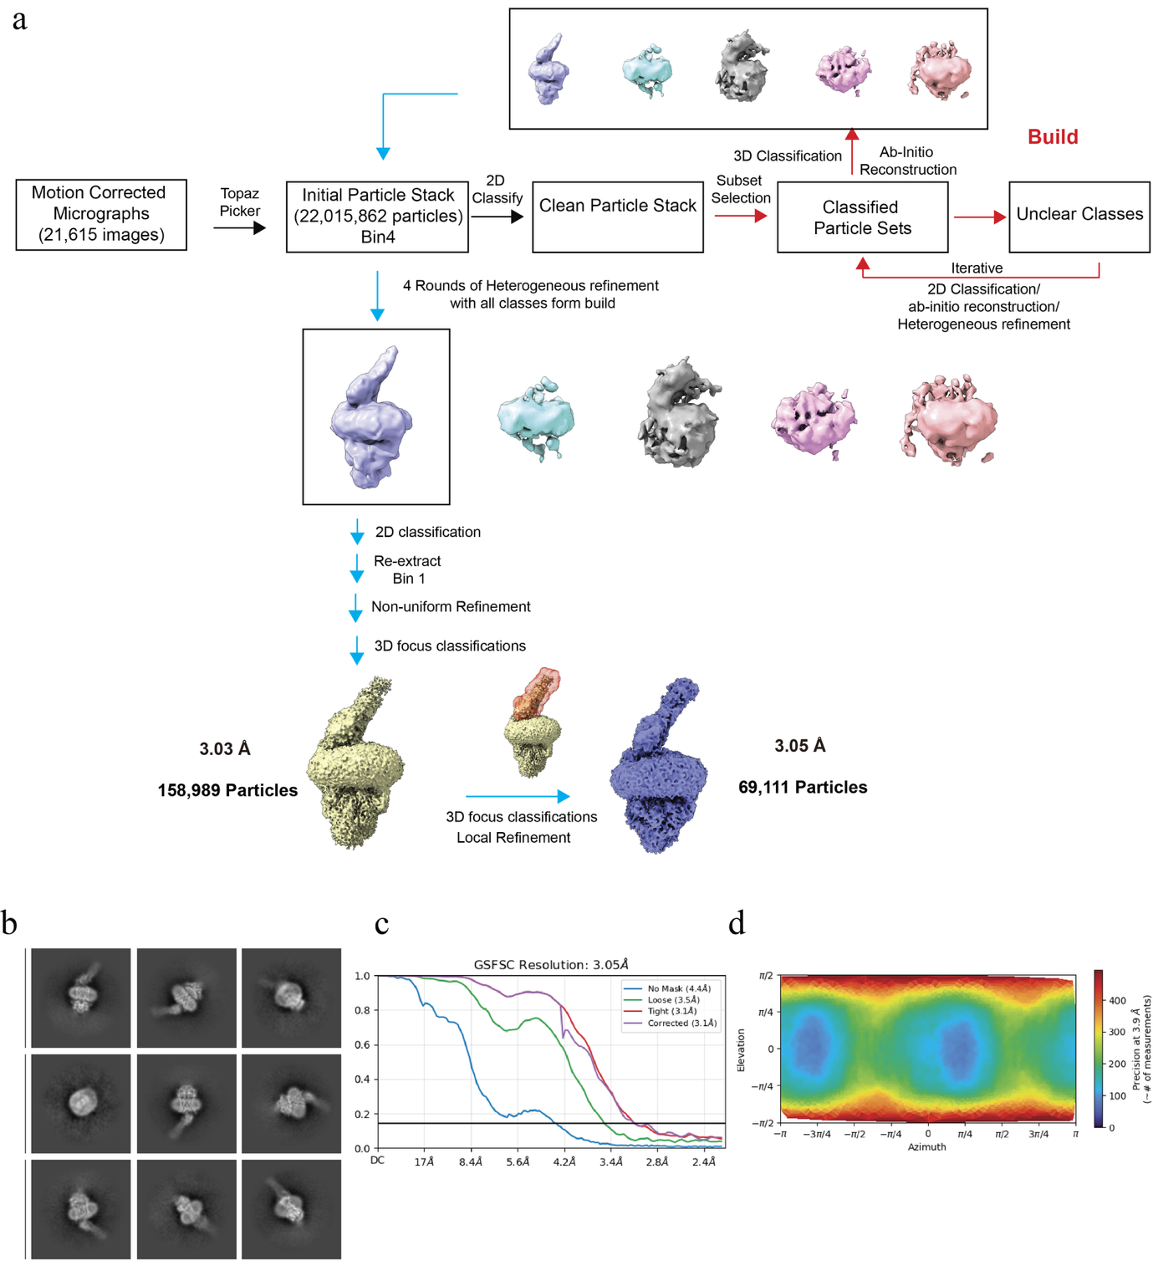
Figure S6. Cryo-EM data processing of the AMP-PNP–bound LptB₂FGCH complex. (a) Cryo-EM processing workflow. (b) Representative 2D class averages. (c) Gold-standard Fourier shell correlation curve, showing an overall resolution of 3.05 Å by the 0.143 criterion. (d) Angular distribution plot for the final particle set.

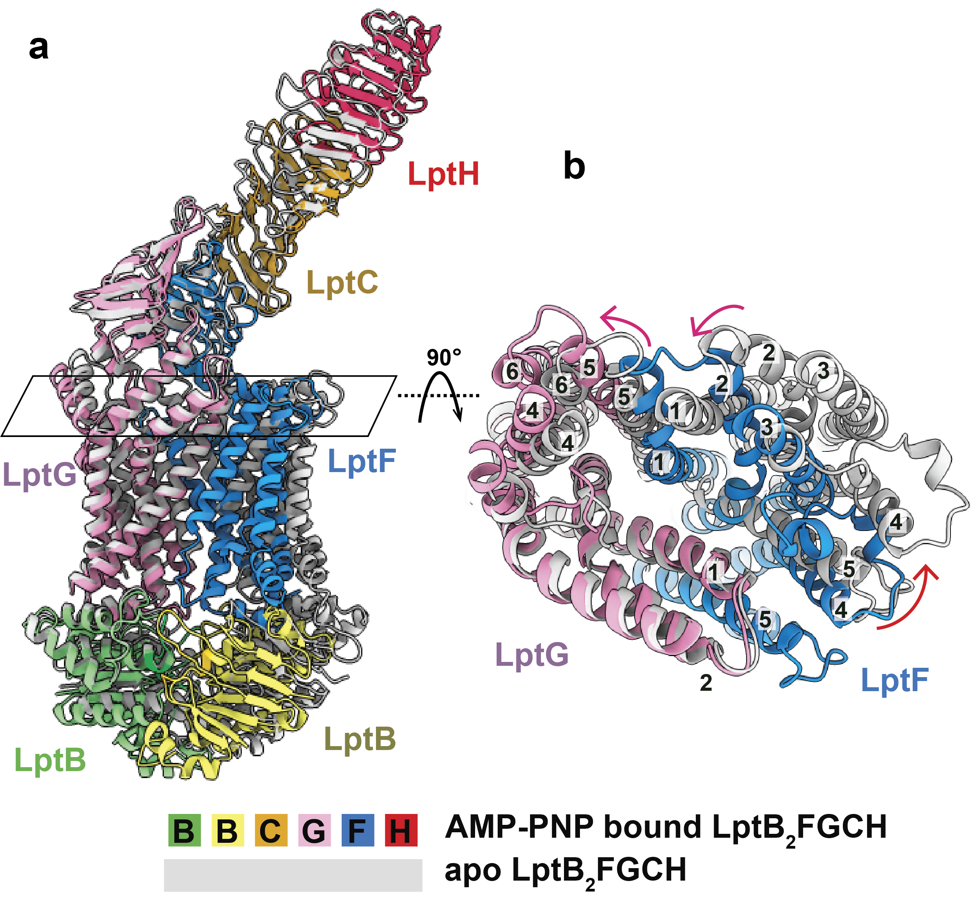

Figure S7. AMP-PNP binding remodels the transmembrane domains of LptB₂FGCH.
(a) Structural overlay of apo and AMP-PNP–bound LptB₂FGCH. The AMP-PNP–bound structure is colored by subunit, with the two LptB protomers shown in green and yellow, LptF in blue, LptG in pink, LptC in gold, and LptH in red; the apo structure is shown in gray. The boxed region marks the transmembrane domain region shown after a 90° rotation in b.
(b) 90° rotated view of the boxed region in a, highlighting nucleotide-dependent rearrangements of the LptF and LptG transmembrane helices. Transmembrane helices are numbered, and arrows indicate major conformational shifts upon AMP-PNP binding.

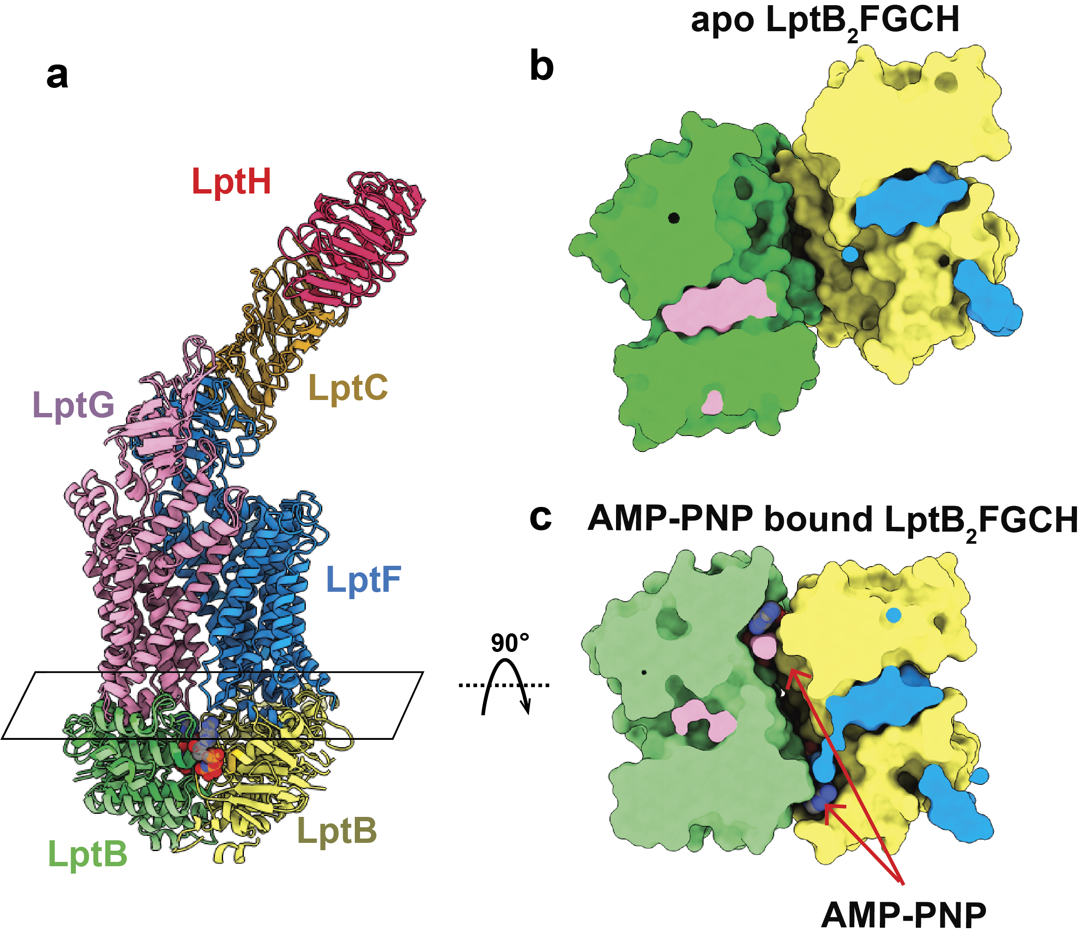
Figure S8. AMP-PNP binding induces LptB₂ NBD closure in the LptB₂FGCH complex.
(a) Overlay of apo and AMP-PNP–bound LptB₂FGCH structures, showing the overall transporter–bridge architecture. The boxed region marks the cytoplasmic LptB₂ nucleotide-binding domains, which are shown after a 90° rotation in panels b and c.
(b, c) 90° rotated cytoplasmic views of the LptB₂ NBD region in the apo (b) and AMP-PNP–bound (c) states. The apo complex shows separated LptB NBDs, whereas AMP-PNP binding promotes NBD closure/dimerization. AMP-PNP molecules are shown as spheres and highlighted by red arrows.

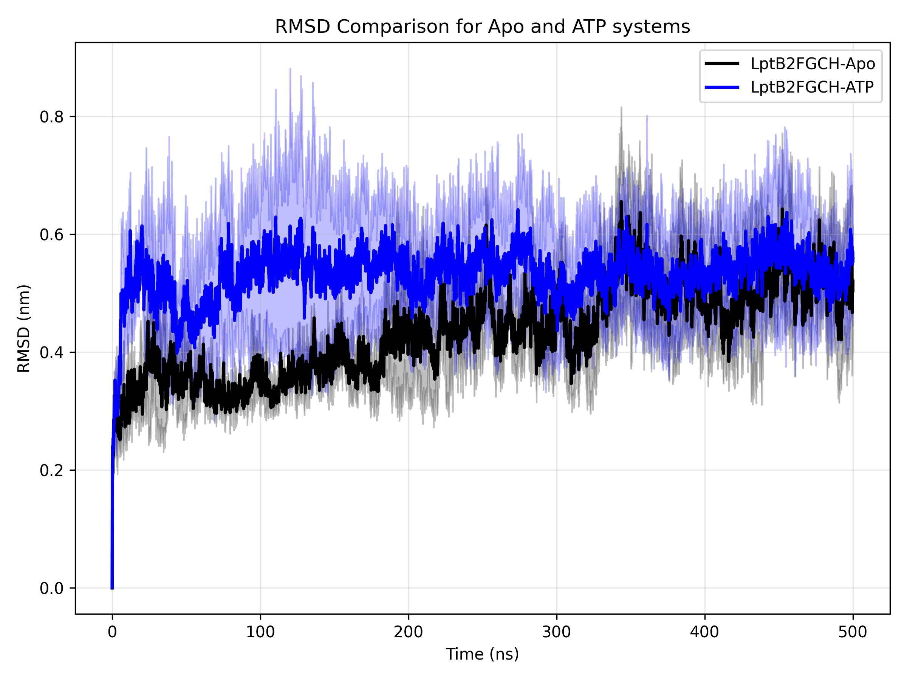
Figure S9. Cα-RMSD analysis of LptB₂FGC-LptH systems. Cα-RMSD profiles of different LptB₂FGC-LptH systems over three independent 500 ns MD simulations. Solid lines represent the mean Cα-RMSD across the three replicas, and shaded regions indicate the standard deviation.

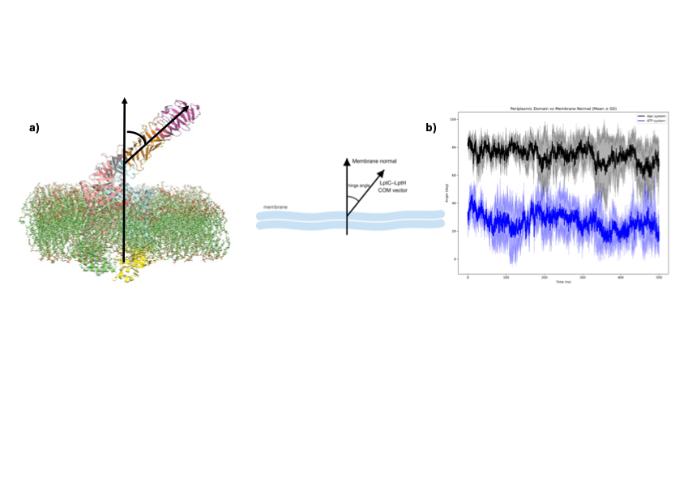
Figure S10. Hinge-angle analysis of the LptC-LptH complex relative to the membrane normal. a) Schematic representation of the hinge-angle definition. The angle was calculated between the membrane normal vector and the centre-of-mass (COM) vector of the LptC-LptH complex, as illustrated using both the molecular structure and a simplified diagram. b) Time evolution of the hinge angle in the apo and ATP-bound LptB2FGCH systems over 500 ns simulations. Solid lines represent the mean hinge angle calculated from three independent replicas, while shaded regions indicate the corresponding standard deviation.

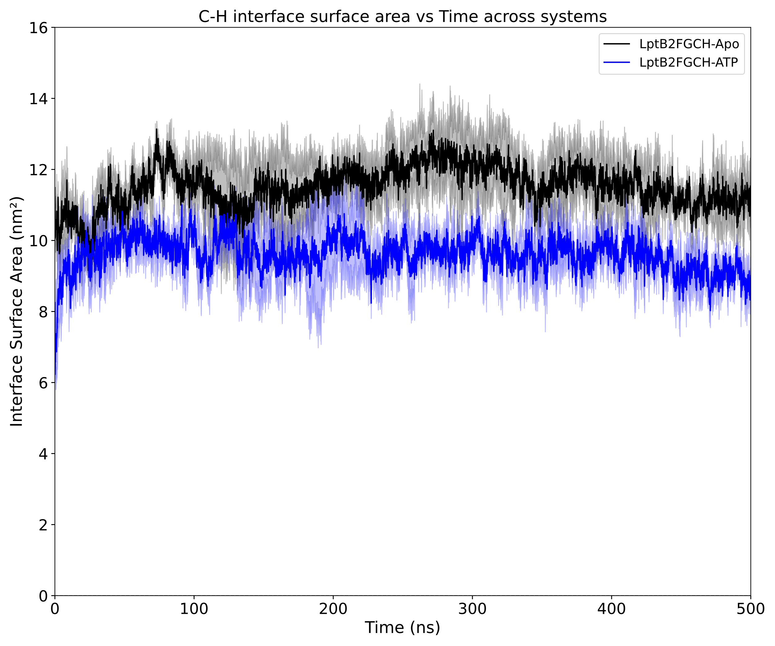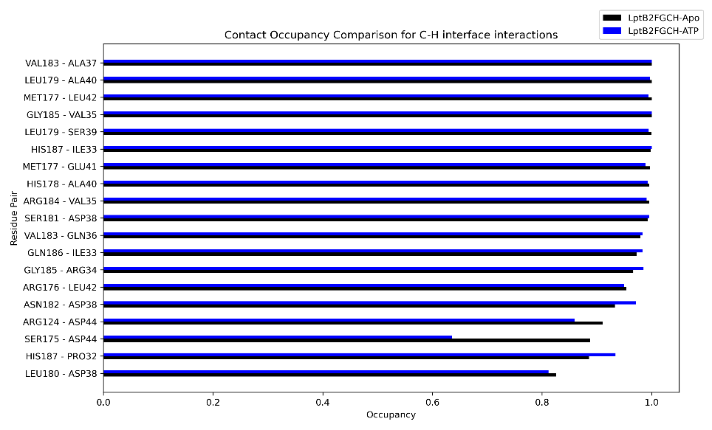
Figure S11. LptC-LptH interface with and without ATP. The interface surface area between LptC and LptH was monitored over three independent 500 ns simulations for the apo and ATP-bound systems (top).
The occupancy of selected residue-residue contacts at the LptC-LptH interface was quantified for the apo and the ATP-bound LptB2FGCH systems. Bars represent the percentage of simulation frames in which each interfacial contact was formed, with apo shown in black and ATP-bound shown in blue (bottom).

Table S1. Cryo-EM data collection, processing, and refinement statistics for LptB₂FGCH with and without AMPPNP.
Data set |  | Apo LptB₂FGCH |  | AMP-PNP LptB₂FGCH
Data collection and processing
Magnification |  | 81,000 |  | 81,000
Voltage (kV) |  | 300 |  | 300
Electron Microscope |  | Krios-GIF-K3 |  | Krios-GIF-K3
Defocus range (μm) |  | -1.0 to -2.5 |  | -1.0 to -2.5
Total exposure time (s) |  | 2 |  | 2
Pixel size (Å) |  | 1.08 |  | 1.122
Total dose (e⁻/ Å²) |  | 40.0 |  | 40.0
Number of frames |  | 40 |  | 40
Does rate (e⁻/ phys. Pixel/s)
No. of initial micrographs |  | 9,879 |  | 21,615
No. of initial particles |  | 12,545,002 |  | 22,015,862
No. of final particles |  | 190,898 |  | 69,111
Symmetry |  | C1 |  | C1
GSFSC Resolution (Å) |  | 3.24 |  | 3.05
FSC threshold (0.143)
Map resolution range (Å) |  | 2.85-30 |  | 2.86-41.33
Refinement
Model resolution cut-off (Å) |  | 3.24 |  | 3.05
Model composition
No. of Protein residues |  | 1447 |  | 1466
No. of ligands |  | 0 |  | 2
RMSDª
Bond lengths (Å) |  | 0.003 |  | 0.003
Bond angles (°) |  | 0.585 |  | 0.661
 | Validation
 | MolProbity score | 2.42 |  | 2.14
 | Clash score | 12.43 |  | 13.69
 | Rotamer outliers (%) | 0 |  | 0
 | Ramachandran plot (%)
 | Favored (%) | 94.49 |  | 94.98
 | Allowed (%) | 5.44 |  | 5.02
 | Disallowed (%) | 0.07 |  | 0
 | CC mask | 0.86 |  | 0.81
 | CC box | 0.76 |  | 0.72
 | CC vol | 0.85 |  | 0.81
 |  |  | ª, root mean square deviation;

