SUPPLEMENTARY INFORMATION
Structured residual co-occurrence in a solitary felid: spatial-demographic organization and reproductive connectivity in Iberian lynx
José Jiménez, Rafael Finat, Juan Francisco Sánchez, Jose Antonio Godoy,
Jose María Gil-Sanchez, Emilio Virgós

SUPPLEMENTARY FIGURES

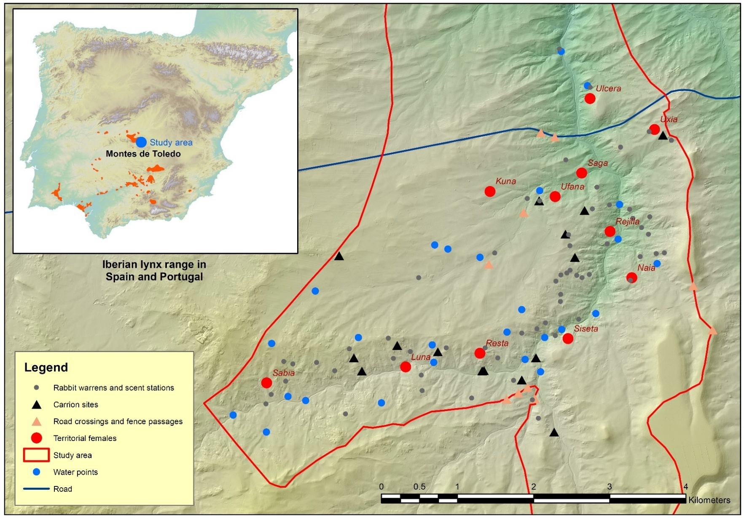

SUPPLEMENTARY FIGURE S1. Spatial distribution of sampling locations and territorial female Iberian lynx within the Montes de Toledo study area. The map of Iberian lynx range in Spain and Portugal was adapted by the authors from the LIFE LYNXCONNECT project (https://lifelynxconnect.eu/censos/#2025; accessed 5 August 2026).

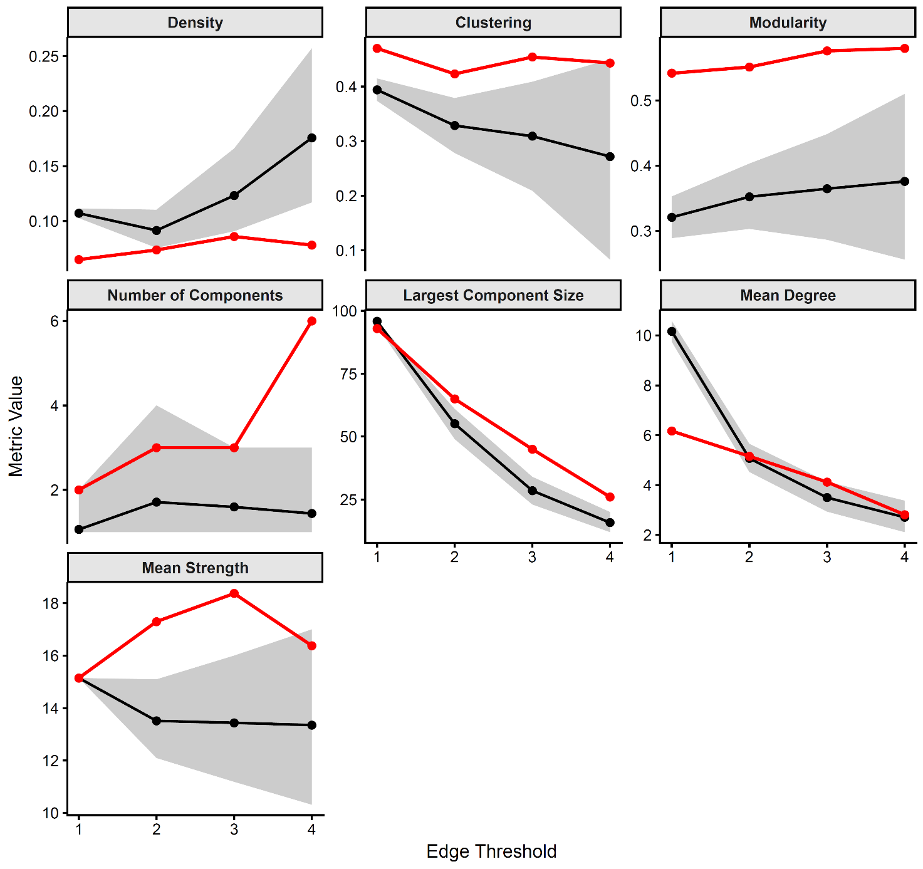
SUPPLEMENTARY FIGURE S2. Sensitivity of residual association-network metrics to the minimum edge-weight threshold. Red points and lines show values for the observed residual association network, black points and lines show mean values obtained from within-year GBI row-column swap permutations, and grey bands indicate the 95% permutation intervals (2.5-97.5%). Permutations preserved residual record size, annual individual occurrence frequencies and annual sampling structure. Metrics are shown across minimum edge-weight thresholds ranging from one to four co-occurrences. Panels show network density, global clustering coefficient, modularity, number of connected components, size of the largest connected component, mean degree and mean strength.

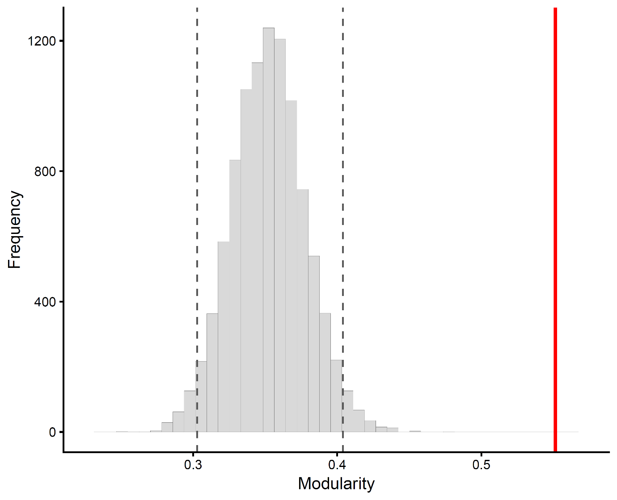

SUPPLEMENTARY FIGURE S3. Distribution of modularity values obtained from 10,000 within-year GBI row-column swap permutations of the residual association network. Permutations preserved residual record size, annual individual occurrence frequencies and annual sampling structure. The histogram shows the distribution of modularity values obtained from randomized networks. Dashed vertical lines indicate the 2.5% and 97.5% quantiles of the permutation distribution, and the red vertical line indicates the observed modularity of the residual association network.

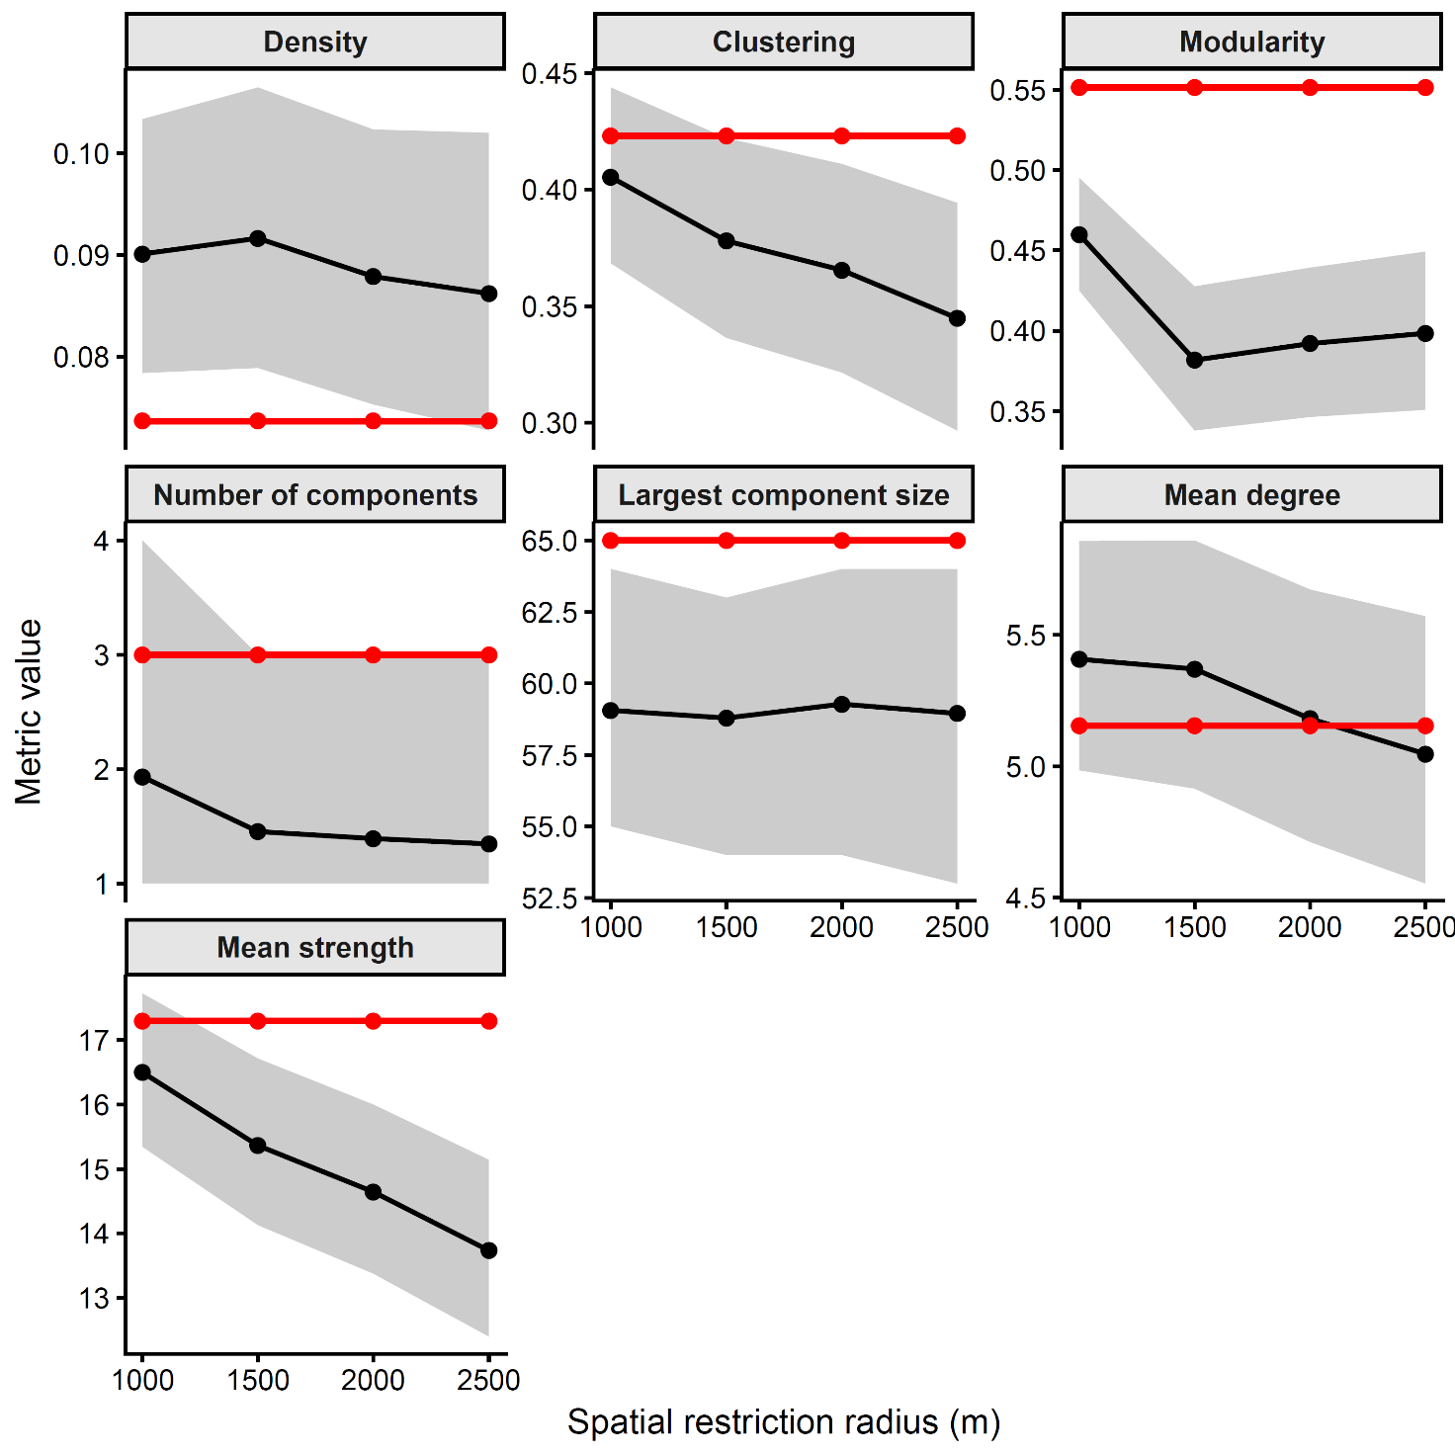
SUPPLEMENTARY FIGURE S4. Spatially restricted GBI row-column swap permutations of residual association-network metrics. Red points and lines show observed values for the residual association network, black points and lines show mean values from spatially restricted permutations, and grey bands indicate the 95% permutation intervals (2.5-97.5%). Permutations preserved residual record size, annual individual occurrence frequencies and annual sampling structure while restricting row-column swaps to individuals associated with spatial reference points within increasing neighbourhood radii (1.0-2.5 km). Panels show density, global clustering coefficient, modularity, number of connected components, size of the largest connected component, mean degree and mean strength across alternative spatial restriction radii.

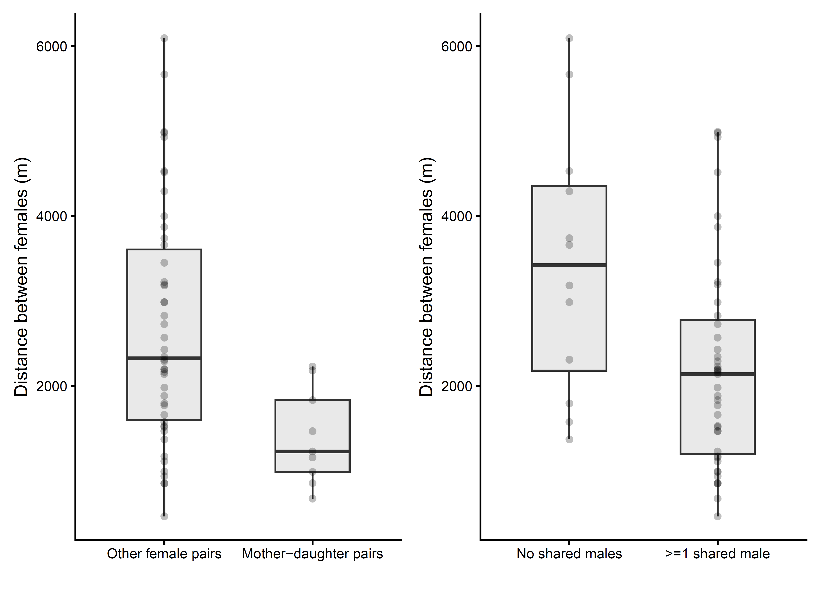

SUPPLEMENTARY FIGURE S5. Female-female spatial distances according to maternal relationship and male-sharing status. Left: Distances between mother-daughter pairs and all other reproductive female pairs. Right: Distances between female pairs sharing no males and female pairs sharing at least one territorial or other recorded male during the study period. Boxes show medians and interquartile ranges, and points represent individual female-female dyads. Mother-daughter pairs were closer than other female pairs, and female pairs sharing at least one male were closer than pairs not sharing males. To account for dyadic non-independence, we used MRQAP with log-transformed female-female distance as the response matrix and the number of shared males and mother-daughter status as predictor matrices, using 10,000 permutations. In this model, both shared males and mother-daughter relationship were negatively associated with female-female distance, indicating that reproductive females connected by maternal recruitment or male sharing were spatially closer.

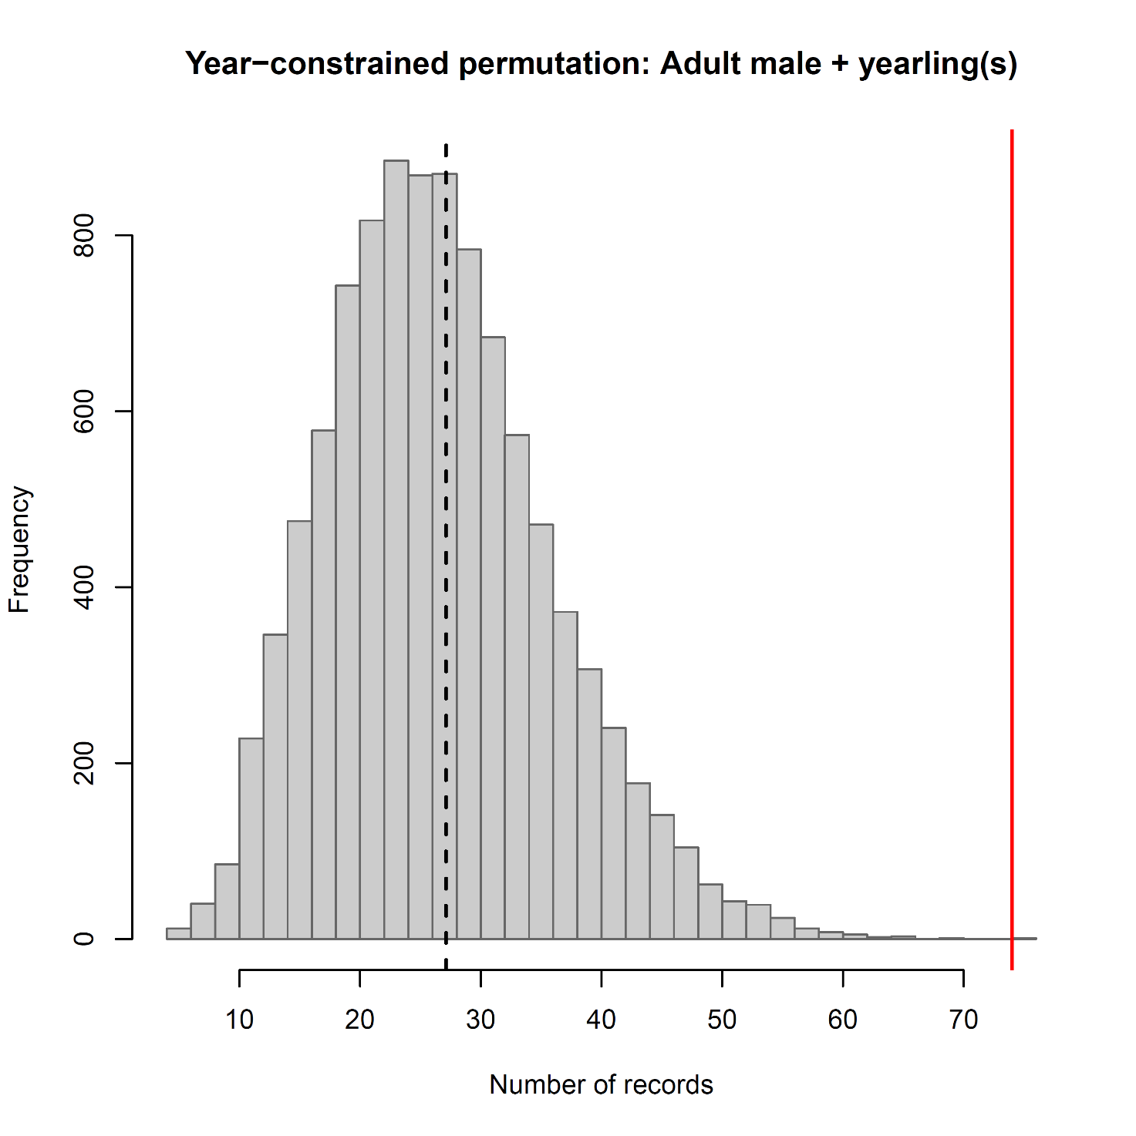

SUPPLEMENTARY FIGURE S6. Year-constrained identity-label permutation test for adult male-yearling records. The histogram shows the distribution of the number of records classified as Adult male + yearling(s) across 10,000 year-constrained identity-label permutations. Individual identities were randomly reassigned within years, and the full kinship-composition classification was rerun for each permuted dataset. The red vertical line indicates the observed value, 74 records. The dashed black vertical line indicates the mean of the permutation distribution.

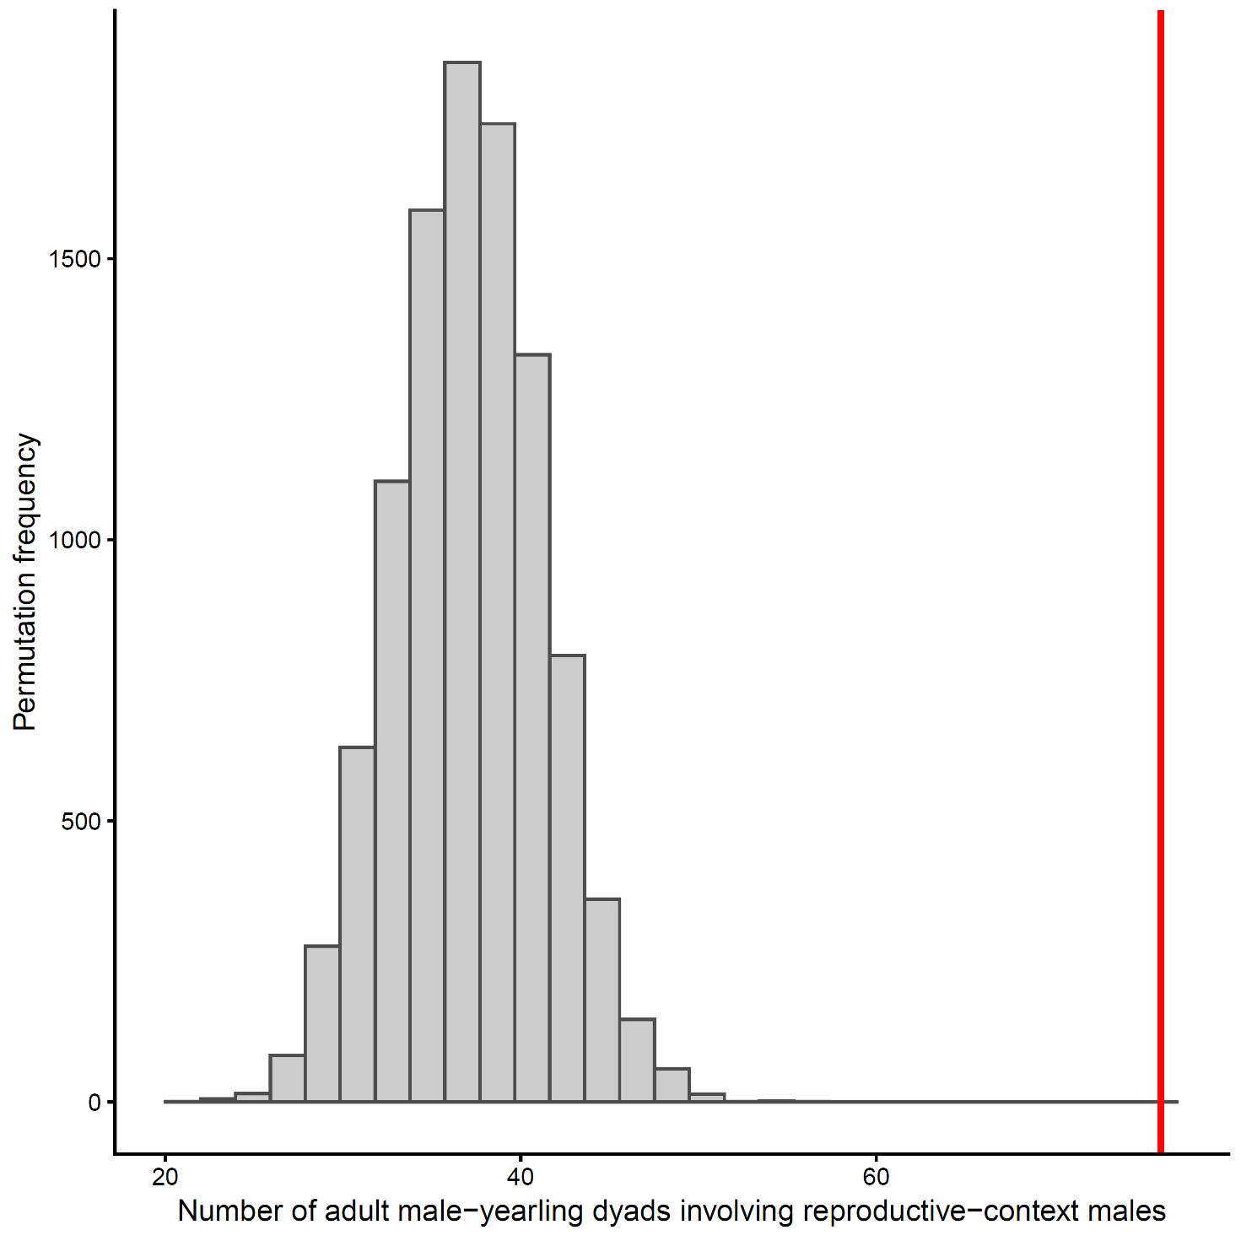

SUPPLEMENTARY FIGURE S7. Year-constrained random male-assignment test for adult male-yearling event dyads involving males from the yearling's documented maternal reproductive context. Grey bars show the permutation distribution of the number of adult male-yearling event dyads involving reproductive-context males under random assignment of adult male identities within years. Permutations preserved event year, yearling identity, maternal identity, yearling birth year and the total number of observed adult male-yearling event dyads. The red vertical line indicates the observed value (76 event dyads). The mean and 95% permutation interval were 36.9 and 29-45 event dyads, respectively.

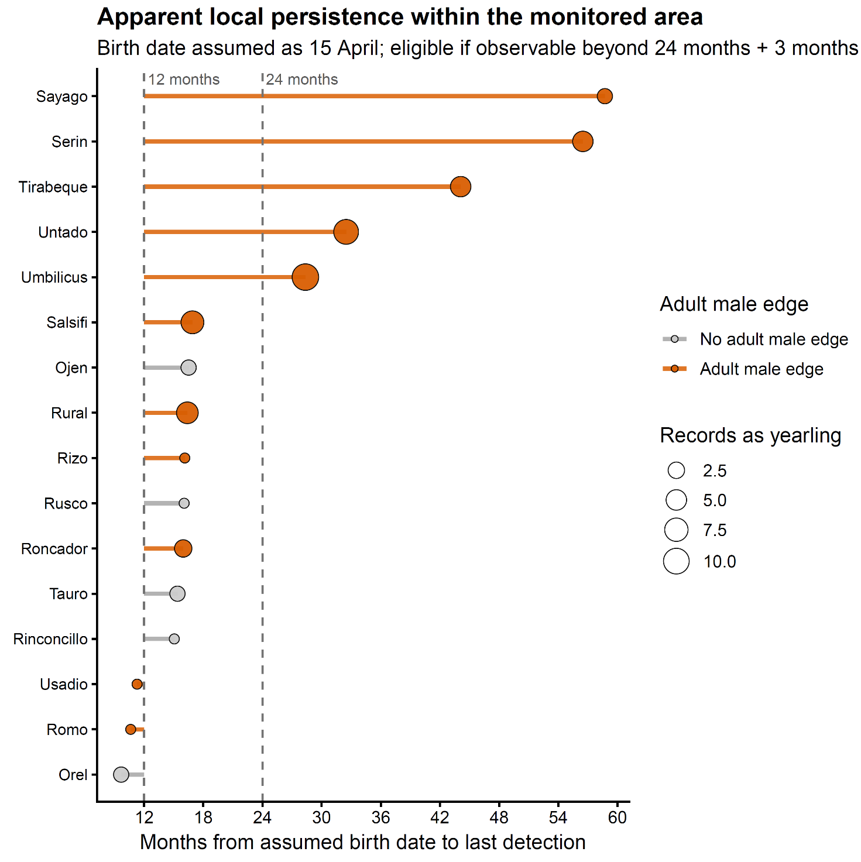

SUPPLEMENTARY FIGURE S8. Apparent persistence within the monitored area according to observed residual edges to adult males during the yearling stage. Persistence was measured as the number of months between the assumed birth date, 15 April of the birth year, and the last camera-trap detection within the monitored area. The analysis included only males with sufficient follow-up opportunity to be observable beyond 24 months of age plus an additional 3-month monitoring window. Dashed vertical lines indicate 12 months and the 24-month dispersal-age threshold. Point size represents the number of camera-trap records during the yearling year.

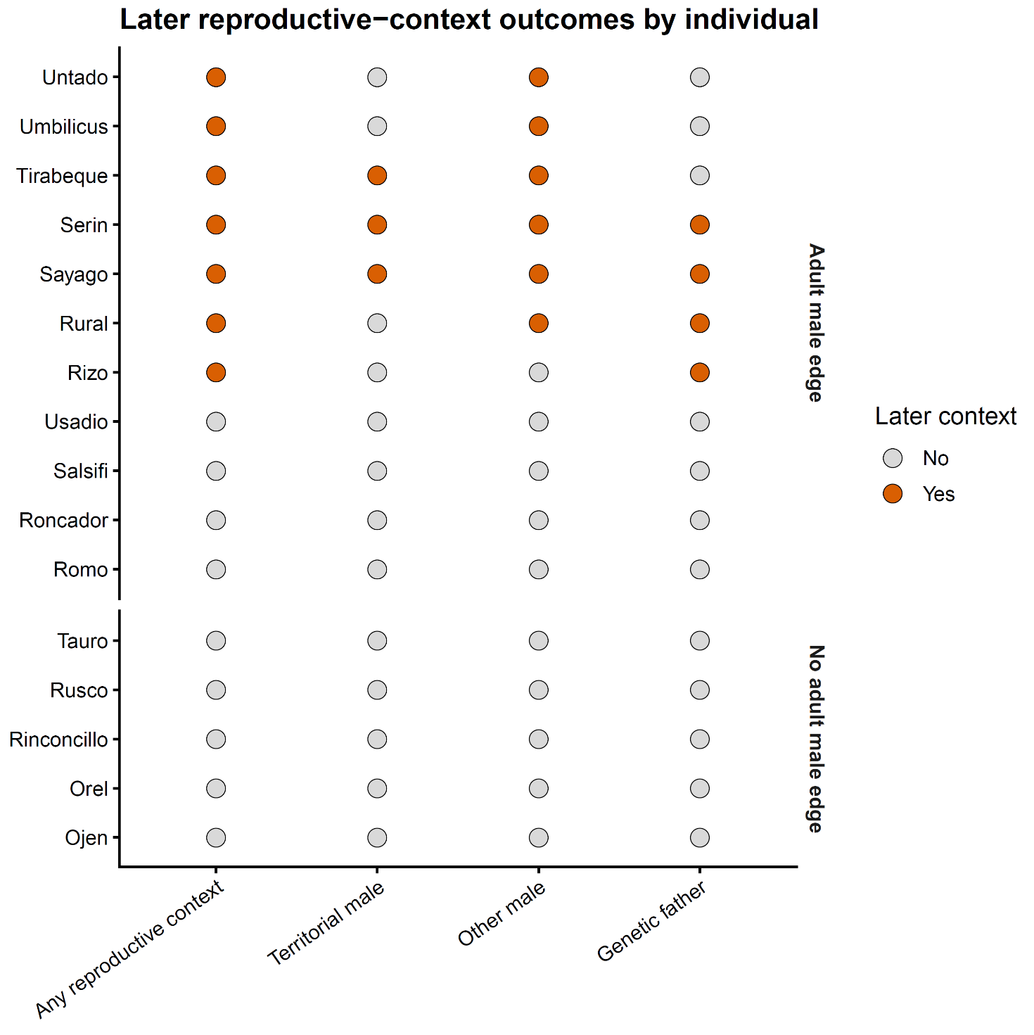

SUPPLEMENTARY FIGURE S9. Later reproductive-context outcomes of male yearlings with and without adult-male residual edges. Individual-level summary of whether each male later appeared in documented reproductive contexts. Points indicate presence (orange) or absence (grey) of four later-context categories: any reproductive context, territorial male, other male, and genetic father. Individuals are grouped according to whether they had an observed residual association edge with an adult male during the yearling stage. The figure shows that later reproductive-context involvement was concentrated among males with adult-male residual edges, whereas males without such edges were not subsequently recorded in any documented reproductive context.

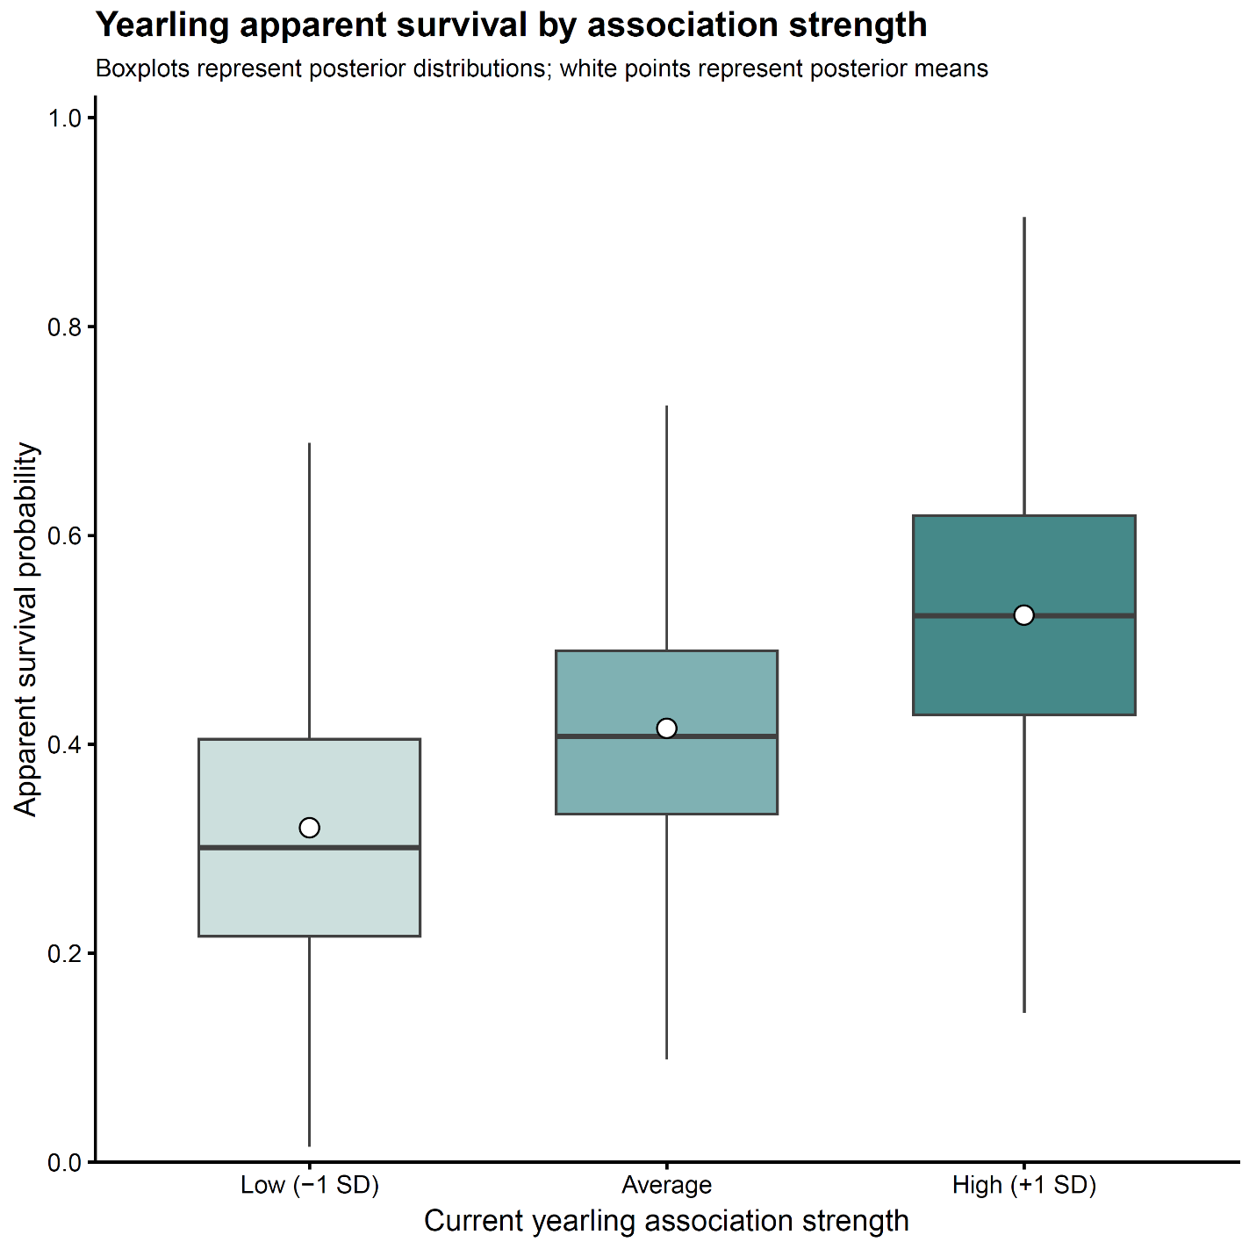

SUPPLEMENTARY FIGURE S10. Yearling apparent survival according to current association strength. Posterior distributions of apparent survival for yearlings with annual association strength one standard deviation below the mean, at the mean and one standard deviation above the mean. Association strength was calculated from residual co-occurrences with males from the documented maternal reproductive environment, log-transformed and standardized. Boxplots show posterior medians and interquartile ranges, whiskers follow the conventional 1.5 interquartile-range rule, and white points indicate posterior means. Predictions correspond to the mean birth cohort, with the maternal random effect set to zero.

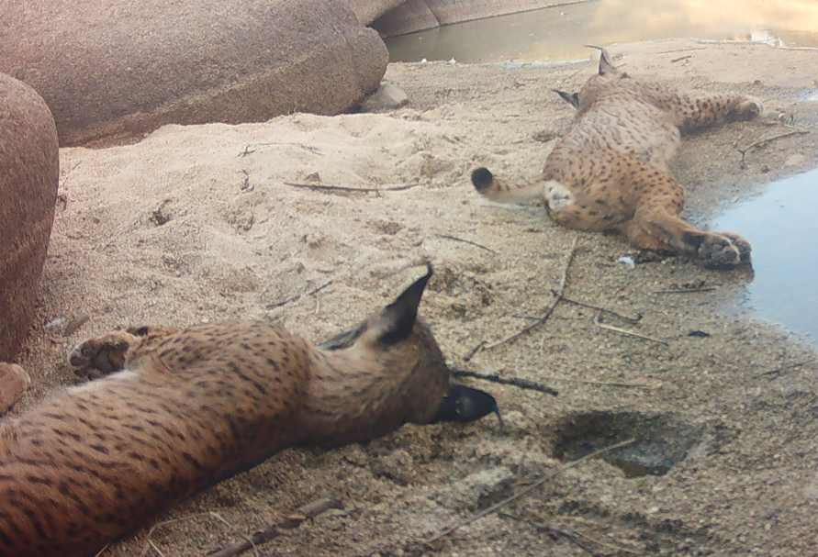
SUPPLEMENTARY FIGURE S11. Close association between the adult male Sayago and the yearling Umbilicus in 2024. Genetic parentage analysis confirmed him as Umbilicus’ father.

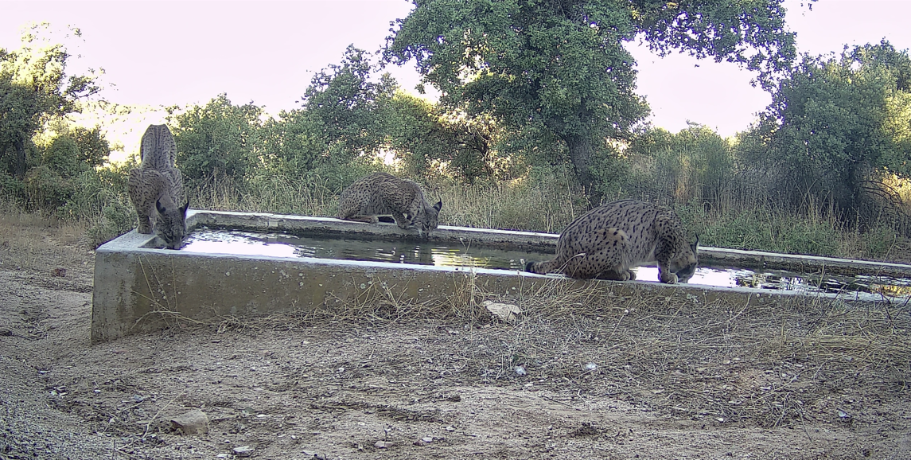

SUPPLEMENTARY FIGURE S12. Male Sayago (3 years old) recorded with the yearlings Ulcera and Umbilicus at a water point in 2024. This image illustrates the adult male-yearling association pattern identified within the residual co-occurrence dataset.

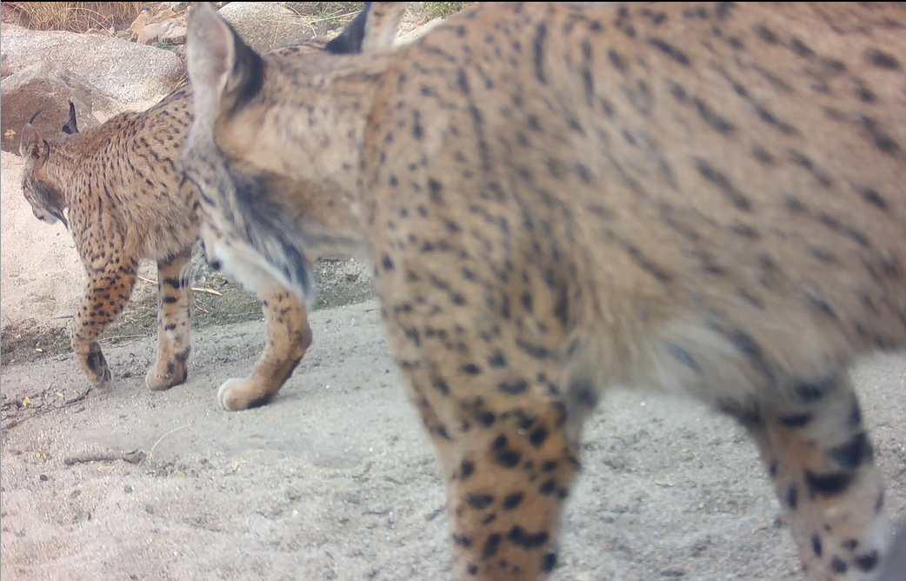
SUPPLEMENTARY FIGURE S13. Adult male Sayago (4 years old) and Umbilicus (2 years old) photographed together in 2025. The Sayago-Umbilicus dyad constituted a high-frequency residual edge in the 2017-2025 residual association network.
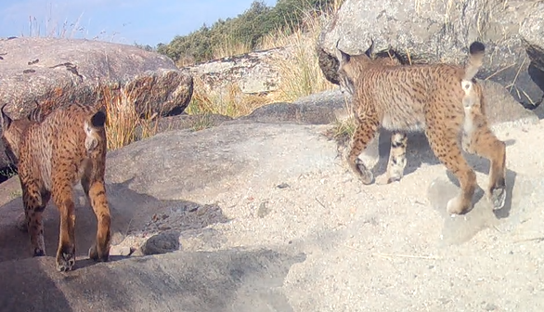

SUPPLEMENTARY FIGURE S14. Adult male Sayago (4 years old) and Umbilicus (2 years old) photographed together in 2025. This dyad formed one of the strongest recurrent residual associations identified in the 2017-2025 residual association network.

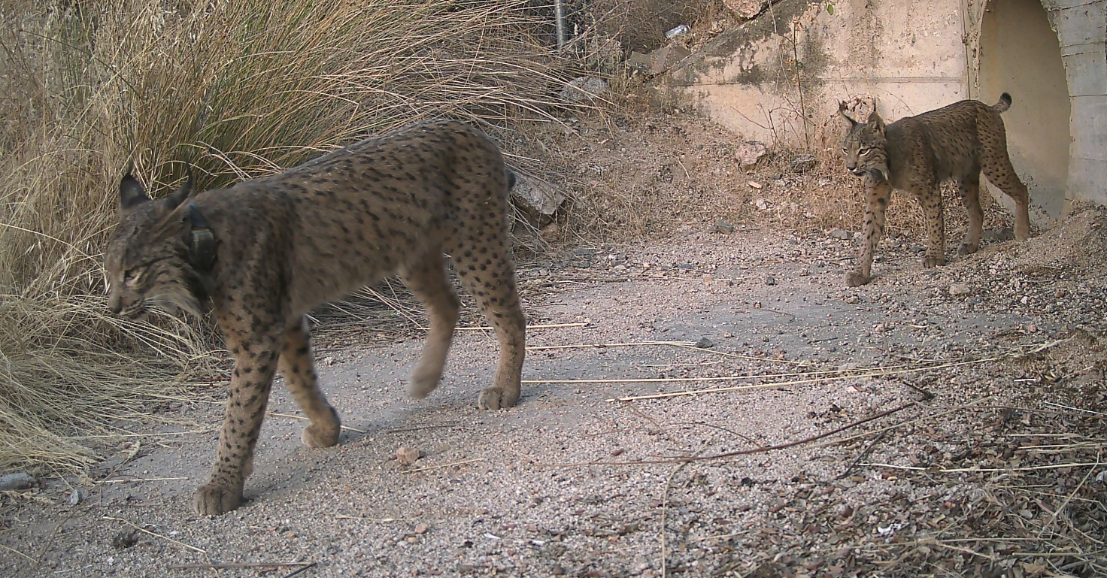
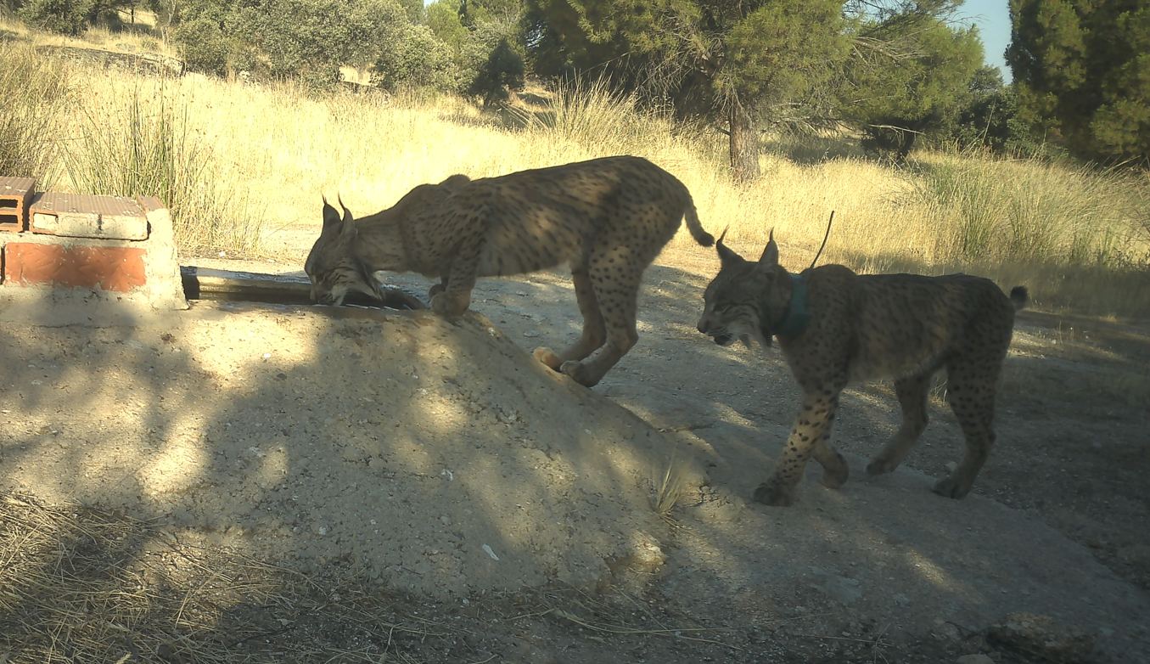
SUPPLEMENTARY FIGURE S15. Adult males Sayago (5 years old) and Umbilicus (3 years old) photographed together at a water point in July 2026. The Sayago-Umbilicus dyad constituted a high-frequency residual edge in the 2017-2025 residual association network.
SUPPLEMENTARY FIGURE S16. Camera-trap image of adult males Serin (5 years old) and Untado (3 years old) recorded together at a wildlife underpass in August 2026. The pair was connected by a strong residual edge based on repeated independent residual co-occurrences in the 2017-2025 association network.

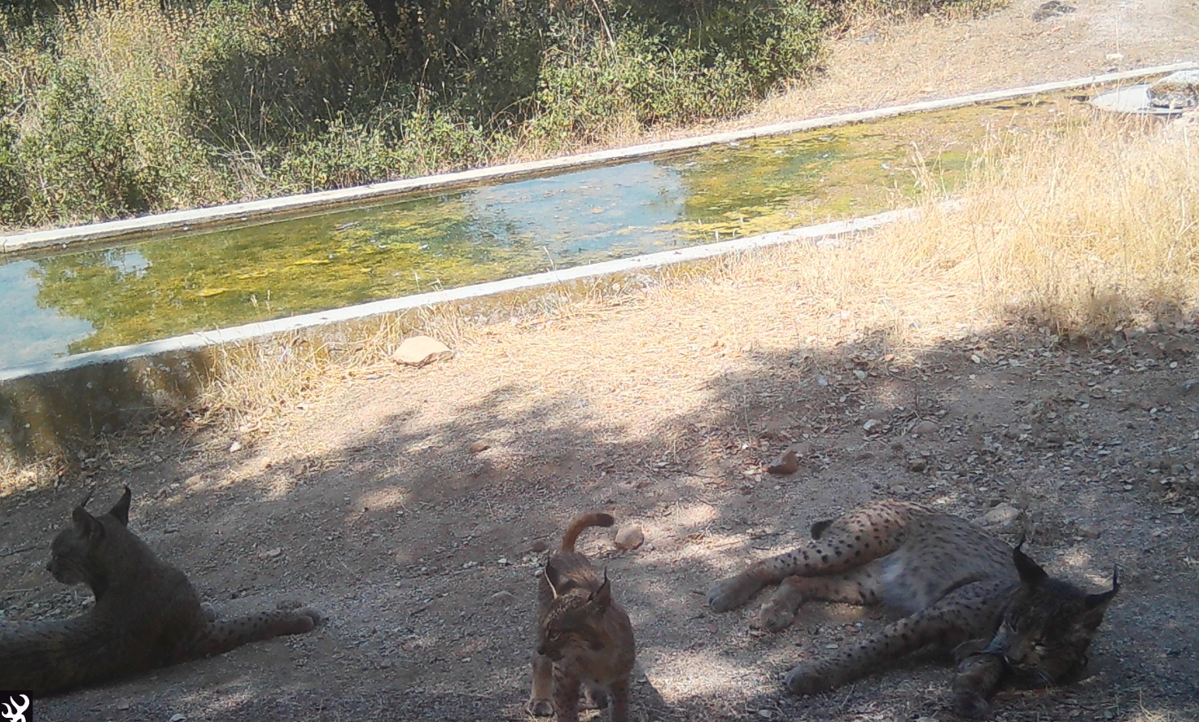
SUPPLEMENTARY FIGURE S17. Adult male Serin (5 years old) and young male Untado (3 years old) resting at a water point in July 2026, together with a cub tentatively attributed to Ulcera. The Serin-Untado dyad constituted a high-frequency residual edge in the 2017-2025 residual association network.
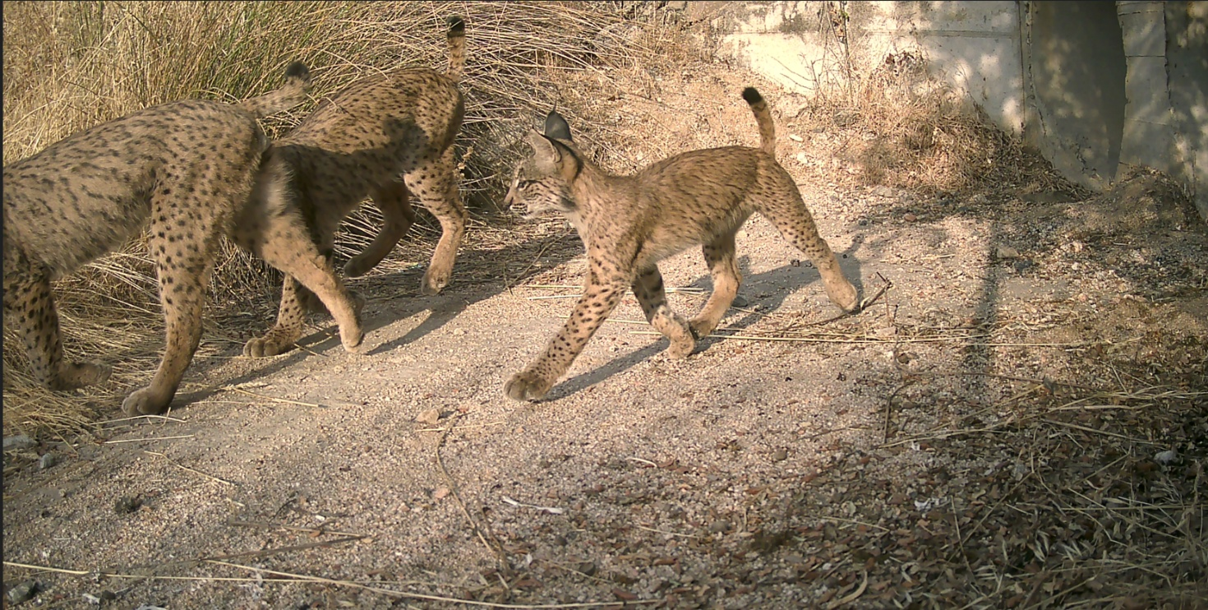
SUPPLEMENTARY FIGURE S18. Camera-trap record from August 2026 at a road crossing showing adult male Serin (5 years old), young male Untado (3 years old), and the same cub attributed to Ulcera as shown in Figure S17.

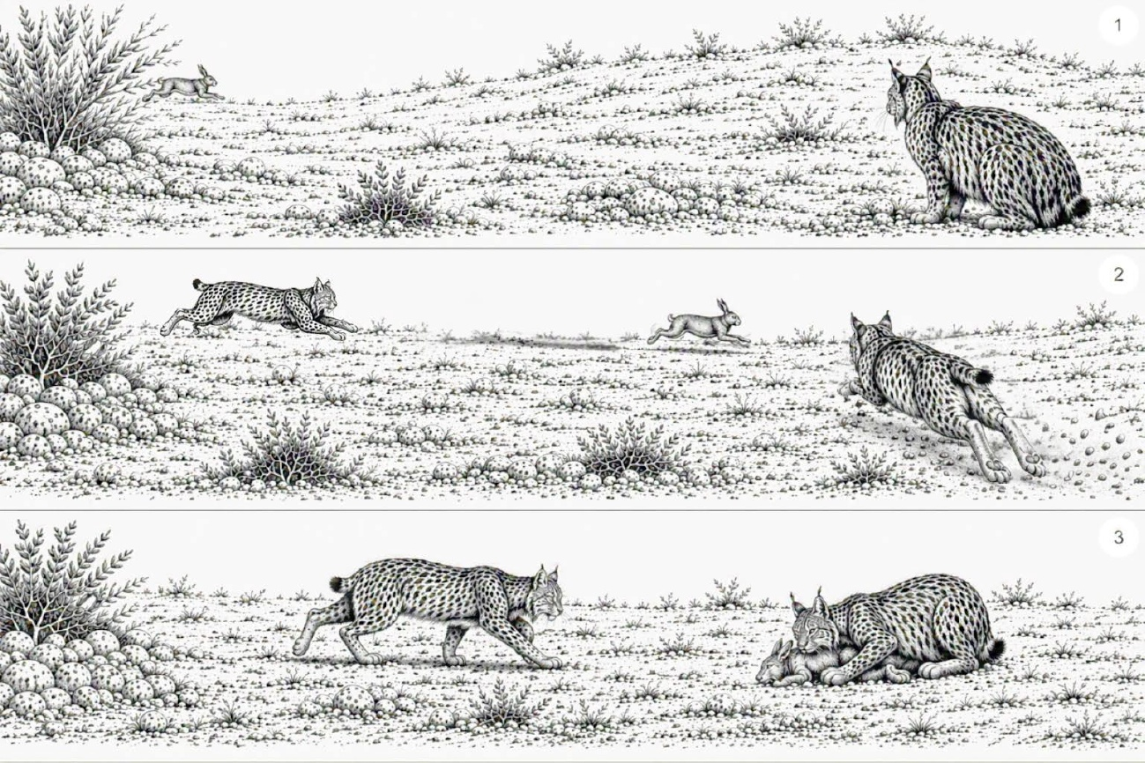

SUPPLEMENTARY FIGURE S19/ SUPPLEMENTARY Videos S1-S2. Apparently coordinated hunting sequence involving two juvenile Iberian lynx. The sequence was recorded on 27 October 2022 and includes two hunting episodes involving two large juvenile lynx. In the first episode, recorded at 15:07 h, a rabbit entered the camera field of view, apparently after being flushed or chased by one juvenile, tentatively identified as Tiza, and passed in front of a second juvenile, Tundra, waiting nearby; the waiting juvenile then initiated a chase, although capture was not confirmed. In the second episode, recorded at 17:47 h, one juvenile, again tentatively identified as Tiza, chased a rabbit towards the position of the second juvenile, Tundra, which remained stationary before rushing forward and apparently intercepting the rabbit.

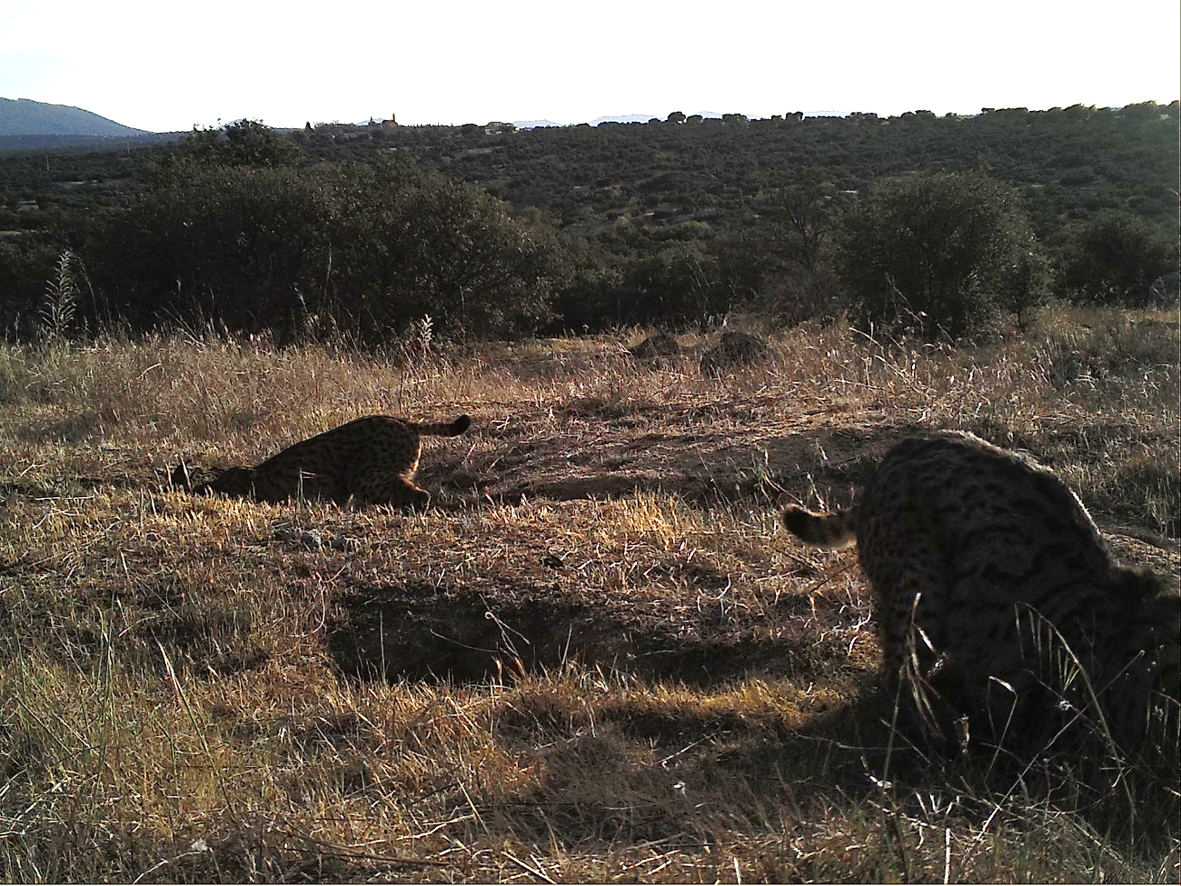

SUPPLEMENTARY FIGURE S20. Adult male (Nerpio) and yearling (Pyros) photographed at a rabbit warren in 2019, each positioned at a different burrow entrance. The configuration is consistent with functionally coordinated hunting behavior, with the two individuals occupying complementary positions around the warren.

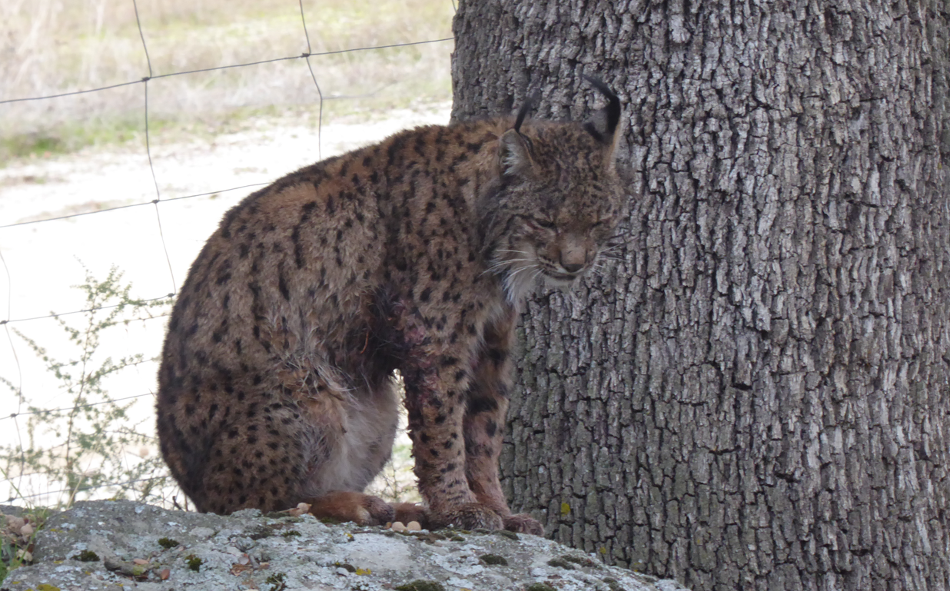

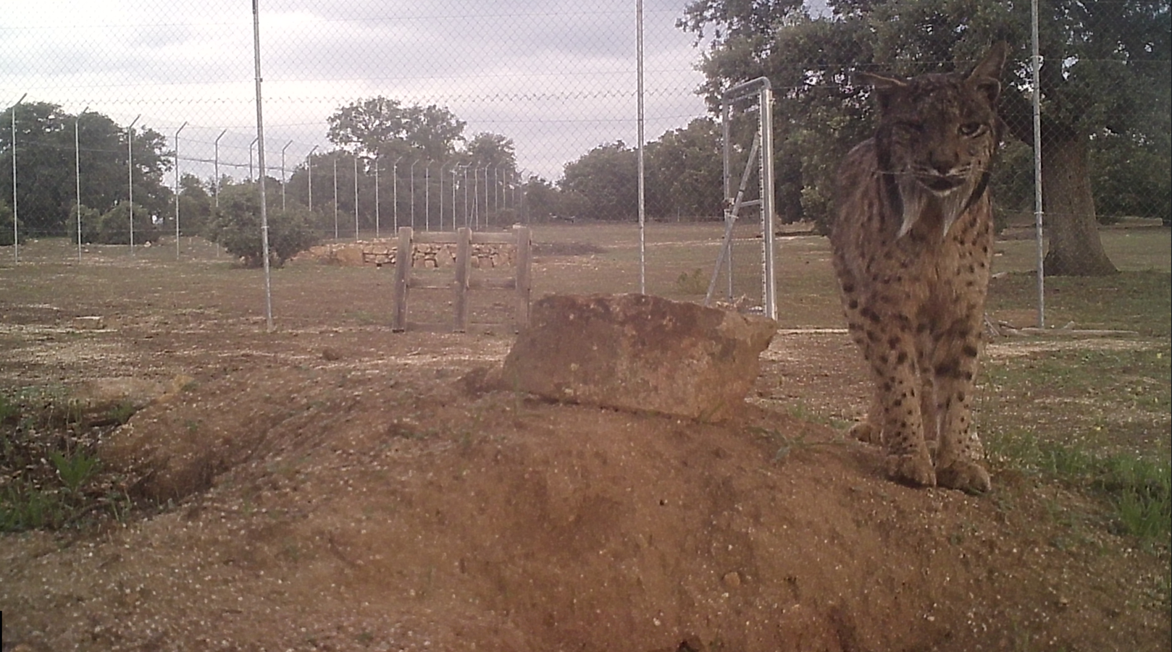
SUPPLEMENTARY FIGURE S21. Mosto after the attack by Lucero on 21 December 2016. Extensive soft-tissue injuries are visible in the pectoral and axillary region, including open wounds and areas of apparent skin tearing.

SUPPLEMENTARY FIGURE S22. Nerpio photographed near the reintroduction enclosure on 19 June 2023. Visible wounds on the facial region are compatible with a recent aggressive encounter, although the circumstances of the interaction were not directly documented.
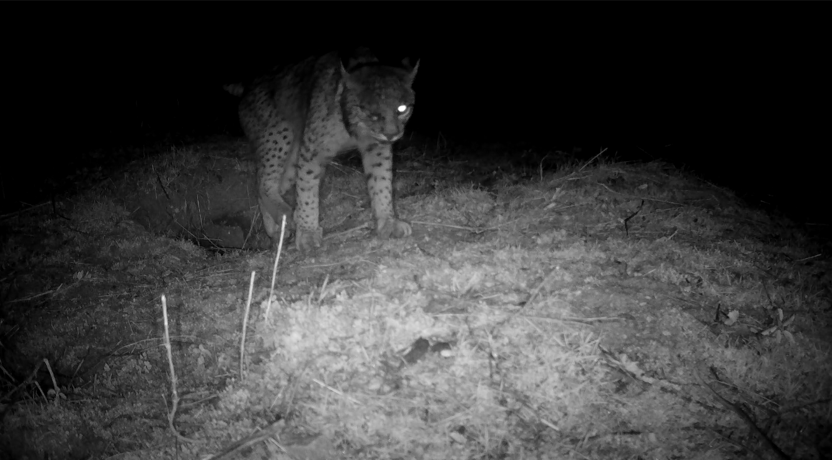

SUPPLEMENTARY FIGURE S23. Sayago photographed at a rabbit warren on 21 January 2026. Visible wounds can be seen on the facial region, consistent with recent agonistic interactions.

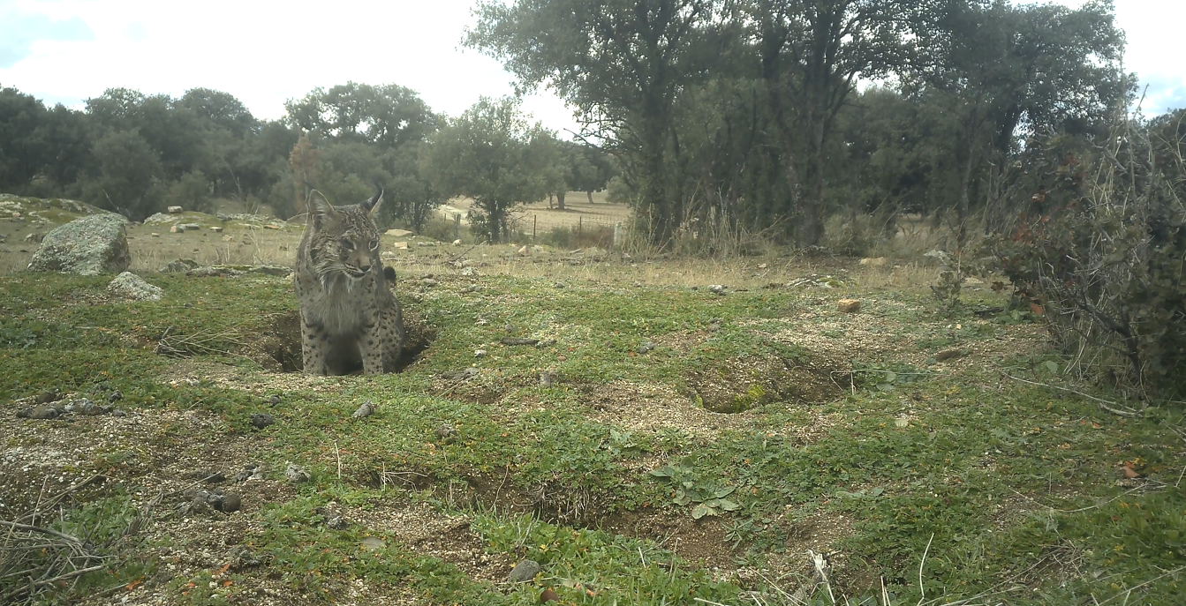

SUPPLEMENTARY FIGURE S24. Vigor, a dispersing male originating from outside the monitored population, photographed at a rabbit warren on 18 January 2026. Visible wounds can be seen on the facial region, consistent with recent agonistic interactions.

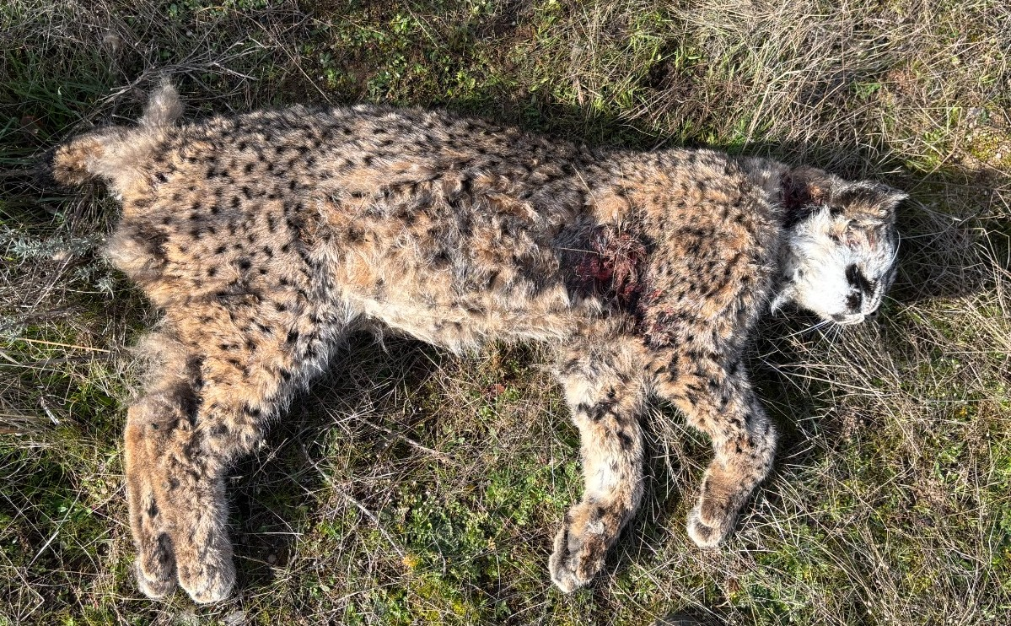

SUPPLEMENTARY FIGURE S25. Dead yearling female (24/03/2025). Field evidence was consistent with a fatal aggressive encounter, although the identity and origin of the attacker could not be established with certainty. The event occurred during the attempted settlement of Quintanar, an adult male from outside the monitored population, in the area where the carcass was found; however, his involvement remains unconfirmed.

SUPPLEMENTARY TABLES

SUPPLEMENTARY TABLE S1. Observed residual network metrics and null expectations across alternative minimum edge-weight thresholds. Residual association networks were reconstructed by retaining dyads recorded together in at least one, two, three or four independent residual co-occurrences. For each threshold, observed network metrics were compared with 10,000 year-constrained group-by-individual (GBI) row-column swap permutations that preserved residual record size, annual individual occurrence frequencies and annual sampling structure. Random mean, random q025 and random q975 indicate the mean, 2.5% quantile and 97.5% quantile of the permutation distribution, respectively. P values are two-sided permutation probabilities.
Metric | Threshold | Observed | Random mean | Random q025 | Random q975 | p value
Density | 1 | 0.06 | 0.11 | 0.10 | 0.11 | <0.001
Clustering | 1 | 0.47 | 0.39 | 0.37 | 0.41 | <0.001
Modularity | 1 | 0.54 | 0.32 | 0.29 | 0.35 | <0.001
Nº components | 1 | 2.00 | 1.06 | 1.00 | 2.00 | 0.12
Largest component size | 1 | 93.00 | 95.87 | 94.00 | 96.00 | 0.02
Mean degree | 1 | 6.17 | 10.17 | 9.75 | 10.58 | <0.001
Mean strength | 1 | 15.15 | 15.15 | 15.15 | 15.15 | 1.00
Density | 2 | 0.07 | 0.09 | 0.08 | 0.11 | 0.03
Clustering | 2 | 0.42 | 0.33 | 0.28 | 0.38 | <0.001
Modularity | 2 | 0.55 | 0.35 | 0.30 | 0.40 | <0.001
Nº components | 2 | 3.00 | 1.71 | 1.00 | 4.00 | 0.31
Largest component size | 2 | 65.00 | 55.11 | 49.00 | 61.00 | <0.001
Mean degree | 2 | 5.15 | 5.07 | 4.52 | 5.65 | 0.75
Mean strength | 2 | 17.30 | 13.51 | 12.10 | 15.09 | <0.001
Density | 3 | 0.09 | 0.12 | 0.09 | 0.17 | 0.02
Clustering | 3 | 0.45 | 0.31 | 0.21 | 0.41 | <0.001
Modularity | 3 | 0.58 | 0.36 | 0.29 | 0.45 | <0.001
Nº components | 3 | 3.00 | 1.60 | 1.00 | 3.00 | 0.23
Largest component size | 3 | 45.00 | 28.49 | 23.00 | 34.00 | <0.001
Mean degree | 3 | 4.12 | 3.50 | 2.93 | 4.13 | 0.05
Mean strength | 3 | 18.37 | 13.44 | 11.19 | 16.00 | <0.001
Density | 4 | 0.08 | 0.18 | 0.12 | 0.26 | <0.001
Clustering | 4 | 0.44 | 0.27 | 0.08 | 0.45 | 0.06
Modularity | 4 | 0.58 | 0.38 | 0.26 | 0.51 | <0.001
Nº components | 4 | 6.00 | 1.44 | 1.00 | 3.00 | <0.001
Largest component size | 4 | 26.00 | 15.77 | 12.00 | 20.00 | <0.001
Mean degree | 4 | 2.81 | 2.71 | 2.11 | 3.38 | 0.72
Mean strength | 4 | 16.38 | 13.35 | 10.32 | 17.00 | 0.09

Radius (m) | Edge threshold | Metric | Observed | Random mean | Random SD | Random q025 | Random q975 | P value | Direction
1000 | 2 | Density | 0.074 | 0.090 | 0.006 | 0.078 | 0.103 | 0.003 | Lower
1000 | 2 | Clustering | 0.423 | 0.405 | 0.019 | 0.368 | 0.444 | 0.364 | Within
1000 | 2 | Modularity | 0.551 | 0.460 | 0.018 | 0.425 | 0.495 | <0.001 | Higher
1000 | 2 | Number of components | 3.000 | 1.933 | 0.772 | 1.000 | 4.000 | 0.407 | Within
1000 | 2 | Largest component size | 65.000 | 59.058 | 2.280 | 55.000 | 64.000 | 0.016 | Higher
1000 | 2 | Mean degree | 5.155 | 5.408 | 0.221 | 4.985 | 5.857 | 0.258 | Within
1000 | 2 | Mean strength | 17.296 | 16.498 | 0.606 | 15.344 | 17.724 | 0.198 | Within
1500 | 2 | Density | 0.074 | 0.092 | 0.007 | 0.079 | 0.106 | 0.004 | Lower
1500 | 2 | Clustering | 0.423 | 0.378 | 0.022 | 0.336 | 0.422 | 0.046 | Higher
1500 | 2 | Modularity | 0.551 | 0.382 | 0.023 | 0.338 | 0.428 | <0.001 | Higher
1500 | 2 | Number of components | 3.000 | 1.454 | 0.652 | 1.000 | 3.000 | 0.139 | Within
1500 | 2 | Largest component size | 65.000 | 58.788 | 2.379 | 54.000 | 63.000 | 0.012 | Higher
1500 | 2 | Mean degree | 5.155 | 5.370 | 0.241 | 4.915 | 5.860 | 0.378 | Within
1500 | 2 | Mean strength | 17.296 | 15.364 | 0.658 | 14.129 | 16.714 | 0.005 | Higher
2000 | 2 | Density | 0.074 | 0.088 | 0.007 | 0.075 | 0.102 | 0.023 | Lower
2000 | 2 | Clustering | 0.423 | 0.365 | 0.023 | 0.322 | 0.411 | 0.015 | Higher
2000 | 2 | Modularity | 0.551 | 0.392 | 0.024 | 0.346 | 0.439 | <0.001 | Higher
2000 | 2 | Number of components | 3.000 | 1.393 | 0.608 | 1.000 | 3.000 | 0.109 | Within
2000 | 2 | Largest component size | 65.000 | 59.276 | 2.579 | 54.000 | 64.000 | 0.034 | Higher
2000 | 2 | Mean degree | 5.155 | 5.181 | 0.242 | 4.712 | 5.673 | 0.924 | Within
2000 | 2 | Mean strength | 17.296 | 14.644 | 0.673 | 13.375 | 16.000 | 0.001 | Higher
2500 | 2 | Density | 0.074 | 0.086 | 0.007 | 0.073 | 0.102 | 0.071 | Within
2500 | 2 | Clustering | 0.423 | 0.345 | 0.025 | 0.297 | 0.394 | 0.003 | Higher
2500 | 2 | Modularity | 0.551 | 0.398 | 0.025 | 0.351 | 0.449 | <0.001 | Higher
2500 | 2 | Number of components | 3.000 | 1.347 | 0.578 | 1.000 | 3.000 | 0.093 | Within
2500 | 2 | Largest component size | 65.000 | 58.948 | 2.808 | 53.000 | 64.000 | 0.038 | Higher
2500 | 2 | Mean degree | 5.155 | 5.047 | 0.260 | 4.554 | 5.571 | 0.662 | Within
2500 | 2 | Mean strength | 17.296 | 13.735 | 0.700 | 12.400 | 15.143 | <0.001 | Higher
SUPPLEMENTARY TABLE S2. Spatially restricted GBI row-column swap results for residual association-network metrics. Residual association networks were reconstructed using the main edge-weight threshold of at least two independent residual co-occurrences. Observed network metrics were compared with 10,000 spatially restricted group-by-individual (GBI) row-column swap permutations. These permutations preserved residual record size, annual individual occurrence frequencies and annual sampling structure, while constraining row-column swaps to individuals assigned to spatial reference points within each spatial restriction radius. Random mean, random SD, random q025 and random q975 indicate the mean, standard deviation, 2.5% quantile and 97.5% quantile of the permutation distribution, respectively. P values are two-sided permutation probabilities. Direction indicates whether the observed value was lower than the 2.5% quantile (Lower), higher than the 97.5% quantile (Higher), or within the 2.5-97.5% permutation interval (Within).

SUPPLEMENTARY TABLE S3. Temporal support of strong residual edges. Strong residual edges were defined as dyads supported by at least five independent residual co-occurrences. For each strong edge, we quantified the number of supporting records, the number of distinct dates, months and years, the temporal span between the first and last record, and the proportion of records concentrated on the most represented date. Values summarize 27 strong residual edges.

Strong-edge set | N edges | Median weight | Median dates | Median months | Median years | Median temporal span days | Median max-day concentration | Edges repeated across several dates and months
weight ≥ 5 | 27 | 7 | 6 | 4 | 2 | 389 | 0.167 | 23/27, 85.2%

Analysis | Dyads | β | R² | Upper-tail P | Two-sided P
Full valid dyads | 444 | 0.202 | 0.129 | <0.001 | <0.001
Excluding strict mother-offspring dyads | 414 | 0.170 | 0.087 | <0.001 | <0.001
SUPPLEMENTARY TABLE S4. QAP regressions testing the relationship between pairwise association strength and pedigree relatedness among individuals with field-assigned maternity and genetically assigned paternity. Association strength was measured using the Simple Ratio Index from annual group-by-individual matrices aggregated across 2017-2025, and relatedness using an additive relationship matrix. Significance was assessed using 10,000 QAP node-label permutations. The second model excluded strict mother-offspring dyads.

SUPPLEMENTARY TABLE S5. Estimates are regression coefficients. Odds ratios are shown only for logistic models and are not reported for MRQAP linear models. The spatial-control MRQAP used 10,000 QAP permutations. The QAP logistic model used 10,000 QAP permutations.
Analysis | Response | Predictor | Estimate | Odds Ratio | P value
Spatial-control MRQAP | same community | same mother | 0.055 | - | 0.082
Spatial-control MRQAP | same community | same cohort | 0.160 | - | <0.001
Spatial-control MRQAP | same community | same territorial male | 0.039 | - | 0.070
Spatial-control MRQAP | same community | spatial proximity | 0.261 | - | <0.001
QAP logistic network regression | edge present | same mother | -0.446 | 0.640 | 0.201
QAP logistic network regression | edge present | same cohort | 0.506 | 1.658 | 0.420
QAP logistic network regression | edge present | n shared males for same year | 0.942 | 2.566 | 0.005
QAP logistic network regression | edge present | spatial proximity | 3.381 | 29.407 | <0.001

SUPPLEMENTARY TABLE S6. Age-specific composition of observed male-young associations in the genetically assigned subset. Percentages represent the proportion of observed male-young associations within each young age class involving each adult male category. One genetically assigned offspring was retained per mother-year litter. Adult males were classified hierarchically as genetic father, recorded territorial male but not genetic father, recorded additional male but not genetic father, or other available adult male. Confidence intervals are exact binomial 95% confidence intervals. This table describes the composition of observed associations and is not interpreted as a test of paternal recognition.

Young age class | Adult male category | Associated pairs | Total associated pairs | Percent | 95% CI
Cub | Genetic father | 5 | 7 | 71.4 | 29.0-96.3
Cub | Recorded territorial male, not genetic father | 1 | 7 | 14.3 | 0.4-57.9
Cub | Recorded as other male, not genetic father | 0 | 7 | 0 | 0.0-41.0
Cub | Other available adult male | 1 | 7 | 14.3 | 0.4-57.9
Yearling | Genetic father | 6 | 7 | 85.7 | 42.1-99.6
Yearling | Recorded territorial male, not genetic father | 0 | 7 | 0 | 0.0-45.9
Yearling | Recorded as other male, not genetic father | 0 | 7 | 0 | 0.0-45.9
Yearling | Other available adult male | 1 | 7 | 14.3 | 0.4-57.9
Two-year-old | Genetic father | 1 | 8 | 12.5 | 0.3-52.7
Two-year-old | Recorded territorial male, not genetic father | 0 | 8 | 0 | 0.0-36.9
Two-year-old | Recorded other male, not genetic father | 2 | 8 | 25 | 3.2-65.1
Two-year-old | Other available adult male | 5 | 8 | 62.5 | 24.5-91.5

SUPPLEMENTARY METHODS

EDGE-THRESHOLD SENSITIVITY ANALYSIS AND YEAR-CONSTRAINED GBI ROW-COLUMN SWAP PERMUTATIONS

Overview
In this Supplementary Method, we describe the sensitivity analysis used to evaluate how the minimum edge-weight threshold affected the structure of the residual association network, together with the year-constrained group-by-individual (GBI) row-column swap permutation procedure used to generate null expectations for each threshold. The aim was to assess how residual network metrics changed across alternative definitions of association strength while preserving key features of the residual co-occurrence dataset. The permutation procedure randomized the residual group-by-individual matrix within years using fixed row-column swaps while preserving residual record size, annual individual occurrence frequencies and annual sampling structure. This approach follows the general framework of permutation-based null models in animal social network analysis ^{1,2}.

Residual group-by-individual matrix
The analysis was applied to the residual group-by-individual matrix used for network construction. Rows represented independent residual co-occurrence records, and columns represented individually identified lynx. Matrix entries indicated whether a given individual was present in a given residual record. Only records containing at least two identified individuals were retained. Pairwise co-occurrence counts were obtained from the cross-product of this matrix, and these counts were used as weighted edges between individuals, following standard approaches for constructing association networks from group-by-individual data ^{1,2}.
The residual dataset excluded records classified as strict mother-offspring associations and records with unknown kinship composition. This ensured that the sensitivity analysis and year-constrained GBI row-column swap permutations were applied to the same residual dataset used to construct the residual association network.

Edge-threshold sensitivity analysis
Residual networks were reconstructed from the same residual group-by-individual matrix using four alternative minimum edge-weight thresholds. For each threshold, dyads were retained when two individuals had been recorded together in at least one, two, three or four independent residual co-occurrences, respectively. Edge weights corresponded to the number of independent residual records in which each dyad co-occurred.
For each threshold, observed network metrics were compared with null expectations generated using year-constrained group-by-individual (GBI) row-column swap permutations. These permutations preserved residual record size, annual individual occurrence frequencies and annual sampling structure while randomizing residual association composition ^{2,3}.
The number of retained vertices decreased from 96 at threshold 1 to 37 at threshold 4, and the number of retained edges decreased from 296 to 52. Across the same threshold range, the number of connected components increased from two to six, whereas the largest connected component contracted from 93 to 26 individuals.

GBI row-column swap permutations
For each threshold, observed network metrics were compared with null expectations generated using year-constrained group-by-individual (GBI) row-column swap permutations. The permutation procedure randomized the residual group-by-individual matrix within years while preserving three features of the observed dataset: the number of individuals per record, the number of records in which each individual appeared, and the annual structure of the observations. These permutations provide null expectations that account for sampling structure and heterogeneity in individual observation frequencies while randomizing residual association composition ^{1,4}.
Permutations were performed separately within years. This year-constrained procedure prevented individuals and records from being randomized across years in which they may not have been available for observation, while preserving broad annual variation in sampling and individual occurrence.
Randomization was implemented using a fixed row-column swap algorithm applied to the residual group-by-individual matrix. At each step, two rows and two columns of the binary matrix were selected. When the resulting 2 × 2 submatrix had a swappable configuration, memberships were exchanged while preserving row sums and column sums. This procedure therefore preserved residual record size and annual individual occurrence frequencies while randomizing residual association composition ¹.
For each threshold, 10,000 randomized group-by-individual matrices were generated using year-constrained row-column swaps. Each randomized matrix was converted into a thresholded weighted network using the same edge-weight criterion as the corresponding observed network and summarized using the same network metrics. This framework is appropriate for repeated detections of individually recognizable animals in camera-trap and other automated-sensing datasets, where null expectations must account for variation in record size, individual occurrence frequency and sampling structure ^{4,5}.

Network metrics and permutation summaries
For each observed and randomized network, we calculated the same set of network metrics: network density, global clustering coefficient, modularity, number of connected components, size of the largest connected component, mean degree and mean strength. Modularity was calculated from Louvain community detection and used here as a network-level metric ^{6,7}. Network analyses were implemented using the igraph package ⁸. Mean degree was defined as the average number of unique associates per individual, whereas mean strength was defined as the average weighted connectivity based on edge weights.
For each metric and threshold, we summarized the observed value, the mean of the randomized networks, the 2.5% and 97.5% quantiles of the permutation distribution, and the corresponding permutation p-value. The resulting values are reported in Table S2. The same results are shown graphically in Figure S2, where observed metrics are plotted across thresholds together with the corresponding means and 2.5-97.5% permutation intervals obtained from the year-constrained GBI row-column swap permutations.
The threshold requiring at least two independent residual co-occurrences was retained for the main residual association network. This threshold removed single-record associations while retaining a large connected component of recurrently associated individuals and preserving the non-random network structure identified by the permutation analyses.

Temporal distribution of strong residual edges
To evaluate whether strong residual edges were driven by short-term detection clusters, we quantified the temporal distribution of records supporting each edge. We focused on residual edges supported by at least five independent co-occurrences. For each edge, we calculated the number of distinct dates, months and years represented, the temporal span between the first and last record, and the proportion of records concentrated on the most frequently represented date.

PEDIGREE-RELATEDNESS ANALYSIS OF RESIDUAL SOCIAL ASSOCIATIONS
Overview
In this Supplementary Method, we describe the supplementary pedigree-relatedness analysis used to evaluate whether pairwise social association strength among Iberian lynxes was associated with pedigree relatedness. The analysis was designed as a complementary test of whether residual association structure retained a kinship component after the exclusion of strict mother-offspring associations.
Pairwise social association strength was quantified using the Simple Ratio Index (SRI), calculated from annual group-by-individual matrices aggregated across the 2017-2025 study period. Pedigree relatedness was quantified from the additive relationship matrix derived from the multigenerational pedigree. Statistical inference was based on Quadratic Assignment Procedure (QAP) regression with 10,000 node-label permutations, following standard recommendations for dyadic network data, in which observations are not statistically independent ^{1,2,4}.

Pedigree relatedness matrix
The pedigree table contained individual identities, maternal assignments from reproductive monitoring and DNA-based paternal assignments when available. Field-based maternal assignments matched all available genetic maternity assignments. To avoid underestimating relatedness because of missing paternal information, the analysis was restricted to individuals with maternal assignments and DNA-based paternal assignments.
The resulting matrix represented expected pedigree relatedness among individuals. Off-diagonal values corresponded to standard pedigree relatedness values, including parent-offspring and full-sibling dyads with expected relatedness of 0.5 and half-sibling dyads with expected relatedness of 0.25. This matrix was then restricted to individuals meeting these parentage criteria that were detected in camera-trap records during the study period.

Annual association matrices and temporal overlap
To avoid including dyads that could not have been observed together because of temporal turnover in the population, association data were processed at the annual scale. For each year from 2017 to 2025, we identified all pedigree individuals detected in at least one camera-trap record during that year. A yearly group-by-individual matrix was then constructed, in which each independent record represented a temporary group and each identified lynx was scored as present or absent.
Annual co-occurrence and detection matrices were accumulated across years. The final SRI matrix was calculated from these accumulated values. A dyad was retained for analysis only if both individuals were detected during at least one common study year. This temporal-overlap constraint excluded dyads without observed annual coexistence and reduced the inclusion of biologically implausible zero-association dyads caused by recruitment, mortality, dispersal or population turnover.

QAP regression
We tested whether pairwise association strength increased with pedigree relatedness using QAP regression. The response matrix was the SRI association matrix, and the predictor matrix was the pedigree-relatedness matrix. The analysis was restricted to the upper triangle of the matrices and to dyads satisfying the temporal-overlap criterion.
For each QAP permutation, the node labels of the relatedness matrix were randomly permuted while the association matrix was kept fixed. This procedure preserved the structure of the observed association matrix while generating a null expectation for the relationship between association strength and relatedness under random assignment of relatedness values to network nodes. We generated 10,000 permutations and calculated upper-tail and two-sided permutation probabilities.

Sensitivity analysis excluding strict mother-offspring dyads
Because mother-offspring associations are the expected dominant form of social association in Iberian lynx, we repeated the QAP analysis after excluding all strict mother-offspring dyads. Mother-offspring dyads were identified directly from the pedigree table using known maternal assignments. These dyads were removed from the set of valid dyads before rerunning the QAP regression.
This sensitivity analysis tested whether any relationship between association strength and pedigree relatedness was driven solely by direct maternal care. Persistence of the relationship after excluding mother-offspring dyads was interpreted as evidence that the kinship component of residual association structure extended beyond the primary maternal association.

Descriptive kinship-class summaries
To aid biological interpretation, residual dyads were grouped into three broad kinship classes after excluding strict mother-offspring dyads:
- More distant relatives: r < 0.25;
- Second-order relatives: 0.25 ≤ r < 0.5;
- First-order relatives: r ≥ 0.5.
For each class, we summarized the number of dyads, mean SRI, median SRI, proportion of dyads with SRI > 0, and mean number of co-occurrences. These summaries were descriptive only and were not used for statistical inference, because dyadic observations are non-independent.

COMMUNITY MEMBERSHIP, SPATIAL CONTROL AND ANNUAL MALE-MEDIATED CONNECTIVITY

Overview
This Supplementary Method describes the analyses used to evaluate whether communities detected in the residual association network were associated with maternal structure, birth cohort, territorial male identity, spatial proximity and annual male-mediated reproductive connectivity. Communities were detected in the main thresholded residual association network using the Louvain community-detection algorithm implemented in igraph ^{6,8}. This algorithm partitions the network by maximizing modularity, which measures the extent to which connections are concentrated within groups relative to the modularity null model ⁷. The resulting communities were treated as network-derived partitions and were not defined a priori from kinship, age, sex or territorial information.
The workflow consisted of three main steps. First, we evaluated whether residual-community co-membership was associated with shared mother, shared birth cohort, shared territorial male identity and spatial proximity using spatial-control MRQAP. Second, because males can vary among breeding females across years, we quantified annual male-mediated reproductive connectivity as the number of males shared by the mothers of same-cohort dyads in the corresponding reproductive year, and tested whether this metric was associated with community co-membership using cohort-restricted community-label permutations. Third, we tested whether annual male-sharing was associated not only with community co-membership, but also with direct residual edge presence in the thresholded residual association network using QAP logistic network regression.
The spatial and reproductive context of breeding females, including mother-daughter proximity and male sharing among females, is described separately in Supplementary Method “Spatial context of breeding females and accumulated male-mediated reproductive-connectivity network”. The year-constrained identity-label permutation analysis used for adult male-yearling record composition is described separately in Supplementary Method “Year-constrained identity-label permutation test for adult male-yearling records and reproductive-context associations”.

Residual Network and Community Detection
The residual association network was constructed from multi-individual records remaining after the exclusion of strict mother-offspring records. Individuals were represented as nodes, and residual co-occurrences between pairs of individuals were represented as weighted undirected edges. Edge weights corresponded to the number of independent residual records in which each dyad co-occurred. Only repeated residual co-occurrences meeting the predefined edge-weight threshold were retained for the main residual network.
Community membership was assigned to each individual from the Louvain partition described above and was used to build a dyadic response matrix indicating whether each pair of individuals belonged to the same community.

Dyadic Attribute Matrices
For each pair of individuals in the residual network, we constructed binary dyadic matrices representing whether both individuals:
- Belonged to the same Louvain community;
- Shared the same mother;
- Were born in the same year;
- Shared the same territorial male identity.
Shared mother was defined as both individuals having the same recorded mother in the pedigree table. Shared birth cohort was defined as both individuals having the same birth year. Shared territorial male identity was defined as both individuals being associated with the same territorial male in the pedigree and reproductive-history dataset.
These matrices formed the basis for the community-membership analyses and were aligned using the same individual order across all matrices.

Spatial Reference Points
Spatial proximity was included to evaluate whether community co-membership could be explained by the spatial organization of breeding females and their descendants. This spatial-control step was motivated by the spatial analysis of breeding females, mother-daughter proximity and shared male reproductive context described in Supplementary Method “Spatial context of breeding females and accumulated male-mediated reproductive-connectivity network”.
Each individual retained for the spatial-control analyses was assigned a spatial reference point according to the following rules:
- Breeding females included in the spatial coordinate dataset were assigned their own fixed female territory center.
- Individuals with known maternal origin were assigned the fixed territory center of their mother when the mother was included in the spatial coordinate dataset.
- Individuals lacking both an own female reference point and a maternal reference point were excluded from spatial-control analyses.
This approach treated breeding female territories as spatially stable and used maternal territory centers as natal spatial references for descendants.

Spatial Proximity Matrix
Euclidean distances were calculated between all pairs of individual spatial reference points. These distances were then converted into a spatial-proximity matrix using:
$$spatial proximity_{ij}=\exp\left(-d_{ij}/1000\right)$$
where $d_{ij}$ is the Euclidean distance in meters between the spatial reference points of individuals $i$ and $j$. Larger values therefore indicate greater spatial proximity.
The spatial-proximity matrix was aligned with the community co-membership matrix and the dyadic attribute matrices.

Spatial-Control MRQAP for Community Co-Membership
To evaluate whether community co-membership was associated with individual attributes after accounting for spatial proximity, we fitted a Multiple Regression Quadratic Assignment Procedure (MRQAP). MRQAP was used because dyadic matrices are non-independent: each individual contributes to multiple pairwise values ^{1,2}. The response matrix was community co-membership, and predictor matrices represented shared mother, shared birth cohort, shared territorial male identity and spatial proximity.
The model was:
$$\text{same} {\text{community}}_{ij}=β_{0}+β_{1} \text{same }{\text{mother}}_{ij}+β_{2} \text{same }{\text{cohort}}_{ij}+β_{3} \text{same territorial }{\text{male}}_{ij}+β_{4} \text{spatial }{\text{proximity}}_{ij}​$$
Significance was assessed using QAP permutations. This procedure accounts for dyadic non-independence by comparing observed coefficients with permutation distributions generated by matrix-label randomization.

Annual Male-Mediated Reproductive Connectivity
Because territorial males and additional males can vary among breeding females across years, we quantified male-mediated reproductive connectivity at the annual scale. For each reproductive female and year, we compiled the set of associated males, including:
- the territorial male recorded for that female and year;
- additional males recorded with that female in the same year.
For each same-cohort dyad, we calculated the number of males shared by the mothers of the two individuals in the corresponding reproductive year. This variable was defined as:
$$\text{n_shared_males_same_}{\text{year}}_{ij}$$
where the value corresponds to the size of the intersection between the annual male set of individual i's mother and the annual male set of individual j's mother in the shared birth year.
This annual male-sharing metric was used because a static shared territorial male variable may not fully capture dynamic male-mediated reproductive context when male identity changes across years. Although male-sharing was quantified from the corresponding reproductive year, both community membership and direct residual edge presence were derived from the cumulative 2017-2025 residual association network.

Cohort-Restricted Community-Label Permutation Test
Because annual male sharing is only biologically meaningful for dyads born in the same year, the main annual male-sharing analysis was restricted to same-cohort dyads. Community membership was derived from the cumulative residual association network, whereas annual male sharing was quantified from the corresponding reproductive year. The restriction within cohorts follows the same logic as year-constrained identity-label permutations used when the biological interpretation of a record depends on year-specific identity availability or age class ^{1,2,4}.
Within same-cohort dyads, we fitted an observed logistic model with community co-membership as the response and the number of males shared by the mothers of the two individuals in the corresponding reproductive year as the predictor:
$$logit\left(Pr\left(same community_{ij}=1\right)\right)=β_{0}+β_{1} n_shared_males_same_year_{ij}$$

Because dyads are not independent, inference was based on a cohort-restricted community-label permutation procedure rather than on the standard logistic-model output. In each permutation, community labels from the cumulative residual association network were randomly permuted among individuals within birth cohorts. This preserved the cohort structure of the dataset while breaking the observed association between community membership and annual male-sharing context.
For each permuted dataset, community co-membership was recalculated for same-cohort dyads, the model was refitted, and the coefficient for $n_shared_males_same_year$ was stored. The observed coefficient was then compared with the permutation distribution to obtain one-sided and two-sided permutation probabilities.

Direct Residual Edge Presence
To evaluate whether annual male sharing was reflected in direct network structure, rather than only in community partitions, we constructed a binary edge-presence matrix from the cumulative residual association network. Each matrix cell indicated whether a pair of individuals was directly connected by a residual edge in the thresholded residual network.
Because annual male sharing is biologically meaningful only among individuals born in the same year, we first conducted a cohort-restricted node-label permutation test using same-cohort dyads. We fitted an observed logistic model with direct residual edge presence as the response and the number of males shared by the mothers of the two individuals in the corresponding reproductive year ($n_shared_males_same_year$) as the predictor. In each permutation, individual labels were randomly permuted within birth cohorts while preserving cohort composition. For each permuted dataset, direct residual edge presence in the cumulative residual association network was recalculated, the model was refitted, and the coefficient for $n_shared_males_same_year$ was stored. The observed coefficient was then compared with the permutation distribution to obtain one-sided and two-sided permutation probabilities.
We additionally fitted a QAP logistic network regression with direct residual edge presence as the response matrix while accounting for the non-independence of dyads in the network ^{1,2}. Predictor matrices represented shared mother, shared birth cohort, annual male sharing and spatial proximity:
$$logit\left(Pr\left(edge_present_{ij}=1\right)\right)=β_{0}+β_{1}same_mother_{ij}+β_{2} same_cohort_{ij}+β_{3} n_shared_males_same_year_{ij}+β_{4} spatial_proximity_{ij}$$

QAP permutations were used to assess coefficient significance while accounting for the non-independence of dyads in the network.
This analysis was used to determine whether annual male-mediated reproductive connectivity was associated with direct residual associations, not only with Louvain community co-membership.

Descriptive Summaries
To aid interpretation, we generated descriptive summaries for same-cohort dyads grouped by the number of males shared by their mothers in the corresponding reproductive year. For each annual male-sharing category, we summarized:

- The number of same-cohort dyads;
- The number and proportion of dyads belonging to the same Louvain community;
- The number and proportion of dyads connected by a direct residual edge;
- Mean residual edge weight;
- Mean spatial proximity;
- The proportion of dyads sharing the same mother.
These summaries were used for descriptive interpretation and visualization.

Correlation Diagnostics
We calculated pairwise correlations between $n_\text{shared_males_same_year}$ and the main dyadic predictors, including shared mother, shared cohort, spatial proximity and shared territorial male identity. These diagnostics were used to evaluate whether the annual male-sharing metric was strongly collinear with other predictors.
Because $n_\text{shared_males_same_year}$ is defined at the annual reproductive scale, it is expected to be structurally associated with shared cohort. For this reason, the main community-level annual male-sharing test was conducted within same-cohort dyads. These diagnostics were used to evaluate potential collinearity among predictors but were not treated as separate inferential tests.

SPATIAL CONTEXT OF BREEDING FEMALES AND ACCUMULATED MALE-MEDIATED REPRODUCTIVE-CONNECTIVITY NETWORK
Overview
This Supplementary Method describes the spatial analyses used to evaluate whether maternal recruitment and male-mediated reproductive context were spatially structured among breeding females. The analyses described here provided the spatial context for the residual-network community analyses in Supplementary Material “Community membership, spatial control and annual male-mediated connectivity”. In particular, the spatial arrangement of breeding females and the spatial structure of male sharing motivated the inclusion of spatial proximity as a dyadic predictor in the community co-membership MRQAP and in the QAP logistic analysis of direct residual edge presence.
The analysis used UTM coordinates for reproductive females included in the spatial dataset, together with pedigree and reproductive-history information for 2017-2025. For each reproductive female, we compiled the set of males associated with her reproductive history, including territorial males and additional males recorded for that female.
Mother-daughter pairs were identified from the pedigree dataset when both the mother and daughter were included in the spatial coordinate dataset. Euclidean distances were then calculated between all pairs of reproductive females. Each female pair was classified according to whether it represented a mother-daughter pair, and the number of shared males was calculated as the size of the intersection between the male sets associated with the two females. Female pairs were also classified according to whether they shared at least one male.
These analyses were used to determine whether maternal recruitment and male-sharing among breeding females were spatially structured, because such spatial structure could influence apparent associations between individual attributes and residual-network communities.

Female-Female Spatial Distances
For each pair of reproductive females included in the spatial dataset, we calculated Euclidean distance using their UTM coordinates. Pairwise distances were summarized according to mother-daughter status and male-sharing status.
Distances between mother-daughter and non-mother-daughter pairs were compared using Wilcoxon rank-sum tests. Distances between female pairs sharing at least one male and female pairs sharing no males were also compared using Wilcoxon rank-sum tests. We additionally calculated the Spearman correlation between female-female distance and the number of shared males.

Shared Male Context
For each reproductive female, we compiled the set of males associated with her reproductive history during 2017-2025. This set included both the territorial male recorded for the female and any additional males recorded with that female.
For each pair of reproductive females, we calculated the number of shared males as the size of the intersection between their male sets. We also classified each pair according to whether the two females shared at least one male.
This accumulated male-sharing metric was used to describe the spatial structure of male-mediated reproductive context among breeding females. The annual male-sharing metric used to test residual-community co-membership and direct residual edges is described separately in Supplementary Material “Community membership, spatial control and annual male-mediated connectivity”.

MRQAP Analysis of Female Spatial Distance
Because female-female distances are pairwise and therefore non-independent, we used a Multiple Regression Quadratic Assignment Procedure, MRQAP, to evaluate the association between spatial distance, maternal relationship and shared male context. ^{2,9}.
The response matrix was log-transformed female-female distance. Predictor matrices represented the number of shared males and mother-daughter relationship. The MRQAP model was fitted using 10,000 permutations.
The model structure was:
$$log_distance_{ij}=β_{0}+β_{1}n_shared_males_{ij}+β_{2}mother_daughter_{ij}$$
where $log_distance_{ij}$ is the log-transformed distance between reproductive females $i$and $j$, $n_shared_males_{ij}$ is the number of males shared by the two females, and $mother_daughter_{ij}$ indicates whether the pair represented a mother-daughter relationship.

Accumulated Male-Mediated Reproductive Neighborhood
To visualize the spatial structure of male-mediated reproductive connectivity, we also constructed an accumulated reproductive-neighborhood map for breeding females.
In this visualization, nodes represented breeding females positioned according to their territory centers. Edges connected pairs of females that shared at least one territorial or additional male during 2017-2025. Edge width was proportional to the number of distinct males shared across the study period. Node size represented the number of offspring from each female represented in the residual association network.
This accumulated map illustrates the spatial arrangement of breeding females connected through shared territorial or additional males across the study period. It provides a spatial representation of the reproductive neighborhoods evaluated at the annual scale in Supplementary Material “Community membership, spatial control and annual male-mediated connectivity”, where male-mediated connectivity was quantified as the number of males shared by the mothers of same-cohort dyads in the corresponding reproductive year.

YEAR-CONSTRAINED IDENTITY-LABEL PERMUTATION TEST FOR ADULT MALE-YEARLING RECORDS AND REPRODUCTIVE-CONTEXT ASSOCIATIONS
Overview
In this Supplementary Method, we describe the year-constrained identity-label permutation test used to evaluate whether adult male-yearling records occurred more often than expected from annual identity availability alone. The analysis focused on records classified as Adult male + yearling(s) in the kinship-composition classification of multi-individual Iberian lynx records. Because age class depends on year, permutations were constrained within years so that individual identities were only reassigned among lynx detected in the same year ^{1,2,4}.
We also conducted a complementary year-constrained random male assignment test to evaluate whether adult male-yearling event dyads were disproportionately associated with males belonging to the yearling’s documented maternal reproductive context. This reproductive context was defined at the mother-birth year level and included territorial males, other recorded local males and genetically assigned fathers. Unlike the identity-label permutation test, which assessed whether adult male-yearling records occurred more often than expected from annual identity availability, this second analysis focused only on observed adult male-yearling dyads and tested whether the adult male involved was more often a reproductive-context male than expected from the set of adult males available in the same year. This provided a null expectation for whether male-yearling associations were structured by maternal reproductive neighborhoods rather than by random annual adult male availability, while preserving biologically meaningful annual constraints on identity availability (Farine, 2017; Farine & Whitehead, 2015; Pinter-Wollman et al., 2014).

Residual kinship-composition dataset
The analysis was applied to the residual multi-individual record set after exclusion of strict mother-offspring records and records with unknown kinship composition. Each record contained the identities of lynx detected within an independent multi-individual record, together with the date of detection and the kinship-composition category assigned by the rule-based classification script. The observed statistic was the number of residual records classified as Adult male + yearling(s).
Before permutation, individual identities in the detection table were standardized to lower case for replacement, while pedigree maps used by the classification function were restored to their original title-case format. Generic labels used during image classification were not permuted as individual identities. These labels were retained as observer-assigned information used by the kinship-composition classification.

Year-constrained identity-label permutations
The permutation test randomized individual identities within each year. For each year, the set of individually identified lynx detected in that year was extracted from the detection table. Individual labels were then randomly reassigned among those same individuals, while preserving the year of each record, the number of individuals detected in each record, generic annotations and the temporal structure of the dataset ^{1,2}.
This year-constrained design was used because the target category, Adult male + yearling(s), depends on year-specific age class. Permuting identities across the entire study period would allow individuals to be reassigned to years in which their age class or availability would be biologically inappropriate. Restricting permutations within years therefore generated a null expectation based on the annual availability of identified individuals ^{1,4}.

Reclassification of permuted datasets
For each permuted dataset, the full kinship-composition classification was rerun using the same rule-based procedure applied to the observed data. This ensured that each permutation generated a complete reclassification of the same residual record set rather than simply reshuffling the final category labels. For each permuted dataset, we recalculated the number of records classified as Adult male + yearling(s).
We generated 10,000 year-constrained identity-label permutations. The observed number of adult male-yearling records was compared with the upper tail of the permutation distribution, corresponding to the directional expectation that this category would occur more often than expected under random identity composition within years.

Reproductive-context enrichment of adult male-yearling dyads
We evaluated whether observed adult male-yearling event dyads were enriched in males belonging to the yearling’s documented maternal reproductive context. For each yearling, reproductive context was defined at the mother-birth year level and included territorial males, other adult males recorded in the mother’s territory and genetically assigned fathers. Genetic fathers were included in the reproductive-context set even when they were not otherwise recorded as territorial or additional males, because incomplete male detection and incomplete genetic sampling can cause reproductively relevant males to be absent from field-based male-context records.
Each observed adult male-yearling event dyad was classified into one of two analytical categories: documented reproductive-context male or no documented reproductive-context link. The latter category was interpreted conservatively, because males lacking a documented reproductive-context link may still have belonged to the yearling’s reproductive neighborhood but remained undetected or genetically unassigned.
The null model preserved the event year, yearling identity, yearling mother, yearling birth year and total number of observed adult male-yearling event dyads. For each permutation, the adult male identity associated with each dyad was randomly reassigned from the set of adult males available in the same year. This generated a year-constrained null expectation for the number of adult male-yearling dyads involving documented reproductive-context males.
Genetic paternity assignments showed that some offspring were sired by males that had not been documented as either territorial males or other males recorded in the mother’s territory. This indicates that the field-based detection of males associated with each female’s reproductive context was imperfect. For this reason, dyads classified as involving males with no documented reproductive-context link should not be interpreted as confirmed associations with males outside the reproductive context. Instead, they should be interpreted only as dyads for which no reproductive-context link was documented with the available territorial, local-male and genetic information. Consequently, the number of adult male-yearling dyads assigned to the documented reproductive-context category represents a minimum estimate of adult male-yearling associations occurring within the maternal reproductive context. Any undetected reproductive males or unassigned genetic fathers would tend to move dyads from the undocumented category into the reproductive-context category, thereby underestimating rather than inflating the strength of the observed reproductive-context enrichment.

COMPOSITION OF OBSERVED MALE-YOUNG ASSOCIATIONS IN THE GENETICALLY ASSIGNED SUBSET
Overview
In this Supplementary Method, we describe the descriptive analysis used to quantify the composition of observed male-young associations according to adult male category. The analysis was restricted to offspring with genetically assigned paternity and was designed to describe whether observed male-young associations involved genetic fathers, recorded territorial males, recorded additional males or other available adult males.
Its purpose was to summarize the observed composition of male-young co-occurrences within the genetically assigned subset and to evaluate how this composition varied across young age classes.

Genetically assigned subset
The analysis used the pedigree and reproductive-context table, which included individual identity, mother identity, birth year, sex, recorded territorial male, recorded additional males and DNA-based paternity assignment when available. Individual identities were standardized before analysis.
Only offspring with genetically assigned fathers were considered. To avoid within-litter pseudoreplication, one genetically assigned offspring was retained per mother-year litter. This produced a subset in which each retained offspring represented a single genetically assigned litter.

Age classes
For each camera-trap record year, young age was calculated as:
age = record year − birth year
Young individuals were then assigned to three calendar-year age classes:
- cubs: age 0;
- yearlings: age 1;
- two-year-olds: age 2.
The analysis was restricted to these three age classes because they represent the period during which young individuals may remain within or near the maternal reproductive area and may still occur in male-associated residual co-occurrences.
.

Available adult males
For each retained offspring-year, we identified the set of adult males available in that same year. Adult males were defined as males aged two years or older that were detected in at least one camera-trap record during the corresponding year. This annual availability constraint ensured that each young individual was compared only with adult males detected in the same year.

Observed male-young associations
For each retained offspring-year and each available adult male, we calculated whether the young individual and the adult male were recorded together in at least one independent camera-trap record during that year. Pairs with at least one co-occurrence were classified as observed male-young associations.
Only observed male-young associations were used in the composition analysis. The analysis therefore describes the adult male categories represented among observed associations, not among all possible young-male pairs.

Adult male categories
Each adult male involved in an observed male-young association was classified hierarchically into one of four categories:
- genetic father;
- recorded territorial male, but not genetic father;
- recorded additional male, but not genetic father;
- other available adult male.
The hierarchy was applied so that a male genetically assigned as the father was always classified as genetic father, even if that male was also recorded as the territorial male or as an additional male in the reproductive-context table. Non-father males were then classified according to whether they were recorded as the territorial male or as an additional male. Remaining associated adult males were classified as other available adult males.

Composition summaries
The composition of observed male-young associations was summarized separately for cubs, yearlings and two-year-olds. For each age class, we calculated the number of observed male-young associations in each adult male category and the percentage represented by that category out of all observed male-young associations in the same age class.
Exact binomial 95% confidence intervals were calculated for each percentage. These confidence intervals describe uncertainty in the observed composition within each age class and were not interpreted as tests of paternal recognition or behavioral mechanism.

LOCAL PERSISTENCE AND LATER REPRODUCTIVE-CONTEXT INCORPORATION OF LOCAL MALE YEARLINGS WITH AND WITHOUT ADULT MALE RESIDUAL EDGES

Overview
In this Supplementary Method, we describe the descriptive analysis used to evaluate whether local male yearlings with residual edges to adult males differed in their local persistence within the monitored area from local male yearlings without such edges.
The analysis was designed to provide a supplementary, hypothesis-generating assessment of whether adult male residual edges during the yearling stage may act as observable markers of local integration. Continued detection within the monitored area may reflect survival, delayed dispersal, local residence, or variation in detectability. We additionally tested whether local male yearlings with adult male residual edges were more likely to appear later in documented reproductive contexts, including as territorial males, recorded additional males or genetically assigned fathers.

Local male yearling subset
The analysis was restricted to male yearlings that were locally born or locally recruited and had documented local maternal context.
This restriction was applied to exclude external dispersers that may have been calendar-year yearlings when detected, but did not represent natal yearlings within the monitored reproductive neighborhood.

Camera-trap records and individual detection histories
Camera-trap records were standardized by individual identity and date-time. Individual identities were converted to lower case and records containing multiple individuals were split into event-individual records.
Two event-individual tables were constructed. The first table included all detections and was used to reconstruct individual detection histories and last detection dates. The second table included only residual records, after excluding strict mother-offspring records and records with unknown kinship composition. This residual table was used exclusively to construct adult male-yearling residual edges.

Residual adult male-yearling edges
Residual edges between local male yearlings and adult males were constructed from residual co-occurrence records. Adult males were defined as males aged two years or older in the corresponding record year. Male yearlings were defined as males aged one year in the corresponding record year.
For each residual record, adult males and male yearlings recorded together were paired. Pairs involving the same individual were excluded. Edges were then summarized by yearling male, yearling year and adult male. Edge weight was defined as the number of distinct residual records in which the yearling and adult male co-occurred during the yearling year.
Each local male yearling was classified according to whether it had at least one residual edge to an adult male during the yearling stage. The main comparison was therefore between:
- local male yearlings with no observed adult male residual edge;
- local male yearlings with at least one adult male residual edge.

Maternal reproductive-context males
For each local male yearling, we identified adult males belonging to the documented maternal reproductive context of the corresponding mother-year litter. These included:
- the recorded territorial male;
- recorded additional males;
- the genetically assigned father, when available.
Adult males involved in residual yearling edges were then classified according to whether they belonged to this documented maternal reproductive context. This classification was used only to describe the composition of observed adult male residual edges. Absence of a context edge was not interpreted as absence of a male from the maternal reproductive context.

Local persistence within the monitored area
Local persistence within the monitored area was measured as the number of months between an assumed birth date and the last camera-trap detection of each local male yearling within the monitored system.
All individuals were assumed to have been born on 15 April of their birth year. For each individual, the following quantities were calculated:
- assumed birth date;
- last camera-trap detection date;
- months from assumed birth date to last detection;
- months from the start of the yearling stage to last detection;
- maximum number of months the individual could have been observed, given the assumed birth date and the last camera-trap date in the dataset.
This measure represents local persistence within the monitored area (not true survival). A longer interval to last detection may reflect continued local residence, delayed dispersal, survival within the monitored area, repeated local use of the monitored area or continued detectability.

Eligibility for post-dispersal local persistence analyses
Post-dispersal local persistence analyses were restricted to individuals with sufficient follow-up opportunity to reach the dispersal-age threshold. The dispersal-age threshold was defined as 24 months from the assumed birth date.
To avoid classifying individuals as not locally persistent when they had not yet had sufficient opportunity to be detected beyond this threshold, we required an additional monitoring window after the threshold. Individuals were considered eligible for post-dispersal local persistence analyses if their maximum observable age was at least:
24 months + 3 additional months
Individuals without this follow-up opportunity were retained in the descriptive edge tables but excluded from post-dispersal local persistence summaries and tests.

Descriptive summaries
For eligible local male yearlings, local persistence within the monitored area was summarized by adult male edge status. For each group, we calculated:
- number of males;
- mean and median number of camera-trap records during the yearling year;
- mean and median total adult male edge weight;
- mean and median months to last detection;
- mean and median months after the start of the yearling stage;
- proportion of males detected after the dispersal-age threshold.
Among local male yearlings with adult male residual edges, we also summarized the composition of edges involving maternal reproductive-context males. Specifically, we calculated:
- number of males with adult male residual edges;
- number and proportion of those males with at least one context edge;
- total adult male edge weight;
- total context edge weight;
- proportion of total edge weight involving context males.

Non-parametric comparison
Because of the small sample size, skewed local persistence times and unequal follow-up opportunities among cohorts, the main comparison of local persistence between edge groups used a Wilcoxon rank-sum test.
The response variable was months from assumed birth date to last detection within the monitored area. The grouping variable was adult male residual edge status during the yearling stage.

Continuous edge strength
To assess whether stronger adult male residual edges were associated with longer local persistence within the monitored area, we calculated Spearman rank correlations between:
- total adult male edge weight and months to last detection;
- maternal reproductive-context edge weight and months to last detection.
These analyses were restricted to eligible individuals. Spearman correlations were used because both edge weights and local persistence times were non-normal and sample size was small.

Sensitivity analysis
As a complementary sensitivity analysis, we examined whether the observed pattern was driven by yearlings connected to adult males that subsequently became locally established or especially influential in later records.
The sensitivity analysis identified local male yearlings with residual edges to the following adult males:
- Sayago
- Serin
- Tirabeque
We then summarized local persistence within the monitored area in two ways:
- comparing males with and without edges to these establishment males;
- repeating the adult male edge comparison after excluding yearlings with edges to these establishment males.
This sensitivity analysis was also restricted to individuals with sufficient follow-up opportunity to assess post-dispersal local persistence.

Later reproductive-context incorporation
To evaluate whether adult male residual edges during the yearling stage were associated with later reproductive incorporation, we classified each eligible local male yearling according to whether it subsequently appeared in any documented reproductive context after its yearling year. Reproductive contexts included being recorded as a territorial male, being recorded as an additional male associated with a breeding female, or being assigned as a genetic father. We compared the proportion of males later appearing in any reproductive context between yearlings with and without adult male residual edges using Fisher’s exact test. The same comparison was also summarized separately for each reproductive-context category.

ANNUAL ASSOCIATION STRENGTH WITH MALES FROM THE REPRODUCTIVE ENVIRONMENT AND APPARENT SURVIVAL DURING THE YEARLING STAGE

Overview

In this Supplementary Method, we describe the analysis used to evaluate whether the annual strength of associations maintained by yearlings with males from their maternal reproductive environment was related to apparent survival during the yearling stage.
The analysis combined annual residual association networks with individual live-recovery histories. Association strength was measured during the same annual interval in which yearling apparent survival was estimated. Apparent survival therefore represented the joint probability that an individual remained alive and within the monitored system, conditional on the live-resighting and dead-recovery processes.

Camera-trap records and annual event structure

Camera-trap records were first classified according to their kinship composition. Each record received a permanent event identifier before any filtering. Individual identities were standardized by converting names to lower case, replacing hyphens with underscores and removing generic labels that did not refer to uniquely identified individuals. Records containing more than one identified individual were expanded to event-individual format while retaining the record year, site, date-time and kinship classification.
All networks were constructed separately by calendar year. Consequently, an edge weight represented only co-occurrences recorded within the corresponding year and did not include information from earlier or later years.

Annual strict mother-offspring and family-group networks

Known mother-offspring relationships were obtained from the pedigree table. Strict mother-offspring records were identified when a known mother and one of her offspring occurred in the same camera-trap record classified as a strict mother-offspring association.
Two annual maternal reference networks were constructed:
- a directed strict mother-offspring network, in which edge weights represented the annual number of records containing a verified mother-offspring dyad;
- an undirected family-group network, in which edges connected all uniquely identified individuals occurring within the same strict mother-offspring record.
These maternal networks were used to characterize direct maternal associations and to distinguish them from the residual associations analyzed subsequently.

Annual residual association networks

Residual association networks were constructed after excluding records classified as strict mother-offspring associations and records with unknown kinship composition. This exclusion removed records primarily attributable to direct maternal care and records that could not be interpreted confidently in relation to kinship.
Within each retained multi-individual record, all unique unordered pairs of identified individuals were generated. Pair identities were standardized so that each dyad had a consistent ordering. Annual edge weight was defined as the number of distinct residual records in which the two individuals co-occurred during that year.
No minimum edge-weight threshold was applied when constructing the covariate used in the survival model. Thus, the continuous measure retained annual edges with weight one as well as stronger repeated associations. A repeated annual edge was defined descriptively as an edge with weight of at least two, but this binary classification was not used as the main model predictor.

Males from the maternal reproductive environment

For each offspring, males from the maternal reproductive environment were identified from the pedigree and reproductive-context table for the corresponding mother and offspring birth year. The set included:
- the recorded territorial male;
- other recorded males associated with the same maternal reproductive context.
Male identities were standardized using the same rules applied to camera-trap records. Duplicate male entries within an offspring-specific reproductive context were removed. If the same male appeared in both categories, the male was retained once and classified as territorial.

Current association strength during the yearling stage

For an offspring born in year c, the yearling stage was assigned to calendar year c + 1. The annual residual network for year c + 1 was then searched for edges connecting that yearling to each male in its maternal reproductive environment.
For every yearling-male pair, an unobserved annual edge was assigned weight zero, whereas an observed edge retained its annual residual co-occurrence weight. Individual-level yearling association metrics were then calculated by summing across all reproductive-environment males. The primary covariate was:
- total annual association strength with males from the maternal reproductive environment during the yearling year.
Additional descriptive quantities included the number of associated males, the number of males connected by repeated annual edges, the maximum dyadic weight, strength with the territorial male and strength with other males.
Total annual yearling strength was transformed as $log(1 + strength)$ to reduce the influence of highly weighted edges. The transformed variable was standardized to mean zero and standard deviation one within the analyzed sample. The fitted effect therefore represented the change in the logit of yearling apparent survival associated with a one-standard-deviation increase in transformed current association strength.

Live-recovery histories

Individual encounter histories were constructed for annual occasions from 2017 through 2025. The observation matrix used three codes:
- 1, observed alive;
- 2, confirmed dead;
- 3, not encountered.
Known death years were entered as the first annual occasion in which the individual was confirmed dead. Histories were checked to ensure that each death occurred after the last live observation and that no live observation occurred after confirmed death. Individuals without any live encounter during the study period were excluded because the conditional model required at least one live observation. Individuals first detected alive in the final occasion were also excluded because no subsequent survival interval was available.

Age classes and analytical eligibility

Age was defined at the beginning of each annual survival interval as occasion year minus birth year. Intervals were assigned to three age classes:
- cub, age zero;
- yearling, age one;
- adult, age two years or older.
The association-strength analysis retained individuals whose available encounter history contained a yearling survival interval and whose yearling-year residual network and reproductive-environment information were available. Given annual networks beginning in 2017 and survival occasions ending in 2025, the temporally eligible birth cohorts were 2016 through 2023. The 2024 cohort was not eligible because its yearling survival interval would extend from 2025 to 2026.
The complete encounter histories of eligible individuals were retained in the fitted model. Cub and adult intervals therefore contributed to estimation of age-specific survival, detection, recovery and latent states, whereas the association-strength effect was activated only for yearling intervals.

Apparent-survival model

We fitted a Bayesian multistate live-recovery model ¹⁰ in NIMBLE. The latent state process distinguished individuals that were alive, newly dead and recovered, or permanently dead. The observation process distinguished individuals observed alive, recovered dead, or not encountered.
Annual apparent survival for individual $i$ during interval $t$ was modeled on the logit scale as:
logit(phi[i,t]) = alpha + beta.cohort cohort[i] + beta.age[age[i,t]] + I(age[i,t] = yearling) beta.strength strength[i] + mother.effect[mother[i]]
Cubs were the reference age class. Birth cohort was standardized within the analyzed sample and entered as a linear covariate. Current yearling association strength was included only when the interval began at age one. Thus, the social covariate did not alter cub or adult survival directly.
A normally distributed random intercept accounted for residual heterogeneity among mothers. The mother-specific effects were assigned mean zero and precision equal to the inverse squared maternal standard deviation.

State-transition and observation processes

An individual alive at occasion t remained alive at occasion t + 1 with probability phi. If the individual died during the interval, the death was recovered with probability r and otherwise entered the permanently dead state without recovery. Individuals already dead remained permanently dead.
An individual in the alive state was observed alive with probability p and was otherwise not encountered. A newly dead and recovered individual was observed in the dead-recovery category with probability one. Permanently dead individuals were assigned to the not-encountered category.
Live-resighting probability $p$ and dead-recovery probability $r$ were modeled as constant across individuals and annual occasions.

Prior distributions

Weakly informative logistic priors centered on zero were assigned to the intercept, cohort effect, age effects and current yearling-strength effect. The maternal standard deviation was assigned a uniform prior between zero and three. Live-resighting and dead-recovery probabilities were assigned uniform priors between zero and one.

Posterior sampling and convergence assessment

Posterior sampling was conducted using three MCMC chains. The retained posterior sample contained 20,000 draws per chain after burn-in and thinning. Initial latent states were generated from the observed live and dead encounters so that individuals were alive from first detection through their last live encounter, confirmed recoveries entered the newly dead state in the corresponding occasion, and later states were permanently dead.
Convergence and numerical precision were assessed using the potential scale reduction factor and Monte Carlo standard error expressed as a percentage of posterior standard deviation. The reference age coefficient was fixed at zero and therefore did not require a convergence diagnostic.

Derived survival quantities

For the mean birth cohort and a mother with random effect zero, posterior apparent survival was derived for three standardized levels of current yearling association strength:
- low strength, one standard deviation below the mean;
- average strength, at the mean;
- high strength, one standard deviation above the mean.
Posterior differences were calculated between high and low strength, high and average strength, and average and low strength. Posterior probabilities were also calculated for a positive strength coefficient and for high-minus-low survival differences exceeding prespecified absolute values.

Interpretation

The analysis quantified the relationship between the strength of associations maintained during the yearling stage and apparent survival during that stage. Apparent survival incorporated both biological survival and continued presence within the monitored system. Accordingly, disappearance from the monitored area could represent mortality or permanent dispersal.

INFANTICIDE BY AN IBERIAN LYNX IN THE MONTES DE TOLEDO

Overview
In this Supplementary Method, we describe the first documented case of infanticide by a male Iberian lynx (Lynx pardinus) in the Montes de Toledo, Toledo, central Spain.

Background
The cubs, which were attacked and killed between 15 and 22 May 2016, belonged to the litter of the female Kea, which was located in the municipality of Pulgar, Toledo, in an area adjacent to the study area. The female had given birth to three cubs, and the litter had previously been located through monitoring of the GPS collar worn by the mother (Vectronic®).

Chronology
The reintroduced male Marchés was observed moving towards the location where the female Kea remained with her cubs. Lucero, the putative father of the cubs, was also recorded in the same area.
Environmental officers and field technicians from the Junta de Castilla-La Mancha visited the location of the litter on 24 May 2016. Remains of one or more dead lynx cubs were found there, almost completely consumed. These remains were transferred to the El Chaparrillo Wildlife Recovery Centre of the Junta de Comunidades de Castilla-La Mancha. Veterinarians Elena Crespo Junquera and Amalia María García Talens examined the remains on 25 May 2016.
Given the possibility that a predation event had occurred, 28 lynx scats, containing 64 fragments, were collected between 21 and 30 May in the vicinity of the location where the cub remains had been found. These scats were sent to Dr Antonio Rodriguez-Hidalgo, from the Institute of Archaeology-Mérida (IAM-CSIC).

Necropsy results
The submitted samples were determined to contain remains of at least two Iberian lynx cubs. Based on the circumstances of the finding, the radiological examination, screening for infectious diseases, and information provided by the species monitoring staff, the necropsy report proposed an attack by a carnivorous predator, possibly an adult individual of the same species, as the most likely cause of death. However, because the remains were highly deteriorated and fragmented, this could not be confirmed with certainty ¹¹.
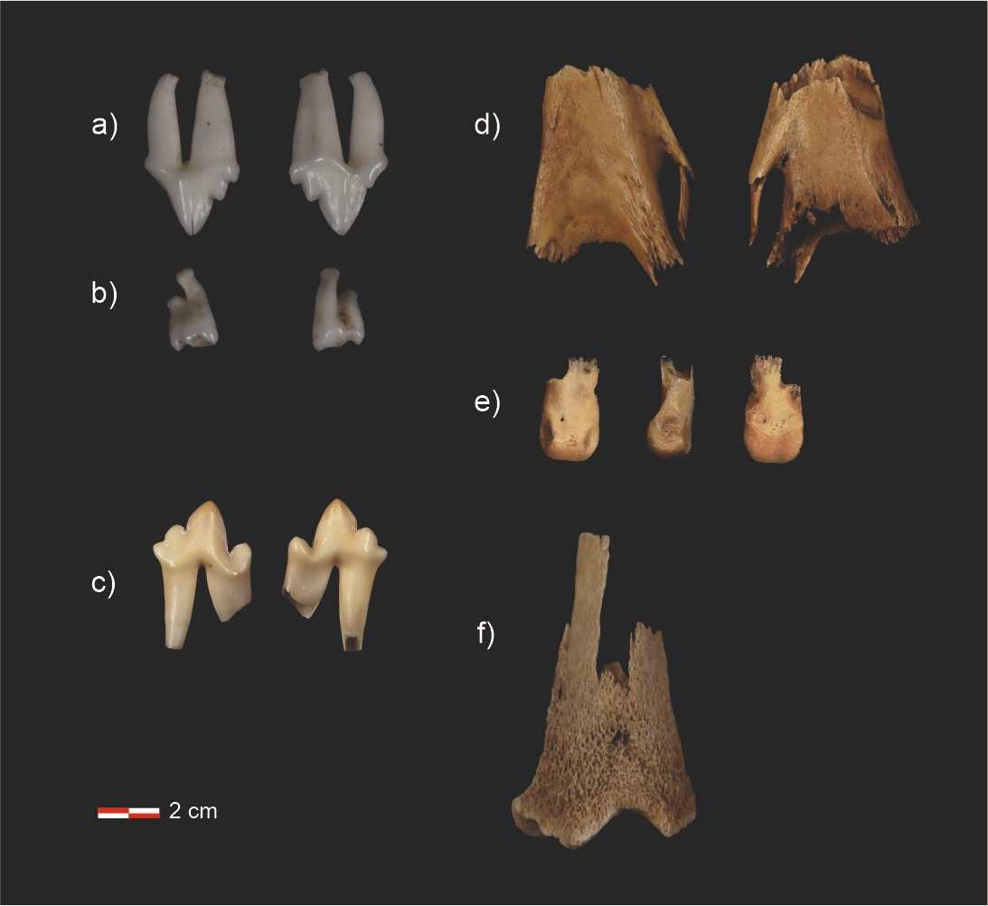

Figure. Felid skeletal and dental element recovered from the contents of Iberian lynx scats: a) P3 of Felis sp. aff. F. catus/F. silvestris, b) M1 of Felis sp. aff. F. catus/F. silvestris, c) lower dp3 of Felidae, cf. Lynx pardinus, d) distal humerus of Felidae, cf. Lynx pardinus, e) second phalanx of Felidae, cf. Lynx pardinus, and f) distal femur of Felidae, cf. Lynx pardinus.

Scat analysis
The scats contained abundant European rabbit (Oryctolagus cuniculus) remains, unidentified small-mammal remains, and eight elements attributable to Carnivora, corresponding to four dental and four postcranial elements. The assemblage allowed the recognition of a minimum number of two individuals of the family Felidae.
Two of the permanent dental remains, P3 and M1, were morphologically and metrically compatible with an adult individual of the genus Felis. Owing to the overlap among the species considered and the limitations resulting from the available anatomical representation, these skeletal and dental elements were conservatively identified as Felis sp. aff. F. catus/F. silvestris.
The six remaining elements differed in size and ontogenetic characteristics from the comparative specimens of the genus Felis and were compatible with a larger-sized felid. The combination of their metric and morphological traits supports their attribution to Felidae, cf. Lynx pardinus. These remains included a lower deciduous dp3 and an upper deciduous DP4, both with incomplete root development and open apices, together with postcranial elements showing a very low degree of skeletal maturation: a humerus and femur with unfused epiphyses and poorly mineralised phalanges (Figure).
The association of these traits indicates the presence of at least one very young juvenile individual of cf. Lynx pardinus. Based on the ontogenetic sequence, the eruption of the deciduous premolars, and the marked immaturity of the appendicular skeleton, the estimated age at death for this individual was less than two months, probably around 5 to 8 weeks ¹².

Determination of infanticide
The recovery and necropsy of the remains of at least two cubs from Kea’s litter, together with the identification of lynx cub remains in relatively fresh lynx scats collected near the presumed mortality site, were consistent with an intraspecific attack and possible infanticide. The locations of both Marchés and Lucero were spatially and temporally compatible with the estimated mortality window, precluding attribution to either individual.

REFERENCES
1. Farine, D. R. A guide to null models for animal social network analysis. Methods Ecol. Evol. 8, 1309–1320 (2017).
2. Farine, D. R. & Whitehead, H. Constructing, conducting and interpreting animal social network analysis. J. Anim. Ecol. 84, 1144–1163 (2015).
3. Wey, T., Blumstein, D. T., Shen, W. & Jordán, F. Social network analysis of animal behaviour: a promising tool for the study of sociality. Anim. Behav. 75, 333–344 (2008).
4. Pinter-Wollman, N. et al. The dynamics of animal social networks: Analytical, conceptual, and theoretical advances. Behav. Ecol. 25, 242–255 (2014).
5. Connor, T. et al. Social network analysis uncovers hidden social complexity in giant pandas. Ursus 2023, 1–13 (2023).
6. Blondel, V. D., Guillaume, J. L., Lambiotte, R. & Lefebvre, E. Fast unfolding of communities in large networks. J. Stat. Mech. Theory Exp. 2008, (2008).
7. Newman, M. E. J. Modularity and community structure in networks. Proc. Natl. Acad. Sci. U. S. A. 103, 8577–8582 (2006).
8. Csárdi, G. & Nepusz, T. The igraph software package for complex network research. InterJournal Complex Sy, 1695 (2006).
9. Dekker, D., Krackhardt, D. & Snijders, T. A. B. Sensitivity of MRQAP tests to collinearity and autocorrelation conditions. Psychometrika 72, 563–581 (2007).
10. Schaub, M. & Badia-Boher, J. A. Comparison of Bayesian Models to Estimate Survival From Dead-Recovery Alone and Together With Live-Encounter Data: Challenges and Opportunities. Ecol. Evol. 15, (2025).
11. Crespo, E. & García-Talens, A. M. Informe Referente Al Examen Forense de Restos de Linces Ibéricos (Lynx Pardinus), Con Número de Referencia TO/VEN _ 27/2016. (2016).
12. Rodriguez-Hidalgo, A. Informe Nº401371_4390328_ARH. (2026).

