Supplementary Material: Beyond Clean Accuracy
Original research article
Aras Ismael Masood
Technical College of Informatics, Sulaimani Polytechnic University, Sulaimani, Iraq, 46001
Corresponding author: aras.masood@spu.edu.iq
Protocol 4.1_publication_final | September 2026

Supplementary overview
This supplement reports detailed outputs for protocol 4.1_publication_final. Machine-readable versions of all 26 numbered tables, 24 per-dataset-seed condition files, 25 publication figures, the validation report, execution summary, reproducibility manifest, and reference-to-claim audit are included in the accompanying complete submission package.

S1. Experimental completeness
Table S1. Automated completeness and duplication checks.
Check | Result
Protocol | 4.1_publication_final
Clean predictor runs | 96 / 96
Shift evaluations | 8,448 / 8,448
Duplicate shifted rows | 0
Forecast prediction rows | 324,576
Datasets / models / shifts | 8 / 4 / 8
All CSV tables / figures | 50 / 25
Validation status | Complete

S2. Dataset characteristics and runtime
Table S2. Dataset sizes after target cleaning and preprocessing dimensions.
Dataset | Total | Train | Val | Test | Features | Classes | Prep s
adult | 48,842 | 34,188 | 7,327 | 7,327 | 105 | 2 | 0.44
bank_marketing | 45,211 | 31,647 | 6,782 | 6,782 | 51 | 2 | 0.38
electricity | 45,312 | 31,718 | 6,797 | 6,797 | 14 | 2 | 4.65
covertype | 581,012 | 406,708 | 87,152 | 87,152 | 98 | 7 | 36.75
numerai | 96,320 | 67,423 | 14,449 | 14,448 | 21 | 2 | 7.91
nomao | 34,465 | 24,125 | 5,170 | 5,170 | 174 | 2 | 6.45
phoneme | 5,404 | 3,782 | 811 | 811 | 5 | 2 | 4.20
miniboone | 130,064 | 91,044 | 19,510 | 19,510 | 50 | 2 | 12.75

S3. Detailed clean performance
Table S3. Clean test metrics across three seeds (mean +/- SD).
Dataset | Model | Accuracy | Balanced accuracy | Macro-F1 | AUROC | ECE
adult | logistic regression | 0.807 +/- 0.000 | 0.822 +/- 0.000 | 0.770 +/- 0.000 | 0.908 +/- 0.000 | 0.023 +/- 0.000
adult | mlp | 0.817 +/- 0.006 | 0.830 +/- 0.005 | 0.781 +/- 0.006 | 0.914 +/- 0.000 | 0.028 +/- 0.007
adult | random forest | 0.823 +/- 0.005 | 0.834 +/- 0.001 | 0.786 +/- 0.004 | 0.920 +/- 0.000 | 0.031 +/- 0.005
adult | xgboost | 0.827 +/- 0.001 | 0.845 +/- 0.002 | 0.793 +/- 0.001 | 0.931 +/- 0.000 | 0.043 +/- 0.002
bank_marketing | logistic regression | 0.808 +/- 0.000 | 0.830 +/- 0.000 | 0.696 +/- 0.000 | 0.902 +/- 0.000 | 0.072 +/- 0.000
bank_marketing | mlp | 0.825 +/- 0.014 | 0.849 +/- 0.004 | 0.717 +/- 0.014 | 0.921 +/- 0.003 | 0.090 +/- 0.016
bank_marketing | random forest | 0.823 +/- 0.003 | 0.861 +/- 0.001 | 0.718 +/- 0.003 | 0.927 +/- 0.001 | 0.093 +/- 0.003
bank_marketing | xgboost | 0.830 +/- 0.011 | 0.864 +/- 0.002 | 0.725 +/- 0.010 | 0.929 +/- 0.001 | 0.083 +/- 0.011
covertype | logistic regression | 0.598 +/- 0.000 | 0.708 +/- 0.000 | 0.506 +/- 0.000 | 0.925 +/- 0.000 | 0.057 +/- 0.000
covertype | mlp | 0.850 +/- 0.007 | 0.925 +/- 0.004 | 0.803 +/- 0.008 | 0.986 +/- 0.001 | 0.014 +/- 0.000
covertype | random forest | 0.915 +/- 0.000 | 0.916 +/- 0.000 | 0.881 +/- 0.001 | 0.993 +/- 0.000 | 0.156 +/- 0.001
covertype | xgboost | 0.861 +/- 0.000 | 0.920 +/- 0.001 | 0.832 +/- 0.001 | 0.987 +/- 0.000 | 0.051 +/- 0.001
electricity | logistic regression | 0.608 +/- 0.000 | 0.624 +/- 0.000 | 0.560 +/- 0.000 | 0.904 +/- 0.000 | 0.280 +/- 0.000
electricity | mlp | 0.674 +/- 0.030 | 0.687 +/- 0.028 | 0.650 +/- 0.040 | 0.891 +/- 0.007 | 0.166 +/- 0.044
electricity | random forest | 0.661 +/- 0.015 | 0.675 +/- 0.015 | 0.632 +/- 0.020 | 0.833 +/- 0.002 | 0.222 +/- 0.006
electricity | xgboost | 0.567 +/- 0.005 | 0.585 +/- 0.005 | 0.489 +/- 0.008 | 0.865 +/- 0.005 | 0.420 +/- 0.006
miniboone | logistic regression | 0.872 +/- 0.000 | 0.873 +/- 0.000 | 0.850 +/- 0.000 | 0.942 +/- 0.000 | 0.035 +/- 0.000
miniboone | mlp | 0.925 +/- 0.000 | 0.929 +/- 0.000 | 0.910 +/- 0.000 | 0.979 +/- 0.000 | 0.008 +/- 0.003
miniboone | random forest | 0.928 +/- 0.002 | 0.933 +/- 0.000 | 0.915 +/- 0.002 | 0.981 +/- 0.000 | 0.035 +/- 0.003
miniboone | xgboost | 0.940 +/- 0.001 | 0.945 +/- 0.001 | 0.928 +/- 0.001 | 0.986 +/- 0.000 | 0.017 +/- 0.001
nomao | logistic regression | 0.942 +/- 0.000 | 0.941 +/- 0.000 | 0.931 +/- 0.000 | 0.986 +/- 0.000 | 0.009 +/- 0.000
nomao | mlp | 0.961 +/- 0.002 | 0.963 +/- 0.002 | 0.953 +/- 0.002 | 0.993 +/- 0.000 | 0.013 +/- 0.002
nomao | random forest | 0.964 +/- 0.003 | 0.963 +/- 0.001 | 0.956 +/- 0.003 | 0.994 +/- 0.000 | 0.020 +/- 0.001
nomao | xgboost | 0.972 +/- 0.000 | 0.972 +/- 0.001 | 0.966 +/- 0.000 | 0.996 +/- 0.000 | 0.007 +/- 0.002
numerai | logistic regression | 0.515 +/- 0.000 | 0.514 +/- 0.000 | 0.514 +/- 0.000 | 0.526 +/- 0.000 | 0.009 +/- 0.000
numerai | mlp | 0.516 +/- 0.002 | 0.516 +/- 0.002 | 0.515 +/- 0.002 | 0.522 +/- 0.002 | 0.017 +/- 0.007
numerai | random forest | 0.517 +/- 0.002 | 0.516 +/- 0.002 | 0.511 +/- 0.009 | 0.521 +/- 0.003 | 0.023 +/- 0.002
numerai | xgboost | 0.512 +/- 0.003 | 0.511 +/- 0.002 | 0.499 +/- 0.013 | 0.517 +/- 0.000 | 0.054 +/- 0.003
phoneme | logistic regression | 0.657 +/- 0.000 | 0.708 +/- 0.000 | 0.647 +/- 0.000 | 0.783 +/- 0.000 | 0.104 +/- 0.000
phoneme | mlp | 0.802 +/- 0.022 | 0.810 +/- 0.004 | 0.780 +/- 0.017 | 0.888 +/- 0.010 | 0.051 +/- 0.011
phoneme | random forest | 0.882 +/- 0.005 | 0.859 +/- 0.008 | 0.858 +/- 0.006 | 0.938 +/- 0.001 | 0.028 +/- 0.003
phoneme | xgboost | 0.871 +/- 0.001 | 0.865 +/- 0.005 | 0.850 +/- 0.000 | 0.938 +/- 0.001 | 0.055 +/- 0.005

S4. Detailed survival summary
Table S4. Dataset-model survival results aggregated across seeds and shift families.
Dataset | Model | Clean BA | Retention STI | Relative CSP | Operational STI | Reversal
adult | logistic regression | 0.822 | 0.963 | 0.988 | 0.979 | 100.0%
adult | mlp | 0.830 | 0.966 | 1.000 | 0.983 | 100.0%
adult | random forest | 0.834 | 0.966 | 0.983 | 0.979 | 100.0%
adult | xgboost | 0.845 | 0.932 | 0.971 | 0.871 | 100.0%
bank_marketing | logistic regression | 0.830 | 0.966 | 1.000 | 0.992 | 100.0%
bank_marketing | mlp | 0.849 | 0.957 | 1.000 | 0.988 | 33.3%
bank_marketing | random forest | 0.861 | 0.956 | 1.000 | 1.000 | 66.7%
bank_marketing | xgboost | 0.864 | 0.951 | 1.000 | 1.000 | 100.0%
covertype | logistic regression | 0.708 | 0.835 | 0.692 | 0.358 | 100.0%
covertype | mlp | 0.925 | 0.777 | 0.621 | 0.621 | 100.0%
covertype | random forest | 0.916 | 0.779 | 0.600 | 0.600 | 33.3%
covertype | xgboost | 0.920 | 0.794 | 0.633 | 0.633 | 33.3%
electricity | logistic regression | 0.624 | 0.973 | 1.000 | NA | 33.3%
electricity | mlp | 0.687 | 0.968 | 0.996 | 0.663 | 100.0%
electricity | random forest | 0.675 | 0.976 | 0.996 | NA | 66.7%
electricity | xgboost | 0.585 | 0.982 | 1.000 | NA | 100.0%
miniboone | logistic regression | 0.873 | 0.883 | 0.763 | 0.763 | 100.0%
miniboone | mlp | 0.929 | 0.868 | 0.750 | 0.750 | 33.3%
miniboone | random forest | 0.933 | 0.886 | 0.767 | 0.767 | 66.7%
miniboone | xgboost | 0.945 | 0.867 | 0.742 | 0.742 | 100.0%
nomao | logistic regression | 0.941 | 0.916 | 0.875 | 0.875 | 0.0%
nomao | mlp | 0.963 | 0.938 | 0.917 | 0.917 | 66.7%
nomao | random forest | 0.963 | 0.949 | 0.942 | 0.942 | 100.0%
nomao | xgboost | 0.972 | 0.937 | 0.942 | 0.942 | 66.7%
numerai | logistic regression | 0.514 | 0.993 | 1.000 | NA | 100.0%
numerai | mlp | 0.516 | 0.993 | 1.000 | NA | 100.0%
numerai | random forest | 0.516 | 0.991 | 1.000 | NA | 66.7%
numerai | xgboost | 0.511 | 0.991 | 1.000 | NA | 66.7%
phoneme | logistic regression | 0.708 | 0.977 | 1.000 | 0.492 | 100.0%
phoneme | mlp | 0.810 | 0.941 | 0.971 | 0.883 | 100.0%
phoneme | random forest | 0.859 | 0.907 | 0.871 | 0.850 | 100.0%
phoneme | xgboost | 0.865 | 0.913 | 0.900 | 0.879 | 100.0%

Table S5. Relative survival summarized by shift family.
Shift family | N trajectories | STI mean | STI SD | CSP mean | Censored
concurrent | 96 | 0.864 | 0.142 | 0.766 | 57.3%
gaussian noise | 96 | 0.870 | 0.140 | 0.776 | 64.6%
feature permutation | 96 | 0.877 | 0.148 | 0.847 | 63.5%
missing features | 96 | 0.899 | 0.104 | 0.868 | 63.5%
outlier contamination | 96 | 0.963 | 0.021 | 1.000 | 100.0%
feature scaling | 96 | 0.974 | 0.047 | 0.973 | 92.7%
subpopulation | 96 | 0.984 | 0.020 | 1.000 | 100.0%
label prevalence | 96 | 0.993 | 0.008 | 1.000 | 100.0%

S5. Rank reversal and sensitivity
Table S6. Top-model rank reversal within each independent dataset-seed block.
Dataset | Seed | Best clean model | Best robust model | Reversal
adult | 42 | xgboost | logistic regression | Yes
adult | 123 | xgboost | random forest | Yes
adult | 999 | xgboost | random forest | Yes
bank_marketing | 42 | random forest | logistic regression | Yes
bank_marketing | 123 | xgboost | logistic regression | Yes
bank_marketing | 999 | xgboost | logistic regression | Yes
covertype | 42 | mlp | logistic regression | Yes
covertype | 123 | mlp | logistic regression | Yes
covertype | 999 | mlp | logistic regression | Yes
electricity | 42 | random forest | xgboost | Yes
electricity | 123 | mlp | xgboost | Yes
electricity | 999 | mlp | xgboost | Yes
miniboone | 42 | xgboost | random forest | Yes
miniboone | 123 | xgboost | random forest | Yes
miniboone | 999 | xgboost | logistic regression | Yes
nomao | 42 | xgboost | random forest | Yes
nomao | 123 | xgboost | random forest | Yes
nomao | 999 | xgboost | xgboost | No
numerai | 42 | mlp | logistic regression | Yes
numerai | 123 | random forest | mlp | Yes
numerai | 999 | random forest | logistic regression | Yes
phoneme | 42 | xgboost | logistic regression | Yes
phoneme | 123 | xgboost | logistic regression | Yes
phoneme | 999 | xgboost | logistic regression | Yes

Table S7. Leave-one-shift-family-out ablation.
Excluded shift | Families | Model reversal | Top reversal | Spearman rho | p
none | 8 | 79.2% | 95.8% | -0.773 | 2.099e-07
gaussian noise | 7 | 79.2% | 95.8% | -0.778 | 1.615e-07
missing features | 7 | 78.1% | 95.8% | -0.744 | 1.051e-06
feature scaling | 7 | 80.2% | 95.8% | -0.776 | 1.843e-07
feature permutation | 7 | 83.3% | 100.0% | -0.773 | 2.099e-07
outlier contamination | 7 | 79.2% | 95.8% | -0.773 | 2.145e-07
label prevalence | 7 | 77.1% | 95.8% | -0.775 | 1.967e-07
subpopulation | 7 | 80.2% | 95.8% | -0.776 | 1.843e-07
concurrent | 7 | 78.1% | 95.8% | -0.762 | 4.026e-07

Table S8. Leave-one-dataset-out association sensitivity.
Excluded dataset | Datasets | Spearman rho | p | Kendall tau | p
none | 8 | -0.773 | 2.099e-07 | -0.605 | 1.94e-07
adult | 7 | -0.748 | 4.696e-06 | -0.582 | 4.236e-06
bank_marketing | 7 | -0.737 | 7.807e-06 | -0.566 | 8.461e-06
electricity | 7 | -0.666 | 0.0001111 | -0.503 | 0.0001009
covertype | 7 | -0.863 | 3.411e-09 | -0.698 | 8.524e-09
numerai | 7 | -0.663 | 0.0001192 | -0.492 | 0.0001464
nomao | 7 | -0.874 | 1.231e-09 | -0.725 | 1.461e-09
phoneme | 7 | -0.778 | 1.113e-06 | -0.614 | 9.62e-07
miniboone | 7 | -0.807 | 2.086e-07 | -0.640 | 2.504e-07

S6. Forecasting detail
Table S9. Pooled out-of-fold forecasting metrics.
Regime | Forecaster | Features | MAE | RMSE | R2 | Failure accuracy | Failure macro-F1
LODO | ffn | combined | 0.1097 | 0.1637 | -0.135 | 0.842 | 0.583
LODO | ffn | confidence only | 0.1170 | 0.1709 | -0.237 | 0.846 | 0.588
LODO | ffn | drift only | 0.1319 | 0.1839 | -0.432 | 0.786 | 0.441
LODO | ffn | no model identity | 0.1184 | 0.1698 | -0.220 | 0.819 | 0.541
LODO | naive no change | combined | 0.0677 | 0.1338 | 0.243 | 0.884 | 0.469
LODO | random forest regressor | combined | 0.0569 | 0.1047 | 0.536 | 0.869 | 0.542
LODO | ridge | combined | 0.1056 | 0.1480 | 0.072 | 0.828 | 0.597
LOSO | ffn | combined | 0.0579 | 0.0934 | 0.631 | 0.892 | 0.763
LOSO | ffn | confidence only | 0.0426 | 0.0683 | 0.802 | 0.932 | 0.833
LOSO | ffn | drift only | 0.0848 | 0.1219 | 0.370 | 0.851 | 0.640
LOSO | ffn | no model identity | 0.0634 | 0.1023 | 0.556 | 0.895 | 0.766
LOSO | naive no change | combined | 0.0685 | 0.1346 | 0.232 | 0.883 | 0.469
LOSO | random forest regressor | combined | 0.0426 | 0.0743 | 0.766 | 0.915 | 0.795
LOSO | ridge | combined | 0.0586 | 0.0918 | 0.643 | 0.894 | 0.742

Table S10. Cluster-aware paired forecasting tests. Positive advantage indicates lower MAE for the combined FFN.
Regime | Comparison with FFN combined | Blocks | FFN MAE | Comparator MAE | FFN advantage | Holm p
LODO | naive no change:combined | 8 | 0.1153 | 0.0677 | -0.0476 | 0.04688
LODO | ridge:combined | 8 | 0.1153 | 0.1056 | -0.0097 | 1.0
LODO | random forest regressor:combined | 8 | 0.1153 | 0.0569 | -0.0584 | 0.04688
LODO | ffn:drift only | 8 | 0.1153 | 0.1347 | 0.0194 | 0.3281
LODO | ffn:confidence only | 8 | 0.1153 | 0.1197 | 0.0044 | 1.0
LODO | ffn:no model identity | 8 | 0.1153 | 0.1231 | 0.0078 | 0.1875
LOSO | naive no change:combined | 8 | 0.0604 | 0.0685 | 0.0081 | 0.9219
LOSO | ridge:combined | 8 | 0.0604 | 0.0586 | -0.0019 | 0.9219
LOSO | random forest regressor:combined | 8 | 0.0604 | 0.0426 | -0.0178 | 0.04688
LOSO | ffn:drift only | 8 | 0.0604 | 0.0867 | 0.0262 | 0.04688
LOSO | ffn:confidence only | 8 | 0.0604 | 0.0448 | -0.0156 | 0.04688
LOSO | ffn:no model identity | 8 | 0.0604 | 0.0656 | 0.0051 | 0.04688

S7. Diagnostic figures
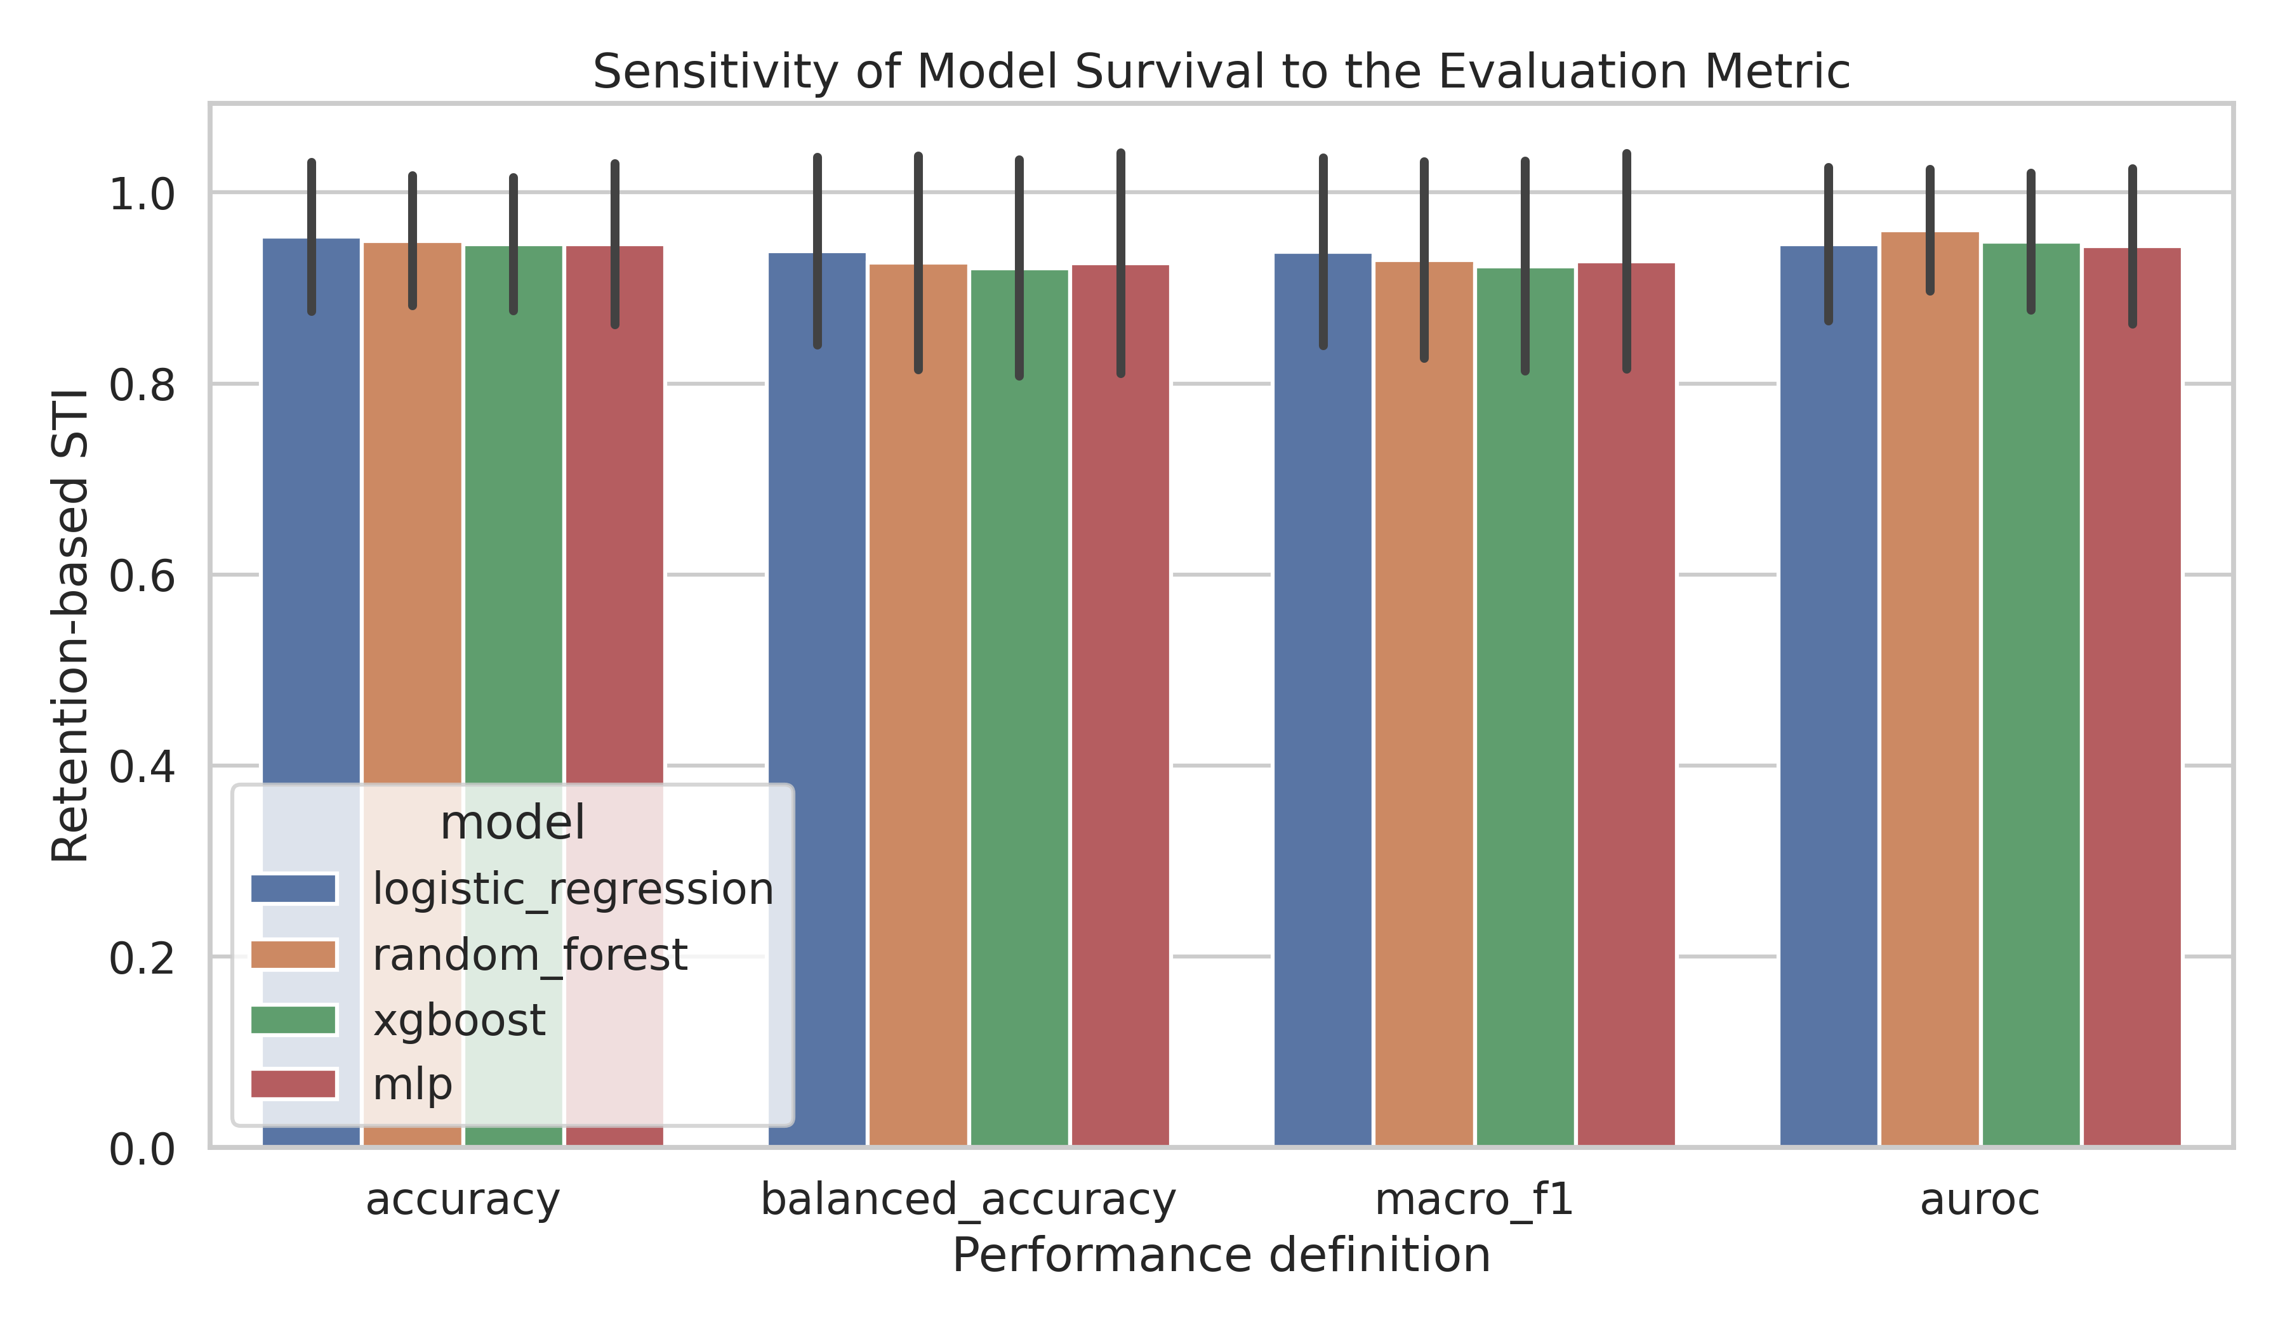
Figure S1. Metric sensitivity of survival rankings across balanced accuracy, accuracy, macro-F1, and AUROC.
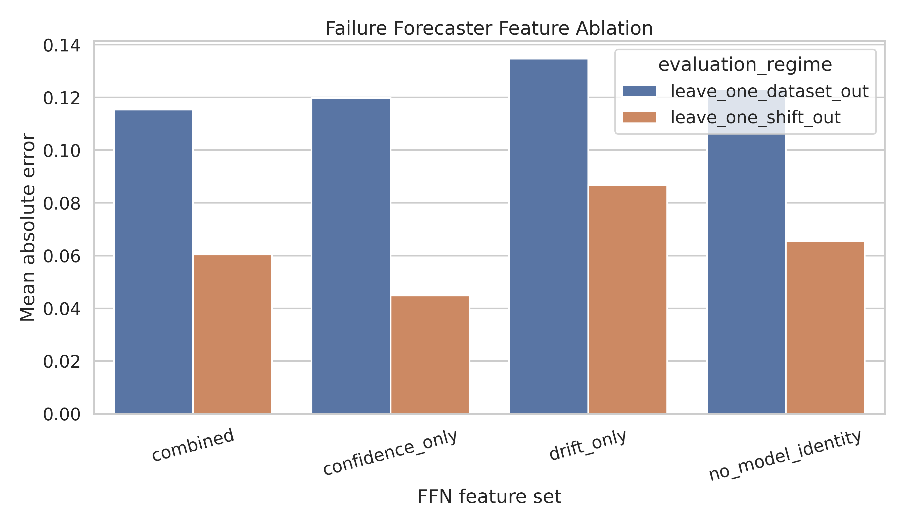
Figure S2. Failure-forecaster feature-group ablation under both transfer regimes.
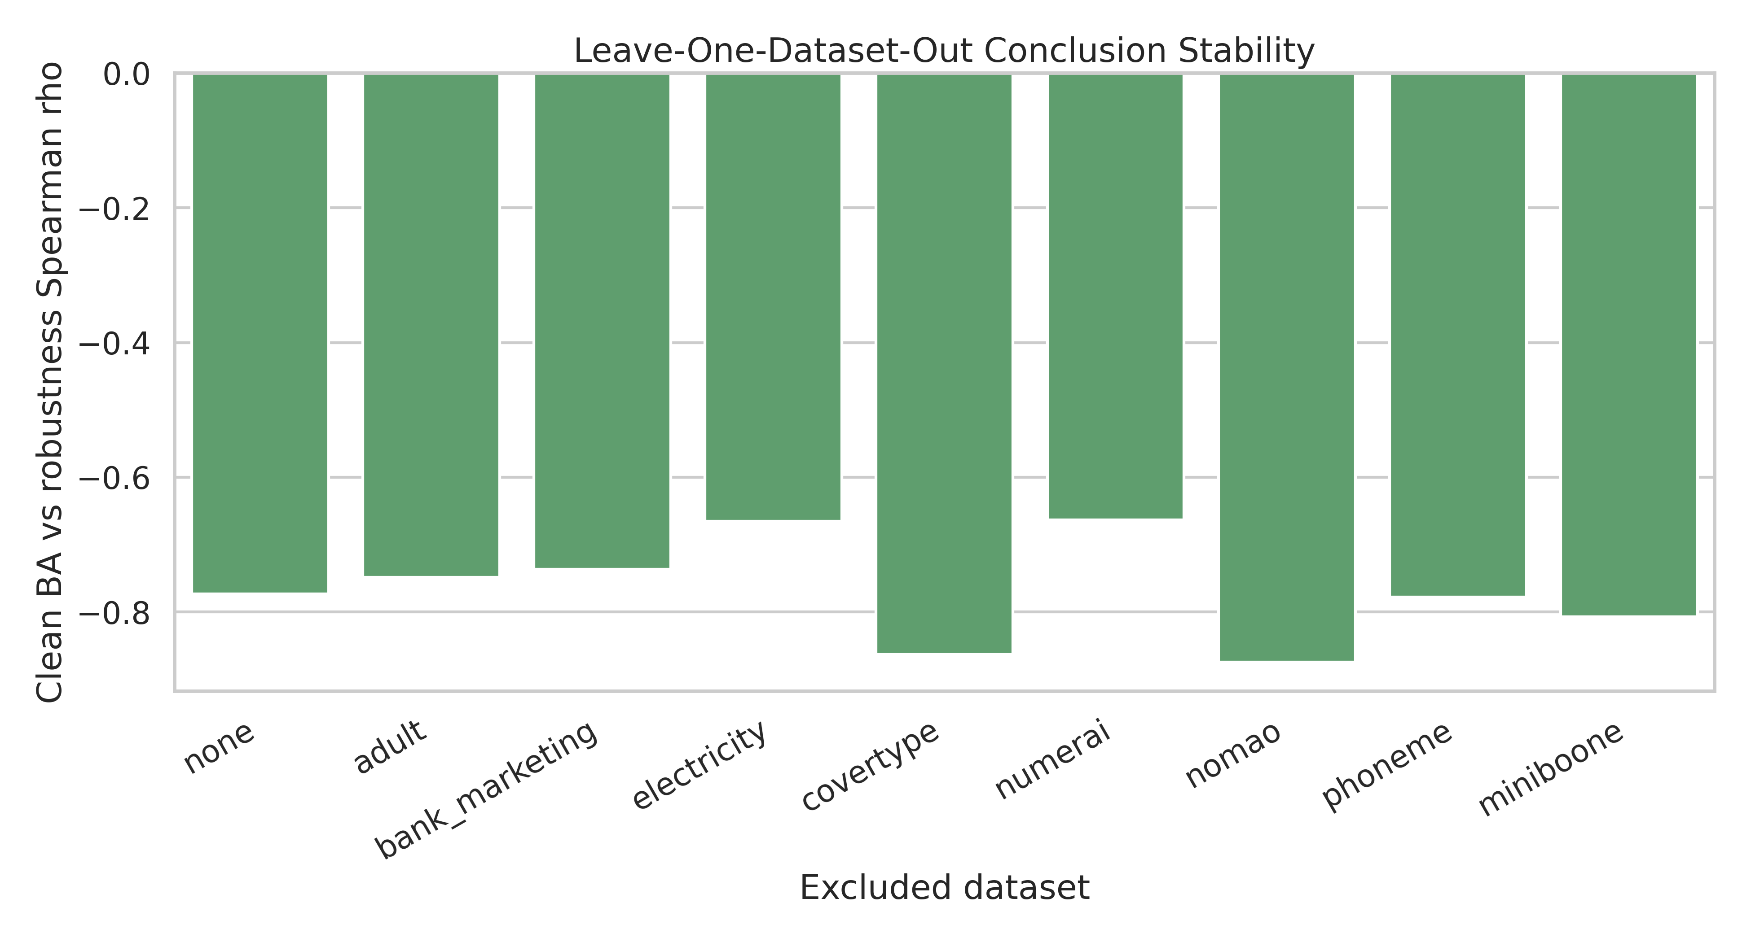
Figure S3. Leave-one-dataset-out sensitivity of the clean-performance versus robustness association.
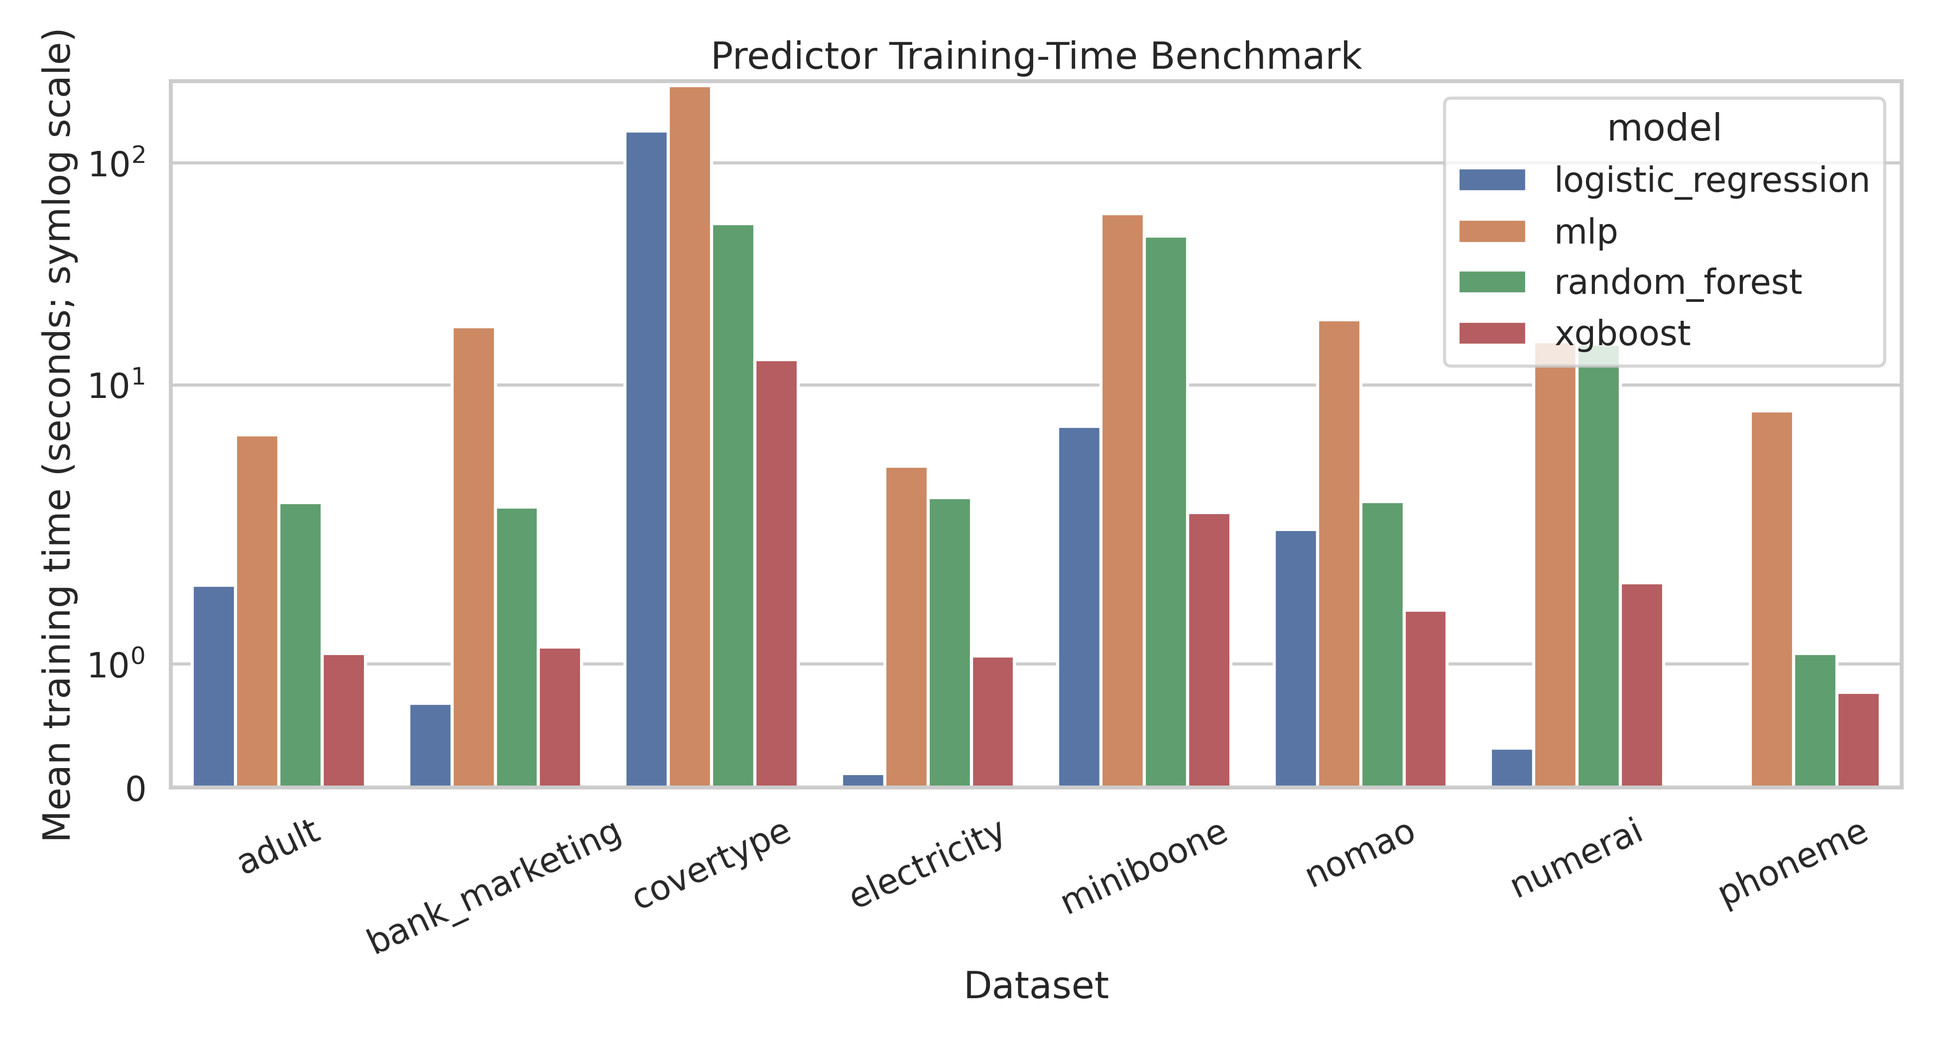
Figure S4. Predictor training time by dataset and model family.
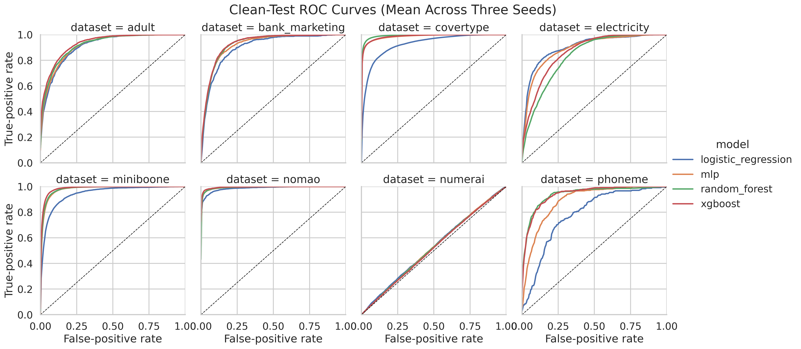
Figure S5. Clean-test ROC curves aggregated across seeds. Covertype uses macro one-vs-rest ROC.

S8. Confusion matrices
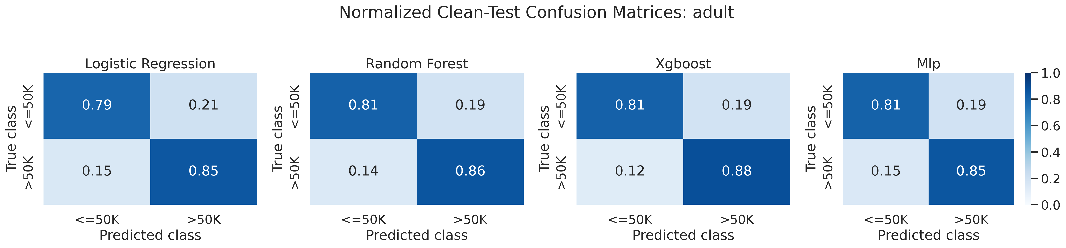
Figure S6. Clean-test confusion matrices for Adult, aggregated over the three predictor seeds.

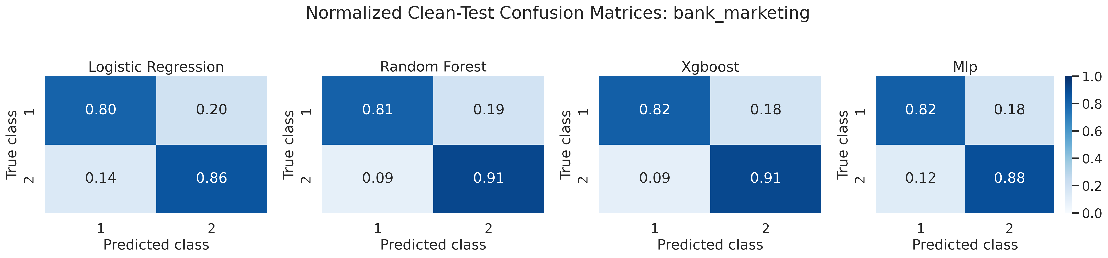
Figure S7. Clean-test confusion matrices for Bank Marketing, aggregated over the three predictor seeds.

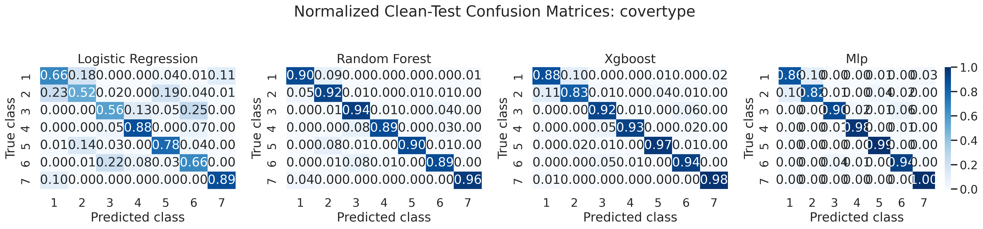
Figure S8. Clean-test confusion matrices for Covertype, aggregated over the three predictor seeds.

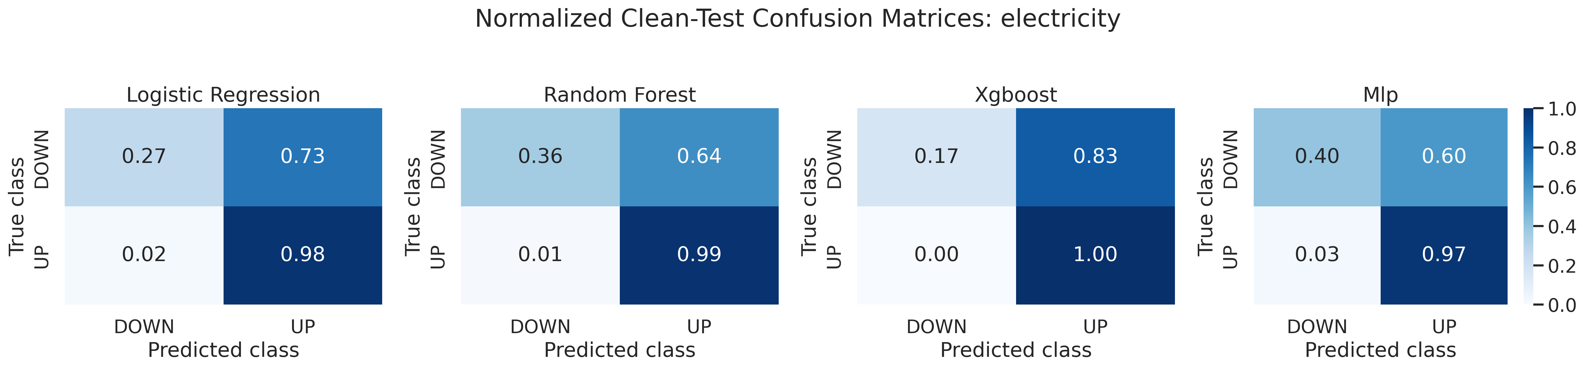
Figure S9. Clean-test confusion matrices for Electricity, aggregated over the three predictor seeds.

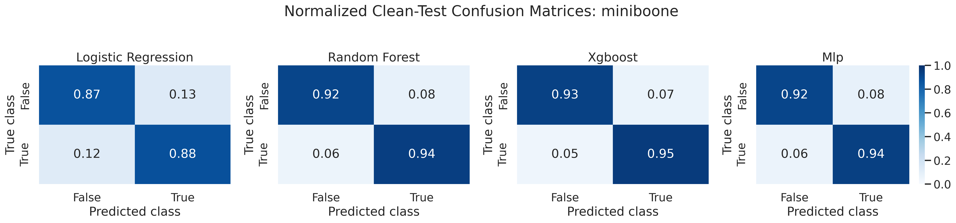
Figure S10. Clean-test confusion matrices for Miniboone, aggregated over the three predictor seeds.

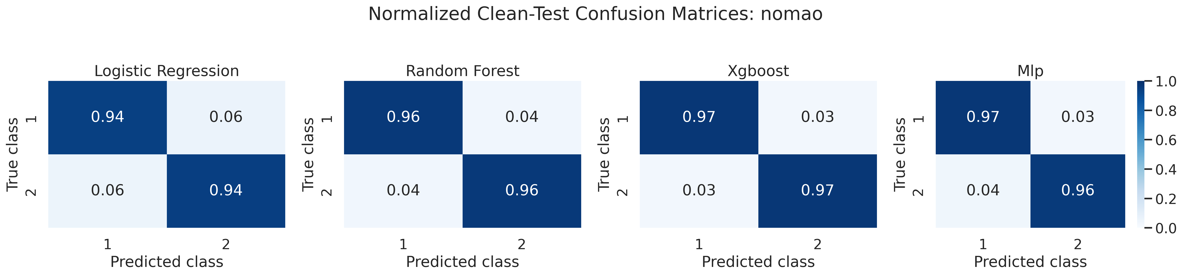
Figure S11. Clean-test confusion matrices for Nomao, aggregated over the three predictor seeds.

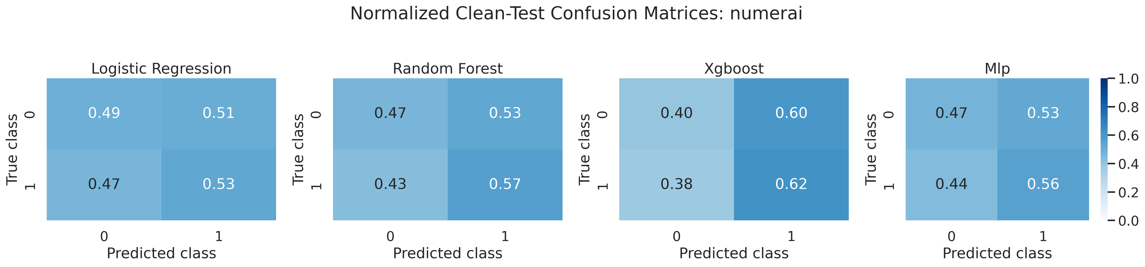
Figure S12. Clean-test confusion matrices for Numerai, aggregated over the three predictor seeds.

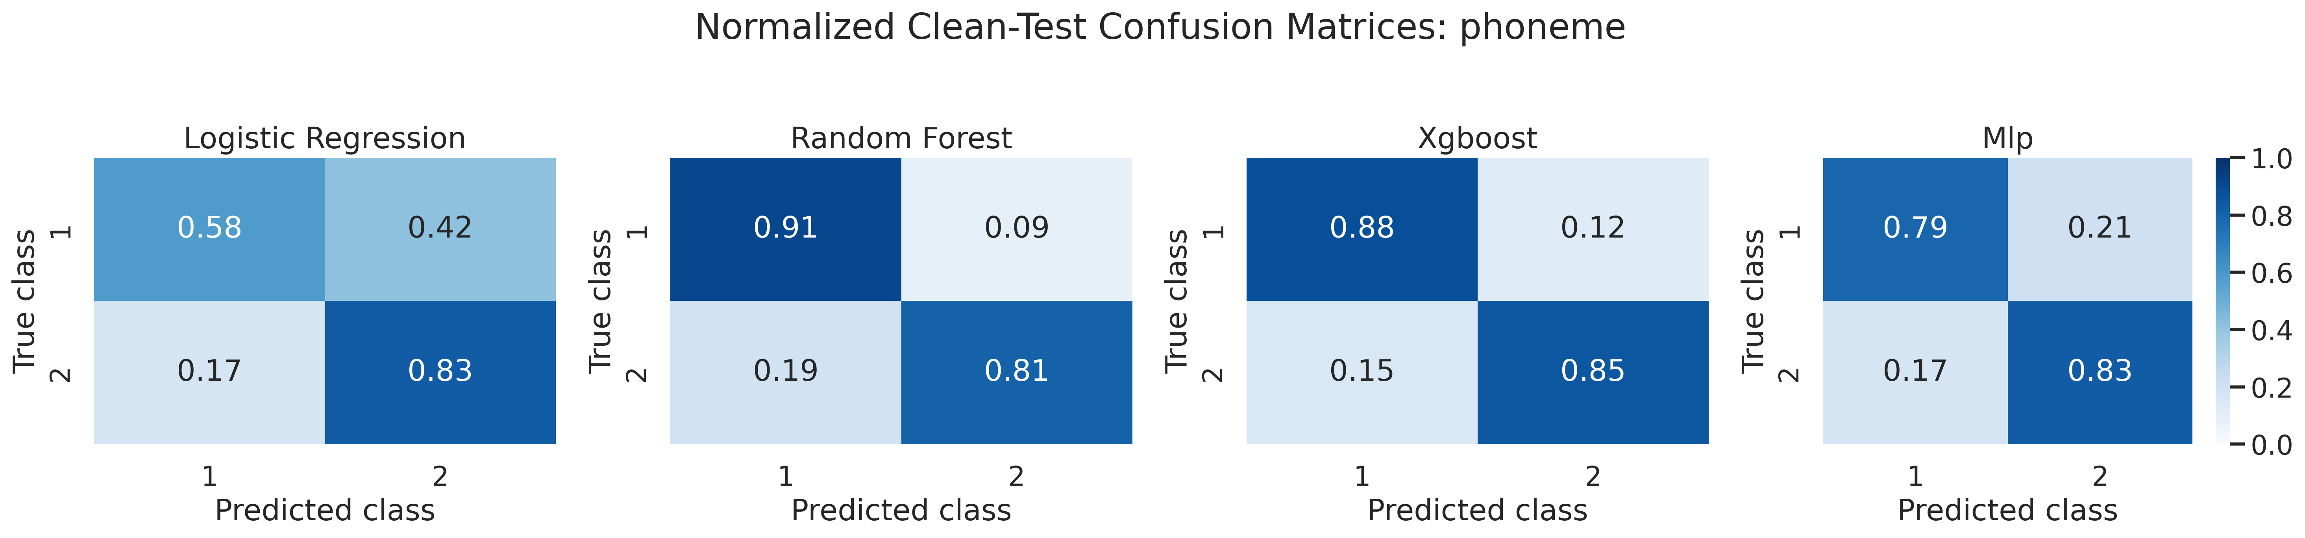
Figure S13. Clean-test confusion matrices for Phoneme, aggregated over the three predictor seeds.

S9. Exact endpoint implementation
The following statements are implementation checks against the archived source code, not alternative post hoc definitions.
- Baseline balanced accuracy was protected by epsilon=10^-8 before division.
- Raw retention was clipped to [0,1.25], then converted to a cumulative-minimum curve.
- Retention-area STI integrated the cumulative-minimum curve after a second clip to [0,1].
- Relative, absolute, and operational events required two consecutive failed severity points.
- No relative event through severity 1.0 was recorded as right-censored at 1.0.
- Absolute and operational endpoints were undefined for baseline balanced accuracy below 0.70.
- Operational and absolute STI used a right-continuous binary survival indicator.

S10. Evidence and reporting audit
Table S11. Submission-readiness audit for the reported study.
Audit item | Result | Interpretation
Literature references | 57 | Each supports a named claim, method, dataset, metric, or reporting decision
Editable equations | 7 | Definitions mirror the executed V4 source
Predictor seeds | 3 | 42, 123, and 999
Neural training ceiling | 100 epochs | Validation early stopping after 15 unimproved epochs
Ablation families | 5 | Feature groups, metric, thresholds/floors, shift exclusions, dataset exclusions
Diagnostic outputs | ROC + confusion matrices | All eight datasets represented

