Supplementary information

Assessing the sustainability of yellow anaconda (Eunectes notaeus) harvest in northeastern Argentina
Bruno F. Camera*, Christine Strüssmann, Itxaso Quintana, Tomás Waller, Mariano Barros, Juan Draque, Patrício A. Micucci, Everton B. P. Miranda
Programa de Pós-graduação em Zoologia, Instituto de Biociências, Universidade Federal de Mato Grosso, Cuiabá, Mato Grosso, Brazil

B. F. C., C. S., I. Q., and E. B. P. de M. conceived and designed the experiments, and wrote the paper. T. W., M. B., J. D., and P. A. M. provided data, revised, and made improvements to the paper.

*Contact information: Bruno Felipe Camera
E-mail address: camera_bruno@hotmail.com
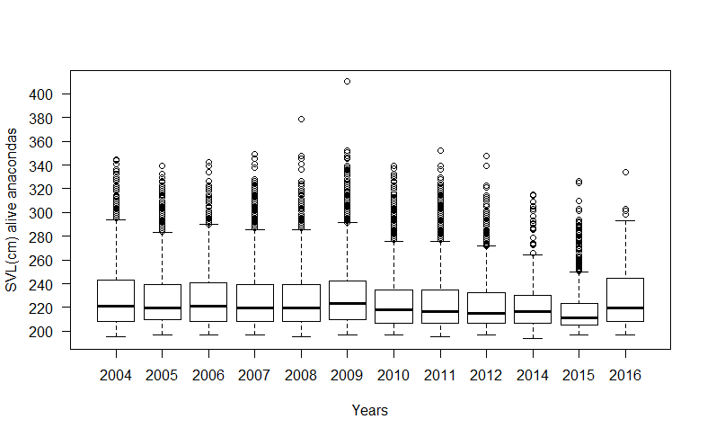
Supplementary figure S1.
Estimated snout-vent length of yellow anacondas harvested by the Programa Curiyú in 2004-2016 in northeastern Argentina.

