5. Results

5.1 Data Screening and Analytic Sample
Three hundred responses were retrieved. Item-level missingness was 1.51% (164 of 10,800 cells), distributed across 128 cases in 69 distinct patterns with no case missing more than three items. Little’s test was consistent with data missing completely at random, χ²(2344) = 2290.94, p = .780, so missingness was addressed by mean replacement under the pre-specified rule for missingness below 5%.
Insufficient-effort response was screened against four pre-specified criteria. One case satisfied both the straightlining criterion (within-person SD ≤ 0.30) and the longstring criterion (ten or more consecutive identical responses) and was removed; two further cases triggered the longstring criterion alone and were retained under the rule requiring two independent flags. No duplicate identifiers and no duplicate response profiles were detected. One additional case fell below the completeness rule of at least 14 of 16 answered items on the research skills test.
The resulting analytic sample comprised 308 participants (video n = 98; infographic n = 104; audio n = 106). All construct distributions fell well within conventional bounds, with absolute skewness not exceeding 0.84 and absolute kurtosis not exceeding 1.07 (Table 1). Mardia’s normalised coefficient of multivariate kurtosis was −4.38, indicating platykurtic multivariate departure from normality; this, together with the dichotomous scoring of the outcome measure and a sample below the conventional minimum for covariance-based estimation, motivated the choice of estimator reported in Section 4.3.

5.2 Descriptive Statistics
Table 1 reports descriptive statistics for all study variables in the final analytic sample.
Table 1
Descriptive Statistics for Study Variables (N = 308)
Variable | M | SD | Min | Max | Skewness | Kurtosis
Information and summary quality | 2.996 | 1.143 | 1.00 | 5.00 | 0.059 | −1.047
Cognitive load reduction | 2.967 | 1.126 | 1.00 | 5.00 | −0.002 | −0.915
Autonomy | 2.973 | 1.137 | 1.00 | 5.00 | −0.067 | −0.950
Competence | 3.002 | 1.185 | 1.00 | 5.00 | −0.002 | −1.074
Relatedness | 3.020 | 1.121 | 1.00 | 5.00 | −0.077 | −0.914
Scientific research skills | 0.721 | 0.266 | 0.00 | 1.00 | −0.841 | −0.356
Note. Perceptual and motivational constructs were measured on five-point Likert scales. Scientific research skills is the proportion of correct responses across 16 dichotomously scored items.

5.3 Measurement Model
The five perceptual and motivational constructs were specified as reflective. Scientific research skills was initially specified in the same way, with its 16 dichotomous items as reflective indicators, but this specification failed convergent validity decisively: no indicator reached the .708 loading criterion (range .508–.649) and average variance extracted was .347. This outcome is theoretically expected rather than anomalous, because the items of an objectively scored achievement test sample a content domain rather than functioning as interchangeable manifestations of a single latent trait. The construct was therefore modelled as a single-item construct using the proportion-correct score. Internal consistency of the test was adequate (KR-20 = .873) and item difficulties were well distributed (.673–.753), with no item approaching a ceiling.
For the five multi-item constructs, all standardised loadings exceeded the .708 criterion (range .870–.912). Composite reliability ranged from .938 to .946, above the .70 threshold and below the .95 ceiling at which redundancy becomes a concern, and ρ_A ranged from .915 to .925. Average variance extracted ranged from .792 to .815, exceeding the .50 criterion for every construct (Table 2).
Table 2
Measurement Model: Reliability and Convergent Validity
Construct | Items | Loading range | α | ρ_A | CR | AVE
Information and summary quality | 4 | .872–.912 | .913 | .915 | .938 | .792
Cognitive load reduction | 4 | .894–.900 | .920 | .921 | .943 | .806
Autonomy | 4 | .870–.903 | .914 | .918 | .939 | .795
Competence | 4 | .895–.910 | .924 | .925 | .946 | .815
Relatedness | 4 | .889–.906 | .921 | .923 | .944 | .807
Scientific research skills | 1 | — | — | — | — | —
Note. α = Cronbach’s alpha; ρ_A = Dijkstra–Henseler’s rho; CR = composite reliability; AVE = average variance extracted. Scientific research skills is a single-item construct; reliability was assessed by KR-20 = .873.
Discriminant validity was supported on all three criteria. The ten heterotrait–monotrait ratios fell between .239 and .537, well below the conservative .85 criterion, and the upper bound of every bootstrap confidence interval remained below that criterion, with the highest at .624 for the information quality–competence pair (Table 3). Every construct’s square root of average variance extracted exceeded its correlations with all other constructs, and no indicator loaded more strongly on a construct other than its own.
Table 3
Discriminant Validity: Heterotrait–Monotrait Ratios with Bootstrap Confidence Intervals
Construct pair | HTMT | 95% CI | Latent r | Construct pair | HTMT | 95% CI | Latent r
IS – CLR | .239 | [.121, .361] | .220 | CLR – AUT | .300 | [.192, .407] | .277
IS – AUT | .413 | [.307, .516] | .382 | CLR – COMP | .262 | [.155, .367] | .242
IS – COMP | .537 | [.445, .624] | .494 | CLR – REL | .292 | [.176, .407] | .271
IS – REL | .412 | [.308, .511] | .378 | AUT – COMP | .482 | [.381, .576] | .445
 |  |  |  | AUT – REL | .296 | [.182, .405] | .273
 |  |  |  | COMP – REL | .448 | [.345, .546] | .414
Note. IS = information and summary quality; CLR = cognitive load reduction; AUT = autonomy; COMP = competence; REL = relatedness. Confidence intervals from 5,000 bootstrap resamples. Square roots of AVE were .890, .898, .892, .903, and .899 respectively, each exceeding every corresponding construct correlation. HTMT is undefined for the single-item outcome construct.
Because all perceptual and motivational constructs were collected in a single self-report instrument, common method bias was assessed using full collinearity variance inflation factors. All values fell between 1.19 and 2.12, below the 3.3 criterion, indicating that common method variance is unlikely to threaten the findings. The dichotomously scored outcome was obtained from an objective test rather than self-report, which further limits shared method variance between the mediators and the criterion.
Estimation. Partial least squares structural equation modelling was selected as the primary estimator under the pre-specified decision rule: the analytic sample of 308 falls below the conventional minimum for covariance-based estimation, the outcome variable is a bounded proportion derived from dichotomous items, multivariate normality does not hold, and the design requires the incorporation of categorical exogenous dummy variables alongside multi-group comparison. The model was estimated using the path weighting scheme with Mode A outer weights, a maximum of 3,000 iterations, and a stop criterion of 1 × 10⁻⁷; convergence was reached in five iterations. Inference is based on 10,000 bootstrap resamples with bias-corrected and accelerated confidence intervals, two-tailed, with no sign changes permitted. The standardised root mean square residual was .038, below the .08 criterion.

5.4 Effects of Summary Modality (H1–H4c)
Because the six outcomes constituted a pre-specified family, the Benjamini–Hochberg false discovery rate procedure was applied at q = .05. Levene’s test based on the median was non-significant for the five Likert composites (p = .47–.92), supporting Fisher’s F with Tukey’s HSD; it was significant for scientific research skills (W = 14.29, p < .001), for which Welch’s procedure and Games–Howell contrasts were used.
Summary modality produced significant differences on all six outcomes after adjustment, supporting H1, H2, H3, H4a, H4b, and H4c (Table 4). Effect magnitudes were sharply heterogeneous. Modality accounted for a large share of variance in scientific research skills (ω² = .164) and moderate shares in the two perceived affordances (ω² = .077 and .079), but only small shares in the three basic psychological needs (ω² = .024–.029). The manipulation therefore influenced performance and appraisal of the summaries far more strongly than reported need satisfaction.
Table 4
Effects of Summary Modality on Study Outcomes
Outcome | Video M (SD) | Infographic M (SD) | Audio M (SD) | F | df | FDR p | ω²
Scientific research skills | 0.86 (0.19) | 0.71 (0.26) | 0.59 (0.27) | 33.65ᵃ | 2, 192.3 | < .001 | .164
Information and summary quality | 3.39 (1.09) | 3.07 (1.16) | 2.59 (1.06) | 13.40 | 2, 295 | < .001 | .077
Cognitive load reduction | 3.43 (1.07) | 2.82 (1.10) | 2.67 (1.08) | 13.76 | 2, 295 | < .001 | .079
Autonomy | 3.25 (1.14) | 2.94 (1.12) | 2.77 (1.12) | 4.59 | 2, 295 | .011 | .024
Competence | 3.32 (1.14) | 2.85 (1.16) | 2.85 (1.21) | 5.36 | 2, 295 | .006 | .028
Relatedness | 3.30 (1.07) | 2.99 (1.17) | 2.78 (1.07) | 5.42 | 2, 295 | .006 | .029
Note. ᵃ Welch’s F. FDR p = Benjamini–Hochberg adjusted p-value within the six-test family. ω² benchmarks: .01 small, .06 medium, .14 large.
Pairwise comparisons (Table 5) disclose a pattern that the omnibus tests conceal. The ordering video > infographic > audio was fully monotonic and statistically supported only for scientific research skills, where all three contrasts were significant and the video–audio difference was large (g = 1.13, 95% CI [0.83, 1.43]).
For the perceptual and motivational outcomes, the pattern was selective rather than graded. The video condition exceeded the audio condition on all five constructs (g = 0.42–0.75), but the infographic condition was distinguishable from the audio condition on information and summary quality alone (g = 0.43, 95% CI [0.15, 0.71]). On cognitive load reduction, autonomy, competence, and relatedness the infographic and audio conditions were statistically indistinguishable, and on competence the difference was effectively nil (g = −0.004). The advantage of visually enriched summaries was thus concentrated in the video condition rather than being a general property of visual presentation: on four of the five perceptual and motivational outcomes the infographic condition patterned with audio rather than with video, even though it outperformed audio on the objective test.
Table 5
Pairwise Comparisons by Summary Modality
Outcome | Contrast | ΔM | p | Hedges’ g | 95% CI for g
Scientific research skills | Video – Infographic | 0.146 | < .001 | 0.64 | [0.36, 0.93]
 | Video – Audio | 0.268 | < .001 | 1.13 | [0.83, 1.43]
 | Infographic – Audio | 0.122 | .004 | 0.46 | [0.18, 0.74]
Information and summary quality | Video – Infographic | 0.320 | .102 | 0.29 | [0.01, 0.57]
 | Video – Audio | 0.802 | < .001 | 0.75 | [0.46, 1.04]
 | Infographic – Audio | 0.482 | .006 | 0.43 | [0.15, 0.71]
Cognitive load reduction | Video – Infographic | 0.613 | < .001 | 0.57 | [0.28, 0.85]
 | Video – Audio | 0.761 | < .001 | 0.71 | [0.42, 1.00]
 | Infographic – Audio | 0.148 | .599 | 0.14 | [−0.14, 0.41]
Autonomy | Video – Infographic | 0.310 | .130 | 0.27 | [−0.01, 0.55]
 | Video – Audio | 0.477 | .009 | 0.42 | [0.14, 0.70]
 | Infographic – Audio | 0.168 | .542 | 0.15 | [−0.13, 0.43]
Competence | Video – Infographic | 0.474 | .013 | 0.41 | [0.13, 0.69]
 | Video – Audio | 0.469 | .014 | 0.40 | [0.12, 0.68]
 | Infographic – Audio | −0.005 | .999 | −0.004 | [−0.28, 0.27]
Relatedness | Video – Infographic | 0.311 | .118 | 0.28 | [−0.00, 0.56]
 | Video – Audio | 0.514 | .003 | 0.48 | [0.20, 0.76]
 | Infographic – Audio | 0.202 | .399 | 0.18 | [−0.10, 0.46]
Note. Games–Howell for scientific research skills; Tukey’s HSD elsewhere. Positive values indicate the first-named condition scored higher. Hedges’ g benchmarks: 0.20 small, 0.50 medium, 0.80 large.

5.5 Structural Model (H5–H9)
All eleven hypothesised paths were supported (Table 6). Both perceived affordances predicted each of the three basic psychological needs, supporting H5a–c and H6a–c. Information and summary quality was consistently the stronger antecedent, with its largest association on competence (β = .464, 95% CI [.369, .542], f² = .28). Cognitive load reduction made a smaller but reliable contribution to each need (β = .140–.202, f² = .03–.05). The two antecedents jointly explained 18.5% of the variance in autonomy, 26.3% in competence, and 18.0% in relatedness.
All three needs predicted scientific research skills, supporting H7a–c: competence was the strongest (β = .316, f² = .13), followed by autonomy (β = .269, f² = .11) and relatedness (β = .182, f² = .05). The direct effects of both affordances on research skills also remained significant, supporting H8 and H9, and the full model explained 52.8% of the variance in the outcome (adjusted R² = .520). The complete estimated model is shown in Figure 1.
Two qualifications temper this pattern. First, the direct effect of information and summary quality on research skills, although significant (β = .107, p = .018), has an incremental contribution below the threshold of negligibility (f² = .017) and should not be interpreted as a substantive independent pathway; Section 4.7 shows that it does not survive the inclusion of experimental condition. Second, no path reached the benchmark for a large incremental effect, so the model describes a coherent but moderate system of relations rather than a dominant determinant. Collinearity was not a concern (inner VIF ≤ 1.58).
Table 6
Structural Model: Direct Effects, Effect Sizes, and Predictive Relevance
Hypothesis | Path | β | SE | t | p | 95% BCa CI | f² | R² (adj.)
H5a | IS → Autonomy | .337 | .053 | 6.43 | < .001 | [.227, .434] | .13 | .185 (.179)
H6a | CLR → Autonomy | .202 | .054 | 3.77 | < .001 | [.093, .304] | .05
H5b | IS → Competence | .464 | .044 | 10.60 | < .001 | [.369, .542] | .28 | .263 (.258)
H6b | CLR → Competence | .140 | .049 | 2.88 | .004 | [.042, .234] | .03
H5c | IS → Relatedness | .335 | .050 | 6.68 | < .001 | [.231, .427] | .13 | .180 (.175)
H6c | CLR → Relatedness | .197 | .053 | 3.74 | < .001 | [.087, .296] | .05
H8 | IS → Research skills | .107 | .046 | 2.32 | .018 | [.017, .198] | .02 | .528 (.520)
H9 | CLR → Research skills | .152 | .041 | 3.71 | < .001 | [.070, .230] | .04
H7a | Autonomy → Research skills | .269 | .050 | 5.37 | < .001 | [.173, .368] | .11
H7b | Competence → Research skills | .316 | .050 | 6.32 | < .001 | [.215, .412] | .13
H7c | Relatedness → Research skills | .182 | .045 | 4.07 | < .001 | [.092, .268] | .05
Note. IS = information and summary quality; CLR = cognitive load reduction. Estimates from 10,000 bootstrap resamples with bias-corrected and accelerated intervals. f² benchmarks: .02 small, .15 medium, .35 large. All hypotheses supported.
Predictive relevance was assessed by tenfold cross-validation with ten repetitions. All Q²predict values were positive (autonomy .105–.167; competence .194–.222; relatedness .108–.162; research skills .288), and the model outperformed the linear regression benchmark on all thirteen indicators, indicating high out-of-sample predictive power.
Figure 1
Estimated Structural Model with Standardised Path Coefficients
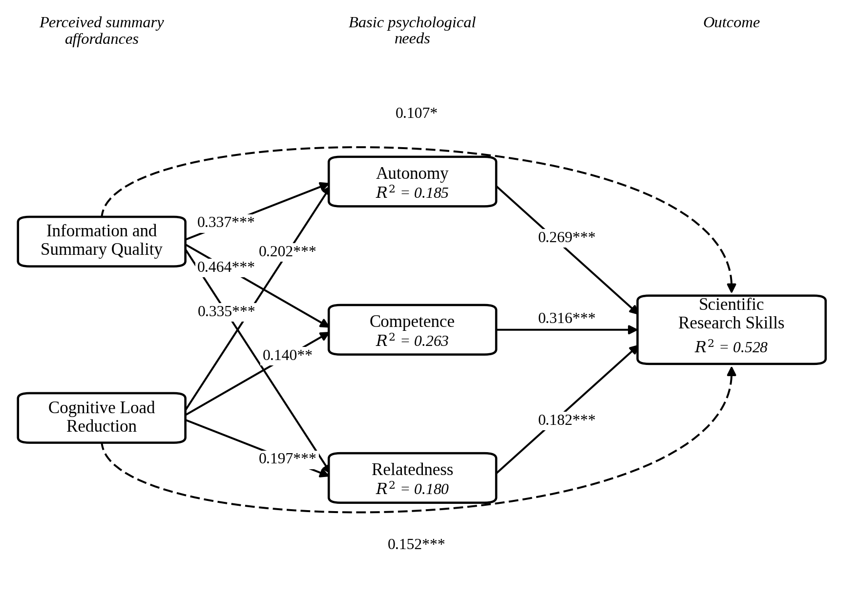
Note. N = 308. Solid arrows denote the hypothesised mediated pathways; dashed arrows denote direct effects. Values are standardised path coefficients from PLS-SEM with 10,000 bootstrap resamples and bias-corrected and accelerated confidence intervals. R² values are reported within each endogenous construct. * p < .05. ** p < .01. *** p < .001.
Figure 1 presents the estimated model. Displayed as a whole, it exposes a structure that the coefficient table conveys only piecewise. The two perceived affordances are not interchangeable antecedents: information and summary quality dominates the transmission into need satisfaction, and its link to competence (β = .464) is the largest coefficient anywhere in the model, whereas cognitive load reduction contributes reliably but modestly to each need while retaining the larger of the two direct paths to the outcome. The three needs then converge on research skills with coefficients of comparable order (.182–.316), so no single need functions as a bottleneck. The contrast between the moderate explained variance in the mediators (.180–.263) and the substantially higher value for the outcome (.528) is itself informative: the measured affordances account for only part of what determines need satisfaction, yet the needs together with those affordances account for slightly more than half the variance in objectively scored performance.

5.6 Mediation Analysis (H10a–c, H11a–c)
All six specific indirect effects were supported, with bias-corrected and accelerated confidence intervals excluding zero (Table 7 and Figure 2), supporting H10a–c and H11a–c.
For information and summary quality, competence carried the largest specific indirect effect (β = .147, 95% CI [.098, .204]), followed by autonomy (β = .091) and relatedness (β = .061). The total indirect effect was .308 against a total effect of .406, so need satisfaction accounted for 73.5% of the total association (95% CI [57.1%, 94.9%]). For cognitive load reduction the three specific indirect effects were comparable in magnitude (.036–.055), summing to .135 against a total effect of .287, corresponding to 47.0% of the total association (95% CI [29.2%, 68.6%]).
Formal contrasts between the specific indirect effects were estimated to avoid unsupported comparative claims. Within the information and summary quality chain, the indirect effect through competence significantly exceeded that through relatedness (Δ = .086, 95% CI [.017, .154], p = .015). No other contrast reached significance, and all three pathways within the cognitive load reduction chain were statistically indistinguishable. Competence can therefore be described as the strongest transmission mechanism only relative to relatedness, and only for perceived summary quality.
In both chains the direct effect remained significant and of the same sign as the indirect effects, which corresponds to complementary partial mediation rather than indirect-only mediation. Basic psychological need satisfaction transmits a substantial share of the association between perceived summary affordances and research skills without fully accounting for it.
Table 7
Direct, Indirect, and Total Effects on Scientific Research Skills
Antecedent | Effect | β | SE | 95% BCa CI | p | Hypothesis
Information and summary quality | Direct | .107 | .046 | [.017, .198] | .018 | H8
 | via Autonomy | .091 | .022 | [.053, .140] | < .001 | H10a
 | via competence | .147 | .027 | [.098, .204] | < .001 | H10b
 | via Relatedness | .061 | .018 | [.030, .101] | < .001 | H10c
 | Total indirect | .298 | .033 | [.234, .364] | < .001
 | Total | .406 | .045 | [.311, .487] | < .001
Cognitive load reduction | Direct | .152 | .041 | [.070, .230] | < .001 | H9
 | via Autonomy | .055 | .018 | [.024, .095] | .001 | H11a
 | via competence | .044 | .017 | [.015, .081] | .004 | H11b
 | via Relatedness | .036 | .014 | [.014, .067] | < .001 | H11c
 | Total indirect | .135 | .031 | [.076, .196] | < .001
 | Total | .287 | .047 | [.191, .373] | < .001
Note. Standardised estimates from 10,000 bootstrap resamples with bias-corrected and accelerated intervals.
Figure 2
Decomposition of Direct, Specific Indirect, and Total Effects on Scientific Research Skills
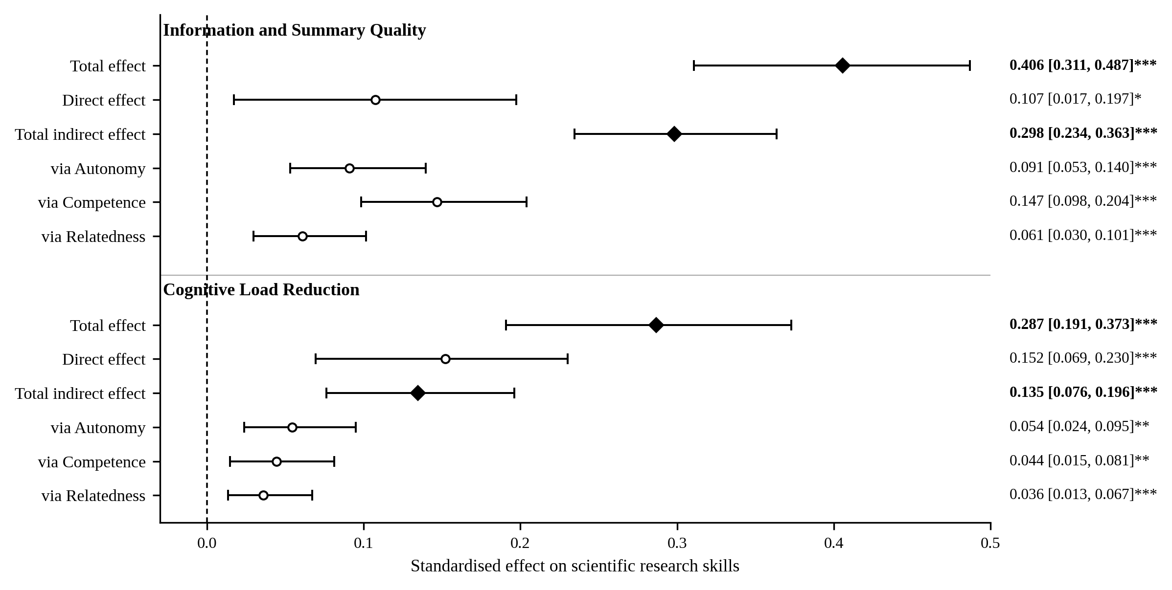
Note. N = 308. Filled diamonds denote total and total indirect effects; open circles denote direct and specific indirect effects. Bars are 95% bias-corrected and accelerated bootstrap confidence intervals from 10,000 resamples. * p < .05. ** p < .01. *** p < .001.
Figure 2 displays the complete decomposition and clarifies that the two chains differ in shape rather than merely in magnitude. For perceived summary quality the indirect component is roughly three times the direct component, so the pathway through need satisfaction carries most of the association; for cognitive load reduction the direct and indirect components are of comparable size, indicating a mechanism only partially motivating in character. The figure also shows that every specific indirect interval lies clearly to the right of zero, so the mediation result does not depend on any single pathway. Within the upper panel the intervals for the competence and relatedness pathways do not overlap, which is consistent with the formal contrast reported above; interval overlap is not itself a significance test, and the contrast rather than the figure supports that comparison.
5.6.1 Aggregate transmission through need satisfaction (H12).
H12 states that basic psychological need satisfaction collectively transmits the effect of perceived summary characteristics on research skills. Tested as the sum of the three specific indirect effects, H12 adds nothing beyond H10 and H11 and would amount to double counting. It was therefore evaluated as a distinct claim about aggregation, by assessing whether the three needs are psychometrically defensible as a single second-order construct and, only if so, estimating the model at that level of abstraction.
Aggregation was supported on all four pre-specified criteria. Estimated by the disjoint two-stage approach, the three first-order constructs loaded on a second-order Basic Psychological Needs construct at .748 (autonomy), .835 (competence), and .709 (relatedness), all above .70; composite reliability was .809 and average variance extracted .586, both above threshold; and the inter-need HTMT values were sufficiently homogeneous (.296–.482) that no pair was simultaneously near-redundant and near-orthogonal. The second-order construct was therefore admissible rather than imposed.
At this level of abstraction, both antecedents predicted aggregate need satisfaction (information and summary quality β = .499, 95% CI [.413, .580]; cognitive load reduction β = .231, 95% CI [.142, .323]), which in turn strongly predicted research skills (β = .594, 95% CI [.511, .676]), with R² = .353 for need satisfaction and .526 for the outcome. The total indirect effects were .297 (95% CI [.236, .363]) for perceived summary quality and .137 (95% CI [.083, .199]) for cognitive load reduction. H12 is supported.
These aggregate estimates reproduce the sums of the corresponding specific indirect effects in the primary model (.298 and .135) almost exactly, which confirms that the two levels of abstraction are describing the same transmission rather than two independent findings. H12 should accordingly be reported as an aggregation-level confirmation, not as a thirteenth independent test, and the primary model remains the basis for all substantive conclusions because it preserves the differential information among the three needs that the study was designed to detect.
5.6.2 Mediation of experimental manipulation.
To align the experimental design with the mediation model, the three-level manipulation was dummy coded with audio as the reference category and entered as an exogenous predictor of the perceived affordances, the needs, and the outcome, producing a serial mediation specification. The model was re-estimated with video as the reference to recover the third pairwise contrast. Including the manipulation raised explained variance in research skills from 52.8% to 57.9%.
The total effect of the video condition relative to audio was β = .474 (95% CI [.364, .583]), decomposing into a direct effect of .275 and a total indirect effect of .200, both significant. The serial pathways through perceived summary quality and each need were significant (β = .018–.051), as were those through cognitive load reduction (β = .010–.016). The manipulation therefore operates partly, but not wholly, through the theorised motivational mechanism.
The infographic condition presents a materially different profile. Its total effect relative to audio was significant (β = .217, 95% CI [.088, .345]), but this was carried almost entirely by the direct path (β = .168, p < .001); the total indirect effect was not significant (β = .049, 95% CI [−.036, .137], p = .277). Relative to video, the infographic condition showed a significant negative total effect (β = −.260, 95% CI [−.366, −.148]) with both direct and indirect components significant. Infographic summaries thus improved objective performance over audio without measurably engaging the self-determination mechanism, whereas video summaries improved performance both directly and through it.
One finding requires explicit correction of the interpretation offered in Section 4.5. When experimental conditions are included, the direct path from information and summary quality to research skills falls to β = .050 and ceases to be significant (p = .260), whereas the paths from the three needs remain essentially unchanged. The apparent direct effect of perceived summary quality in the reduced model was therefore partly absorbing variance attributable to the manipulation, and H8 should not be interpreted as evidence of an independent direct pathway.
Table 8
Effect Decomposition for the Experimental Manipulation on Scientific Research Skills
Contrast | Total effect | Direct effect | Total indirect | 95% BCa CI (indirect)
Video vs. audio | .474*** | .275*** | .200*** | [.118, .279]
Infographic vs. audio | .217*** | .168*** | .049 (ns) | [−.036, .137]
Infographic vs. video | −.260*** | −.109** | −.151*** | [−.237, −.064]
Note. Standardised estimates from 5,000 bootstrap resamples. ** p < .01. *** p < .001. ns = not significant.

5.7 Multi-Group and Robustness Analysis
Measurement invariance was assessed by the MICOM procedure with 2,000 permutations before any structural comparison. Configural invariance holds by design. Compositional invariance was established for all five constructs in the video–infographic comparison (c = .999–1.000, all p > .05). In the two comparisons involving the audio condition, compositional invariance was established for cognitive load reduction and the three needs but was not established for information and summary quality (video vs. audio c = .9972, p = .008; infographic vs. audio c = .9974, p = .028). Structural paths originating from that construct are therefore not comparable across those pairs, and no such comparison is reported.
Full measurement invariance was not attained in any pair: composite means differed for most constructs, as expected given that the experimental manipulation was designed to shift them. Partial measurement invariance was established, which permits comparison of structural coefficients but not of composite means.
Across the eleven structural paths and three pairwise comparisons, only one difference survived Bonferroni adjustment (α = .0167). The path from cognitive load reduction to research skills was substantial in the video condition (β = .284) but absent in the audio condition (β = −.015), a difference of .299 (permutation p = .005). The path from autonomy to research skills was weaker in the video condition than in the infographic (Δ = −.256, p = .027) and audio (Δ = −.277, p = .030) conditions, but neither difference met the adjusted criterion and both should be treated as provisional. The mediation mechanism is therefore largely invariant across modalities, with the single robust exception that reductions in cognitive load translate into measurable performance gains only when the summary is delivered in video form.
Confirmatory re-estimation by covariance-based SEM.
Because partial least squares estimate composites rather than common factors, the model was re-estimated by maximum likelihood as a confirmatory check. The measurement model fitted the analytic sample well, χ²(160) = 170.90, p = .263, χ²/df = 1.07, CFI = .998, TLI = .997, RMSEA = .015 (90% CI [.000, .031]), SRMR = .028, with standardised loadings from .816 to .888 and no Heywood cases. The full structural model likewise fitted acceptably, χ²(172) = 198.43, p = .082, χ²/df = 1.15, CFI = .994, TLI = .993, RMSEA = .023, SRMR = .028, again with all parameters within admissible bounds.
The two estimators converged closely (Table 9). Across all eleven structural paths the largest absolute discrepancy was .032, no coefficient changed sign, and no significance decision changed. The covariance-based estimates were uniformly slightly larger, which is the expected direction because maximum likelihood corrects for measurement error that composite-based estimation retains; the same pattern appears in the explained variance for the outcome (.551 against .528). The structural conclusions are therefore not artefacts of estimator choice.
One qualification applies. Treating a proportion score derived from 16 dichotomous items as a continuous, normally distributed endogenous variable is a stronger assumption than the partial least squares specification requires. The covariance-based results are accordingly reported as corroborative rather than primary.
Table 9
Convergence of Partial Least Squares and Covariance-Based Estimates
Path | PLS-SEM β | CB-SEM β | Difference
IS → Autonomy | .337 | .362 | .025
CLR → Autonomy | .202 | .208 | .006
IS → Competence | .464 | .496 | .032
CLR → Competence | .140 | .140 | .000
IS → Relatedness | .335 | .365 | .030
CLR → Relatedness | .197 | .203 | .006
IS → Research skills | .107 | .095 | −.012
CLR → Research skills | .152 | .148 | −.004
Autonomy → Research skills | .269 | .279 | .010
Competence → Research skills | .316 | .321 | .005
Relatedness → Research skills | .182 | .179 | −.003
R² (research skills) | .528 | .551 | .023

5.8 Sensitivity Analysis
Seventeen cases exceeded Cook’s distance criterion of 4/n in the outcome equation. Re-estimating the model without them increased explained variance in research skills from .528 to .595, with no change in the sign or significance of any path and a maximum absolute change in any standardised coefficient of .027. The findings are not contingent on influential observations.

5.9 Summary of Hypothesis Testing
Table 10 consolidates the decision for every hypothesis together with the statistic on which it rests. Decisions for H1–H4c derive from the group-comparison family after false discovery rate adjustment; decisions for H5–H12 derive from the latent structural model with bias-corrected bootstrap intervals.
Table 10
Hypothesis Testing Summary
H | Test | Statistic | p | 95% CI | Effect size | Decision
H1 | Welch ANOVA | F(2, 192.3) = 33.65 | < .001 | — | ω² = .164 | Supported
H2 | ANOVA | F(2, 295) = 13.40 | < .001 | — | ω² = .077 | Supported
H3 | ANOVA | F(2, 295) = 13.76 | < .001 | — | ω² = .079 | Supported
H4a | ANOVA | F(2, 295) = 4.59 | .011 | — | ω² = .024 | Supported
H4b | ANOVA | F(2, 295) = 5.36 | .006 | — | ω² = .028 | Supported
H4c | ANOVA | F(2, 295) = 5.42 | .006 | — | ω² = .029 | Supported
H5a | PLS path | β = .337 | < .001 | [.227, .434] | f² = .13 | Supported
H5b | PLS path | β = .464 | < .001 | [.369, .542] | f² = .28 | Supported
H5c | PLS path | β = .335 | < .001 | [.231, .427] | f² = .13 | Supported
H6a | PLS path | β = .202 | < .001 | [.093, .304] | f² = .05 | Supported
H6b | PLS path | β = .140 | .004 | [.042, .234] | f² = .03 | Supported
H6c | PLS path | β = .197 | < .001 | [.087, .296] | f² = .05 | Supported
H7a | PLS path | β = .269 | < .001 | [.173, .368] | f² = .11 | Supported
H7b | PLS path | β = .316 | < .001 | [.215, .412] | f² = .13 | Supported
H7c | PLS path | β = .182 | < .001 | [.092, .268] | f² = .05 | Supported
H8 | PLS path | β = .107 | .018 | [.017, .198] | f² = .02 | Partially supportedᵃ
H9 | PLS path | β = .152 | < .001 | [.070, .230] | f² = .04 | Supported
H10a | Indirect effect | β = .091 | < .001 | [.053, .140] | — | Supported
H10b | Indirect effect | β = .147 | < .001 | [.098, .204] | — | Supported
H10c | Indirect effect | β = .061 | < .001 | [.030, .101] | — | Supported
H11a | Indirect effect | β = .055 | .001 | [.024, .095] | — | Supported
H11b | Indirect effect | β = .044 | .004 | [.015, .081] | — | Supported
H11c | Indirect effect | β = .036 | < .001 | [.014, .067] | — | Supported
H12 | Second-order model | β = .297 / .137 | < .001 | [.236, .363] / [.083, .199] | — | Supportedᵇ
Note. ᵃ H8 is statistically significant but its incremental contribution is at the boundary of negligibility, and the path is not significant once experimental condition is controlled (β = .050, p = .260); it should not be interpreted as an independent direct pathway. ᵇ H12 was evaluated as an aggregation-level claim using a psychometrically justified second-order construct, not as a separate test of the same indirect effects reported under H10 and H11.

