Supporting Information for
Macrophage membrane camouflaged puerarin and probucol co-assembled nanoparticles for targeted anti-atherosclerosis therapy
Yan Gao^{a,1}, Yangyang Bai^{a,1}, Jieying Zeng^{a,1}, Yinuo Wang^{b}, Yuxin Zhangª, Mengjie Jia^{c}, Yajie Guoª, Juhui Qiu^{e}, Yiliang Li^{f}, Li Fu^{g,*}, Guixue Wang^{d,e,*}, Yi Wang^{a,d,*}
- School of Basic Medical Sciences, Chongqing Medical University, Chongqing, 400016, China.
- Chongqing Medical University-University of Leicester Joint Institute, Chongqing, 400016, China.
- Department of Critical Care Medicine, The First Affiliated Hospital of Chongqing Medical University, Chongqing 400010, China.
- JinFeng Laboratory, Chongqing, 401329, China.
- Key Laboratory for Biorheological Science and Technology of the Ministry of Education, National Local Joint Engineering Lab for Vascular Implants, College of Bioengineering, Chongqing University, Chongqing, 400044, China.
- The Eighth Affiliated Hospital of Sun Yat-sen University, Shenzhen 518033, China.
- Geriatrics Department, Neurological Rehabilitation Department, The Eighth Affiliated Hospital of Sun Yat-sen University, Shenzhen 518033, China.

¹ Co-first authors: Yan Gao, Yangyang Bai and Jieying Zeng
*Co-Corresponding author: Li Fu − The Eighth Affiliated Hospital of Sun Yat-sen University, Shenzhen 518033, China; Geriatrics Department, Neurological Rehabilitation Department, The Eighth Affiliated Hospital of Sun Yat-sen University, Shenzhen 518033, China; Email: fuliruo302@163.com
*Co-Corresponding author: Guixue Wang − JinFeng Laboratory, Chongqing, 401329, China; Key Laboratory for Biorheological Science and Technology of the Ministry of Education, National Local Joint Engineering Lab for Vascular Implants, College of Bioengineering, Chongqing University, Chongqing, 400044, China; Email: wanggx@cqu.edu.cn
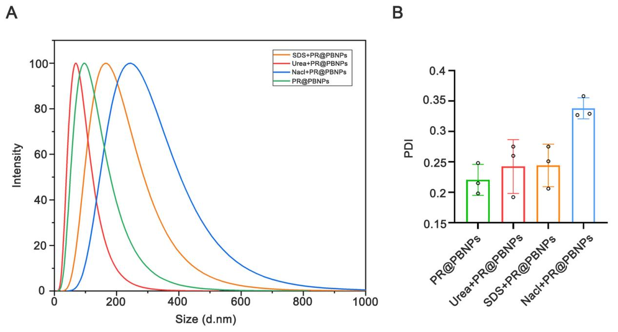
*Corresponding author: Yi Wang − School of Basic Medical Sciences, Chongqing Medical University, Chongqing, 400016, China; JinFeng Laboratory, Chongqing, 401329, China; Email: wangyi@cqmu.edu.cn

Figure S1. (A) Hydrodynamic diameter and (B) PDI of PR@PBNPs following treatment with SDS, Urea, or NaCl solution. Values are shown as mean ± SD (n = 3).

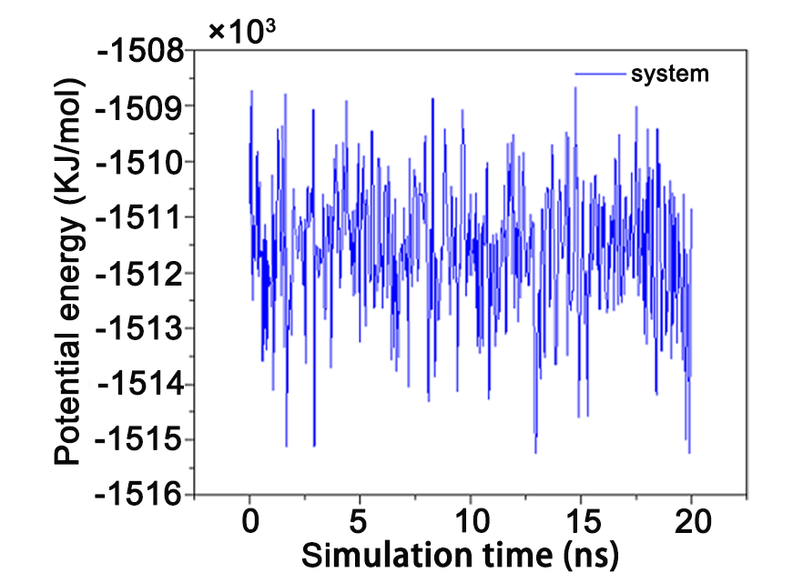
Figure S2. Potential energy changes of the system during the self-assembly process of PR@PBNPs.

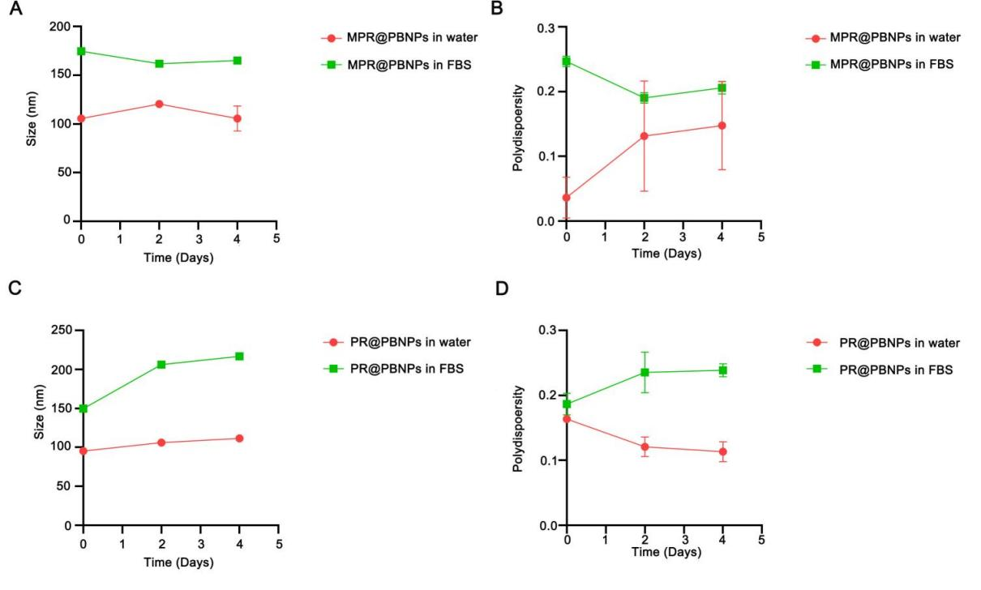
Figure S3. Stability study of PR@PBNPs and MPR@PBNPs. (A) Size and (B) PDI of MPR@PBNPs in water and 10% FBS within 4 days. (C) Size and (D) PDI of PR@PBNPs in water and 10% FBS within 4 days (n = 3, mean ± SD).
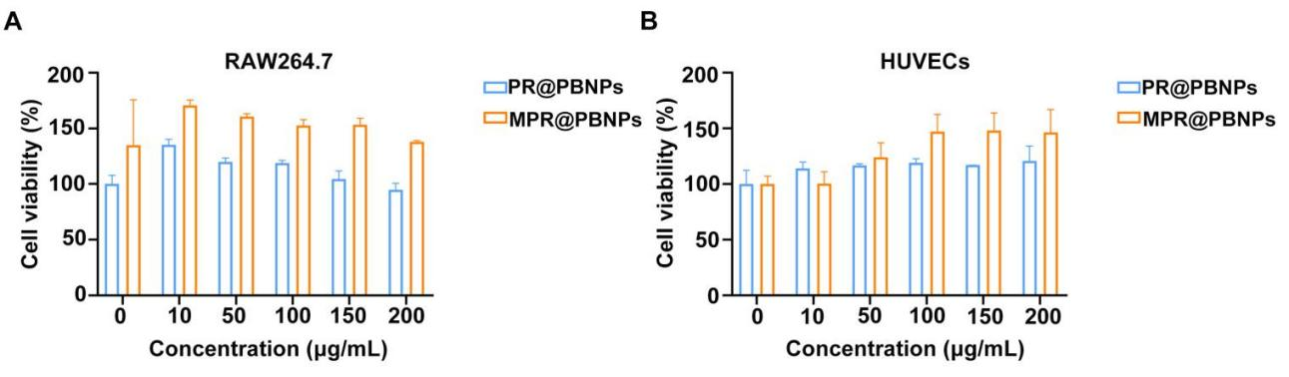
Figure S4. in vitro cytotoxicity assessment of PR@PBNPs and MPR@PBNPs. (A) Toxicity effects of PR@PBNPs and MPR@PBNPs on RAW264.7 cells at different concentrations. (B) Toxic effects of PR@PBNPs and MPR@PBNPs on HUVECs at different concentrations. All experiments were repeated three times (n=3), and the data were expressed as mean ± standard deviation (SD).
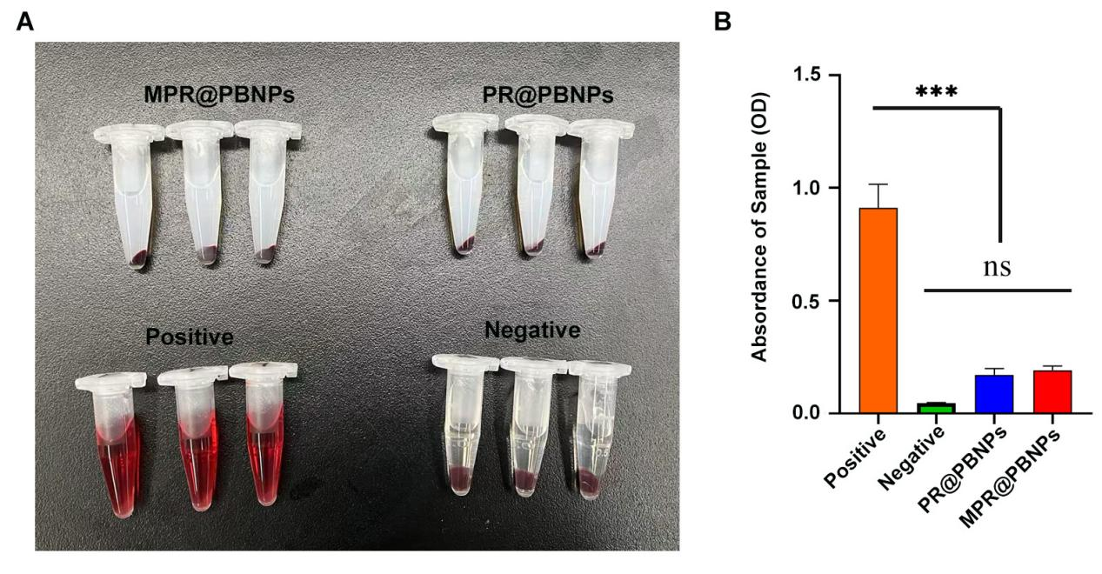
Figure S5. Hemolytic effects of PR@PBNPs and MPR@PBNPs. (A) Images of hemolysis tests for PR@PBNPs and MPR@PBNPs. (B) Absorbance of the supernatant of diluted anticoagulant blood treated with PR@PBNPs and MPR@PBNPs (n = 3, mean ± SD).

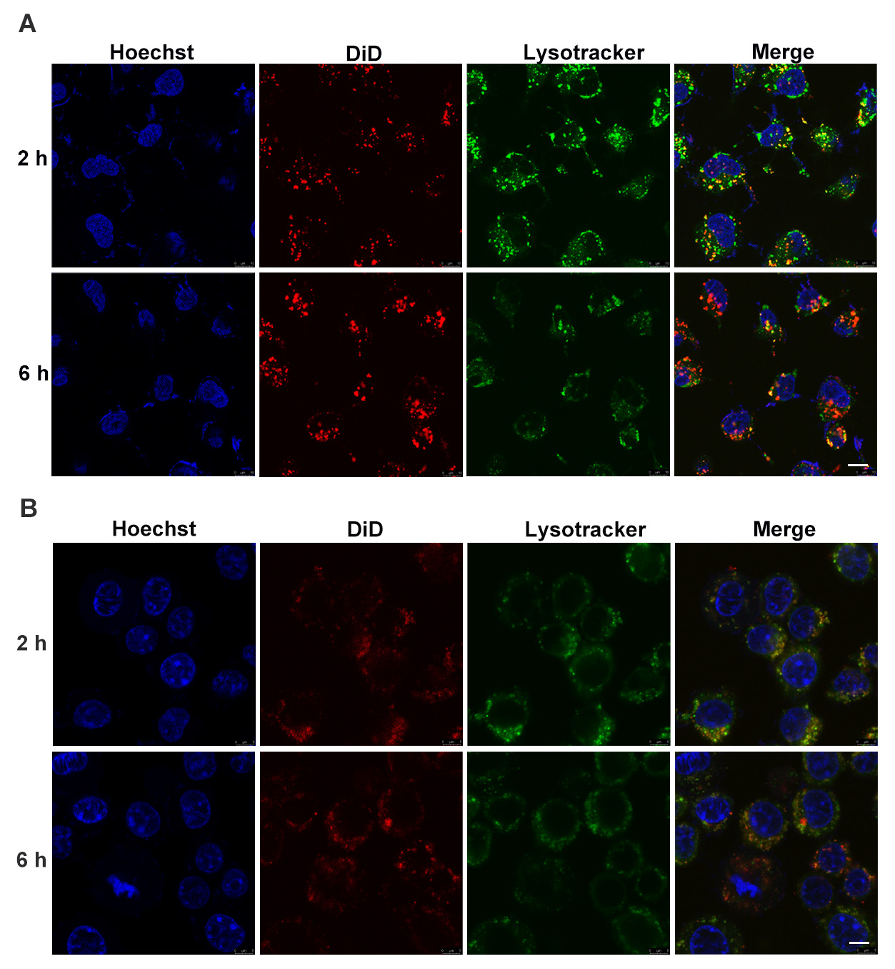
Figure S6. The distribution of MPR@PBNPs in HUVECs and RAW264.7 cells after being uptaken . (A) Images of MPR@PBNPs in HUVECs after being uptaken (scale =10 μm). (B) Images of MPR@PBNPs in RAW264.7 cells after being uptaken (scale =10 μm).

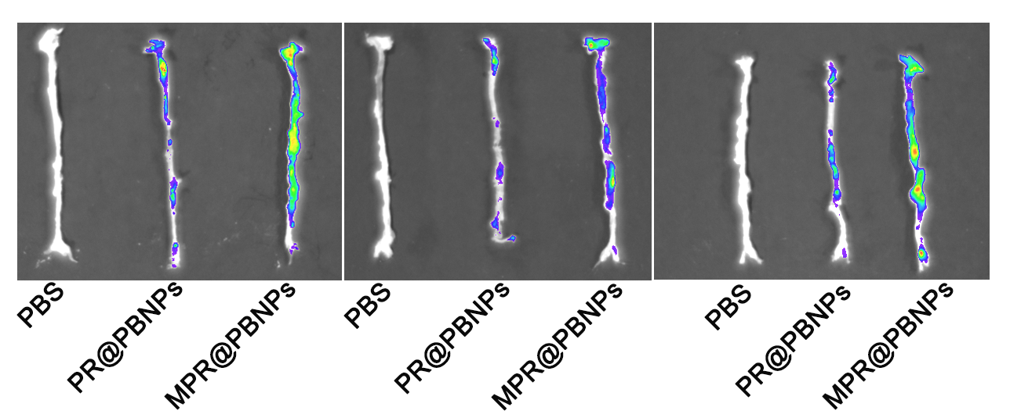
Figure S7. Fluorescence images of DiD-PR@PBNPs or DiD-MPR@PBNPs in isolated aorta following i.v. administration for 24 h.

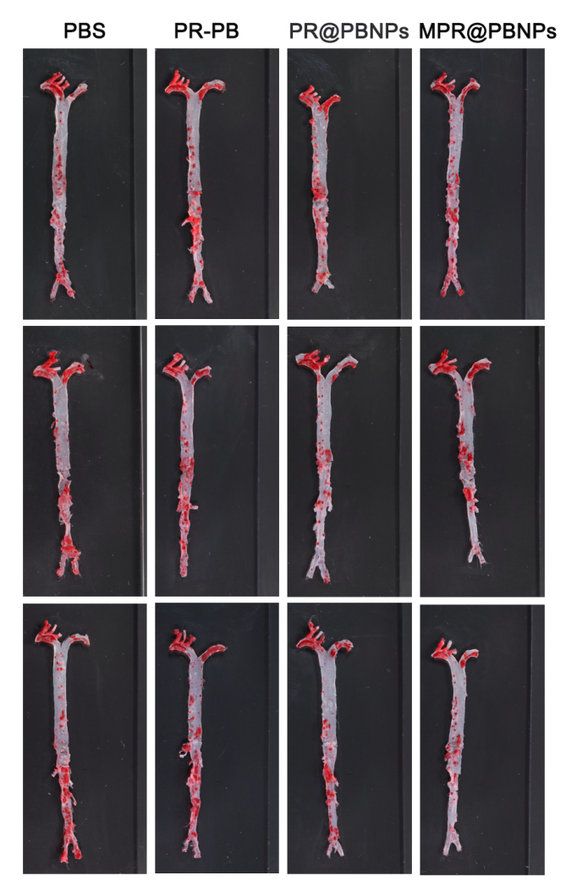
Figure S8. Images of Oil Red O (ORO)-stained aortas of mice from different experimental groups.

Figure S9. The body weight changes of mice in different treatment groups.

