Supplementary material
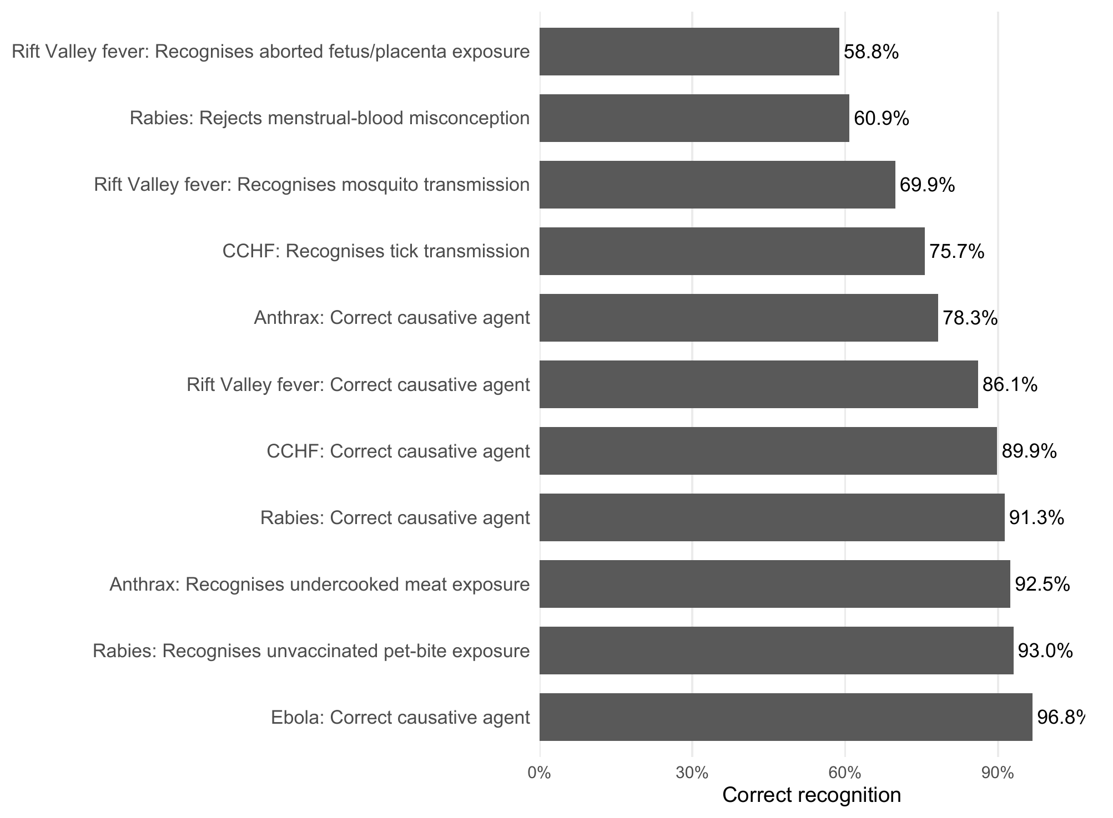
Supplementary Figure S1. Quality-assured disease-specific recognition indicators. Only prespecified items with a defensible scoring direction are shown; no arbitrary good/moderate/poor threshold was applied.
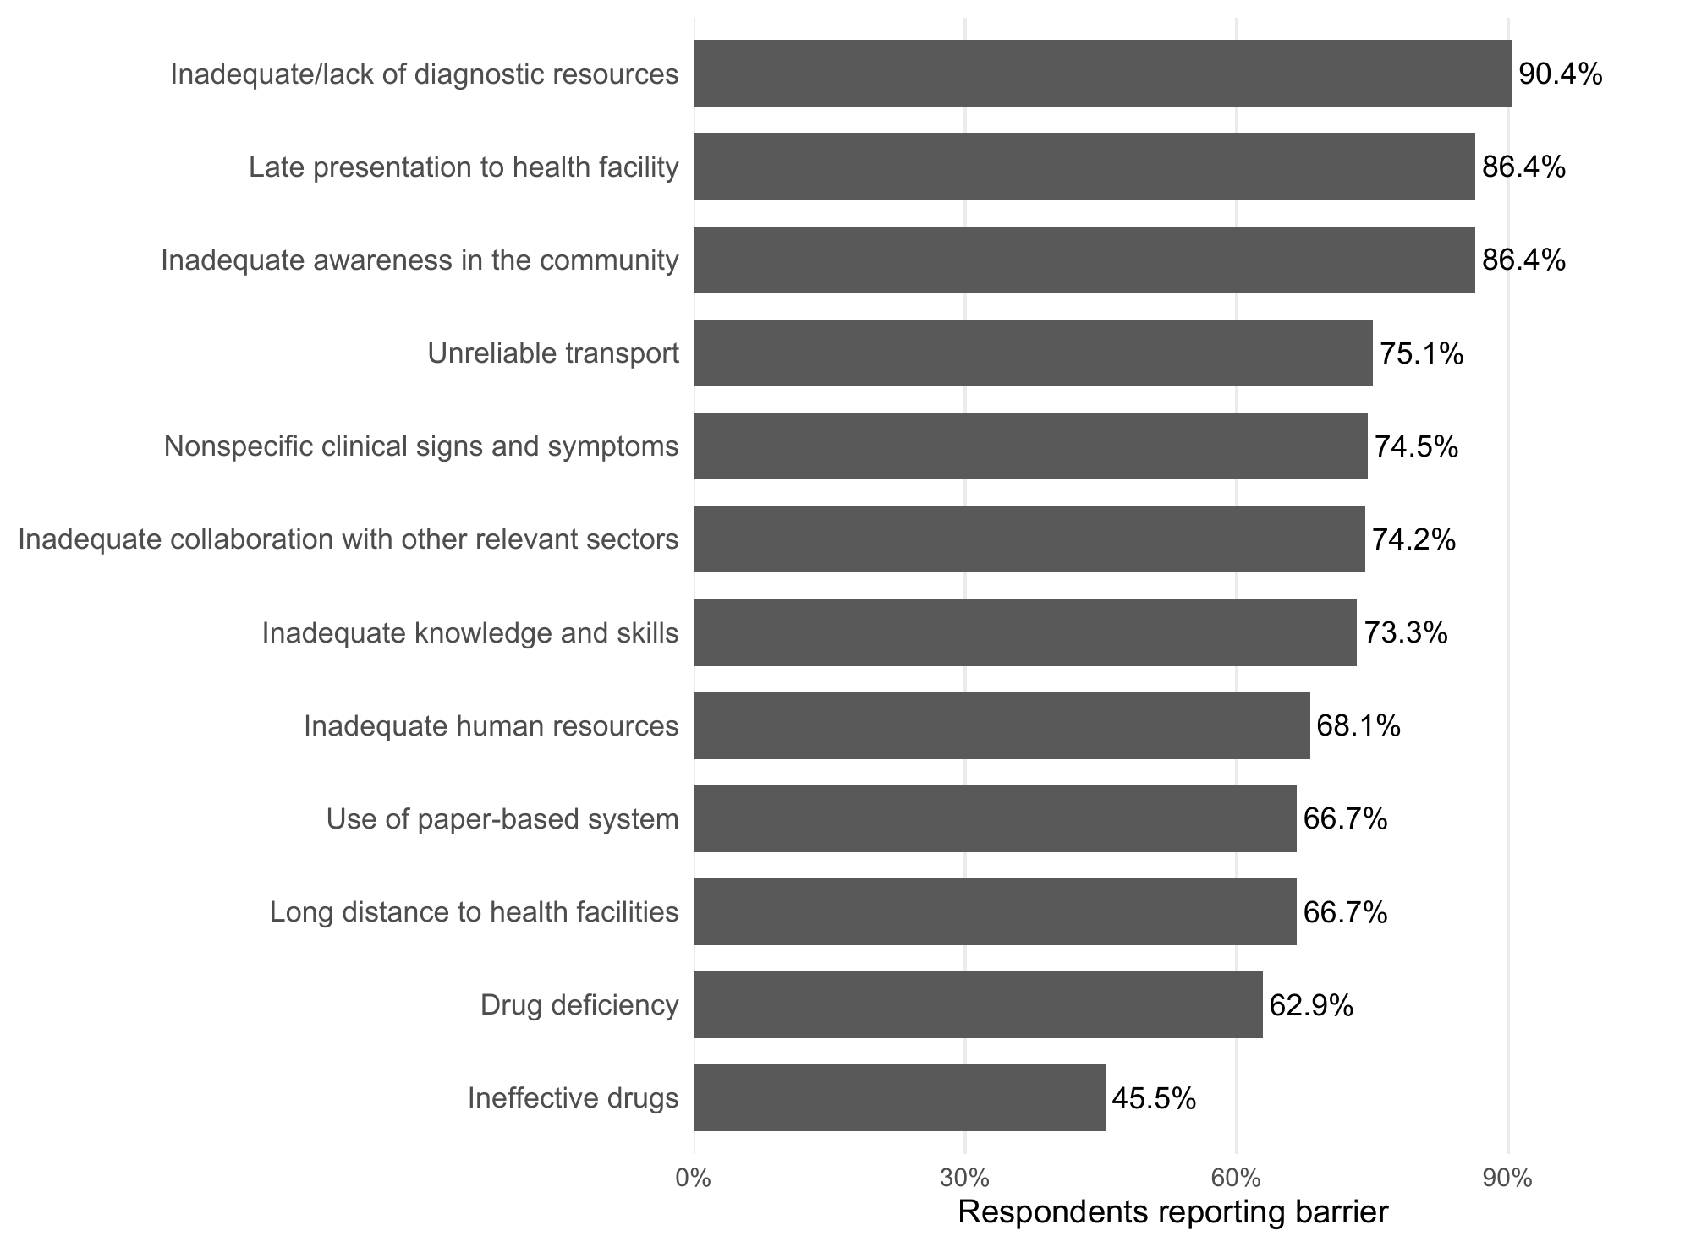
Supplementary Figure S2. Health-worker-reported One Health and health-system barriers that may constrain recognition and referral. Each barrier is presented separately; no composite barrier score was created.
Supplementary Table S1. Referral pathway details

Panel A. Reported referral-destination network groups
Referral network level | n/N (%)
National/reference laboratory | 121/273 (44.3)
Regional referral hospital | 70/273 (25.6)
District/HCIV/hub pathway | 58/273 (21.2)
Private laboratory | 20/273 (7.3)
Multiple referral levels | 3/273 (1.1)
Other/unclear | 1/273 (0.4)
Note. Referral destinations were derived from free-text responses and grouped into mutually exclusive network levels. These data describe reported pathways and are not a laboratory-network audit.

Panel B. Reported referral-linkage gap by facility level
Facility level | n/N (%) | 95% CI
Facility type
Dispensary | 9/35 (25.7) | 14.2–42.1
Health centre II | 6/14 (42.9) | 21.4–67.4
Health centre III | 22/135 (16.3) | 11.0–23.4
Health centre IV | 5/76 (6.6) | 2.8–14.5
Hospital | 6/85 (7.1) | 3.3–14.6
Facility tier
Higher-level (HCIV/hospital) | 11/161 (6.8) | 3.9–11.8
Lower-level (Private clinic/Medical centre/HCII/HCIII) | 37/184 (20.1) | 15.0–26.5
Note. Confidence intervals are Wilson 95% confidence intervals. The outcome is respondent-reported absence of specimen-referral linkage and is not an audited facility attribute.

Panel C. Result-return and patient-communication modes
Stage and mode | n/N (%)
Receive referral result
Phone call/SMS | 108/292 (37.0)
Collected physically on paper | 152/292 (52.1)
Digital technology | 112/292 (38.4)
Communicate result to patient
Phone call/SMS | 146/293 (49.8)
Collected physically on paper | 189/293 (64.5)
Digital technology | 25/293 (8.5)
Note. Modes were not mutually exclusive; respondents could report more than one mode.
Supplementary Table S2. Secondary and sensitivity analyses

Panel A. Training/CME reported as an information source and disease-recognition score
Variable | Mean score difference (95% CI) | p-value
Training programme/CME reported as an information source
No | Reference
Yes | 1.12 (0.50–1.73) | <0.001
District
Mbarara | Reference
Ibanda | -0.18 (-0.86–0.49) | 0.596
Kazo | -0.26 (-0.89–0.38) | 0.429
Kiruhura | 0.12 (-0.53–0.78) | 0.713
Professional cadre
Medical/clinical | Reference
Nursing | -0.27 (-0.75–0.22) | 0.280
Laboratory | -0.51 (-1.29–0.28) | 0.206
Other | -0.47 (-1.02–0.08) | 0.096
Note. Linear regression model included 334 respondents and 54 facility clusters and adjusted for district and professional cadre. CME = continuing medical education; CI = confidence interval.

Panel B. Five-level facility model for reported referral-linkage gap
Facility type | PR (95% CI) | p-value
Private clinic/Medical centre | 1.00 (Ref)
Health centre II | 1.67 (0.45–6.21) | 0.446
Health centre III | 0.63 (0.20–2.00) | 0.437
Health centre IV | 0.26 (0.07–0.91) | 0.035
Hospital | 0.27 (0.07–1.01) | 0.052
Note. Modified Poisson regression with facility-clustered robust standard errors. N=345; outcome events=48; facility clusters=54. PR = prevalence ratio; CI = confidence interval; Ref = reference category.

Panel C. Primary referral-linkage model additionally adjusted for disease-recognition score
Variable | PR (95% CI) | p-value
Facility tier
Higher-level (HCIV/hospital) | 1.00 (Ref)
Lower-level (Private clinic/Medical centre//HCII/HCIII) | 2.73 (1.40–5.31) | 0.003
District
Mbarara | 1.00 (Ref)
Ibanda | 1.34 (0.54–3.30) | 0.528
Kazo | 0.77 (0.26–2.24) | 0.630
Kiruhura | 0.83 (0.35–1.97) | 0.667
Professional cadre
Medical/clinical | 1.00 (Ref)
Nursing | 0.97 (0.43–2.20) | 0.937
Laboratory | 0.49 (0.14–1.67) | 0.256
Other | 0.79 (0.23–2.73) | 0.716
Training programme/CME reported as an information source
No | 1.00 (Ref)
Yes | 0.81 (0.38–1.73) | 0.580
Disease-recognition score
Per 1-point increase | 1.08 (0.84–1.39) | 0.547
Note. Modified Poisson regression with facility-clustered robust standard errors; N=334, outcome events=47, facility clusters=54. PR = prevalence ratio; CI = confidence interval; Ref = reference category.

