Online Resource 1: Supplementary Information
Persistent Cardiac Surgery-Associated Acute Kidney Injury Identifies a High-Risk Phenotype after Pediatric Congenital Heart Surgery
Journal: Pediatric Cardiology
Mehmet Akif Dereli¹, Selman Kesici^{2,3}, Izzet Turkalp Akbasli^{2,3*}, Semanur Gozupek¹, Safak Alpat⁴, Mehmet Celegen^{2,3}, Benan Bayrakci^{2,3}
¹ Department of Pediatrics, Faculty of Medicine, Hacettepe University, Ankara, Türkiye
² The Center for Life Support Practice and Research, Hacettepe University, Ankara, Türkiye
³ Department of Pediatric Intensive Care Medicine, Department of Pediatrics, Faculty of Medicine, Hacettepe University, Ankara, Türkiye
⁴ Division of Pediatric Cardiac Surgery, Department of Cardiovascular Surgery, Faculty of Medicine, Hacettepe University, Ankara, Türkiye
Corresponding author: Izzet Turkalp Akbasli; Email: iakbasli@hacettepe.edu.tr
Patients were classified as having no early CS-AKI (n = 150), transient CS-AKI (n = 40), or persistent CS-AKI (n = 29) in the 219-patient cohort. Postoperative day 0 (POD0) was defined as the first 24 h after completion of surgery. Unless otherwise stated, continuous variables are median [first quartile (Q1), third quartile (Q3)] and categorical variables are n (%).
Citation numbers in this Online Resource correspond to the reference list of the main manuscript.

Supplementary Methods

S1. Study Windows, Eligibility, and Data Completeness
Consecutive patients aged ≤18 years who underwent surgery for congenital heart disease during 2023-2024 were screened. The protocol-defined CS-AKI ascertainment window comprised POD0-POD6, consistent with pediatric cardiac-surgery cohorts that evaluate postoperative AKI within the first week [3, 5]. Daily protocol creatinine collection ended at POD6; later events could be identified only from clinically obtained measurements and were outside the study-specific perioperative attribution window. The mortality outcome was restricted to in-hospital deaths before POD90 to focus on short-term perioperative mortality. One death attributed to sepsis and one death after POD90 were excluded. These operational restrictions do not prove that the excluded events were unrelated to surgery and may introduce selection bias. Among 288 screened patients, exclusions were preoperative AKI (n = 12), first AKI after POD6 (n = 7), sepsis-related death (n = 1), death after POD90 (n = 1), and incomplete records preventing retrieval of all required analysis variables (n = 48). In all 48 incomplete-data exclusions, urine-output documentation was insufficiently complete or reliable for the required analyses because reliable urine-output data were required for fluid-balance derivation and other prespecified analyses. The final analytic cohort was complete for reported variables; no imputation was performed. To characterize potential selection associated with complete-case inclusion, available characteristics and postoperative outcomes of these 48 patients were compared descriptively with the analytic cohort (Table S2). Standardized mean differences were used for continuous and two-level variables and Cramér V for the overall three-level CS-AKI phenotype; p values were exploratory and were not adjusted for multiplicity.

S2. AKI Staging and Timing Phenotypes
AKI was defined according to Kidney Disease: Improving Global Outcomes (KDIGO) serum-creatinine criteria as an increase to ≥1.5 times baseline or ≥0.3 mg/dL above baseline [16]. Stage 1 comprised 1.5-1.9 times baseline or an absolute increase ≥0.3 mg/dL; stage 2, 2.0-2.9 times baseline; and stage 3, ≥3.0 times baseline or therapeutic renal replacement therapy (RRT). No additional patient was classified as stage 3 solely by an alternative absolute-creatinine or pediatric estimated glomerular filtration rate (eGFR) criterion. Hourly urine output was reviewed; no patient had a urine-output-based stage higher than the creatinine-based stage. Therapeutic RRT was defined as dialysis initiated for established or evolving kidney dysfunction or its complications, including oliguria or anuria, progressive or diuretic-refractory fluid overload, refractory electrolyte or acid-base disturbances, or other uremic complications. Prophylactic peritoneal dialysis or passive peritoneal drainage instituted routinely after surgery in the absence of these indications was not classified as therapeutic RRT. Therapeutic RRT was incorporated into the persistent-CS-AKI definition because dialysis can lower POD3 serum creatinine and preclude valid creatinine-based assessment. Ten patients received therapeutic RRT and all were classified as having persistent CS-AKI: five would otherwise have been classified as transient on the basis of POD3 creatinine alone, two died before POD3 while receiving therapeutic RRT, and the remaining three independently met the creatinine-based persistence criterion. Four patients first meeting AKI criteria during POD3-POD6 remained in the no early CS-AKI reference group. Tables S3-S4 report stage distribution and sensitivity analyses.

S3. Variables and Exposure Definitions
Growth measures used World Health Organization (WHO) standards [17, 18]. Weight-for-age measures were limited to children aged <10 years; body mass index (BMI)-for-age was used only for older patients in machine-learning analyses. Recorded variables included diagnosis, operation, cyanosis, ventricular physiology, prior cardiac arrest or AKI, preoperative respiratory support, prior cardiac intervention, Risk Adjustment for Congenital Heart Surgery version 1 (RACHS-1) and Society of Thoracic Surgeons-European Association for Cardio-Thoracic Surgery (STAT) measures, bypass and cross-clamp durations, minimum temperature, baseline laboratory values, POD0 vasoactive-inotropic score (VIS), lactate, and fluid balance. For tabular descriptive summaries and univariable association analyses, cardiopulmonary bypass and aortic cross-clamp durations were restricted to recipients; nonrecipients were treated as ineligible for duration analysis rather than assigned a structural value of 0 min. Deep hypothermia was approximated by minimum temperature ≤22 °C because circulatory-arrest status was unavailable. VIS was calculated according to Gaies et al. [19]. Fluid accumulation for POD0, POD1, and POD2 was calculated independently for each 24-h interval as [(intake - output)/(baseline weight × 1000)] × 100 [20]; no cumulative fluid-overload measure across days was available. Nephrotoxic or kidney-relevant exposures were recorded from 1 day before surgery through POD6; at least one dose counted as exposure. Agents/classes were diuretics, aminoglycosides, vancomycin, piperacillin-tazobactam, amphotericin, nonsteroidal anti-inflammatory drugs (NSAIDs), angiotensin-converting enzyme inhibitors/angiotensin receptor blockers, iodinated contrast, and colistin. Duration, number of doses, cumulative dose, and time-varying treatment were not modeled. Reported agent-specific and composite analyses focused on aminoglycosides, vancomycin, and NSAIDs and represent perioperative exposure associations.

S4. Outcomes and Free-Day Measures
Principal outcomes were short-term in-hospital mortality before POD90 and ventilator-free days through day 28 (VFD28). Mechanical-ventilation duration included invasive ventilation and post-extubation noninvasive ventilation, while intubation duration was reported separately. Additional clinical measures included extracorporeal membrane oxygenation (ECMO), therapeutic RRT, intensive-care and hospital length of stay, and intubation-, intensive-care-, and hospital-free days through day 28. Free days equaled 28 minus the smaller of duration and 28; death within 28 days was assigned 0. VFD28 = 0 was also analyzed.

S5. Statistical and Machine-Learning Details
Statistical analyses and non-machine-learning figures were prepared in R 4.5.3. Machine-learning analyses, model interpretation, and related visualizations were performed in Python 3.12.11 with CatBoost 1.2.10, Optuna 4.9.0, scikit-learn 1.6.1, SHAP 0.48.0, NumPy 2.3.4, pandas 2.3.3, SciPy 1.15.3, and Matplotlib 3.10.8. False discovery rate (FDR) correction, Firth regression, area under the receiver operating characteristic curve (AUC) comparison, CatBoost, SHapley Additive exPlanations (SHAP), and decision-curve analysis followed references [21-26]. Continuous predictors were modeled continuously in Table S5; Fig. S3 shows separate exploratory thresholds. The univariable cardiopulmonary bypass and aortic cross-clamp duration analyses in Table S5 were restricted to recipients. In the full-cohort multivariable model of any early CS-AKI reported in main Table 3, aortic cross-clamp was entered as two terms: receipt (binary) and, among recipients, duration per 30 min centered at the recipient median (60 min), with nonrecipients set to 0 on the centered duration term. This is the standard parameterization for a semicontinuous variable with a structural zero and keeps the between-group contrast separate from the within-recipient duration gradient. In a likelihood-ratio test the duration term did not reach significance (chi-square = 2.55, df = 1, p = 0.110). This model had 69 events and 8.6 events per variable. Age was modeled continuously in regression analyses. Because crude age-group patterns suggested nonlinearity, age was additionally summarized in clinically interpretable categories in Fig. S2; this grouped analysis was exploratory and did not replace the continuous multivariable term.
The modified renal angina index (RAI) was calculated post hoc as a benchmark using the Basu et al. risk-by-injury framework [10]. Risk scores were 1 for pediatric intensive care unit admission, 3 for a history of solid-organ or bone-marrow transplantation, and 5 for invasive mechanical ventilation plus at least one vasopressor or inotrope. Injury scores were 1, 2, 4, or 8 according to the worse of fluid accumulation (<5%, 5%-<10%, 10%-<15%, or ≥15%, respectively) and the decrease in estimated creatinine clearance from baseline (no decrease, >0%-<25%, 25%-<50%, or ≥50%, respectively). The higher of the fluid-accumulation and estimated-creatinine-clearance injury scores was multiplied by the risk score, yielding a total score from 1 to 40. For this cardiac-surgery benchmark, POD0 injury was assessed over the first 24 h after surgery rather than the first 8 h of pediatric intensive care unit admission used by Basu et al.; the continuous RAI score, rather than the original threshold of ≥8, was used for discrimination and as the ML-3 input.
To assess the feasibility of identifying persistent CS-AKI from widely available variables, CatBoost models were trained with persistent CS-AKI as the sole target (29/219). The ML-1 candidate pool comprised preoperative and intraoperative variables: age, sex, age-appropriate anthropometric z-scores, cyanosis, single-ventricle physiology, continuous STAT mortality score, cardiopulmonary bypass and aortic cross-clamp durations, minimum temperature, deep hypothermia, prior cardiac intervention, preoperative respiratory support, and preoperative creatinine, albumin, blood urea nitrogen (BUN), sodium, lactate, and hemoglobin. ML-2 added creatinine-free POD0 hemodynamic/perfusion variables (maximum VIS, lactate, and fluid accumulation), and ML-3 added the RAI score to ML-2. Because the event count was low, parsimony was prioritized. Forced clinical anchors were age, age-appropriate weight/BMI z-score, single-ventricle physiology, prior cardiac intervention, preoperative respiratory support, baseline creatinine, and the continuous STAT mortality score. Remaining candidate variables were evaluated by recursive feature elimination with cross-validation within the training data, and variables selected in at least 80% of training folds were retained to limit selection leakage. The stable ML-2 feature set comprised the seven forced anchors, preoperative BUN, and POD0 maximum VIS, lactate, and fluid accumulation (11 variables). Postoperative creatinine and other postoperative kidney-function biomarkers were excluded from ML-1 and ML-2.
Model development and internal validation used nested cross-validation. The dataset was divided into 10 outer folds, each serving once as an independent test set. For each outer fold, the remaining training data were divided into five inner folds for feature selection and hyperparameter tuning. Optuna 4.9.0 with a Tree-structured Parzen Estimator searched the CatBoost hyperparameter space. The best-performing inner-loop configuration was used to refit the model on the complete outer training set, and performance was assessed on the held-out outer test fold. The best-performing configuration for the reported ML-2 model used loss_function = Logloss, iterations = 250, depth = 3, learning_rate = 0.03, l2_leaf_reg = 6, random_seed = 42, and verbose = 0. Patient-level predictions from the 10 outer test folds were combined to estimate discrimination, calibration slope, Brier score, and decision-curve performance. This nested procedure reduced overfitting risk and provided an internally validated estimate of generalization performance.

S6. Additional TRIPOD+AI Reporting Details
Reporting followed the Transparent Reporting of a Multivariable Prediction Model for Individual Prognosis or Diagnosis plus Artificial Intelligence (TRIPOD+AI) statement [14]. No formal a priori sample-size calculation was performed; the study size was determined by the consecutive eligible cohort accrued during the prespecified study period. With 29 persistent CS-AKI events, the study was considered suitable only for exploratory internally validated modeling rather than definitive model development, and this limitation informed parsimonious feature selection and cautious interpretation. All 219 participants entered the nested cross-validation framework, and each participant contributed once to an outer held-out test fold. No class weighting, oversampling, undersampling, or post hoc probability recalibration was used. The CatBoost output was a predicted probability of persistent CS-AKI; no classification threshold was selected for clinical use. No formal fairness-constrained modeling or subgroup-specific performance evaluation was undertaken because the small single-center cohort did not support stable subgroup estimates. No separate external evaluation dataset was used. No prospective model-development protocol was prepared, and the study was not registered. Patients and the public were not involved in the design, conduct, reporting, interpretation, or dissemination planning of this retrospective study. The model is not intended for current clinical implementation; procedures for handling unavailable or low-quality input data and the expertise required of end users were therefore not specified. Analytical code is not available for sharing, as stated in the Data Availability Statement.
Table S1a. Expanded baseline and operative distributions by CS-AKI timing group
Expanded baseline and operative distributions with unadjusted p values, standardized effect sizes where available, and FDR-adjusted q values. The prespecified descriptive family comprised 22 comparisons: the 20 variables presented in main Table 1 plus principal diagnosis and index operation. Variables outside this descriptive family show an em dash in the q column. Cardiopulmonary-bypass and aortic cross-clamp durations were summarized only among recipients; nonrecipient structural zeros were excluded, and the corresponding recipient counts are shown in the table.
Characteristic | Overall (N = 219) | No early CS-AKI (150) | Transient CS-AKI (40) | Persistent CS-AKI (29) | p | ES | q
Age at operation, months | 27 [5, 96] | 52 [12, 118] | 10.5 [4, 26] | 4 [2, 7] | <0.001 | −1.10 (SMD) | <0.001
Male sex | 122 (56) | 80 (53) | 25 (62) | 17 (59) | 0.551 | 0.11 (SMD) | 0.580
Weight, kg | 11.0 [5.8, 23.5] | 15.5 [8.0, 28.0] | 7.0 [4.8, 12.0] | 5.0 [3.5, 6.5] | <0.001 | −1.02 (SMD) | <0.001
Weight-for-age z-score | −1.62 [−2.72, −0.44] | −1.19 [−2.35, −0.25] | −2.12 [−2.95, −0.97] | −2.61 [−3.43, −1.80] | 0.001 | −0.59 (SMD) | 0.003
Malnutrition (weight-for-age z-score <-2) | 71/179 (40) | 35/113 (31) | 19/38 (50) | 17/28 (61) | 0.005 | 0.60 (SMD) | 0.008
Height-for-age z-score | −0.92 [−1.89, −0.14] | −0.73 [−1.64, −0.08] | −1.57 [−2.37, −0.37] | −1.68 [−2.71, −0.76] | 0.005 | −0.47 (SMD) | 0.008
Principal diagnosis |  |  |  |  | 0.004 | 0.26 (Cramér V) | 0.007
Ventricular septal defect | 39 (18) | 20 (13) | 13 (32) | 6 (21)
Atrial septal defect | 29 (13) | 29 (19) | 0 (0) | 0 (0)
Tetralogy of Fallot | 23 (11) | 12 (8) | 7 (18) | 4 (14)
Coarctation of the aorta | 14 (6) | 13 (9) | 1 (2) | 0 (0)
Double-outlet right ventricle | 14 (6) | 9 (6) | 3 (8) | 2 (7)
Transposition of the great arteries | 14 (6) | 9 (6) | 3 (8) | 2 (7)
Other | 86 (39) | 58 (39) | 13 (32) | 15 (52)
Index operation |  |  |  |  | <0.001 | 0.29 (Cramér V) | <0.001
VSD closure | 23 (11) | 9 (6) | 10 (25) | 4 (14)
ASD closure | 22 (10) | 22 (15) | 0 (0) | 0 (0)
TOF complete repair | 16 (7) | 10 (7) | 4 (10) | 2 (7)
Pulmonary artery banding | 15 (7) | 7 (5) | 3 (8) | 5 (17)
PAPVD repair | 12 (5) | 11 (7) | 0 (0) | 1 (3)
Mitral valve replacement | 11 (5) | 11 (7) | 0 (0) | 0 (0)
Other | 120 (55) | 80 (53) | 23 (57) | 17 (59)
Cyanosis at operation | 68 (31) | 33 (22) | 18 (45) | 17 (59) | <0.001 | 0.75 (SMD) | <0.001
Single-ventricle physiology | 40 (18) | 19 (13) | 10 (25) | 11 (38) | 0.003 | 0.58 (SMD) | 0.005
Cardiac arrest history | 13 (6) | 4 (3) | 3 (8) | 6 (21) | <0.001 | 0.56 (SMD) | —
Prior AKI history | 22 (10) | 17 (11) | 5 (12) | 0 (0) | 0.125 | −0.49 (SMD) | 0.158
Preoperative respiratory support (any) | 28 (13) | 10 (7) | 5 (12) | 13 (45) | <0.001 | 0.97 (SMD) | <0.001
Preoperative invasive mechanical ventilation | 17 (8) | 7 (5) | 2 (5) | 8 (28) | <0.001 | 0.62 (SMD) | —
Prior cardiac intervention | 74 (34) | 54 (36) | 12 (30) | 8 (28) | 0.582 | −0.18 (SMD) | 0.582
Type of prior intervention |  |  |  |  | 0.015 | 0.29 (Cramér V) | —
Open palliative | 33 (45) | 22 (41) | 8 (67) | 3 (38)
Open repair | 24 (32) | 22 (41) | 2 (17) | 0 (0)
Transcatheter | 17 (23) | 10 (19) | 2 (17) | 5 (62)
STAT category |  |  |  |  | 0.002 | 0.24 (Cramér V) | —
Category 1 | 79 (36) | 60 (40) | 13 (32) | 6 (21)
Category 2 | 63 (29) | 48 (32) | 12 (30) | 3 (10)
Category 3 | 17 (8) | 10 (7) | 4 (10) | 3 (10)
Category 4 | 55 (25) | 31 (21) | 10 (25) | 14 (48)
Category 5 | 5 (2) | 1 (1) | 1 (2) | 3 (10)
STAT category 4-5 (high risk) | 60 (27) | 32 (21) | 11 (28) | 17 (59) | <0.001 | 0.76 (SMD) | <0.001
STAT mortality score | 0.50 [0.25, 1.30] | 0.50 [0.20, 0.80] | 0.50 [0.20, 1.40] | 1.50 [0.50, 2.10] | <0.001 | 0.89 (SMD) | <0.001
Cardiopulmonary bypass performed | 192 (88) | 134 (89) | 35 (88) | 23 (79) | 0.338 | −0.28 (SMD) | 0.375
CPB duration, min (recipients) | 92 [63, 134] | 91 [60, 117] | 100 [72, 142] | 90 [77, 164] | 0.098 | 0.52 (SMD) | —
Aortic cross-clamp performed | 184 (84) | 131 (87) | 33 (82) | 20 (69) | 0.049 | −0.44 (SMD) | 0.070
Aortic cross-clamp duration, min (recipients) | 60 [35, 90] | 56 [32, 82] | 62 [42, 104] | 66 [37, 105] | 0.224 | 0.30 (SMD) | —
Intraoperative minimum temperature, °C | 28.0 [28.0, 30.0] | 28.0 [28.0, 30.0] | 28.0 [26.0, 28.0] | 28.0 [26.0, 34.0] | 0.70 | 0.18 (SMD) | —
Deep hypothermia (≤22 °C) | 13 (6) | 7 (5) | 3 (8) | 3 (10) | 0.298 | 0.22 (SMD) | 0.351
Baseline creatinine, mg/dL | 0.32 [0.24, 0.45] | 0.35 [0.27, 0.47] | 0.26 [0.20, 0.35] | 0.25 [0.20, 0.30] | <0.001 | −0.48 (SMD) | <0.001
Preoperative albumin, g/dL | 4.30 [3.85, 4.50] | 4.40 [4.08, 4.60] | 4.10 [3.58, 4.32] | 3.80 [3.10, 4.10] | <0.001 | −0.79 (SMD) | <0.001
Preoperative BUN, mg/dL | 10.7 [8.3, 13.3] | 11.3 [9.2, 13.8] | 8.7 [7.6, 12.1] | 8.1 [6.0, 10.7] | <0.001 | −0.69 (SMD) | <0.001
Preoperative hemoglobin, g/dL | 12.6 [11.6, 13.8] | 12.8 [11.7, 13.9] | 12.4 [11.6, 13.5] | 12.2 [10.9, 13.2] | 0.127 | −0.28 (SMD) | 0.158
Preoperative sodium, mEq/L | 138 [136, 140] | 139 [137, 140] | 137 [135, 139] | 136 [134, 139] | <0.001 | −0.76 (SMD) | —
Effect size: standardized mean difference for two-level and continuous variables and Cramér V for multilevel categorical variables. For standardized mean differences, the sign is oriented as persistent CS-AKI minus no early CS-AKI. An em dash in the q column indicates a variable outside the prespecified descriptive FDR family. Weight-for-age measures were evaluated in children aged <10 years. BMI-for-age was used only in ML analyses for patients aged ≥10 years. Abbreviations: ASD, atrial septal defect; CPB, cardiopulmonary bypass; ES, effect size; PA, pulmonary artery; PAPVD, partial anomalous pulmonary venous drainage; PDA, patent ductus arteriosus; SMD, standardized mean difference; TOF, tetralogy of Fallot; VSD, ventricular septal defect.
Table S1b. Crude early CS-AKI proportions by operation type
Operations performed in at least five patients are reported descriptively. Small denominators and confounding by age and complexity preclude comparative inference.
Operation | n | Any early CS-AKI, n (%) | Persistent CS-AKI, n (%)
Central shunt | 5 | 5 (100) | 3 (60)
VSD closure | 23 | 14 (61) | 4 (17)
Pulmonary artery banding | 15 | 8 (53) | 5 (33)
Aortic arch repair | 7 | 3 (43) | 1 (14)
Arterial switch | 5 | 2 (40) | 1 (20)
Open atrial septectomy | 10 | 4 (40) | 2 (20)
PA reconstruction | 5 | 2 (40) | 0 (0)
TOF complete repair | 16 | 6 (38) | 2 (12)
Fontan | 6 | 2 (33) | 0 (0)
Glenn | 9 | 3 (33) | 1 (11)
Aortic valve repair | 8 | 2 (25) | 0 (0)
Tricuspid valve repair | 5 | 1 (20) | 0 (0)
PAPVD repair | 12 | 1 (8) | 1 (8)
Aortic arch repair (end-to-end) | 5 | 0 (0) | 0 (0)
ASD closure | 22 | 0 (0) | 0 (0)
Coarctation end-to-end anastomosis | 5 | 0 (0) | 0 (0)
Mitral valve replacement | 11 | 0 (0) | 0 (0)
PDA ligation | 5 | 0 (0) | 0 (0)
Table S2. Comparison of the analytic cohort and patients excluded because of incomplete required variables
Characteristic | Analytic cohort (N = 219) | Excluded for incomplete data (N = 48) | p | ES
Age at operation, months | 27 [5, 96] | 37.5 [3, 150] | 0.194 | 0.22 (SMD)
STAT category 4-5 | 60 (27.4) | 15 (31.3) | 0.598 | 0.08 (SMD)
STAT mortality score | 0.50 [0.25, 1.30] | 0.70 [0.50, 1.33] | 0.110 | 0.25 (SMD)
CS-AKI phenotype, overall |  |  | 0.565 | 0.07 (Cramér V)
No early CS-AKI | 150 (68.5) | 30 (62.5) | — | −0.13 (SMD)
Transient CS-AKI | 40 (18.3) | 12 (25.0) | — | 0.16 (SMD)
Persistent CS-AKI | 29 (13.2) | 6 (12.5) | — | −0.02 (SMD)
ECMO | 18 (8.2) | 4 (8.3) | 1.000 | 0.00 (SMD)
Therapeutic RRT | 10 (4.6) | 3 (6.3) | 0.709 | 0.07 (SMD)
In-hospital mortality before POD90 | 16 (7.3) | 4 (8.3) | 0.765 | 0.04 (SMD)
Data are presented as median [Q1, Q3] or n (%). Effect size is the standardized mean difference (SMD) for continuous and two-level variables and Cramér V for the overall three-level CS-AKI phenotype. Continuous-variable SMDs were calculated from group means and standard deviations. SMDs are oriented as excluded patients minus the analytic cohort; positive values indicate higher values or proportions among excluded patients. Phenotype component rows are descriptive; the p value and Cramér V shown for CS-AKI phenotype refer to the overall three-level comparison. Exploratory p values were obtained using Welch's t test for continuous variables, Fisher's exact test for binary categorical variables, and Pearson's chi-square test for the overall CS-AKI phenotype. Effect sizes rather than statistical significance were emphasized for assessment of potential selection, and no multiplicity adjustment was applied.
Abbreviations: CS-AKI, cardiac surgery-associated acute kidney injury; ECMO, extracorporeal membrane oxygenation; ES, effect size; POD, postoperative day; RRT, renal replacement therapy; SMD, standardized mean difference; STAT, Society of Thoracic Surgeons-European Association for Cardio-Thoracic Surgery.
Table S3. KDIGO peak-stage distribution during the early CS-AKI window by timing phenotype
Severity and duration are related but not identical. Complete stage definitions are given in Supplementary Methods S2. SCr, serum creatinine.
KDIGO stage | Total (N = 219) | Transient CS-AKI | Persistent CS-AKI
No early CS-AKI (stage 0 during POD0-2) | 150 (68.5) | - | -
Stage 1 (SCr 1.5-1.9× or ≥0.3 mg/dL increase) | 35 (16.0) | 29 | 6
Stage 2 (SCr 2.0-2.9×) | 15 (6.8) | 11 | 4
Stage 3 (SCr ≥3.0× or therapeutic RRT) | 19 (8.7) | 0 | 19
Early CS-AKI (stage ≥1 during POD0-2) | 69 (31.5) | 40 | 29
Table S4. Sensitivity analyses of the AKI definition
Panel (a) evaluates concordance of the ratio and absolute-increment creatinine criteria. Panel (b) rederives persistence from POD3 creatinine after removing the therapeutic-RRT component.

(a) Concordance of the two serum-creatinine criteria
Definition | Incidence | Transient CS-AKI | Persistent CS-AKI | Patients reclassified
Ratio ≥1.5× baseline only | 69 (31.5%) | 40 | 29 | reference
Ratio ≥1.5× or absolute ≥0.3 mg/dL | 69 (31.5%) | 40 | 29 | 0

(b) Persistence restricted to creatinine alone
Group | n | Short-term in-hospital mortality before POD90
No early CS-AKI | 150 | 1%
Transient CS-AKI | 45 | 13%
Persistent CS-AKI (creatinine-only, POD3) | 24 | 38%
Five patients receiving therapeutic RRT were reclassified from persistent CS-AKI to transient CS-AKI in the creatinine-only analysis. This sensitivity analysis illustrates the effect of dialysis-related lowering of serum creatinine on POD3 classification.
Table S5. Complete univariable logistic regression results
Odds ratios (ORs) and 95% confidence intervals (CIs) are reported for any early CS-AKI and persistent CS-AKI. For each outcome, q values were Benjamini-Hochberg-adjusted within a separate 22-variable univariable-regression family; the two outcome-specific families were not pooled with each other or with the descriptive family. Continuous variables were modeled continuously; exploratory thresholds are shown separately in Fig. S3. Cardiopulmonary-bypass and aortic cross-clamp duration models were restricted to recipients, with nonrecipient structural zeros excluded.
Variable | Any early CS-AKI OR (95% CI) | q | Persistent CS-AKI OR (95% CI) | q
Age (per month) | 0.98 (0.97-0.99) | <0.001 | 0.97 (0.95-0.99) | 0.006
Weight-for-age z-score (per unit; children aged <10 years) | 0.81 (0.68-0.97) | 0.036 | 0.77 (0.62-0.96) | 0.033
Weight-for-age z-score <-2 | 2.67 (1.43-5.01) | 0.006 | 2.78 (1.21-6.35) | 0.029
Cyanosis | 3.65 (1.98-6.72) | <0.001 | 3.86 (1.73-8.64) | 0.004
Single-ventricle physiology | 3.02 (1.49-6.09) | 0.006 | 3.39 (1.45-7.92) | 0.013
RACHS-1 ≥3 | 1.88 (1.05-3.35) | 0.048 | 2.98 (1.26-7.06) | 0.026
STAT category 4-5 | 2.52 (1.36-4.68) | 0.008 | 4.84 (2.15-10.92) | <0.001
Prior cardiac intervention | 0.73 (0.39-1.35) | 0.34 | 0.72 (0.30-1.70) | 0.47
CPB duration (per 30 min; recipients) | 1.27 (1.07-1.51) | 0.011 | 1.28 (1.04-1.57) | 0.030
Aortic cross-clamp duration (per 30 min; recipients) | 1.26 (1.01-1.56) | 0.048 | 1.18 (0.88-1.58) | 0.33
Off-pump (no CPB) | 1.59 (0.69-3.63) | 0.31 | 2.10 (0.77-5.74) | 0.19
Deep hypothermia (≤22 °C) | 1.95 (0.63-6.02) | 0.31 | 2.08 (0.54-8.04) | 0.34
Minimum temperature (per °C) | 1.02 (0.95-1.10) | 0.58 | 1.05 (0.95-1.16) | 0.35
Maximum VIS on POD0 (per unit) | 1.12 (1.07-1.18) | <0.001 | 1.15 (1.08-1.21) | <0.001
VIS >15 (POD0) | 3.47 (1.54-7.83) | 0.007 | 6.22 (2.53-15.30) | <0.001
POD0 fluid accumulation (per percentage point) | 1.28 (1.13-1.45) | <0.001 | 1.58 (1.32-1.90) | <0.001
Aminoglycoside | 1.97 (1.05-3.70) | 0.048 | 2.78 (1.24-6.22) | 0.026
Vancomycin | 2.14 (1.09-4.23) | 0.044 | 2.91 (1.26-6.73) | 0.026
NSAID | 0.50 (0.28-0.89) | 0.035 | 0.46 (0.21-1.02) | 0.077
Aminoglycoside/vancomycin/NSAID (any) | 1.15 (0.57-2.32) | 0.69 | 1.40 (0.51-3.90) | 0.51
Preoperative albumin (per 1 g/dL) | 0.44 (0.29-0.67) | <0.001 | 0.44 (0.28-0.70) | 0.002
Preoperative creatinine (per 0.1 mg/dL) | 0.57 (0.44-0.75) | <0.001 | 0.70 (0.51-0.98) | 0.054
Table S6. Early CS-AKI by CPB duration among bypass recipients (n = 192)
CPB duration was analyzed only among bypass recipients; nonrecipient structural zeros were excluded. Results are univariable and do not establish a causal or modifiable effect.

(a) Duration categories
CPB duration | n | Any early CS-AKI, n (%) | Persistent CS-AKI, n (%)
<60 min | 45 | 10 (22) | 4 (9)
60-<120 min | 90 | 23 (26) | 8 (9)
120-150 min | 22 | 7 (32) | 0 (0)
>150 min | 35 | 18 (51) | 11 (31)

(b) Threshold ORs
Threshold | Outcome | n exposed | OR (95% CI) | p
>90 min | Any early CS-AKI | 98 | 1.15 (0.62-2.13) | 0.66
>90 min | Persistent CS-AKI | 98 | 0.86 (0.36-2.07) | 0.74
>120 min | Any early CS-AKI | 57 | 2.41 (1.26-4.64) | 0.008
>120 min | Persistent CS-AKI | 57 | 2.45 (1.01-5.94) | 0.047
>150 min | Any early CS-AKI | 35 | 3.10 (1.46-6.58) | 0.003
>150 min | Persistent CS-AKI | 35 | 5.54 (2.20-13.97) | <0.001
Table S7. Perioperative nephrotoxic-agent exposure associations with early CS-AKI
Crude estimates and estimates adjusted for age and STAT category 4-5 are reported. Because exposure could occur after AKI onset and dose and timing were not modeled, estimates should not be interpreted causally.
Agent | Outcome | Crude OR (95% CI) | p | Adjusted OR (95% CI) | p
Aminoglycoside | Any early CS-AKI | 1.97 (1.05-3.70) | 0.036 | 0.94 (0.46-1.90) | 0.85
Aminoglycoside | Persistent CS-AKI | 2.78 (1.24-6.22) | 0.013 | 1.31 (0.54-3.21) | 0.55
Vancomycin | Any early CS-AKI | 2.14 (1.09-4.23) | 0.028 | 1.06 (0.50-2.23) | 0.88
Vancomycin | Persistent CS-AKI | 2.91 (1.26-6.73) | 0.013 | 1.55 (0.61-3.92) | 0.36
NSAID | Any early CS-AKI | 0.50 (0.28-0.89) | 0.019 | 0.76 (0.40-1.44) | 0.40
NSAID | Persistent CS-AKI | 0.46 (0.21-1.02) | 0.056 | 0.69 (0.29-1.64) | 0.40
Table S8. Clinical outcomes by broad severity-persistence phenotype
Severity was grouped as mild (KDIGO stage 1) or severe (stages 2-3) and cross-classified by transient versus persistent CS-AKI status. These small, uneven subgroups are exploratory; all stage-3 cases were persistent.
Phenotype | n | Mortality | ECMO | VFD28 = 0 | VFD28
No early CS-AKI | 150 | 1 (1%) | 3 (2%) | 6 (4%) | 27 [27-28]
Mild (stage 1) - Transient CS-AKI | 29 | 1 (3%) | 2 (7%) | 3 (10%) | 26 [24-27]
Severe (stage 2-3) - Transient CS-AKI | 11 | 1 (9%) | 0 (0%) | 1 (9%) | 26 [22-26]
Mild (stage 1) - Persistent CS-AKI | 6 | 1 (17%) | 1 (17%) | 1 (17%) | 16 [8-20]
Severe (stage 2-3) - Persistent CS-AKI | 23 | 12 (52%) | 12 (52%) | 15 (65%) | 0 [0-16]
Table S9. Exploratory comparison of discrimination for persistent CS-AKI
Information sets and validation schemes differed. The ML models used the nested 10-outer-fold/5-inner-fold procedure described in Supplementary Methods S5, whereas benchmark scores were calculated directly.
Approach | AUC (95% CI) | Information used
Modified RAI (Basu 2014-based) | 0.89 (0.83-0.95) | Baseline risk × POD0 early injury (estimated creatinine-clearance decrease + fluid accumulation)
ML-3 (ML-2 + RAI; benchmark) | 0.89 (0.82-0.97) | ML-2 + RAI (includes POD0 creatinine)
ML-2 (ML-1 + POD0 hemodynamic/perfusion; primary) | 0.85 (0.77-0.93) | ML-1 + maximum VIS, lactate, and fluid accumulation
ML-1 (preoperative + intraoperative) | 0.80 (0.70-0.89) | Preoperative and intraoperative variables
STAT mortality score | 0.72 (0.60-0.83) | Preoperative/operative benchmark
RACHS-1 category | 0.68 (0.59-0.78) | Preoperative/operative benchmark
Table S10. Pairwise DeLong comparisons of discrimination for persistent CS-AKI
Comparisons were exploratory and were not adjusted for multiplicity. Because information sets and validation schemes differed, the p values should not be interpreted as definitive head-to-head comparisons.
Comparison | p
ML-1 vs ML-3 | 0.010
ML-2 vs RAI | 0.34
RAI vs STAT | 0.014

Supplementary Figures
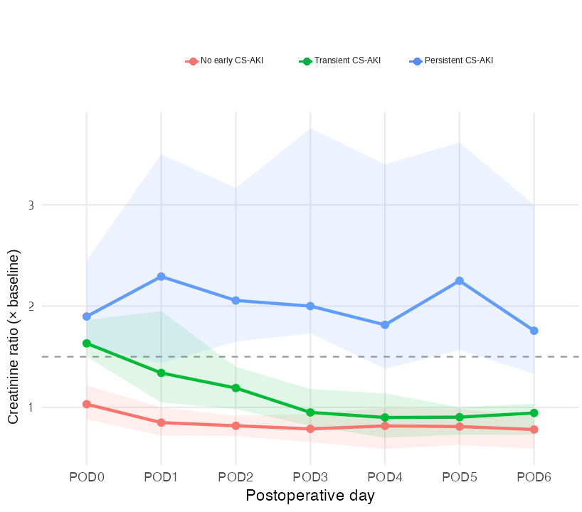
Fig. S1 Serum-creatinine-ratio trajectories by phenotype. The horizontal dashed line marks the 1.5-times-baseline AKI threshold. Lines show medians and shaded bands are IQRs.
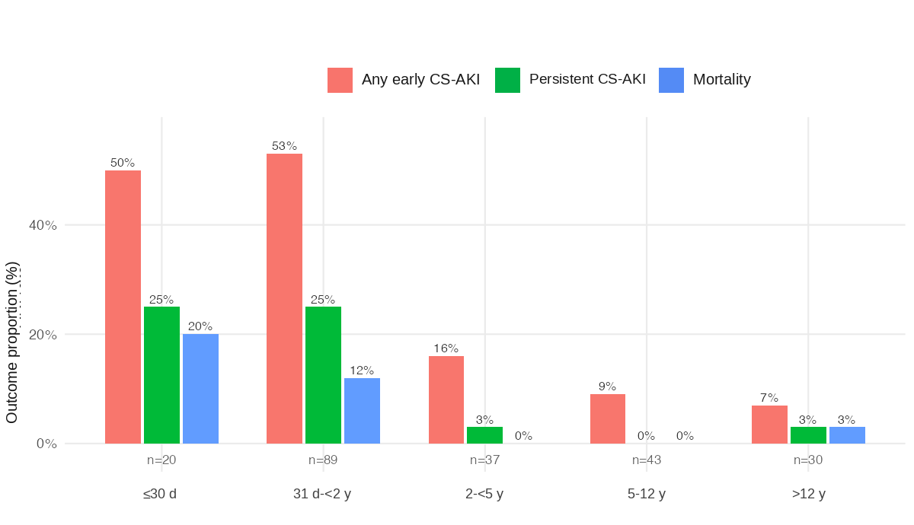
Fig. S2 Crude proportions of any early CS-AKI, persistent CS-AKI, and mortality by age group. Age bands were ≤30 days, 31 days to <2 years, 2 to <5 years, 5-12 years, and >12 years; group sizes are shown below categories. The grouped pattern suggests nonlinearity but does not provide stable age-specific estimates.
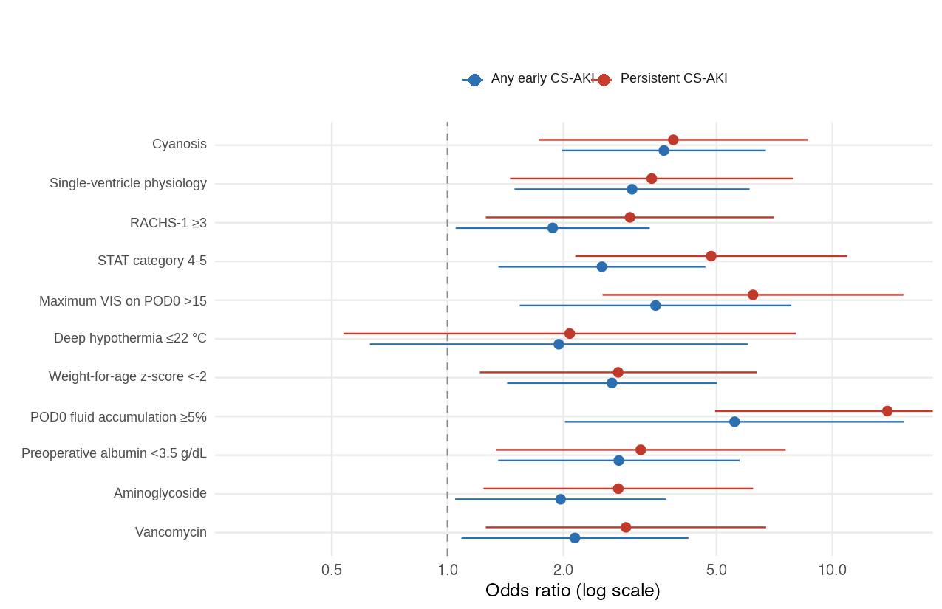
Fig. S3 Exploratory dichotomized representations of selected perioperative variables. These threshold analyses are separate from the continuous-variable analyses in Table S5. Points are ORs and bars are 95% CIs.

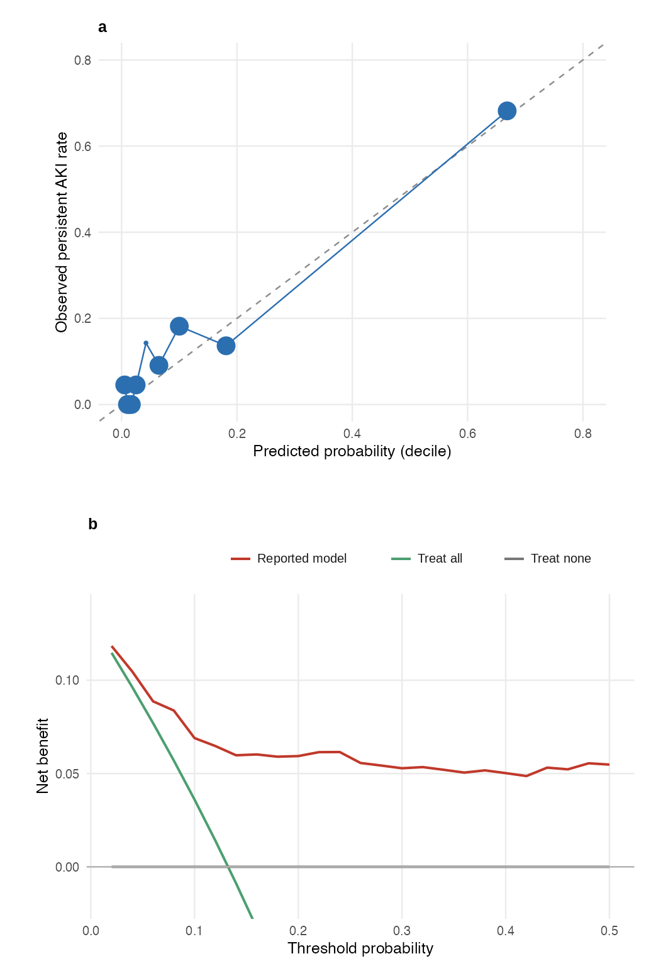
Fig. S4 Calibration and exploratory decision-curve analysis for the primary ML-2 model. (a) Grouped observed versus predicted persistent CS-AKI risk; calibration slope 0.87 and Brier score 0.073. (b) Net benefit across the displayed threshold range. The analysis is exploratory because no specific intervention threshold was prespecified.
Table S11. TRIPOD+AI Reporting Checklist
Completed checklist based on Collins et al. [14]. Page and location references correspond to the final main manuscript and this Online Resource file.
Section/Topic | Item | D&E¹ | Checklist Item | Page/Location
TITLE
Title | 1 | D; E | Identify the study as developing or evaluating the performance of a multivariable prediction model, the  target population, and the outcome to be predicted | Partially reported: the title identifies the target population and outcome phenotype but does not explicitly identify prediction-model development/evaluation (Main manuscript, p. 1).
ABSTRACT
Abstract | 2 | D; E | Provide a summary of objectives, study design, setting, participants, sample size, predictors, outcome, statistical analysis, results, and conclusions. | Main manuscript, pp. 2-3 (Abstract)
INTRODUCTION
Background | 3a | D; E | Explain the healthcare context (including whether diagnostic or prognostic) and rationale for developing  or evaluating the prediction model, including references to existing models | Main manuscript, pp. 3-4 (Introduction)
Background | 3b | D; E | Describe the target population and the intended purpose of the prediction model in the context of the  care pathway, including its intended users (e.g., healthcare professionals, patients, public) | Main manuscript, pp. 3-4 and 15-19 (Introduction and Discussion)
Background | 3c | D; E | Specify the study objectives, including whether the study describes the development or validation of a  prediction model (or both) | Main manuscript, pp. 3-4 (Introduction)
Objectives | 4 | D; E | Specify the study objectives, including whether the study describes the development or validation of a  prediction model (or both) | Main manuscript, pp. 3-4 (Introduction)
METHODS
Data | 5a | D; E | Describe the sources of data separately for the development and evaluation datasets (e.g., randomized trial, cohort, routine care or registry data), the rationale for using these data, and representativeness of  the data | Main manuscript, p. 4; Online Resource 1, p. 1 (Methods S1)
Data | 5b | D; E | Specify the dates of the collected participant data, including start and end of participant accrual; and, if applicable, end of follow-up | Main manuscript, p. 4; Online Resource 1, p. 1 (Methods S1)
Participants | 6a | D; E | Specify key elements of the study setting (e.g., primary care, secondary care, general population) including the number and location of centers | Main manuscript, p. 4 (Study Design and Participants)
Participants | 6b | D; E | Describe the eligibility criteria for study participants | Main manuscript, pp. 4-5; Online Resource 1, p. 1 (Methods S1)
Participants | 6c | D; E | Give details of any treatments received, and how they were handled during model development or evaluation, if relevant | Main manuscript, pp. 6-7; Online Resource 1, pp. 1-2 (Methods S3-S4)
Data preparation | 7 | D; E | Describe any data pre-processing and quality checking, including whether this was similar across relevant sociodemographic groups | Main manuscript, pp. 7-8; Online Resource 1, pp. 1-3 (Methods S1-S5)
Outcome | 8a | D; E | Clearly define the outcome that is being predicted and the time horizon, including how and when assessed, the rationale for choosing this outcome, and whether the method of outcome assessment is consistent across sociodemographic groups | Main manuscript, pp. 5-6; Online Resource 1, p. 1 (Methods S2)
Outcome | 8b | D; E | If outcome assessment requires subjective interpretation, describe the qualifications and demographic characteristics of the outcome assessors | Not applicable: outcome was objectively derived from recorded serum creatinine and renal replacement therapy
Outcome | 8c | D; E | Report any actions to blind assessment of the outcome to be predicted | Not applicable: no separate subjective outcome adjudication was required
Predictors | 9a | D | Describe the choice of initial predictors (e.g., literature, previous models, all available predictors) and any pre-selection of predictors before model building | Main manuscript, pp. 7-8; Online Resource 1, pp. 2-3 (Methods S5)
Predictors | 9b | D; E | Clearly define all predictors, including how and when they were measured (and any actions to blind assessment of predictors for the outcome and other predictors) | Main manuscript, pp. 6-8; Online Resource 1, pp. 1-3 (Methods S3-S5)
Predictors | 9c | D; E | If predictor measurement requires subjective interpretation, describe the qualifications and demographic characteristics of the predictor assessors | Not applicable: predictors were objective recorded clinical variables
Sample size | 10 | D; E | Explain how the study size was arrived at (separately for development and evaluation) and justify that the study size was sufficient to answer the research question. Include details of any sample size calculation | Online Resource 1, p. 3 (Methods S6; exploratory sample-size rationale)
Missing data | 11 | D; E | Describe how missing data were handled. Provide reasons for omitting any data | Main manuscript, pp. 4, 8-9, and 18-19; Online Resource 1, pp. 1 and 6 (Methods S1; Table S2)
Analytical methods | 12a | D | Describe how the data were used (e.g., for development and evaluation of model performance) in the analysis, including whether the data were partitioned, considering any sample size requirements | Main manuscript, pp. 7-8; Online Resource 1, pp. 2-3 (Methods S5)
Analytical methods | 12b | D | Depending on the type of model, describe how predictors were handled in the analyses (functional form, rescaling, transformation, or any standardization). | Main manuscript, pp. 7-8; Online Resource 1, pp. 2-3 (Methods S5)
Analytical methods | 12c | D | Specify the type of model, rationale², all model-building steps, including any hyperparameter tuning, and method for internal validation | Main manuscript, pp. 7-8; Online Resource 1, pp. 2-3 (Methods S5)
Analytical methods | 12d | D; E | Describe if and how any heterogeneity in estimates of model parameter values and model performance was handled and quantified across clusters (e.g., hospitals, countries). See TRIPOD-Cluster for additional considerations³ | Not applicable: single-center study with no cluster-level evaluation
Analytical methods | 12e | D; E | Specify all measures and plots used (and their rationale) to evaluate model performance (e.g., discrimination, calibration, clinical utility) and, if relevant, to compare multiple models | Main manuscript, pp. 7-8 and 13-15 (Table 4 on p. 14; Fig. 3 on p. 15); Online Resource 1, pp. 9 and 12 (Tables S9-S10; Fig. S4)
Analytical methods | 12f | E | Describe any model updating (e.g., recalibration) arising from the model evaluation, either overall or for particular sociodemographic groups or settings | Not applicable: no model updating or recalibration was performed
Analytical methods | 12g | E | For model evaluation, describe how the model predictions were calculated (e.g., formula, code, object, application programming interface) | Online Resource 1, pp. 2-3 (Methods S5; outer-fold predictions)
Class imbalance | 13 | D; E | If class imbalance methods were used, state why and how this was done, and any subsequent methods to recalibrate the model or the model predictions | Online Resource 1, p. 3 (Methods S6)
Fairness | 14 | D; E | Describe any approaches that were used to address model fairness and their rationale | Online Resource 1, p. 3 (Methods S6)
Model output | 15 | D | Specify the output of the prediction model (e.g., probabilities, classification). Provide details and rationale for any classification and how the thresholds were identified | Main manuscript, pp. 7-8; Online Resource 1, p. 3 (Methods S6)
Training versus evaluation | 16 | D; E | Identify any differences between the development and evaluation data in healthcare setting, eligibility criteria, outcome, and predictors | Main manuscript, pp. 7-8; Online Resource 1, pp. 2-3 (Methods S5)
Ethical approval | 17 | D; E | Name the institutional research board or ethics committee that approved the study and describe the participant-informed consent or the ethics committee waiver of informed consent | Main manuscript, pp. 20-21 (Ethics Approval; Consent to Participate)
Funding | 18a | D; E | Give the source of funding and the role of the funders for the present study | Main manuscript, p. 20 (Funding)
Conflicts of interest | 18b | D; E | Declare any conflicts of interest and financial disclosures for all authors | Main manuscript, p. 21 (Competing Interests)
Protocol | 18c | D; E | Indicate where the study protocol can be accessed or state that a protocol was not prepared | Online Resource 1, p. 3 (Methods S6)
Registration | 18d | D; E | Provide registration information for the study, including register name and registration number, or state that the study was not registered | Online Resource 1, p. 3 (Methods S6)
Data Sharing | 18e | D; E | Provide details of the availability of the study data | Main manuscript, p. 21 (Data Availability)
Code sharing | 18f | D; E | Provide details of the availability of the analytical code⁴ | Main manuscript, p. 21 (Data Availability)
PATIENT & PUBLIC INVOLVEMENT
Patient & Public  Involvement | 19 | D; E | Provide details of any patient and public involvement during the design, conduct, reporting, interpretation, or dissemination of the study or state no involvement. | Online Resource 1, p. 3 (Methods S6)
RESULTS
Participants | 20a | D; E | Describe the flow of participants through the study, including the number of participants with and without the outcome and, if applicable, a summary of the follow-up time. A diagram may be helpful. | Main manuscript, pp. 4-5 (Fig. 1 on p. 5)
Participants | 20b | D; E | Report the characteristics overall and, where applicable, for each data source or setting, including the key dates, key predictors (including demographics), treatments received, sample size, number of outcome events, follow-up time, and amount of missing data. A table may be helpful. Report any differences across key demographic groups. | Main manuscript, pp. 8-10 (Tables 1-2 on pp. 9-10); Online Resource 1, pp. 4-6 (Tables S1a-S2)
Participants | 20c | E | For model evaluation, show a comparison with the development data of the distribution of important predictors (demographics, predictors, and outcome). | Not applicable: no separate external evaluation dataset
Model development | 21 | D; E | Specify the number of participants and outcome events in each analysis (e.g., for model development, hyperparameter tuning, model evaluation) | Main manuscript, pp. 13-15; Online Resource 1, p. 3 (Methods S6)
Model  specification | 22 | D | Provide details of the full prediction model (e.g., formula, code, object, application programming interface) to allow predictions in new individuals and to enable third-party evaluation and implementation, including any restrictions to access or re-use (e.g., freely available, proprietary)⁵ | Main manuscript, pp. 7-8; Online Resource 1, pp. 2-3 (Methods S5; partial reporting)
Model performance | 23a | D; E | Report model performance estimates with confidence intervals, including for any key subgroups (e.g., sociodemographic). Consider plots to aid presentation. | Main manuscript, pp. 2-3 and 13-15 (Table 4 on p. 14; Fig. 3 on p. 15); Online Resource 1, pp. 9 and 12 (Tables S9-S10; Fig. S4)
Model performance | 23b | D; E | If examined, report results of any heterogeneity in model performance across clusters. See TRIPOD Cluster for additional details³. | Not applicable: single-center study with no cluster-level performance analysis
Model updating | 24 | E | Report the results from any model updating, including the updated model and subsequent performance | Not applicable: no model updating was performed
DISCUSSION
Interpretation | 25 | D; E | Give an overall interpretation of the main results, including issues of fairness in the context of the objectives and previous studies | Main manuscript, pp. 15-19 (Discussion)
Limitations | 26 | D; E | Discuss any limitations of the study (such as a non-representative sample, sample size, overfitting, missing data) and their effects on any biases, statistical uncertainty, and generalizability | Main manuscript, pp. 18-19 (Limitations)
Usability of the  model in the  context of current  care | 27a | D | Describe how poor quality or unavailable input data (e.g., predictor values) should be assessed and handled when implementing the prediction model | Not specified because the model is not intended for current clinical implementation; Online Resource 1, p. 3 (Methods S6)
Usability of the  model in the  context of current  care | 27b | D | Specify whether users will be required to interact in the handling of the input data or use of the model, and what level of expertise is required of users | Not specified because the model is not intended for current clinical implementation; Online Resource 1, p. 3 (Methods S6)
Usability of the  model in the  context of current  care | 27c | D; E | Discuss any next steps for future research, with a specific view to applicability and generalizability of the model | Main manuscript, pp. 15-19 (Discussion and Conclusions)
1 D=items relevant only to the development of a prediction model; E=items relating solely to the evaluation of a prediction model; D; E=items applicable to both the development and evaluation of a prediction model
2 Separately for all model building approaches.
3 TRIPOD-Cluster is a checklist of reporting recommendations for studies developing or validating models that explicitly account for clustering or explore heterogeneity in model performance (e.g., at different hospitals or centers). Debray et al, BMJ 2023; 380: e071018 [DOI: 10.1136/bmj-2022-071018]
4 This relates to the analysis code, for example, any data cleaning, feature engineering, model building, evaluation.
5 This relates to the code to implement the model to get estimates of risk for a new individual.

