Figure S1. Forest Plot of Effect Sizes for Pairwise Age Group Comparisons in BA Infants
Effect sizes (r = Z/√N) with 95% confidence intervals are shown. Larger r values indicate greater between-group differences. Comparisons with adjusted P < 0.05 are highlighted in red.

Figure S2. Piecewise Linear Regression Identifying Breakpoints in Age-Serum MMP-7 Relationship
Two breakpoints were identified at 50 days (95% CI: 31–69) and 92 days (95% CI: 75–110) using the segmented package in R. The fitted lines represent the three distinct phases of MMP-7 trajectory.

Figure S3. Gender-stratified analysis of serum MMP-7 levels.
Each panel displays the distribution of MMP-7 for males and females within a specific age and disease category. The displayed P values (above each pair of boxes) are from Wilcoxon rank-sum tests. No significant gender-dependent differences were found in any subgroup.

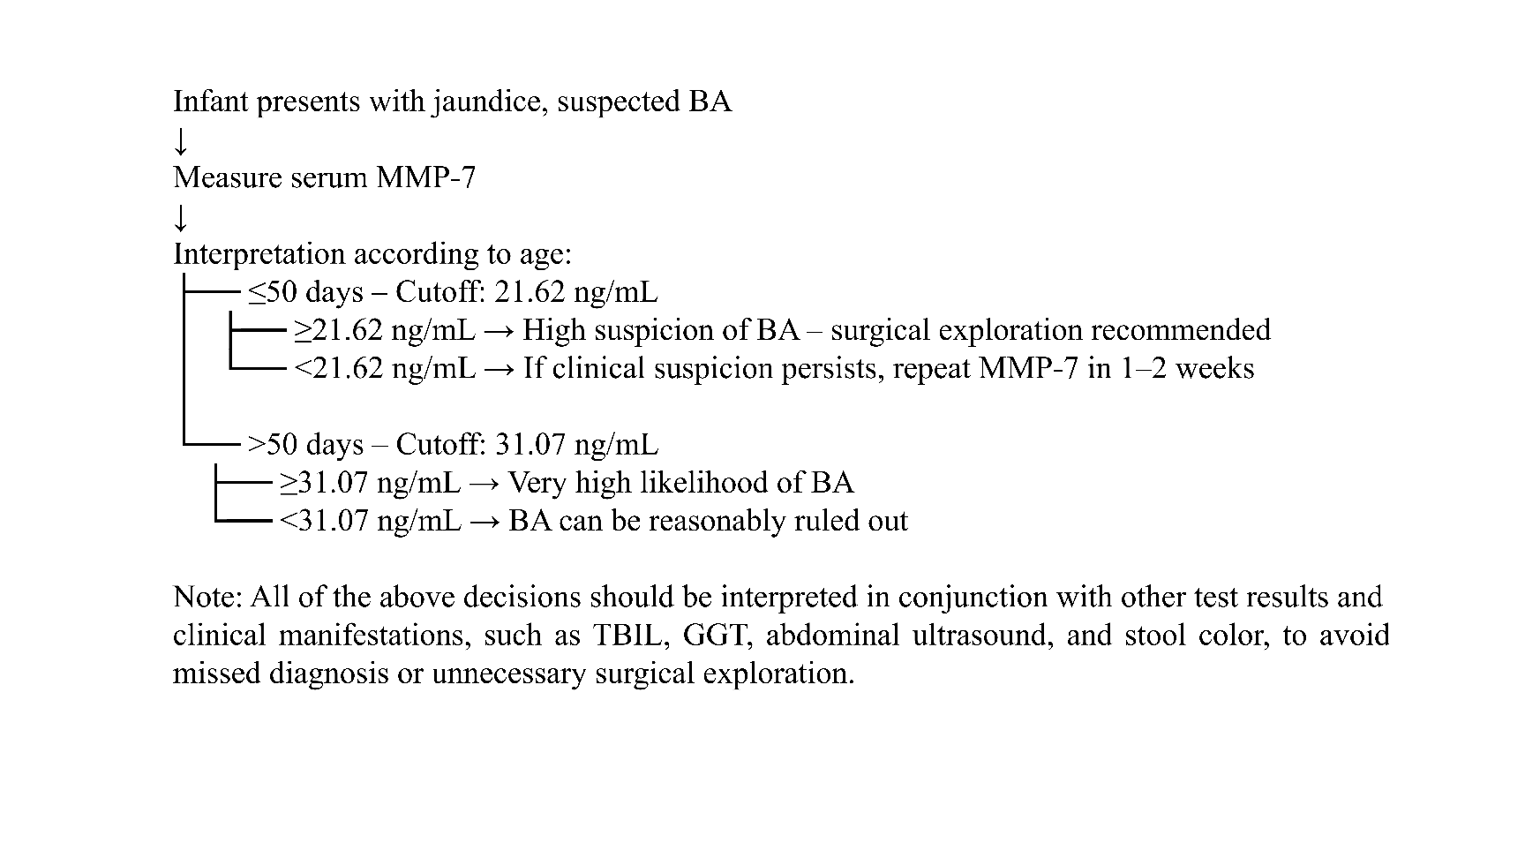
Figure S4. Proposed clinical diagnostic flowchart for BA using age‑stratified serum MMP‑7 cutoffs.

