Supplementary Information

Extraction and purification method for Aula valves
The Aula valves were extracted from a natural-grade diatomaceous earth, “Celatom®” (Ep minerals, USA), through a two-step process. The first step was to minimize the calcite content and impurities as much as possible by immersing the powder in hydrochloric acid (3N) under ambient conditions for 48 hours, followed by washing the suspension with deionized water until it became neutral. The second step was to remove the siliceous debris and minimize the large variation of Aula valve size found in the sample — probably associated with the presence of valves belonging to more than one species — by applying a settling-based separation method. This was performed by letting the valves (suspended in deionized water and ultrasonicated for 5 min in an ultrasonic bath) settle for 30 min in a 50 ml falcon tube, then carefully taking out ≈ 35 ml, leaving only ≈ 15 ml at the bottom. The process was repeated by refilling the tubes with deionized water and repeating the settling step three times to ensure the separation of the larger valves in the bottom fraction. The structural parameters of the valves in the bottom fraction (the purified sample) were statistically analyzed, following the statistical framework developed in Ghobara et al.¹, and the results were summarized in Table S1. Figure S1 shows the difference between the natural and processed samples under SEM.

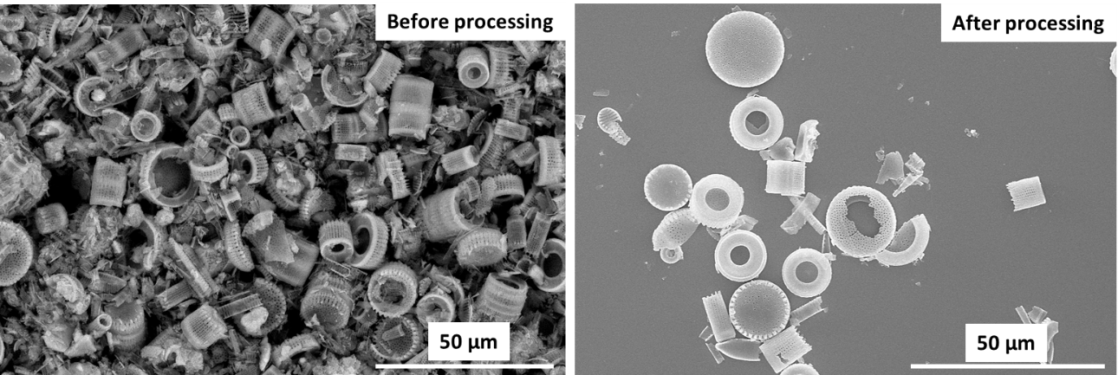

Fig. S1. The SEM micrograph at the left shows the natural grade Celatom sample before processing, having a wide range of valve sizes and a considerable amount of debris. The SEM micrograph at the right shows the final purified sample (i.e., the bottom fraction), being cleaner and more homogenous.

Table S1. Statistical analysis of the structural parameters of Aula valves (weighted mean, internal and external errors—the bold print indicates the significant error). The min-max values of parameters are provided to show their range in the purified sample.

Parameter | Description | Min- Max | Weighted mean ‘X_{w}’ | dX_{int} | dX_{ext}
2r_{v} | Valve diameter (2 x radius) [µm] | 6.2 – 18.2 | 13.9 | 0.006 | 0.9
h_{v} | Valve height [µm] | 2.9 – 6.2 | 4.4 | 0.007 | 0.4
W_{s} | Spine area width [µm] | 0.40 – 0.93 | 0.59 | 0.02 | 0.04
2r_{a,v} | Areolae diameter on the valve face [µm] | 0.22 – 0.33 | 0.25 | 0.01 | 0.02
d_{a,v} | Areolae lattice spacing [µm] | 0.70 – 0.90 | 0.82 | 0.002 | 0.02
A_{a,v} | The lattice angle [degree] | 54.4° – 67.8° | 60.0° | 0.008° | 1.6°
W_{d} | Defect width [µm] | 0.0 – 7.0 | 3.4 | 0.2 | 0.8
h_{c} | Collum height [µm] | 1.0 – 1.9 | 1.4 | 0.008 | 0.1
h_{s} | Spines height [µm] | 0.80 – 1.15 | 1.00 | 0.05 | 0.08
D_{R} | Ringleist thickness [µm] | 0.48 – 0.57 | 0.53 | 0.01 | 0.05
Ri,% | Ringleist opining ratio [%] | 33 – 59 | 51 | 0.9 | 5
D_{M} | Mantle thickness [µm] | 0.40 – 0.78 | 0.54 | 0.008 | 0.05
2r_{a,M} | Areolae diameter (2 x radius) on mantle [µm] | 0.13 – 0.32 | 0.20 | 0.01 | 0.05
d_{a,M} | Areolae spacing within stria on mantle [µm] | 0.47 – 0.66 | 0.56 | 0.003 | 0.04
d_{a, Mstr} | Areolae spacing between adjacent striae on mantle [µm] | 0.66 – 1.15 | 0.8 | 0.003 | 0.1
A_{a,M} | The lattice angle [degree] | 78.5° – 92.0° | 84.0° | 0.1° | 3.0°

Extraction and purification method for GP and CR valves
First, the diatom culture (containing diatom living cells) was ultrasonicated in an ultrasonic bath for 3 min to disperse living cells. Then, the suspension was treated with about the same volume (1:1) of hydrogen peroxide (30%). The mixture was left boiling on a hot plate — covered with a petri dish to enable simple refluxing — in a fume hood for about 1 hour, and then it was left to calm down overnight to continue the digestion of organic materials. After that, the diatom siliceous parts were collected by centrifugation. The collected sample was washed with deionized water and recollected by centrifugation several times until the pH became neutral. Finally, the concentrated clean sample (suspended in deionized water) was stored until further use.

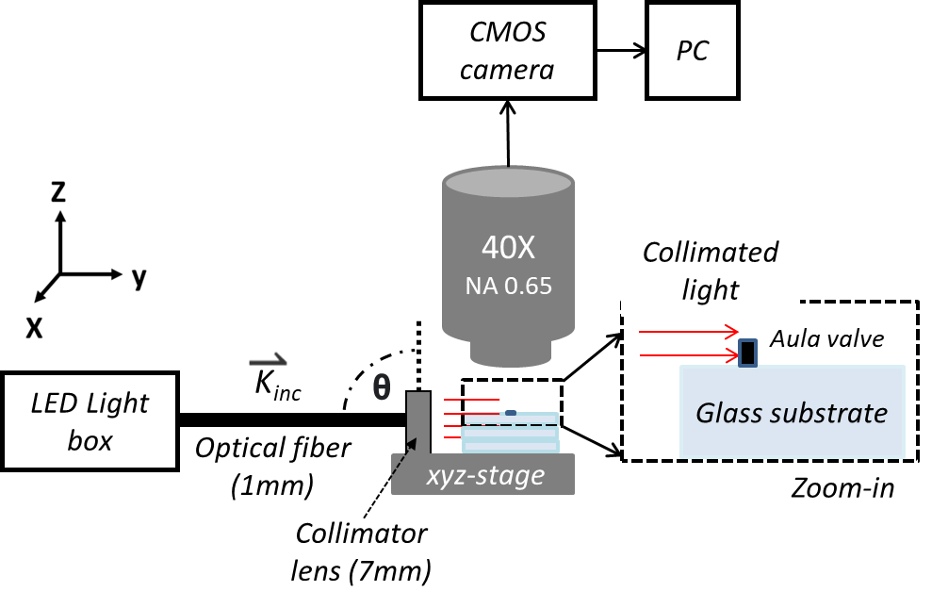

Fig. S2. The experimental setup for the side-illumination technique. It should be noted that, under side-illumination, the images of the glass substrate without diatom valves were homogenously dark, which means the reflected fraction of light by the glass substrate (due to the 5° tilt) has a negligible influence on the obtained images.

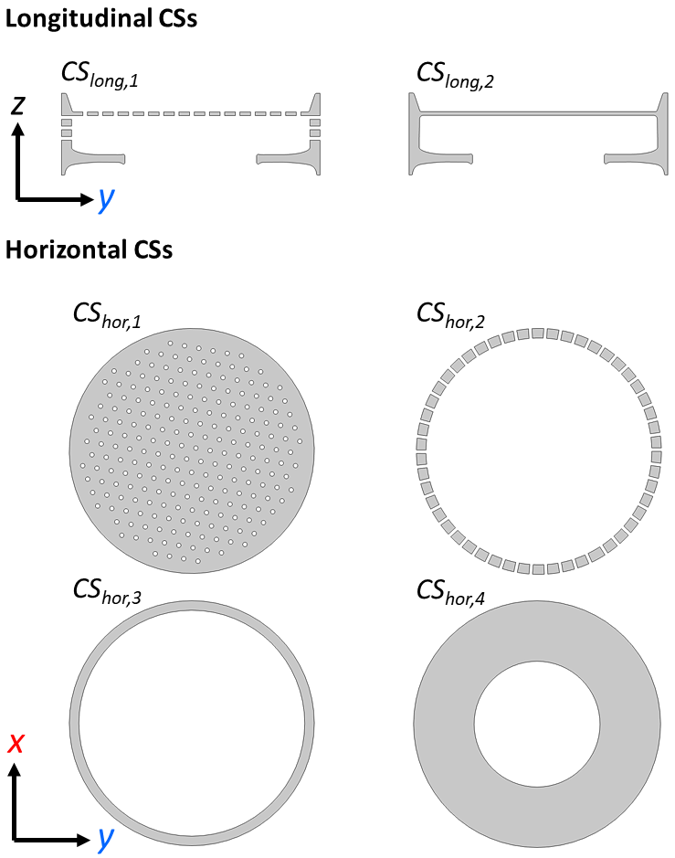

Fig. S3. The representative 2D CSs of the Aula valve. The CS_{long,1} and CS_{long,2} show the valve with and without areolae, respectively. The CS_{hor,1} shows the porous plate of the valve face, which has a disc-like structure of an approximated height of 200 nm. Moreover, CS_{hor,2} and CS_{hor,3} show the mantle with and without areolae, respectively. Furthermore, CS_{hor,4} shows the Ringleist, which has a hollow disc-like structure. It should be noted that Aula CS_{long,i} and CS_{hor,i} represent the z-y and x-y planes in the 3D valve, respectively.
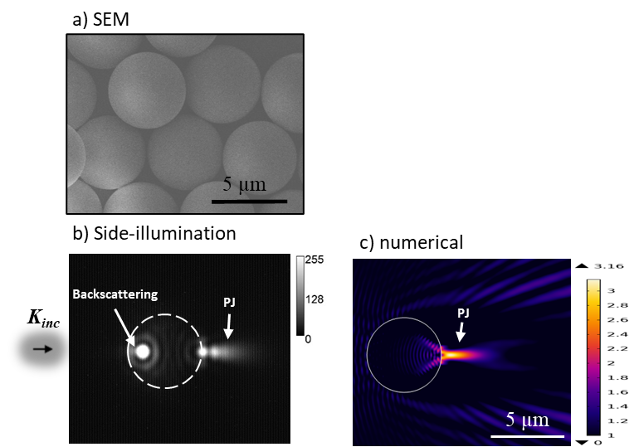

Fig. S4. (a) SEM micrograph of silica microspheres. (b) a microsphere under side-illumination, as appeared under the 40x objective. In the side-illumination setup, the microsphere was illuminated from the left-hand side by a red LED (λ_{max} = 660 nm), yielding a PJ beam at the rear side, besides a backscattering spot on the front side. The intensity scale in (b) is a greyscale value. (c) The 2D simulation results for the wave propagation (in-plane E field) across 5 µm circle (represents 2D CS in the 3D sphere) at the same wavelength (λ_{vac} = 660 nm), where n_{sphere} = 1.46 and n_{medium} = 1. The color code ranges from 1 V/m (E_{input}) to 3.16 V/m (E_{max}).

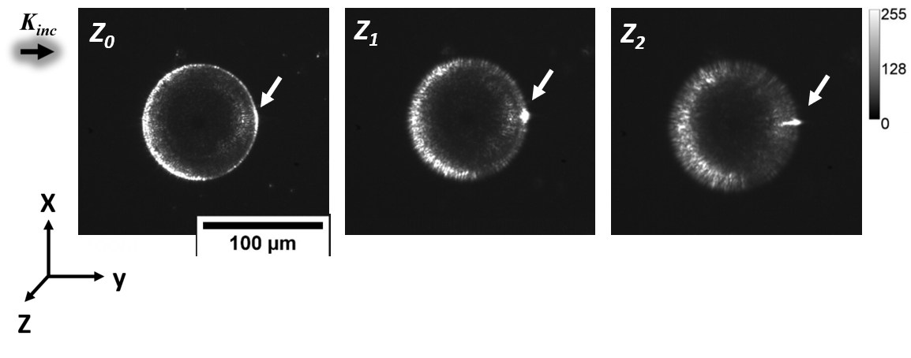

Fig. S5. An example of the focal-plane dependence of the observed focusing by CR valves after being illuminated from the side. All micrographs are for the same valve illuminated from the left-hand side (λ_{max} ≈ 660 nm) but observed at different focal planes (z_{i}). Each step on the z-axis is ≈ 14 ± 1 μm. The intensity scale is a greyscale value.

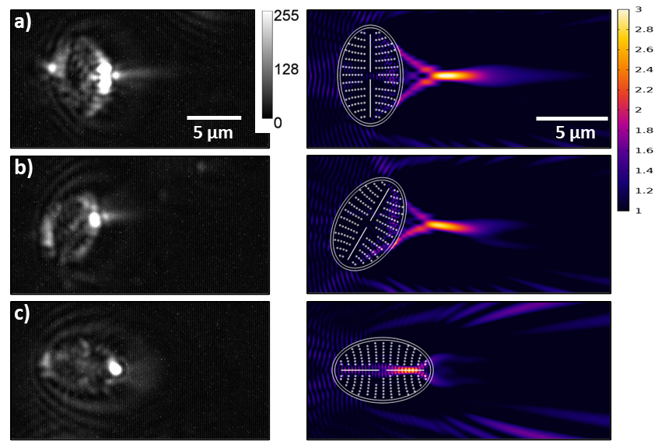

Fig. S6. At left, experimental results show the dependency of the generated PJ length and position on the valve rotation under a left-hand side-illumination (λ_{max} ≈ 660 nm). These valves were extracted from Fig. 3d, the background was subtracted, and the contrast was enhanced to disclose the PJ beam. At right, the associated 2D simulation results for the wave propagation (in-plane E field) across a 2D model representing the GP valve face (built based on the statistically representative structural parameters obtained from Ghobara et al.¹) at λ_{vac} = 660 nm show comparable results while rotating the 2D model under the same simulation conditions. The color code ranges from black (1 V/m) over purple/red (2 V/m) to yellow (3 V/m), only emphasizing the enhanced field (E_{Norm} > E_{input}), while the black areas indicate E_{Norm} ≤ E_{input}, where E_{input} = 1 V/m.

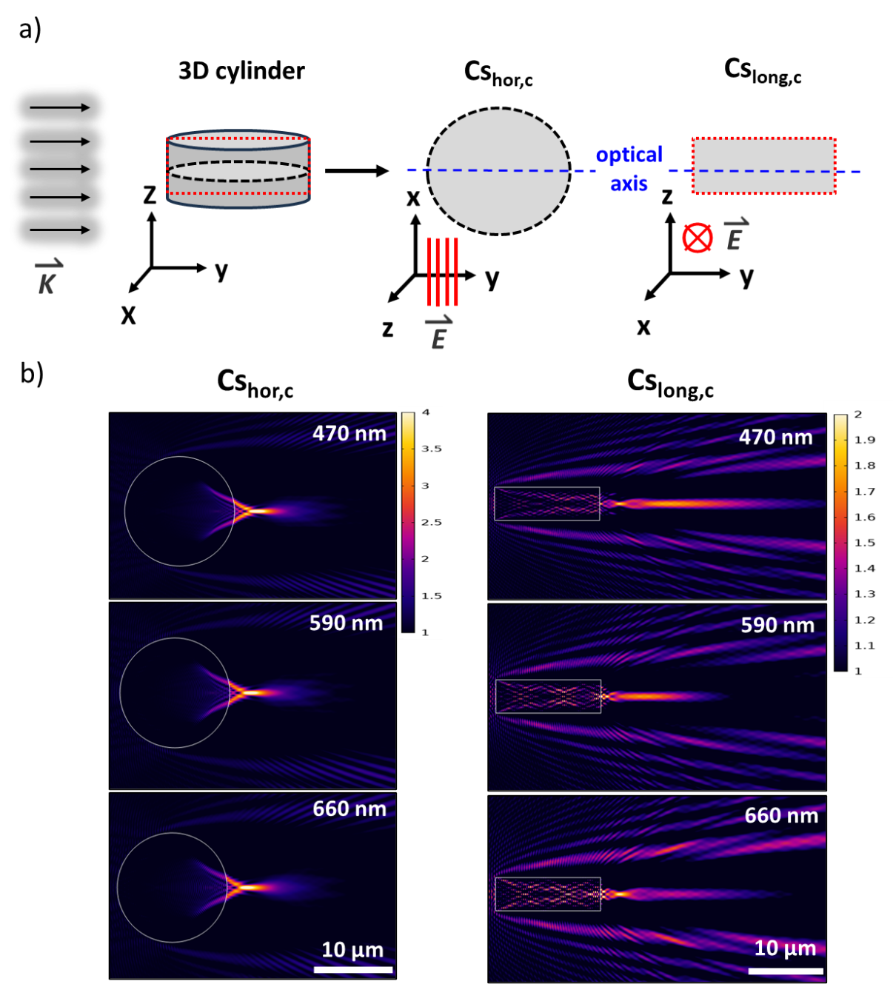

Fig. S7. (a) A sketch shows the side-illumination of a silica solid microcylinder (of the same dimensions as an Aula valve) alongside the extracted CSs. The longitudinal (CS_{long,c}) and horizontal (CS_{hor,c}) CSs have the same dimensions as CS_{long,1} and CS_{hor,1}, respectively. Assuming the incident beam on the 3D microcylinder has x-polarization, its electric field component oscillates on the x-axis (perpendicular to the y-axis, the propagation direction), which means that it oscillates in-plane the 2D horizontal CS and out-of-plane the 2D longitudinal CS. (b) the numerical analysis results of the 2D CSs at different λ_{vac}. The FWHM of the PJ beam generated by CS_{hor,c} is about 570 nm, 650 nm, or 700 nm for λ_{vac} 470 nm, 590 nm, or 660 nm, respectively. The color code is given in V/m units.

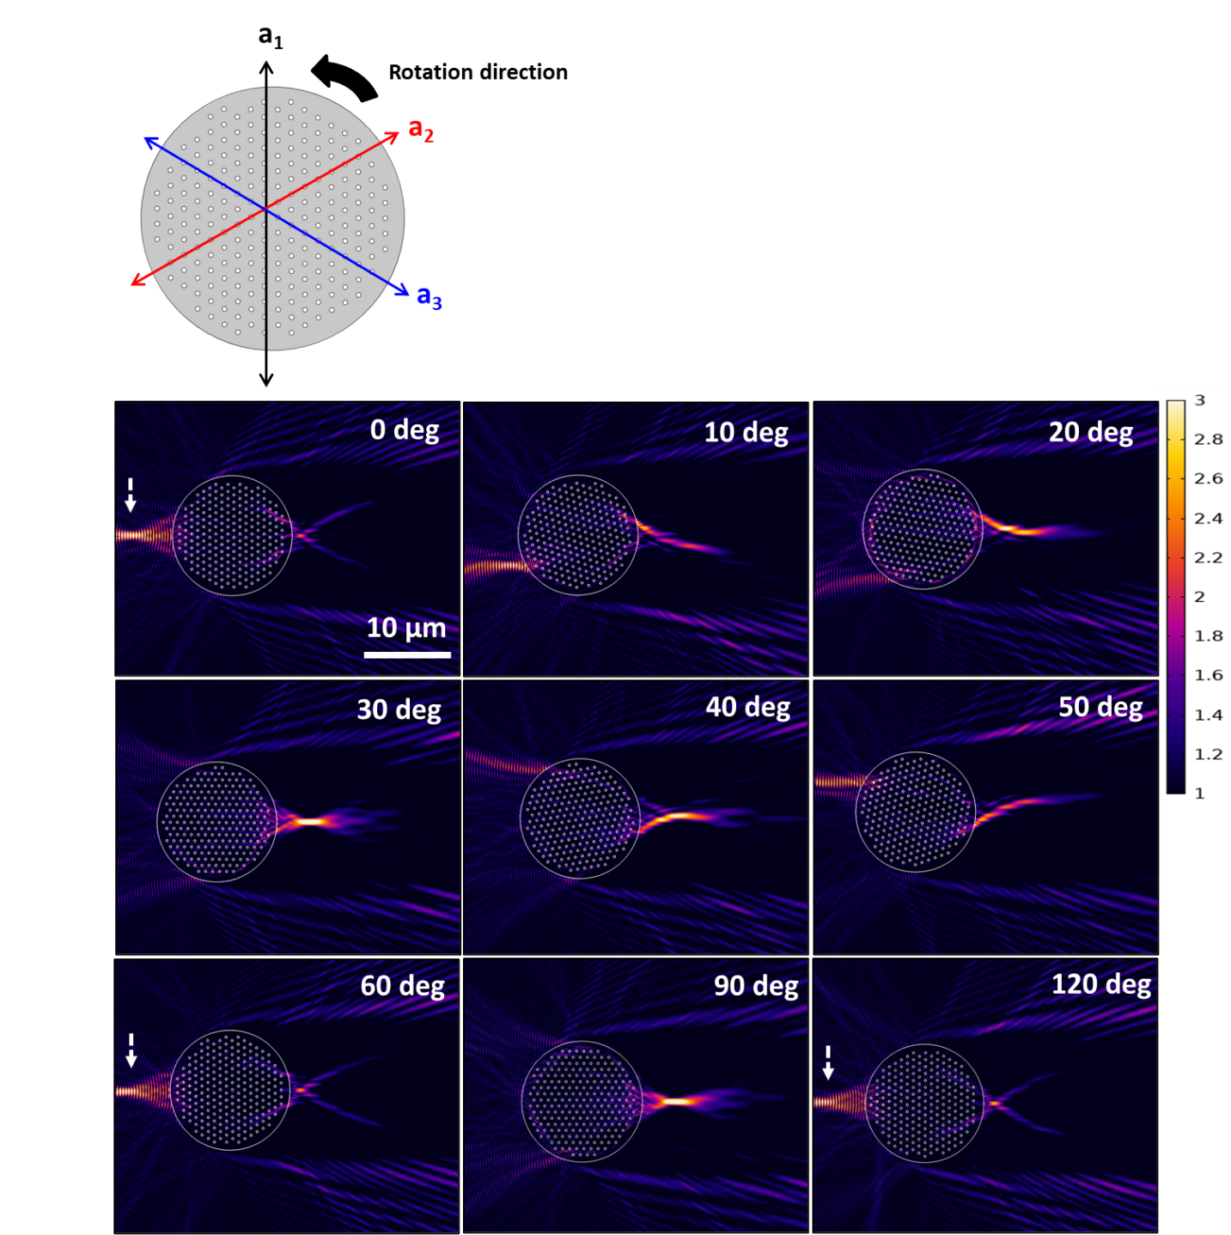

Fig. S8. Rotating the symmetry axes (a₁, a₂, and a₃) relative to the direction of the incident light of CS_{hor,1} at λ_{vac} 660 nm (in-plane E field) in air causes changes in the position and intensity of the generated PJ beam. The white arrows indicate the formation of a PJ beam mainly in the reflectance each 60°. The color code is given in V/m units.

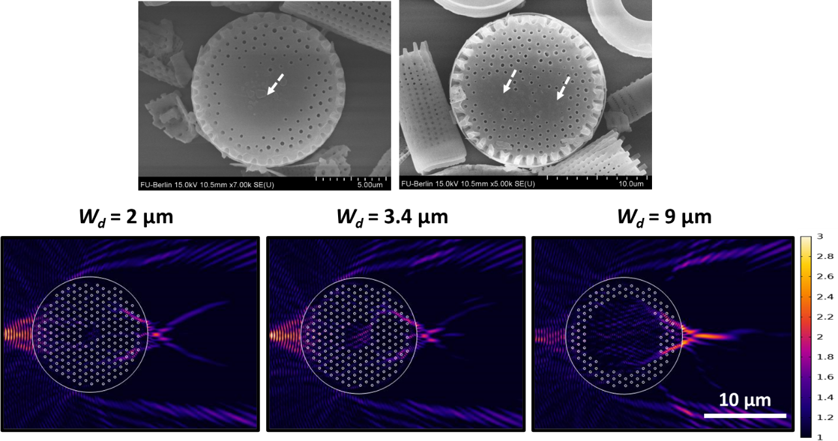

Fig. S9. SEM micrographs show Aula valves with defects indicated by white arrows (at the top). Simulation results show the influence of the presence of a defect in the hexagonal lattice of CS_{hor,1} and its width W_{d} on the generated PJ at λ_{vac} 660 nm in air at rotational angle = 0 degree (at the bottom). At a small W_{d}, the PJ is still mainly generated at reflectance. In contrast, at a large W_{d}, the generated PJ beam is largely restored in the transmittance again. The color code is given in V/m, and the simulated wave (E_{input} = 1 V/m, in-plane E field) was initiated from the left-hand side.

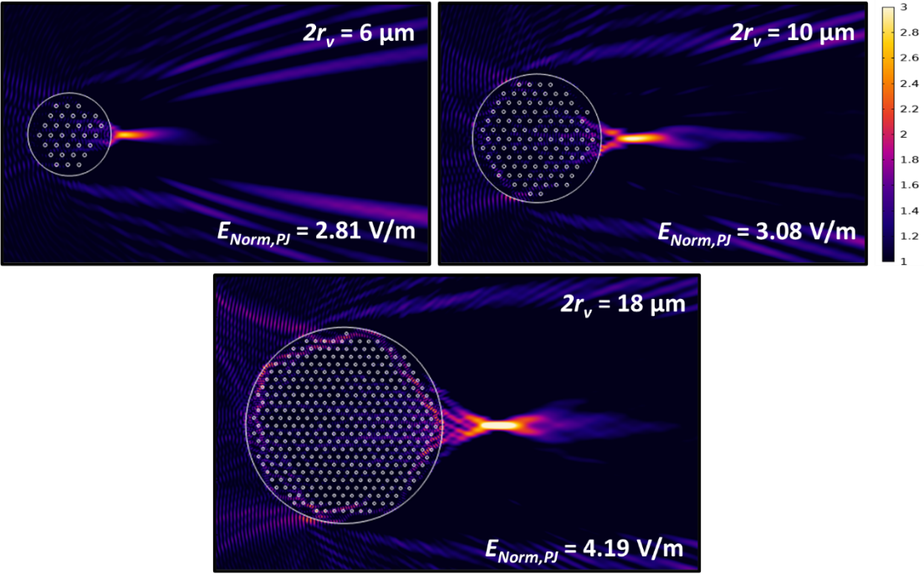

Fig. S10. Simulation results show the influence of valve diameter 2r_{v} on the generated PJ beam at λ_{vac} 660 nm in air. By increasing 2r_{v} of CS_{hor,1}, the E_{Norm,PJ} increases. The color code is given in V/m, and the simulated wave (E_{input} = 1 V/m, in-plane E field) was initiated from the left-hand side.

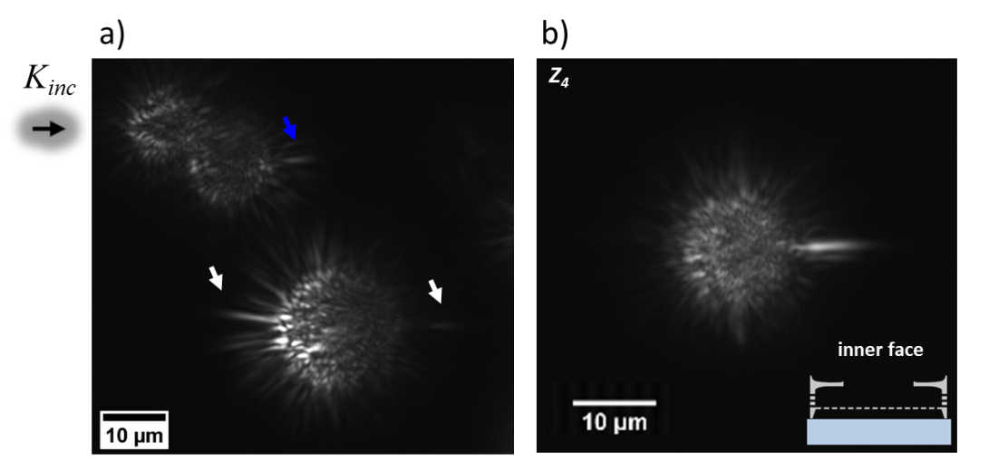

Fig. S11. (a) Anomalous experimental observation at λ_{max} = 660 nm. An Aula valve (at the bottom) shows what seems to be pronounced PJ at the front side (to occur in reflectance) and another PJ at the rear side but of much weaker strength. Another Aula valve (at the top) shows a normal PJ generated at the rear side above an Aula valve, indicated by the blue arrow. (b) Experimental result shows the focusing behavior of an Aula valve (2r_{v} ≈ 13.7 μm) having its inner face upward and illuminated by the blue LED (λ_{max} = 470 nm). z₄ is about 5.6 ± 0.4 μm above z₀ on the z-axis.

References
1. Ghobara, M., Oschatz, C., Fratzl, P. & Reissig, L. Numerical Analysis of the Light Modulation by the Frustule of Gomphonema parvulum: The Role of Integrated Optical Components. Nanomaterials 13, 113 (2022).

