Immobilized PMA on a pyridine-based rigid polymer as a heterogeneous catalyst for the synthesis of 5-aminopyrazole-4-carbonitrile
Sara Sakiª, Mohammad Mehdi Khodaei^{a,b}*
ªDepartment of Organic Chemistry, Razi University, 67149-67346 Kermanshah, Iran; E-mail: mmkhoda@razi.ac.ir
^{b}Nanoscience and Nanotechnology Research Center (NNRC), Razi University, 67149-67346 Kermanshah, Iran

List of Figures
Fig.S1. ¹H NMR of 5-amino-1,3-diphenyl-1H-pyrazole-4-carbonitrile(5a).
Fig.S2. ¹³C NMR of 5-amino-1,3-diphenyl-1H-pyrazole-4-carbonitrile(5a).
Fig. S3. ¹H NMR of 5-amino-3-(3-nitrophenyl)-1-phenyl-1H-pyrazole-4-carbonitrile(5c).
Fig. S4. ¹³C NMR of 5-amino-3-(3-nitrophenyl)-1-phenyl-1H-pyrazole-4-carbonitrile(5c).
Fig. S5. ¹H NMR of 5-amino-3-(4-chlorophenyl)-1-phenyl-1H-pyrazole-4-carbonitrile (5g).
Fig. S6. ¹³C NMR 5-amino-3-(4-chlorophenyl)-1-phenyl-1H-pyrazole-4-carbonitrile (5g).
Fig. S7. ¹H NMR of 5-amino-1-phenyl-3-(thiophen-2-yl)-1H-pyrazole-4-carbonitrile(5i).
Fig. S8. ¹³C NMR of 5-amino-1-phenyl-3-(thiophen-2-yl)-1H-pyrazole-4-carbonitrile(5i).

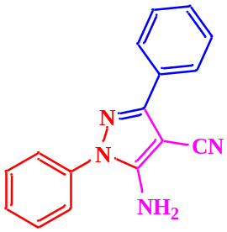
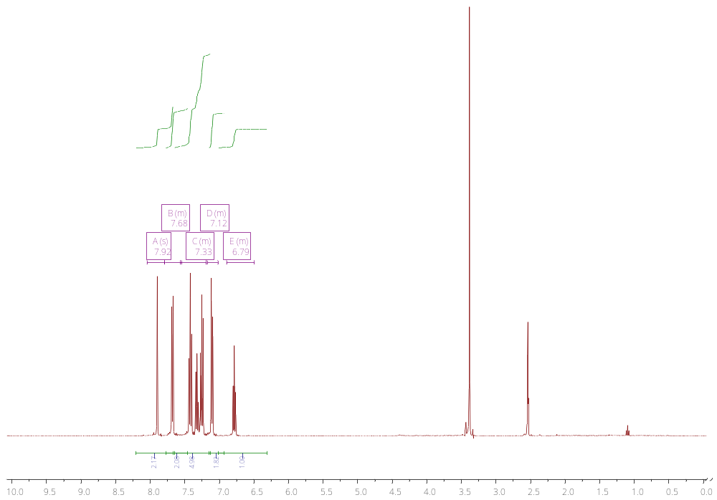
Fig.S1. ¹H NMR of 5-amino-1,3-diphenyl-1H-pyrazole-4-carbonitrile.
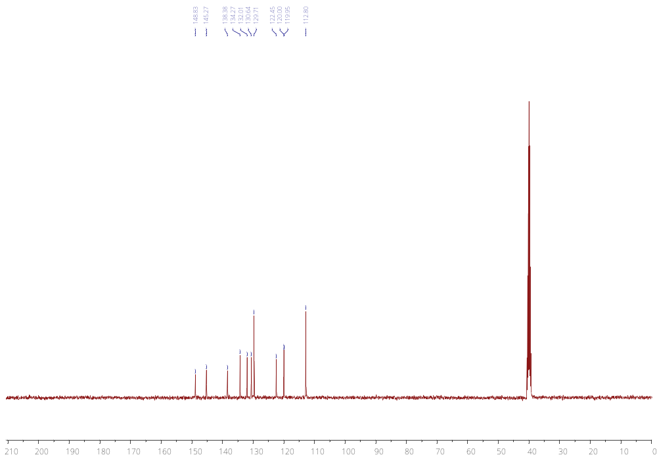
Fig.S2. ¹³C NMR of 5-amino-1,3-diphenyl-1H-pyrazole-4-carbonitrile.

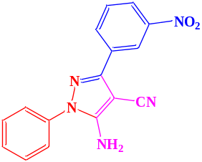
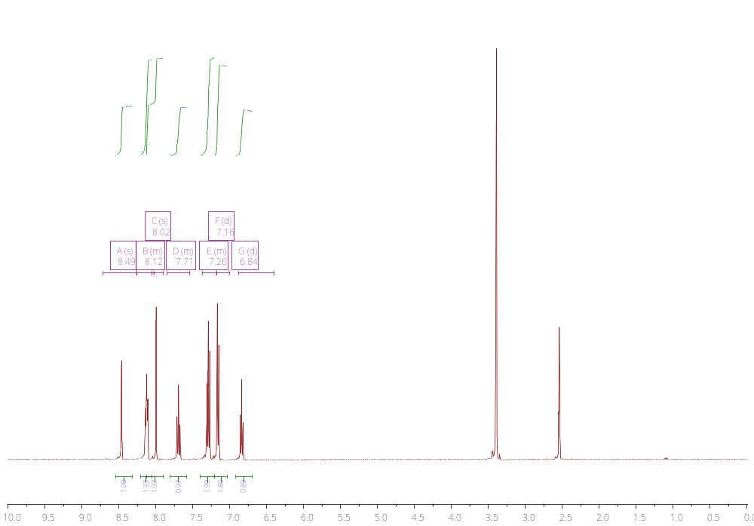
Fig.S3. ¹H NMR of 5-amino-3-(3-nitrophenyl)-1-phenyl-1H-pyrazole-4-carbonitrile.
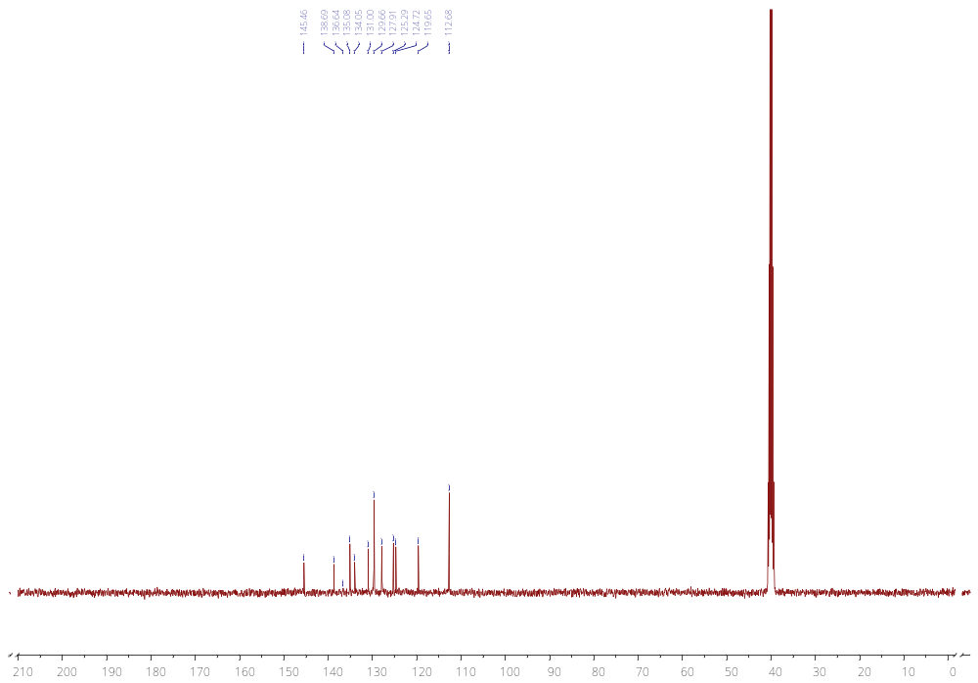Fig.S4. ¹³C NMR of 5-amino-3-(3-nitrophenyl)-1-phenyl-1H-pyrazole-4-carbonitrile.

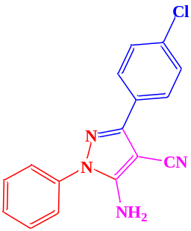
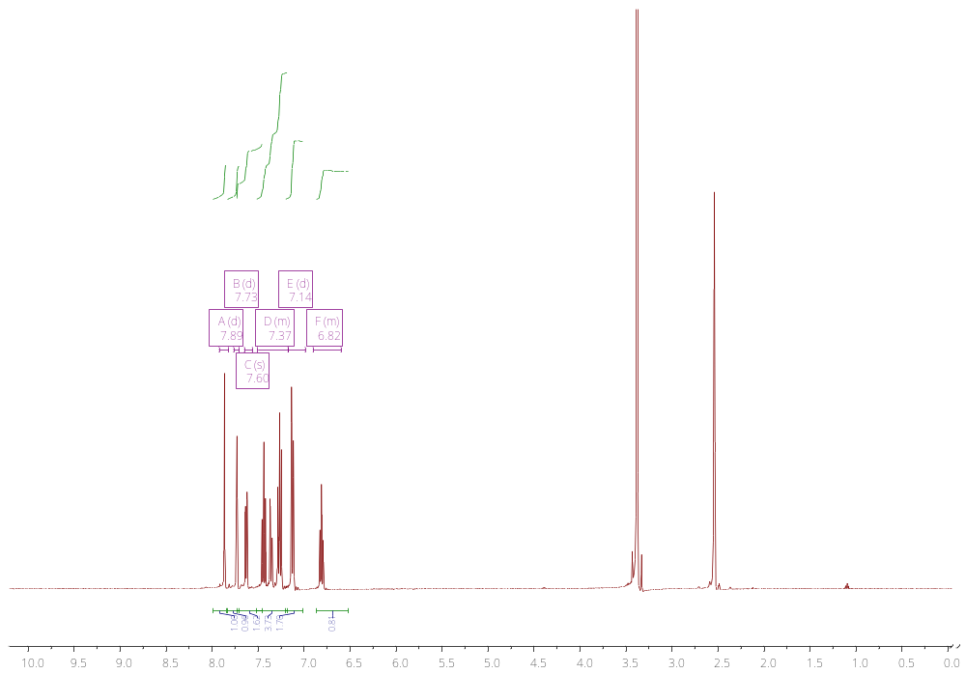
Fig.S5. ¹H NMR of 5-amino-3-(4-chlorophenyl)-1-phenyl-1H-pyrazole-4-carbonitrile.
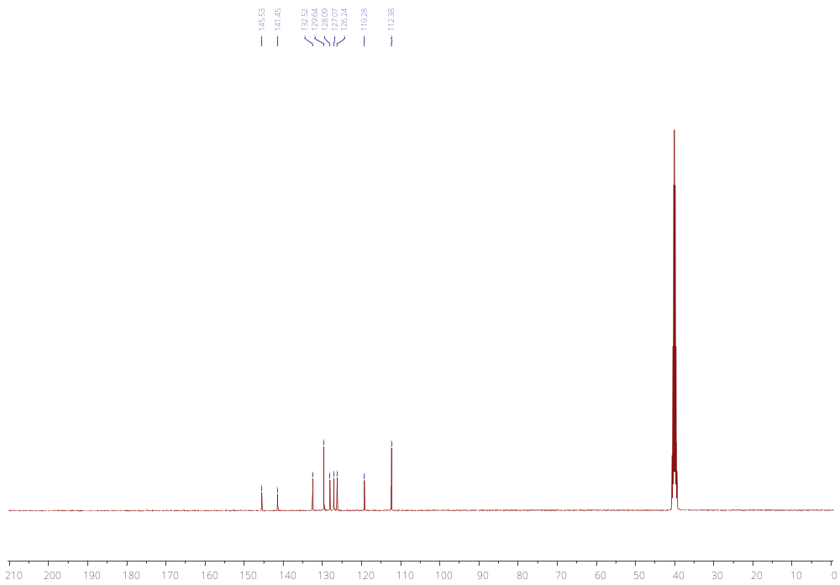
Fig.S6. ¹³C NMR of 5-amino-3-(4-chlorophenyl)-1-phenyl-1H-pyrazole-4-carbonitrile.

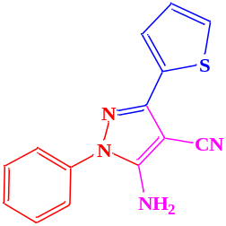
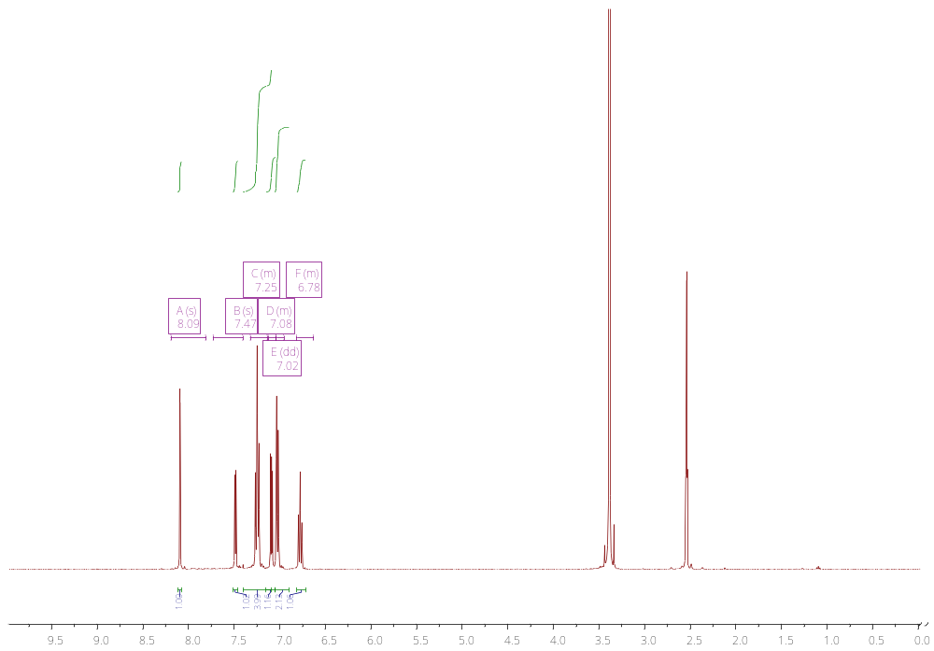

Fig. S7. ¹H NMR of 5-amino-1-phenyl-3-(thiophen-2-yl)-1H-pyrazole-4-carbonitrile.
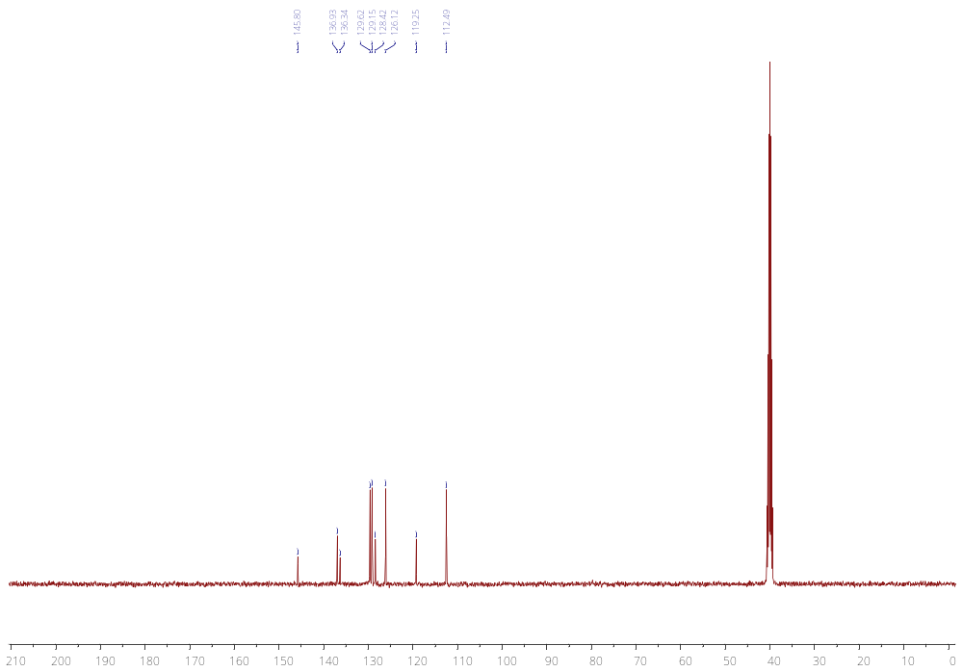
Fig. S8. ¹3C NMR of 5-amino-1-phenyl-3-(thiophen-2-yl)-1H-pyrazole-4-carbonitrile.

