Aerosol hygroscopicity and photodegradation in the polluted Indo-Gangetic Plain compared with the clean Himalayas examined using a quartz crystal microbalance
Shailina Srivastava^{1,2,3}, Aishwarya Singh^{1,2,4}, Tariq Ahmed⁵, Christi Jose^{1,2,6}, Bin Bai³, Mangattayil Devaprasad^{1,2}, Rizana Salim^{1,2,7}, Subrat Sharma⁸, Atul Kumar Srivastava⁹, Deewan Singh Bisht⁹, Govindan Pandithurai¹, M. O. Andreae^{10,11}, Scot T. Martin^{12,13}, Ravi Krishna Raghunathan^{1,14}, Pengfei Liu³, Sachin S. Gunthe^{1,2}
¹Center for Atmospheric and Climate Sciences, Indian Institute of Technology Madras,
Chennai 600036, India

²Environmental Engineering Division, Dept of Civil Engineering, Indian Institute of Technology Madras, Chennai 600036, India
³School of Earth and Atmospheric Sciences, Georgia Institute of Technology, Atlanta, GA 30332, USA
⁴Aerosol Chemistry Department, Max Planck Institute for Chemistry, Mainz 55128, Germany
⁵Department of Geology, University of Ladakh, Leh 194101, India
⁶SOCAAR, University of Toronto, Ontario M5S 1A4, Canada
⁷Department of Chemistry, University of California, Irvine, CA, 92697, USA
⁸Rashtriya Raksha University, Ladakh UT Campus, Leh 194101, Ladakh UT, India
⁹Indian Institute of Tropical Meteorology, Ministry of Earth Sciences, New Delhi 110060, India
¹⁰Max Planck Institute for Chemistry, 55128 Mainz, Germany
¹¹Scripps Institution of Oceanography, University of California, San Diego, La Jolla, CA 92093, USA
¹²Department of Earth and Planetary Sciences, Harvard University, Cambridge, MA 02138, USA
¹³John A. Paulson School of Engineering & Applied Sciences, Harvard University, Cambridge, MA 02138, USA
¹⁴Dept of Chemical Engineering, Indian Institute of Technology Madras, Chennai 600036, India
*Corresponding author(s). E-mail(s): shailinasrivastava@cacs.iitm.ac.in; s.gunthe@iitm.ac.in
Additional information on QCM-based hygroscopicity and photodegradation analysis
The hygroscopicity and photodegradation of the collected aerosol particles were analyzed using a highly sensitive mass-balance Quartz Crystal Microbalance (QCM, QSense Analyzer, Biolin Scientific). This instrument is capable of measuring mass changes at the nanogram level. The core principle relies on the Sauerbrey equation (S1), which describes the linear relationship between the decrease in the crystal's resonant frequency ($∆f$) and the adsorbed mass (∆m)^{1,2}. This relationship is given by:

$∆f=-\frac{C}{n}∆m$ (S1)

Here, $C$ (=17.7 ng.cm⁻².Hz⁻¹ for 5 MHz AT-cut crystals) is the mass sensitivity constant, and n is the overtone number (1,3,5,..). This equation is valid under the assumption that the deposited film is rigid and perfectly coupled to the sensor surface.^{1,2}

For the QCM experiments, prior to use, the sensors were meticulously cleaned using 2% Sodium dodecyl sulfate (SDS), Milli-Q water, and methanol, followed by drying with N₂ gas and a 20-minute UV-Ozone treatment (1 mW/cm²) to eliminate organic contaminants. The amount of water absorbed/adsorbed or mass lost was determined by measuring the difference in resonant frequencies between the aerosol-coated sensor and a blank sensor at a particular RH and then converting this difference to mass using the Sauerbrey equation. To ensure accuracy, the low flow rate of 0-30 sccm was carefully monitored and checked using a Gilibrator (Sensidyne) before and after each experiment.

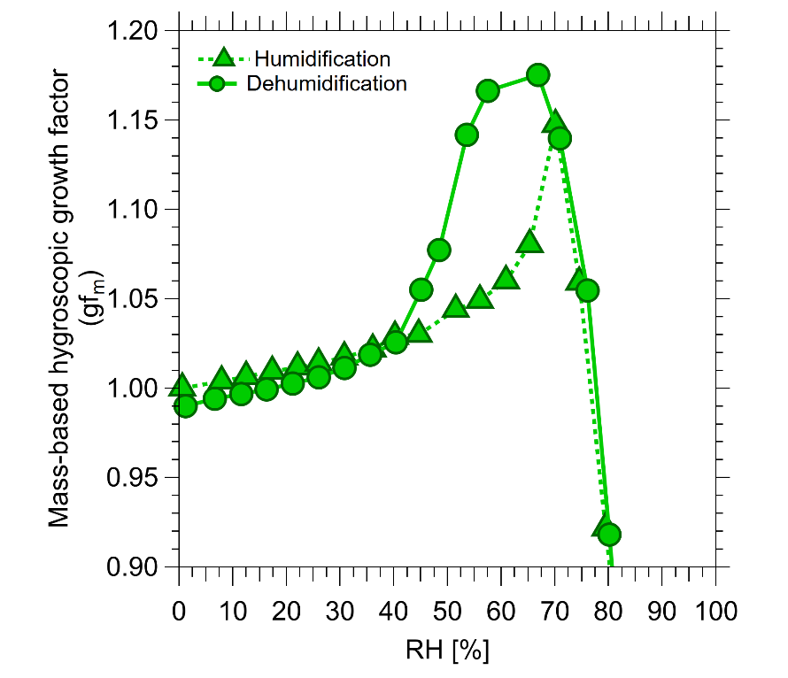

Figure S1. Average mass-based hygroscopic growth factor (gf_{m}) of Leh aerosols as a function of relative humidity (RH) during humidification and dehumidification cycles. The distinct separation between the humidification and dehumidification branches, particularly at RH ~ 40%, indicates pronounced hysteresis, suggesting a persistent difference in aerosol water uptake and retention between the two RH trajectories. The observed hysteresis is characteristic of particles undergoing a phase transition, with the deliquescence and efflorescence processes occurring at different RH conditions.

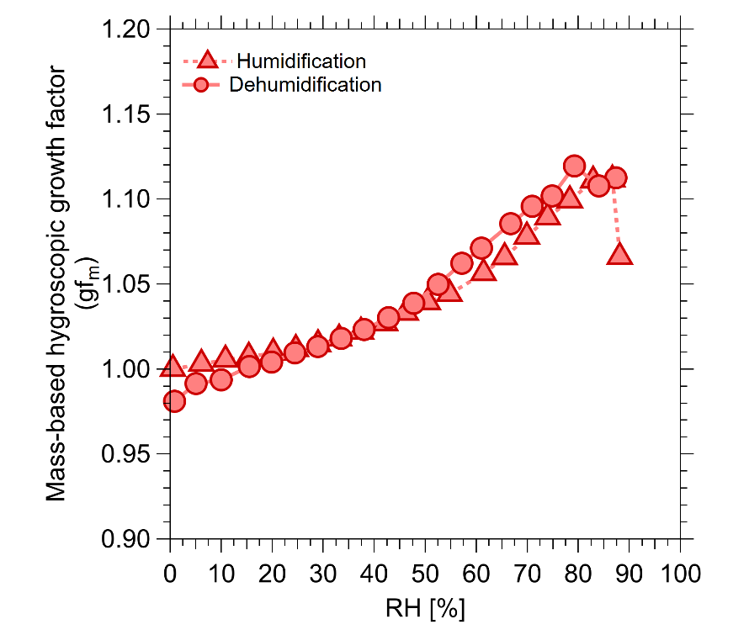

Figure S2. Average mass-based hygroscopic growth factor (gf_{m}) of Delhi aerosol particles as a function of relative humidity (RH) during humidification and dehumidification cycles. The humidification and dehumidification branches largely overlap, with no distinct deliquescence transition or pronounced hysteresis observed across the measured RH range.

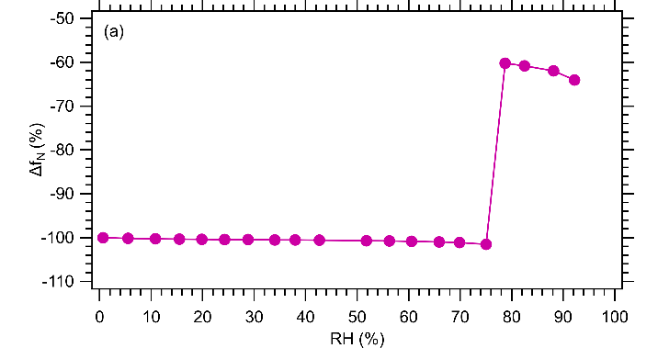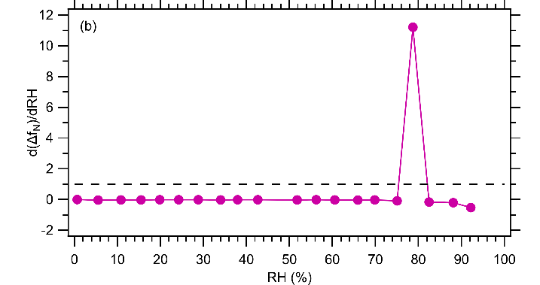

Figure S3: Humidity-driven phase change (deliquescence) in (NH₄)₂SO₄ aerosols. This figure details the hygroscopic behavior of (NH₄)₂SO₄ particles. Panel (a) illustrates the change in normalized QCM oscillation frequency (Δf_{N} %) as a function of relative humidity (RH), demonstrating water uptake by the collected aerosol particles. The decrease in Δf_{N} (normalized to the dry state at RH < 5%) tracks the progressive absorption of water by the aerosols. Panel (b) shows the first derivative, d(Δf_{N})/d(RH)) vs. RH, which is used to precisely identify the Deliquescence Relative Humidity (DRH). The DRH occurs when the rate of water uptake, d(Δf_{N})/d(RH)) reaches or surpasses 1 (indicated by the dashed line).

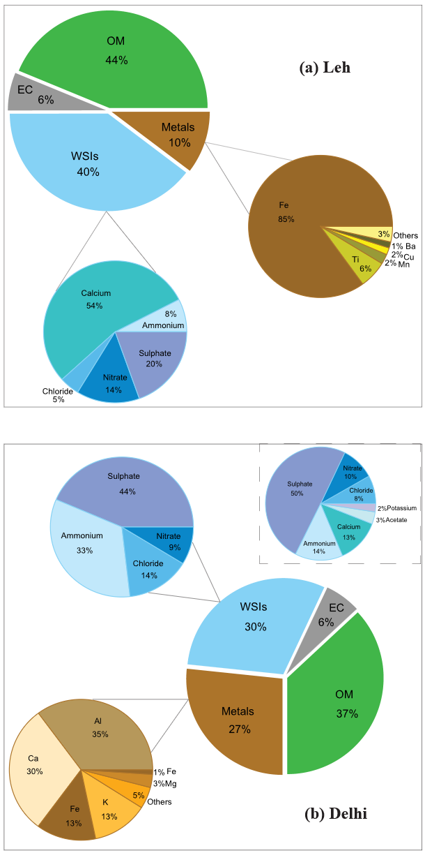

Figure S4. Chemical composition of aerosol particles at Leh (a) and Delhi (b). The inset in panel (b) shows chemical composition measured in the present study, while the outer region represents data compiled from literature^{3,4} for the same season.

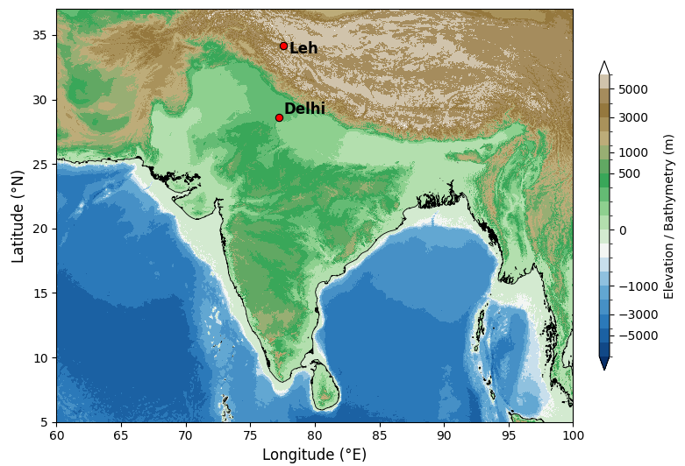

Figure S5: Topographic map illustrating the geographical locations of the two aerosol sampling sites in India. Leh, a high-altitude cold desert site in the western Himalayas (~3500 m amsl), and Delhi, an urban site in the Indo-Gangetic Plain (~220 m amsl), are indicated⁵.

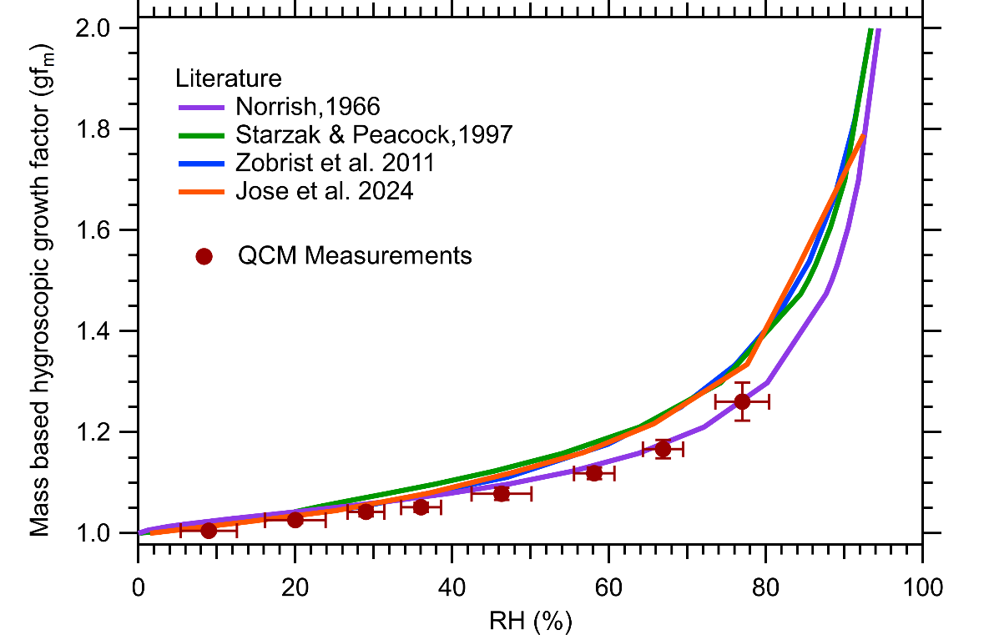
Figure S6. Validation of QCM hygroscopicity measurement using sucrose. Comparison of the mass-based hygroscopic growth factor ${gf}_{m}$ values obtained experimentally via QCM against predictions from several literature models and QCM experiments (Norrish, Starzak and Peacock, Zobrist, and Jose). The strict adherence of the experimental ${gf}_{m}$ values to the model and experimental calculations confirms the reliability of the QCM technique in the sub-saturated RH regime.

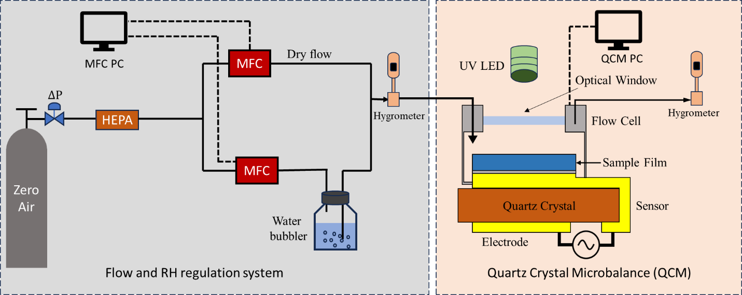

Figure S7: Experimental Setup for Measuring Aerosol-Water Vapor Interactions and Photodegradation using QCM. The schematic depicts the system used to achieve controlled humidity conditions (via parallel MFCs supplying dry and humidified air) over the aerosol-coated QCM sensor (measuring mass changes). The chamber platform includes a UV LED for photogradation experiments and is monitored by thermohygrometers measuring the RH of the incoming and outgoing flows.

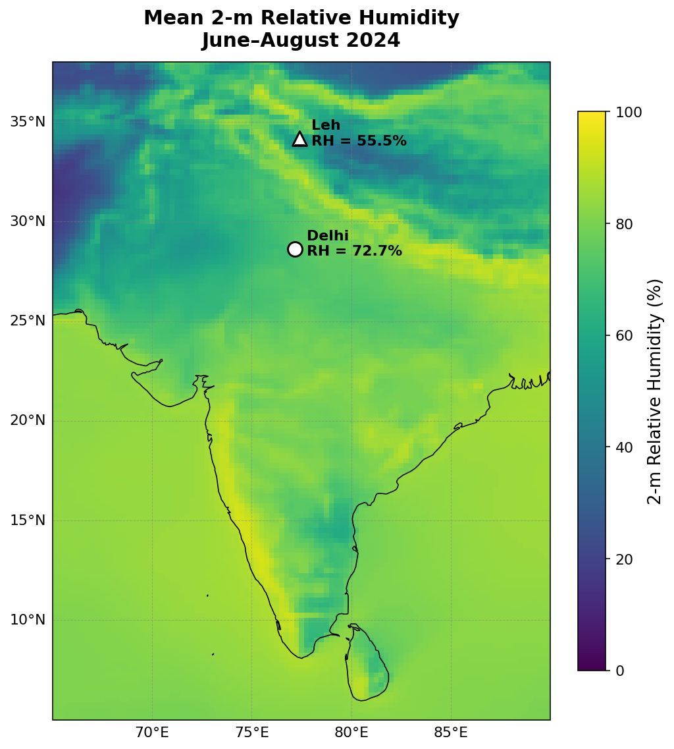
Figure S8: Spatial distribution of mean 2-m relative humidity (RH) over India during June-August 2024 based on ERA5 reanalysis data. The symbols indicate the two aerosol sampling locations, Leh (34.18°N, 77.41°E) and Delhi (28.63°N, 77.17°E), with the corresponding mean RH values shown at each site, highlighting the spatial variation in RH across the two contrasting regions⁶.

Table S1: Mass-based hygroscopic growth factor (gf_{m}) and the corresponding hygroscopicity parameter (κ_{m}) at different RH values in the subsaturated region for ambient aerosol particles (PM_{2.5}) sampled from Leh. The measurements were obtained from the QCM experiments.
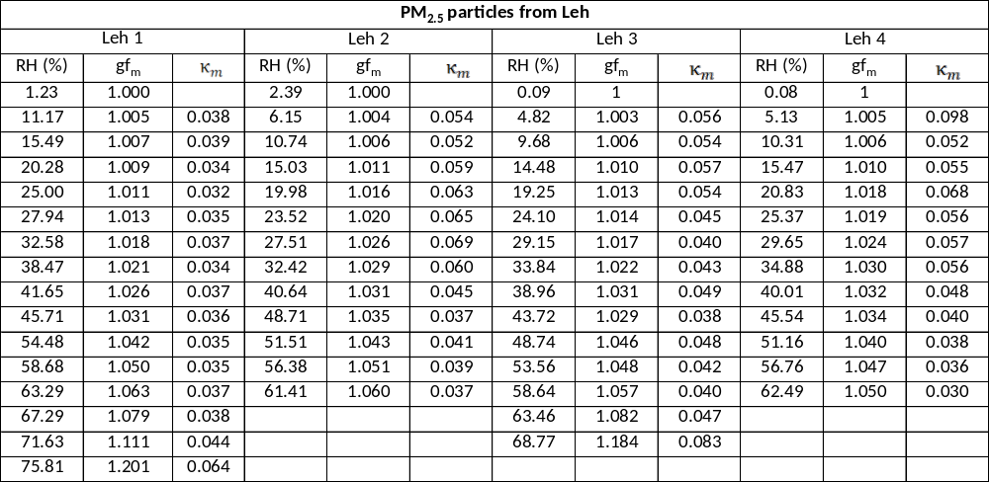

Table S2: Mass-based hygroscopic growth factor (gf_{m}) and the corresponding hygroscopicity parameter (κ_{m}) at different RH values in the subsaturated region for ambient aerosol particles (PM_{2.5}) sampled from Delhi. The measurements were obtained from the QCM experiments.
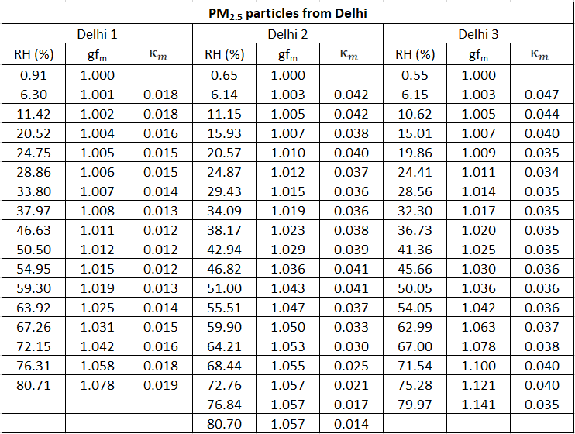

References
1. Jose, C. et al. Complex Hygroscopic Behavior of Ambient Aerosol Particles Revealed by a Piezoelectric Technique. ACS Earth Space Chem. 8, 983–991 (2024).
2. Rodahl, M. & Kasemo, B. On the measurement of thin liquid overlayers with the quartz-crystal microbalance. Sens. Actuators A Phys. 54, 448–456 (1996).
3. Bhowmik, H. S. et al. Temporal and spatial variability of carbonaceous species (EC; OC; WSOC and SOA) in PM2.5 aerosol over five sites of Indo-Gangetic Plain. Atmos. Pollut. Res. 12, 375–390 (2021).
4. Bhowmik, H. S. et al. Temporal and spatial variability of carbonaceous species (EC; OC; WSOC and SOA) in PM2.5 aerosol over five sites of Indo-Gangetic Plain. Atmos. Pollut. Res. 12, 375–390 (2021).
5. Becker, J. J. et al. Global Bathymetry and Elevation Data at 30 Arc Seconds Resolution: SRTM30_PLUS. Marine Geodesy 32, 355–371 (2009).
6. Hersbach, H., Bell, B., Berrisford, P., Biavati, G., Horányi, A., Muñoz Sabater, J., Nicolas, J., Peubey, C., Radu, R., Rozum, I., Schepers, D., Simmons, A., Soci, C., Dee, D., Thépaut, J-N. (2023): ERA5 hourly data on single levels from 1940 to present. Copernicus Climate Change Service (C3S) Climate Data Store (CDS), DOI: 10.24381/cds.adbb2d47 (Accessed on 16-08-2026).
7. Copernicus Climate Change Service, Climate Data Store, (2024): ERA5 post-processed daily-statistics on single levels from 1940 to present. Copernicus Climate Change Service (C3S) Climate Data Store (CDS), DOI: 10.24381/cds.4991cf48 (Accessed on 03-09-2026).

