Supplementary Materials

Fig. 1: Modified SESF for Bogiani Fishery SES Co-management Challenges in Northeastern Bangladesh
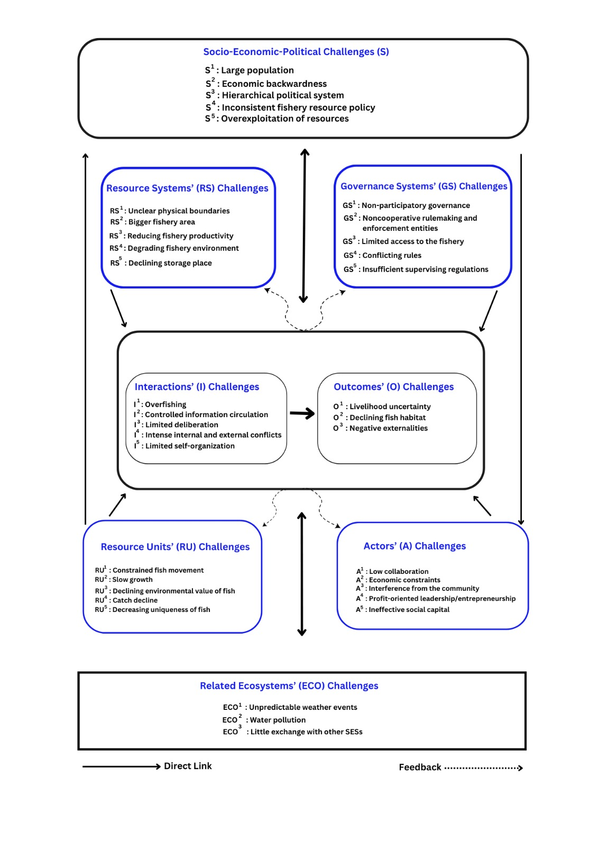
Table 1: Documents Used to Describe the Contexts of Bogiani Fishery
Type of Documents | Extracted Information from Documents
Statistical Yearbook Bangladesh 2021, Bangladesh Bureau of Statistics (BBS) | Information about per capita national income to compare fishers’ income in Tahirpur area
Statistical Yearbook Bangladesh 2020, Bangladesh Bureau of Statistics (BBS) | Information about poverty was gathered to compare the situations of fishers in Tahirpur subdistrict
Statistical Yearbook Bangladesh 2019, Bangladesh Bureau of Statistics (BBS) | Information about rainfall and temperature was collected to compare the location and condition of Bogiani fishery
Yearbook of Fisheries Statistics of Bangladesh 2017-18, Department of Fisheries, Bangladesh | This document was utilized to gather information about fish production, fish production area, fish species, fisheries development and management, and community-based fisheries management in Bangladesh to compare in Tahirpur subdistrict contexts
District Statistics 2011, Sunamganj, Bangladesh Bureau of Statistics (BBS) 2013 | Information about population density and growth rate in Tahirpur subdistrict
Banglapedia, 2021 | Information about the location, topography and socioeconomic conditions in Tahirpur subdistrict to compare the conditions of fishers

Table 2: Third-Tier Variables Derived from Second-Tier Variables of Fisher’s Social-Economic-Political Settings (S)
Variables | Fishers’ perceived challenges
S1a: High population density | In 2011, Tahirpur’s population was 215,200, with a density of 682 people/km² (BBS, 2013). Population growth rate in Tahirpur was 3.27% in 2011, compared to 2.02% in Sunamganj district and 1.47% nationally (BBS 2013). Approximately 80% of Tahirpur’s population directly or indirectly depends on fishing for livelihood during the rainy season, which affects fish production and habitat in the area (Interviews).
S2a: Low per capita income | Per capita income for 2020-21 in Bangladesh was US$2,227 (BBS, 2021); in contrast, the average yearly household income among fishers was below $1000 (Interviews). In 2016, the poverty rate in Tahirpur Upazila was 26.2%, compared to 26% in Sunamganj district, 16.2% in Sylhet division, and 24.3% at the national level (BBS, 2020). Economic development has remained low in the north-eastern wetland areas of Bangladesh over the decades. About 75% of people are poor, 10-15% have modest wealth, and 5-7% are affluent. Fishers report their challenges in bearing leasing and maintenance costs to manage fisheries (Interviews).
S2b: Lack of economic diversity | Agriculture is the main source of income for 68.05% of people in Tahirpur (Banglapedia, 2021), with other income sources being scarce in the area. There are some seasonal jobs in agriculture (paddy cultivation) and the stone quarry (picking sand and stone) during the dry season. While fishers have the right to catch fish in the open haor water during the rainy season, mediators prohibit fishing in the area. Fishers often borrow money from NGOs, moneylenders, and relatives to cover living expenses (Interviews).
S3a: Hierarchical legal structure | Local government executives, UNO, and DC (Deputy Commissioner of the district), often lease wetland fisheries to influential individuals, violating government rules and depriving local fishers of their customary fishing rights. Formal rules are established via a top-down process (Interviews).
S3b: Intensity of conflicts | Conflicts originate from disagreements in decisions or interests among fishers, government officials, or influential people to control a fishery (Interviews).
S4a: Inconsistent fisheries resource policy | Rules assign fishing rights to local fishers, but the government allocates fisheries to the highest bidders in the auction (Interviews).
S5a: Increasing demand for fish | Mediators overexploit fish due to higher demand in local markets, leading to species extinction and habitat damage.
S5b: Lack of conservation measures | Regulations for using and conserving fisheries are not strongly enforced in the area.
Table 3: Third-Tier Variables Derived from Second-Tier Variables of Fisher’s Related Ecosystems (ECO)

Variables | Fishers’ perceived challenges
ECO1a: Extreme weather events | Increasing temperature, unusual precipitation patterns, and floods adversely affect spawning and fries in the fishery.
ECO2a: Medium pollution from agricultural production and sedimentation from upstream floods | Pesticides and fertilizers from neighboring agricultural lands hamper the growth of plankton in fisheries. Fish production is also hampered by sedimentation from upstream floods.
ECO3a: Declining flows into and out of the focal SES | Flows of fish species into or out of the Bogiani fishery are falling due to overexploitation.

Table 4: Third-Tier Variables Derived from Second-Tier Variables of Fishery Resource Systems (RS)

Variables | Fishers’ perceived challenges
RS1a: Fuzzy spatial and ecological fishery boundaries | Fishery boundaries adjoin private agricultural and marsh lands on two sides. Fish catching areas and sanctuaries are inseparable. Fishing is prohibited in the sanctuaries, yet fishers still catch fish in conservation areas.
RS2a: Declining carrying capacity | Many fish species have become extinct or endangered, such as Chitol (Chitala chitala), Ghagot (Sperata aor), Nandina (Labeo nandina), Kalibaus (Labeo calbasu), Ghonia (Labeo boggut), and Mrigal carp (Cirrhinus cirrhosus)
RS3a: Decreasing biophysical features | The shortage of phytoplankton, caused by increasing temperatures, shallow water levels, reduced rainfall, and overexploitation, disrupts favorable conditions for fish growth. Catches have been decreasing.
RS4a: Recurring hazards | Floods and heavy rainfall promote fish growth during the rainy season (June-November), but low rainfall and high temperatures hamper fish production during the dry season (December-May). The silt carried by floods has filled much of the fishery for fish production in the dry season. The pollution from agricultural land, use of artificial feeds, and release of exotic species are altering the diet, variety, and quality of wetland fish.
RS5a: Disturbances to storage capacity | Low rainfall and water levels during the dry season, rising temperatures, and unregulated fishing hinder the fishery's ability to recover from damage.

Table 5: Third-Tier Variables Derived from Second-Tier Variables of Fishery Resource Units (RU)
Variables | Fishers’ perceived challenges
RU1a: Constrained fish unit mobility | The natural movement of fish is affected when the fishery is separated from the larger wetland area during the dry season (December to May). The migration of fish in the open water of haor during the rainy season is restricted by local fishers using nets in the haor and rivers. The high dam built to prevent flooding of paddy fields during the monsoon also restricts water flow and fish migration within and between fisheries and rivers. These restrictions on natural water movement reduce food availability and affect the spawning of many deep-water and migratory fish species.
RU2a: Declining growth rate | The fishery growth is decreasing due to food-chain disturbances triggered by human-natural factors (overharvesting, increased pollution, sedimentation). Spawning is affected by low water levels and high temperatures during the peak reproductive months of April to June.
RU3a: Decreasing strategic value of fish | Bogiani can nurture diverse fish species and contribute to other fisheries in the larger wetland area. Its contribution to neighboring fisheries and fish species diversity has been declining over the years. Many fish species are increasingly becoming extinct.
RU4a: Overexploitation of resources | Fishers harvest the maximum units from the fishery, as they may not retain the lease next time.
RU5a: Declining typical qualities | Typical size, length, color, smell, and taste of wetland fish have been lacking.

Table 6: Third-Tier Variables Derived from Second-Tier Variables of Actors (A)
Variables | Fishers’ perceived challenges
A1a: Similar fishery users | Forty-eight fishers from similar kinfolks in Jamalghor village are direct users of the fishery. About 100 local people catch fish and support the mediator in managing it.
A1b: Diverse government bodies | Five government bodies (i.e., fishery, land, cooperatives, police, UNO) oversee the fishery.
A2a: Low socioeconomic condition | Fishing is the main source of income for most fishers. Some fishers have little land, and most are landless. Fishers’ socioeconomic conditions are quite characterized by low-income and subsistence livelihoods.
A3a: Crisis | Catch decline is ruining fishers’ livelihoods and the fishery habitat. The mediator dominates TJMSS and keeps most of the profits. Local people attempt to catch fish or demand benefits from the fishery. The mediator suppresses threats by engaging local leaders (UP and Upazila chairmen) and law enforcement agencies (UNO, OC).
A4a: profit-oriented leadership/entrepreneurship | Fishers manage the fishery using traditional knowledge with a commercial mindset. The mediator is concerned about his benefits from the fishery. TJMSS leaders also maintain good relations with the mediator and government bodies to ensure their benefits from the fishery. Entrepreneurial activities are limited to leasing and extracting fishery resources. TJMSS and the mediator engage a few members in management. There are no fish processing plants in the Tahirpur area.
A5a: Lower trust and reciprocity | Fishers have working relations to manage the fishery, but they lack trust and reciprocity. Bonding social ties are prevalent because fishers come from the same clan in the same village. They have weak connections with government officials and local residents. They fail to collaborate and collect assistance (money, decisions, law enforcement, and fish extraction) from their relations to manage the fishery.

Table 7: Third-Tier Variables Derived from Second-Tier Variables of Fishery Governance Systems (GS)

Variables | Fishers’ perceived challenges
GS1a: Low community participation in fisheries co-management | Although the fishery management is community-based, some fishers exercise power. TJMSS members are recruited from chosen circles to ensure their control over the fishery. Governance of the fishery has remained top-down and non-participatory.
GS2a: Dysfunctional rulemaking and enforcing organizations | There is a lack of collaboration between government bodies and TJMSS in managing the fishery. Government bodies prioritize the interests of the mediator. The mediator has established complete control over the fishery after fishers handed it over to him for six years.
GS3a: Limited property rights | The mediator (non-fisher) controls fishers’ rights in the fishery. The open bidding process and high expenses permit the rich and powerful to establish control over wetland fisheries.
GS4a: Rigid rules-in-use | While fishers are the entitled users of Bogiani, the mediator alone operates it. The mediator makes decisions on daily activities (from fostering to harvesting fish) and ignores fishers’ collective choices by imposing his own rules to manage the fishery.  Fishers are omitted from enforcing rules. TJMSS committee members follow the mediator’s guidance to manage the fishery. Some TJMSS members are working in the fishery as nominal members. The mediator maintains good relations with government officials and political leaders to manage the fishery.
GS5a: Inadequate social monitoring | Loose interpersonal relations among fishers, despite higher homogeneity, restrict effective social monitoring of the fishery.
GS5b: Inadequate biophysical monitoring | Fishers lack the ability to monitor how food chain disruptions, rising temperatures, and decreasing rainfall affect the fishery.
GS5c: Absence of graduated sanctions | Fishers socially try to resolve issues with local people.

Table 8: Third-Tier Variables Derived from Second-Tier Variables of Interactions (I)

Variables | Fishers’ perceived challenges
I1a: Adverse effects of harvesting on SES | Overharvesting leads to fishery degradation and the extinction of fish species.
I2a: Limited access to information | TJMSS committee shares limited information with fishers about fish availability, total catch, profit, time of catching and selling fish, and the fishery’s most productive areas.
I3a: Issue-specific deliberation | TJMSS involves fishers in the deliberation when problems arise with locals in the fishery.
I4a: Conflict among fishery users | Conflicts among fishers arise due to unequal rights and participation in fishery management. Fishers receive little payment, while committee members receive better payment for maintaining good relations with the mediator. The mediator provides fishers a sack of rice twice a year for each fisher, cash, funds for home repairs and children’s marriages, and salaried jobs in the fishery to minimize conflicts
I4b: Conflict with externals | Fishers have conflicts with local groups that demand benefits and illegally catch fish. Fish catching by landowners in the fishery border often creates tension with fishers. The mediator controls the larger wetland area beyond the fishery, which leads to conflicts with local people who fish in the open wetlands. He negotiates with local influential people and groups to manage tension.
I5a: Lacking self-organization | Fishers have failed to form a cooperative to obtain the lease and manage the fishery independently. Their self-organization remains weak due to a lack of effective collective action and engagement. Fishers self-organize ways to monitor the fishery and punish illegal fishing, such as seizing nets, consulting with local people who catch fish without approval, and working with law enforcement agencies to penalize deviators.

Table 9: Third-Tier Variables Derived from Second-Tier Variables of Outcomes (O)
Variables | Fishers’ perceived challenges
O1a: Low socioeconomic sustainability | Fishers fail to earn a stable income from fishing to support their families. Benefits of the fishery are unequally distributed.
O2a: Lower habitat conservation | No steps are taken to excavate, prevent water pollution, or restore the natural food cycle. Fish habitat has degraded due to reduced nutrients, broken food chains, and pollution. Declining resources and habitat damage weaken its resilience.
O3a: Lower interchange between Bogiani and other SESs | Fishers catch juvenile fish and kill non-fish species (crabs, snails) while fishing. Bogiani has partial interchange with other SESs (e.g., tourism, fish processing plants) in the area. Tourism has not flourished as an enterprise, yet it pollutes the fishery and neighboring areas through plastic and other liquid and solid waste. There are no fishery-based industries in the area.

