Optimization and Performance Investigation of a Hybrid Nano-Coated Flat Plate Solar Water Collector Using Box–Behnken Design
Markndeyulu Vuggirala¹, N. Alagappan², CH V K N S N Moorthy^{,3}, N.V. Narasimha rao⁴
1Research scholar Department of Mechanical Engineering, Annamalai University, Annamalai Nagar, Chidambaram, Tamil Nadu, India.
¹markan.317@gmail.com
²algatesmech06@gmail.com
⁴nimmani.nvrao@gmail.com
³Vasavi College of Engineering, Ibrahimbagh, Hyderabad, Telangana State, India
*Corresponding Author: krishna.turbo@gmail.com
ABSTRACT
The thermal performance of a flat plate solar collector using Al₂O₃ + Fe₃O₄+Commercial black paint hybrid nanocoating was examined in this research. The flat plate solar collector was tested using different nanocoating concentrations, flow rates and Angles in an arid environment. The experimental setup entails a solar collector (flat plate type) the conventional solar absorber plate was made up of copper, which was coated with Al₂O₃ + Fe₃O₄+Commercial black paint (hybrid nanocoating). A coating of black paint with two different vol% of Al₂O₃ + Fe₃O₄ nanoparticles (1%, 1.5% and 2%), for improving the heat transfer rate. Performance tests carried out at different flow rates (60,90 and 120 kg/hr) and keeping collectors at different angles(15º,30º and 45º ).
NOMENCLATURE
BBD - Box-Behnken Design
Cu - Copper
ID - Inner Diameter
OD - Outer Diameter
RSM - Response Surface Methodology
DOE - Design of Experiments
FPC - Flat Plate Collector
SC - Solar Collector
TRNSYS - Transient System Simulation Tool
RSM is a useful tool for parameter optimization and provides precise location of optimum. Box-Behnken designs, and Central Composite designs are commonly used RSM designs for parameter optimization and to fit second order polynomials to response surfaces, due to their simplicity.

- INTRODUCTION
An enormous heating load is turned on during peak hours, exacerbating the already existing imbalance between supply and demand for power. Considerable progress can be made in closing the gap if the heating load is shifted from conventional to non-traditional energy sources. Being completely free to operate, solar energy is the most efficient renewable energy source available. It may also close the gap between supply and demand for electricity, saving money. Many applications needing fluid temperatures lower than 80˚C use flat plate collectors, including space heating and household hot water. A straightforward and efficient technique to use solar energy is to heat water for household use. One variety of solar thermal collectors [1]. Collector outcome is calculated [2]. The study was carried out in Bangladesh, with a 12-month data collection period. It has been discovered that the FPC water heater can operate continuously [3]& [4].The working fluid in the paper is suggested to be a phase transition material. At a certain temperature, it goes through a phase transition and releases latent heat, which heats the water. It is recommended. [5] that it is suggested to tilt the collecting mount weekly, seasonally, or biannually rather than leaving it in place all year. Finding out the long-term performance of the FPC using the system advisor model is the goal of the experiment.[6]. In this [7] In this research, two FPC are examined: one has a traditional design, and the other has a novel design, meaning that in this collector, heat transmission occurs directly from the absorber plate to the fluid. Additionally, GI is employed in place of Cu for the absorber plate material. Additionally, choosing a different collector results in a slight change in the output temperatures.
2. LITERATURE
The sun is the primary source of energy for most terrestrial sources. The sun produces 1.8 x10¹⁵ TW of energy, or more than 99.9% of all energy sent to Earth today. The energy from the sun's radiation that reaches Earth each day is 100,000 times more than the total energy generated by all of the world's power plants combined. Because of this, there won't be a possible worldwide energy crisis because of the sun, and solar energy is equal to 20,000 times what people currently consume. Given that there is no pollution or environmental harm associated with its usage, this quantity appears to be a great source for meeting human requirements.
Hartley et al. [8] determined the hourly optimum inclination angle and used these values to calculate the annual average optimum inclination angle for Valencia, Spain. Their study demonstrated that positioning a SC at this annual average optimum tilt angle enables it to capture the maximum amount of solar radiation, as the greatest proportion of daily solar energy is received during the hours surrounding solar noon. Additionally, they found that the annual solar irradiation collected using the yearly average optimum tilt angle is only about 6% lower than that obtained by adjusting the collector tilt on a monthly basis. However, the analysis did not take the surface azimuth angle into account. Oladiran [9] investigated the average global solar radiation incident on tilted surfaces across three climatic zones in Nigeria. The total solar radiation was evaluated by varying the surface azimuth angle from 0° to 75° at intervals of 15°. The results were presented for three different collector tilt angles. The study revealed that the mean annual solar radiation was maximized when the collector tilt angle was approximately 10° lower than the local latitude. Azmi et al. [10] determined the monthly optimal inclination angle for Brunei Darussalam and compared their findings with those reported by Nijegorodov. The results showed only a slight difference between the two studies, indicating good agreement in the estimated optimal tilt angles. Shariah et al. [11] used TRNSYS software to evaluate the prime inclination angle for passive heat exchange device installed in the northern and southern parts of Jordan, thereby identifying the most suitable slope for maximizing system performance. Tang and Wu [12] estimated the optimum tilt angle for maximizing the energy output of solar collectors using monthly global and diffuse solar radiation data measured on a horizontal surface. They developed a mathematical model to determine the optimum collector tilt angle and presented contour maps showing the optimal inclination of south-facing collectors for year-round operation across China. Their analysis was based on monthly horizontal solar radiation data from 152 locations throughout the country. Zhai et al. [13] experimentally investigated the performance of a solar air collector for air-heating applications. Their results demonstrated that mounting the collector at the optimum tilt angle significantly enhances the natural ventilation rate, thereby improving the overall thermal performance of the system. Ulgen [14] developed a mathematical model to determine the optimum tilt angles for SC on monthly, seasonal, and annual bases for Izmir, Turkey. The study revealed that the optimum tilt angle varied throughout the year, ranging from 0° in June to 61° in December. Similarly, Elminir et al. [15] theoretically investigated the optimum tilt angle for solar collectors in Helwan, Egypt, and compared the predictions of various mathematical models with experimental measurements. The findings demonstrated good agreement between the theoretical and experimental results, with only minor deviations observed. Gopinathan et al. [17] investigated the monthly average daily global solar radiation incident on equator-facing surfaces tilted at various inclination and azimuth angles for three locations in South Africa. Their results showed that maximum solar energy was obtained at an azimuth angle of 180° (equator-facing) for all tilt angles, as the studied locations are situated in the Southern Hemisphere. Gunerhan and Hepbasli [18] determined the optimum daily tilt angle for solar collectors in Izmir, Turkey, and recommended adjusting the collector inclination to the monthly average optimum tilt angle to improve annual energy utilization efficiency. Similarly, Skeiker [19] developed an analytical equation for estimating the optimum daily tilt angle and applied it to several cities in Syria. The predicted results were in good agreement with those reported by Nijegorodov, thereby validating the proposed model. N. Alagappan et al. [20] experimentally investigated the performance enhancement of a flat plate solar water collector by incorporating Fe₃O₄ metallic nanoparticles into black paint as a selective nanocoating. Three different nanoparticle concentrations (1.0 g, 1.5 g, and 2.0 g) were applied to separate flat plate collectors, and the thermal performance was evaluated at tilt angles of 15°, 30°, and 45° under water flow rates of 60, 90, and 120 kg/h. The results demonstrated that the Fe₃O₄ nanocoating improved the collector's thermal efficiency by increasing solar absorptivity and reducing surface emissivity. The study concluded that nanocoating is a cost-effective and promising technique for enhancing the performance of flat plate solar water heating systems. N. Alagappan et al. N. Alagappan et al. [21] investigated the thermal performance of flat plate solar collectors coated with Al₂O₃ nanoparticle-enhanced selective surfaces. The study evaluated the effect of different Al₂O₃ nanoparticle concentrations (1.0 g, 1.5 g, and 2.0 g) incorporated into black paint and applied to three separate flat plate collectors. The collectors were tested at tilt angles of 15°, 30°, and 45° under water flow rates of 60, 90, and 120 kg/h to assess their thermal efficiency. Furthermore, the heat gain of the copper absorber coated with Al₂O₃ nanocoating was optimized using the Box–Behnken Design (BBD), and the experimental data were analyzed through Design of Experiments (DOE) software. The results demonstrated that the Al₂O₃ nanocoating significantly enhanced the collector's thermal performance by improving solar energy absorption and heat transfer characteristics. Ahmad et al. [22] theoretically investigated the optimum tilt angle of flat plate solar collectors for maximizing solar radiation at ten locations worldwide. Solar radiation on inclined surfaces was estimated using several isotropic models, including those of Liu and Jordan (1962), Koronakis (1986), Tian et al. (2001), and Badescu (2002), as well as anisotropic models proposed by Hay (1979), Steven and Unsworth (1980), Skartveit and Olseth (1986), and Reindl et al. (1990). The predicted values were validated using solar radiation data from the India Meteorological Department, Pune, collected between 1991 and 2001. The study reported optimum monthly tilt angles of 56° in December and 58° in January, while the optimum tilt angle approached 0° during the summer months. The annual optimum tilt angle was found to be approximately equal to the geographical latitude, and the annual energy loss associated with using a fixed yearly tilt instead of monthly optimum tilt angles was estimated to be about 15%. Al-Rawahi et al. [23] developed a model to estimate hourly terrestrial solar radiation on horizontal and inclined surfaces in Muscat using an isotropic diffuse radiation model. Their analysis indicated that the optimum collector tilt angle during January was 40° facing south, whereas a horizontal collector orientation provided greater solar radiation absorption during June. Akachukwu [24] experimentally determined the optimum tilt angle for solar collectors in Zaria by measuring solar radiation with a solar radiometer positioned at inclination angles ranging from horizontal to vertical in 1° increments. The results showed that the optimum tilt angle was 30° during January, June, November, and December, and 10° during March and September. The optimum annual tilt angle was determined to be 22.5°, resulting in a 4.23% increase in annual solar radiation compared with a horizontal collector. Idowu et al. [25] estimated the optimum tilt angles for solar collectors operating in low-latitude tropical regions. Their study recommended optimum tilt angles of +25° for November to January, +15° for February, September, and October, −15° for August, and −25° for May to July, as well as March and April, thereby demonstrating the importance of seasonal tilt angle adjustment for maximizing solar energy capture.
Box-Behnken design:
For response surface approach, the Box-Behnken design works well because it allows for the following tasks:
(i) Estimating the quadratic model's parameters.
(ii) Creating sequential designs.
(iii) Using blocks
(iv) Identifying instances where the model does not suit the data.
Doehlert matrix, Box-Behnken design, and three-level full factorial design are the response surface designs that are compared with each other. The results show that the Doehlert matrix and Box-Behnken design are significantly more efficient than the three-level full factorial designs, but only marginally more efficient than the central composite design.

3.EXPERMENTAL PROCEDURE

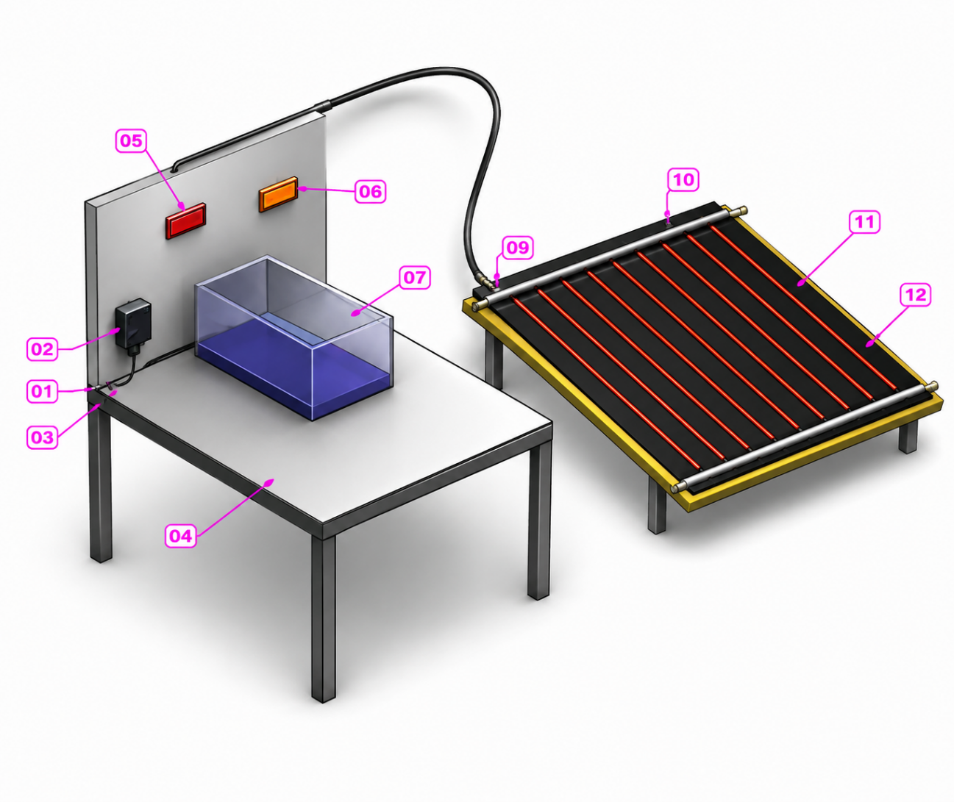
Figure 1 Experimental setup
(1) External Motor (2) Rotameter (3) Pipe (4) Table (5) Digital Temperature Indicator
(6) Thermocouple nob (7) Water Tank (8) Water Pipe Connected to Collector
(9) Inlet Value (10) Out Value (11) Absorber Plates (12) Copper Tubes
The schematic diagram of the solar flat collector along with the tank under consideration is shown in Figure-1, along with thermocouple locations. The flat plate collector is mounted inclined facing north south near to 100 liters tank. The experiment part consists of a 2.0 m² of flat plate collector which is having the nine numbers of riser tubes of outer diameter 1.27 cm made up from the copper with a length of 6 feet and a wall thickness of 1.2 cm. These riser tubes are consists of a copper heat collecting surfaces of thickness 0.20 mm. The wall temperature distribution of the riser pipe of collector plate was measured by fixing the thermocouples alternatively on riser pipes. In addition, the temperature of water flowing at inlet and outlet were fixing the thermos couples at entrance and exit. The flow of water from tank is controlled with help of ball valve cock which is having certain opening for maintain the flow of water entering into the collector plate. This ball valve cock having the marking for different flow rate.
3.1Specification of Flat Plate Collector
- Flat plate collector area =1.8 m²
- Two glass cover of 4mm thickness are provided with pads. The absorber is of the tube and sheet type.
- Number of tubes=9 Tubes
- Dimensions
- outer diameter = 10 mm
- Wall thickness=1 mm
- Long=2m (9 tubes of 10mm OD .Imm wall thickness and 2m long are Equi-spaced and 75 mm width corrugated black painted fins are embedded over the stube).

- The bottom and top headers outer diameter=25mm.
- Black paint is used as the coating on the absorber.
- 50mmthickmineralwoolinsulationisusedbelowtheabsorberandaroundtheedges.
The collector was tested with selective coating of commercial black paint is coated with mixing of Al₂O₃at different ratios (1%,1.5%and 2%) on absorber plate. And keeping collector at different tilt angles (30º,45º and 60º). Collector used in this work having dimensions of 1 x1.2 m and 2 mm thickness made with copper and 9 copper tubes with 10mm outside and 9 mm inside diameter are equally spaced on the collector. 60 mm diameter inlet and outlet headers are used and same was tested for different solar radiations and for different collector tilts. Water is used as working substance and the same was tested for different flow rates, different ratios of Al₂O₃ coating on three collectors and different tilts angles. thermos couples placed at different position on experimental setup. Experiment was conducted from 8.00 am to Performance Characteristics of Solar Thermal Flat Plate Collector with Different Selective Surface Coatings & Heat Transfer Fluids 5.00 pm on different days for a particular collector angle such as 30°, 45° and 60°. Top heat loss coefficient and collector efficiency was calculated with the data obtained.
3.2 Collectors with Nanocoating
collector C3 coated with 2g of Hybrid coating in commercial black paint.
Collector C2 coated with 1.5g of Hybrid coating in commercial blackpaint.

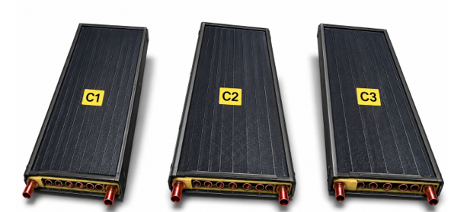
Collector C1 coated with 1g of Hybrid coating in commercial black paint.
Figure 2. Collectors coated with nano particulars with different ratios
3.3 Data Reduction
Thermal efficiency is given by the ratio of the heat output to the heat input. The thermal efficiency of the FPC (η%),
is evaluated by,
1. Heat gain by the cold fluid or useful energy:
Q_{c} = m_{c} C_{pc} ($ΔT$) watts
m_{c} = Mass flow of cold fluid kg/s
C_{pc}= Specific heat ofcold fluid = 4186.8 j/kg-k.
2. Heat Energy absorbed by the Collector:
Q_{a}= I×A watts
I = Intensity of solar radiation in w/m²
average solar power in India is 5kw
but I = 5 cos α (α= angle of tilt)
FPC Surface Area of Collector = 0.1×2=0.2 m²
Total collector area (A) = Surface area x number of tubes (n) A = 0.2 × 9 =1.8 m²
3. Efficiency of the unit:
(η%) = $\frac{Qc}{Qa}$ ×100
3.4 Expected Outcomes
It is recommended that AL₂O₃ nano particles is mixed in commercial black paint and coated on absorber plate and is selected for experimentation which will result in Both theoretical and experimental analysis may show enhancement in the performance of the collector.
- Absorbance capacity is expected to enhance by Nano Particles.
- Nano coatings will show a positive influence on the absorptivity and emissivity of absorber.
- Increase in the output temperature of the working fluid in the collector with the metallic coatings is expected.
- Nano coatings may allow in reduction of cost.
3.5 Process Parameters And Their Levels
Table 1. process parameters
Parameters | Levels
Parameters | -1 | 0 | 1
Flow rate(kg/hr) | 60 | 90 | 120
Angle (degrees) | 15 | 30 | 45
Concentration (grams) | 1 | 1.5 | 2

3.6 Design of Matrix
Table 2. Design of Matrix
 |  | Factor 1 | Factor 2 | Factor 3 | Response 1 | Response 2 | Response 3
Std | Run | A:flow rate | B:Angle | C:concentration | efficiency | Qa | Qc
 |  | kg/hr | degrees | Grams | %
4 | 1 | 120 | 45 | 1.5 | 54.9373 | 6.3639 | 3.20481
3 | 2 | 60 | 45 | 1.5 | 36.4462 | 6.3639 | 2.17444
2 | 3 | 120 | 15 | 1.5 | 48.5962 | 8.6931 | 3.93317
1 | 4 | 60 | 15 | 1.5 | 30.016 | 8.6931 | 2.46436
6 | 5 | 120 | 30 | 1 | 46.7249 | 7.79418 | 3.35048
16 | 6 | 90 | 30 | 1.5 | 43.2422 | 7.79418 | 3.15293
11 | 7 | 90 | 15 | 2 | 36.2694 | 8.6931 | 2.93549
5 | 8 | 60 | 30 | 1 | 29.7581 | 7.79418 | 2.17444
17 | 9 | 90 | 30 | 1.5 | 43.2422 | 7.79418 | 3.15293
15 | 10 | 90 | 30 | 1.5 | 43.2422 | 7.79418 | 3.15293
7 | 11 | 60 | 30 | 2 | 33.4778 | 7.79418 | 2.46436
14 | 12 | 90 | 30 | 1.5 | 43.2422 | 7.79418 | 3.15293
9 | 13 | 90 | 15 | 1 | 31.2667 | 8.6931 | 2.5006
8 | 14 | 120 | 30 | 2 | 57.9389 | 7.79418 | 4.22452
10 | 15 | 90 | 45 | 1 | 49.544 | 6.3639 | 2.93549
12 | 16 | 90 | 45 | 2 | 61.5029 | 6.3639 | 3.69654
13 | 17 | 90 | 30 | 1.5 | 43.2422 | 7.79418 | 3.15293

Design of Experts (DOE) is an efficient aid to plan experiments and to effectively analyze the data obtained. The experimental task begins at the selection of the input variables and the response (output) that is to be measured. BBD resulted in 17 runs of simulation arranged by three factors as listed in Table2, for copper absorbed plate with hybrid nano coating of (Al₂O₃ and Fe₃O₄).

4. RESULTS AND DISCUSSIONS

4.1 ANOVA for Quadratic model
Table 3. ANOVA Response 1 efficiency
Source | Sum of Squares | df | Mean Square | F-value | p-value
Model | 1335.70 | 9 | 148.41 | 8.59 | 0.0049 | Significant
A-flow rate | 770.27 | 1 | 770.27 | 44.56 | 0.0003
B-Angle | 395.96 | 1 | 395.96 | 22.91 | 0.0020
C-concentration | 127.16 | 1 | 127.16 | 7.36 | 0.0301
AB | 0.0020 | 1 | 0.0020 | 0.0001 | 0.9917
AC | 14.04 | 1 | 14.04 | 0.8123 | 0.3974
BC | 12.10 | 1 | 12.10 | 0.6998 | 0.4305
A² | 12.27 | 1 | 12.27 | 0.7098 | 0.4274
B² | 3.91 | 1 | 3.91 | 0.2262 | 0.6488
C² | 0.8144 | 1 | 0.8144 | 0.0471 | 0.8344
Residual | 121.00 | 7 | 17.29
Lack of Fit | 121.00 | 3 | 40.33
Pure Error | 0.0000 | 4 | 0.0000
Cor Total | 1456.70 | 16
Factor coding is Coded.
Sum of squares is Type III – Partial.

Table 4. Fit Statistics
Std. Dev. | 4.16 |  | R² | 0.9169
Mean | 43.10 |  | Adjusted R² | 0.8101
C.V. % | 9.65 |  | Predicted R² | -0.3291
 |  |  | Adeq Precision | 10.5669

A negative Predicted R² implies that the overall mean may be a better predictor of your response than the current model. In some cases, a higher order model may also predict better.
Adeq Precision measures the signal to noise ratio. A ratio greater than 4 is desirable. Your ratio of 10.567 indicates an adequate signal. This model can be used to navigate the design space.

Table 5. Coefficients in Terms of Coded Factors
Factor | Coefficient Estimate | df | Standard Error | 95% CI Low | 95% CI High | VIF
Intercept | 43.24 | 1 | 1.86 | 38.85 | 47.64
A-flow rate | 9.81 | 1 | 1.47 | 6.34 | 13.29 | 1.0000
B-Angle | 7.04 | 1 | 1.47 | 3.56 | 10.51 | 1.0000
C-concentration | 3.99 | 1 | 1.47 | 0.5110 | 7.46 | 1.0000
AB | -0.0223 | 1 | 2.08 | -4.94 | 4.89 | 1.0000
AC | 1.87 | 1 | 2.08 | -3.04 | 6.79 | 1.0000
BC | 1.74 | 1 | 2.08 | -3.18 | 6.65 | 1.0000
A² | -1.71 | 1 | 2.03 | -6.50 | 3.08 | 1.01
B² | 0.9638 | 1 | 2.03 | -3.83 | 5.75 | 1.01
C² | 0.4398 | 1 | 2.03 | -4.35 | 5.23 | 1.01

The coefficient estimate represents the expected change in response per unit change in factor value when all remaining factors are held constant. The intercept in an orthogonal design is the overall average response of all the runs. The coefficients are adjustments around that average based on the factor settings. When the factors are orthogonal the VIFs are 1; VIFs greater than 1 indicate multi-colinearity, the higher the VIF the more severe the correlation of factors. As a rough rule, VIFs less than 10 are tolerable response than the current model. In some cases, a higher order model may also predict better.
Adeq Precision measures the signal to noise ratio. A ratio greater than 4 is desirable. Your ratio of 10.567 indicates an adequate signal. This model can be used to navigate the design space.
The Model F-value of 8.59 implies the model is significant. There is only a 0.49% chance that an F-value this large could occur due to noise.
P-values less than 0.0500 indicate model terms are significant. In this case A, B, C are significant model terms. Values greater than 0.1000 indicate the model terms are not significant. If there are many insignificant model terms (not counting those required to support hierarchy), model reduction may improve your model.

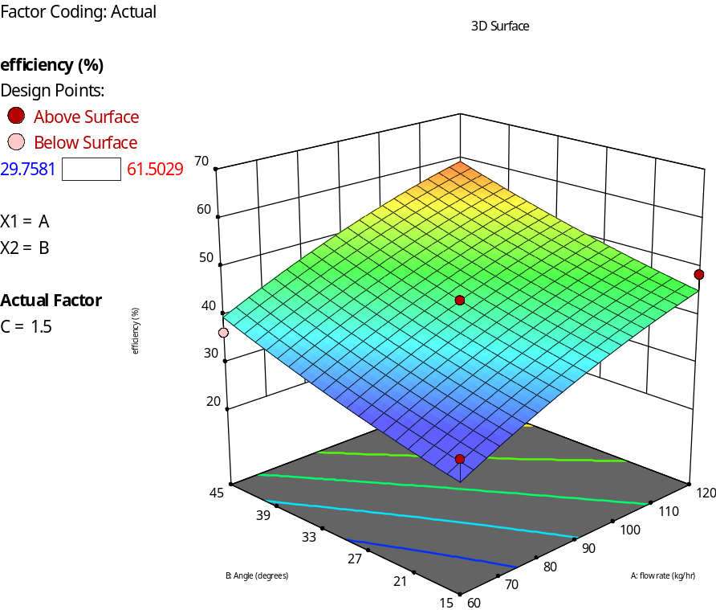
4.1(a) Effciency with respect to angle and flow rate
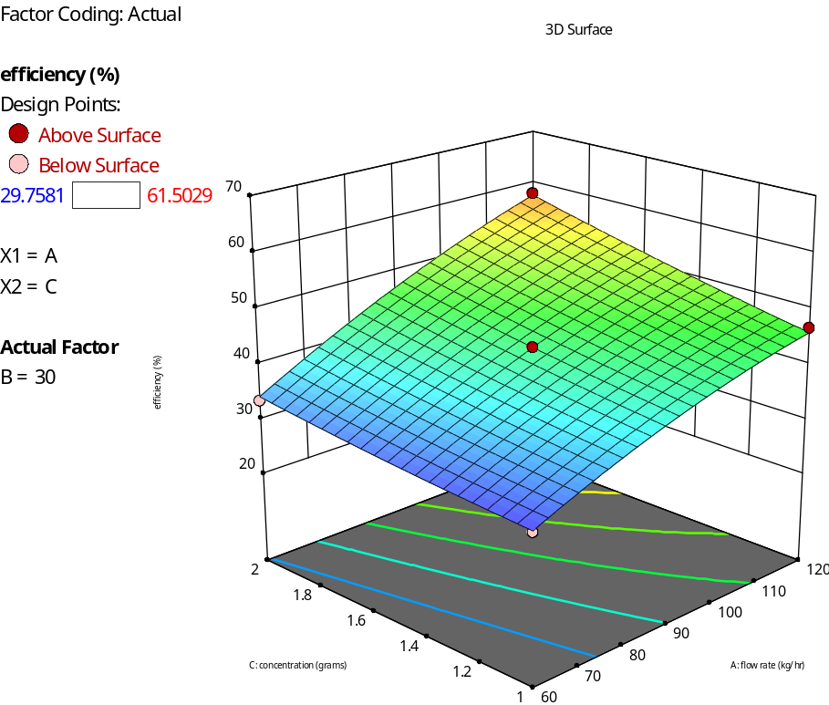
4.1(b) Efficiency with respect to concentration and flow rate
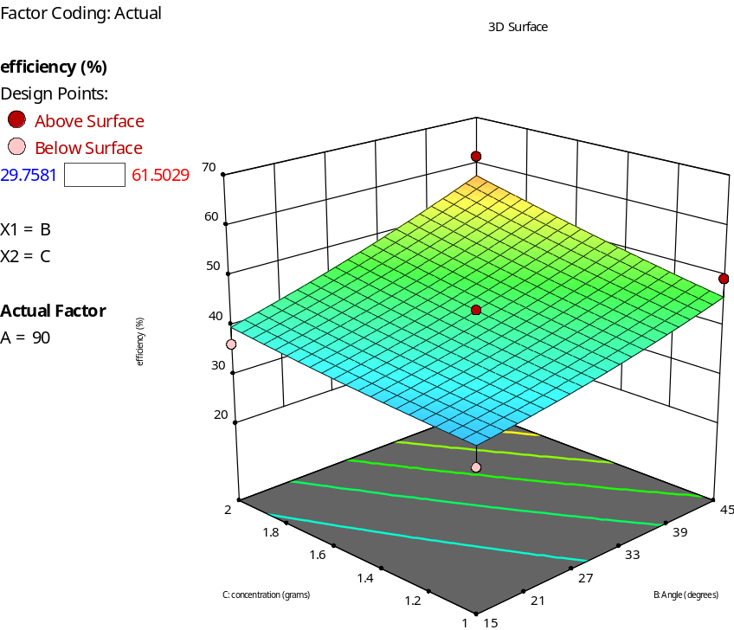
4.1(c) Efficiency with respect to concentration and angle

4.2 ANOVA for Quadratic model
Table 3. ANOVA Response 2 Qa
Source | Sum of Squares | df | Mean Square | F-value | p-value
Model | 11.15 | 9 | 1.24
A-flow rate | 0.0000 | 1 | 0.0000
B-Angle | 10.85 | 1 | 10.85
C-concentration | 0.0000 | 1 | 0.0000
AB | 0.0000 | 1 | 0.0000
AC | 0.0000 | 1 | 0.0000
BC | 0.0000 | 1 | 0.0000
A² | 0.0000 | 1 | 0.0000
B² | 0.2972 | 1 | 0.2972
C² | 0.0000 | 1 | 0.0000
Residual | 0.0000 | 7 | 0.0000
Lack of Fit | 0.0000 | 3 | 0.0000
Pure Error | 0.0000 | 4 | 0.0000
Cor Total | 11.15 | 16

Factor coding is Coded.
Sum of squares is Type III – Partial.

Table 4. Fit Statistics
Std. Dev. | 0.0000 |  | R² | 1.0000
Mean | 7.67 |  | Adjusted R² | 1.0000
C.V. % | 0.0000 |  | Predicted R² | 1.0000
 |  |  | Adeq Precision | NA⁽¹⁾

P-values less than 0.0500 indicate model terms are significant. In this case there are no significant model terms. Values greater than 0.1000 indicate the model terms are not significant. If there are many insignificant model terms (not counting those required to support hierarchy), model reduction may improve your model.

Table 5. Coefficients in Terms of Coded Factors
Factor | Coefficient Estimate | df | Standard Error | 95% CI Low | 95% CI High | VIF
Intercept | 7.79 | 1
A-flow rate | 0.0000 | 1 |  |  |  | 1.0000
B-Angle | -1.16 | 1 |  |  |  | 1.0000
C-concentration | 0.0000 | 1 |  |  |  | 1.0000
AB | 0.0000 | 1 |  |  |  | 1.0000
AC | 0.0000 | 1 |  |  |  | 1.0000
BC | 0.0000 | 1 |  |  |  | 1.0000
A² | 0.0000 | 1 |  |  |  | 1.01
B² | -0.2657 | 1 |  |  |  | 1.01
C² | 0.0000 | 1 |  |  |  | 1.01
The coefficient estimate represents the expected change in response per unit change in factor value when all remaining factors are held constant. The intercept in an orthogonal design is the overall average response of all the runs. The coefficients are adjustments around that average based on the factor settings. When the factors are orthogonal the VIFs are 1; VIFs greater than 1 indicate multi-colinearity, the higher the VIF the more severe the correlation of factors. As a rough rule, VIFs less than 10 are tolerable.
⁽¹⁾ Case(s) with leverage of 1.0000: Pred R² and PRESS statistic not defined.
The Predicted R² of 1.0000 is in reasonable agreement with the Adjusted R² of 1.0000; i.e. the difference is less than 0.2.

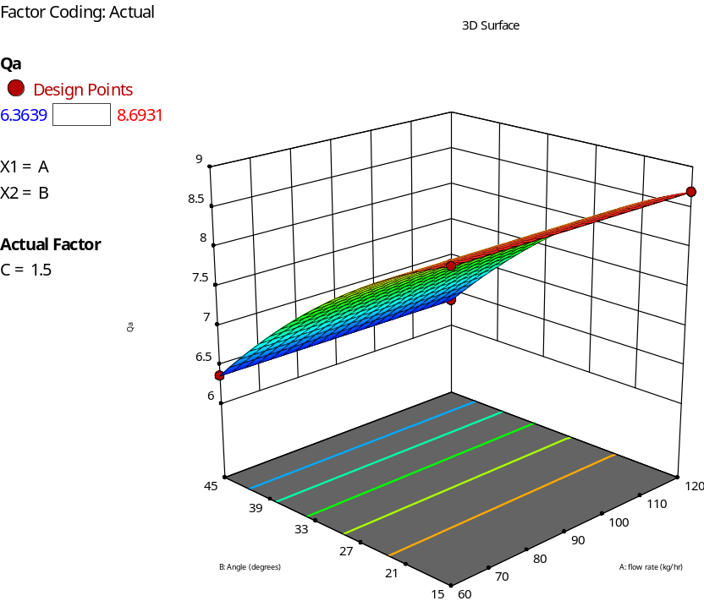
4.2(a) Response Qa with respect to angle and flow rate
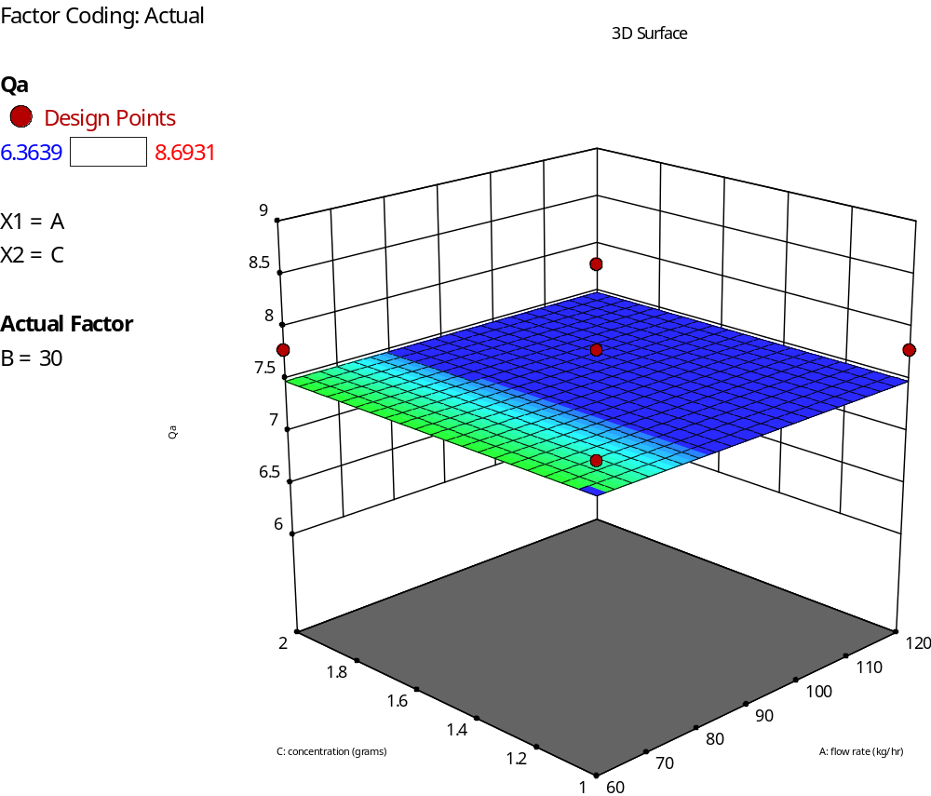
4.2(b) Response Qa with respect to concentration and flow rate
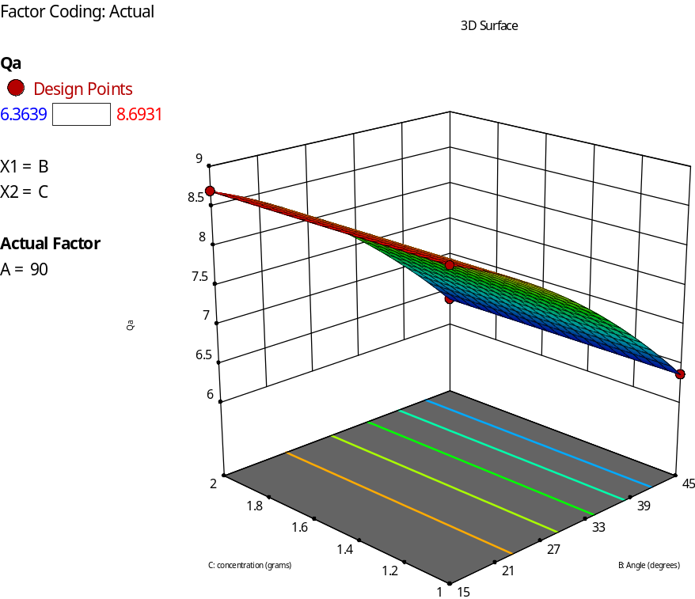

4.2 (c) Response Qa with respect to concentration and angle

4.3 ANOVA for Quadratic model
Table 6. Response 3 Qc
Source | Sum of Squares | df | Mean Square | F-value | p-value
Model | 4.66 | 9 | 0.5172 | 5.69 | 0.0160 | significant
A-flow rate | 3.69 | 1 | 3.69 | 40.59 | 0.0004
B-Angle | 0.0039 | 1 | 0.0039 | 0.0434 | 0.8410
C-concentration | 0.6961 | 1 | 0.6961 | 7.65 | 0.0278
AB | 0.0481 | 1 | 0.0481 | 0.5282 | 0.4909
AC | 0.0853 | 1 | 0.0853 | 0.9375 | 0.3652
BC | 0.0266 | 1 | 0.0266 | 0.2923 | 0.6055
A² | 0.0313 | 1 | 0.0313 | 0.3436 | 0.5762
B² | 0.0633 | 1 | 0.0633 | 0.6954 | 0.4319
C² | 0.0007 | 1 | 0.0007 | 0.0082 | 0.9303
Residual | 0.6369 | 7 | 0.0910
Lack of Fit | 0.6369 | 3 | 0.2123
Pure Error | 0.0000 | 4 | 0.0000
Cor Total | 5.29 | 16
Factor coding is Coded.
Sum of squares is Type III – Partial.

Table 7. Fit Statistics
Std. Dev. | 0.3016 |  | R² | 0.8797
Mean | 3.05 |  | Adjusted R² | 0.7249
C.V. % | 9.89 |  | Predicted R² | -0.9255
 |  |  | Adeq Precision | 8.8223
P-values less than 0.0500 indicate model terms are significant. In this case there are no significant model terms. Values greater than 0.1000 indicate the model terms are not significant. If there are many insignificant model terms (not counting those required to support hierarchy), model reduction may improve your model.

Table 8. Coefficients in Terms of Coded Factors
Factor | Coefficient Estimate | df | Standard Error | 95% CI Low | 95% CI High | VIF
Intercept | 3.15 | 1 | 0.1349 | 2.83 | 3.47
A-flow rate | 0.6794 | 1 | 0.1066 | 0.4273 | 0.9316 | 1.0000
B-Angle | 0.0222 | 1 | 0.1066 | -0.2300 | 0.2744 | 1.0000
C-concentration | 0.2950 | 1 | 0.1066 | 0.0428 | 0.5472 | 1.0000
AB | -0.1096 | 1 | 0.1508 | -0.4662 | 0.2470 | 1.0000
AC | 0.1460 | 1 | 0.1508 | -0.2106 | 0.5026 | 1.0000
BC | 0.0815 | 1 | 0.1508 | -0.2751 | 0.4382 | 1.0000
A² | -0.0862 | 1 | 0.1470 | -0.4337 | 0.2614 | 1.01
B² | -0.1226 | 1 | 0.1470 | -0.4702 | 0.2250 | 1.01
C² | -0.0133 | 1 | 0.1470 | -0.3609 | 0.3343 | 1.01
The coefficient estimate represents the expected change in response per unit change in factor value when all remaining factors are held constant. The intercept in an orthogonal design is the overall average response of all the runs. The coefficients are adjustments around that average based on the factor settings. When the factors are orthogonal the VIFs are 1; VIFs greater than 1 indicate multi-colinearity, the higher the VIF the more severe the correlation of factors. As a rough rule, VIFs less than 10 are tolerable.
Adeq Precision measures the signal to noise ratio. A ratio greater than 4 is desirable. Your ratio of 8.822 indicates an adequate signal. This model can be used to navigate the design space.
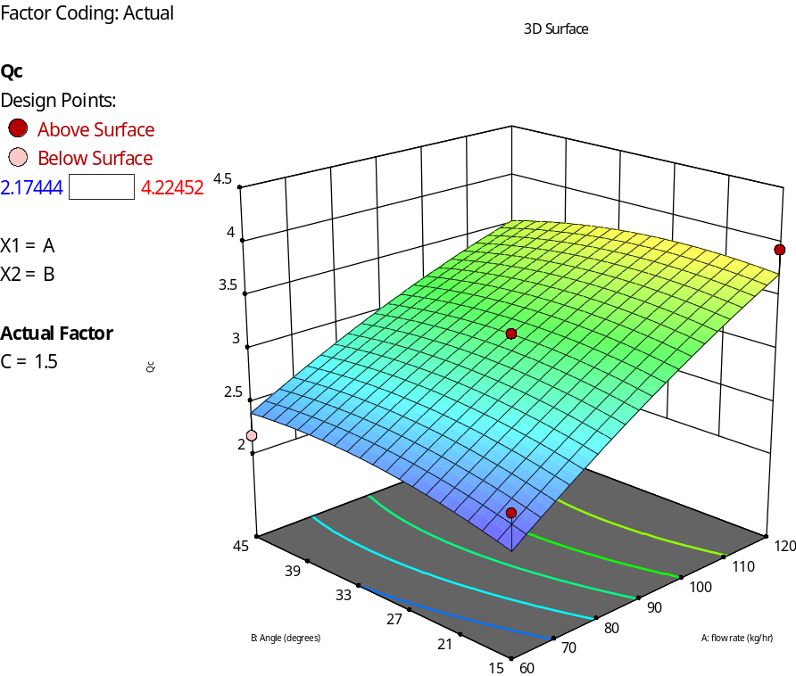
4.3(a) Response Qc wth respect to angle and flow rate
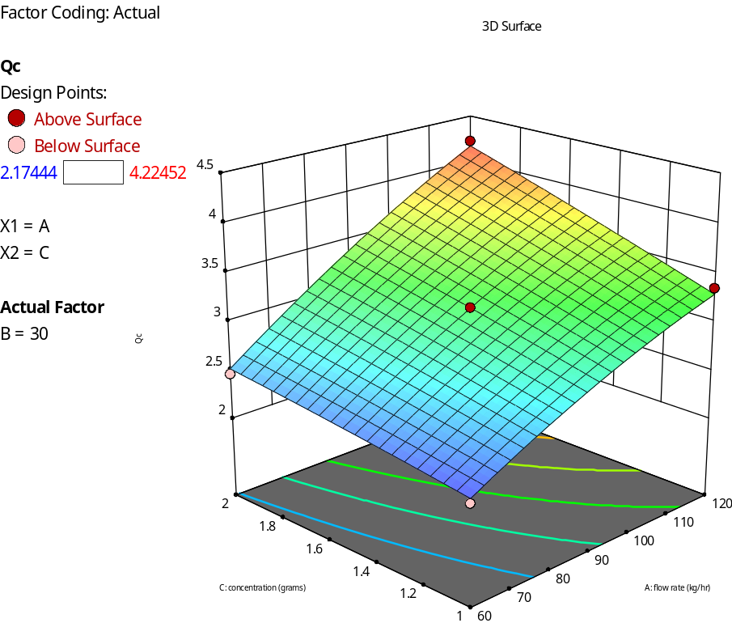
4.3(b) Response Qc with respect to concentration and flow rate
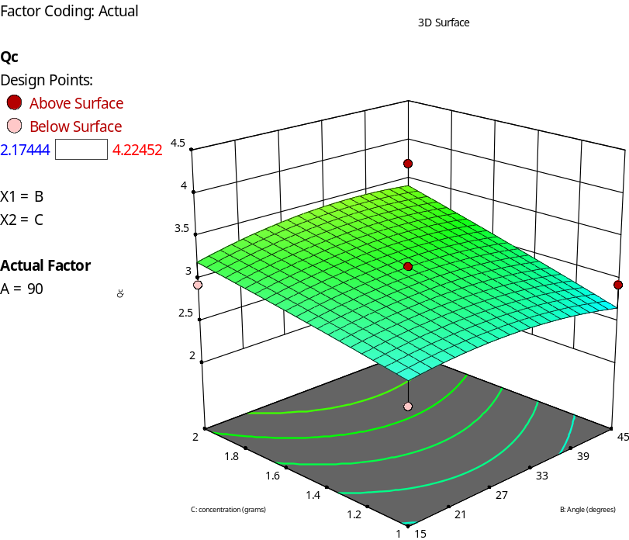
4.3(c) Response Qc with respect to angle and flow rate

Table 9. Factors
Factor | Name | Level | Low Level | High Level | Std. Dev. | Coding
A | flow rate | 90.00 | 60.00 | 120.00 | 0.0000 | Actual
B | Angle | 30.00 | 15.00 | 45.00 | 0.0000 | Actual
C | concentration | 1.50 | 1.0000 | 2.00 | 0.0000 | Actual

Two-sided Confidence = 95% Population = 99%

Table 10. Point Prediction
Solution 1 of 100 Response | Predicted Mean | Predicted Median | Observed | Std Dev | n | SE Pred | 95% PI low | Data Mean | 95% PI high
efficiency | 43.2422 | 43.2422 |  | 4.15765 | 1 | 4.55448 | 32.4726 |  | 54.0119
Qa* | 7.79418 | 7.79418 |  | 0 | 1 | 0 | 7.79418 |  | 7.79418
Qc | 3.15293 | 3.15293 |  | 0.301627 | 1 | 0.330416 | 2.37162 |  | 3.93424

Table 11.Confirmation
Analysis | Predicted Mean | Predicted Median | Observed | Std Dev | n | SE Pred | 95% PI low | Data Mean | 95% PI high
efficiency | 43.2422 | 43.2422 |  | 4.15765 | 1 | 4.55448 | 32.4726 |  | 54.0119
Qa* | 7.79418 | 7.79418 |  | 0 | 1 | 0 | 7.79418 |  | 7.79418
Qc | 3.15293 | 3.15293 |  | 0.301627 | 1 | 0.330416 | 2.37162 |  | 3.93424

4.4 Comparison Table:
comparing experimental results with optimised value
Table 9. Comparison Table
 | Parameters | Experiment value | RSM Optimised Value
Optimised Operating Parameters | Flow Rate | 90 | 90
Optimised Operating Parameters | Angle | 30 | 30
Optimised Operating Parameters | Concentration | 1.5 | 1.5
 | Efficiency | 43.24 | 43.24

5. CONCLUSION
This work proposes to use various nano coating techniques to improve absorptivity and reduce emissivity in a liquid flat plate solar water collector. It is a novel and cutting-edge approach in the field of solar systems that can be readily implemented at a reasonable cost. Potential research results are discussed, along with the setup requirements for the experiment and the coating techniques for the nanomaterials.
Using these Nano coatings on liquid flat plate collectors may, overall, greatly increase the effectiveness of the solar collector, according to the research done.
To assess the heat, increase of copper absorbers employing nano coating of hybrid coating (Al2O3+Fe₃o₄), experiments are carried out using BBD and assessed using Design of Experiments (DOE) software.
Comparing the SWHS to regular black paint from the store, it is evident that the new coating which contains hybrid coating (Al2O3+Fe₃o₄) particles collects thermal energy more effectively. Above results were compared with experimental and RSM.

References
[1] Solar District Heating, SDH. [Online]. Available: http://www.solar-district-heating.eu/SDH.
[2] Jianhua Fan, Louise Jivan Shah, and Simon Furbo, “Evaluation of Test Method for Solar Collector Efficiency,” Proceedings of Eurosun, Glasgow, UK, ISES-Europe, pp. 1-7, 2006. [Google Scholar] [Publisher Link]
[3] Jianhua Fan, Louise Jivan Shah, and Simon Furbo, “The Effect of the Volume Flow Rate on the Efficiency of a Solar Collector,” Proceedings of Eurosun, Glasgow, UK, ISES-Europe, 2006. [Google Scholar] [Publisher Link]
[4] G.F. Jones, and Noam Lior, “Flow Distribution in Manifolded Solar Collectors with Negligible Buoyancy Effects,” Solar Energy, vol. 52, no. 3, pp. 289-300, 1994. [CrossRef] [Google Scholar] [Publisher Link]
[5] Volker Weitbrecht, David Lehmann, and Andreas Richter, “Flow Distribution in Solar Collectors with Laminar Flow Conditions,” Solar Energy, vol. 73, no. 6, pp. 433-441, 2002. [CrossRef] [Google Scholar] [Publisher Link]
[6] X.A. Wang, and L.G. Wu, “Analysis and Performance of Flat-Plate Solar Collector Arrays,” Solar Energy, vol. 45, no. 2, pp. 71-78, 1990. [CrossRef] [Google Scholar] [Publisher Link]
[7] P.B. Rasmussen, and S. Svendsen, “Soleff Program for Calculation of the Efficiency of Solar Collectors,” User Guide and General Program Documentation, Thermal Insulation Laboratory, Technical University of Denmark, 1996. [Google Scholar]
[8] L.E. Hartley, J.A. Martinez-Lozano, M.P. Utrillas, F. Tena, R. Pedro, The optimiza tion of the angle of inclination of a solar collector to maximize the incident solar radiation, Renewable Energy 6 (1999) 180–298.
[9] M.T. Oladiran, Mean global radiation captured by inclined collectors at various surface azimuth angles in Nigeria, Applied Energy 52 (4) (1995) 317–330.
[10] M. Azmi, M. Yakup, A.Q. Malik, Optimum tilt angle and orientation for solar collector in Brunei Darussalam, Renewable Energy 24 (2001) 223–234.
[11]A. Shariah, M.A. Al-Akhras, I.A. Al-Omari, Optimizing the tilt angle of solar collectors, Renewable Energy 12 (2002) 587–598.
[12] R. Tang, T. Wu, Optimal tilt-angles for solar collectors used in China, Applied Energy 79 (2004) 239–248.
[13] X.Q. Zhai, Y.J. Dai, R.Z. Wang, Experimental investigation on air heating and natural ventilation of a solar air collector, Energy and Buildings 37 (2005) 373–381.
[14] K. Ulgen, Optimum tilt angle for solar collectors, Energy Sources A: Recovery, Utilization and Environmental Effects 28 (2006) 1171–1180.
[15] H.K. Elminir, A.E. Ghitas, F. El-Hussainy, R. Hamid, M.M. Beheary, K.M. Abdel Moneim, Optimum solar flat plate collector slope: case study for Helwan, Egypt, Energy Conversion and Management 47 (2006) 624–637.
[16] J. Mathur, S. Mathur, Anupma, Summer-performance of inclined roof solar chimney for natural ventilation, Energy and Buildings 38 (2006) 1156–1163.
[17]K.K. Gopinathan, N.B. Maliehe, M.I. Mpholo, Study on the intercepted insu lation as a function of slope and azimuth of the surface, Energy 32 (2007) 213–220.
[18] H. Gunerhan, A. Hepbasli, Determination of the optimum tilt angle of solar col lectors for building applications, Building and Environment 42 (2007) 779–783.
[19] K. Skeiker, Optimum tilt angle and orientation for solar collectors in Syria, Energy Conversion and Management 50 (2009) 2439–2448.
[20] Markndeyulu Vuggirala, N. Alagappan, CH V K N S N Moorthy, N.V.Narasimrao rao, "An Experimental Investigation of Solar Nano Fe3O4 Coating Exhibiting Higher Solar Absorption Efficiency using Box- Behnken Design," International Journal of Engineering Trends and Technology (IJETT), vol. 72, no. 9, pp. 184-196, 2024. Crossref, https://doi.org/10.14445/22315381/IJETT-V72I9P115.
[21] Markndeyulu Vuggirala, N. Alagappan, CH V.K.N.S.N. Moorthy, N.V. Narasimrao Rao, "Comparative Analysis of a Cost-Effective Solar Nano Al2O3 Coating Exhibiting Superior Solar Absorption Efficiency over Box-Behnken Design," International Journal of Mechanical Engineering, vol. 11, no. 7, pp. 119-131, 2024. Crossref, https://doi.org/10.14445/23488360/IJME-V11I7P110.
[22] Ahmad, M. J., & Tiwari, G. N. (2008). Optimization of tilt angle for solar collector to receive maximum radiation. The Open Renewable Energy Journal, 2, 19–24. https://doi.org/10.2174/1876387100902010019.
[23] Al-Rawahi, N. Z., Zurigat, Y. H., & Al-Azri, N. A. (2011). Prediction of hourly solar radiation on horizontal and inclined surfaces for Muscat/Oman. Journal of Engineering Research, 8(2), 19–31. https://doi.org/10.24200/tjer.vol8iss2pp19- 31 Badescu, V. (2002). 3D isotropic solar radiation model: Application to sunshine statistics. Theoretical and Applied Climatology, 72(3–4), 127–136. https://doi.org/10.1007/s00704-002-0683-9.
[24] Akachukwu, B. E. (2011). Prediction of optimum angle of inclination for flat plate solar collector in Zaria, Nigeria. Agricultural Engineering International: CIGR Journal, 13(4), 1–7.
[25] Idowu, S. O., Olarenwaju, M. O., & Ifedayo, I. O. (2013). Determination of optimum tilt angles for solar collectors in low-altitude tropical regions. International Journal of Energy and Environmental Engineering, 4(29), 1–10. https://doi.org/10.1186/2251-6832-4-29.

