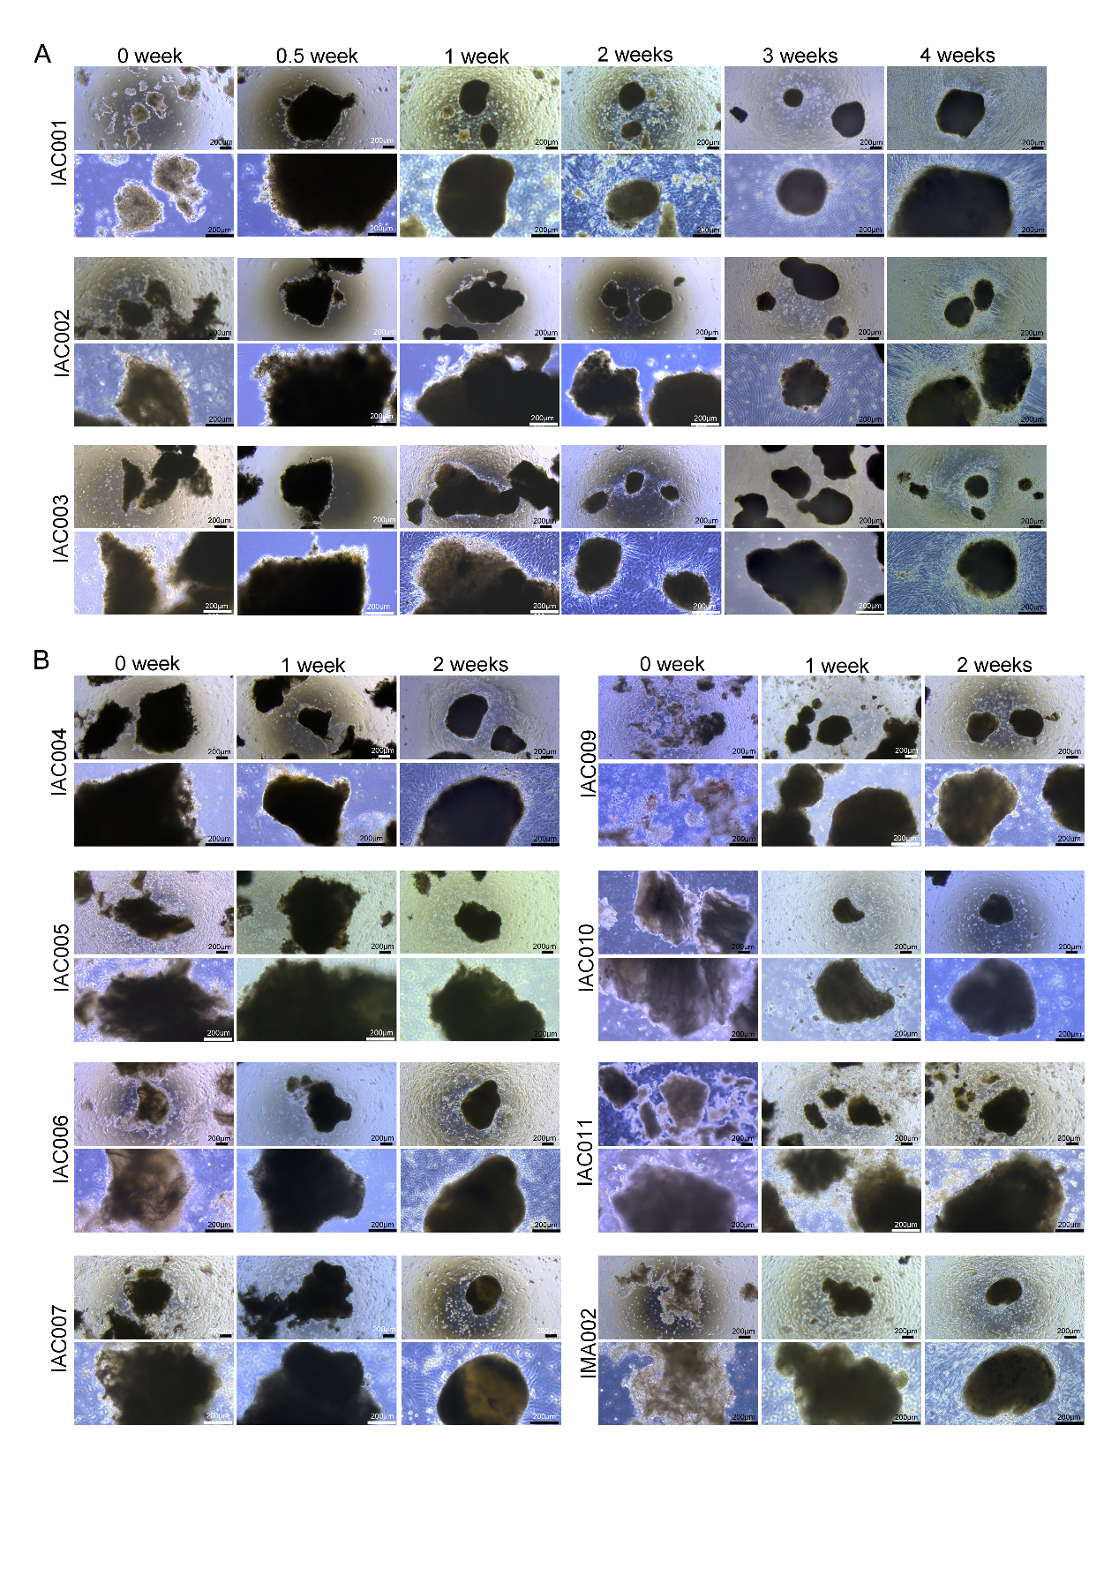

Figure S1. Tracking organoid morphogenesis by bright-field microscopy
(A) Bright-field microscopy of patient-derived invasive lung cancer organoids at 0, 0.5,1, 2, and 4 weeks, illustrating progressive morphological maturation from irregular tissue fragments to compact spherical structures. Scale bars, 200 μm.
(B) Bright-field microscopy of patient-derived invasive lung cancer organoids at 0, 1, and 2 weeks, illustrating progressive morphological maturation from irregular tissue fragments to compact spherical structures. Scale bars, 200μm.

