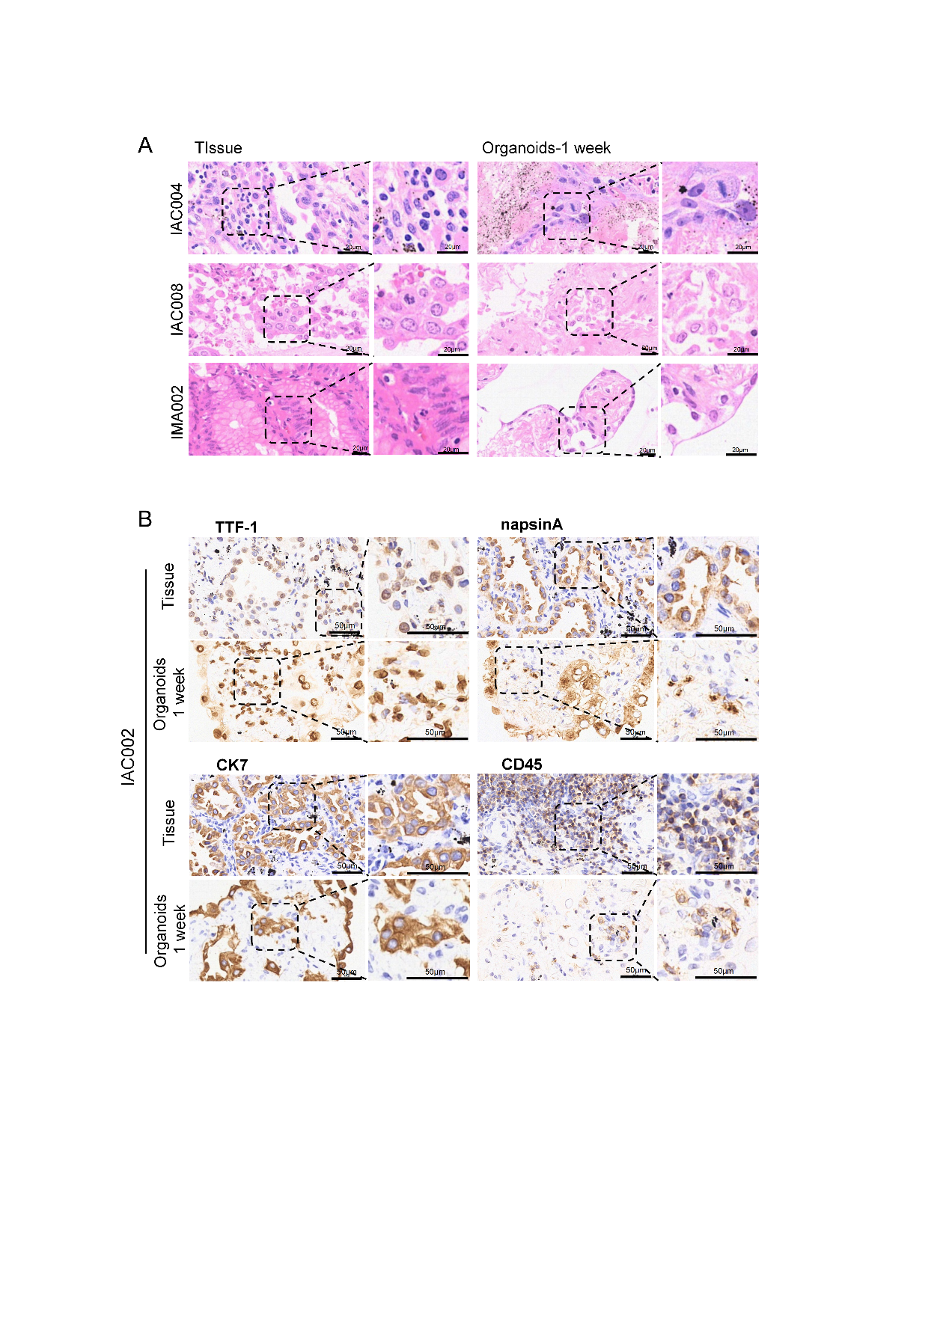

Figure S2. Histological and immunophenotypic fidelity of patient-derived organoids to primary tumors
(A) H&E staining of primary tumor tissues and matched organoids. Scale bars, 20μm.
(B) Comparison of IHC staining for canonical markers between IAC tissues and matched organoids.

