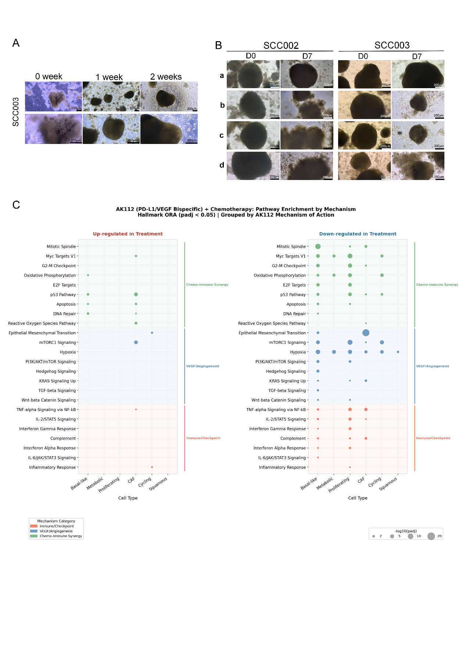

Figure S4. Establishment, drug treatment, and transcriptomic profiling of SCC organoids
(A) Bright-field microscopy of SCC003 organoids at 0, 1, and 2 weeks.
(B) Representative brightfield images of SCC002 and SCC003 organoids at baseline (D0) and 7 days post-treatment (D7) with treatments a, b, c, d.
(C) Hallmark pathway enrichment analysis of AK112 plus chemotherapy.

