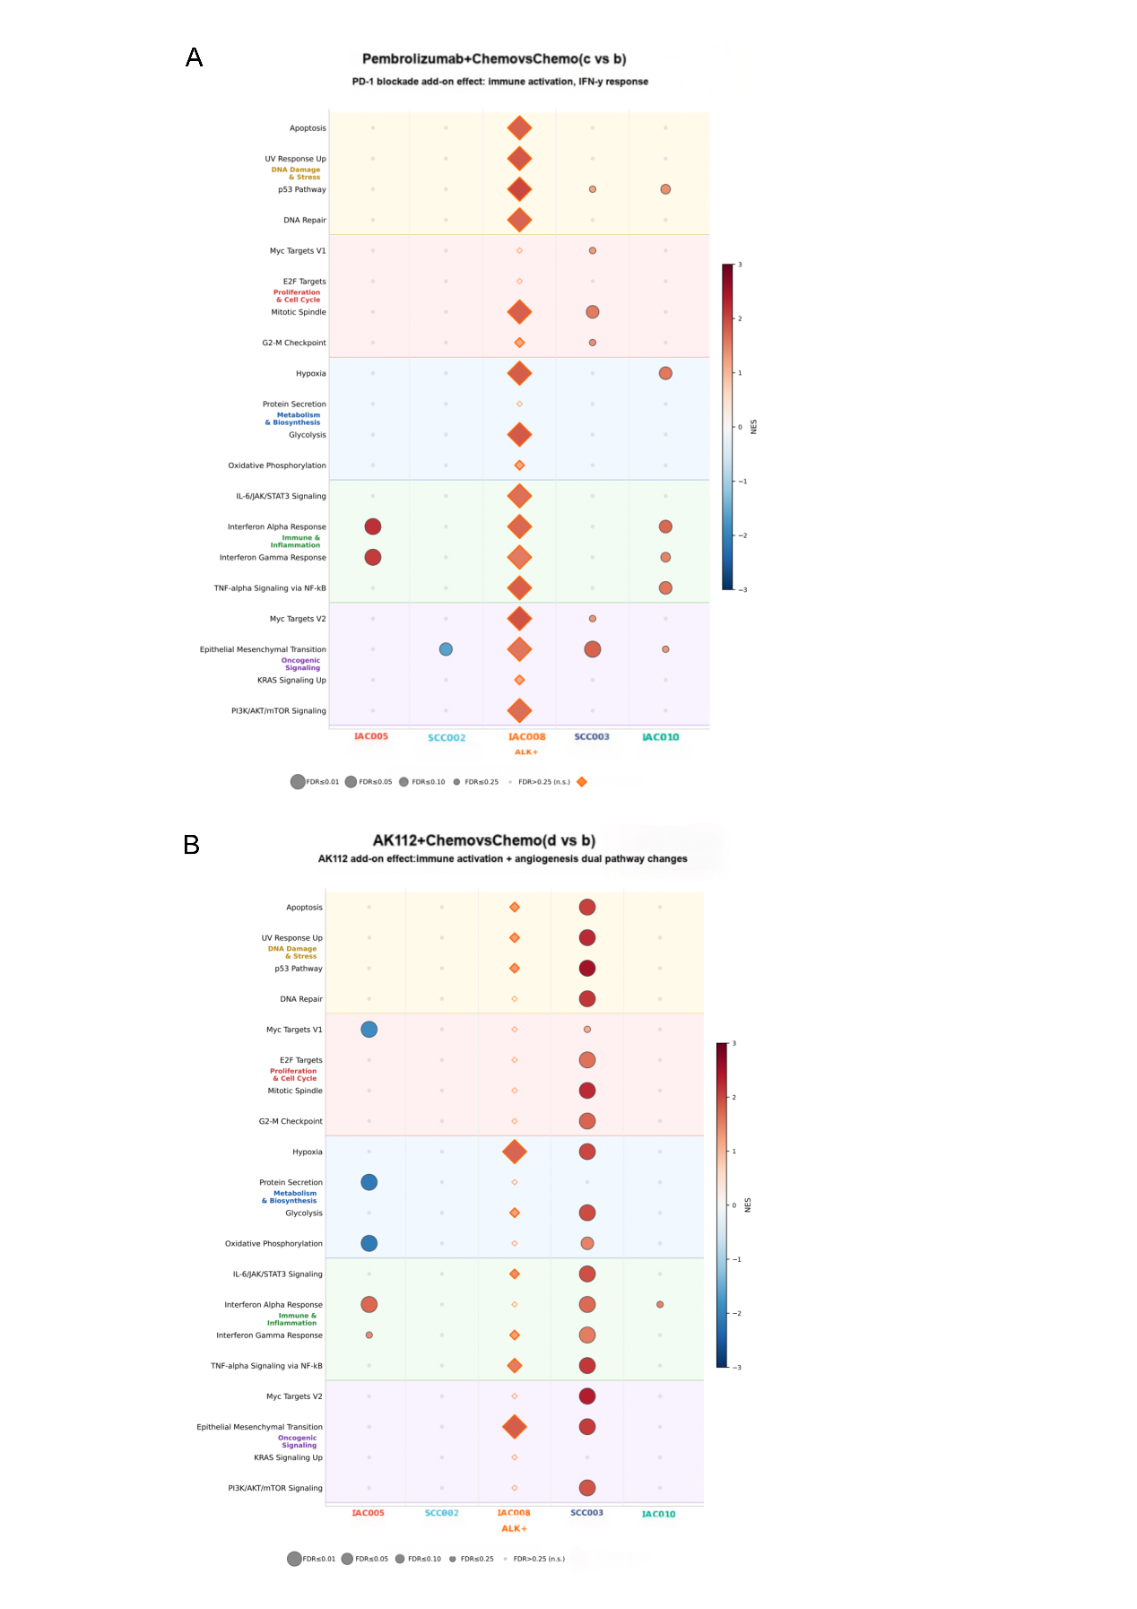

Figure S5. Comparative transcriptomic pathway modulation by PD-1 blockade vs. PD-1/VEGF dual blockade in lung adenocarcinoma and squamous cell carcinoma organoids
(A) GSEA dot plot for the Pembrolizumab+Chemo vs. Chemo comparison (c vs b), reflecting the net transcriptomic effect of PD-1 blockade on a chemotherapy background.
(B) GSEA dot plot comparing the AK112 plus chemotherapy vs. chemotherapy alone arms (d vs b), illustrating the distinct transcriptomic effects of AK112 on a chemotherapy background.

