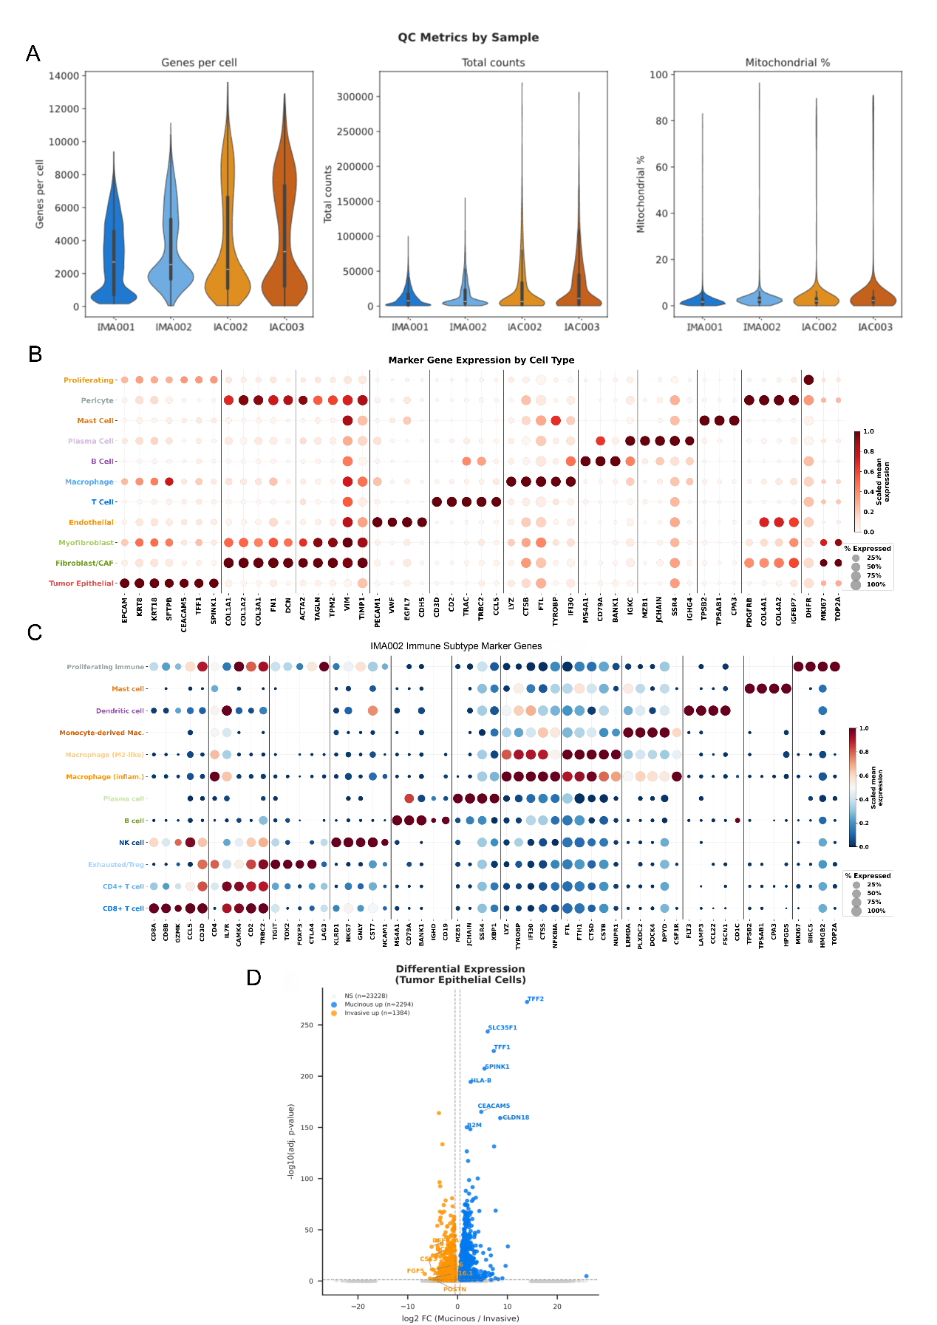

Figure S3. High-resolution Single-cell transcriptomic dissection of organoids heterogeneity
(A) Violin plots of key quality control metrics across the four organoid samples: genes detected per cell, total UMI counts, and mitochondrial gene percentage. Colored bars at the base indicate subtype (blue: mucinous; orange: invasive). Box plots within violins show median and interquartile range.
(B) Dot plot showing scaled mean expression (color intensity) and percentage of expressing cells (dot size) for canonical marker genes across the indicated cell populations, including tumor epithelial, fibroblast/CAF, endothelial, immune (T cell, macrophage, B cell, plasma cell, mast cell), and proliferating subsets.
(C) Dot plot of canonical marker gene expression across 12 IMA002 immune subtypes. Dot size represents the percentage of cells expressing each gene; dot color indicates scaled mean expression (blue–red diverging scale). Vertical lines demarcate gene groups per cell type.
(D) Differential gene expression in tumor epithelial cells between mucinous and invasive phenotypes.

