Supporting information
Facile fabrication of ternary MoO₂/Fe₂O₃/CNFs nanofibers with efficient electromagnetic wave absorption performance
Fuyao Chen ^{1,2*}, Zhehong Lu ³, Han Chen ¹, Dongqi Liu ^{4*}, Jingshuai Liu ¹, Xuzhen Zhang¹, Junmin Wan ¹, Yi Huang ¹, Juming Yao ^{1*}

1: School of Materials Science and Engineering, Zhejiang Sci-Tech University, Hangzhou, 311200, China.
2: Tongxiang Research Institute of Zhejiang Sci-Tech University, JiaXing, 314000, China.
3: College of Chemistry and Molecular Sciences, Henan University, Kaifeng, 475004, China.
4: Xi’an Modern Chemistry Research Institute, Xi’an 710065, China.
Corresponding author：Dr Fuyao Chen, Dr Dongqi Liu, Prof. Juming Yao.
Address: School of Materials Science and Engineering, Zhejiang Sci-Tech University, Hangzhou, 311200, China.
Xi'an Modern Chemistry Research Institute, Xi'an, 710000, China.
Tel./fax： Fuyao Chen, +86 17855371372; Dongqi Liu, +86 18691850785; Juming Yao, +86 13967196026
Email: 17855371372@163.com, ldqnjust1997@163.com, yaoj@zstu.edu.cn
Experimental Section
Figure S1. XPS survey spectrum of MoO₂/Fe₂O₃/CNF-2 composites.
Figure S2. SEM images of MoO₂/PVA (a), Fe₂O₃/PVA (b), MoO₂/Fe₂O₃/PVA-1 (c), and MoO₂/Fe₂O₃/PVA-3 (d).
Figure S3. SEM images of MoO₂/CNF (a), Fe₂O₃/CNF (b), MoO₂/Fe₂O₃/CNF-1 (c), and MoO₂/Fe₂O₃/CNF-3 (d).
Figure S4. Fiber diameter distribution of MoO₂/PVA (a), Fe₂O₃/PVA (b), MoO₂/Fe₂O₃/PVA-1 (c), MoO₂/Fe₂O₃/PVA-2 (d) and MoO₂/Fe₂O₃/PVA-3 (e).
Figure S5. Fiber diameter distribution of MoO₂/CNF (a), Fe₂O₃/CNF (b), MoO₂/Fe₂O₃/CNF-1 (c), MoO₂/Fe₂O₃/CNF-2 (d) and MoO₂/Fe₂O₃/CNF-3 (e).
Figure S6. N₂ adsorption-desorption isotherms and pore size distribution curves of MoO₂/Fe₂O₃/CNF-1 (a), MoO₂/Fe₂O₃/CNF-3 (b).
Figure S7. Relationship between RL and 1/4λ of MoO₂/CNF (a), Fe₂O₃/CNF (b), MoO₂/Fe₂O₃/CNF-1 (c), MoO₂/Fe₂O₃/CNF-2 (d) and MoO₂/Fe₂O₃/CNF-3 (e).
Figure S8. CST far-field simulation at 10.56 GHz of PEC coated with MoO₂/CNF (a), Fe₂O₃/CNF (b), MoO₂/Fe₂O₃/CNF-1 (c) and MoO₂/Fe₂O₃/CNF-3 (d)
Fig S1. XPS survey spectrum of MoO₂/Fe₂O₃/CNF-2 composites
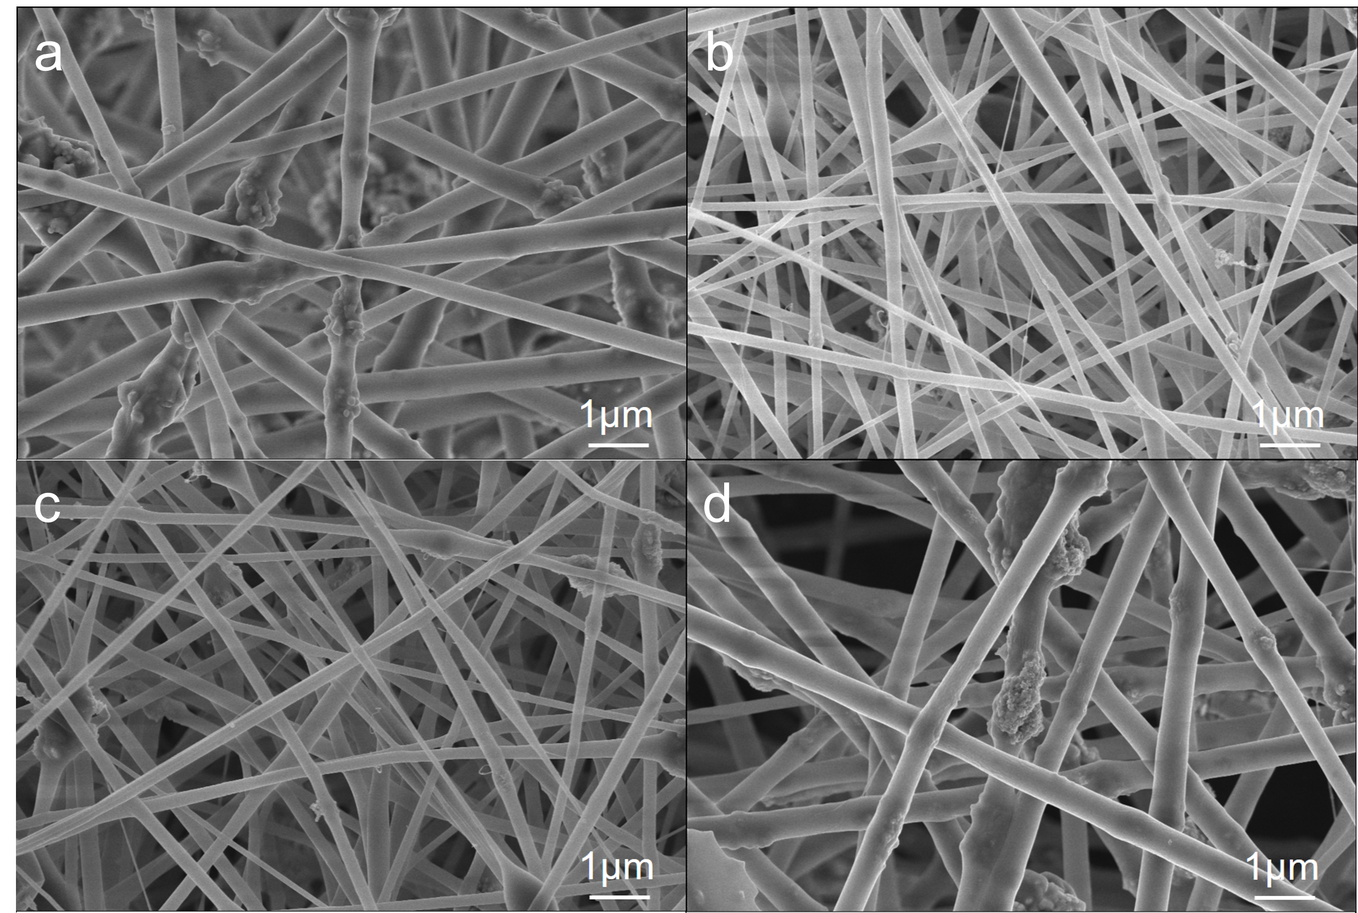
Fig S2. SEM images of MoO₂/PVA (a), Fe₂O₃/PVA (b), MoO₂/Fe₂O₃/PVA-1 (c), and MoO₂/Fe₂O₃/PVA-3 (d).
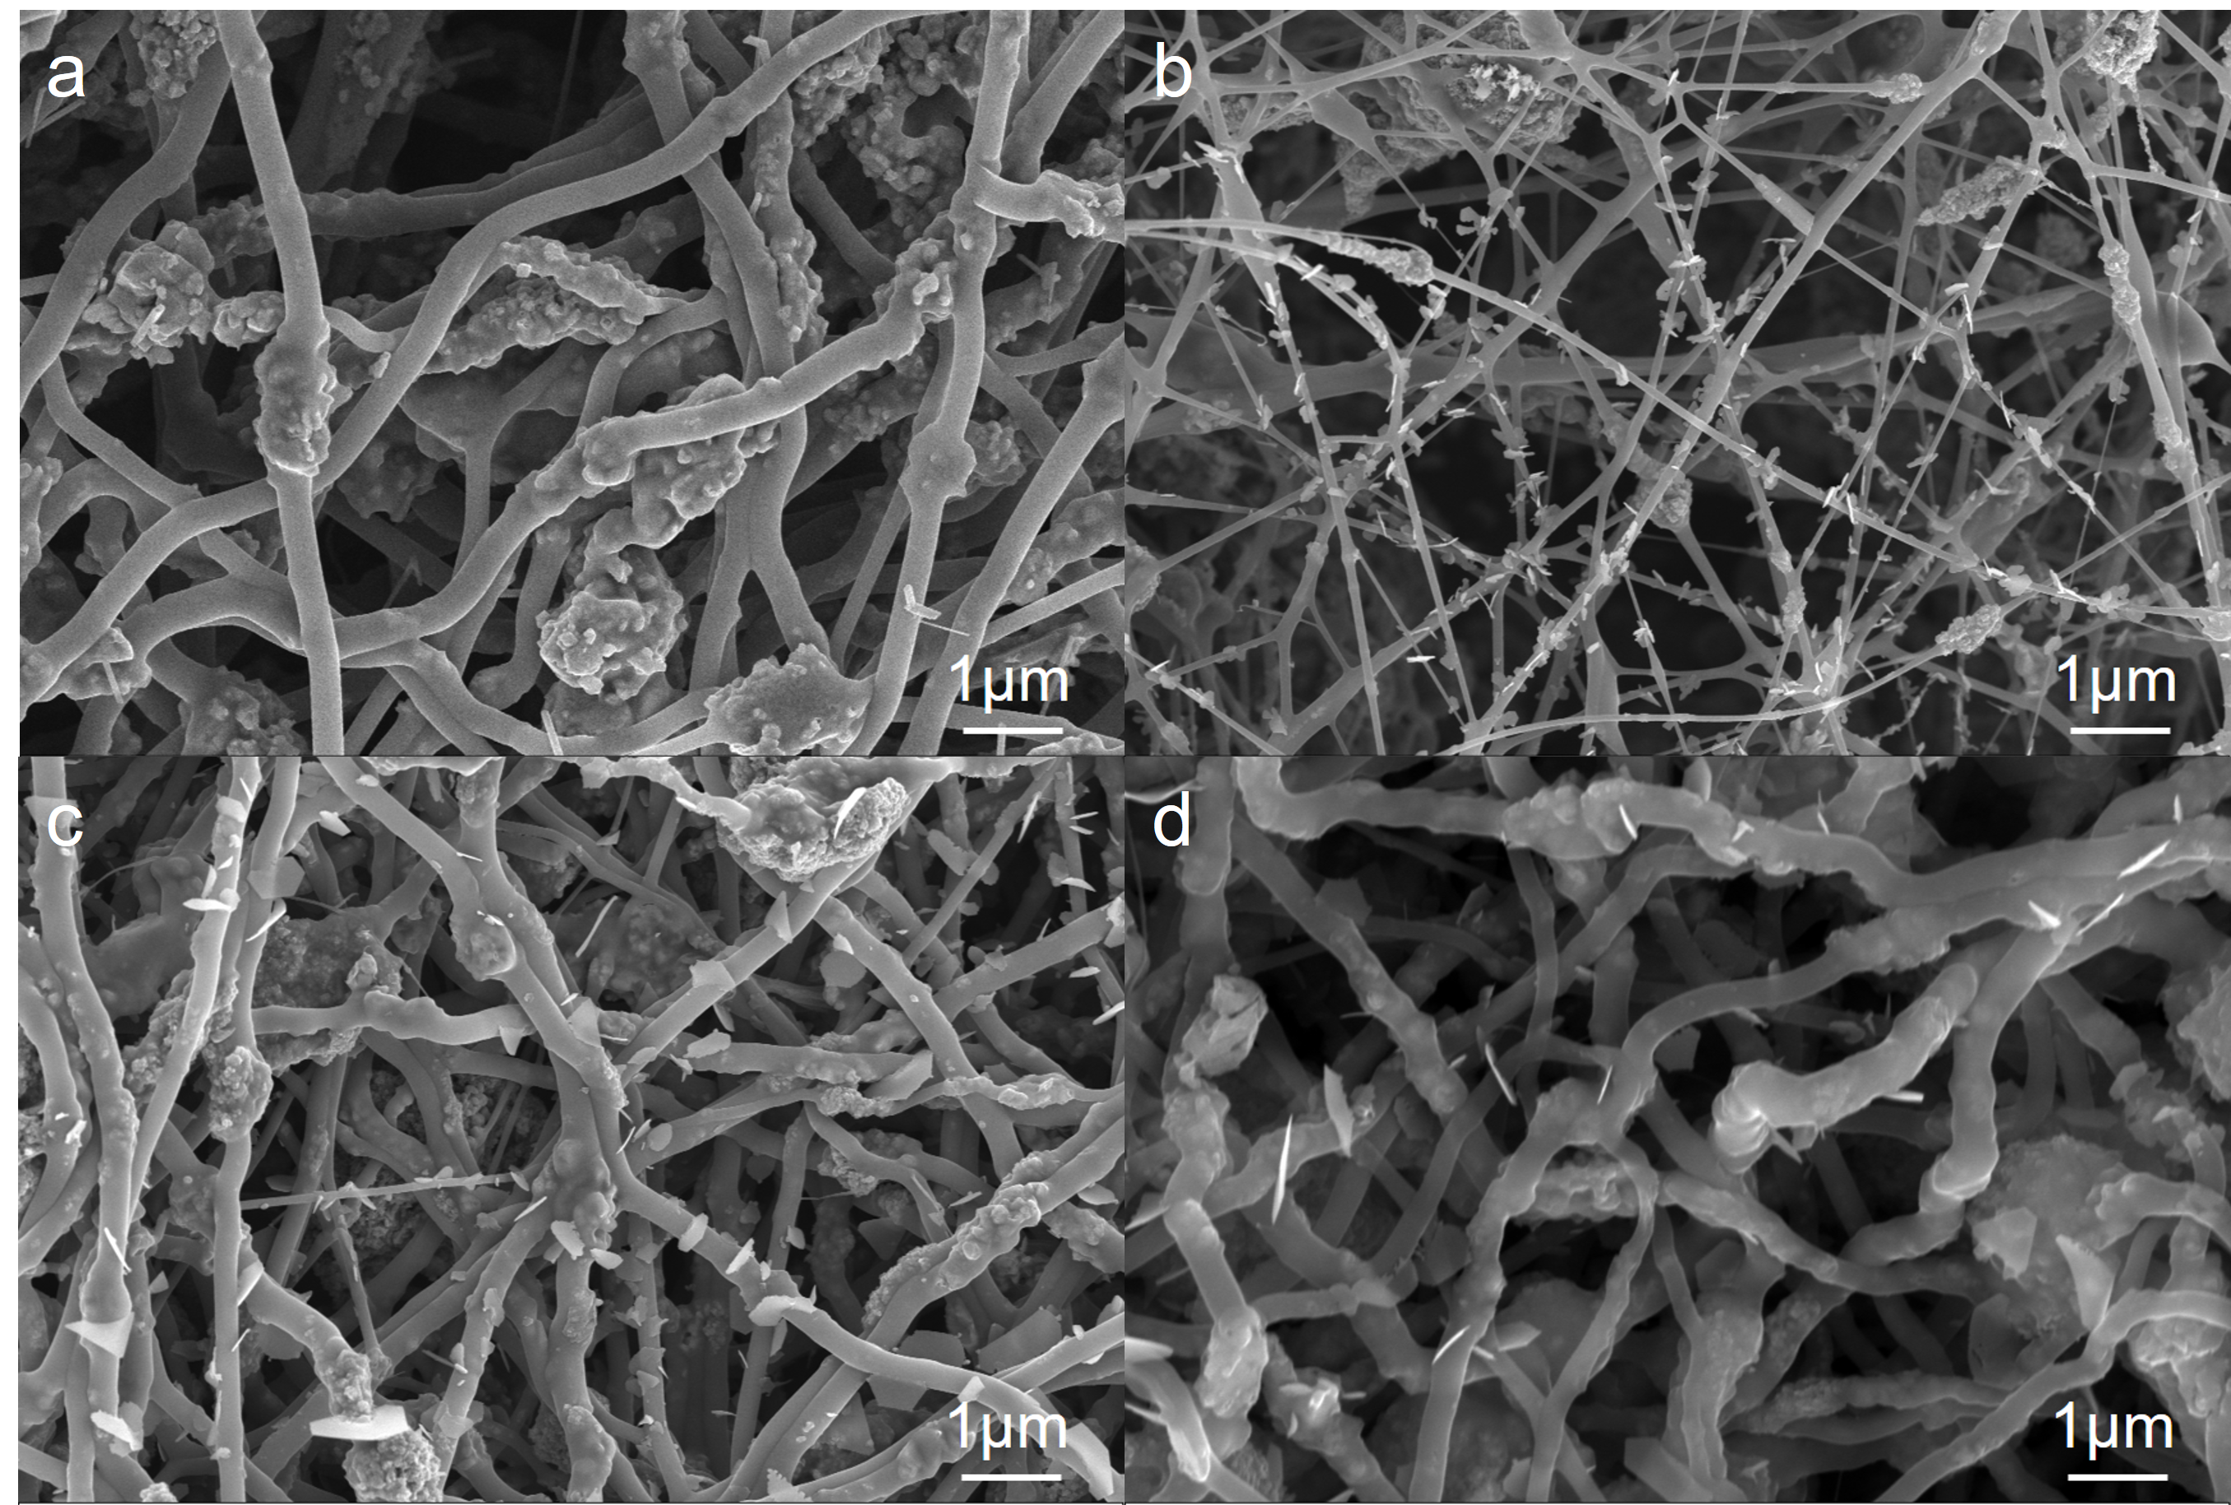
Fig S3. SEM images of MoO₂/CNF (a), Fe₂O₃/CNF (b), MoO₂/Fe₂O₃/CNF-1 (c), and MoO₂/Fe₂O₃/CNF-3 (d).
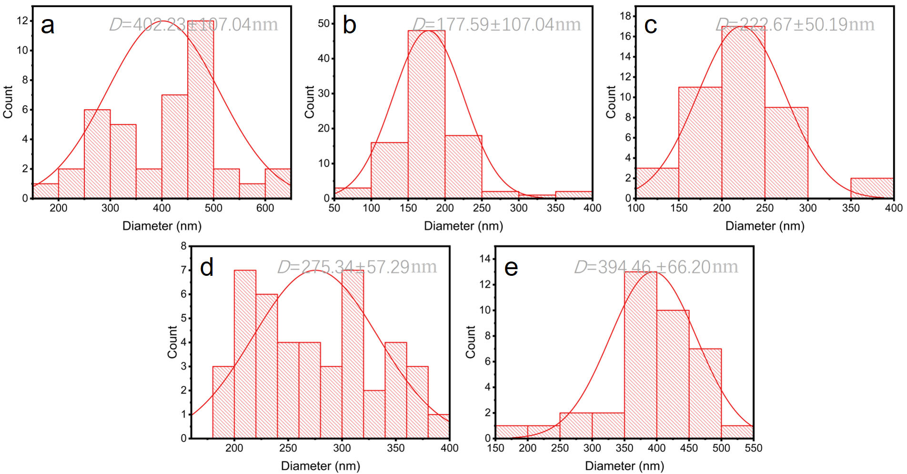
Fig S4. Fiber diameter distribution of MoO₂/PVA (a), Fe₂O₃/PVA(b), MoO₂/Fe₂O₃/PVA-1(c), MoO₂/Fe₂O₃/PVA-2(d) and MoO₂/Fe₂O₃/PVA-3(e).
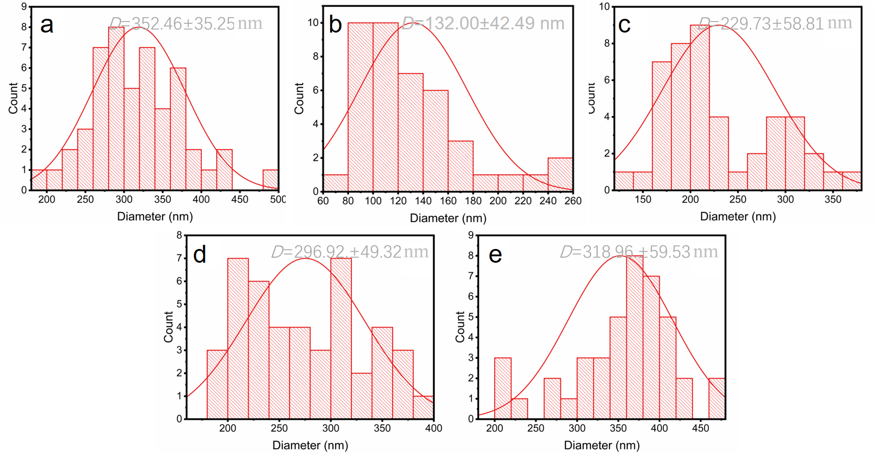
Fig S5. Fiber diameter distribution of MoO₂/CNF (a), Fe₂O₃/CNF (b), MoO₂/Fe₂O₃/CNF-1(c), MoO₂/Fe₂O₃/CNF-2(d) and MoO₂/Fe₂O₃/CNF-3 (e).
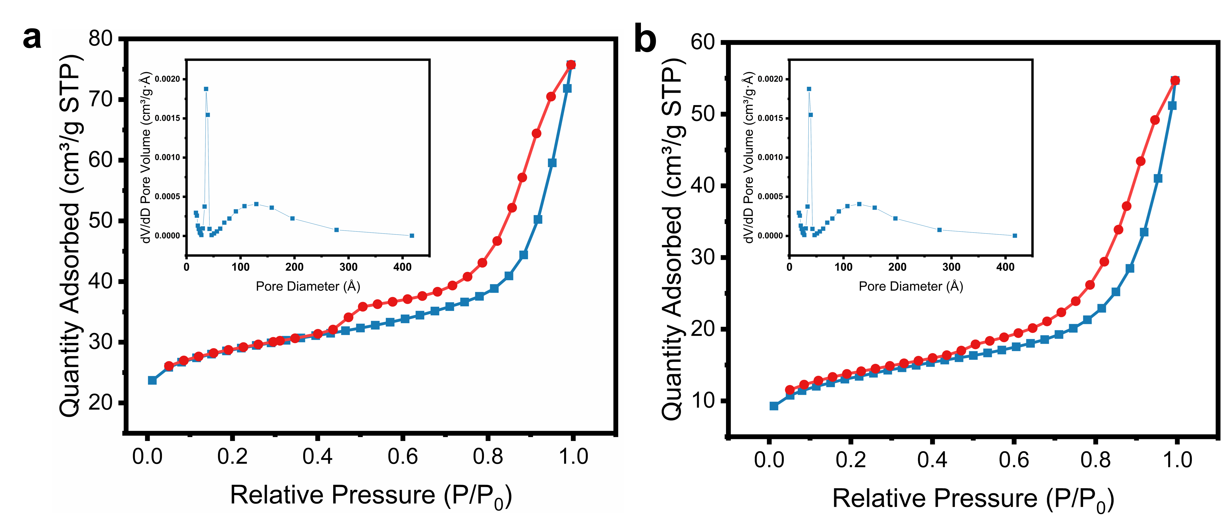
Fig S6. N₂ adsorption-desorption isotherms and pore size distribution curves of MoO₂/Fe₂O₃/CNF-1 (a), MoO₂/Fe₂O₃/CNF-3 (b)

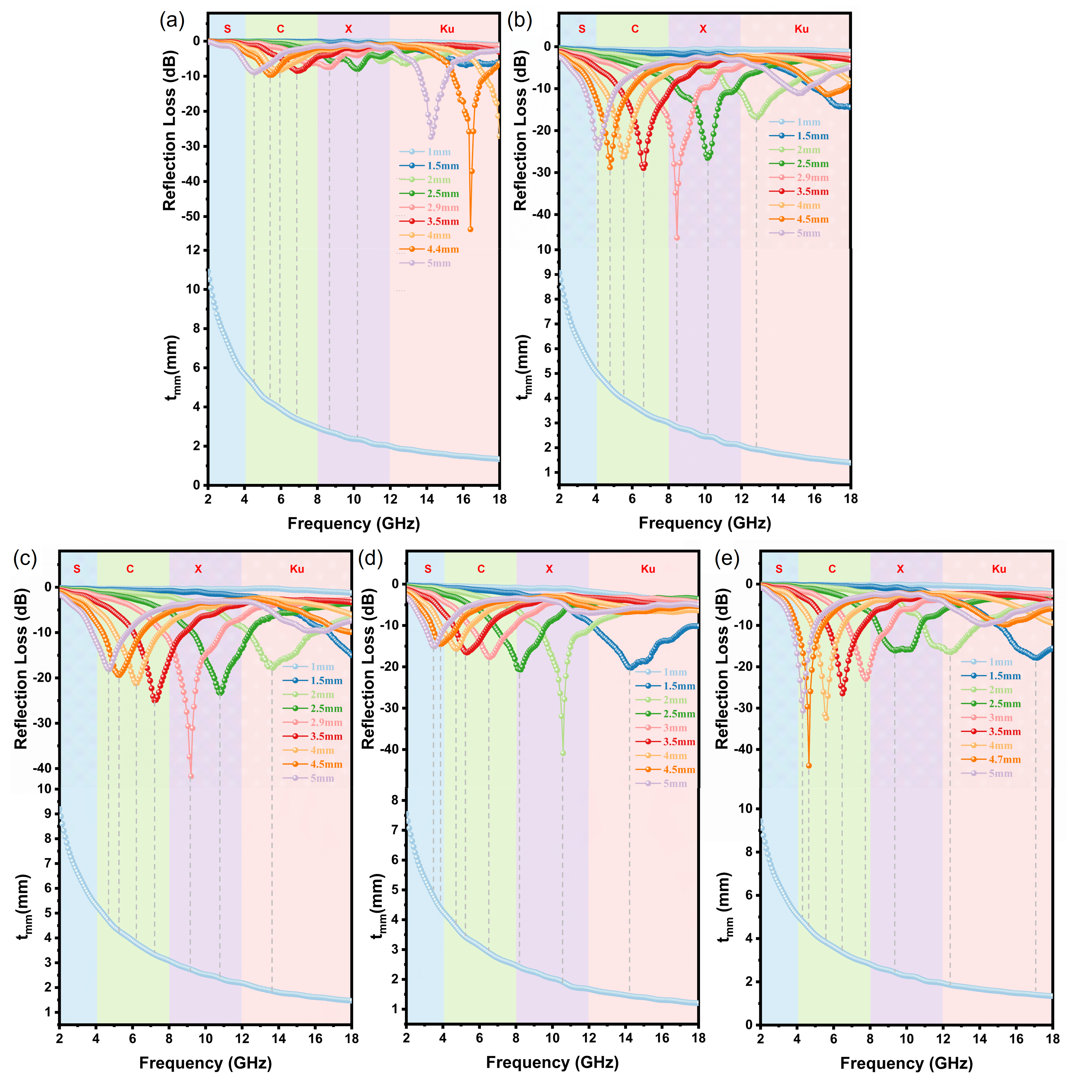
Fig S7 Relationship between RL and 1/4λ of MoO₂/CNF (a), Fe₂O₃/CNF (b), MoO₂/Fe₂O₃/CNF-1(c), MoO₂/Fe₂O₃/CNF-2(d) and MoO₂/Fe₂O₃/CNF-3(e).
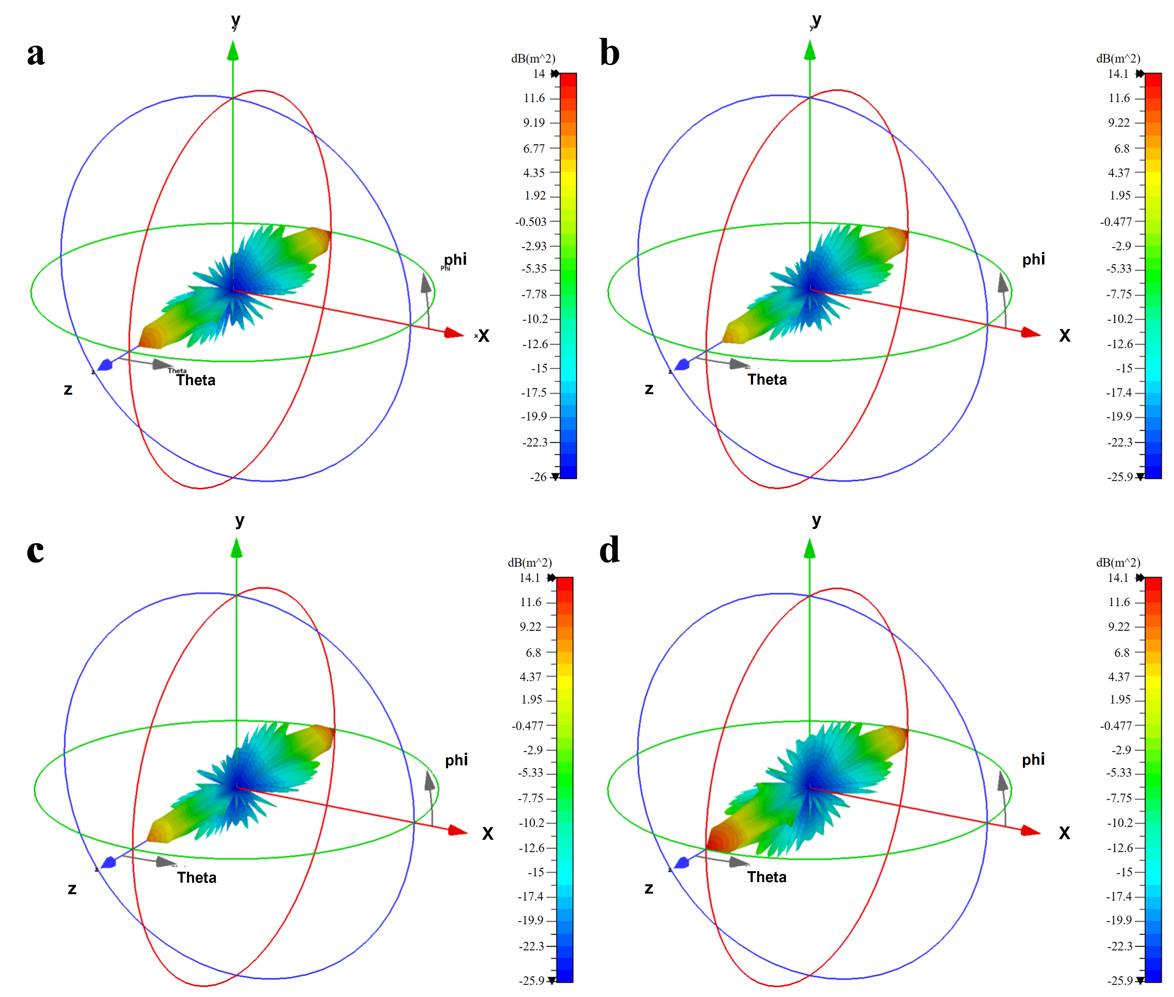
Fig. S8. CST far-field simulation at 10.56 GHz of PEC coated with MoO₂/CNF (a), Fe₂O₃/CNF (b), MoO₂/Fe₂O₃/CNF-1 (c) and MoO₂/Fe₂O₃/CNF-3 (d)

