Supplementary Information
Breast Cancer Evaluation and Targeted Investigational Therapy (BEAT-IT): A Pilot Prospective Tissue-Testing Study for Breast Cancer Clinical Trial Enrollment
Lim B, et al.

Contents
Supplementary Figure 1. Oncoprint of targeted-sequencing results across the study cohort
Supplementary Figure 2. Multivariate Cox proportional-hazards model of all-cause mortality
Supplementary Table 1. Therapeutic clinical trial protocols with participations
Supplementary Table 2. Genes covered by the targeted sequencing panels
Supplementary Table 3. Turnaround time by assay
Supplementary Table 4. Therapeutic protocols incorporating targeted agents directed at alterations identified in this study
Supplementary Table 5. Trial allocation rates in published precision oncology programs

Supplementary Figure 1. Oncoprint of targeted-sequencing results across the study cohort.
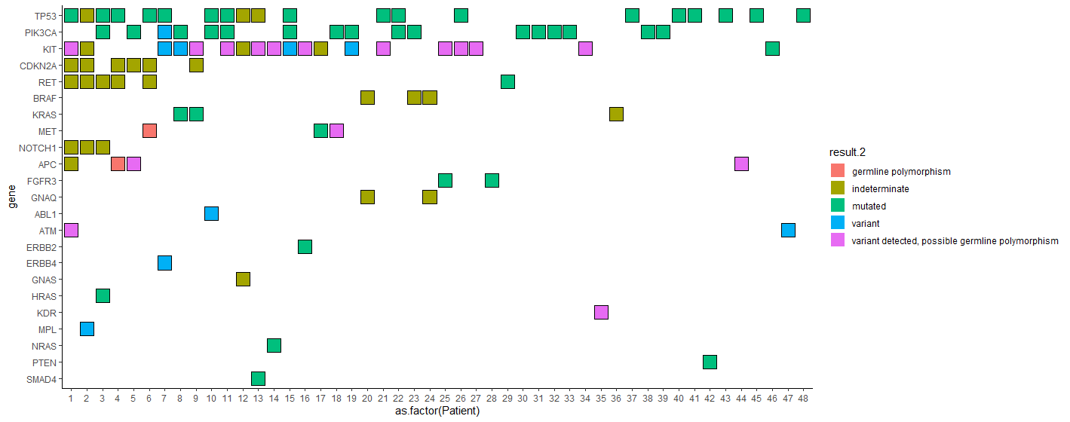
Rows list the 23 cancer-associated genes interrogated, and columns (x-axis) represent individual patients (numbered 1-48). Each colored square indicates the presence of a reportable alteration in the corresponding gene for a given patient, while empty cells denote no detected alteration. Variant classification is encoded by color (legend at right): red, germline polymorphism; olive, alteration of indeterminate significance; green, confirmed somatic mutation; blue, variant of uncertain significance (VUS); and magenta, variant detected and classified as a possible germline polymorphism. This oncoprint highlights recurrent alterations in genes such as TP53, PIK3CA, CDKN2A, and BRAF, and illustrates substantial inter-patient heterogeneity in the mutational landscape.

Supplementary Figure 2. Multivariate Cox proportional-hazards model identifying independent predictors of all-cause mortality.
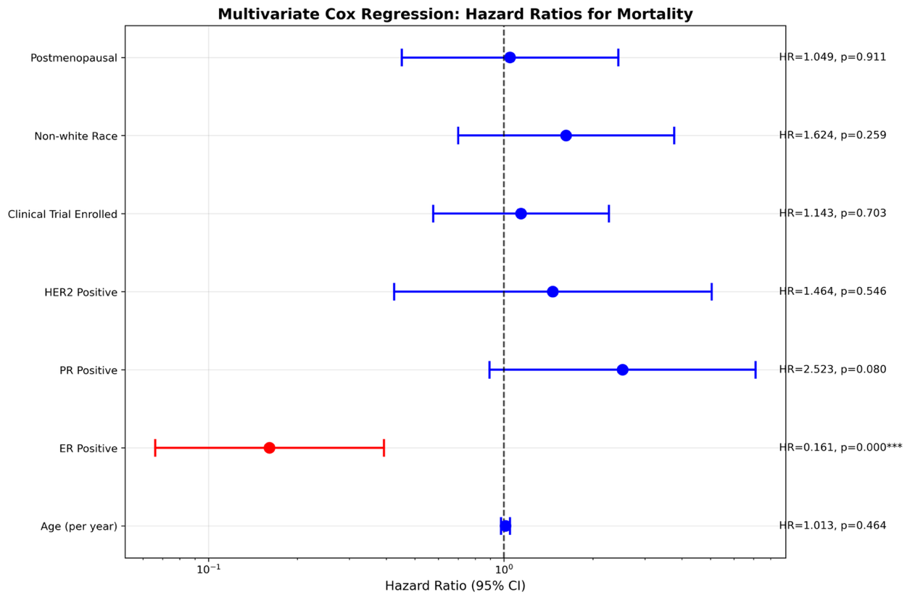
Dots represent adjusted hazard ratios (HRs) for each covariate derived from the multivariable Cox proportional hazards model, with horizontal bars indicating the corresponding 95% confidence intervals (CIs) displayed on a logarithmic scale. The dashed vertical line at HR = 1.0 denotes no association with mortality risk. Covariates that remained statistically significant after multivariable adjustment (p < 0.05) are shown in red, while non-significant covariates are shown in blue.
Estrogen receptor (ER) positivity was independently associated with a significantly reduced risk of death (HR 0.16), whereas age showed a modest, non-significant increase in mortality risk per year (HR 1.01). Postmenopausal status, non-White race, clinical trial enrollment, HER2 positivity, and progesterone receptor (PR) positivity were not significantly associated with overall survival after adjustment.

Supplemental Table 1. Number of patients who were enrolled into the clinical trials based on available genomic, proteomic information
 | N | %
Completed biopsies | 99 | 77%
Patients on clinical trial(s) post biopsy | 35 (50 clinical trial participations) | 35%

Supplemental Table 2. The list of NGS panel that was used for the Oncoprint.
Gene | Sequenom | CMS46 | CMS50
ABL1 | N | Y | Y
AKT1 | Y | Y | Y
ALK | N | Y | Y
APC | N | Y | Y
ATM | N | Y | Y
BRAF | Y | Y | Y
CDH1 | N | Y | Y
CDKN2A | N | Y | Y
CSF1R | N | Y | Y
CTNNB1 | N | Y | Y
EGFR | N | Y | Y
ERBB2 | N | Y | Y
ERBB4 | N | Y | Y
EZH2 | N | N | Y
FBXW7 | N | Y | Y
FGFR1 | N | Y | Y
FGFR2 | N | Y | Y
FGFR3 | N | Y | Y
FLT3 | N | Y | Y
GNA11 | N | N | Y
GNAQ | Y | N | Y
GNAS | Y | Y | Y
HNF1A | N | Y | Y
HRAS | N | Y | Y
IDH1 | Y | Y | Y
IDH2 | Y | N | Y
JAK2 | N | Y | Y
JAK3 | N | Y | Y
KDR | N | Y | Y
KIT | N | Y | Y
KRAS | Y | Y | Y
MET | Y | Y | Y
MLH1 | N | Y | Y
MPL | N | Y | Y
NOTCH1 | N | Y | Y
NPM1 | N | Y | Y
NRAS | Y | Y | Y
PDGFRA | N | Y | Y
PIK3CA | Y | Y | Y
PTEN | N | Y | Y
PTPN11 | N | Y | Y
RB1 | N | Y | Y
RET | Y | Y | Y
SMAD4 | N | Y | Y
SMARCB1 | N | Y | Y
SMO | N | Y | Y
SRC | N | Y | Y
STK11 | N | Y | Y
TP53 | N | Y | Y
VHL | N | Y | Y
Total genes | 11 | 46 | 50
Y, gene included in panel; N, gene not included.

Supplemental table 3. Turnaround time from biopsy to the result reported to physician
 | Days Average (Range)
Immunohistochemistry | 20 (2-121)
Cytogenetics | 20 (5-99)
Molecular Diagnostics | 21 (8-101)

Supplemental Table 4. The metrics of our measurements and comparison to other reported benchmarks
Metric | Result |  | Benchmark comparison
Biopsy adequacy | 77 % (98/128) yielded ≥2 viable cores | NCI‑MATCH 87 %* (DNA only); SAFIR‑2 85 %*
Turn‑around time (TAT) | Median 20 days (IQR 16–24) from tissue receipt to molecular‑tumor‑board recommendation | NCI‑MATCH median 25 days*
Patient‑level match rate | 27 % (35/128) received a biologically matched regimen | Similar to MSK‑IMPACT 25 %†, higher than SAFIR‑2 19 %*
Safety | 0 hospitalizations; 1 grade‑1 pneumothorax resolved with overnight observation | Comparable to literature for image‑guided biopsies

