Supplementary Figures
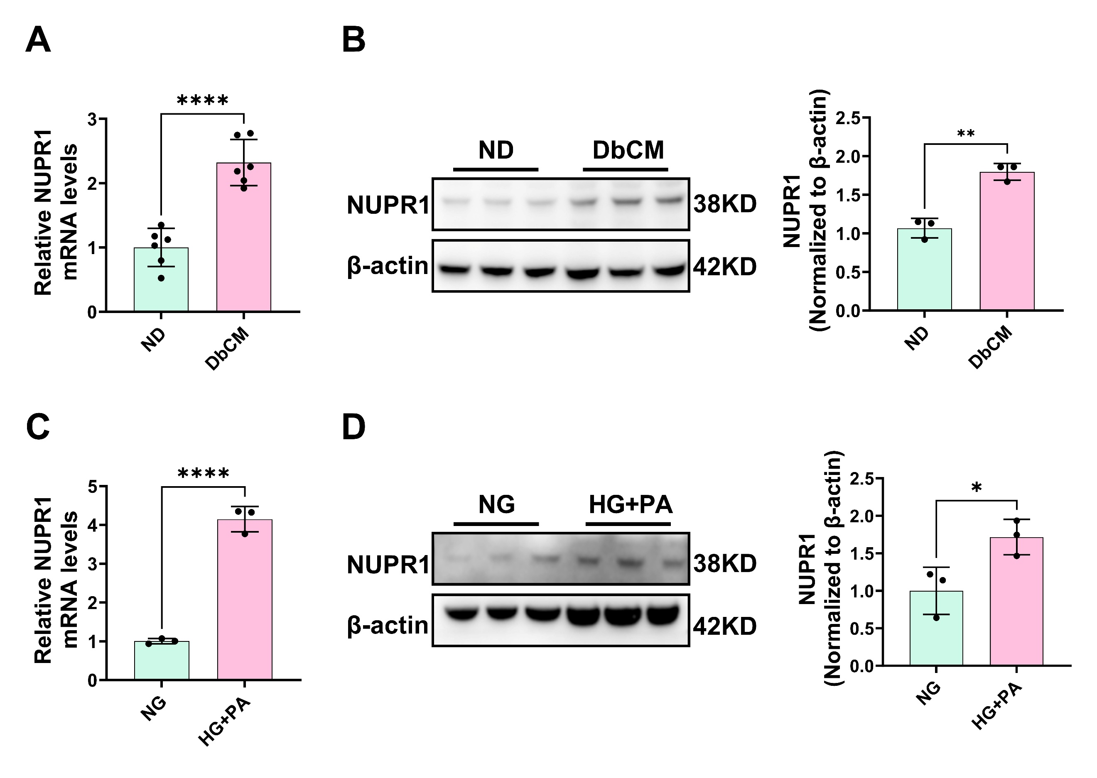

Figure S1. NUPR1 is elevated in DbCM models.
A-B. In cardiac tissue of HFD/STZ–induced DbCM mice, qRT-PCR and western blot analyzed the mRNA and protein expression of NUPR1 (n=3 for western blot and n=6 for qRT-PCR per group). C-D. Primary cardiomyocytes were cultured with HG+PA for 48h, qRT-PCR and western blot analyzed the mRNA and protein expression of NUPR1 (n=3 independent experiments). *P<0.05, **P<0.01, ***P<0.001, and ****P<0.0001 were considered statistically significant.

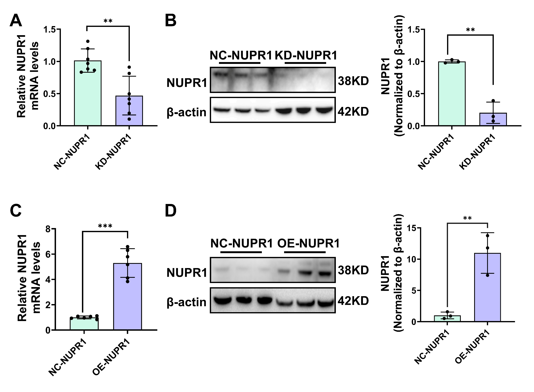

Figure S2. NUPR1 overexpression and knockdown efficiency were validated by qRT-PCR and western blot.
A-B. In cardiac tissue of C57BL/6 mice injected with AAV9-shNupr1 through tail vein for 4 weeks, qRT-PCR and western blot analyzed the mRNA and protein expression of NUPR1 (n=3 for western blot and n=7 for qRT-PCR per group). C-D. In cardiac tissue of C57BL/6 mice injected with AAV9-OE-NUPR1 through tail vein for 4 weeks, qRT-PCR and western blot analyzed the mRNA and protein expression of NUPR1 (n=3 for western blot and n=6 for qRT-PCR per group). *P<0.05, **P<0.01, ***P<0.001, and ****P<0.0001 were considered statistically significant.

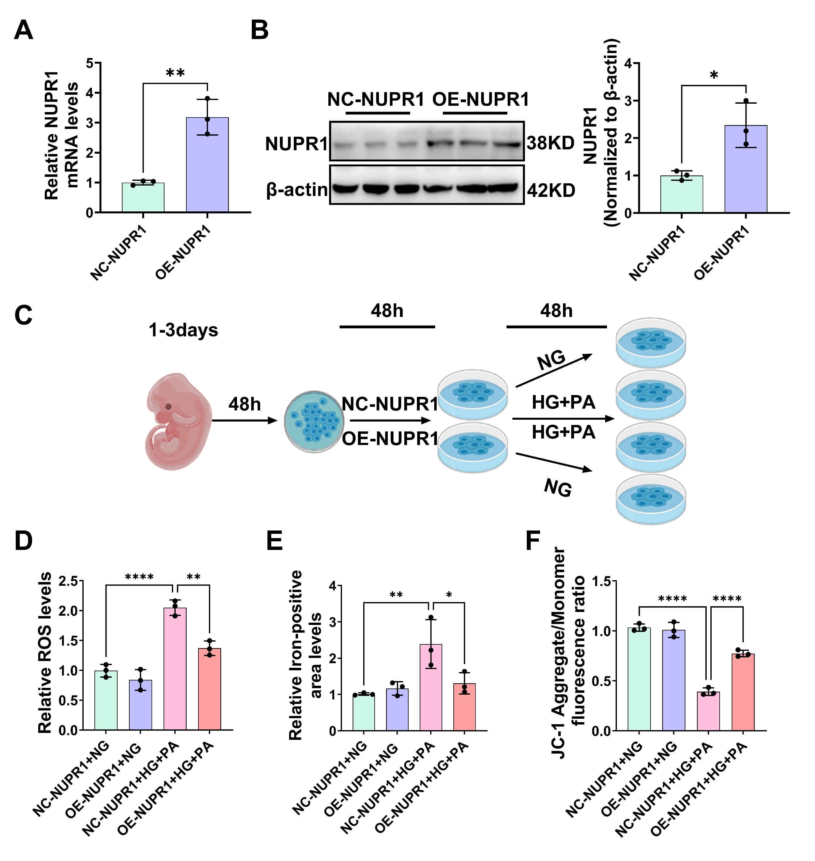

Figure S3. Overexpression of NUPR1 attenuates HG+PA induced injury in primary cardiomyocytes.
A-B. Primary cardiomyocytes were transfected with NUPR1-plasmid for 48 hours, expression of NUPR1 mRNA and protein assessed using qRT-PCR and western blot (n=3 independent experiments). C. Diagram showing experimental design for the study of overexpression of NUPR1 in the in vitro model of diabetic heart injuries. D. Relative fluorescence intensity ratio of lipid peroxidation (n=3 independent experiments). E. Relative fluorescence intensity ratio of FerroOrange (n=3 independent experiments). F. Relative fluorescence intensity ratio of JC-1 (Aggregate/Monomer) (n=3 independent experiments). *P<0.05, **P<0.01, ***P<0.001, and ****P<0.0001 were considered statistically significant.
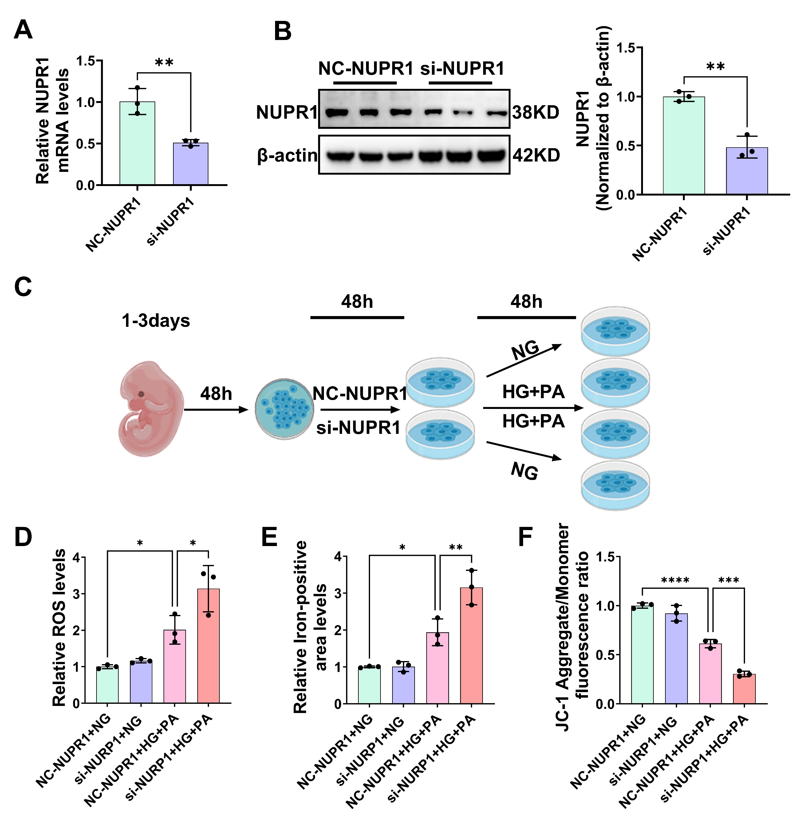

Figure S4. Knockdown of NUPR1 exacerbates HG+PA induced injury in primary cardiomyocytes.
A-B. Primary cardiomyocytes were transfected with si-NUPR1 for 48 hours, expression of NUPR1 mRNA and protein assessed using qRT-PCR and western blot (n=3 independent experiments). C. Diagram showing experimental design for the study of knockdown of NUPR1 in the in vitro model of diabetic heart injuries. D. Relative fluorescence intensity ratio of lipid oxidation (n=3 independent experiments). E. Relative fluorescence intensity ratio of FerroOrange (n=3 independent experiments). F. Relative fluorescence intensity ratio of JC-1 (Aggregate/Monomer) (n=3 independent experiments). *P<0.05, **P<0.01, ***P<0.001, and ****P<0.0001 were considered statistically significant.
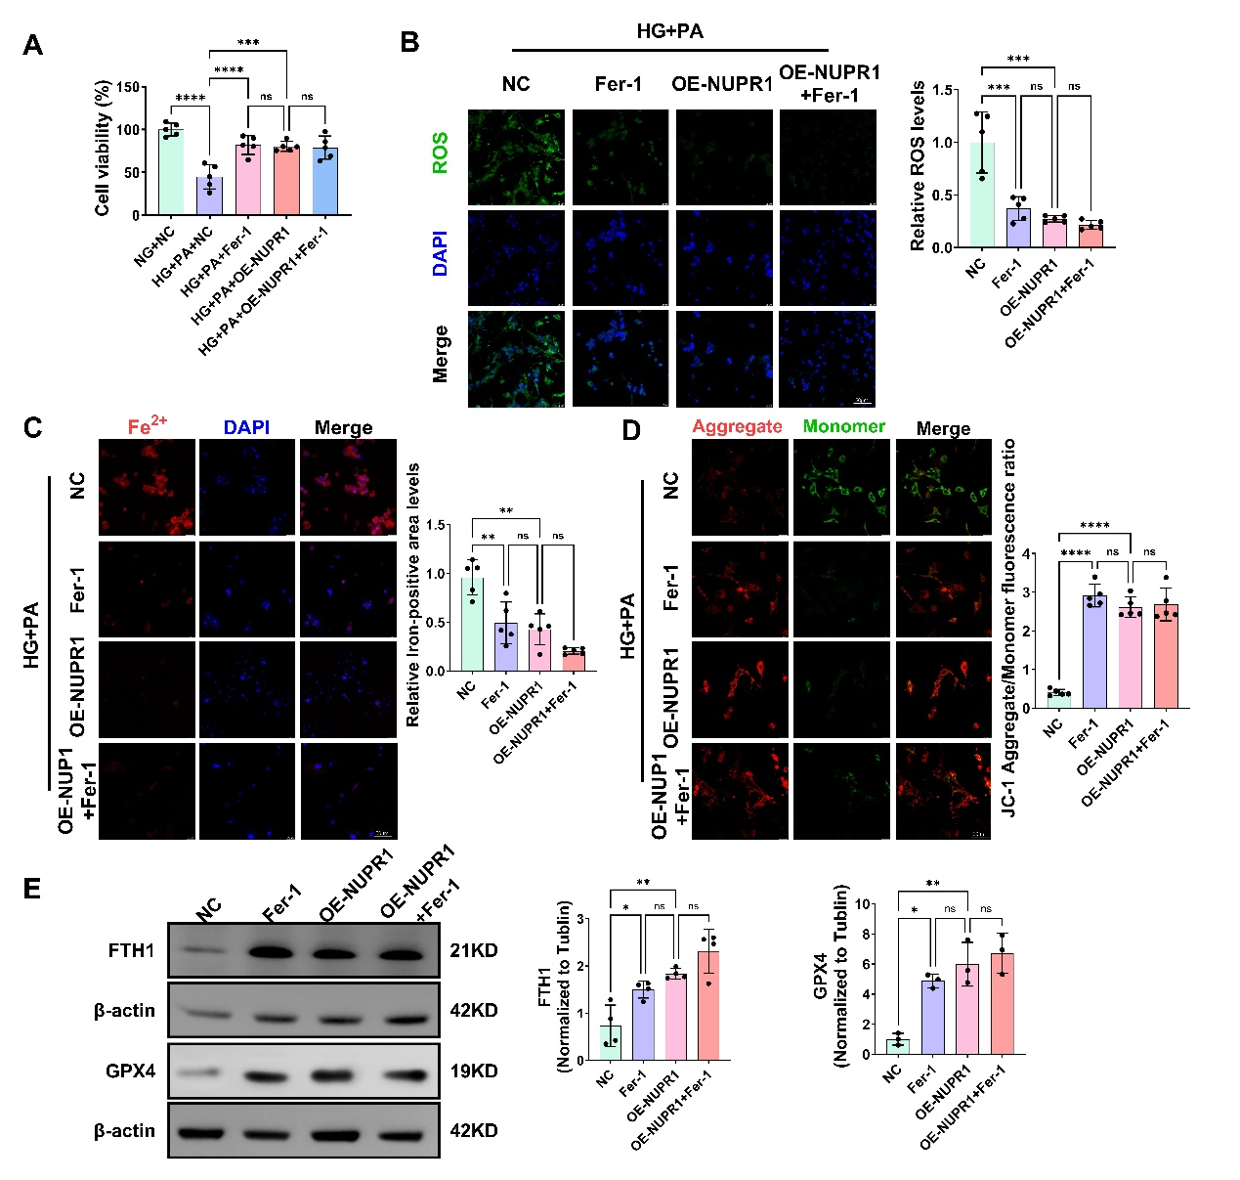

Figure S5. NUPR1 overexpression mimics the anti-ferroptotic effect of Fer-1 in HG+PA-treated cardiomyocytes.
A. CCK-8 viability (n=5 independent experiments). B-D. Representative fluorescence images of BODIPY 581/591 C11 (ROS accumulation), FerroOrange (Fe²⁺ accumulation), and JC-1 staining (scale bar: 50μm) and relative fluorescence intensity ratio (n=5 independent experiments). E. Representative immunoblots (left) and densitometric analysis (right) of GPX4 and FTH1 protein levels (n=3/4 independent experiments). *P<0.05, **P<0.01, ***P<0.001, and ****P<0.0001 were considered statistically significant.

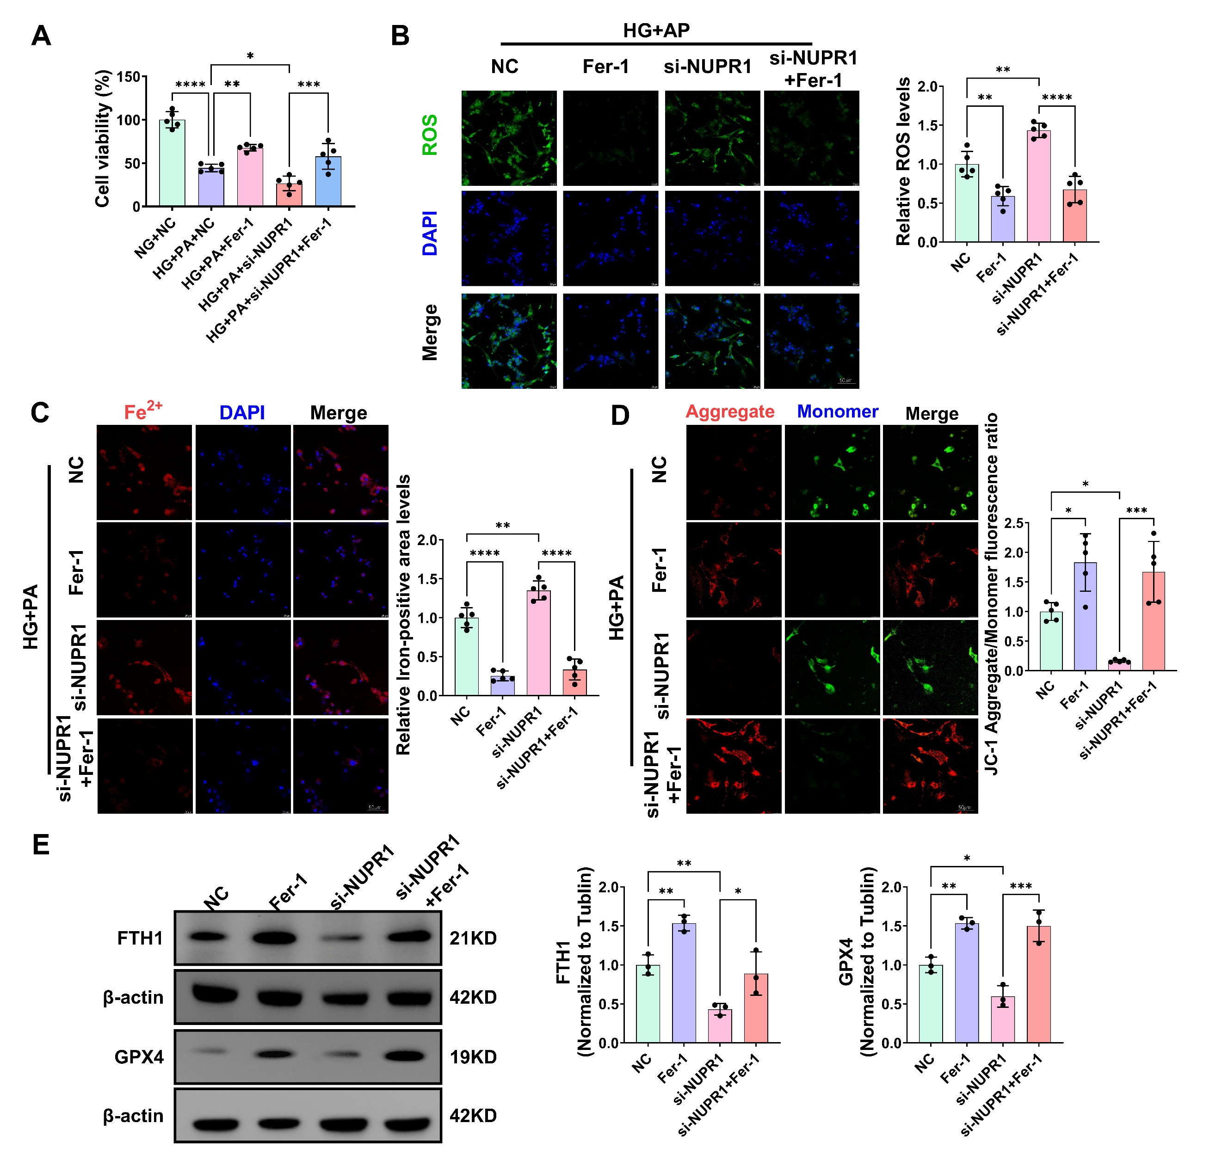

Figure S6. NUPR1 silencing sensitizes cardiomyocytes to ferroptosis, which is rescued by Fer-1.
A. CCK-8 viability (n=5 independent experiments). B-D. Representative fluorescence images of BODIPY 581/591 C11 (ROS accumulation), FerroOrange (Fe²⁺ accumulation), and JC-1 staining (scale bar: 50μm) and relative fluorescence intensity ratio (n=5 independent experiments). E. Representative immunoblots (left) and densitometric analysis (right) of GPX4 and FTH1 protein levels (n=3 independent experiments). *P<0.05, **P<0.01, ***P<0.001, and ****P<0.0001 were considered statistically significant.
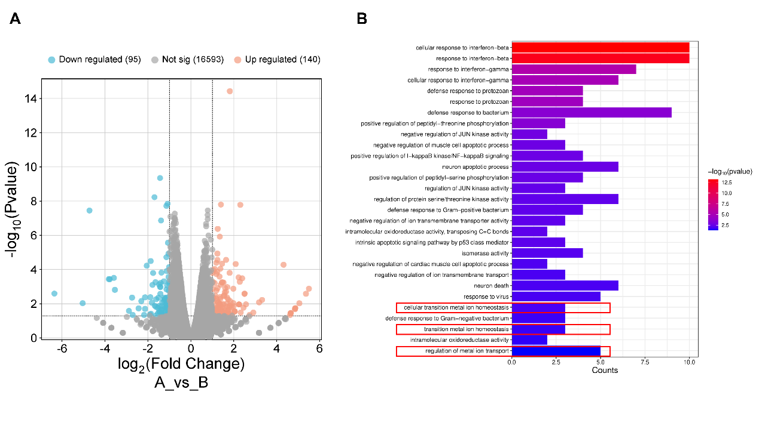

Figure S7. RNA‑seq analysis of NUPR1‑overexpressing mouse hearts.
A. Volcano plot showing 235 differentially expressed genes in OE‑NUPR1 vs. NC‑NUPR1 left ventricles. Raw data deposited in GEO (GSE331544). B. GO enrichment analysis reveals that, besides immune‑related terms, NUPR1 overexpression significantly enriches iron homeostasis‑associated biological processes, including “cellular transition metal ion homeostasis”, “transition metal ion homeostasis”, and “response to iron ion” (highlighted).
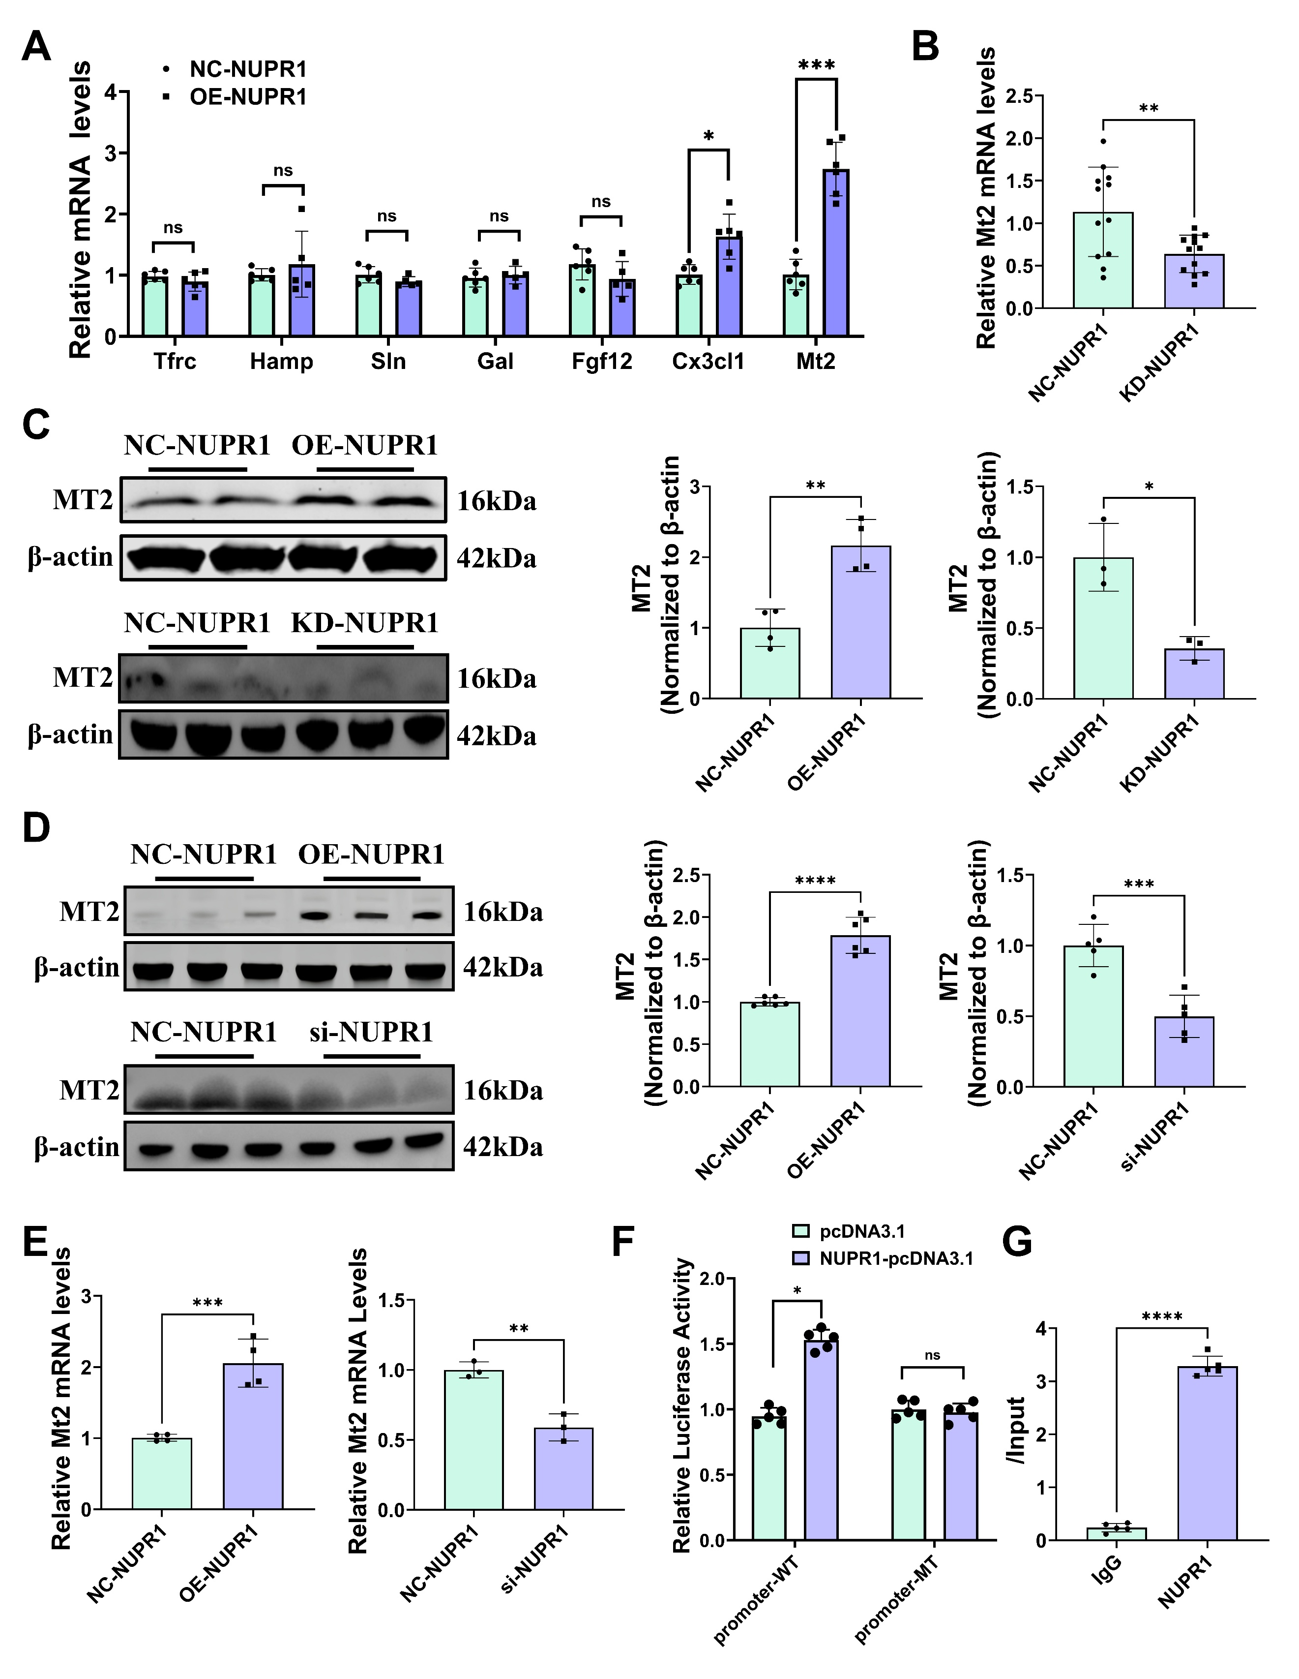

Figure S8. Prediction and validation of NUPR1 as an upstream transcription factor of MT2.
A. Relative mRNA levels in OE-NUPR1 treated mice (n=6 per group). B. Relative mRNA levels in KD-NUPR1 treated mice (n=12 per group). C. Relative protein levels in OE-NUPR1/ KD-NUPR1 treated mice (n=3/4 per group). D. Relative protein levels in OE-NUPR1/ si-NUPR1 treated cell (n=6 independent experiments). E. Relative mRNA levels in OE-NUPR1/ si-NUPR1 treated cell (n=3/4 independent experiments). F. Dual-luciferase reporter assay in HEK293T cells. Cells were co-transfected with a wild-type MT2 promoter-luciferase construct (pGL3-MT2-WT), a Renilla internal control (pRL-TK), and either pcDNA3.1-Nupr1 (NUPR1 OE) or empty vector (Vector). Firefly luciferase activity was normalized to Renilla (n=5 independent experiments). G. Chromatin immunoprecipitation (ChIP) assay confirming NUPR1 binding to the MT2 promoter. *P<0.05, **P<0.01, ***P<0.001, and ****P<0.0001 were considered statistically significant.

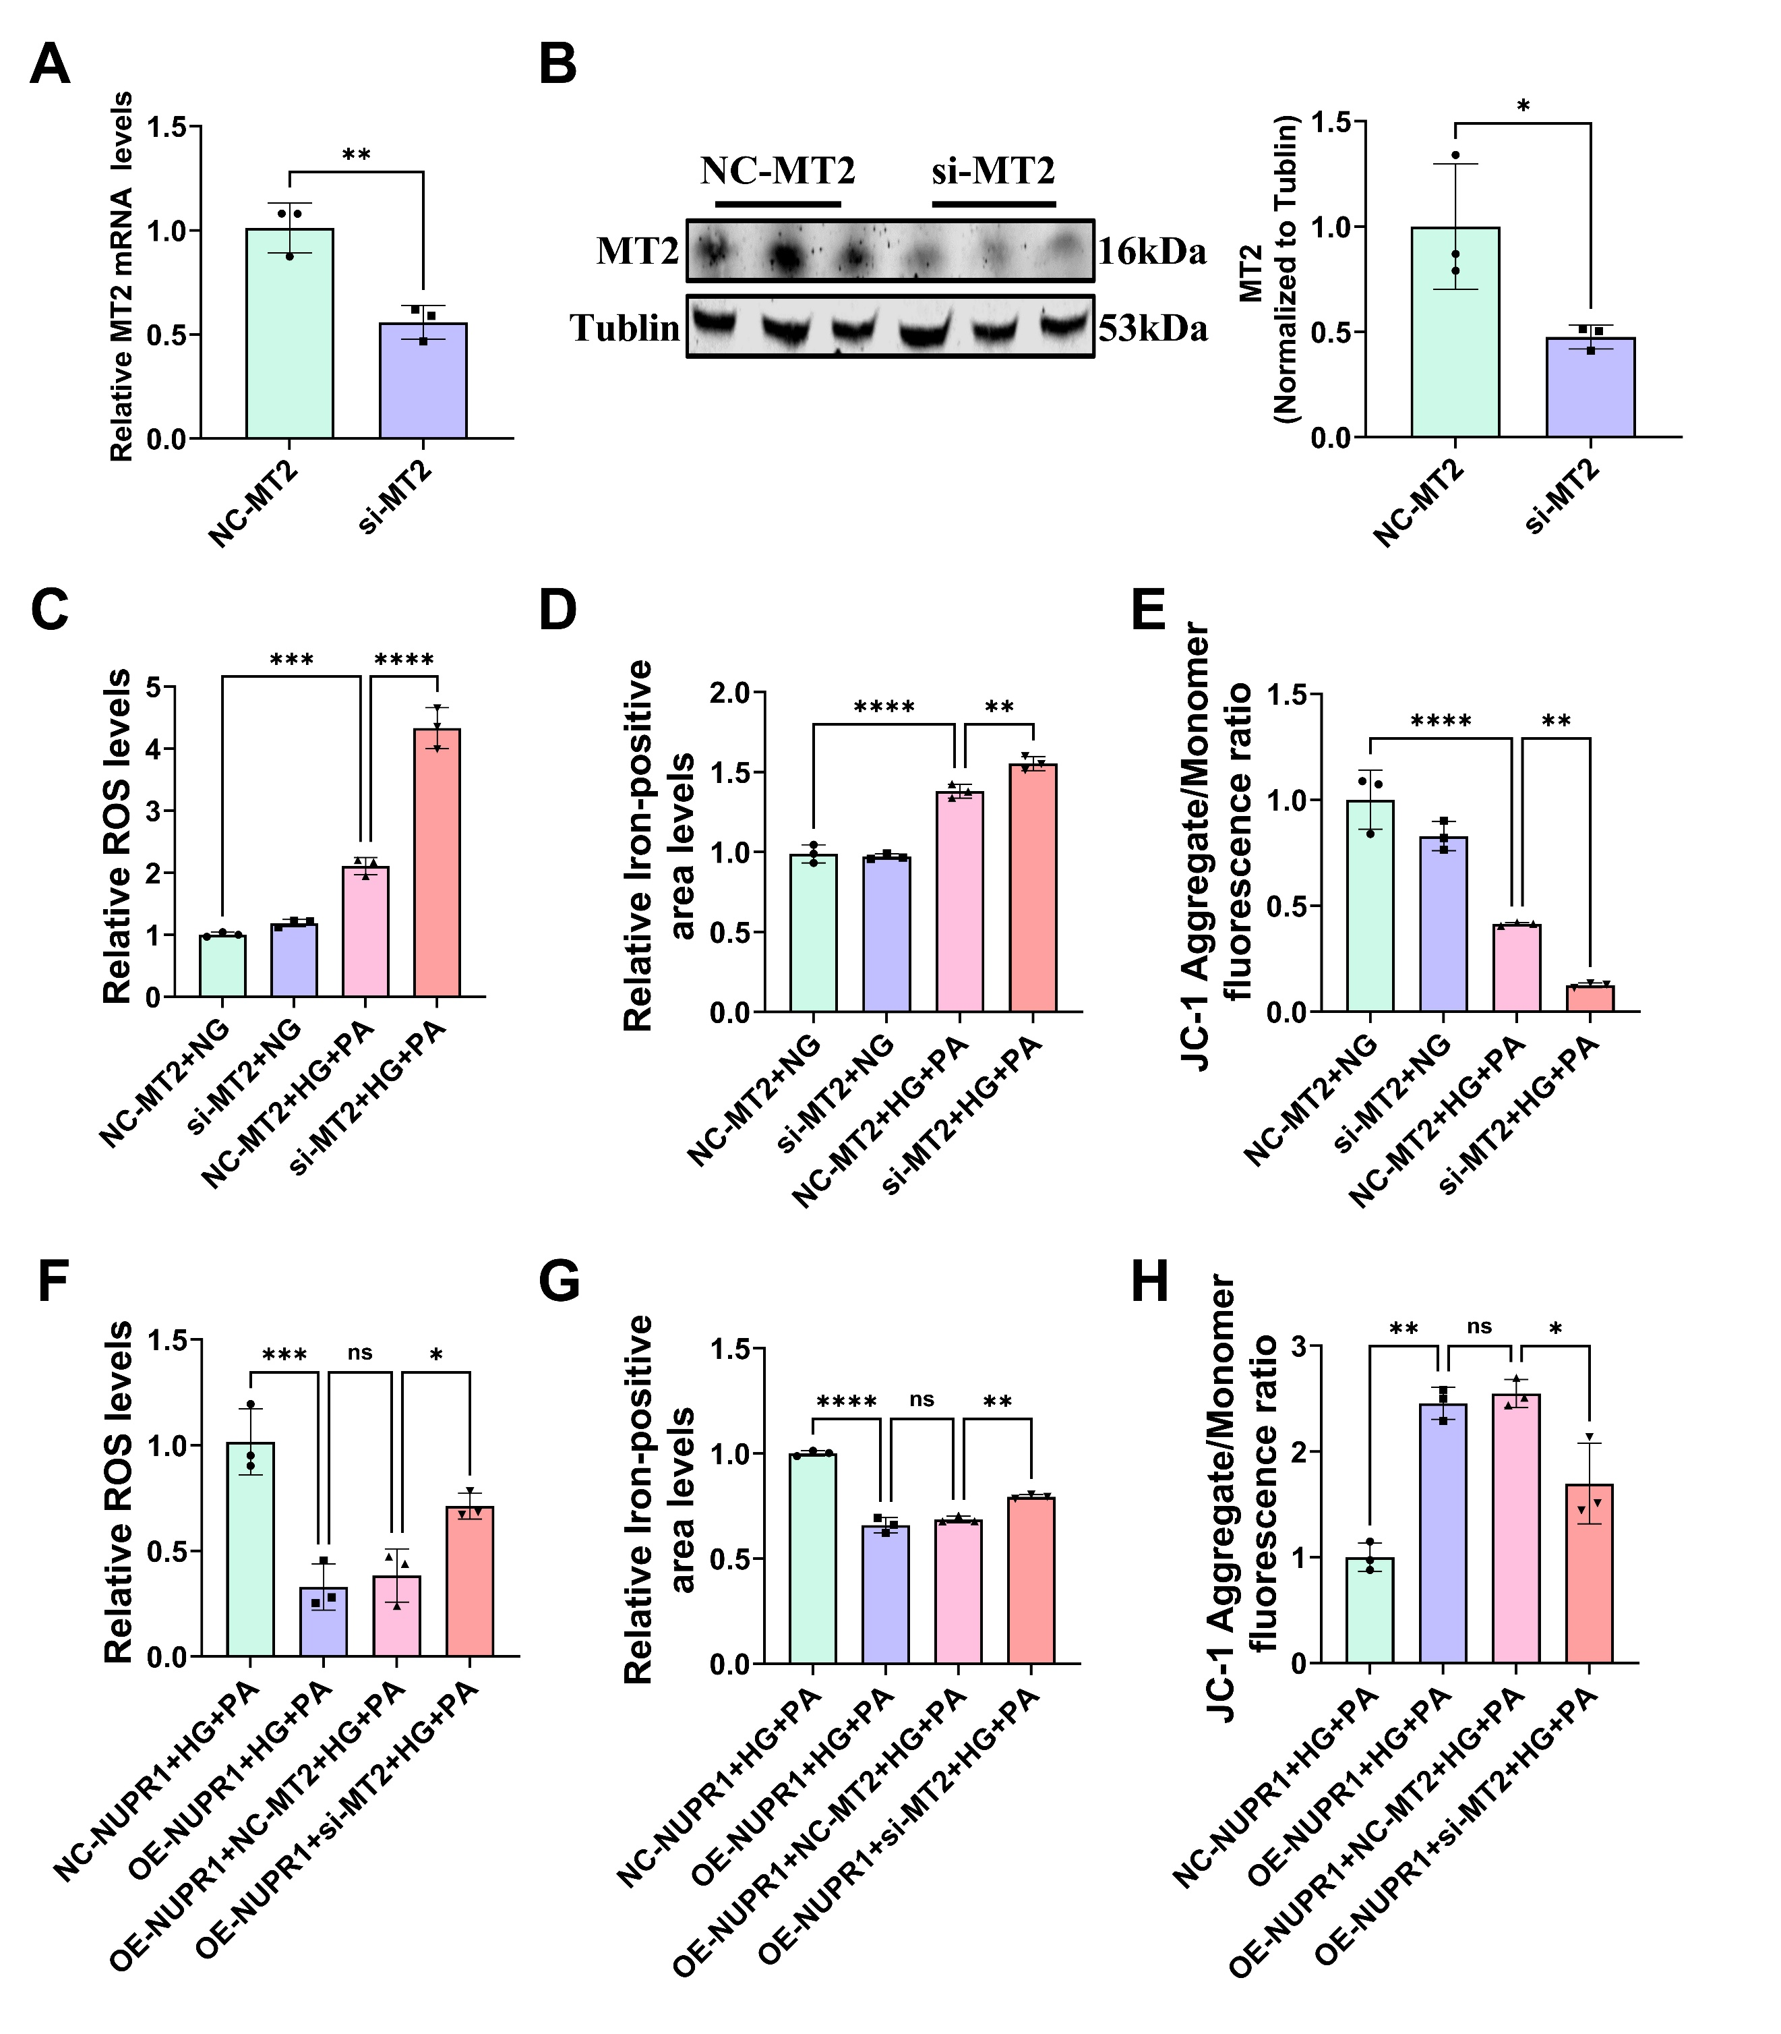

Figure S9. NUPR1 exerts anti-ferroptotic and anti-oxidative effects in DdCM by regulating MT2.
A-B. Primary cardiomyocytes were transfected with si-MT2 for 48 hours, expression of MT2 mRNA and protein assessed using qRT-PCR and western blot (n=3 independent experiments). C & F. Relative fluorescence intensity ratio of lipid peroxidation (n=3 independent experiments). D & G. Relative fluorescence intensity ratio of FerroOrange (n=3 independent experiments). E & H. Relative fluorescence intensity ratio of JC-1 (Aggregate/Monomer) (n=3 independent experiments). *P<0.05, **P<0.01, ***P<0.001, and ****P<0.0001 were considered statistically significant.
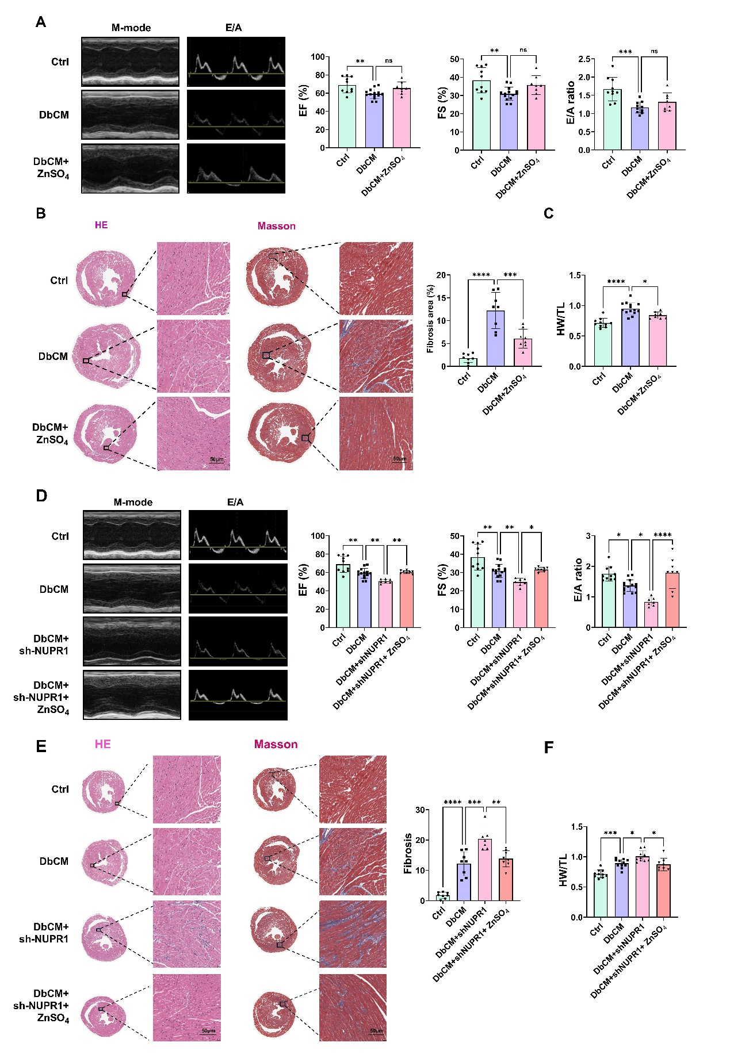
Figure S10. Effects of zinc supplementation on DCM mice with or without NUPR1 knockdown.
A, D. Representative echocardiographic images and quantitative analysis of EF%, FS% and E/A ratio (n=8-15per group). B, E. Representative sections of HE staining and Masson’s trichrome staining and their statistical results (n=8 per group; scale bar: 50μm) C, F. HW/TL ratio (n=10-15 per group). *P<0.05, **P<0.01, ***P<0.001, and ****P<0.0001 were considered statistically significant.

