Supplementary materials

Supplement to: Dadabhai S, Samandari T, Zhang B, et al. Relative efficacy, safety and immunogenicity of bivalent versus monovalent COVID-19 mRNA booster vaccines: a randomized trial

SUPPLEMENTARY MATERIALS APPENDIX CONTENT

- Appendix 1. Glossary
- Appendix 2. Study Team
- Appendix 3. Supplementary methods
- Appendix 4. Full eligibility criteria and COVID-19 case definitions
- Appendix 5. Protocol v. 8.0 June 28, 2023
- Appendix 6. Statistical Analysis Plan (SAP) for the CoVPN 3008 randomized trial
- Figure S1. Schedule of evaluations during the RCT from baseline (M0) to month 12
- Figure S2. Schedule of evaluations following a PCR-positive nasal swab for SARS-CoV-2 infection
- Figure S3. Forest plot of relative efficacy of bivalent versus monovalent booster for SARS-CoV-2 incidence within 6 months after boost in the randomized cohort
- Figure S4. Covariate-adjusted cumulative incidence of COVID-19 cases within 6 months after boost in the randomized cohort
- Figure S5. Forest plot of relative efficacy of bivalent versus monovalent booster for SARS-CoV-2 incidence within 12 months after boost in the per protocol (FPP) cohort
- Figure S6. Covariate-adjusted cumulative incidence of COVID-19 cases within 12 months after boost in the per protocol (FPP) cohort
- Figure S7A. ID50 neutralizing antibody titers to the BA.4/5 SARS-CoV-2 strain by study arm (bivalent and monovalent) and baseline CD4 count at 350 cells/mL cutoffs in PWH
- Figure S7B. ID50 neutralizing antibody titers to the XBB.1.5 SARS-CoV-2 strain by study arm (bivalent and monovalent) and baseline CD4 count at 350 cells/mL cutoffs in PWH
- Figure S8. Correlation between fold-change from baseline to month 1 in the neutralizing antibody titers to BA.4/5 and XBB.1.5 strains of SARS-CoV-2
- Figure S9. Correlations between neutralizing antibody titers to BA.4/5 and XBB.1.5 at baseline vaccination and month 1
- Figure S10. Time to early termination by study arm
- Table S1. Solicited adverse events within 7 days after booster vaccination by grade in the Safety Subset who received booster vaccination under the randomization scheme
- Table S2. Unsolicited adverse events between day 0 and day 28 days after booster vaccination in the Safety Subset who received booster vaccination under the randomization scheme.
- Table S3. Summary of unsolicited adverse events reported by ≥1% of participants in any treatment group between day 0 and day 28 after booster vaccination in the Safety Subset who received booster vaccination under the randomization scheme.
- Table S4. Serious adverse events between booster vaccination through end of follow up reported by preferred term in both study arms among participants who received booster vaccination under the randomization scheme (Full Analysis Set aka randomized cohort).
- Table S5. Pregnancy outcomes up through end of follow up among participants who received booster vaccination under the randomization scheme (Full Analysis Set aka randomized cohort).
- Table S6. Characteristics of the PWH in the immunogenicity subset for neutralizing antibody assessment by arm
- Table S7. Peripheral oxygen saturation (SpO2) distribution among participants with COVID-19 like symptoms
- Table S8. Demographics of participants in the Safety Subset who received booster vaccination under the randomization scheme.

APPENDIX 1

GLOSSARY

AE Adverse event
Anti-NP anti-nucleoprotein serology
ARDS Acute Respiratory Distress Syndrome
ART Antiretroviral therapy
BARC SA Bio Analytical Research Corporation South Africa
BARDA Biomedical Advanced Research and Development Authority
BMI Body mass index
BP Blood pressure
CDC US Center for Disease Control and Prevention
CERI Center for Epidemic Response and Innovation
Covid-19 Coronavirus disease of 2019
CoVPN COVID-19 Prevention Network
CRF Case report form
D Dose
DAIDS Division of AIDS
ECMO Extracorporeal membrane oxygenation
FAS Full analysis set
FIO₂ Fraction of Inspired Oxygen
FPP Per protocol
HIV Human immunodeficiency virus
HR Hazard ratio
ICU Intensive care unit
NAAT Nucleic acid amplification test
NAB Neutralizing antibody
NIAID National Institute of Allergy and Infectious Diseases
PaO₂ Partial pressure of oxygen
PBMC Peripheral blood mononuclear cells
PWH People living with HIV
PWoH People living without HIV
POC anti-S Point-of-care anti-spike serology
QC Quality control
SAE Serious adverse event
SAMRC South African Medical Research Council
SARS-CoV-2 Severe acute respiratory syndrome coronavirus 2
SAP Statistical Analysis Plan
SpO₂ Peripheral capillary oxygen saturation
VOC Variant of concern

APPENDIX 2

STUDY TEAM MEMBERS

First name | Surname | Organization
Sharlaa | Badal-Faesen | Clinical HIV Research Unit / Helen Joseph CRS
Kagisho | Baepanye | Hutchinson Centre Research Institute of South Africa
Veronique | Bailey | Hutchinson Centre Research Institute of South Africa
Katekani | Baloyi-Oseh | Hutchinson Centre Research Institute of South Africa
Mumtaz | Booley | Hutchinson Centre Research Institute of South Africa
Johannes Louis | Botha | TASK Eden
Yolande | Brown | Hutchinson Centre Research Institute of South Africa
Valerie | Brown | The Emmes Company, LLC
Lisa | Bunts | Fred Hutchinson Cancer Center
Soritha | Coetzer | Synexus Helderberg
Shirley | Collie | BioInformatiCo
Rodney | Dawson | University of Cape Town Lung Institute CRS
Pallabi | Deb | Fred Hutchinson Cancer Center
Hana | El Sahly | Baylor College of Medicine
Jill | El-Khorazaty | The Emmes Company, LLC
Andries | Engelbrecht | Hutchinson Centre Research Institute of South Africa
Marianne | Gildea | FHI 360
Dhevium | Govender | Hutchinson Centre Research Institute of South Africa
Jen | Hanke | Fred Hutchinson Cancer Center
Jayla | Harris | Fred Hutchinson Cancer Center
Simone | Hendricks | Hutchinson Centre Research Institute of South Africa
Nick | Hopkinson | Fred Hutchinson Cancer Center
Haley | Howell | The Emmes Company, LLC
Nzeera | Ketter | Fred Hutchinson Cancer Center
Kentse | Khuto | Hutchinson Centre Research Institute of South Africa
Faatima | Laher Omar | Hutchinson Centre Research Institute of South Africa
Leolin | Katsidzira | University of Zimbabwe
Kim | Linton | The Emmes Company, LLC
James | Ludwig | Fred Hutchinson Cancer Center
Bongile | Mabilane | Hutchinson Centre Research Institute of South Africa
Matshidiso | Malefo | Hutchinson Centre Research Institute of South Africa
Ndiitwani | Mamushiana | Ndlovu Research Centre
Daciana | Margineantu | Fred Hutchinson Cancer Center
Jeanine | May | The Emmes Company, LLC
Fatima | Mayat | Perinatal HIV Research Unit
Cindy | Molitor | Fred Hutchinson Cancer Center
Yeshnee | Naidoo | KwaZulu-Natal Research Innovation and Sequencing Platform
Michelle | Nebergall | Fred Hutchinson Cancer Center
Alan | Nguyen | Fred Hutchinson Cancer Center
Sarah | Nikles | The Emmes Company, LLC
Bianca | Noronha | The Emmes Company, LLC
Melissa | Peda | Fred Hutchinson Cancer Center
Tamara | Phiri | Queen Elizabeth Central Hospital, Malawi
Shanthie | Pillay | Hutchinson Centre Research Institute of South Africa
Sureshnee | Pillay | KwaZulu-Natal Research Innovation and Sequencing Platform
Lori | Proulx-Burns | Fred Hutchinson Cancer Center
Laurie | Rinn | Fred Hutchinson Cancer Center
Lisa | Sanders | Fred Hutchinson Cancer Center
Carrie | Sopher | Fred Hutchinson Cancer Center
Smitha | Sripathy | Fred Hutchinson Cancer Center
Michael | Stirewalt | Fred Hutchinson Cancer Center
Houriiyah | Tegally | KwaZulu-Natal Research Innovation and Sequencing Platform
Sara | Thiebaud | Fred Hutchinson Cancer Center
Alicia | Toledano | The Emmes Company, LLC
Stephanie | Van Wyk | Centre for Epidemic Response & Innovation
Shamaya | Whitby | Fred Hutchinson Cancer Center
Stephany | Wilcox | Hutchinson Centre Research Institute of South Africa
Eduan | Wilkinson | Centre for Epidemic Response & Innovation
Haven | Wilvich | Fred Hutchinson Cancer Center
Charles | Wiysonge | South African Medical Research Council
Nelisiwe | Xaba | Hutchinson Centre Research Institute of South Africa
Ntokozo | Xulu | Hutchinson Centre Research Institute of South Africa

APPENDIX 3

SUPPLEMENTARY METHODS

Trial Oversight
The trial sponsor, the South African Medical Research Council (SAMRC), provided oversight on the trial design, site selection and monitoring, and data analysis, with input from Biomedical Advanced Research and Development Authority (BARDA), the National Institute of Allergy and Infectious Diseases (NIAID), the Covid-19 Prevention Network (CoVPN), and the protocol team.

Trial Vaccines Storage and Preparation
The mRNA-1273 and 1273.1222 vaccines were stored long term -50° and -15° C. Unpunctured vials could be stored at 2° to 8° C at clinical sites before preparation and administration for up to 30 days from removal from freezer. Punctured vials were held between 2° and 25° C for up to 12 hours from time of first vial puncture. The injections prepared from punctured vials had to administered within 12 hours from first vial puncture. No dilution was required and doses could be held in syringes for up to 8 hours at room temperature before administration.

Safety Assessments
All adverse events were graded according to the Division of AIDS (DAIDS) Table for Grading the Severity of Adult and Pediatric Adverse Events, Corrected Version 2.1, July 2017 [1]. The study team supported sites in monitoring PWH to ensure referral for adherence counselling or optimize treatment as appropriate, in cases of poorly controlled HIV. Pregnant participants continuing their pregnancy were referred for local prenatal care including fetal ultrasound, syphilis testing/treatment, and HIV testing, if not already known to be living with HIV. All pregnancies were followed up for outcomes. Confirmed Covid-19 cases were closely monitored to permit early interventions, as appropriate, to prevent complications, including temperature monitoring, pulse oximetry, provision of oxygen, steroids and other medications, and hospitalization.

Post-SARS-CoV-2 Infection Diagnosis Schedule
All participants with SARS-CoV-2 infection confirmed by nucleic acid amplification test (NAAT), regardless of symptoms or rationale for being tested, entered the same post-diagnosis schedule. During the post-diagnosis time period, participants used daily diaries to record temperature, heart rate, oxygen saturation, and presence and severity of respiratory and systemic symptoms of Covid-19. Daily signs and symptoms were recorded for 14 days or through symptom resolution, whichever was later. An overall severity assessment was completed 28 days following diagnosis. To further address the persistence of NAAT-detectable SARS-CoV2, an update to the post-diagnosis schedule was made beginning in April 2022 to add additional nasal swabs collected at day 14 and day 28 following the initial NAAT-positive swab, with additional swabs collected every 14 days as needed until a negative result was obtained.

COVID-19 Assessment
For the assessment of severe Covid-19 endpoints, severe symptoms included any of the following:
- Clinical signs indicative of severe systemic illness, respiratory rate ≥ 30 per minute, heart rate ≥ 125 beats per minute, SpO₂ ≤ 93% on room air at sea level or PaO₂/FIO₂ < 300 mm Hg, OR
- respiratory failure or Acute Respiratory Distress Syndrome (ARDS, defined as needing high-flow oxygen, non-invasive or mechanical ventilation, or ECMO [extracorporeal membrane oxygenation]), evidence of shock (systolic blood pressure < 90 mmHg, diastolic blood pressure < 60 mmHg or requiring vasopressors), OR
- Significant acute renal, hepatic or neurologic dysfunction, OR
- Admission to an intensive care unit or death.

Data Management
Clinical case report form (CRF) data were initially collected in Advantage eClinical® software managed by The Emmes Company, LLC (Rockville, Maryland, USA) and later in REDCap managed by BioInformatiCo (Johannesburg, South Africa). Neutralizing antibody testing was performed by the National Institute for Communicable Diseases (NICD, Johannesburg, South Africa). Data management and analyses were performed at the CoVPN statistical and data management center, Fred Hutchinson Cancer Center (Seattle, USA).

SARS-CoV-2 Serology Assays
The point-of-care anti-spike serology (POC anti-S) was performed by site staff using the EcoTest IgG/IgM rapid kit. All site staff performing testing were required to document training on proper conduct of the tests. Central lab anti-nucleoprotein (NP) serology (anti-NP) testing was performed using the Abbott Allinity anti-NP IgG assay at the Bio Analytical Research Corporation South Africa Global Central Laboratory (BARC SA, Johannesburg, South Africa).

Hybrid and vaccine Immunity categorization
A comprehensive SARS-CoV-2 serostatus was established for analysis for the SARS-CoV-2 immune status covariate: hybrid versus vaccine immunity covariate. This status was determined by combining the results from POC anti-S (obtained at baseline in both Part A and Part B), anti-NP (obtained only at baseline in Part A), and nasal swab NAAT tests (throughout Parts A and B). A positive result in any of these tests by baseline (time of booster receipt) classified the participant’s overall SARS-CoV-2 status as positive. POC anti-S results were available for all participants, and any missing data for NAAT and anti-NP results were imputed (see details in the SAP).

Sample Size and Randomization
Details about randomization and sample size calculation are provided in the SAP, which is provided at the end of this Supplementary Material.

Analysis approaches
Two approaches were used to analyze the effect of bivalent vs. monovalent booster with the study endpoints: a calendar-time-scale Cox regression approach and a study-time-scale counterfactual cumulative incidence approach. Both approaches accounted for baseline variables to improve efficiency and potentially improve unbiasedness due to chance imbalances in prognostic factors between the randomized arms and to account for the fact the main analyses were conducted in the per-protocol cohort.

Calendar-time-scale Cox regression approach: In the first approach, we conducted a calendar-time-scale Cox proportional-hazards regression analysis and quantified the association via the hazard ratio. The Cox regression analysis allows flexible nonparametric modeling of the baseline hazard as a function of the calendar time, which helps acknowledge that the Covid-19 epidemic could have undergone unpredictable changes over the study period. Another advantage of the Cox regression approach is that it naturally takes into account all follow-up of study participants. For the primary analyses comparing the monovalent and bivalent groups among the randomized cohort/FPP participants, time origin of each participant equals the number of days between the participant’s receipt of the booster dose and the time of the first dose among the randomized cohort/FPP participants plus 13 days. Secondary analyses also repeated the analyses with time origin being the number of days between the booster dose and the first dose among the randomized cohort/FPP participants. Section 9 in the SAP summarizes the target population and time origins of various analyses, and additional details of the Cox regression approach can be found in SAP Section 10.3.

Counterfactual cumulative incidence approach: In the second approach, we produced estimates of the counterfactual cumulative incidence over time, and we quantified the association via both the cumulative risk difference and the cumulative risk ratio. Under standard causal assumptions, the counterfactual probability of a Covid-19 event occurring before a given time point was identified from the observed data using a G-computation result. One obtains unbiased estimates of the counterfactual cumulative incidence when estimates of the following nuisance parameters were obtained: (i) the conditional probability of Covid-19-free survival, given monovalent/bivalent vaccination status and covariates; (ii) the conditional probability of censoring, given monovalent/bivalent vaccination status and covariates, and (iii) the probability of assignment to the bivalent arm. The conditional probabilities of survival and censoring were estimated using Cox regression, and the probability of assignment to the bivalent arm was estimated using sample proportion.

The time origin was the booster date for analyses of the FAS cohort and 13 days after the booster date for the PP cohort. Estimates of the cumulative incidence curves were produced for all time points between the time origin and a final stopping time. Cumulative incidence analyses used 165 days and 365 days post the time origin as final stopping times. Study participants with an endpoint observed after the stopping time were considered to have censored outcomes.

APPENDIX 4

FULL ELIGIBILITY CRITERIA

- Age ≥ 18 years if participant self-reports living with HIV or another comorbidity known to be associated with severe Covid-19, for example (CDC.gov for exhaustive list):
• Hypertension
• Type 2 diabetes mellitus
• Overweight, obese, or severely obese (i.e., body mass index [BMI] ≥ 25 kg/m2)
• Heart conditions, such as heart failure, coronary artery disease, or cardiomyopathies
• Chronic kidney disease
• COPD (chronic obstructive pulmonary disease)
• Cancer
• Non-HIV immunocompromised state (weakened immune system) or solid organ transplant
• Pregnancy
• Sickle cell disease
• Smoking
- Willingness to be followed and remain in the catchment area for the planned duration of the study.
- Ability and willingness to provide informed consent.
- Willingness to discuss HIV infection status, undergo related testing/monitoring labs, and receive counseling and referrals to minimize HIV acquisition/improve HIV care as appropriate based on their infection status.
- Assessment of Understanding: Participant demonstrates understanding of this study; completes a questionnaire prior to first vaccination with demonstration of understanding of all questionnaire items answered incorrectly.
- Agrees not to enroll in another interventional study of an investigational research agent until after the study is completed and all the data has been obtained. Enrolment in studies of investigational research agents for the treatment of Covid-19 is allowed for participants who develop Covid-19 disease.
7. Received at least one prior dose of vaccine during from the observational cohort from which the
Ubuntu Trial recruited

COVID-19 AND SEVERE COVID-19 DEFINITIONS

 | Covid-19 (CDC) | Covid-19 (COVE) | Severe Covid-19
Post-baseline NAAT | Positive | Positive | Positive
Symptom onset | Within 14 days before or after +NAAT | Within 14 days before +NAAT | Within 14 days before +NAAT
Eligible systemic symptoms  OR | At least ONE of the following systemic symptoms:  - fever (≥ 38ºC)  - chills  - myalgia  - headache  - sore throat  - new loss of taste or smell | At least TWO of the following systemic symptoms:  - fever (≥ 38ºC)  - chills  - myalgia  - headache  - sore throat  - new loss of taste or smell | At least TWO of the following systemic symptoms:  - fever (≥ 38ºC)  - chills  - myalgia  - headache  - sore throat  - new loss of taste or smell
Eligible respiratory symptom(s) | At least ONE of the following respiratory signs/symptoms:  - cough  - shortness of breath or difficulty breathing  - clinical or radiographical evidence of pneumonia | At least ONE of the following respiratory signs/symptoms:  - cough  - shortness of breath or difficulty breathing  - clinical or radiographical evidence of pneumonia | At least ONE of the following respiratory signs/symptoms:  - cough  - shortness of breath or difficulty breathing  - clinical or radiographical evidence of pneumonia
Eligible severe conditions | n/a | n/a | ANY of the following:  - clinical signs indicative of severe systemic illness  - respiratory rate ≥ 30 breaths per minute  - heart rate ≥ 125 beats per minute  - SpO₂ ≤ 93% on room air at sea level or PaO₂/FIO₂ < 300 mm Hg  - respiratory failure or ARDS*  - evidence of shock**  - significant acute renal, hepatic, or neurologic dysfunction  - admission to an intensive care unit or death.
Severe condition timing | n/a | n/a | Within 14 days before / 28 days after +NAAT
Date of diagnosis | Earlier date of earliest eligible symptom and NAAT | Later date of earliest eligible symptom and NAAT | Later date of documented Covid-19 and earliest eligible severe symptom
Independent adjudication | Not required | Required | Required
*ARDS (Acute Respiratory Distress Syndrome) is defined as needing high-flow oxygen, noninvasive or mechanical ventilation, or ECMO (extracorporeal membrane oxygenation).
**Evidence of shock includes systolic blood pressure < 90 mmHg, diastolic blood pressue < 60 mmHg, or requiring vasopressors.

APPENDIX 5
Protocol v. 8.0 June 28, 2023
Appended to the end of the Supplementary Materials

APPENDIX 6
Statistical Analysis Plan (SAP) for the CoVPN 3008 randomized trial
Appended to the end of the Supplementary Materials

Figure S1. Schedule of evaluations during the RCT from baseline (M0) to month 12

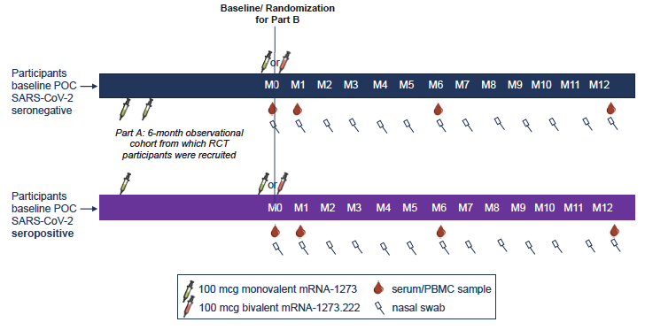

Figure S2. Schedule of evaluations following a PCR-positive nasal swab for SARS-CoV-2 infection

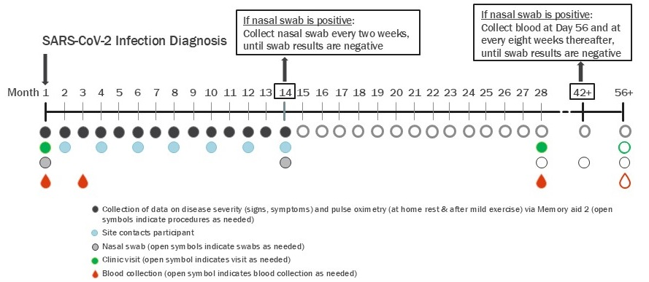
Note: During follow up, prespecified symptoms that met the criteria for suspicion of COVID-19 were solicited approximately every 2 weeks. Participants were also encouraged to report symptoms at any time. The presence of symptoms triggered a site visit to collect two nasal swabs within 72 hours for local SARS-CoV-2 NAAT and, if positive, for quantification and whole genome sequencing at a central laboratory. Participants who tested positive by NAAT attended additional visits where symptoms, serum/peripheral blood mononuclear cells, and nasal swabs were collected.
Figure S3. Forest plot of relative efficacy of bivalent versus monovalent booster for SARS-CoV-2 incidence within 6 months after boost in the randomized cohort
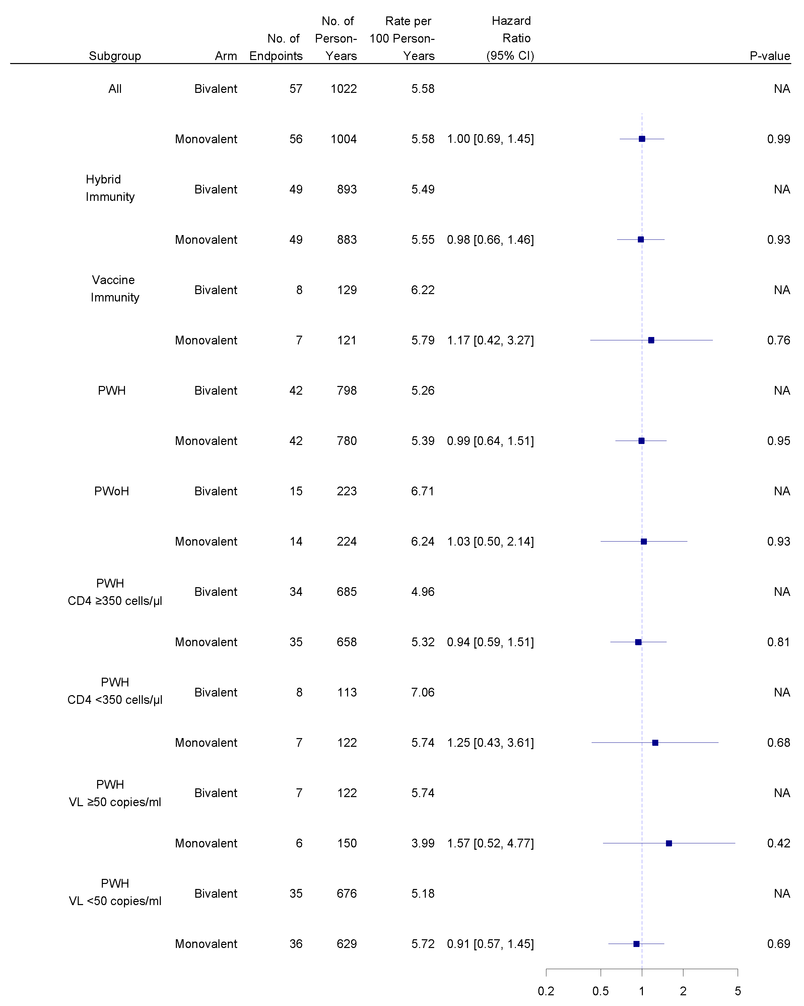

Figure S4. Covariate-adjusted cumulative incidence of COVID-19 cases within 6 months after boost in the randomized cohort
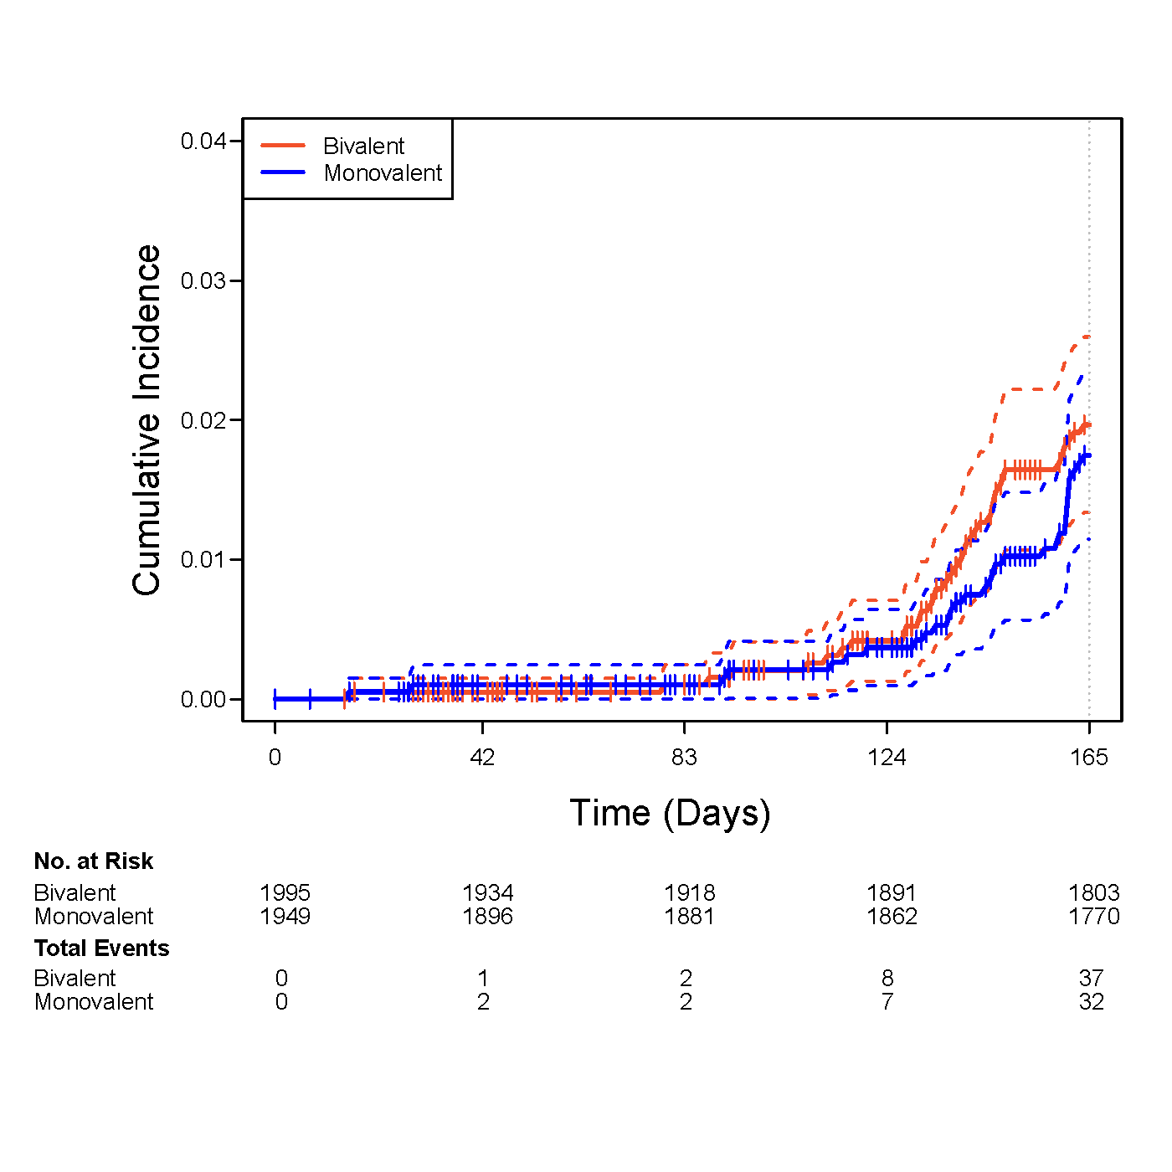

Figure S5. Forest plot of relative efficacy of bivalent versus monovalent booster for SARS-CoV-2 incidence within 12 months after boost in the per protocol (FPP) cohort

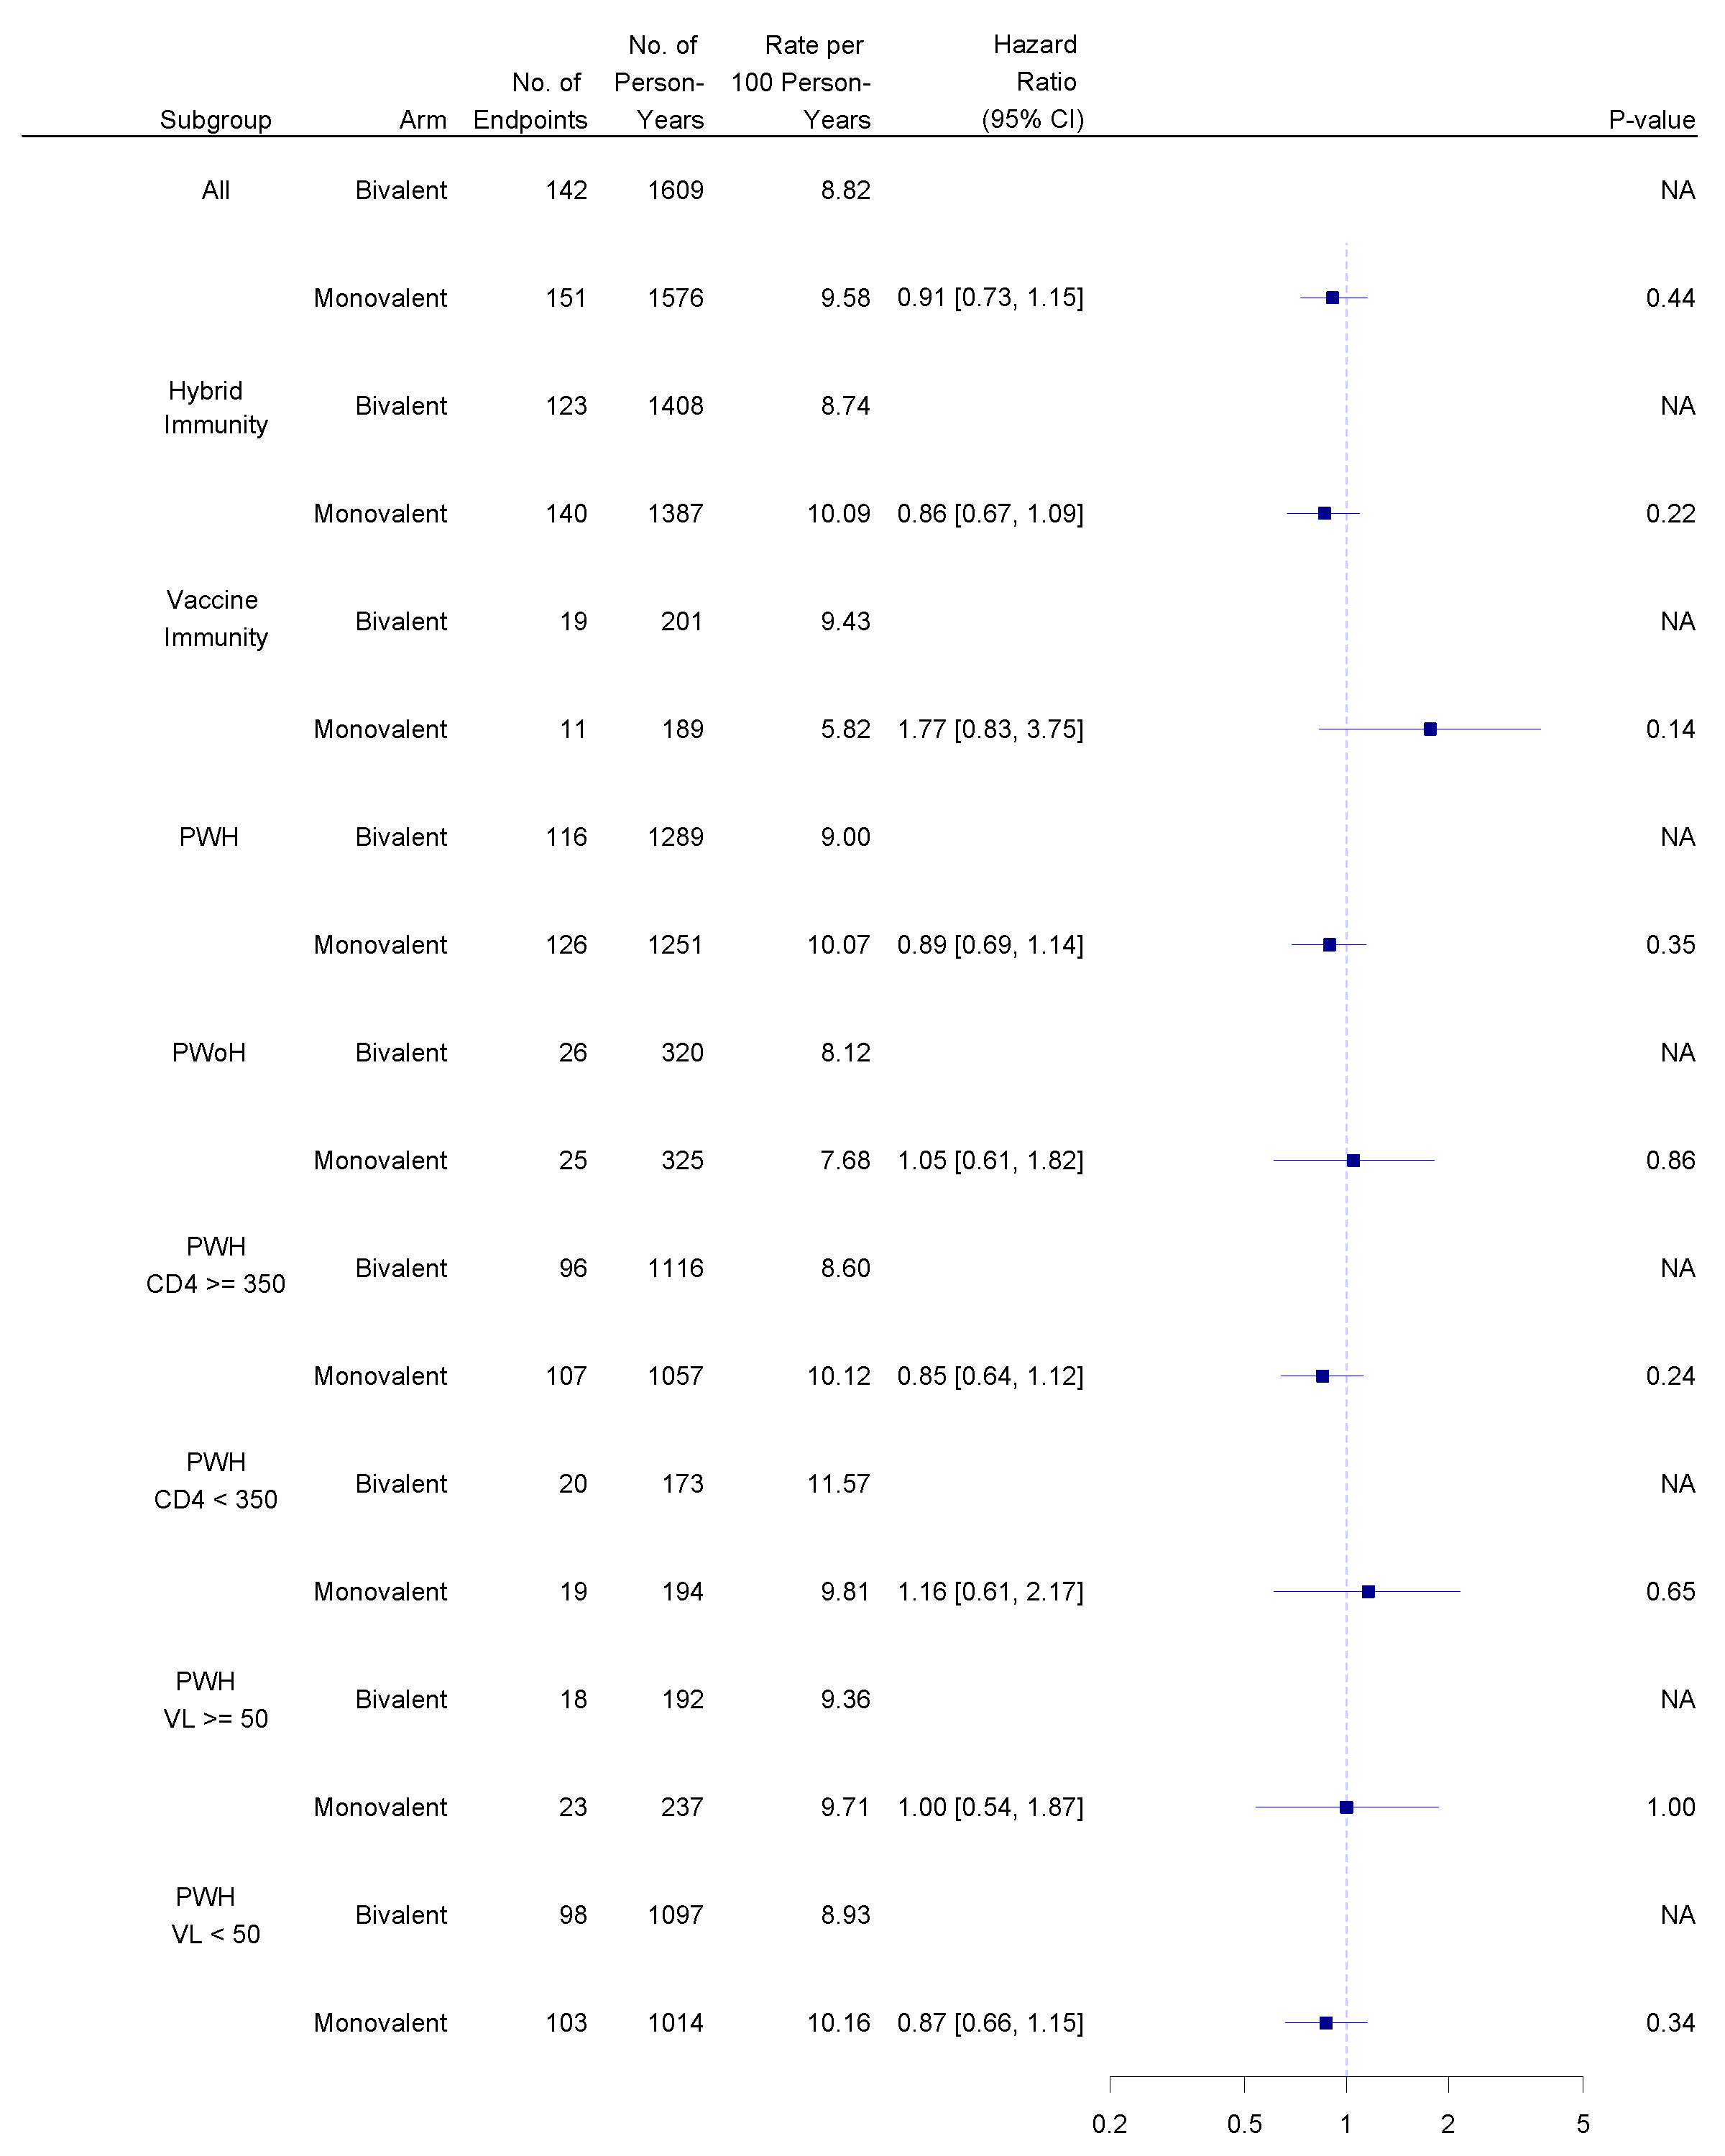

Figure S6. Covariate-adjusted cumulative incidence of COVID-19 cases within 12 months after boost in the per protocol (FPP) cohort
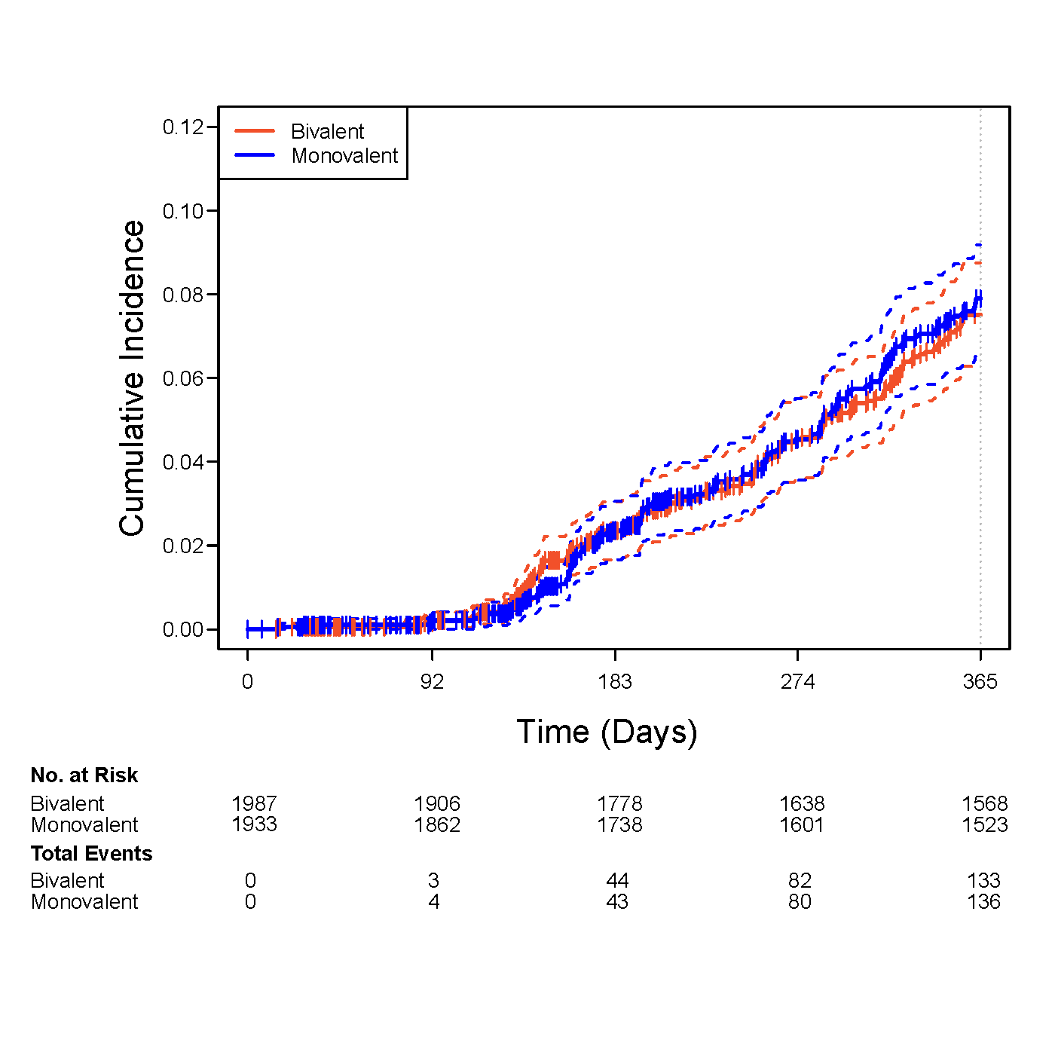

Figure S7A. ID50 neutralizing antibody titers to the BA.4/5 SARS-CoV-2 strain by study arm (bivalent and monovalent) and baseline CD4 count at 350 cells/mL cutoffs in PWH.

GMT=geometric mean titer. LOD=limit of detection.
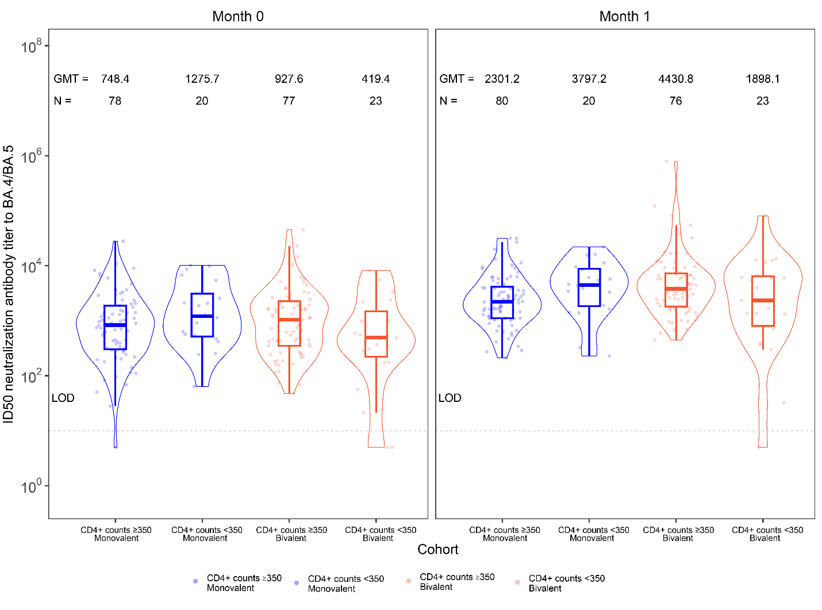

Figure S7B. ID50 neutralizing antibody titers to the XBB.1.5 SARS-CoV-2 strain by study arm (bivalent and monovalent) and baseline CD4 count at 350 cells/mL cutoffs in PWH.

GMT=geometric mean titer. LOD=limit of detection.

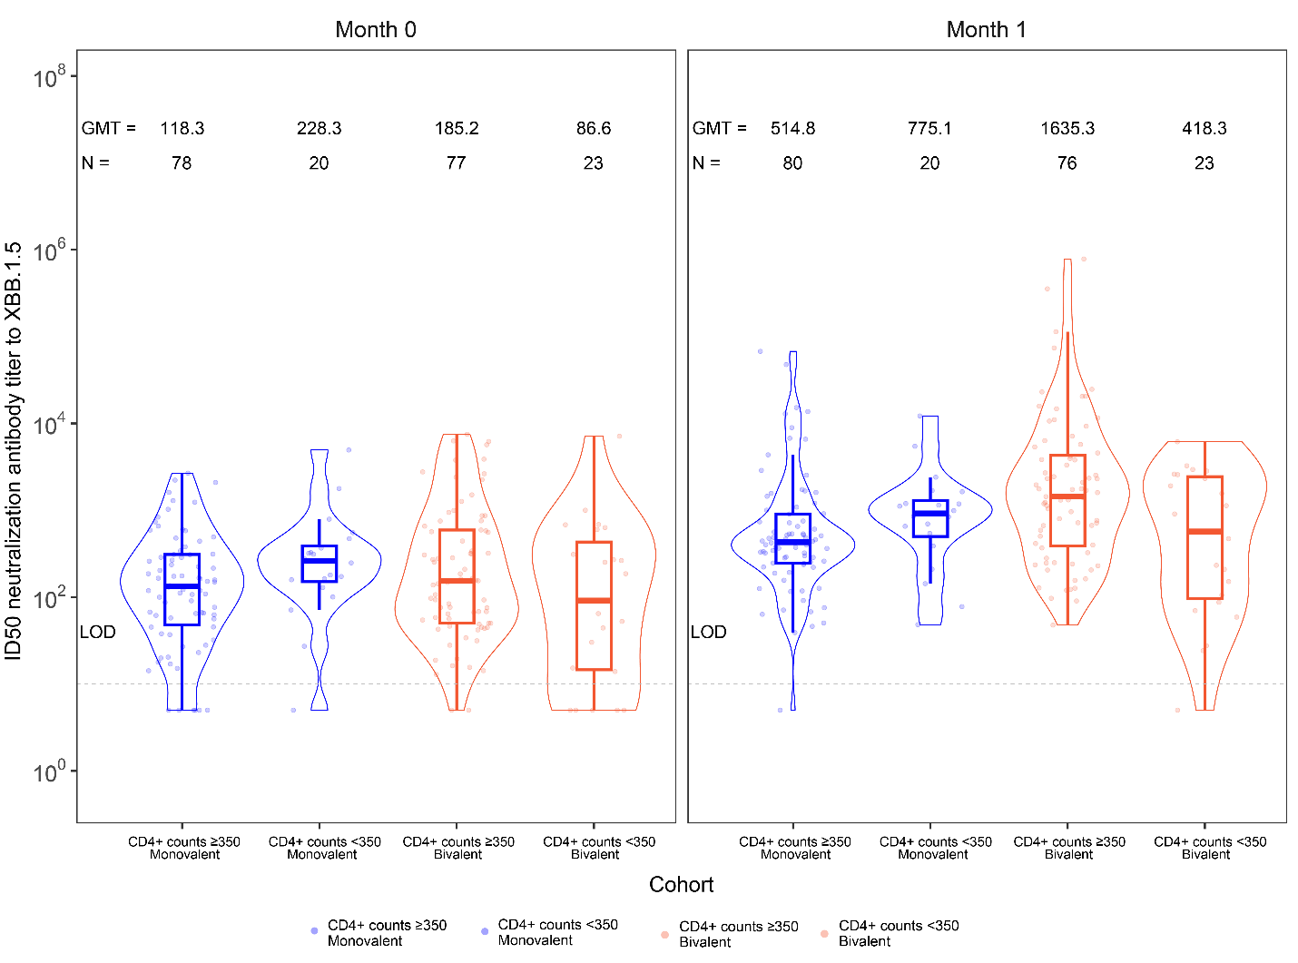

Figure S8. Correlation between fold-change from baseline to month 1 in the neutralizing antibody titers to BA.4/5 and XBB.1.5 strains of SARS-CoV-2

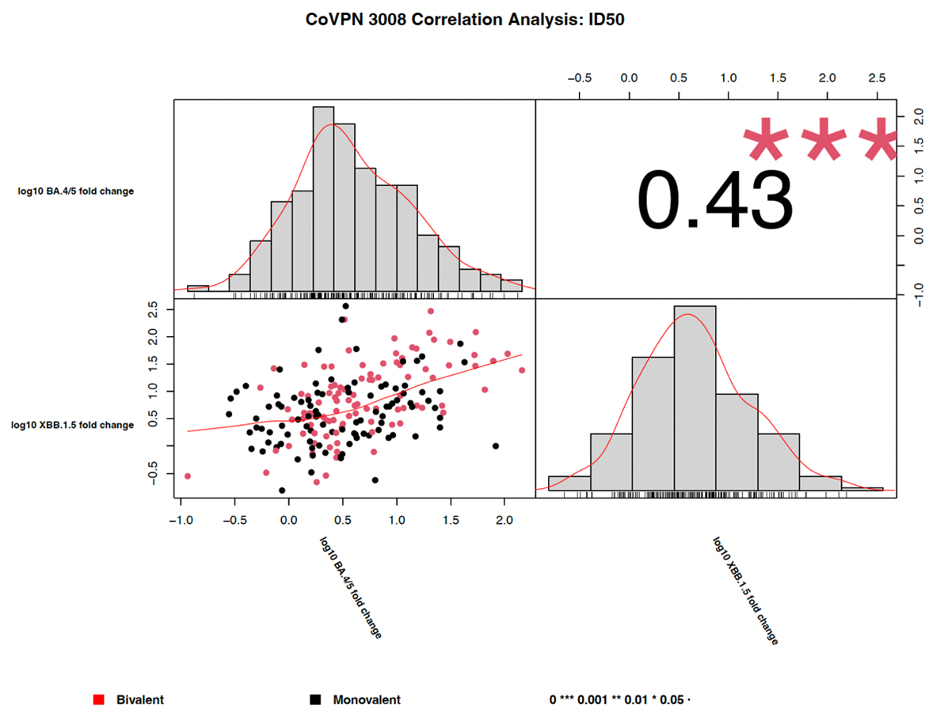
Figure S9. Correlations between neutralizing antibody titers to BA.4/5 and XBB.1.5 at baseline vaccination and month 1

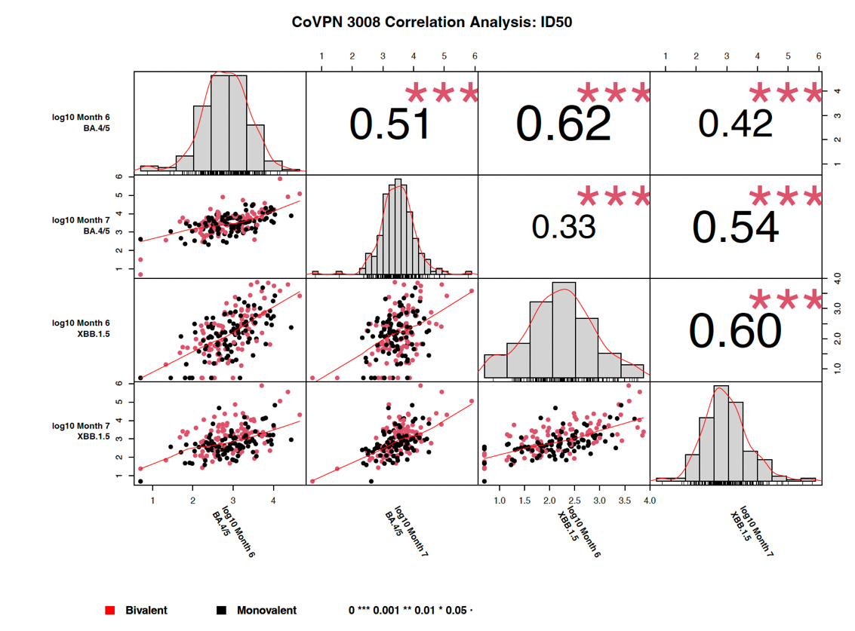
Figure S10. Time to early termination by study arm

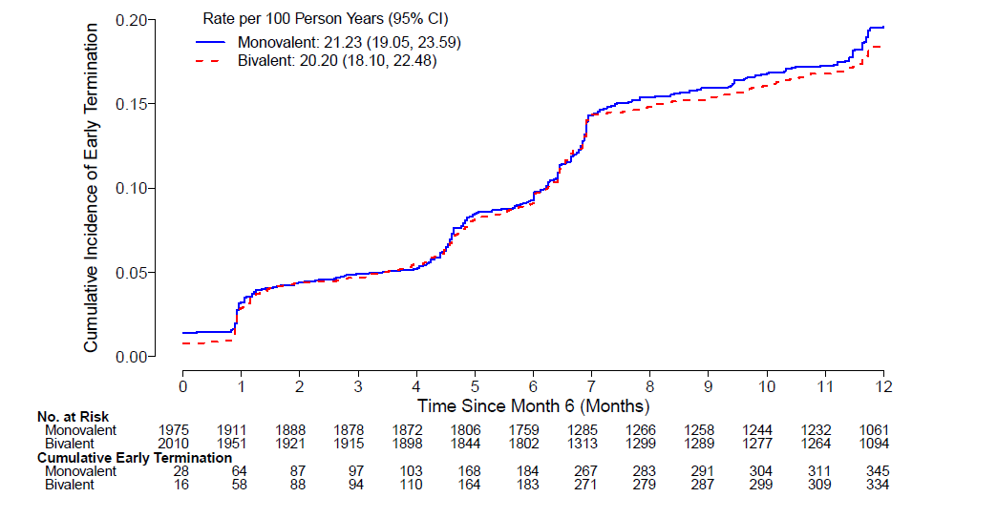
Time (months)

Table S1. Solicited adverse events within 7 days after booster vaccination by grade in the Safety Subset who received booster vaccination under the randomization scheme

Solicited Adverse Event  n (%) | People living with HIV |  |  |  |  | People living without HIV |  |  |  |  | Total  (n=173)
Solicited Adverse Event  n (%) | Study Group 1  (n=5)  (HIV+, Anti-S  SARS2-) |  | Study Group 2  (n=100)  (HIV+, Anti-S  SARS2+) |  | Total (n=105) | Study Group 3  (n=6)  (HIV-, Anti-S  SARS2-) |  | Study Group 4  (n=62)  (HIV-, Anti-S  SARS2+) |  | Total (n=68)
Solicited Adverse Event  n (%) | Monovalent  (N=2) | Bivalent  (N=3) | Monovalent  (N=48) | Bivalent  (N=52) | Total (n=105) | Monovalent  (N=3) | Bivalent  (N=3) | Monovalent  (N=31) | Bivalent  (N=31) | Total (n=68) | Monovalent  (N=84) | Bivalent  (N=89)
Any Reactogenicity | 0 | 0 | 10 (20.8) | 8 (15.4) | 18 (17.1) | 1 (33.3) | 0 | 11 (35.5) | 7 (22.6) | 19 (27.9) | 22 (26.2) | 15 (16.9)
Grade 1 | 0 | 0 | 9 (18.8) | 4 (7.7) | 13 (12.4) | 0 | 0 | 6 (19.4) | 5 (16.1) | 11 (16.2) | 15 (17.9) | 9 (10.1)
Grade 2 | 0 | 0 | 1 (2.1) | 4 (7.7) | 5 (4.8) | 1 (33.3) | 0 | 4 (12.9) | 2 (6.5) | 7 (10.3) | 6 (7.1) | 6 (6.7)
Grade 3 | 0 | 0 | 0 | 0 | 0 | 0 | 0 | 1 (3.2) | 0 | 1 (1.5) | 1 (1.2) | 0
Grade 4 | 0 | 0 | 0 | 0 | 0 | 0 | 0 | 0 | 0 | 0 | 0 | 0
Any Local Reactogenicity | 0 | 0 | 4 (8.3) | 6 (11.5) | 10 (9.5) | 1 (33.3) | 0 | 7 (22.6) | 6 (19.4) | 14 (20.6) | 12 (14.3) | 12 (13.5)
Grade 1 | 0 | 0 | 4 (8.3) | 4 (7.7) | 8 (7.6) | 1 (33.3) | 0 | 3 (9.7) | 4 (12.9) | 8 (11.8) | 8 (9.5) | 8 (9.0)
Grade 2 | 0 | 0 | 0 | 2 (3.8) | 2 (1.9) | 0 | 0 | 4 (12.9) | 2 (6.5) | 6 (8.8) | 4 (4.8) | 4 (4.5)
Grade 3 | 0 | 0 | 0 | 0 | 0 | 0 | 0 | 0 | 0 | 0 | 0 | 0
Grade 4 | 0 | 0 | 0 | 0 | 0 | 0 | 0 | 0 | 0 | 0 | 0 | 0
Local Reactogenicity
Erythema/Redness | 0 | 0 | 0 | 1 (1.9) | 1 (1.0) | 0 | 0 | 0 | 0 | 0 | 0 | 1 (1.1)
Grade 1 | 0 | 0 | 0 | 1 (1.9) | 1 (1.0) | 0 | 0 | 0 | 0 | 0 | 0 | 1 (1.1)
Grade 2 | 0 | 0 | 0 | 0 | 0 | 0 | 0 | 0 | 0 | 0 | 0 | 0
Grade 3 | 0 | 0 | 0 | 0 | 0 | 0 | 0 | 0 | 0 | 0 | 0 | 0
Grade 4 | 0 | 0 | 0 | 0 | 0 | 0 | 0 | 0 | 0 | 0 | 0 | 0
Induration/Swelling | 0 | 0 | 1 (2.1) | 2 (3.8) | 3 (2.9) | 0 | 0 | 1 (3.2) | 1 (3.2) | 2 (2.9) | 2 (2.4) | 3 (3.4)
Grade 1 | 0 | 0 | 1 (2.1) | 1 (1.9) | 2 (1.9) | 0 | 0 | 1 (3.2) | 1 (3.2) | 2 (2.9) | 2 (2.4) | 2 (2.2)
Grade 2 | 0 | 0 | 0 | 1 (1.9) | 1 (1.0) | 0 | 0 | 0 | 0 | 0 | 0 | 1 (1.1)
Grade 3 | 0 | 0 | 0 | 0 | 0 | 0 | 0 | 0 | 0 | 0 | 0 | 0
Grade 4 | 0 | 0 | 0 | 0 | 0 | 0 | 0 | 0 | 0 | 0 | 0 | 0
Lymphadenopathy | 0 | 0 | 1 (2.1) | 2 (3.8) | 3 (2.9) | 1 (33.3) | 0 | 2 (6.5) | 0 | 3 (4.4) | 4 (4.8) | 2 (2.2)
Grade 1 | 0 | 0 | 1 (2.1) | 2 (3.8) | 3 (2.9) | 1 (33.3) | 0 | 1 (3.2) | 0 | 2 (2.9) | 3 (3.6) | 2 (2.2)
Grade 2 | 0 | 0 | 0 | 0 | 0 | 0 | 0 | 1 (3.2) | 0 | 1 (1.5) | 1 (1.2) | 0
Grade 3 | 0 | 0 | 0 | 0 | 0 | 0 | 0 | 0 | 0 | 0 | 0 | 0
Grade 4 | 0 | 0 | 0 | 0 | 0 | 0 | 0 | 0 | 0 | 0 | 0 | 0
Pain/Tenderness | 0 | 0 | 4 (8.3) | 4 (7.7) | 8 (7.6) | 1 (33.3) | 0 | 7 (22.6) | 6 (19.4) | 14 (20.6) | 12 (14.3) | 10 (11.2)
Grade 1 | 0 | 0 | 4 (8.3) | 3 (5.8) | 7 (6.7) | 1 (33.3) | 0 | 3 (9.7) | 4 (12.9) | 8 (11.8) | 8 (9.5) | 7 (7.9)
Grade 2 | 0 | 0 | 0 | 1 (1.9) | 1 (1.0) | 0 | 0 | 4 (12.9) | 2 (6.5) | 6 (8.8) | 4 (4.8) | 3 (3.4)
Grade 3 | 0 | 0 | 0 | 0 | 0 | 0 | 0 | 0 | 0 | 0 | 0 | 0
Grade 4 | 0 | 0 | 0 | 0 | 0 | 0 | 0 | 0 | 0 | 0 | 0 | 0
Any Systemic Reactogenicity | 0 | 0 | 7 (14.6) | 8 (15.4) | 15 (14.3) | 1 (33.3) | 0 | 11 (35.5) | 6 (19.4) | 18 (26.5) | 19 (22.6) | 14 (15.7)
Grade 1 | 0 | 0 | 6 (12.5) | 5 (9.6) | 11 (10.5) | 0 | 0 | 6 (19.4) | 4 (12.9) | 10 (14.7) | 12 (14.3) | 9 (10.1)
Grade 2 | 0 | 0 | 1 (2.1) | 3 (5.8) | 4 (3.8) | 1 (33.3) | 0 | 4 (12.9) | 2 (6.5) | 7 (10.3) | 6 (7.1) | 5 (5.6)
Grade 3 | 0 | 0 | 0 | 0 | 0 | 0 | 0 | 1 (3.2) | 0 | 1 (1.5) | 1 (1.2) | 0
Grade 4 | 0 | 0 | 0 | 0 | 0 | 0 | 0 | 0 | 0 | 0 | 0 | 0
Systemic Reactogenicity
Arthralgia | 0 | 0 | 1 (2.1) | 5 (9.6) | 6 (5.7) | 1 (33.3) | 0 | 4 (12.9) | 1 (3.2) | 6 (8.8) | 6 (7.1) | 6 (6.7)
Grade 1 | 0 | 0 | 1 (2.1) | 2 (3.8) | 3 (2.9) | 1 (33.3) | 0 | 3 (9.7) | 0 | 4 (5.9) | 5 (6.0) | 2 (2.2)
Grade 2 | 0 | 0 | 0 | 3 (5.8) | 3 (2.9) | 0 | 0 | 1 (3.2) | 1 (3.2) | 2 (2.9) | 1 (1.2) | 4 (4.5)
Grade 3 | 0 | 0 | 0 | 0 | 0 | 0 | 0 | 0 | 0 | 0 | 0 | 0
Grade 4 | 0 | 0 | 0 | 0 | 0 | 0 | 0 | 0 | 0 | 0 | 0 | 0
Chills | 0 | 0 | 1 (2.1) | 3 (5.8) | 4 (3.8) | 0 | 0 | 1 (3.2) | 1 (3.2) | 2 (2.9) | 2 (2.4) | 4 (4.5)
Grade 1 | 0 | 0 | 1 (2.1) | 2 (3.8) | 3 (2.9) | 0 | 0 | 1 (3.2) | 0 | 1 (1.5) | 2 (2.4) | 2 (2.2)
Grade 2 | 0 | 0 | 0 | 1 (1.9) | 1 (1.0) | 0 | 0 | 0 | 1 (3.2) | 1 (1.5) | 0 | 2 (2.2)
Grade 3 | 0 | 0 | 0 | 0 | 0 | 0 | 0 | 0 | 0 | 0 | 0 | 0
Fever | 0 | 0 | 0 | 0 | 0 | 0 | 0 | 2 (6.5) | 0 | 2 (2.9) | 2 (2.4) | 0
Grade 1 | 0 | 0 | 0 | 0 | 0 | 0 | 0 | 1 (3.2) | 0 | 1 (1.5) | 1 (1.2) | 0
Grade 2 | 0 | 0 | 0 | 0 | 0 | 0 | 0 | 0 | 0 | 0 | 0 | 0
Grade 3 | 0 | 0 | 0 | 0 | 0 | 0 | 0 | 1 (3.2) | 0 | 1 (1.5) | 1 (1.2) | 0
Grade 4 | 0 | 0 | 0 | 0 | 0 | 0 | 0 | 0 | 0 | 0 | 0 | 0
Headache | 0 | 0 | 7 (14.6) | 6 (11.5) | 13 (12.4) | 1 (33.3) | 0 | 8 (25.8) | 6 (19.4) | 15 (22.1) | 16 (19.0) | 12 (13.5)
Grade 1 | 0 | 0 | 6 (12.5) | 5 (9.6) | 11 (10.5) | 0 | 0 | 3 (9.7) | 4 (12.9) | 7 (10.3) | 9 (10.7) | 9 (10.1)
Grade 2 | 0 | 0 | 1 (2.1) | 1 (1.9) | 2 (1.9) | 1 (33.3) | 0 | 5 (16.1) | 2 (6.5) | 8 (11.8) | 7 (8.3) | 3 (3.4)
Grade 3 | 0 | 0 | 0 | 0 | 0 | 0 | 0 | 0 | 0 | 0 | 0 | 0
Grade 4 | 0 | 0 | 0 | 0 | 0 | 0 | 0 | 0 | 0 | 0 | 0 | 0
Malaise/Fatigue | 0 | 0 | 2 (4.2) | 6 (11.5) | 8 (7.6) | 1 (33.3) | 0 | 7 (22.6) | 4 (12.9) | 12 (17.6) | 10 (11.9) | 10 (11.2)
Grade 1 | 0 | 0 | 2 (4.2) | 5 (9.6) | 7 (6.7) | 0 | 0 | 4 (12.9) | 2 (6.5) | 6 (8.8) | 6 (7.1) | 7 (7.9)
Grade 2 | 0 | 0 | 0 | 1 (1.9) | 1 (1.0) | 1 (33.3) | 0 | 3 (9.7) | 2 (6.5) | 6 (8.8) | 4 (4.8) | 3 (3.4)
Grade 3 | 0 | 0 | 0 | 0 | 0 | 0 | 0 | 0 | 0 | 0 | 0 | 0
Grade 4 | 0 | 0 | 0 | 0 | 0 | 0 | 0 | 0 | 0 | 0 | 0 | 0
Myalgia | 0 | 0 | 1 (2.1) | 4 (7.7) | 5 (4.8) | 1 (33.3) | 0 | 5 (16.1) | 3 (9.7) | 9 (13.2) | 7 (8.3) | 7 (7.9)
Grade 1 | 0 | 0 | 1 (2.1) | 3 (5.8) | 4 (3.8) | 1 (33.3) | 0 | 2 (6.5) | 2 (6.5) | 5 (7.4) | 4 (4.8) | 5 (5.6)
Grade 2 | 0 | 0 | 0 | 1 (1.9) | 1 (1.0) | 0 | 0 | 3 (9.7) | 1 (3.2) | 4 (5.9) | 3 (3.6) | 2 (2.2)
Grade 3 | 0 | 0 | 0 | 0 | 0 | 0 | 0 | 0 | 0 | 0 | 0 | 0
Grade 4 | 0 | 0 | 0 | 0 | 0 | 0 | 0 | 0 | 0 | 0 | 0 | 0
Nausea | 0 | 0 | 3 (6.3) | 3 (5.8) | 6 (5.7) | 0 | 0 | 3 (9.7) | 1 (3.2) | 4 (5.9) | 6 (7.1) | 4 (4.5)
Grade 1 | 0 | 0 | 2 (4.2) | 2 (3.8) | 4 (3.8) | 0 | 0 | 2 (6.5) | 0 | 2 (2.9) | 4 (4.8) | 2 (2.2)
Grade 2 | 0 | 0 | 1 (2.1) | 1 (1.9) | 2 (1.9) | 0 | 0 | 1 (3.2) | 1 (3.2) | 2 (2.9) | 2 (2.4) | 2 (2.2)
Grade 3 | 0 | 0 | 0 | 0 | 0 | 0 | 0 | 0 | 0 | 0 | 0 | 0
Grade 4 | 0 | 0 | 0 | 0 | 0 | 0 | 0 | 0 | 0 | 0 | 0 | 0

All AEs were graded according to the Division of AIDS Table for Grading the Severity of Adult and Pediatric Adverse Events (https://rsc.niaid.nih.gov/clinical-research-sites/daids-adverse-event-grading-tables).
Table S2. Unsolicited adverse events between day 0 and day 28 after booster vaccination in the Safety Subset who received booster vaccination under the randomization scheme

Unsolicited Adverse Event  n (%) | People living with HIV |  |  |  |  | People living without HIV |  |  |  |  | Total  (n=173)
Unsolicited Adverse Event  n (%) | Study Group 1  (n=5)  (HIV+, Anti-S  SARS2-) |  | Study Group 2  (n=100)  (HIV+, Anti-S  SARS2+) |  | Total (n=105) | Study Group 3  (n=6)  (HIV-, Anti-S  SARS2-) |  | Study Group 4  (n=62)  (HIV-, Anti-S  SARS2+) |  | Total (n=68)
Unsolicited Adverse Event  n (%) | Monovalent  (N=2) | Bivalent  (N=3) | Monovalent  (N=48) | Bivalent  (N=52) | Total (n=105) | Monovalent  (N=3) | Bivalent  (N=3) | Monovalent  (N=31) | Bivalent  (N=31) | Total (n=68) | Monovalent  (N=84) | Bivalent  (n=89)
Regardless of relationship to study vaccination
All | 0 | 0 | 0 | 1 (1.9) | 1 (1.0) | 0 | 0 | 2 (6.5) | 1 (3.2) | 3 (4.4) | 2 (2.4) | 2 (2.2)
Mild | 0 | 0 | 0 | 0 | 0 | 0 | 0 | 0 | 0 | 0 | 0 | 0
Moderate | 0 | 0 | 0 | 1 (1.9) | 1 (1.0) | 0 | 0 | 2 (6.5) | 0 | 2 (2.9) | 2 (2.4) | 1 (1.1)
Severe | 0 | 0 | 0 | 0 | 0 | 0 | 0 | 0 | 1 (3.2) | 1 (1.5) | 0 | 1 (1.1)
Potentially life-threatening | 0 | 0 | 0 | 0 | 0 | 0 | 0 | 0 | 0 | 0 | 0 | 0
Fatal | 0 | 0 | 0 | 0 | 0 | 0 | 0 | 0 | 0 | 0 | 0 | 0
Related to study vaccination
All | 0 | 0 | 0 | 0 | 0 | 0 | 0 | 0 | 1 (3.2) | 1 (1.5) | 0 | 1 (1.1)
Mild | 0 | 0 | 0 | 0 | 0 | 0 | 0 | 0 | 0 | 0 | 0 | 0
Moderate | 0 | 0 | 0 | 0 | 0 | 0 | 0 | 0 | 0 | 0 | 0 | 0
Severe | 0 | 0 | 0 | 0 | 0 | 0 | 0 | 0 | 1 (3.2) | 1 (1.5) | 0 | 1 (1.1)
Potentially life-threatening | 0 | 0 | 0 | 0 | 0 | 0 | 0 | 0 | 0 | 0 | 0 | 0
Fatal | 0 | 0 | 0 | 0 | 0 | 0 | 0 | 0 | 0 | 0 | 0 | 0

Table S3: Summary of unsolicited adverse events reported by ≥1% of participants in any treatment group between 0 and day 28 day after booster vaccination in the Safety Subset who received booster vaccination under the randomization scheme.
n (%) | People living with HIV |  |  |  |  | People living without HIV |  |  |  |  | Total  (n=173)
n (%) | Study Group 1 (n=5)  (HIV+, Anti-S SARS2-) |  | Study Group 2 (n=100)  (HIV+, Anti-S SARS2+) |  | Total (n=105) | Study Group 3 (n=6)  (HIV-, Anti-S SARS2-) |  | Study Group 4 (n=62)  (HIV-, Anti-S SARS2+) |  | Total (n=68)
n (%) | Monovalent  (N=2) | Bivalent  (N=3) | Monovalent  (N=48) | Bivalent  (N=52) | Total (n=105) | Monovalent  (N=3) | Bivalent  (N=3) | Monovalent  (n=31) | Bivalent  (N=31) | Total (n=68) | Monovalent  (N=84) | Bivalent  (N=89)
Totals
Number of participants reporting unsolicited AEs | 0 | 0 | 0 | 1 (1.9) | 1 (1.0) | 0 | 0 | 2 (6.5) | 1 (3.2) | 3 (4.4) | 2 (2.4) | 2 (2.2)
Number of unsolicited AEs | 0 | 0 | 0 | 1 | 1 | 0 | 0 | 2 | 4 | 6 | 2 | 5
Events by System Organ Class / Preferred Term
Infections and infestations | 0 | 0 | 0 | 1 (1.9) | 1 (1.0) | 0 | 0 | 1 (3.2) | 1 (3.2) | 2 (2.9) | 1 (1.2) | 2 (2.2)
Lower respiratory tract infection | 0 | 0 | 0 | 1 (1.9) | 1 (1.0) | 0 | 0 | 0 | 1 (3.2) | 1 (1.5) | 0 | 2 (2.2)
Tonsillitis | 0 | 0 | 0 | 0 | 0 | 0 | 0 | 1 (3.2) | 0 | 1 (1.5) | 1 (1.2) | 0
Metabolism and nutrition disorders | 0 | 0 | 0 | 0 | 0 | 0 | 0 | 1 (3.2) | 0 | 1 (1.5) | 1 (1.2) | 0
Abnormal loss of weight | 0 | 0 | 0 | 0 | 0 | 0 | 0 | 1 (3.2) | 0 | 1 (1.5) | 1 (1.2) | 0
General disorders and administration site conditions | 0 | 0 | 0 | 0 | 0 | 0 | 0 | 0 | 1 (3.2) | 1 (1.5) | 0 | 1 (1.1)
Fatigue | 0 | 0 | 0 | 0 | 0 | 0 | 0 | 0 | 1 (3.2) | 1 (1.5) | 0 | 1 (1.1)
Injection site pain | 0 | 0 | 0 | 0 | 0 | 0 | 0 | 0 | 1 (3.2) | 1 (1.5) | 0 | 1 (1.1)
Nervous system disorders | 0 | 0 | 0 | 0 | 0 | 0 | 0 | 0 | 1 (3.2) | 1 (1.5) | 0 | 1 (1.1)
Headache | 0 | 0 | 0 | 0 | 0 | 0 | 0 | 0 | 1 (3.2) | 1 (1.5) | 0 | 1 (1.1)
Adverse events are sorted by descending overall system organ class frequency. All preferred terms for system organ classes experienced by ≥1% participants are displayed.

Table S4: Serious adverse events between booster vaccination through end of follow up reported by preferred term in both study arms among participants who received booster vaccination under the randomization scheme (Full Analysis Set)

n (%) | People living with HIV |  |  |  |  | People living without HIV |  |  |  |  | Total  (n=3988)
n (%) | Study Group 1 (n=801)  (HIV+, Anti-S SARS2-) |  | Study Group 2 (n=2285)  (HIV+, Anti-S SARS2+) |  | Total (n=3086) | Study Group 3 (n=223)  (HIV-, Anti-S SARS2-) |  | Study Group 4 (n=679)  (HIV-, Anti-S SARS2+) |  | Total (n=902)
n (%) | Monovalent  (N=398) | Bivalent  (N=403) | Monovalent  (N=1131) | Bivalent  (N=1154) | Total (n=3086) | Monovalent  (N=110) | Bivalent  (N=113) | Monovalent  (N=337) | Bivalent  (N=342) | Total (n=902) | Monovalent  (N=1976) | Bivalent  (N=2012)
Totals
# of participants reporting serious AEs | 6 (1.5) | 13 (3.2) | 27 (2.4) | 26 (2.3) | 72 (2.3) | 3 (2.7) | 3 (2.7) | 14 (4.2) | 3 (0.9) | 23 (2.5) | 50 (2.5) | 45 (2.2)
# of serious AEs, regardless of relationship to study vaccination | 7 | 13 | 30 | 27 | 77 | 3 | 3 | 14 | 3 | 23 | 54 | 46
# of serious AEs, related to study vaccination | 0 | 0 | 0 | 0 | 0 | 0 | 0 | 0 | 0 | 0 | 0 | 0
Events by Preferred Term
Death | 1 (0.3) | 2 (0.5) | 2 (0.2) | 2 (0.2) | 7 (0.2) | 0 | 0 | 1 (0.3) | 0 | 1 (0.1) | 4 (0.2) | 4 (0.2)
Abortion spontaneous | 0 | 0 | 1 (0.1) | 1 (0.1) | 2 (0.1) | 0 | 0 | 1 (0.3) | 1 (0.3) | 2 (0.2) | 2 (0.1) | 2 (0.1)
Malaria | 0 | 0 | 4 (0.4) | 0 | 4 (0.1) | 0 | 0 | 0 | 0 | 0 | 4 (0.2) | 0
Pneumonia | 0 | 1 (0.2) | 2 (0.2) | 1 (0.1) | 4 (0.1) | 0 | 0 | 0 | 0 | 0 | 2 (0.1) | 2 (0.1)
Stab wound | 0 | 1 (0.2) | 0 | 1 (0.1) | 2 (0.1) | 1 (0.9) | 0 | 1 (0.3) | 0 | 2 (0.2) | 2 (0.1) | 2 (0.1)
Premature labour | 0 | 0 | 0 | 1 (0.1) | 1 (<0.1) | 0 | 0 | 2 (0.6) | 0 | 2 (0.2) | 2 (0.1) | 1 (<0.1)
Stillbirth | 1 (0.3) | 0 | 0 | 1 (0.1) | 2 (0.1) | 0 | 0 | 0 | 1 (0.3) | 1 (0.1) | 1 (0.1) | 2 (0.1)
Acute kidney injury | 0 | 0 | 1 (0.1) | 1 (0.1) | 2 (0.1) | 0 | 0 | 0 | 0 | 0 | 1 (0.1) | 1 (<0.1)
Gastroenteritis | 0 | 1 (0.2) | 1 (0.1) | 0 | 2 (0.1) | 0 | 0 | 0 | 0 | 0 | 1 (0.1) | 1 (<0.1)
Gun shot wound | 0 | 0 | 1 (0.1) | 0 | 1 (<0.1) | 0 | 1 (0.9) | 0 | 0 | 1 (0.1) | 1 (0.1) | 1 (<0.1)
Injury | 0 | 1 (0.2) | 0 | 0 | 1 (<0.1) | 0 | 1 (0.9) | 0 | 0 | 1 (0.1) | 0 | 2 (0.1)
Lower limb fracture | 0 | 2 (0.5) | 0 | 0 | 2 (0.1) | 0 | 0 | 0 | 0 | 0 | 0 | 2 (0.1)
Meningitis | 0 | 0 | 1 (0.1) | 1 (0.1) | 2 (0.1) | 0 | 0 | 0 | 0 | 0 | 1 (0.1) | 1 (<0.1)
Pulmonary tuberculosis | 0 | 1 (0.2) | 1 (0.1) | 0 | 2 (0.1) | 0 | 0 | 0 | 0 | 0 | 1 (0.1) | 1 (<0.1)
Road traffic accident | 1 (0.3) | 0 | 1 (0.1) | 0 | 2 (0.1) | 0 | 0 | 0 | 0 | 0 | 2 (0.1) | 0
Abdominal pain lower | 0 | 0 | 0 | 0 | 0 | 0 | 0 | 1 (0.3) | 0 | 1 (0.1) | 1 (0.1) | 0
Abnormal uterine bleeding | 0 | 0 | 0 | 1 (0.1) | 1 (<0.1) | 0 | 0 | 0 | 0 | 0 | 0 | 1 (<0.1)
Abortion spontaneous complicated | 0 | 0 | 0 | 1 (0.1) | 1 (<0.1) | 0 | 0 | 0 | 0 | 0 | 0 | 1 (<0.1)
Acute Kidney Injury | 1 (0.3) | 0 | 0 | 0 | 1 (<0.1) | 0 | 0 | 0 | 0 | 0 | 1 (0.1) | 0
Alcohol use disorder | 0 | 0 | 1 (0.1) | 0 | 1 (<0.1) | 0 | 0 | 0 | 0 | 0 | 1 (0.1) | 0
Alcoholic pancreatitis | 1 (0.3) | 0 | 0 | 0 | 1 (<0.1) | 0 | 0 | 0 | 0 | 0 | 1 (0.1) | 0
Anaemia | 0 | 0 | 1 (0.1) | 0 | 1 (<0.1) | 0 | 0 | 0 | 0 | 0 | 1 (0.1) | 0
Anal fistula | 0 | 1 (0.2) | 0 | 0 | 1 (<0.1) | 0 | 0 | 0 | 0 | 0 | 0 | 1 (<0.1)
Ankle fracture | 0 | 0 | 0 | 1 (0.1) | 1 (<0.1) | 0 | 0 | 0 | 0 | 0 | 0 | 1 (<0.1)
Anogenital warts | 0 | 0 | 1 (0.1) | 0 | 1 (<0.1) | 0 | 0 | 0 | 0 | 0 | 1 (0.1) | 0
Asthma | 0 | 1 (0.2) | 0 | 0 | 1 (<0.1) | 0 | 0 | 0 | 0 | 0 | 0 | 1 (<0.1)
Cancer pain | 0 | 1 (0.2) | 0 | 0 | 1 (<0.1) | 0 | 0 | 0 | 0 | 0 | 0 | 1 (<0.1)
Carbuncle | 0 | 0 | 0 | 0 | 0 | 0 | 0 | 1 (0.3) | 0 | 1 (0.1) | 1 (0.1) | 0
Cellulitis | 0 | 0 | 0 | 0 | 0 | 0 | 0 | 1 (0.3) | 0 | 1 (0.1) | 1 (0.1) | 0
Cerebral haemorrhage | 0 | 0 | 0 | 0 | 0 | 0 | 0 | 1 (0.3) | 0 | 1 (0.1) | 1 (0.1) | 0
Cerebral infarction | 0 | 0 | 0 | 0 | 0 | 0 | 0 | 1 (0.3) | 0 | 1 (0.1) | 1 (0.1) | 0
Cervix carcinoma | 0 | 0 | 0 | 1 (0.1) | 1 (<0.1) | 0 | 0 | 0 | 0 | 0 | 0 | 1 (<0.1)
Chemical burn of skin | 0 | 0 | 0 | 0 | 0 | 1 (0.9) | 0 | 0 | 0 | 1 (0.1) | 1 (0.1) | 0
Cholecystitis acute | 0 | 0 | 1 (0.1) | 0 | 1 (<0.1) | 0 | 0 | 0 | 0 | 0 | 1 (0.1) | 0
Completed suicide | 0 | 0 | 0 | 0 | 0 | 0 | 0 | 1 (0.3) | 0 | 1 (0.1) | 1 (0.1) | 0
Complicated malaria | 0 | 0 | 0 | 1 (0.1) | 1 (<0.1) | 0 | 0 | 0 | 0 | 0 | 0 | 1 (<0.1)
Diabetic ketoacidosis | 0 | 0 | 1 (0.1) | 0 | 1 (<0.1) | 0 | 0 | 0 | 0 | 0 | 1 (0.1) | 0
Extrapulmonary tuberculosis | 0 | 0 | 0 | 1 (0.1) | 1 (<0.1) | 0 | 0 | 0 | 0 | 0 | 0 | 1 (<0.1)
Serious adverse events (SAE) are sorted by descending overall preferred term frequency. An SAE was defined as: Any adverse event deemed serious by investigator or Sponsor based on the following criteria: death, a life-threatening adverse event, non-elective inpatient hospitalization, prolongation of existing non-elective hospitalization, persistent/significant incapacity, substantial disruption of the ability to conduct normal life functions, congenital anomaly/birth defect, or any other event considered medically important and thus serious even if it does not result in death, is not life-threatening, or does not require hospitalization.

Table S5: Pregnancy outcomes up through end of follow up among participants who received booster vaccination under the randomization scheme (Full Analysis Set)

Study Group 1  (HIV+, Anti-S SARS2-)  (N=801) | Monovalent  (N=398) | 17 Full-term live births  1 Premature live birth  1 Therapeutic/elective abortion  1 Spontaneous abortion (<20 weeks)  1 Spontaneous fetal death and/or still birth (≥20 weeks)  0 Ectopic pregnancies  0 Congenital abnormalities
Study Group 1  (HIV+, Anti-S SARS2-)  (N=801) | Bivalent  (N=403) | 8 Full-term live births  3 Premature live births  1 Therapeutic/elective abortion  1 Spontaneous abortion (<20 weeks)  2 Spontaneous fetal death and/or still birth (≥20 weeks)  0 Ectopic pregnancies  0 Congenital abnormalities
Study Group 2  (HIV+, Anti-S SARS2+)  (N=2285) | Monovalent  (N=1131) | 34 Full-term live births  1 Premature live birth  1 Therapeutic/elective abortion  5 Spontaneous abortions (<20 weeks)  1 Spontaneous fetal death and/or still birth (≥20 weeks)  0 Ectopic pregnancies  0 Congenital abnormalities
Study Group 2  (HIV+, Anti-S SARS2+)  (N=2285) | Bivalent  (N=1154) | 52 Full-term live births  4 Premature live births  4 Therapeutic/elective abortion  6 Spontaneous abortions (<20 weeks)  1 Spontaneous fetal death and/or still birth (≥20 weeks)  0 Ectopic pregnancies  0 Congenital abnormalities
Study Group 3  (HIV-, Anti-S SARS2-)  (N=223) | Monovalent  (N=110) | 1 Full-term live births  0 Premature live births  0 Therapeutic/elective abortion  0 Spontaneous abortion (<20 weeks)  0 Spontaneous fetal death and/or still birth (≥20 weeks)  0 Ectopic pregnancies  0 Congenital abnormalities
Study Group 3  (HIV-, Anti-S SARS2-)  (N=223) | Bivalent  (N=113) | 0 Full-term live births  0 Premature live births  0 Therapeutic/elective abortion  0 Spontaneous abortion (<20 weeks)  0 Spontaneous fetal death and/or still birth (≥20 weeks)  0 Ectopic pregnancies  0 Congenital abnormalities
Study Group 4  (HIV-, Anti-S SARS2+)  (N=679) | Monovalent  (N=337) | 12 Full-term live births  3 Premature live births  0 Therapeutic/elective abortion  1 Spontaneous abortion (<20 weeks)  0 Spontaneous fetal death and/or still birth (≥20 weeks)  0 Ectopic pregnancies  0 Congenital abnormalities
Study Group 4  (HIV-, Anti-S SARS2+)  (N=679) | Bivalent  (N=342) | 10 Full-term live births  1 Premature live birth  0 Therapeutic/elective abortion  3 Spontaneous abortions (<20 weeks)  1 Spontaneous fetal death and/or still birth (≥20 weeks)  0 Ectopic pregnancies  0 Congenital abnormalities
All groups pooled | Monovalent  (N=1976) | 64 Full-term live births  5 Premature live births  2 Therapeutic/elective abortion  7 Spontaneous abortions (<20 weeks)  2 Spontaneous fetal death and/or still birth (≥20 weeks)  0 Ectopic pregnancies  0 Congenital abnormalities  Total pregnancy outcomes: 80
 | Bivalent  (N=2012) | 70 Full-term live births  8 Premature live births  5 Therapeutic/elective abortion  10 Spontaneous abortions (<20 weeks)  4 Spontaneous fetal death and/or still birth (≥20 weeks)  0 Ectopic pregnancies  0 Congenital abnormalities  Total pregnancy outcomes: 97
Among participants who received booster vaccination under the randomization scheme, there are 515 participants assigned female sex at birth in Study Group 1, 1825 in Study Group 2, 43 in Study Group 3, and 326 in Study Group 4. Data on childbearing potential of these participants are not collected in this study.
Table S6. Characteristics of the PWH in the immunogenicity subset for neutralizing antibody assessment by arm

 | Study Group 1  (n=100)  PWH baseline anti-NP negative (anti-SP +/- or PCR +/-) |  | Study Group 2  (n=100)  PWoH baseline anti-NP negative (anti-SP +/- or PCR +/-) |  | Total  (n=200)
Characteristic | Monovalent N = 50 | Bivalent  N = 50 | Monovalent N = 50 | Bivalent  N = 50 | Monovalent  N = 100 | Bivalent  N = 100
Country - N (%)
RSA | 39 (78.0%) | 34 (68.0%) | 41 (82.0%) | 40 (80.0%) | 80 (80.0%) | 74 (74.0%)
Non-RSA | 11 (22.0%) | 16 (32.0%) | 9 (18.0%) | 10 (20.0%) | 20 (20.0%) | 26 (26.0%)
Baseline SARS-CoV-2 status - N (%)
Hybrid | 24 (48.0%) | 25 (50.0%) | 50 (100.0%) | 50 (100.0%) | 74 (74.0%) | 75 (75.0%)
Vaccine | 26 (52.0%) | 25 (50.0%) | 0 (0.0%) | 0 (0.0%) | 26 (26.0%) | 25 (25.0%)
Recent SARS-CoV-2 infection in Part A - N (%) | 10 (20.0%) | 13 (26.0%) | 6 (12.0%) | 11 (22.0%) | 16 (16.0%) | 24 (24.0%)
Sex assigned at birth - N (%)
Male | 17 (34.0%) | 21 (42.0%) | 12 (24.0%) | 14 (28.0%) | 29 (29.0%) | 35 (35.0%)
Female | 33 (66.0%) | 29 (58.0%) | 38 (76.0%) | 36 (72.0%) | 71 (71.0%) | 65 (65.0%)
Age (years) - median (range) | 39.5 (20.0, 65.0) | 39.0 (18.0, 55.0) | 39.0 (22.0, 53.0) | 38.0 (23.0, 57.0) | 39.0 (20.0, 65.0) | 39.0 (18.0, 57.0)
Age category - N (%)
≤40 years | 32 (64.0%) | 27 (54.0%) | 28 (56.0%) | 31 (62.0%) | 60 (60.0%) | 58 (58.0%)
>40 years | 18 (36.0%) | 23 (46.0%) | 22 (44.0%) | 19 (38.0%) | 40 (40.0%) | 42 (42.0%)
History of tuberculosis at baseline - N (%) | 13 (26.0%) | 11 (22.0%) | 5 (10.0%) | 5 (10.0%) | 18 (18.0%) | 16 (16.0%)
Baseline CD4 count* (cells/mm3) - N (%)
<200 | 1 (2.0%) | 3 (6.0%) | 3 (6.0%) | 2 (4.0%) | 4 (4.0%) | 5 (5.0%)
200 - <350 | 8 (16.0%) | 13 (26.0%) | 8 (16.0%) | 5 (10.0%) | 16 (16.0%) | 18 (18.0%)
350 - <500 | 10 (20.0%) | 10 (20.0%) | 5 (10.0%) | 7 (14.0%) | 15 (15.0%) | 17 (17.0%)
≥500 | 31 (62.0%) | 24 (48.0%) | 34 (68.0%) | 36 (72.0%) | 65 (65.0%) | 60 (60.0%)
Baseline CD4 count* (cells/mm3) - median (IQR) | 647.0 (423.0, 854.3) | 473.5 (311.3, 643.8) | 655.0 (384.5, 917.0) | 643.5 (471.3, 850.0) | 647.0 (415.5, 888.3) | 563.0 (367.0, 835.0)
Baseline HIV viral load* (copies/mL) - N (%)
<50 | 36 (72.0%) | 38 (76.0%) | 40 (80.0%) | 45 (90.0%) | 76 (76.0%) | 83 (83.0%)
≥50 | 14 (28.0%) | 12 (24.0%) | 10 (20.0%) | 5 (10.0%) | 24 (24.0%) | 17 (17.0%)
Missing | 0 (0.0%) | 0 (0.0%) | 0 (0.0%) | 0 (0.0%) | 0 (0.0%) | 0 (0.0%)
Baseline HIV viral load* (copies/mL) - median (IQR) | 67.0 (55.0, 2,178.3) | 103.0 (40.0, 2,640.0) | 1,518.0 (40.0, 4,978.0) | 60.0 (28.0, 1,767.0) | 183.0 (40.0, 3,213.0) | 80.0 (40.0, 2,484.5)
(Missing) | 32 | 33 | 35 | 40 | 67 | 73
Baseline ART status* - N (%)
On ART | 47 (94.0%) | 49 (98.0%) | 47 (94.0%) | 49 (98.0%) | 94 (94.0%) | 98 (98.0%)
Not on ART | 3 (6.0%) | 1 (2.0%) | 3 (6.0%) | 1 (2.0%) | 6 (6.0%) | 2 (2.0%)

Note. Baseline refers to the time when the randomized cohort received the booster vaccine.

Table S7: Peripheral oxygen saturation (SpO₂) distribution among participants with COVID-19 like symptoms
Day of SpO₂ recording post PCR positive date | # Reading  / Day | SpO₂ > 97% | SpO₂ 95-96% | SpO₂ 93-94% | SpO₂ 90-92% | SpO₂ < 90%
Day <1 | 7 | 0 | 0 | 1 | 4 | 2
Day 1 | 6 | 0 | 0 | 3 | 0 | 3
Day 2 | 10 | 0 | 0 | 2 | 4 | 4
Day 3 | 16 | 0 | 0 | 2 | 8 | 6
Day 4 | 29 | 0 | 0 | 2 | 13 | 14
Day 5 | 24 | 0 | 0 | 5 | 9 | 10
Day 6-7 | 64 | 0 | 0 | 11 | 26 | 27
Day 8-9 | 54 | 0 | 0 | 9 | 16 | 29
Day >=10 | 121 | 0 | 0 | 23 | 37 | 61

Table S8: Demographics of participants in the Safety Subset who received booster vaccination under the randomization scheme.
 | Monovalent (N=84) | Bivalent (N=89) | Total (N=173)
Country – n (%)
RSA | 83 (98.8%) | 88 (98.9%) | 171 (98.8%)
Non-RSA | 1 (1.2%) | 1 (1.1%) | 2 (1.2%)
Baseline SARS-CoV-2 status - n (%)
Hybrid | 82 (97.6%) | 88 (98.9%) | 170 (98.3%)
Vaccine | 2 (2.4%) | 1 (1.1%) | 3 (1.7%)
Recent SARS-CoV-2 infection in Part A – n (%) | 8 (9.5%) | 15 (16.9%) | 23 (13.3%)
Sex assigned at birth - n (%)
Male | 23 (27.4%) | 28 (31.5%) | 51 (29.5%)
Female | 61 (72.6%) | 61 (68.5%) | 122 (70.5%)
Age (years) – median (range) | 37.0 (20.0, 67.0) | 38.0 (19.0, 60.0) | 37.0 (19.0, 67.0)
Age category - n (%)
≤40 years | 55 (65.5%) | 53 (59.6%) | 108 (62.4%)
>40 years | 29 (34.5%) | 36 (40.4%) | 65 (37.6%)
History of tuberculosis at Baseline - n (%) | 15 (17.9%) | 12 (13.5%) | 27 (15.6%)
Baseline CD4 count* (cells/mm³) - n (%)
<200 | 1 (2.0%) | 4 (7.3%) | 5 (4.8%)
200 - <350 | 4 (8.0%) | 11 (20.0%) | 15 (14.3%)
350 - <500 | 7 (14.0%) | 4 (7.3%) | 11 (10.5%)
≥500 | 38 (76.0%) | 36 (65.5%) | 74 (70.5%)
Baseline CD4 count* (cells/mm³) – median (IQR) | 756.0 (514.5, 1028.8) | 651.0 (331.5, 866.5) | 699.0 (423.0, 955.0)
Baseline HIV viral load* (copies/mL) - n (%)
<50 | 45 (90.0%) | 44 (80.0%) | 89 (84.8%)
≥50 | 5 (10.0%) | 11 (20.0%) | 16 (15.2%)
Missing | 0 (0.0%) | 0 (0.0%) | 0 (0.0%)
Baseline HIV-1 viral load* (copies/mL) – median (IQR) | 203.0 (40.0, 7320.0) | 2466.0 (69.5, 35206.0) | 568.0 (40.0, 19442.8)
Baseline ART status* – n (%)
On ART | 49 (98.0%) | 51 (92.7%) | 100 (95.2%)
Not on ART | 1 (2.0%) | 4 (7.3%) | 5 (4.8%)
*Only measured among PWH. The denominators for calculating percentages under the ’Total’ column are the number of monovalent participants in study groups 1 and 2 (N=50) and the number of bivalent participants in study groups 1 and 2 (N=55). Baseline refers to the time when the randomized cohort received the booster vaccine.

