Supplementary Material

Micro-morphological analysis of foliar uptake and retention of airborne particulate matter (PM)-bound toxic metals: Implication for their Phytoremediation
Triratnesh Gajbhiye^{1,2} , Sudhir Kumar Pandey¹*, Tanzil Gaffar Malik¹, Ki-Hyun Kim**³, Mohammed Latif Khan**⁴
¹Department of Botany, Guru Ghasidas Central University, Bilaspur (C.G.), India
²Department of Botany, Govt. Shankar Sao Patel College Waraseoni, M.P., India-481331
³Department of Civil & Environmental Engineering, Hanyang University, Seoul 133-791, Korea
⁴Department of Botany, Dr. Hari Singh Gour Vishwavidyalaya (A Central University), Sagar- 470003, Madhya Pradesh, India

*Corresponding author: S. K. Pandey, Tel: +91-7587194630, E-mail: pandey.sudhir@ggu.ac.in skpbhu@gmail.com
**Co-corresponding authors: K.H. Kim, E-mail: kkim61@hanyang.ac.kr; M. L. Khan, Email khanml61@gmail.com

Table S1. Metal concentrations in the four samples at the six study sites (in µg g⁻¹, n = 3).
- Foliar dust
Site | Plant species | Fe | Pb | Cd | Cu
1 | F. religiosa | 35654±15.3 | 84.4±1.96 | 1.89±0.05 | 126±1.53
2 | M. indica | 36587±26.5 | 95.4±1.04 | 2.15±0.22 | 152±2.52
3 | B. monosperma | 39287±15.3 | 75.6±1.67 | 1.44±0.24 | 142±3.61
4 | A. scholaris | 36547±25.2 | 102±2.03 | 2.51±0.40 | 188±2.08
5 | A. indica | 30567±20.8 | 65.5±2.15 | 1.68±0.17 | 118±1.53
6 | S. siamea | 40254±15.3 | 114±2.08 | 3.21±0.16 | 201±2.08

- Leaf
Site | Plant species | Fe | Pb | Cd | Cu
1 | F. religiosa | 2854±20.8 | 9.32±0.79 | 0.35±0.12 | 14.1±1.61
2 | M. indica | 2968±26.5 | 11.4±1.06 | 0.37±0.11 | 17.4±1.04
3 | B. monosperma | 3547±28.5 | 7.41±0.98 | 0.22±0.07 | 14.7±1.38
4 | A. scholaris | 3041±20.8 | 12.5±1.83 | 0.75±0.09 | 19.5±1.99
5 | A. indica | 2352±20.8 | 6.96±1.17 | 0.24±0.06 | 12.4±1.32
6 | S. siamea | 3225±15.3 | 13.5±0.93 | 0.59±0.09 | 22.5±0.81

(c) Road dust
Site | Plant species | Fe | Pb | Cd | Cu
1 | F. religiosa | 34124±30.6 | 58.5±2.91 | 1.54±0.82 | 102±3.33
2 | M. indica | 35141±26.5 | 69.8±2.74 | 1.94±0.37 | 137±2.65
3 | B. monosperma | 37894±20.8 | 52.4±1.28 | 0.98±0.38 | 124±2.08
4 | A. scholaris | 34875±30.6 | 79.8±1.47 | 2.24±0.66 | 171±2.65
5 | A. indica | 29174±20.8 | 37.4±1.32 | 1.41±0.57 | 96.8±1.49
6 | S. siamea | 37845±20.5 | 79.2±3.20 | 2.72±0.72 | 164±1.53

(d) Soil
Site | Plant species | Fe | Pb | Cd | Cu
1 | F. religiosa | 30544±20.8 | 10.5±1.68 | 0.17±0.08 | 19.6±3.99
2 | M. indica | 36942±22.8 | 11.6±0.97 | 0.21±0.04 | 21.4±2.40
3 | B. monosperma | 41542±20.0 | 6.45±0.97 | 0.14±0.05 | 23.6±2.66
4 | A. scholaris | 35641±15.3 | 8.46±1.14 | 0.16±0.03 | 20.4±2.00
5 | A. indica | 29645±25.2 | 7.51±1.16 | 0.20±0.04 | 22.6±2.91
6 | S. siamea | 31564±26.5 | 9.64±1.21 | 0.19±0.06 | 25.4±2.37

Table S2a. Correlations between metal concentrations in different matrices.
(i) Foliar dust (ii) Leaf
 | Fe | Pb | Cd | Cu |  |  | Fe | Pb | Cd | Cu
Fe | 1 |  |  |  |  | Fe | 1
Pb | 0.66 | 1 |  |  |  | Pb | 0.28 | 1
Cd | 0.46 | 0.93** | 1 |  |  | Cd | 0.17 | 0.87* | 1
Cu | 0.67 | 0.85* | 0.89** | 1 |  | Cu | 0.46 | 0.87* | 0.82* | 1

(iii) Road dust (iv) Soil
 | Fe | Pb | Cd | Cu |  |  | Fe | Pb | Cd | Cu
Fe | 1 |  |  |  |  | Fe | 1
Pb | 0.63 | 1 |  |  |  | Pb | -0.29 | 1
Cd | 0.27 | 0.83* | 1 |  |  | Cd | -0.57 | 0.51 | 1
Cu | 0.60 | 0.84* | 0.78* | 1 |  | Cu | 0.10 | -0.42 | 0.09 | 1
* Correlation is significant at the 0.05 level (1-tailed).
**Correlation is significant at the 0.01 level (1-tailed).

Table S2b. Correlations between leaf vs. foliar dust, road dust, and soil samples.
Leaf | Fe | Pb | Cd | Cu
Foliar dust | 0.94** | 0.99** | 0.81* | 0.98**
Road dust | 0.96** | 0.96** | 0.84* | 0.93**
Soil | 0.76 | 0.56 | -0.11 | 0.38
*Correlation is significant at the 0.05 level (1-tailed).
**Correlation is significant at the 0.01 level (1-tailed).

Table S3. Enrichment factors for target metals in different matrices at the six study sites.
(a) EF for Pb
Sample | Site 1  F. religiosa | Site 2  M. indica | Site 3  B. monosperma | Site 4  A. scholaris | Site 5  A. indica | Site 6  S. siamea
Foliar dust | 4.14 | 4.56 | 3.37 | 4.88 | 3.75 | 4.96
Leaf | 5.71 | 6.72 | 3.66 | 7.19 | 5.18 | 7.33
Road dust | 3.00 | 3.48 | 2.42 | 4.00 | 2.24 | 3.66
Soil | 0.60 | 0.55 | 0.27 | 0.42 | 0.44 | 0.53

(b) EF for Cd
Sample | Site 1  F. religiosa | Site 2  M. indica | Site 3  B. monosperma | Site 4  A. scholaris | Site 5  A. indica | Site 6  S. siamea
Foliar dust | 18.9 | 21.0 | 13.1 | 24.5 | 19.6 | 28.5
Leaf | 44.3 | 44.5 | 22.2 | 88.1 | 36.4 | 65.3
Road dust | 16.1 | 19.7 | 9.2 | 22.9 | 17.3 | 25.7
Soil | 1.99 | 2.03 | 1.20 | 1.60 | 2.53 | 2.15

(c) EF for Cu
Sample | Site 1  F. religiosa | Site 2  M. indica | Site 3  B. monosperma | Site 4  A. scholaris | Site 5  A. indica | Site 6  S. siamea
Foliar dust | 4.95 | 5.82 | 5.06 | 7.20 | 5.40 | 6.99
Leaf | 6.92 | 8.21 | 5.80 | 8.98 | 7.39 | 9.77
Road dust | 4.18 | 5.46 | 4.58 | 6.86 | 4.65 | 6.07
Soil | 0.90 | 0.81 | 0.80 | 0.80 | 1.07 | 1.13

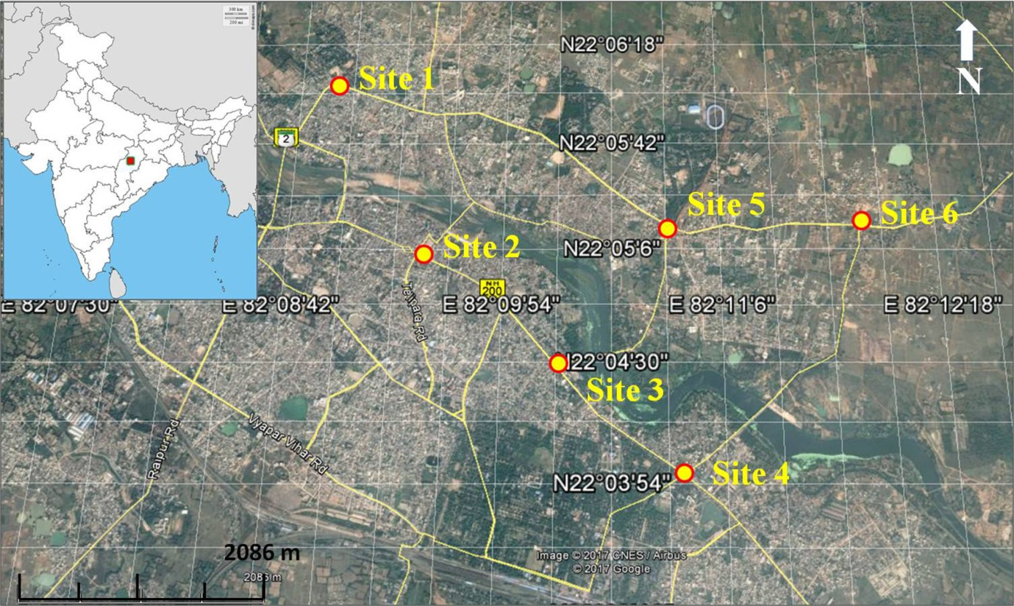
Fig. S1. Geographical locations of the study sites in Bilaspur, India (source: Google Earth).
Site 1 (F. religiosa) Nootan Chowk, Sarkanda, Bilaspur, traffic square; Site 2 (M. indica) Shanichari Bazaar Chowk, Bilaspur, busiest traffic square in the city; Site 3 (B. monosperma) Dayal Band Chowk, Bilaspur, high traffic density; Site 4 (A. scholaris) Torwa Chowk, Bilaspur, bypass road joining the highway, heavy vehicular load; Site 5 (A. indica) Raj Kishor Nagar Chowk, Bilaspur, dense traffic activity; Site 6 (S. siamea) Mopka, Bilaspur, busy square with light and heavy vehicular traffic loads.

