Cannabidiol attenuates kidney injury and mitochondrial calcium dysregulation in experimental cardiorenal syndrome.

Table of Contents
Supplementary Figure 1. Cannabidiol attenuates cardiac dysfunction and pathological remodeling in experimental cardiorenal syndrome. ......... Page 2

Supplementary Figure 2. Experimental cardiorenal syndrome selectively impairs mitochondrial complex I while preserving mitochondrial membrane potential and respiratory chain complexes II–V. ......... Page 3

Supplementary Figure 3. Cannabidiol administration does not alter renal function, oxidative stress, inflammatory signaling, or mitochondrial function in healthy mice. ......... Page 4

Supplementary Figure 4. Representative renal Doppler ultrasonography confirms that cannabidiol does not alter renal blood flow under physiological conditions. ......... Page 5

Supplementary Table 1. Antibodies used for Western blot analysis…… Page 6

Supplementary Table 2. Sequences of primers used for quantitative real-time PCR (qPCR)..Page 7

Supplementary Table 3. Echocardiographic data …… Page 8

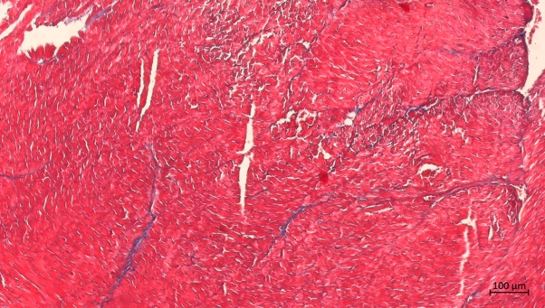
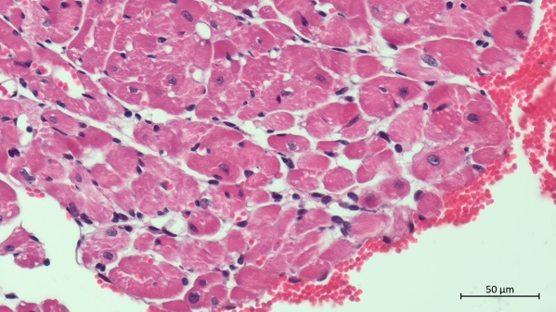
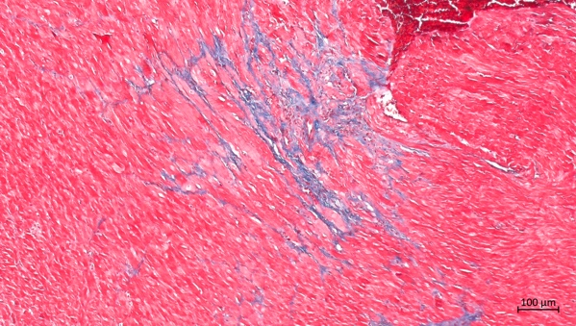
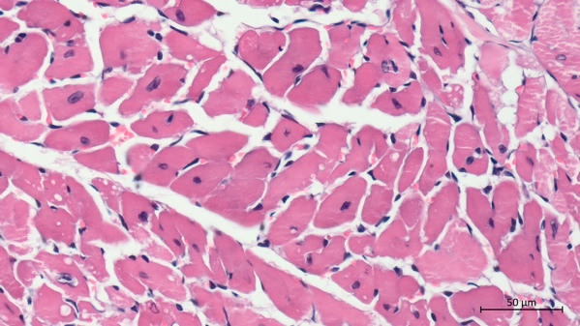
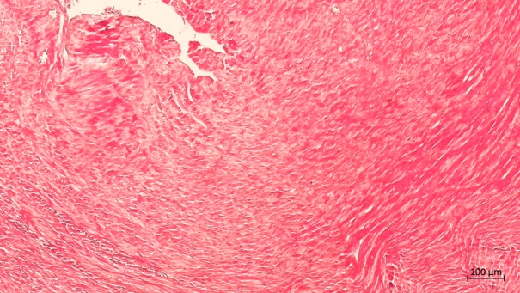
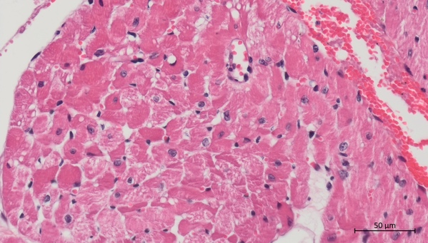
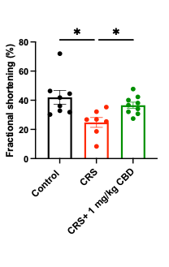
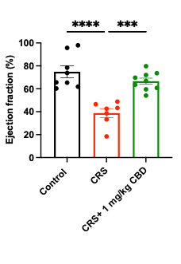
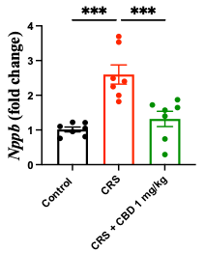
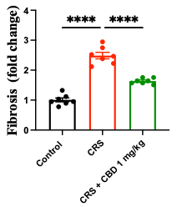
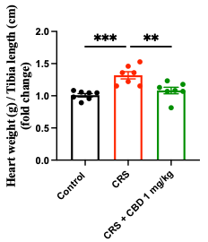
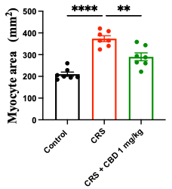
CRS
Supplementary Figure 1. Cannabidiol attenuates cardiac dysfunction and pathological remodeling in experimental cardiorenal syndrome. (A) Representative M-mode echocardiographic images (Control, CRS, CRS+1 mg/kg CBD). (B) Ejection fraction and (C) fractional shortening. (D) Cardiac Nppb (BNP) mRNA expression. (E) Representative H&E and Masson’s trichrome staining. (F) Cardiomyocyte cross-sectional area. (G) Myocardial fibrosis. (H) Heart weight/tibia length. Mean ± SEM; one-way ANOVA, Tukey’s test. *p<0.05, **p<0.01, ***p<0.001, ****p<0.0001.
H
G
F
E
CRS+ 1 mg/kg CBD
Control
D
C
B
A
Supplementary Figure 1. Cannabidiol attenuates cardiac dysfunction and pathological remodeling in experimental cardiorenal syndrome.
Masson
CRS
Control
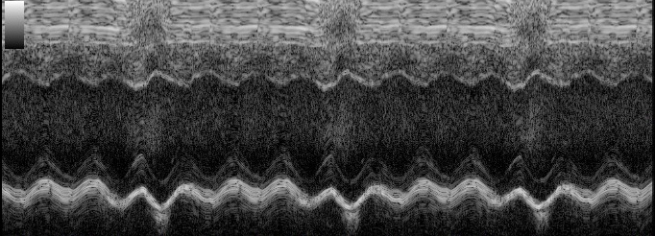
Masson
CRS+1 mg/kg CBD
H&E
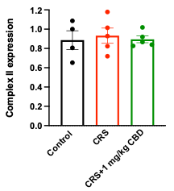
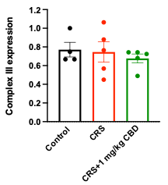
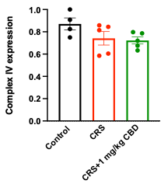
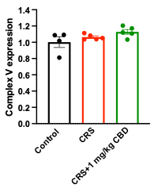
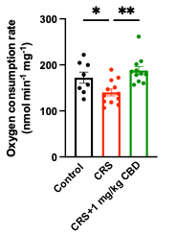
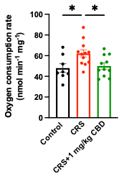
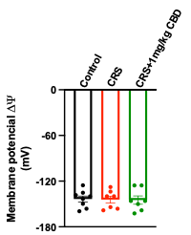
Supplementary Figure 2. Experimental cardiorenal syndrome selectively impairs mitochondrial complex I while preserving mitochondrial membrane potential and respiratory chain complex II-V.
A
B
C
D
E
F
G
Supplementary Figure 2. Experimental cardiorenal syndrome selective mitochondrial complex I dysfunction without alterations in mitochondrial potential or respiratory chain complexes II-V. Representative immunoblots and quantification of complexes II (A), III (B), IV (C), and V (D). Oxygen consumption during state 3 (E) and state 4 (F) respiration. Mitochondrial membrane potential (ΔΨm) assessed by safranin O fluorescence (G). No significant differences were observed among groups for complexes II–V or ΔΨm, indicating preserved respiratory chain integrity outside complex I (Figure 4). Mean ± SEM; one-way ANOVA, Tukey’s test (n = 5–11). *p<0.05, **p<0.01.
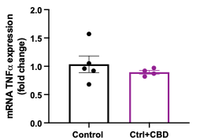
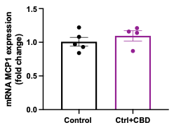
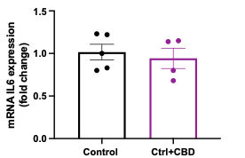
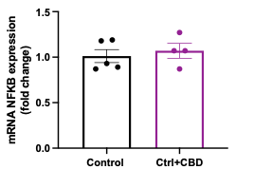
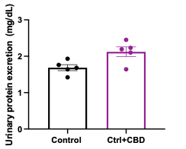
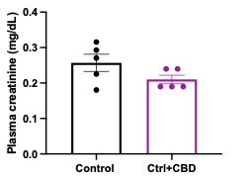
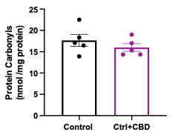
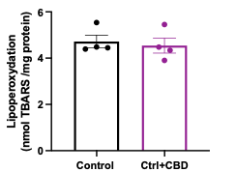
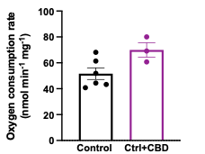
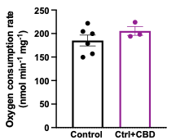
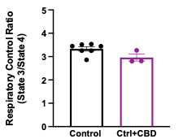
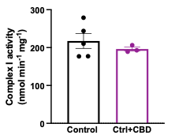
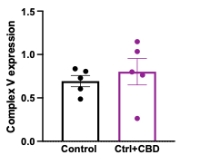
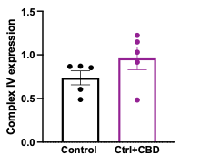
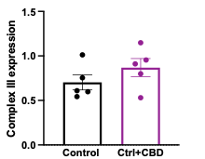
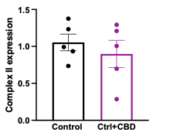
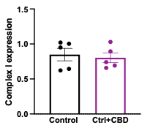
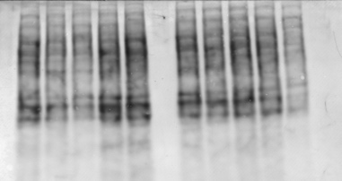
Supplementary Figure 3. Cannabidiol administration does not alter renal function, oxidative stress, inflammatory signaling, or mitochondrial function in healthy mice. (A) Plasma creatinine. (B) Proteinuria. (C) Lipid peroxidation. (D) Protein carbonylation. (E–H) Renal mRNA of Nfkb1, Il6, Ccl2, and Tnfa. (I) Respiratory control ratio. (J–K) State 3 and state 4 oxygen consumption. (L) Complex I activity. (M) Protein expression of respiratory chain complexes. No significant differences were observed between control and CBD-treated mice. Mean ± SEM; Student’s t-test.
M
H
G
F
E
L
K
J
I
D
C
B
A
Supplementary Figure 3. Cannabidiol administration does not alter renal function, oxidative stress, inflammatory signaling or mitochondrial function in healthy mice.
CBS
CI
CII
CIV
CIII
CV
Control
Ctrl +CBD

Supplementary Figure 4. Representative renal Doppler ultrasonography confirms that cannabidiol does not alter renal blood flow under physiological conditions.

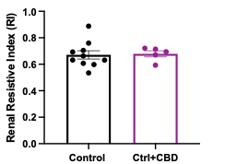
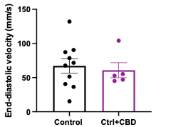
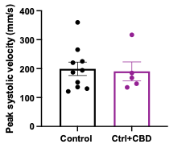
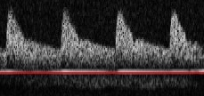
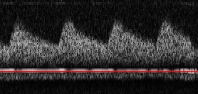
E
D
C
B
A
Ctrl + CBD
Control

Supplementary Figure 4. Cannabidiol does not alter renal Doppler ultrasonographic parameters in healthy mice. Representative renal Doppler images from control (A) and CBD-treated control mice (1 mg/kg, B). Peak systolic velocity (C), end-diastolic velocity (D), and renal resistive index (E). No differences were observed between groups.

Supplementary Table 1. Antibodies used for Western blot analysis
Antibody | Supplier | Catalog No. | Dilution
SerpinA3K | Proteintech | 55480-1 | 1:2500
PGC-1α | Santa Cruz Biotechnology | sc-517380 | 1:1000
TFAM | Santa Cruz Biotechnology | sc-166965 | 1:1000
MCU | Cell Signaling Technology | 14997 | 1:2000
Total OXPHOS Rodent WB Antibody Cocktail | Abcam | ab110413 | 1:2000
GAPDH | Santa Cruz Biotechnology | sc-47724 | 1:1000
Abbreviations: SERPINA3K, serpin family A member 3K; PGC-1α, peroxisome proliferator-activated receptor gamma coactivator 1-alpha; TFAM, mitochondrial transcription factor A; MCU, mitochondrial calcium uniporter; OXPHOS, oxidative phosphorylation; GAPDH, glyceraldehyde-3-phosphate dehydrogenase.

Supplementary Table 2. Sequences of primers used for quantitative real-time PCR (qPCR).
Gene | Primer | Sequence (5’–3’)
B-Actin | F | GAAAAGATGACCCAGATCATG
B-Actin | R | ATCACAATGCCAGTGGTAC
IL6 | F | CTTCTTGGGACTGATGCTGGT
IL6 | R | CTCTGTGAAGTCTCCTCTCCG
TNFa | F | CAGAAAGCATGATCCGCGAC
TNFa | R | ATCCCTGGGACCGATCA
MCP1 | F | GTTAACGCCCCACTCACCT
MCP1 | R | AAAAACTACAGCTTCTTTGGGACACCT
NFKB | F | AGCAACCAAAACAGAGGGGA
NFKB | R | TGCAAATTTTGACCTGTGGG
B-Actin: Beta-actin; IL6: Interleukin 6; TNFa: Tumor necrosis factor alpha; MCP1: Monocyte chemoattractant protein 1; NFKB: Nuclear factor kappa B.

Supplementary Table 3. Echocardiographic data
Variable | Control, n=8 | Control+CBD, n=7 | CRS, n=7 | CRS+CBD, n=9
PULMONARY FLOW
Velocity Time Integral (VTI) | 30.24 ± 4.45† | 34.16 ± 5.68†† | 21.11 ± 6.96* | 25.63 ± 6.01
Peak velocity | -764.25 ± 157.83 | -929.68 ± 104.59††† | -579.19 ± 135.77 | -669.50 ± 173.71
Peak Pressure | 2.43 ± 0.93 | 3.51 ± 0.79††† | 1.41 ± 0.71 | 1.91 ± 0.91
Mean velocity | -456.82 ± 90.92† | -530.20 ± 84.96††† | -316.80 ± 83.68* | -375.58 ± 98.10
Mean pressure | 1.26 ± 0.48 | 1.76 ± 0.44††† | 0.69 ± 0.35 | 0.94 ± 0.45
Total time | 67.02 ± 7.02 | 64.42 ± 2.88 | 66.14 ± 13.25 | 69.94 ± 13.83
LEFT VENTRICULAR SYSTOLIC FUNCTION AND STRUCTURE
SA FS (%) | 41.95 ± 13.54 | 41.50 ± 3.02 | 24.79 ± 8.94 | 36.57 ± 6.29
SA EDV (µL) | 57.98 ± 12.58 | 66.70 ± 32.68 | 60.22 ± 11.88 | 55.04 ± 14.20
SA ESV (µL) | 22.75 ± 11.14 † | 17.76 ± 8.86 †† | 38.53 ± 9.59 * | 17.23 ± 7.42 †††
SA EF (%) | 74.88 ± 14.84 †††† | 72.97 ± 2.99 †††† | 38.81 ± 10.31**** | 66.66 ± 7.96 †††
SA PWTH (%) | 66.66 ± 37.03 | 56.11 ± 29.23 | 32.38 ± 22.14 | 42.29 ± 24.06
SA LV mass (Uncorrected)(mg) | 116.11 ± 35.73 | 132.95 ± 83.12 | 160.66 ± 19.29 | 128.51 ± 32.36
SA SV (µL) | 39.08 ± 7.22 | 48.94 ± 24.24 | 33.89 ± 14.49 | 35.03 ± 11.24
SA CO (mL/min) | 13.87 ± 3.93 | 18.55 ± 9.06 † | 12.12 ± 6.51 | 13.53 ± 5.13
TRANSMITRAL FLOW AND GLOBAL DIASTOLIC INDICES
EA ACC m/s2 | 63.92 ± 43.01 | 72.28 ± 17.71 | 65.55 ± 67.22 | 41.04 ± 21.05
E | 720.53 ± 182.93 | 856.79 ± 126.14† | 555.19 ± 113.56 | 613.44 ± 215.94
DT | 52.17 ± 21.86 | 35.34 ± 15.56 | 50.38 ± 40.32 | 55.18 ± 23.61
A | 452.80 ± 106.53 | 563.14 ± 51.83† | 298.36 ± 111.76 | 386.88 ± 227.12
E/A | 1.60 ± 0.26 | 1.54 ± 0.27 | 2.00 ± 0.41 | 1.78 ± 0.52
IVCT | 19.04 ± 2.54 | 22.84 ± 6.60 | 23.10 ± 5.99 | 20.27 ± 6.89
ET | 63.72 ± 11.80 | 54.72 ± 6.17 | 57.66 ± 11.36 | 61.90 ± 12.32
IVRT | 25.83 ± 5.72 | 24.24 ± 6.18 | 25.66 ± 8.87 | 22.46 ± 4.95
MPI | 0.73 ± 0.12 | 0.90 ± 0.30 | 0.89 ± 0.24 | 0.75 ± 0.18
Values are expressed as mean ± SD. Data were analyzed by one-way ANOVA followed by Holm–Sidak-adjusted pairwise comparisons. Only statistically significant differences versus Control (*) and CRS (†) are indicated. One, two, three, and four repeated symbols indicate p<0.05, p<0.01, p<0.001, and p<0.0001, respectively. Abbreviations: A, late transmitral filling velocity; CO, cardiac output; DT, deceleration time; E, early transmitral filling velocity; E/A, early-to-late transmitral filling velocity ratio; EA ACC, E-to-A acceleration; EDV, end-diastolic volume; EF, ejection fraction; ESV, end-systolic volume; ET, ejection time; FS, fractional shortening; HIR, heart failure with reduced ejection fraction; IVCT, isovolumic contraction time; IVRT, isovolumic relaxation time; LV, left ventricular; MPI, myocardial performance index; PWTH, posterior wall thickening; SA, short-axis; SV, stroke volume; VTI, velocity-time integral.

