Revising river dynamics beyond gauged basins through hybrid ML-based modelling

Yiheng Du* and Ilias G. Pechlivanidis*

Swedish Meteorological and Hydrological Institute, 601 76 Norrköping, Sweden

Supplementary Figures
This section presents 4 figures, which are referenced in Result and Method Sections. We introduce them here to provide additional evaluation of the hybrid modelling framework and supporting information on model uncertainty and observational data availability. Supplementary Figs. 1-2 present complementary performance metrics for low extremes and total volume of the streamflow, using logarithmic Nash-Sutcliffe efficiency (logNSE) and scaled mean absolute error (SMAE), respectively. Supplementary Fig. 3 quantifies uncertainty associated with the spatial selection of training stations across annual and seasonal periods. Supplementary Fig. 4 shows the spatial distribution and temporal availability of the streamflow observations used in the study.

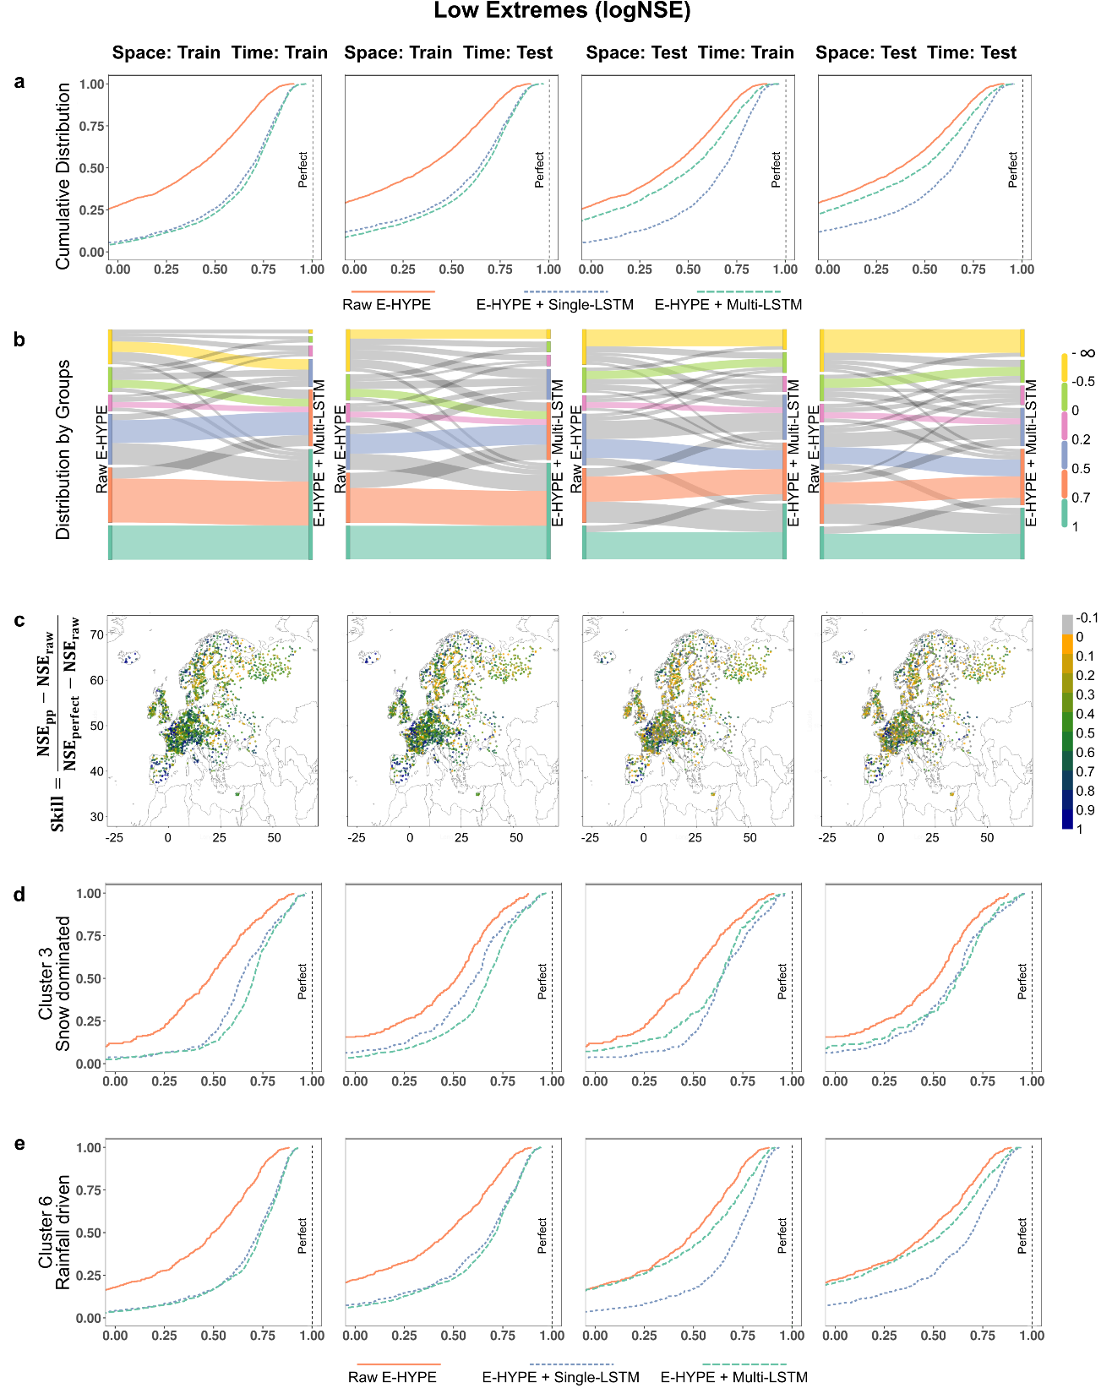
Supplementary Fig. 1 | Hybrid modelling enhances the simulation of low streamflow extremes. a, Cumulative distribution of logarithmic Nash-Sutcliffe efficiency (logNSE) across validation basins for raw (E-HYPE) and post-processed (with single LSTM and Multi-LSTM) simulations. A systematic rightward shift indicates widespread improvement in reproducing low-flow variability. b, Distribution of basins among predefined performance groups before and after post-processing, showing transitions between performance categories. c, Spatial pattern of relative performance changes as skills. Positive values denote improved performance from post-processing. d, Cumulative logNSE distribution for a representative snow-dominated hydrological cluster, where high streamflows are primarily controlled by snow accumulation and melting processes. e, Same as in d, but for a rainfall-driven hydrological cluster, where streamflow response is mainly governed by rainfall.
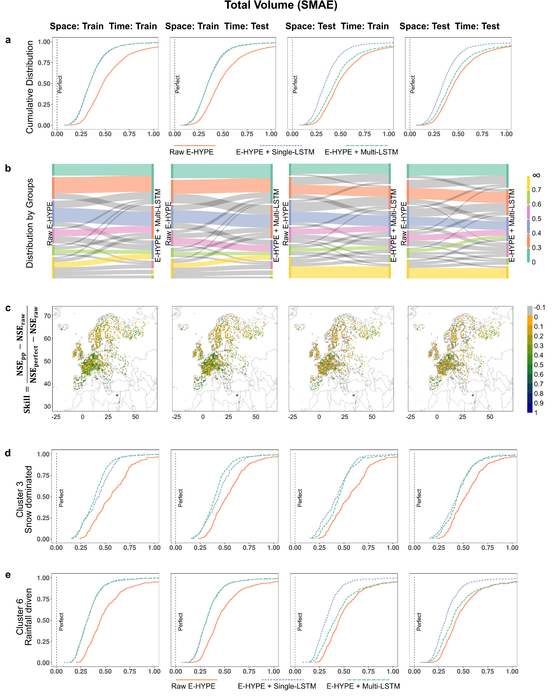
Supplementary Fig. 2 | Hybrid Modelling enhances the simulation of total volume. a, Cumulative distribution of scaled mean absolute error (SMAE) across validation basins for raw (E-HYPE) and post-processed (with single LSTM and Multi-LSTM) simulations. A systematic leftward shift indicates widespread improvement in reproducing total volume. b, Distribution of basins among predefined performance groups before and after post-processing, showing transitions between performance categories. c, Spatial pattern of relative performance changes as skills. Positive values denote improved performance from post-processing. d, Cumulative SMAE distribution for a representative snow-dominated hydrological cluster, where high streamflows are primarily controlled by snow accumulation and melting processes. e, Same as in d, but for a rainfall-driven hydrological cluster, where streamflow response is mainly governed by rainfall.

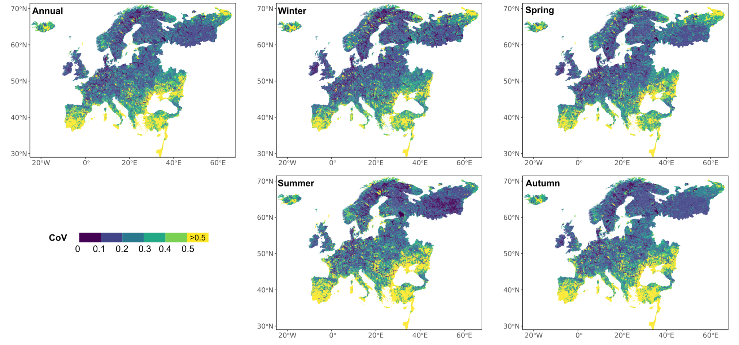
Supplementary Fig. 3 | Model uncertainty due to spatial location of the training stations. Uncertainty is expressed as coefficient of variation (CoV) averaged across the year and seasons (winter (December-February), spring (March-May), summer (June-August) and autumn (September-November)) during 1961-2025.

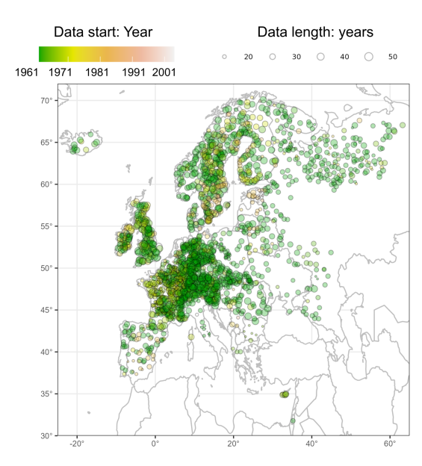
Supplementary Fig. 4 | Availability of streamflow observations. Spatial distribution of the stations used in the study, annotated with the start year and duration of the observational data. This figure is reproduced from panel (b) of Fig. 1 in Du and Pechlivanidis (2025) ³⁵, using the same observational dataset.

