Supplementary Materials

Table 1: Chemicals and Materials

Materials | M. Wt. (g mol⁻¹ | Source | Purity
2-Aminoethanol | 61.08 | Sigma-Aldrich | ≥ 98%
Cinnamaldehyde | 132.16 | Sigma-Aldrich | ≥ 95%
Chloroacetic acid | 94.50 | Sigma-Aldrich | ≥ 99%
4-Methoxybenzaldehyde | 136.15 | Sigma-Aldrich | ≥ 98%
1-Bromododedcane | 249.23 | Sigma-Aldrich | ≥ 97%
Ethyl alcohol | 46.07 | Sigma-Aldrich | ≥ 99.8%
Xylene | 106.17 |  | ≥ 99%
Hydrochloric acid | 36.46 | Sigma-Aldrich | 37% (w/w)

All chemicals were of analytical grade and used as received without further purification.

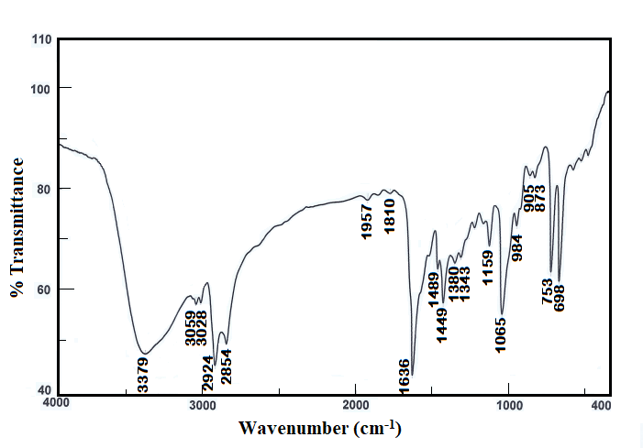
Fig. 1. FTIR spectra of 2-(((1E,2E)-3-phenylallylidene)amino)ethan-1-ol.
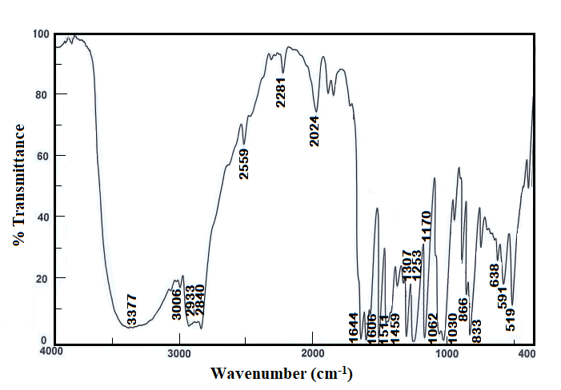
Fig. 2. FTIR spectra of (E)-2-((4-methoxybenzylidene)amino)ethan-1-ol.

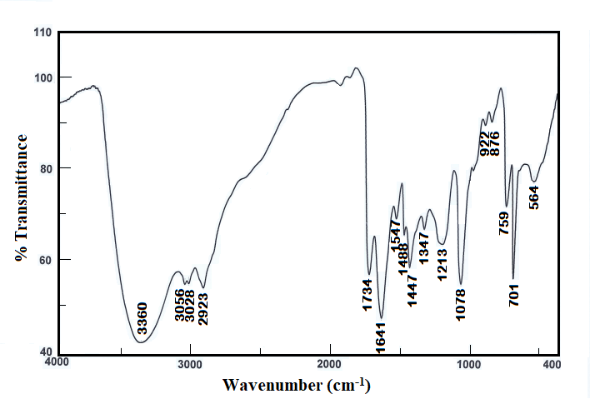
Fig. 3. FTIR spectra of 2-(((1E,2E)-3-phenylallylidene)amino)ethyl-2-chloroacetate.
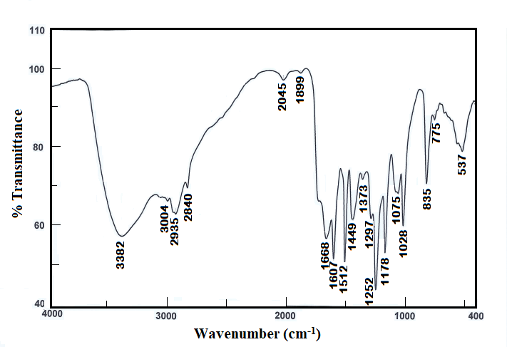
Fig. 4. FTIR spectra of (E)-2-((4-methoxybenzylidene)amino)ethyl-2-chloroacetate.

Fig. 5. Curve of (ɳ_{w} against –log C) plot of Surfactant (1) at different temperatures.

Fig. 6. Curve of (ɳ_{w} against –log C) plot of Surfactant (2) at different temperatures.
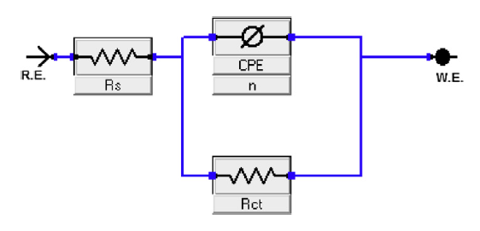
Fig. 7. The equivalent circuit used for the pattern of calculated impedance measurements of CS in a 1 M HCl solution in presence and absence of varying concentrations of surfactant (1) and surfactant (2).

Fig. 8. Plot (ln K_{ads} vs. 1/T) for CS in 1 M HCl solution containing different concentrations of Surfactant (1) & Surfactant (2).

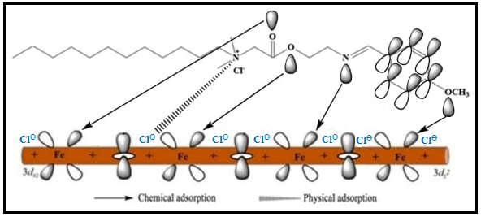
Fig. 9. Corrosion inhibition mechanism (physical and chemical adsorption) scheme of Surfactant (2) on CS surface.

