Supplementary Figures

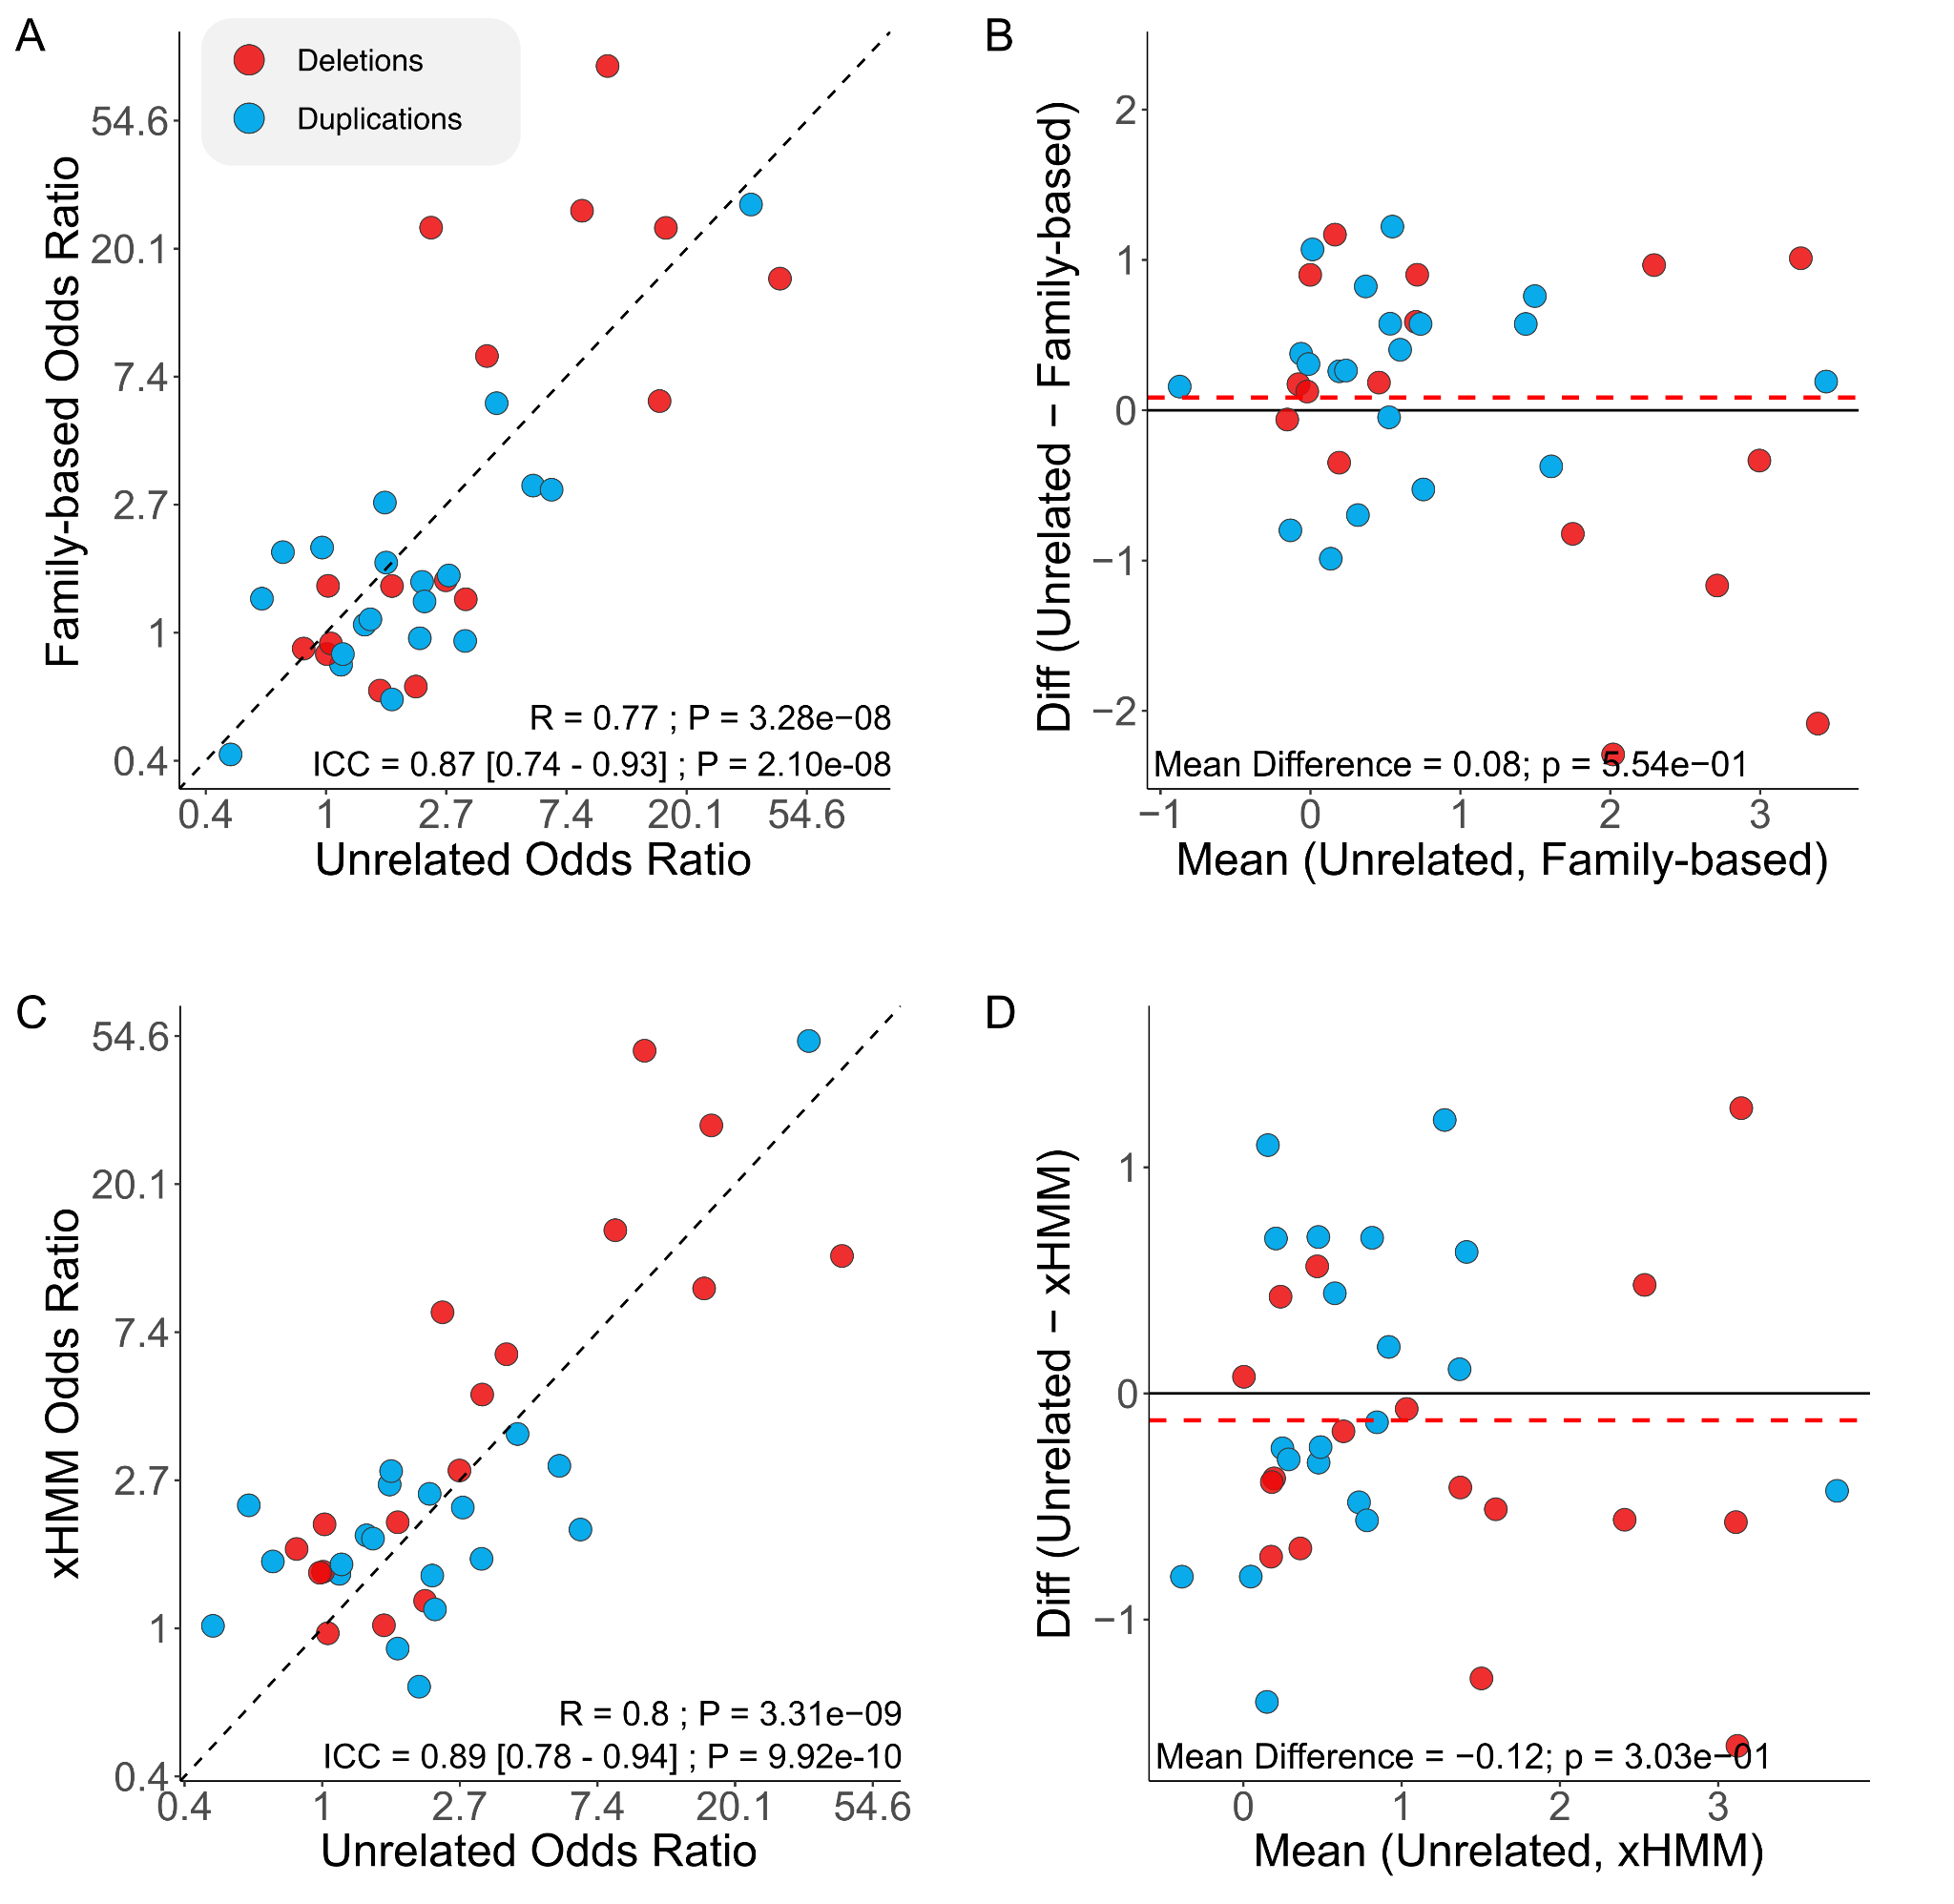
Figure S1. Correlation and systematic bias of recurrent CNV effect estimates across ASD analyses
(A) Comparison of effect size estimates for recurrent CNVs between unrelated case-control and family-based analyses. R indicates the Pearson correlation between the two sets of estimates, while ICC represents the intraclass correlation coefficient as a measure of concordance. (B) Bland–Altman plot showing the agreement between two analyses. The mean difference represents the systematic bias between the two analyses and is derived from a paired t-test comparing the two sets of estimates. (C–D) Same as A–B, but comparing extra-familial and exome-based (xHMM) estimates.

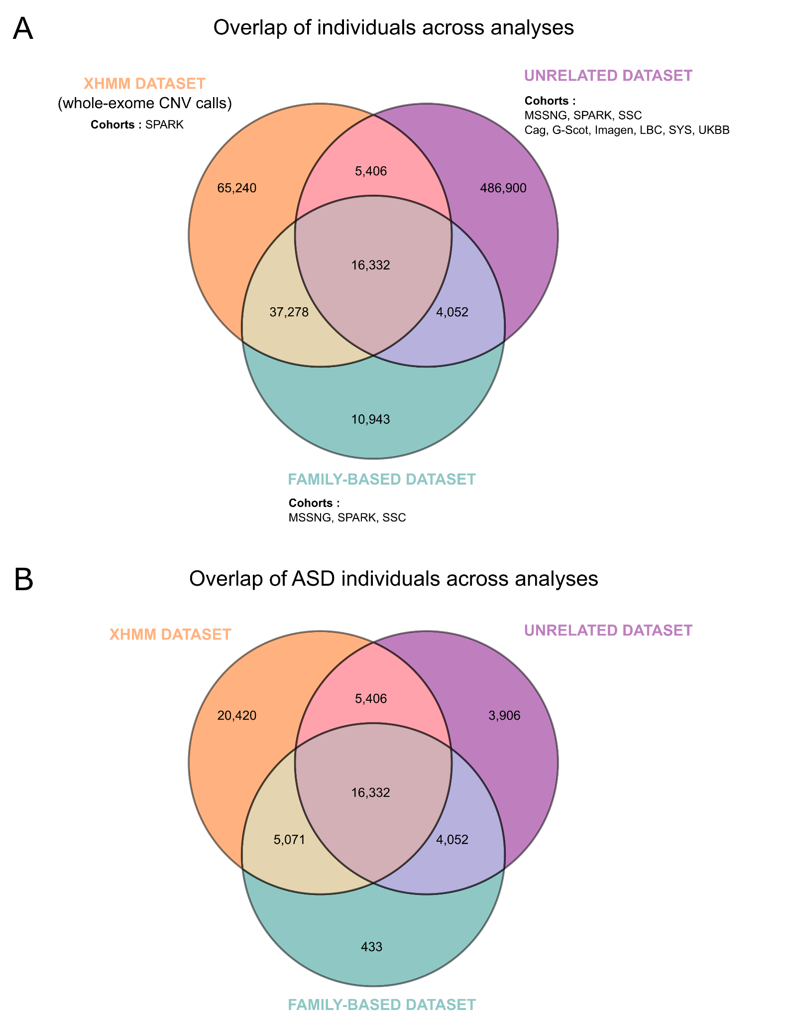
Figure S2. Overlap of individuals across analyses
(A) Venn diagram showing the overlap of all individuals across the three analytical datasets: unrelated, family-based (related), and exome-based (xHMM). (B) Same as A but restricted to individuals with an ASD diagnosis.
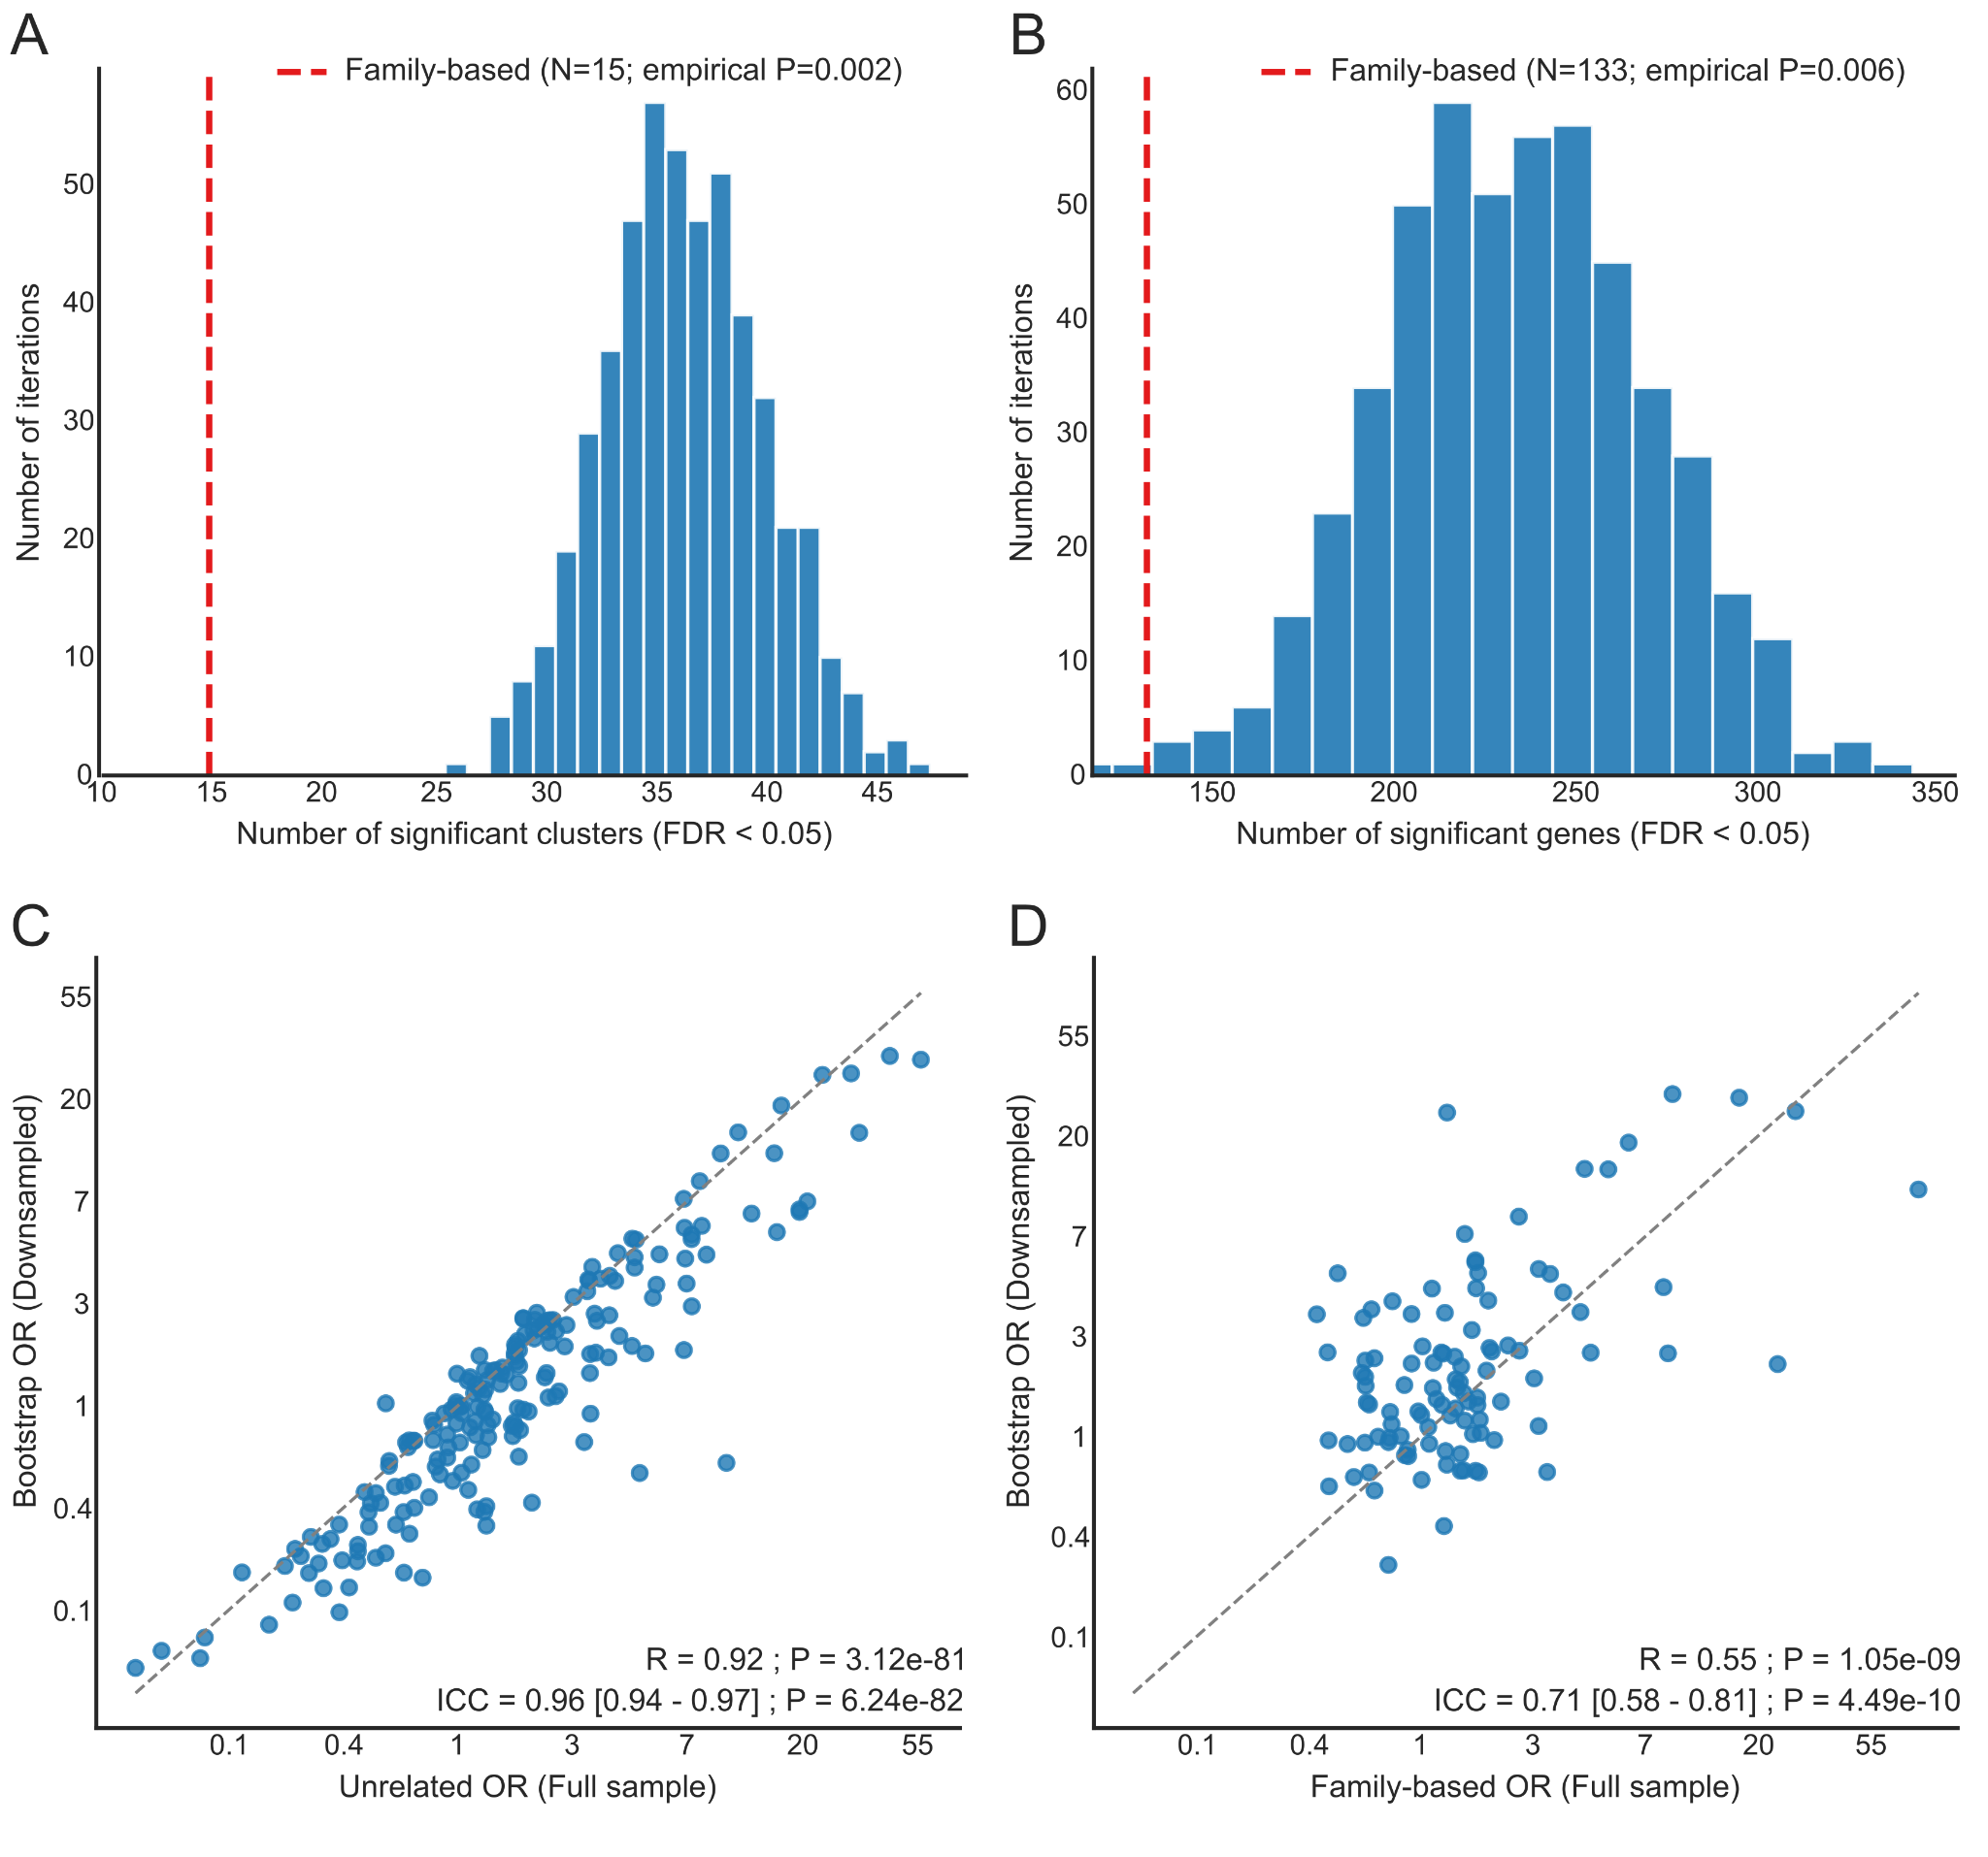Figure S3. Downsampling of the unrelated case-control dataset to the family-based sample size.
To test whether the greater number of associations detected in the unrelated case-control design reflects design properties rather than sample size alone, we repeatedly downsampled the unrelated dataset to match the family-based case: control ratio and sample size (N = 500 iterations) and re-ran the ASD CNV-GWAS in each iteration.
(A) Distribution of the number of significant gene clusters (FDR < 0.05) across the 500 downsampled iterations. The dashed red line indicates the count observed in the family-based analysis (N = 15; empirical P = 0.002). (B) Same as (A) for the number of significant genes (family-based N = 133; empirical P = 0.006). (C) Correlation between per-cluster odds ratios from the full unrelated analysis and the mean across downsampled iterations. (D) Correlation between per-cluster odds ratios from the full family-based analysis and the downsampled unrelated estimates.
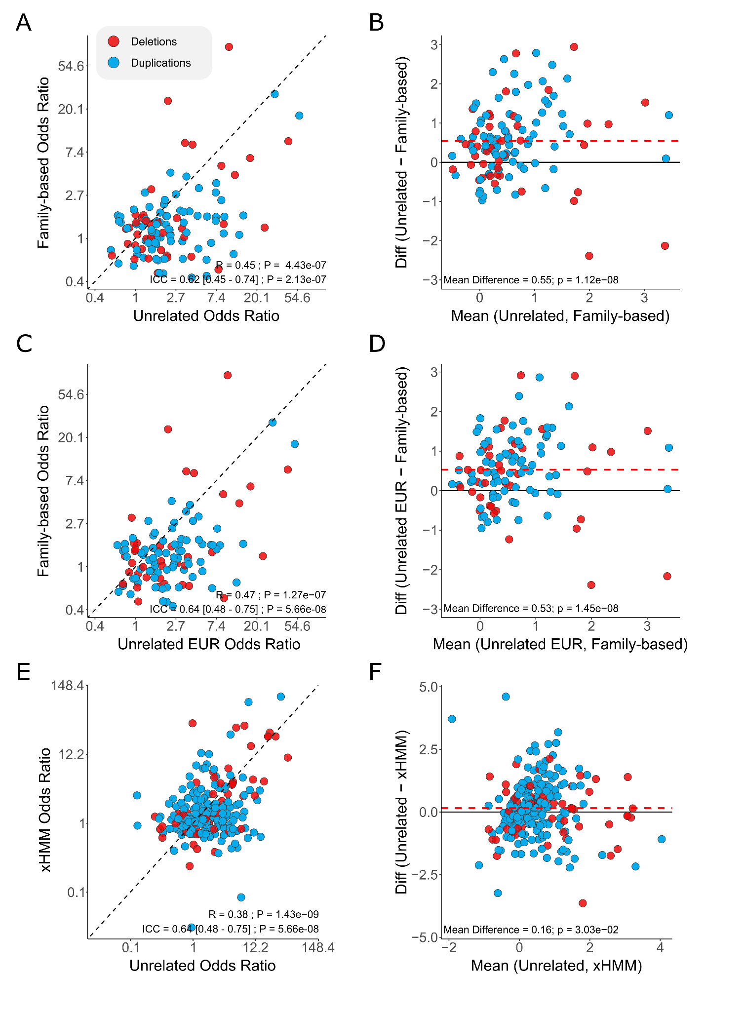
Figure S4. Correlation and systematic bias of gene cluster estimates across ASD analyses
(A) Comparison of effect size estimates for gene clusters between extra-familial and intra-familial datasets. R indicates the Pearson correlation between the two sets of estimates, while ICC represents the intraclass correlation coefficient as a measure of concordance.
(B) Bland–Altman plot showing the agreement between two analyses (extra- and intra-familial analyses). The mean difference represents the systematic bias between the two analyses and is derived from a paired t-test comparing the two sets of estimates. (C–D )Same as A–B but comparing European-only extra-familial and intra-familial estimates. (E–F) Same as A–B but comparing extra-familial and exome-based (xHMM) estimates.
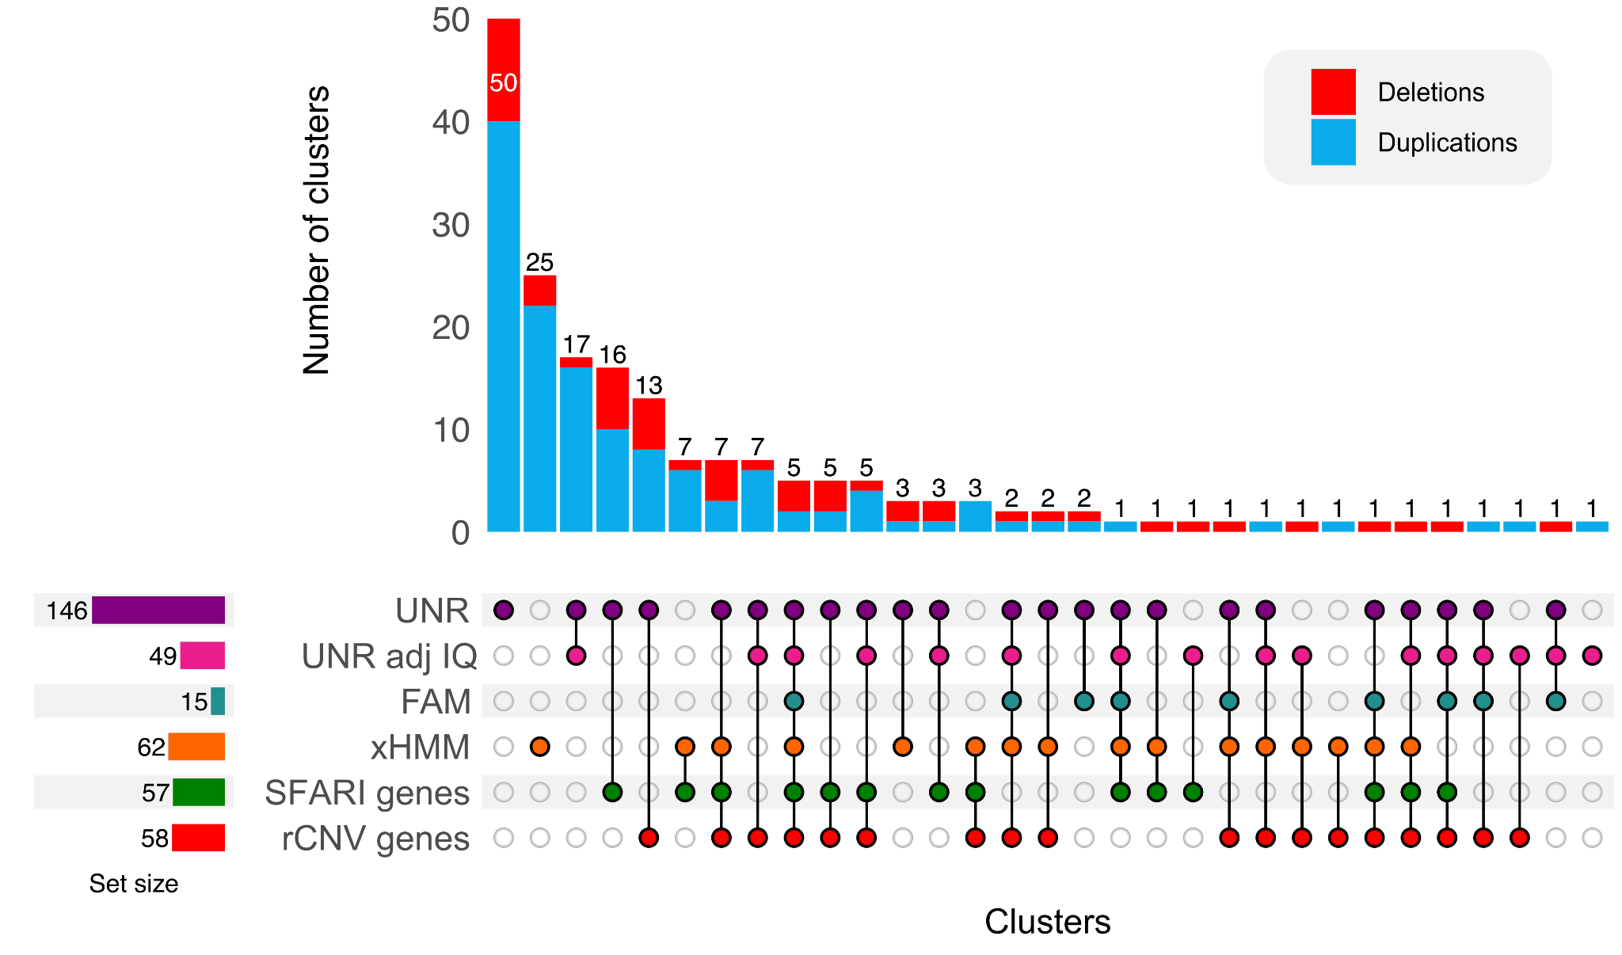
Figure S5. Overlap of significant gene clusters across ASD analyses.
Upset plot showing the overlap of significant gene clusters (FDR q < 0.05) across ASD analyses. UNR and UNR adj IQ represent clusters identified with unrelated controls without and with adjustment for cognitive ability, respectively. FAM refers to the family-based analysis and xHMM to the sensitivity analysis using whole-exome CNV calls from SPARK. SFARI genes and rCNV genes denote clusters overlapping genes from the SFARI database or the recurrent CNV list, respectively.
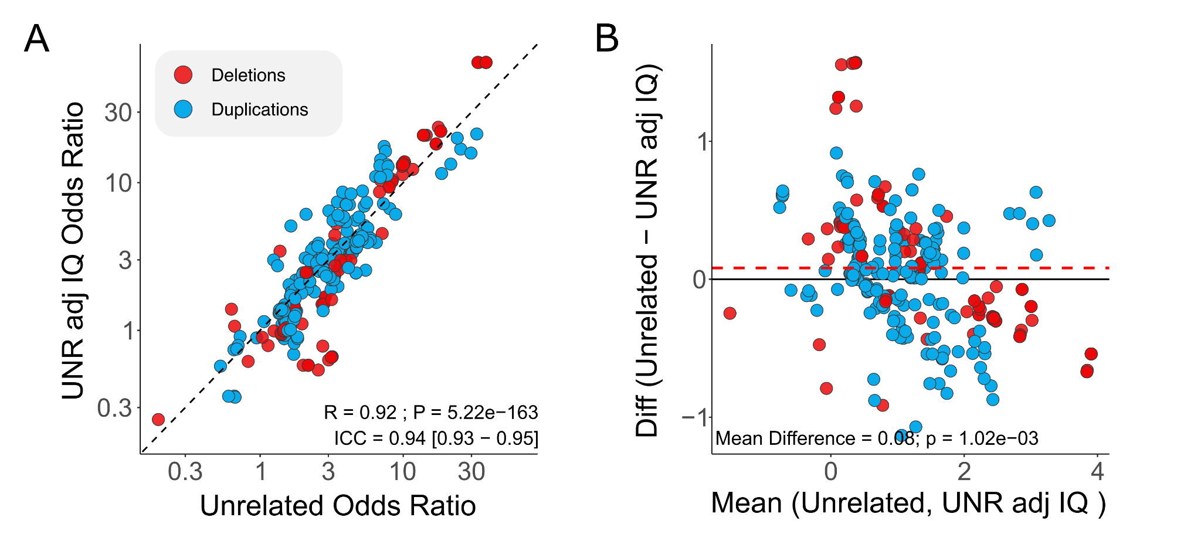
Figure S6. ASD CNV-GWAS estimates before and after adjustment for cognitive ability
(A) Comparison of effect size estimates for gene clusters in the unrelated case-control analysis of ASD, without and with adjustment for cognitive ability. R indicates the Pearson correlation between the two sets of estimates, while ICC represents the intraclass correlation coefficient as a measure of concordance.
(B) Bland–Altman plot showing the agreement between two analyses. The mean difference represents the systematic bias between the two analyses and is derived from a paired t-test comparing the two sets of estimates.

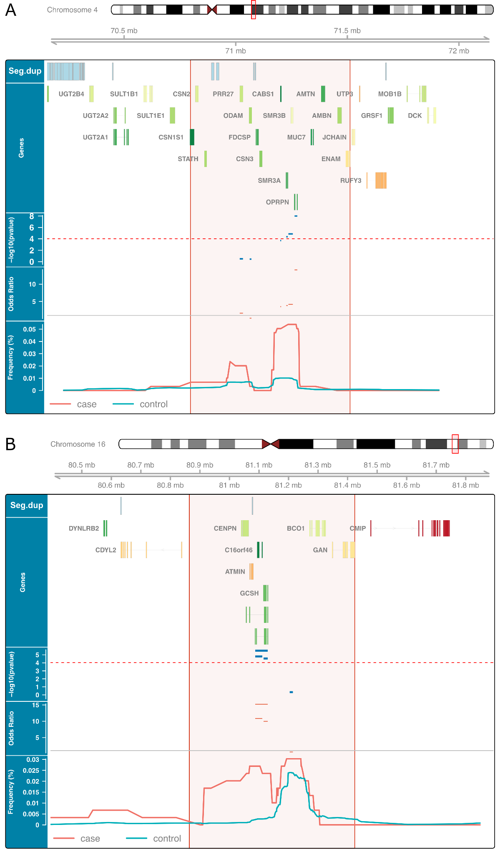
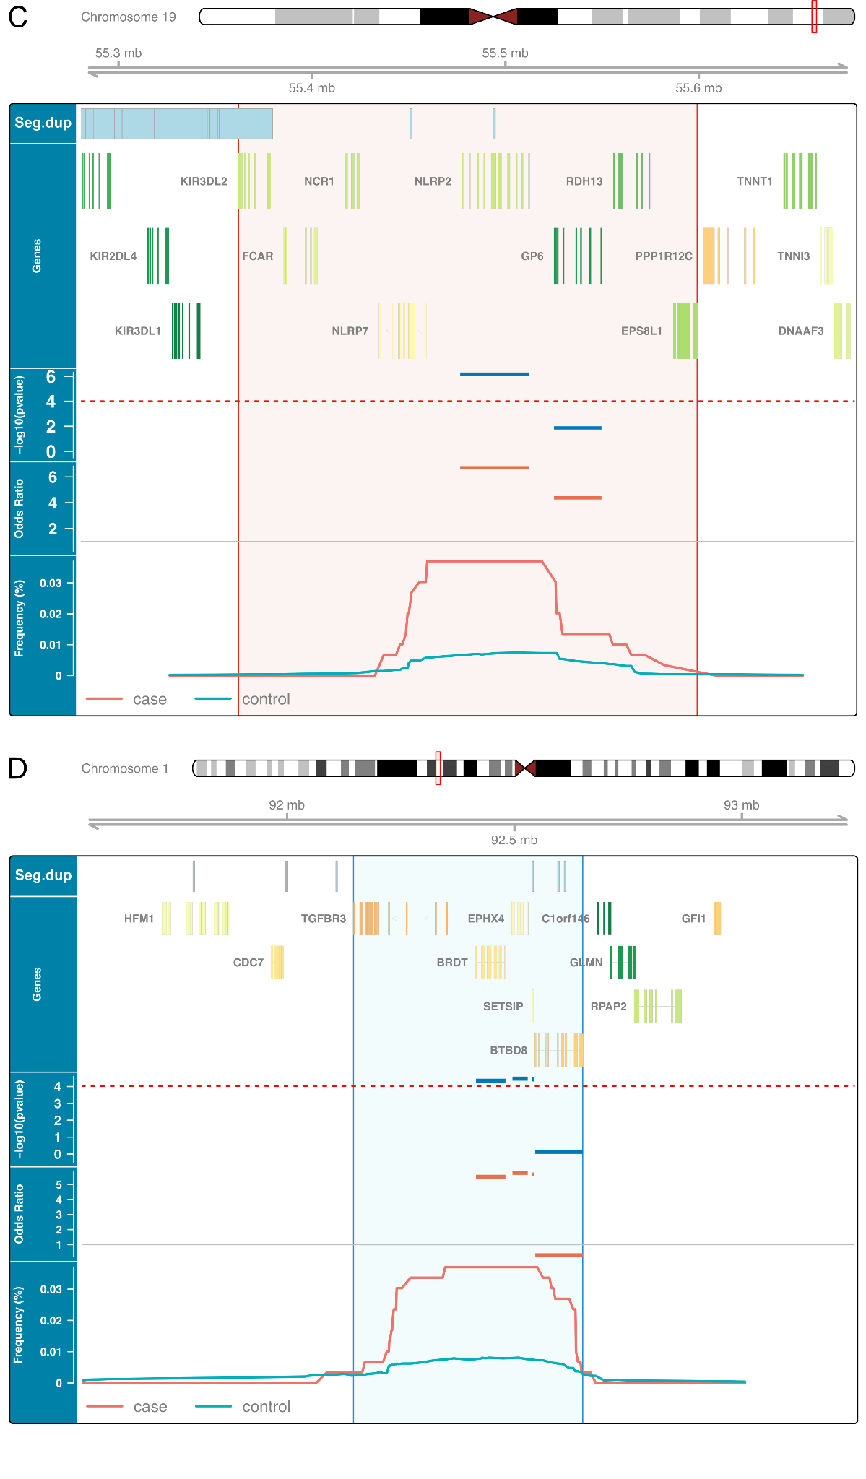
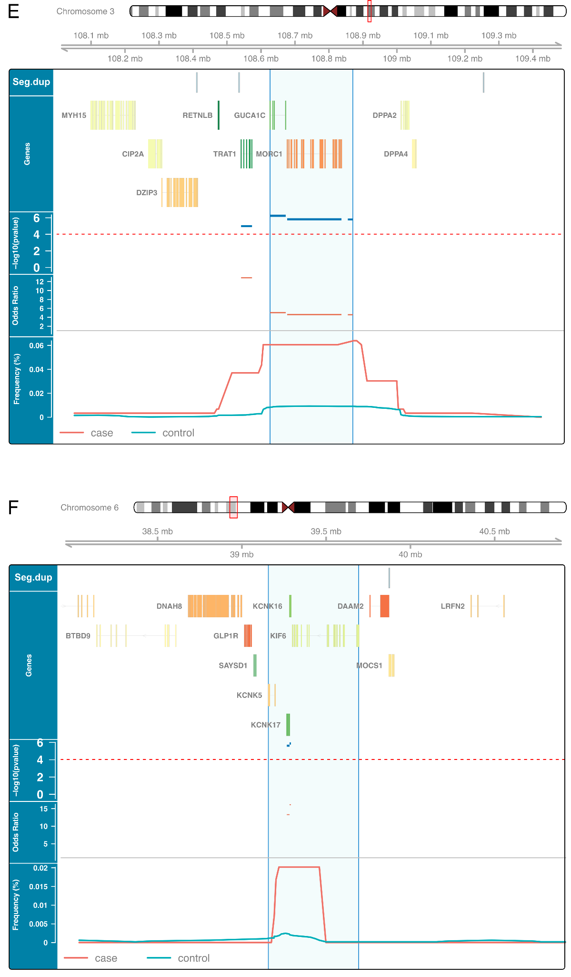
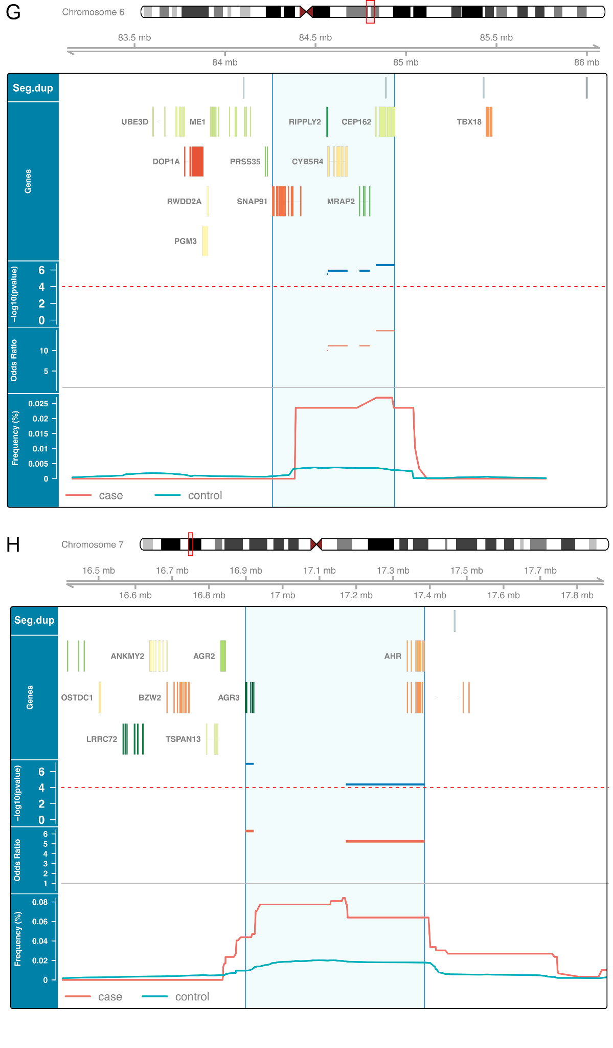
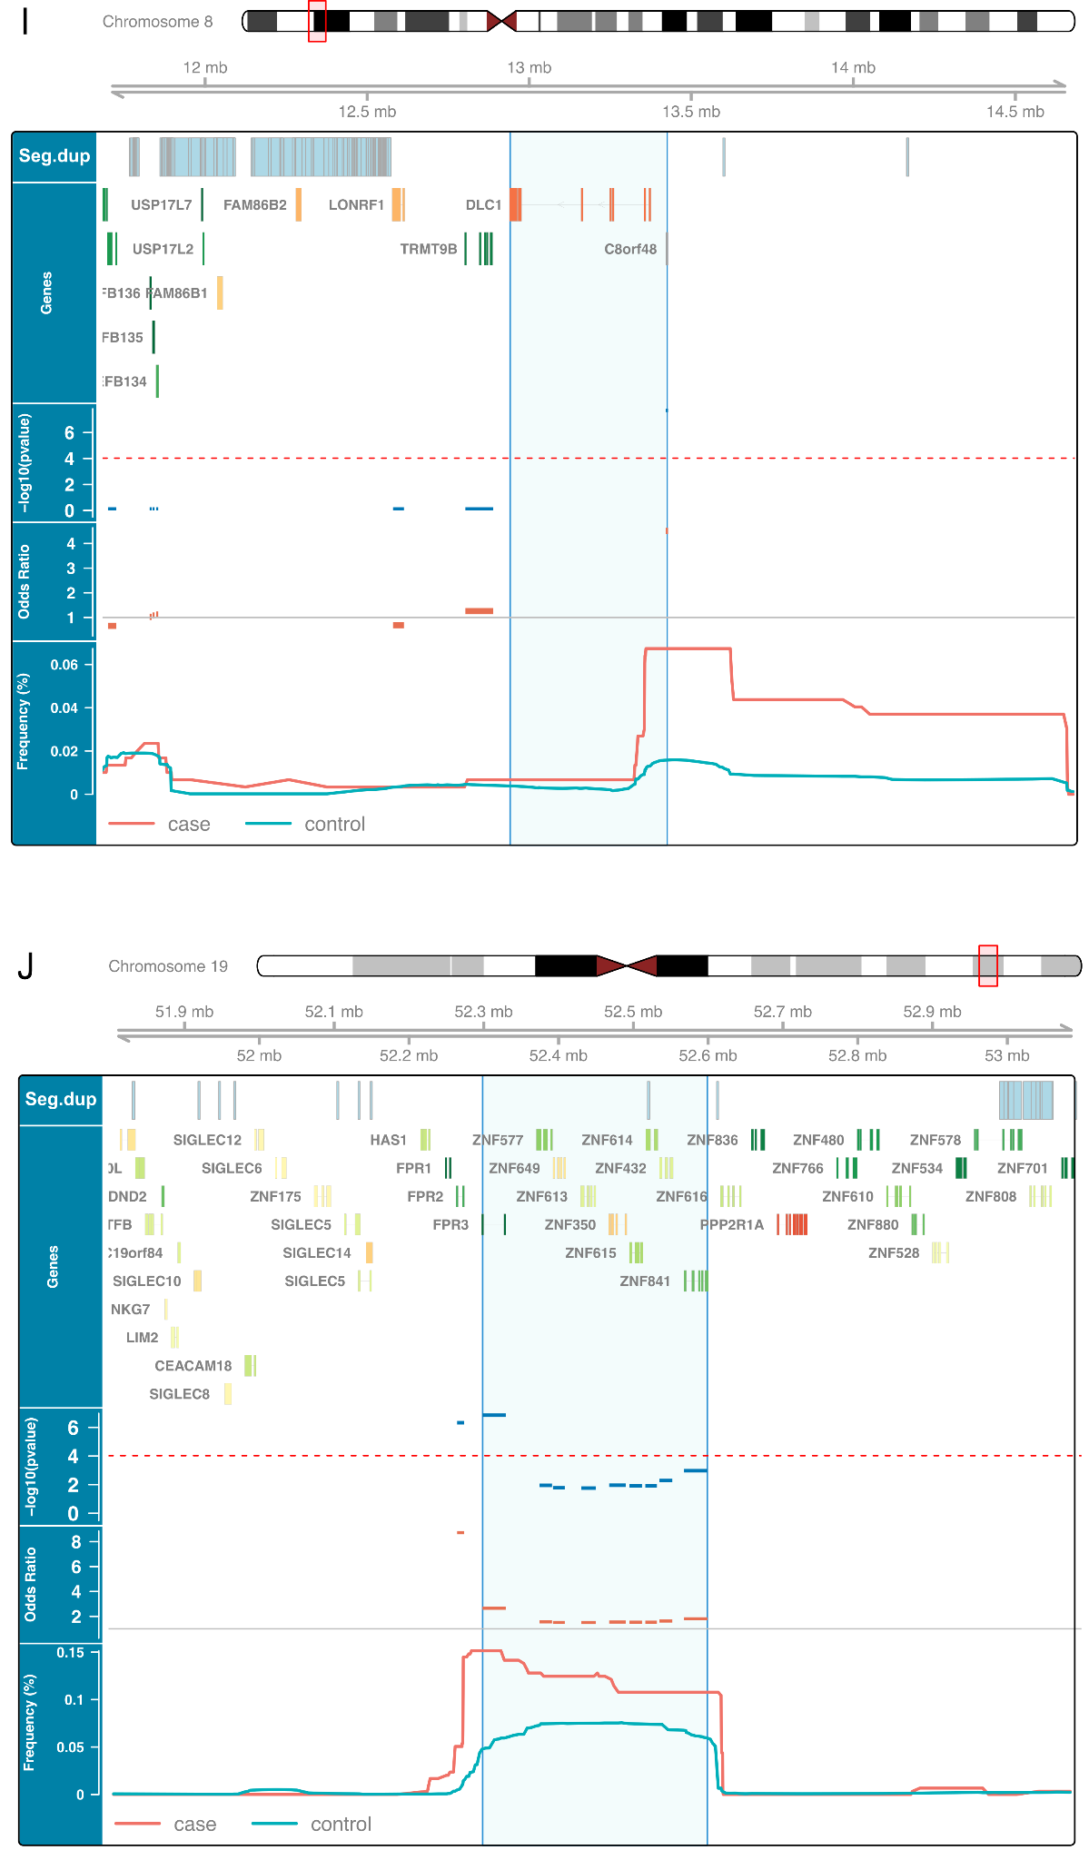
Figure S7. Novel ASD-associated loci without prior evidence of association with neurodevelopmental or psychiatric conditions.
Each panel (A–J) displays a genomic locus identified in the unrelated ASD CNV-GWAS: (A) Del. 4q13, (B) Del. 16q23, (C) Del. 19q13, (D) Dup. 1p22, (E) Dup. 3q13, (F) Dup. 6p21, (G) Dup. 6q14, (H) Dup. 7p21, (I) Dup. 8p22, (J) Dup. 19q13.
For each locus, tracks display from top to bottom: segmental duplications, gene annotations colour-coded by LOEUF score, gene-level association statistics (−log₁₀ p-value), odds ratios, and CNV frequencies in cases (red) and controls (cyan). The dashed horizontal line indicates the Bonferroni significance threshold. Vertical lines denote the boundaries of the ASD-associated gene cluster. All association statistics are derived from the unrelated case-control analysis.

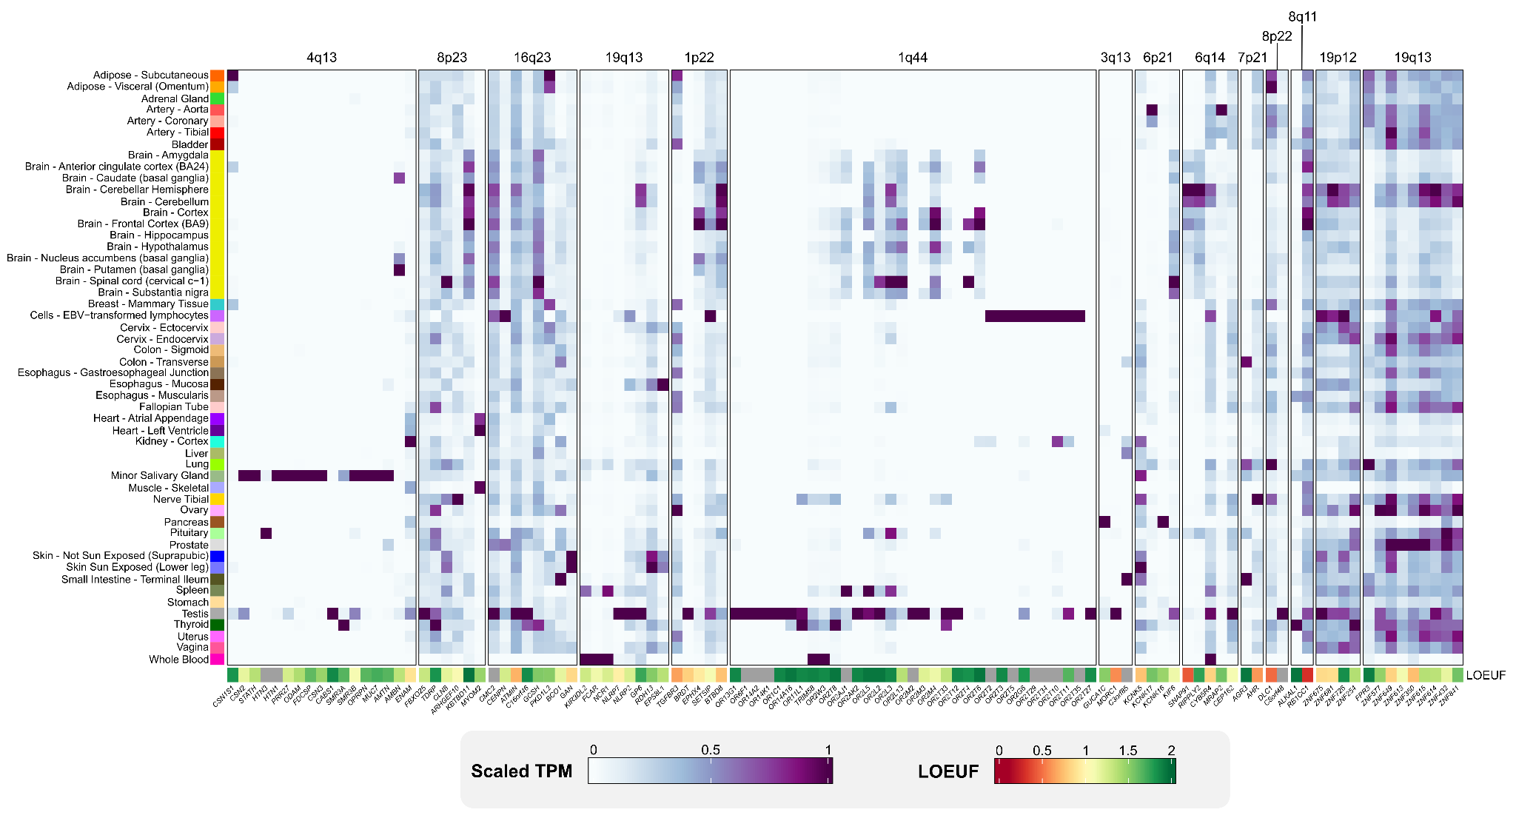
Figure S8. Gene expression across tissues for genes in novel ASD-associated loci
Each column represents a gene included in one of the 14 novel ASD-associated loci identified by the unrelated ASD CNV-GWAS and detected in GTEx tissues. Gene expression data are derived from GTEx v10 (RNASeQC v2.4.2, median TPM across donors) and scaled per gene using min-max normalization. Genes are grouped by genomic region (columns), and tissues are shown in rows. The bottom bar indicates the Loss-of-Function Observed/Expected Upper bound Fraction (LOEUF).
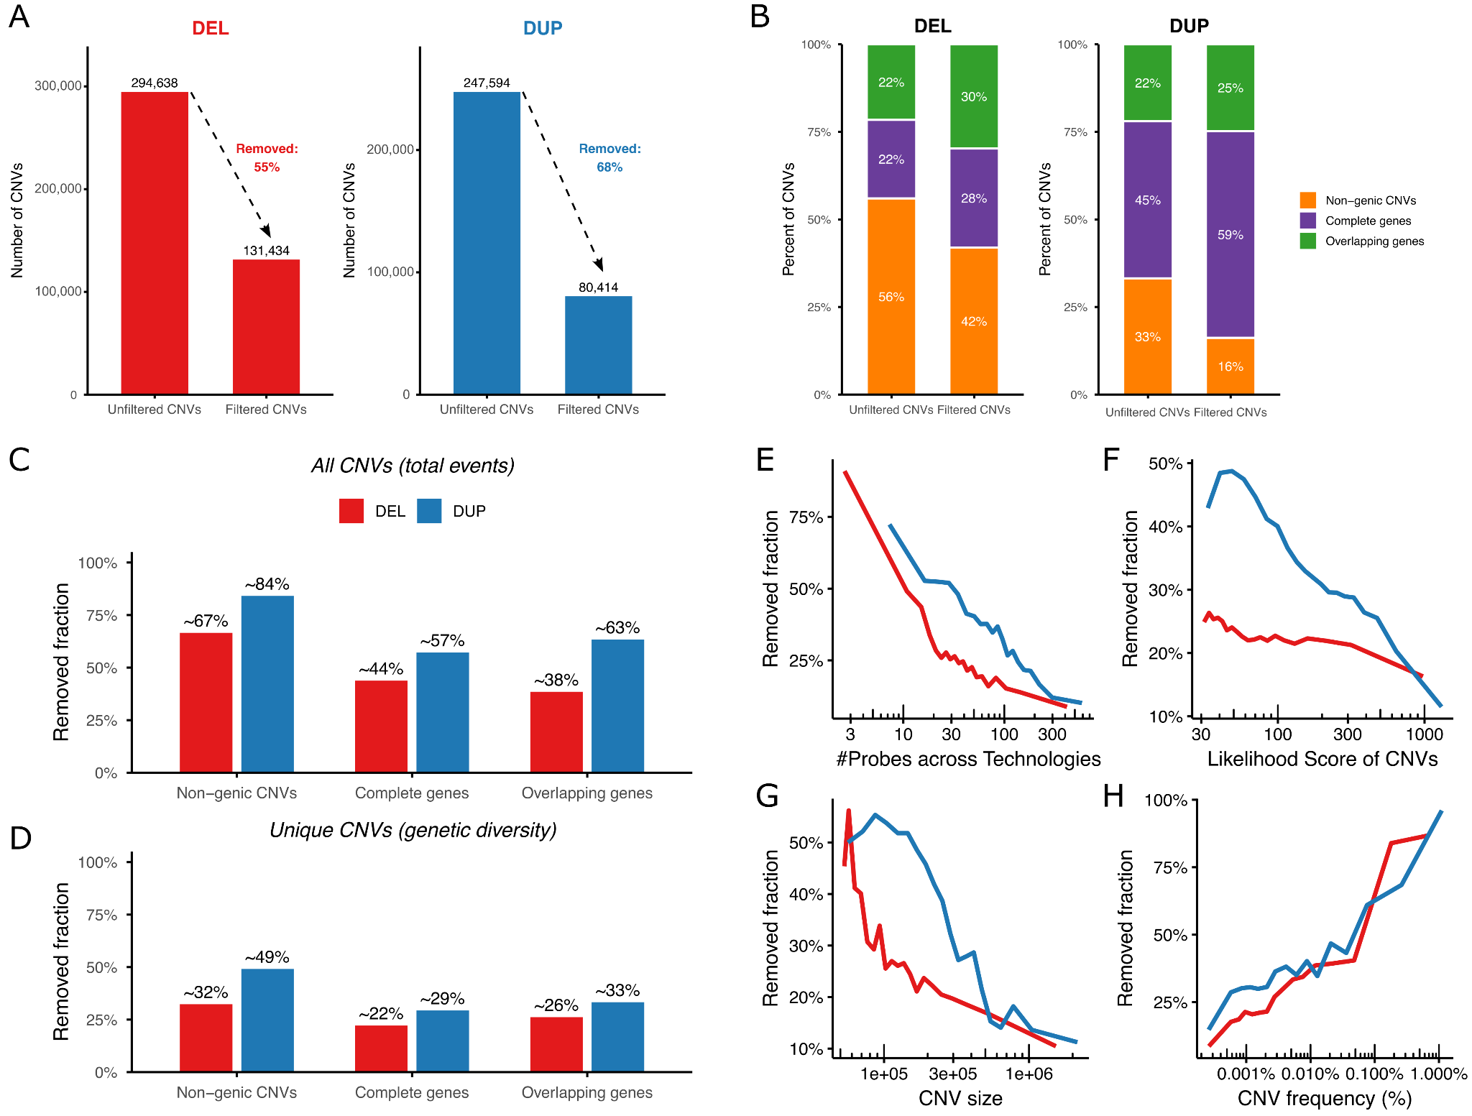
Figure S9. Quality control filtering of CNVs with heterogeneous frequencies
(A) Number of CNVs for deletions (DEL) and duplications (DUP) before and after applying our filtering process, which excludes CNVs with heterogeneous frequencies across technologies, cohorts, and batches. (B) Composition of the dataset before and after filtering. Non-genic CNVs (orange) do not encompass any gene. Complete genes (purple) are CNVs fully encompassing at least one gene. Overlapping genes (green) are CNVs partially overlapping (disrupting) one or more genes. (C) Fraction of CNVs removed from the dataset for each category (Non-genic CNVs, Complete genes, and Overlapping genes), separately for deletions (DEL) and duplications (DUP). (D) Same as (C), but computed on unique CNVs only, representing the genetic diversity removed from the dataset. (E-H) Fraction of CNVs removed across bins of (E) median number of probes across technologies, (F) likelihood score of the CNV call, (G) CNV size, and (H) CNV frequency in the general population, separately for deletions (red) and duplications (blue). CNVs were divided into 20 equally sized bins based on quantiles of each variable.
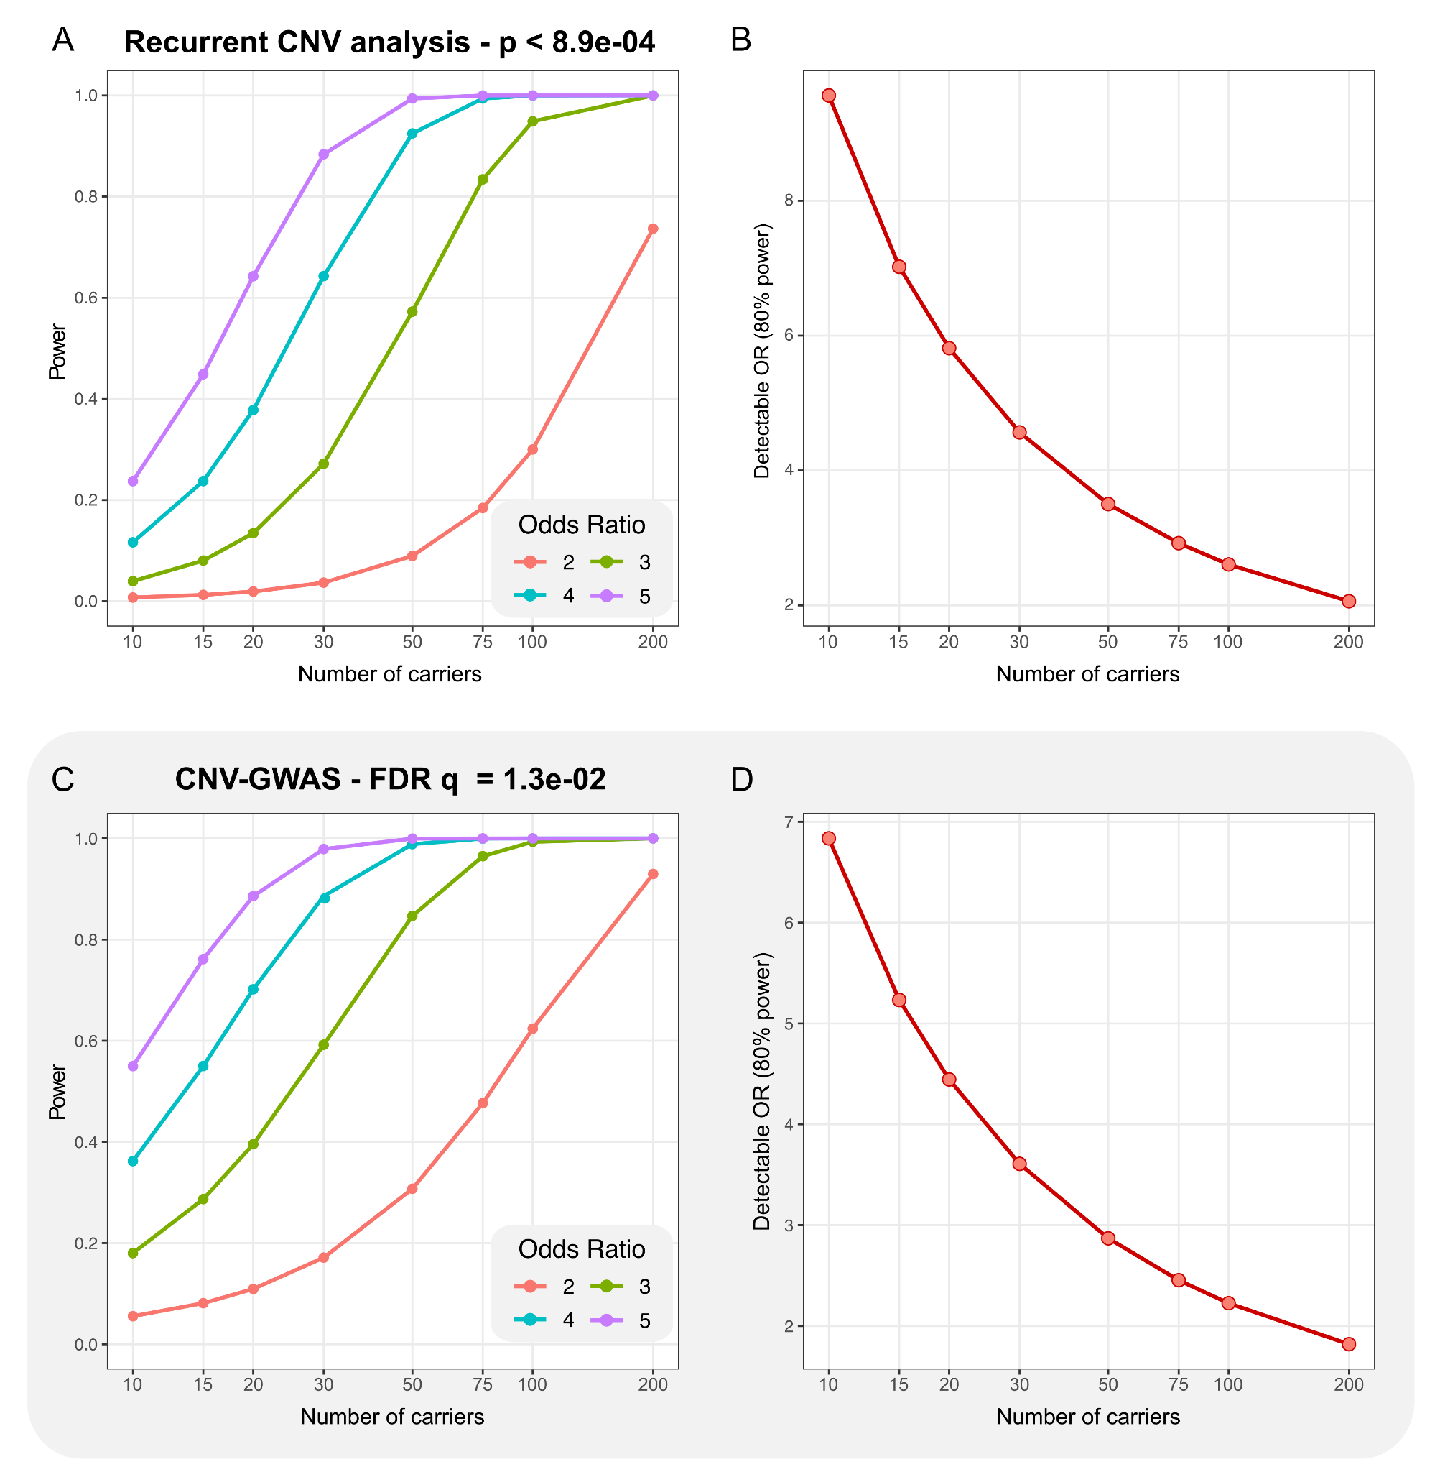
Figure S10. Power analysis for the minimum carrier threshold used in the recurrent CNV and CNV-GWAS analyses.
Power calculations were performed using the unrelated control dataset with the genpwr R package, with a logistic regression model and dominant true and test models, across a range of carrier counts (10–200) and odds ratios. (A–B) Power calculations for the Recurrent CNV analysis, using the Bonferroni threshold (p < 8.9e-04). (A) Statistical power to detect associations as a function of the number of carriers, shown for odds ratios of 2, 3, 4, and 5. (B) Minimum odds ratio that can be detected with 80% power as a function of the number of carriers. (C–D) Same analyses for the CNV-GWAS, using the FDR-corrected significance threshold (p = 1.3e-02). At the minimum threshold of 15 carriers used in this study, both analyses were well-powered (>80%) to detect large-effect CNVs (OR ≥ 7.0 for recurrent CNVs; OR ≥ 5.2 for the CNV-GWAS).

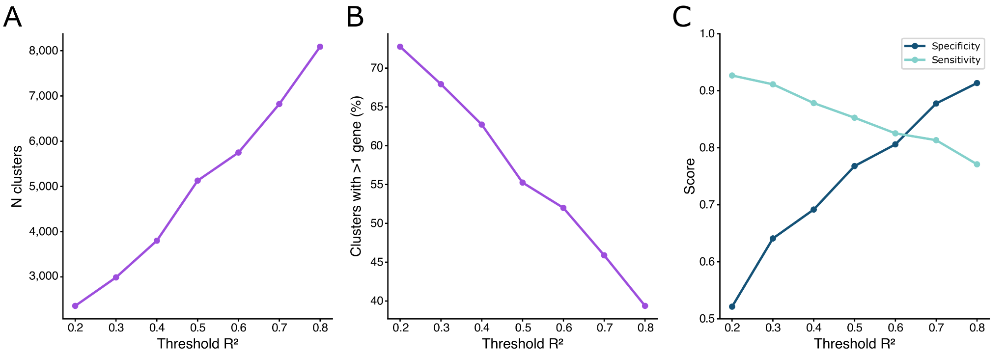
Figure S11. Selection of the r² threshold for gene cluster definition
Gene clusters were defined by grouping genes encompassed within CNVs shared by the same carriers, based on the squared Pearson correlation coefficient (r²) between carrier frequencies. To select an appropriate threshold, clusters obtained across a range of r² values (0.2–0.8) were evaluated based on the total number of clusters, the proportion of multi-gene clusters, and their ability to capture the gene sets of known recurrent CNVs. This clustering was performed on all genes encompassed within CNVs across the genome, independent of the minimum carrier count threshold applied in the CNV-GWAS. The number of clusters shown here is therefore not directly comparable to the number of clusters tested in the ASD CNV-GWAS.
(A) Number of gene clusters identified genome-wide at each threshold. (B) Percentage of clusters containing more than one gene at each threshold. (C) Sensitivity and specificity of clusters in capturing recurrent CNV gene sets at each threshold. For each recurrent CNV, sensitivity and specificity were computed using the largest overlapping cluster, then averaged across all recurrent CNVs. An r² threshold of 0.5 was selected within the range yielding comparable sensitivity and specificity, balanced against the total number and multi-gene composition of clusters.

