Urban Genomics in a Rapidly Urbanizing Megacity Reveals Layered Cardiometabolic Genetic Architecture

Running title: Genomic Structure of SHANGHAI Cohort
Ruoning Hu¹†, Jia Wen^{1,2}†, Yang Gao¹†, Huanyu Lin², Weishun Zeng², Yu Chai¹, Jingchun Luo², Yan Zheng¹, Yan Lu^{1,2}, The Han100K Initiative##, Li Jin^{1,2,}*, Shuhua Xu^{1,2,3*}

¹State Key Laboratory of Genetics and Development of Complex Phenotypes, Center for Evolutionary Biology, School of Life Sciences, Fudan University, Shanghai 200438, China;
²Human Phenome Institute, Zhangjiang Fudan International Innovation Center, Fudan University, Shanghai 201203, China
³Inner Mongolia Key Laboratory of Life Health and Bioinformatics, School of Life Science and Technology, Inner Mongolia University of Science and Technology, Baotou 014010, China.
†These authors contributed equally to this work;
*Correspondence and requests for materials should be addressed to S.X. (xushua@fudan.edu.cn) or L.J. (lijin@fudan.edu.cn).
##Full list of participants (collaborators) of the Han100K Initiative can be found online via https://pog.fudan.edu.cn/han100k/#/participants.

Fig. S1. Sequencing coverage and sex inference of SHANGHAI samples.
(A) The distribution of mean sequencing depth across WGS samples after genome alignment and duplicate removal. (B) Sex inference based on sex chromosome coverage and heterozygosity in the non-pseudoautosomal region of chromosome X.

Fig. S2. Pedigree of the family included in this study.
Kinship in the SHANGHAI dataset was inferred using KING v2.2¹, with only first-degree relationships shown. Each sample is labeled with sample ID and age. Blue squares represent males, and pink circles represent females. Samples filled in black were not included in this study.

Fig. S3. Read alignment, quality control and variant calling.
A comprehensive description of the quality control and bioinformatics analysis is available in the Methods.

Fig. S4. Distribution of genomic variants in SHANGHAI.
(A, B) Relationship between sequencing depth and the number of single-nucleotide variants (SNVs) (A) or small insertions and deletions (Indels) (B) detected in each sample. (C) Number of structural variant (SV) types carried per individual.

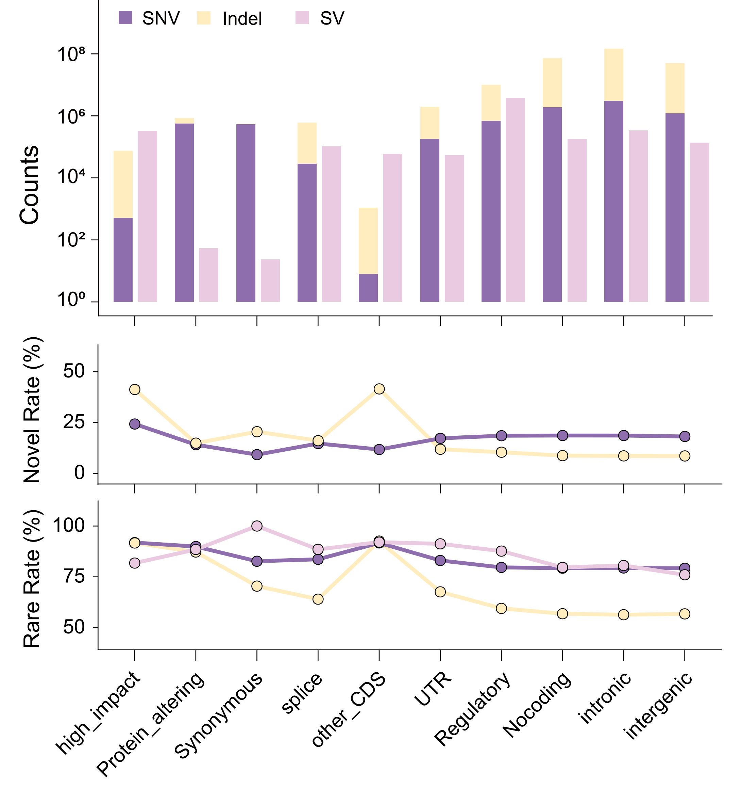
Fig. S5. Variant annotation distribution in SHANGHAI.
Number of variants (SNVs, Indels, and SVs) across different genomic annotation categories (top), together with the proportions of novel (middle) and rare (bottom) variants in each region.

Fig. S6. IBD-sharing network between SHANGHAI individuals and Chinese reference populations.
(A) Overall IBD-sharing network between SHANGHAI individuals and Chinese reference populations²⁻¹². (B) Filtered network highlighting relatively recent genetic connectivity between SHANGHAI individuals and reference populations.

Fig. S7. Population structure of SHANGHAI in the context of worldwide populations.
Principal component analysis (PCA) of SHANGHAI individuals and reference populations from the 1000 Genomes Project Phase 3 (1KGP3)³, Human Genome Diversity Project (HGDP)⁴, and other East Asian datasets^{2,5-12}.

Fig. S8. Population structure of SHANGHAI in the context of Chinese populations.
(A) PCA of SHANGHAI individuals and reference Chinese populations²⁻¹². SHANGHAI samples are shown as colored points, whereas reference Chinese populations are shown in grey. (B) PCA of SHANGHAI individuals and reference populations from Han Chinese datasets². SHANGHAI.UYG individuals were excluded from this analysis. (C) PCA of SHANGHAI individuals and 1KGP3³ CHB (Han Chinese in Beijing, China) and CHS (Southern Han Chinese) populations. The 95% confidence ellipses represent the distributions of the CHB and CHS reference populations.

Fig. S9. Pairwise F_{ST} relationships of the SHANGHAI dataset.
(A)Pairwise F_{ST} values between SHANGHAI and reference populations from the 1KGP3³, HGDP⁴ and other East Asian datasets^{2,5-12}. Pairwise F_{ST} values were repeatedly calculated 100 times with equal sample sizes for each population. Bars on the top and left indicate population classifications. SAS (South Asian), AMR (Admixed American), AFR (African), EUR (European), and EAS (East Asian) denote the five continental-level ancestry groups defined in the 1000 Genomes Project. Population abbreviations include CHB (Han Chinese in Beijing, China), JPT (Japanese in Tokyo, Japan), CHS (Southern Han Chinese), CDX (Chinese Dai in Xishuangbanna, China), KHV (Kinh in Ho Chi Minh City, Vietnam), CEU (Utah residents with Northern and Western European ancestry), TSI (Toscani in Italy), FIN (Finnish in Finland), GBR (British in England and Scotland), IBS (Iberian population in Spain), YRI (Yoruba in Ibadan, Nigeria), LWK (Luhya in Webuye, Kenya), GWD (Gambian in Western Divisions in the Gambia), MSL (Mende in Sierra Leone), ESN (Esan in Nigeria), ASW (Americans of African ancestry in SW USA), ACB (African Caribbeans in Barbados), MXL (Mexican ancestry from Los Angeles, USA), PUR (Puerto Ricans from Puerto Rico), CLM (Colombians from Medellín, Colombia), PEL (Peruvians from Lima, Peru), GIH (Gujarati Indians from Houston, Texas), PJL (Punjabi from Lahore, Pakistan), BEB (Bengali from Bangladesh), STU (Sri Lankan Tamil from the UK), and ITU (Indian Telugu from the UK).
(B) A fan-like chart showing genetic differences (F_{ST})¹³ between SHANGHAI and other East Asian populations. Each branch represents a pairwise comparison between SHANGHAI subgroups and other East Asian populations. Branch lengths are proportional to F_{ST} values, indicated by gray circles. Only the top 26 populations with the closest F_{ST} relationships are shown.

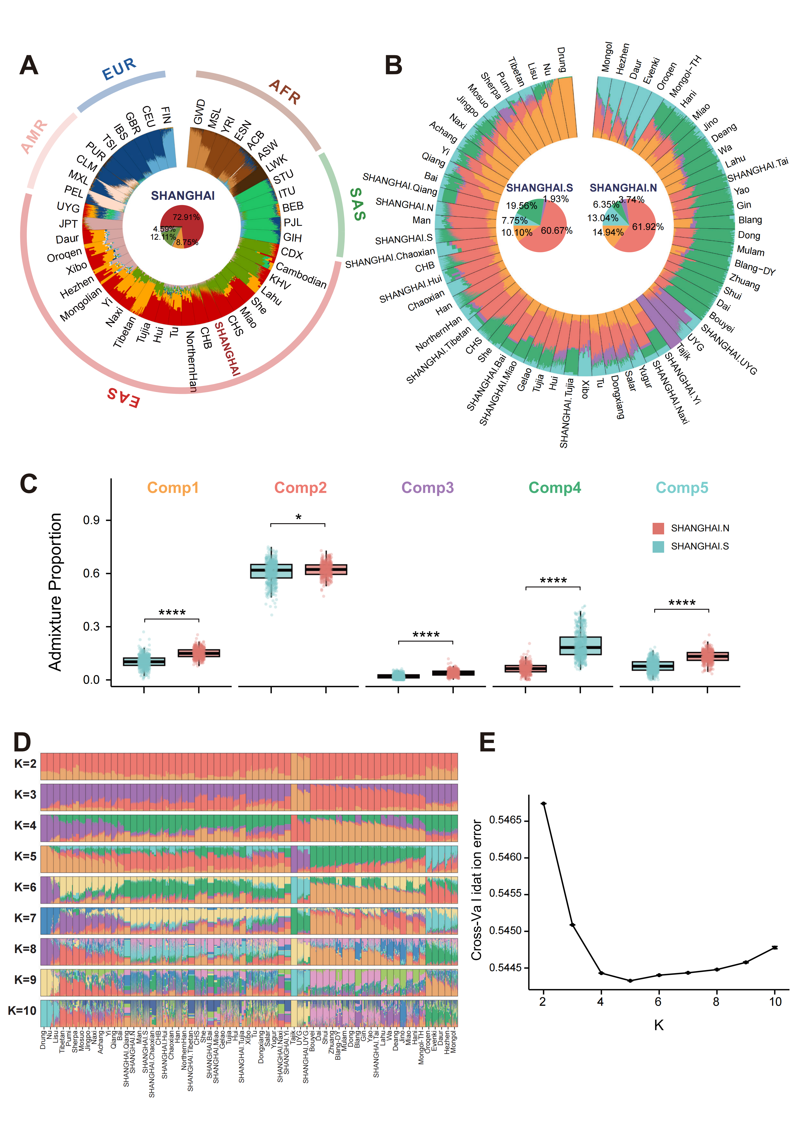
Fig. S10. ADMIXTURE analysis of SHANGHAI ancestral composition.
(A)ADMIXTURE¹⁴ analysis of all SHANGHAI samples together with 1KGP3³ , HGDP⁴ and other East Asian samples^{2,5-12}. This panel shows the results for the optimal K value = 11. (B-E) ADMIXTURE analysis of SHANGHAI samples together with other East Asian populations. (B) shows the results for the optimal K value = 5, with pie charts in the center highlighting differences in ancestral composition between SHANGHAI.N and SHANGHAI.S. (C) displays the proportions of five ancestral components between SHANGHAI.N and SHANGHAI.S, statistical significance assessed using the Wilcoxon rank-sum test. (D) shows ADMIXTURE analysis at different K values and (E) presents the cross-validation errors across different K values used to determine the optimal number of ancestral components.

Fig. S11. Distribution of maternal and paternal haplogroups within SHANGHAI subgroups.
Distribution of paternal haplogroups (Y-chromosome haplogroups, left) and maternal haplogroups (mitochondrial DNA haplogroups, right) across SHANGHAI subgroups, presented as stacked bar plots of relative proportions.

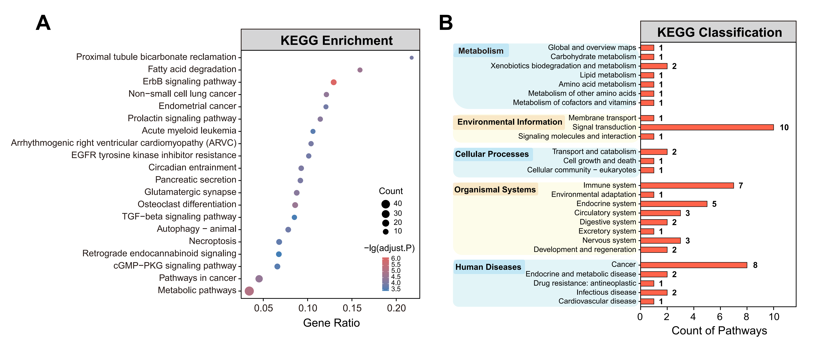
Fig. S12. Kyoto Encyclopedia of Genes and Genomes (KEGG) enrichment of significant XP-EHH signals.
(A) Candidate regions with empirical P-values below 0.5% were used as the input regions for KEGG¹⁵ pathway enrichment analysis. The top 20 enriched pathways ranked by Benjamini-Hochberg (BH)-adjusted P-values are shown.
(B) Similar functional categories were grouped based on KEGG pathway classifications, and the number of pathways within each category was summarized (https://www.genome.jp/kegg/pathway.html), and the number of categories in each group was summarized.

Fig. S13. Local XP-EHH distribution of highlighted cardiovascular-associated genes putatively under selection.
Local Manhattan plot showing XP-EHH^{16,17} values across highlighted cardiovascular-associated genes, including 20 kb upstream and downstream regions.

Fig. S14. Local iHS distribution and global population prevalence of the representative SNV rs99780 in the FADS gene family.
(A) Local iHS^{17,18} values across the FADS gene family, including 20 kb upstream and downstream regions. The putative adaptive variant rs99780 is shown in black, while other SNVs are colored according to pairwise linkage disequilibrium with this variant based on the SHANGHAI dataset.
(B) Global population allele frequency distribution of rs99780 based on the PGG.SNV database¹⁹.

Fig. S15. Local iHS distribution, tissue-specific expression, and global population allele frequency of the representative SNV rs61970775 in the DOCK9/DOCK9-DT region.
(A) Local iHS^{17,18} values across DOCK9 and DOCK9-DT, including 20 kb upstream and downstream regions. The putative adaptive variant rs61970775 is shown in black, while other SNVs are colored according to pairwise linkage disequilibrium with this variant based on the SHANGHAI dataset.
(B) Global population allele frequency distribution of rs61970775 based on the PGG.SNV database¹⁹.
(C) Multi-tissue expression of DOCK9 and DOCK9-DT based on the GTEx dataset²⁰ (GTEx Analysis Release V10). The x-axis represents different tissues, and the y-axis shows gene expression levels in Transcripts Per Million (TPM).
(D) Regulatory effect of the representative SNV rs61970775 on DOCK9-DT in arterial tissues, based on the GTEx dataset (GTEx Analysis Release V10).
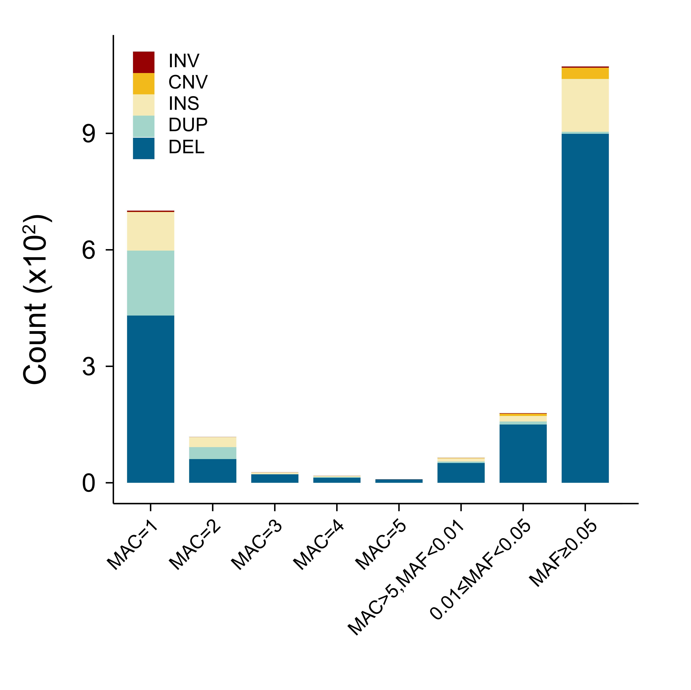
Fig. S16. SVs in linkage disequilibrium with variants in the GWAS Catalog.
SVs in strong linkage disequilibrium (r² ≥ 0.8) with GWAS Catalog-associated ²¹ variants, including INV, CNV, INS, DUP, and DEL, are shown separately.

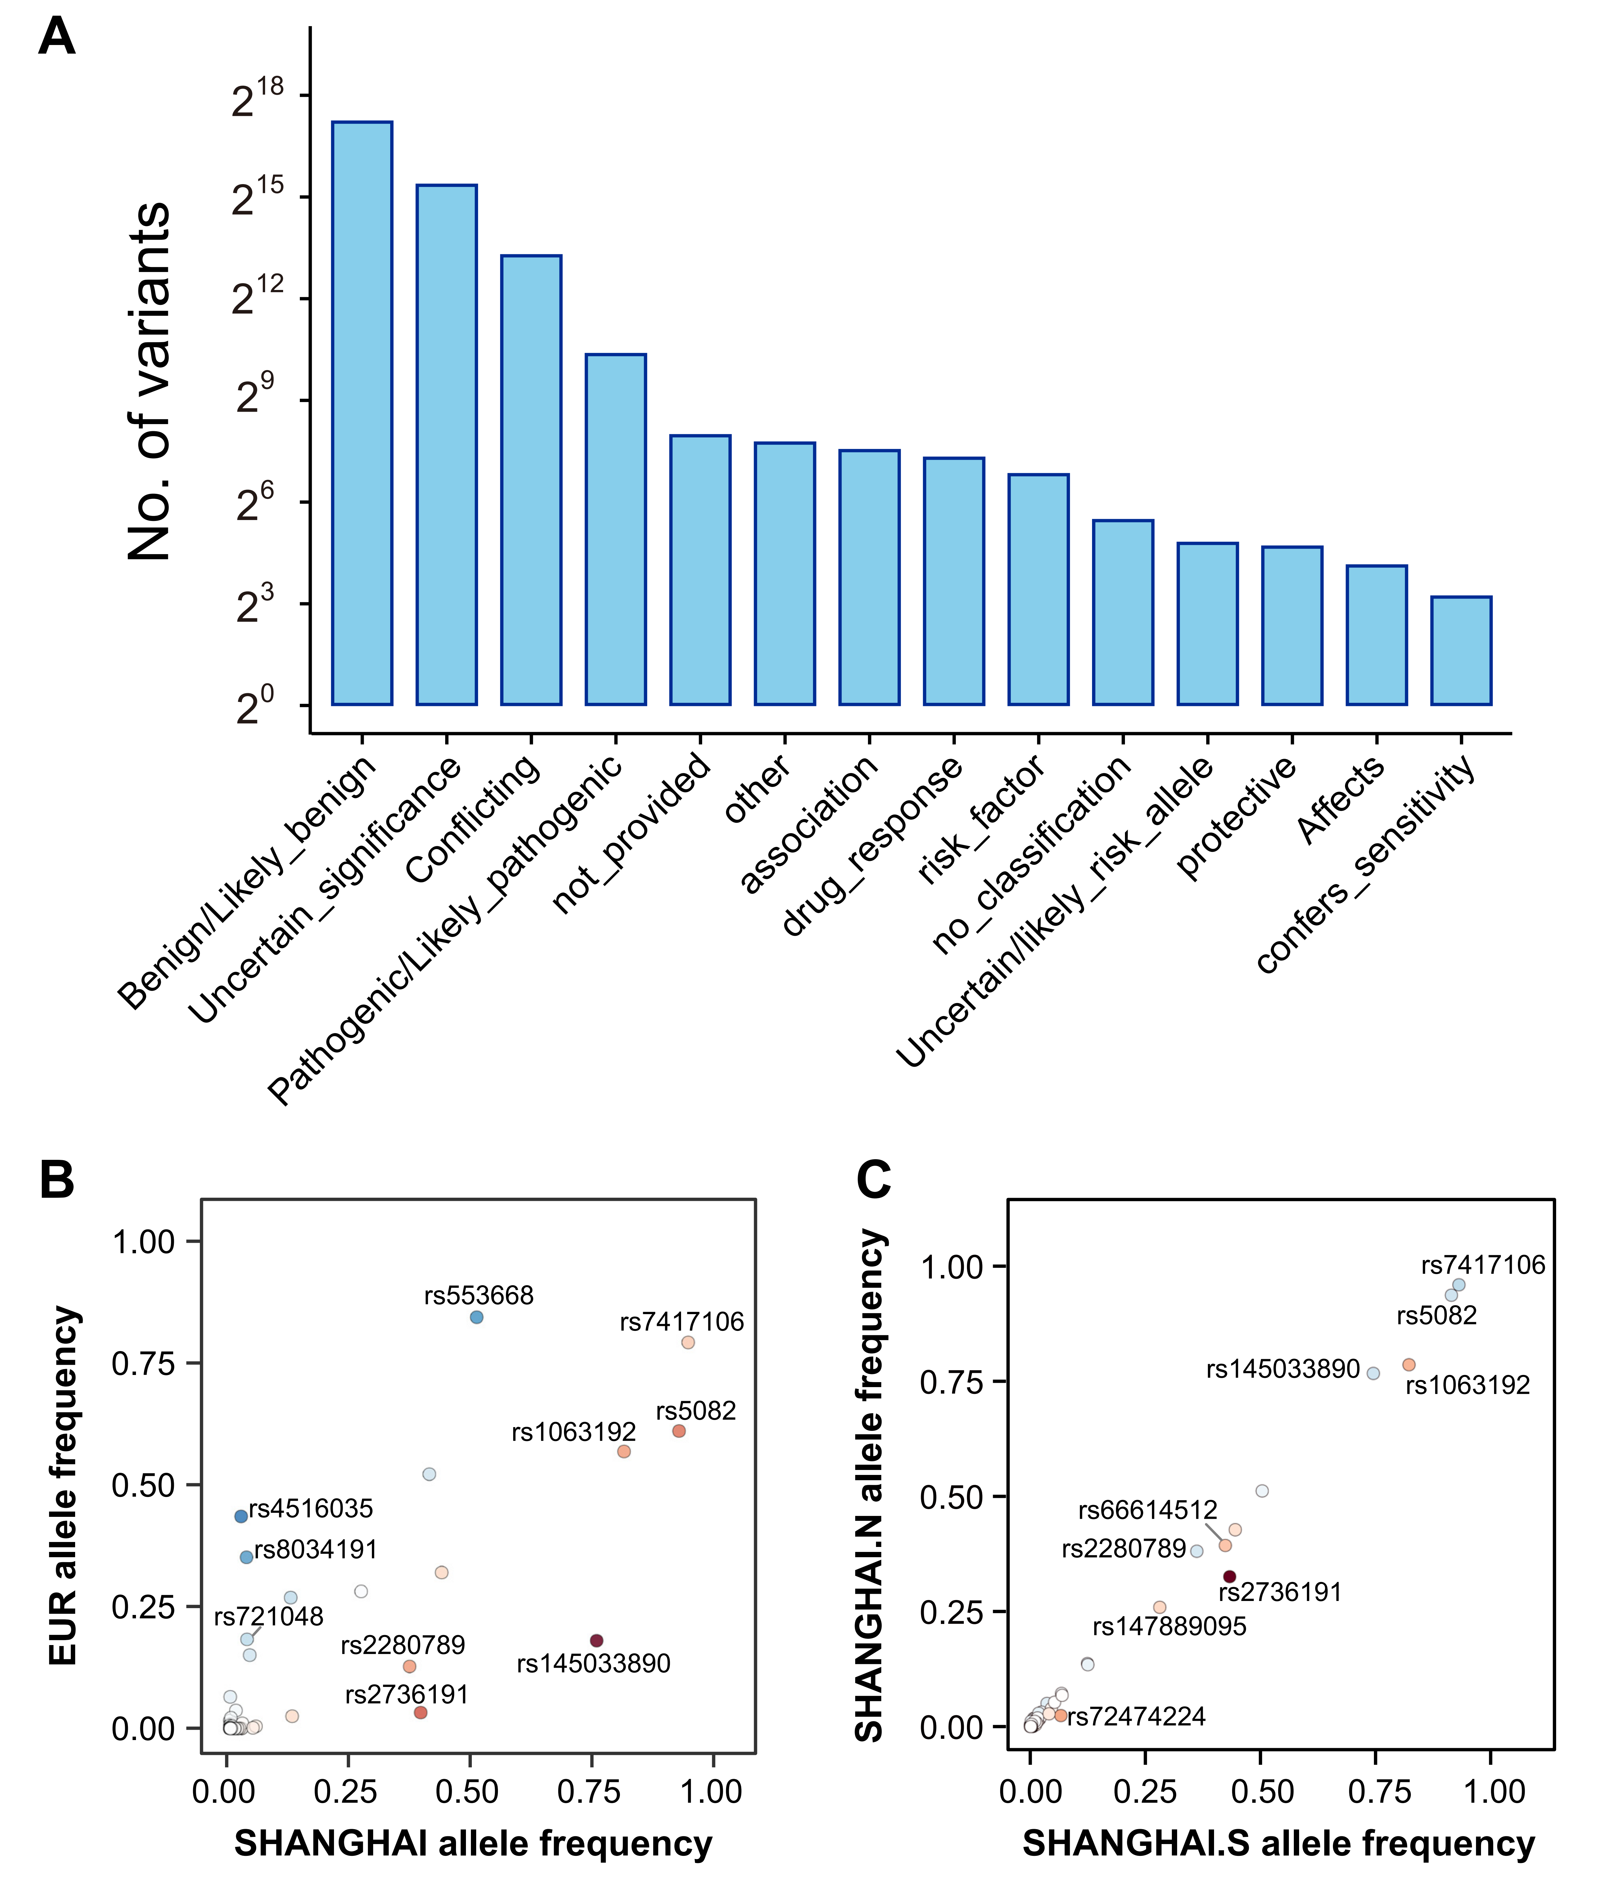
Fig. S17. Clinical annotation of variants in the SHANGHAI dataset.
(A) Numbers of variants assigned to different clinical categories according to ClinVar ²². (B, C) Frequency spectra of ClinVar-annotated pathogenic and likely pathogenic variants in European populations (Non-Finnish Europeans, NFE, gnomAD v2.1²³) (B) and in SHANGHAI subgroups (SHANGHAI.N vs. SHANGHAI.S) (C).

Fig. S18. Phenotypic associations of ClinVar-annotated rs5082 in SHANGHAI and its genotype distribution across global populations.
(A) Distribution of rs5082 genotypes across global populations, based on data from the 1KGP3³. The inset in the lower left shows a significant correlation between the GG genotype frequency and latitude (Pearson r = 0.49). (B) Associations between rs5082 genotypes (GG, GA, AA) and lipid metabolism-related phenotypes. Due to the very small number of individuals carrying the GG genotype (n = 2), statistical comparisons were not performed for this group, and results are shown for descriptive purposes only. Statistical significance was evaluated using the Wilcoxon rank-sum test. Abbreviations: ApoA-I, Apolipoprotein A-I; ApoB, Apolipoprotein B; BMI, Body Mass Index; HDL-C, High-Density Lipoprotein Cholesterol; LDL-C, Low-Density Lipoprotein Cholesterol; Lp(a), Lipoprotein(a); TC, Total Cholesterol; TG, Triglycerides.

Fig. S19. Global distribution of rs2736191 genotypes and their association with NCR3 expression in SHANGHAI.
(A) Global population prevalence of rs2736191 based on the PGG.SNV database¹⁹. (B) Correlation between G allele frequency and latitude, showing a significant negative association (Pearson r = -0.526). (C) Association between rs2736191 genotypes and NCR3 expression levels in SHANGHAI. Statistical significance of differences in gene expression among genotype groups was assessed using the Wilcoxon rank-sum test and is indicated by asterisks (*: P < 0.05; **: P < 0.01; ***: P < 0.001; ****: P < 0.0001; ns: not significant).

Fig. S20. KEGG pathway enrichment analysis and population-specific frequency distributions of small-variant protein-truncating variants (PTVs) and frameshift SVs.
(A, B) KEGG¹⁵ pathway enrichment analysis of genes affected by small-variant PTVs (A) and frameshift SVs (B) . The top 20 enriched pathways ranked by BH adjusted p-values are shown as enriched terms. (C) Frequency spectrum of small-variant PTVs in European populations (Non-Finnish Europeans, NFE, gnomAD v2.1²³) (left) and SHANGHAI subgroups (SHANGHAI.N vs. SHANGHAI.S) (right). (D) Frequency spectrum of frameshift SVs in SHANGHAI subgroups (SHANGHAI.N vs. SHANGHAI.S).

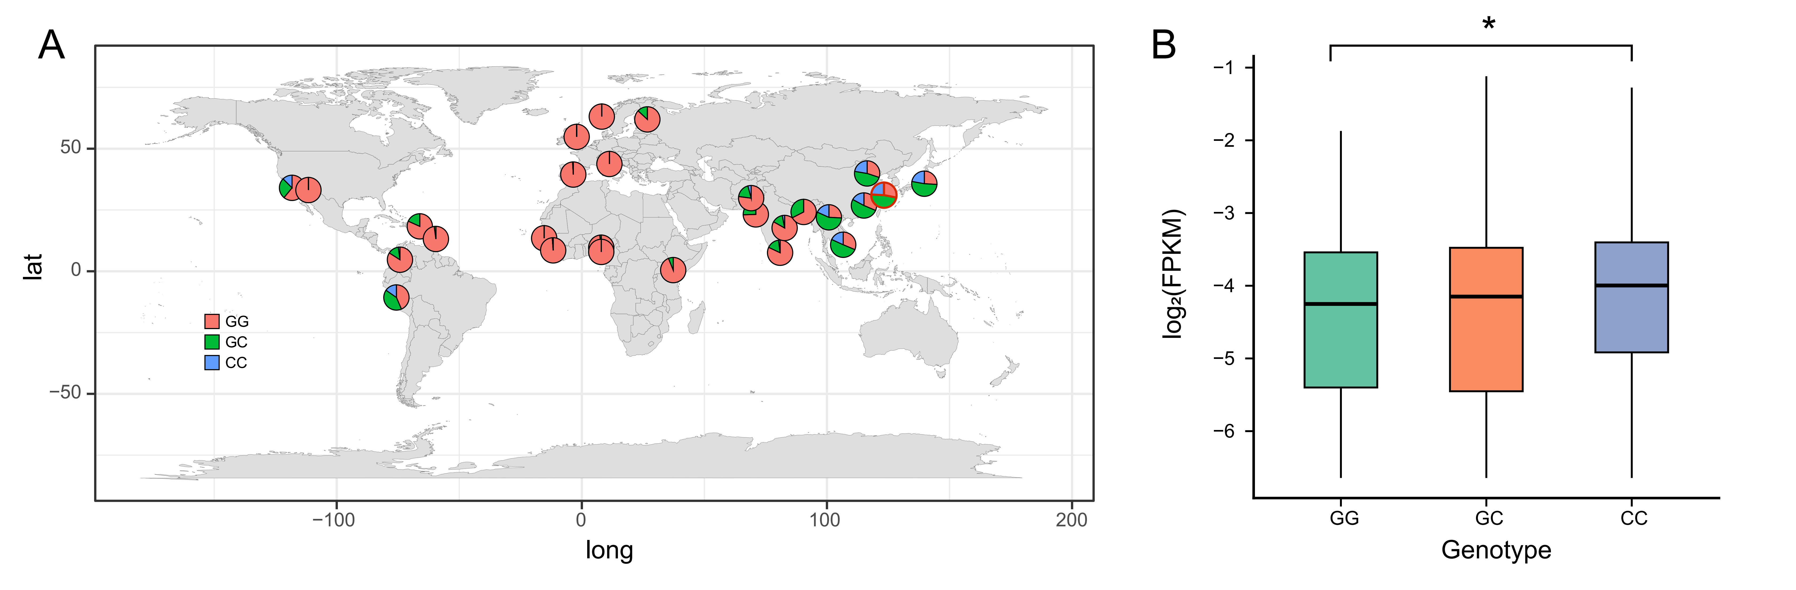
Fig. S21. Global distribution of rs17143187 genotypes and their association with ABCB5 expression in SHANGHAI.
(A) Distribution of rs17143187 genotypes across global populations, based on data from the 1KGP3³. Red-outlined pie charts indicate the genotype frequency distribution in SHANGHAI. (B) Association between rs17143187 genotypes and ABCB5 expression levels in SHANGHAI. Statistical significance of genotype-expression associations was assessed using the Wilcoxon rank-sum test and is indicated by asterisks (*: P < 0.05; **: P < 0.01; ***: P < 0.001; ****: P < 0.0001; ns: not significant).

Fig. S22. Global distribution of rs11078928 genotypes and their association with GSDMB expression in SHANGHAI.
(A) Distribution of rs11078928 genotypes across global populations, based on data from the 1KGP3³. (B) Correlation between TT genotype frequency and latitude, showing a significant negative association (Pearson r = -0.7219). (C) Association between rs11078928 genotypes and GSDMB expression levels in SHANGHAI. Statistical significance of genotype-expression associations was assessed using the Wilcoxon rank-sum test and is indicated by asterisks (*: P < 0.05; **: P < 0.01; ***: P < 0.001; ****: P < 0.0001; ns: not significant).

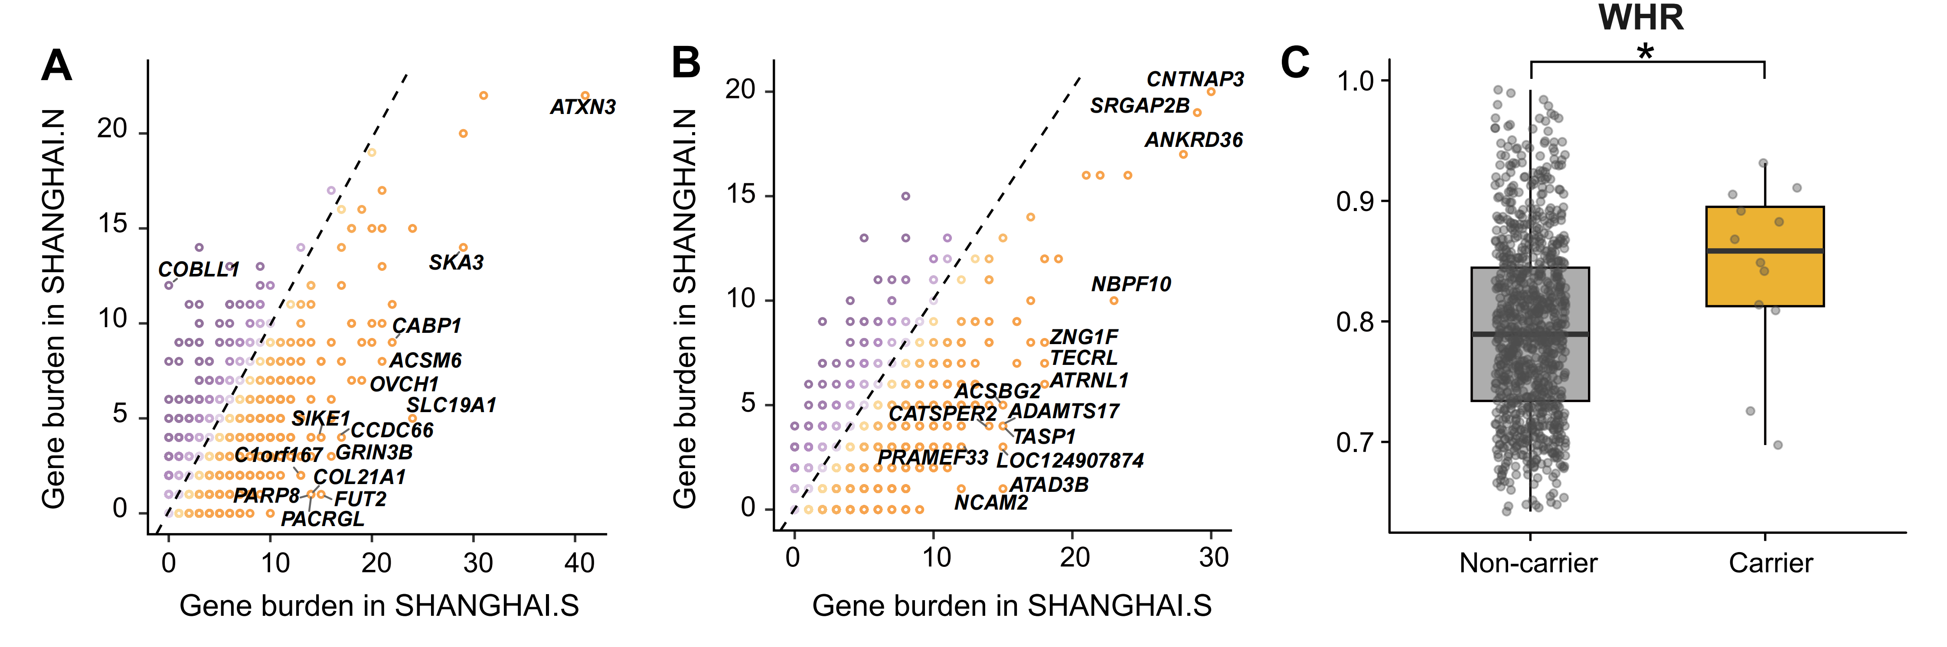
Fig. S23. Gene-based collapsing analysis of rare variant burden across SHANGHAI subgroups and phenotype association of a representative gene.
(A,B) Distribution of gene-based collapsing results for rare small-variant PTVs (A) and rare frameshift SVs (B) across SHANGHAI subgroups. (C) Boxplot comparing waist-hip ratio (WHR) between carriers and non-carriers of rare variants in the COBLL1 gene. Statistical significance of genotype-expression associations was assessed using the Wilcoxon rank-sum test and is indicated by asterisks (*: P < 0.05; **: P < 0.01; ***: P < 0.001; ****: P < 0.0001; ns: not significant).

Fig. S24. Leading causes of death and their proportions reported by the Shanghai Municipal Health Commission in 2024.

Fig. S25. Distribution of LDL-C levels in SHANGHAI.Han and SHANGHAI.Tai subgroups
Distribution of LDL-C levels between SHANGHAI.Han and SHANGHAI.Tai subgroups. Statistical significance was evaluated using the Wilcoxon rank-sum test.

Fig. S26. Effect of rare variant burden on different LDL-C phenotypes in SHANGHAI.
(A) Logistic regression analysis of LDL dyslipidemia (LDL-C > 4.1 mmol/L) in individuals carrying rare small-variant PTVs, deleterious missense variants, or frameshift SVs in core LDL-C-related genes (Materials and Methods), compared with the remaining SHANGHAI individuals (noncarriers). Data are presented as odds ratios (OR) ± 95% confidence intervals (CI). "Positive" and "negative" indicate the reported direction of variant effects on LDL-C levels, while "binary" does not distinguish the effect direction. (B) Logistic regression analysis of optimal LDL-C levels (LDL-C < 1.8 mmol/L) in individuals carrying rare small-variant PTVs, deleterious missense variants, or frameshift SVs in core LDL-C-related genes, compared with the remaining SHANGHAI individuals (noncarriers). Data are presented as OR ± 95% CI.

Fig. S27. Effect of rare variant burden on LDL dyslipidemia risk among individuals with non-top PRS in SHANGHAI.
Logistic regression analysis of LDL dyslipidemia among individuals with non-top PRS carrying rare small-variant PTVs, deleterious missense variants, or frameshift SVs in core LDL-C-related genes (Methods), compared with noncarriers within the same PRS group. Data are presented as OR ± 95% CI. "Positive" and "negative" indicate the reported direction of variant effects on LDL-C levels, while "binary" does not distinguish the effect direction.

References
1 Manichaikul, A. et al. Robust relationship inference in genome-wide association studies. Bioinformatics 26, 2867–2873 (2010).
2 Gao, Y. et al. PGG. Han: the Han Chinese genome database and analysis platform. Nucleic Acids Research 48, D971–D976 (2020).
3 Consortium, G. P. A global reference for human genetic variation. Nature 526, 68 (2015).
4 Bergström, A. et al. Insights into human genetic variation and population history from 929 diverse genomes. Science 367, eaay5012 (2020).
5 Lu, D. et al. Ancestral origins and genetic history of Tibetan highlanders. The American Journal of Human Genetics 99, 580–594 (2016).
6 Feng, Q. et al. Genetic history of Xinjiang’s Uyghurs suggests Bronze Age multiple-way contacts in Eurasia. Molecular biology and evolution 34, 2572–2582 (2017).
7 Ma, X. et al. Genetic origins and sex-biased admixture of the Huis. Molecular Biology and Evolution 38, 3804–3819 (2021).
8 Ge, X. et al. Genetic origins and adaptive evolution of the Deng people on the Tibetan Plateau. Molecular Biology and Evolution 40, msad205 (2023).
9 Gao, Y. et al. Reconstructing the ancestral gene pool to uncover the origins and genetic links of Hmong–Mien speakers. BMC biology 22, 59 (2024).
10 Lou, H. et al. Haplotype-resolved de novo assembly of a Tujia genome suggests the necessity for high-quality population-specific genome references. Cell Systems 13, 321–333. e326 (2022).
11 Yang, Z. et al. Genetic evidence of tri-genealogy hypothesis on the origin of ethnic minorities in Yunnan. BMC biology 20, 166 (2022).
12 Zeng, W. et al. Ancient Yellow River ancestry and divergent admixture histories in the Qiang people. Science Advances 12, eady6667 (2026).
13 Weir, B. S. & Cockerham, C. C. Estimating F-statistics for the analysis of population structure. evolution, 1358–1370 (1984).
14 Alexander, D. H., Novembre, J. & Lange, K. Fast model-based estimation of ancestry in unrelated individuals. Genome research 19, 1655–1664 (2009).
15 Kanehisa, M. & Goto, S. KEGG: kyoto encyclopedia of genes and genomes. Nucleic acids research 28, 27–30 (2000).
16 Sabeti, P. C. et al. Genome-wide detection and characterization of positive selection in human populations. Nature 449, 913–918 (2007).
17 Szpiech, Z. A. & Hernandez, R. D. selscan: an efficient multithreaded program to perform EHH-based scans for positive selection. Molecular biology and evolution 31, 2824–2827 (2014).
18 Voight, B. F., Kudaravalli, S., Wen, X. & Pritchard, J. K. A map of recent positive selection in the human genome. PLoS biology 4, e72 (2006).
19 Zhang, C. et al. PGG. SNV: understanding the evolutionary and medical implications of human single nucleotide variations in diverse populations. Genome biology 20, 215 (2019).
20 Consortium, G. The GTEx Consortium atlas of genetic regulatory effects across human tissues. Science 369, 1318–1330 (2020).
21 MacArthur, J. et al. The new NHGRI-EBI Catalog of published genome-wide association studies (GWAS Catalog). Nucleic acids research 45, D896–D901 (2017).
22 Landrum, M. J. et al. ClinVar: public archive of relationships among sequence variation and human phenotype. Nucleic acids research 42, D980–D985 (2014).
23 Karczewski, K. J. et al. The mutational constraint spectrum quantified from variation in 141,456 humans. Nature 581, 434–443 (2020).

