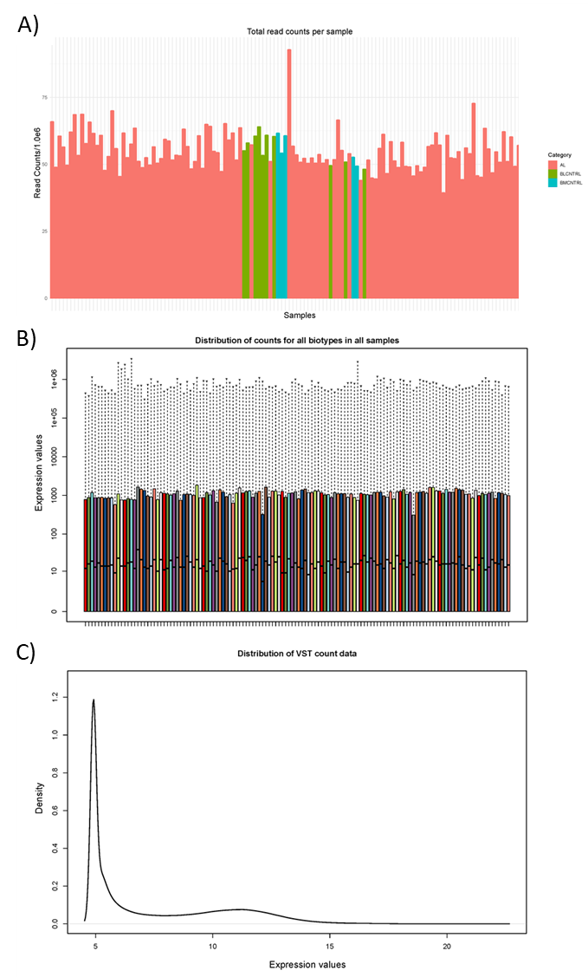
Supplemental Figure 1: Overview of gene counts acquired in the canine acute leukemia, peripheral blood and bone marrow control samples. A) Bar plot showing the total read counts within each sample. The color of the bar corresponds to the sample type. B) Bar plot of the distribution of gene counts for all gene biotypes in all samples. C) Line graph representing the distribution of the variance stabilizing transformed gene counts in all samples. Abbreviations: AL, Acute leukemia; BLCNTRL, blood control; BMCNTRL, Bone marrow control; Variance stabilizing transformation, VST.

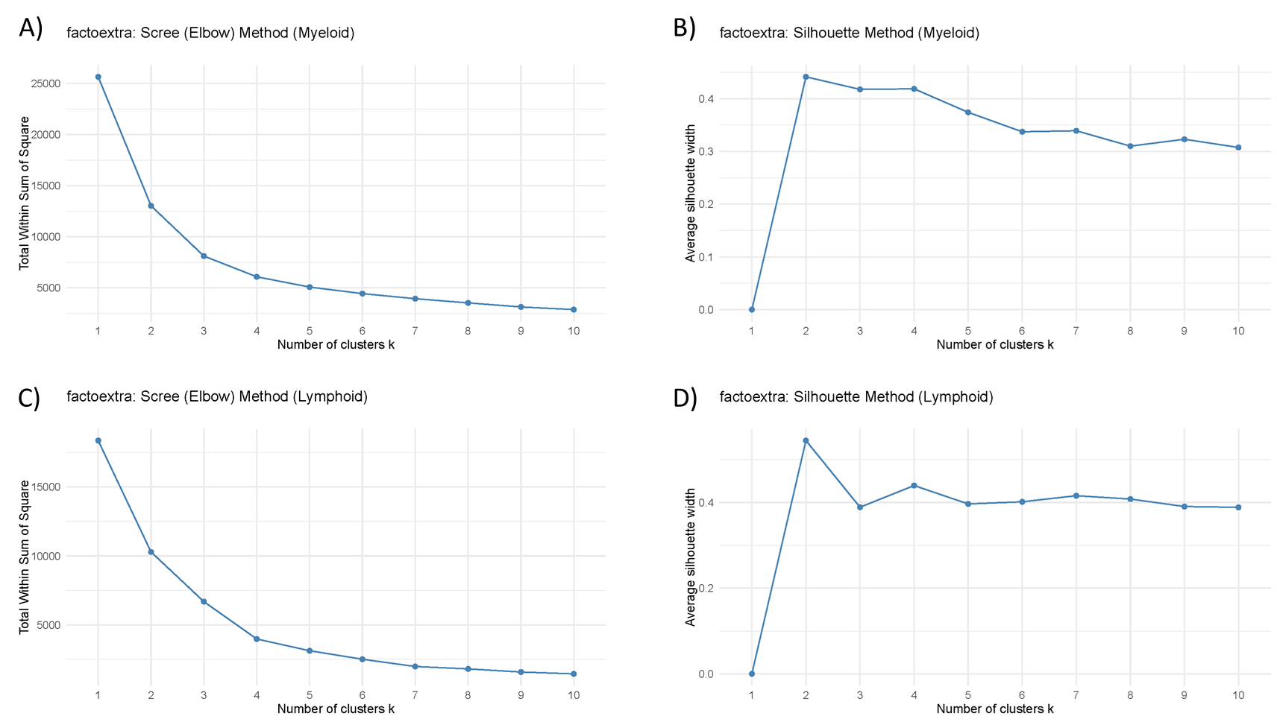
Supplemental Figure 2. Determination of optimal cluster number for myeloid and lymphoid subgroups. Scree (elbow) and silhouette analyses used to determine the optimal number of k-means clusters for myeloid (A–B) and lymphoid (C–D) cases. Elbow plots display total within-cluster sum of squares across k = 1–10, while silhouette plots show average silhouette width.

Supplemental Figure 3. Comparison of hematologic parameters between lymphoid and myeloid groups. Boxplots display percentage and absolute counts of measurable cell populations. P-values indicate statistical significance between groups.

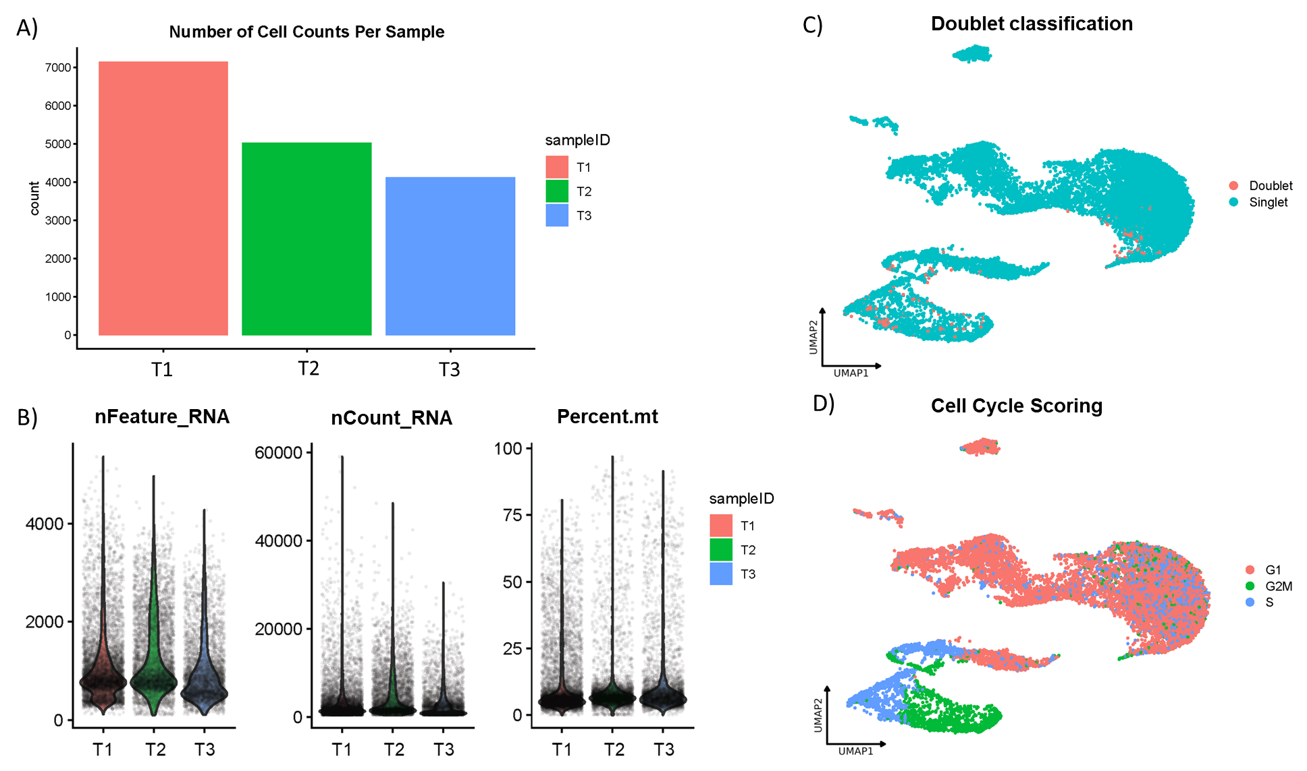
Supplemental Figure 4. Pre-filter quality control metrics for single-cell thymus RNA sequencing. A) Total number of cells captured per sample prior to QC filtering. B) Distributions of nFeature_RNA, nCount_RNA, and percent.mt used to define filtering thresholds. C) UMAP highlighting predicted doublets. D) UMAP showing cell cycle phase scoring, demonstrating expected proliferative compartmentalization.

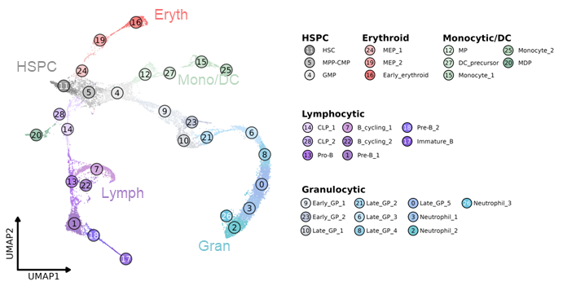

Supplemental Figure 5. Previously published canine bone marrow single-cell reference atlas used for developmental mapping of canine acute leukemia. UMAP visualization of the integrated canine bone marrow single-cell RNA sequencing atlas illustrating major hematopoietic developmental trajectories, including hematopoietic stem and progenitor cells (HSPCs), erythroid, granulocytic, monocytic/dendritic cell, and lymphoid lineages. Individual clusters are labeled according to their original annotations. Cell type-specific signatures derived from this atlas were used for gene set variation analysis (GSVA) and module score analyses throughout the current study. Reproduced from Harris et al. (2025) with permission.³⁷

Supplemental Figure 6. Comparison of hematologic parameters across myeloid transcriptional subgroups. Boxplots show complete blood count parameters and percentage/absolute counts of immune cell populations across myeloid clusters (1–3). P-values represent subgroup comparisons.

Supplemental Figure 7. Comparison of hematologic parameters across lymphoid transcriptional subgroups. Boxplots show complete blood count parameters and percentage/absolute counts of immune cell populations across lymphoid clusters (1–3). P-values represent subgroup comparisons.

