Supplementary information

Title: Mapping the Multi-Tiered Magmatic Plumbing System of the Tatun Volcano Group, Taiwan: Insights from Mineral Thermobarometry and Reservoir Evolution

Authors: Guo-Teng Hong^{1,2}*, Kuo-Lung Wang^{2,3}, Yoshiyuki Iizuka^{3,4}, Cheng-Hong Chen², Yu-Shiang Wang³, Cheng-Horng Lin³, Yuan-Hsi Lee⁵, Daniel P. Miggins⁶

Affiliations:
¹Geological Survey and Mining Management Agency, MOEA, Taipei, Taiwan
²Department of Geosciences, National Taiwan University, Taipei, Taiwan
³Institute of Earth Sciences, Academia Sinica, Taipei, Taiwan
⁴Graduate School of Arts and Letters, Tohoku University, Sendai, Japan
⁵Department of Earth and Environmental Sciences, National Chung Cheng University, Chiayi, Taiwan
⁶OSU Argon Geochronology Laboratory, College of Earth, Ocean, and Atmospheric Sciences, Oregon State University, Corvallis, USA

*Corresponding author: Guo-Teng Hong (gthong@gsmma.gov.tw)

- Tatun Volcano Group Eruption Ages
Based on the known radioactive dating (K-Ar, Ar-Ar, U-Pb, FTD, ZDD) results of the TVG volcanic rocks, the eruption periods of the four synthems (Fig. 2) – Chutze (Zz), Tatun (Tt), Chihsing-Huangtsui (Cs-Hz), and Tinghuohsiu-Nantse (Dh) – are nearly the same, mostly within 1 Ma (Fig. S1). Despite their comagmatic nature and high lithological similarity, only the Chihsing-Huangtsui synthem has the youngest unrest records, extending into the Holocene (ca. 8.7 ka; Lee et al. 2026).
Refer to Fig. 2 for the spatial distribution of the four synthems in the TVG.
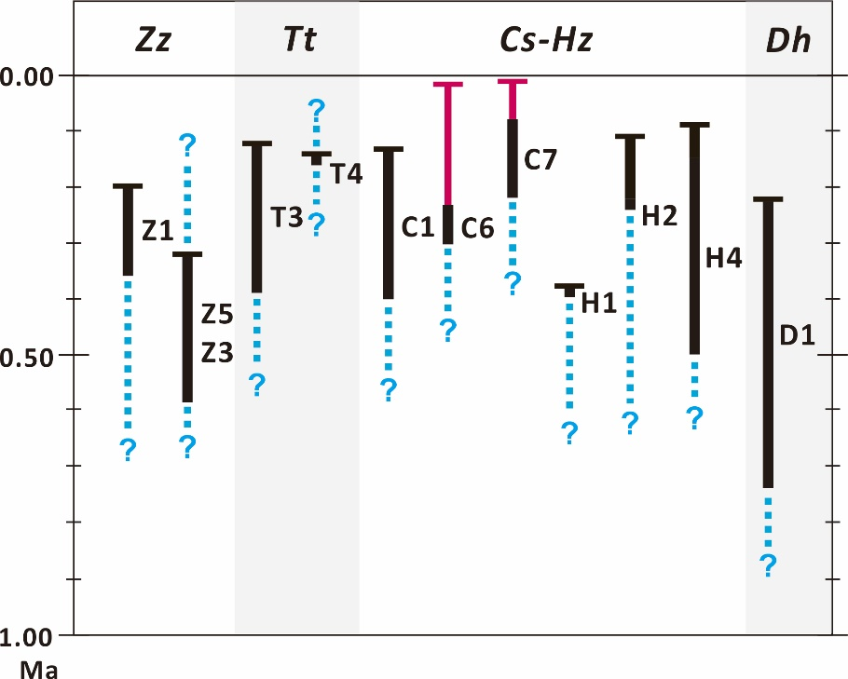
Fig. S1_Age distributions of the four synthems and their containing lithosomes (referring to Fig. 2) in the TVG (K-Ar: Juang & Bellon 1984; Juang & Chen 1989; Juang 1993; Ar-Ar: Lee 1996; Pi et al. 2025; Jabagat et al. 2026; U-Pb: Chu et al. 2018; Zircon Double Dating: Pi et al. 2025; Jabagat et al. 2026; Ignacio et al. 2026). Radiometrically dated lithosome units are shown with black solid lines indicating their ages and blue dashed lines for uncertain ages. Recent advances in young tephra dating (Jabagat et al. 2026; Ignacio et al. 2026) push the latest eruptive age in the TVG (marked with red dashed lines) into the Holocene. Abbreviations: Synthems Chutze (Zz), Tatun (Tt), Chihsing-Huangtsui (Cs-Hz), and Tinghuohsiu-Nantze (Dh).

- Amphibole decomposition occurrences
For the 22 textural types of amphibole occurrences illustrating decomposition processes through magma decompression (Asc), thermal oxidation (Ox), recrystallization (Rc), and resorption (Rs) (Fig. 6), remaining textural types, along with examples other than those in Fig. 7, are supplemented as follows.
Asc Ox Rc: During magma ascent, a decompression-induced rim formed on an entrained amphibole; thermal oxidation was imposed to develop an inner rim, and then recrystallization patches formed (I-e type; Fig. 6, Fig. S2a), or recrystallization occurred first, then an oxidization rim grew (I-g type; Fig. 6, Fig. S2b) .
Rs Asc Rc+Ox: Magma replenishment-induced heating caused resorption of amphibole crystals. Magma ascent then led to the growth of a decompression rim on amphibole. Near the surface, amphibole recrystallization and thermal oxidation occurred, resulting in patchy replacement of the amphibole core. (IV-e type; Fig. 6, Fig. S2c).
Rs Ox: Amphibole crystals were resorbed by recharged magma and subsequently underwent thermal oxidation near the surface, forming either a thermally oxidized pseudomorph (IV-f type; Fig. 6, Fig. S2d) or an oxidation rim (IV-g type; Fig. 6, Fig. S2e).
Rs Rc+Ox: Amphibole crystals were resorbed by recharged magma, then ascended and stalled near the surface, where they recrystallized and were thermally oxidized, forming replaced patches and rims, respectively (IV-j type; Fig. 6, Fig. S2f).
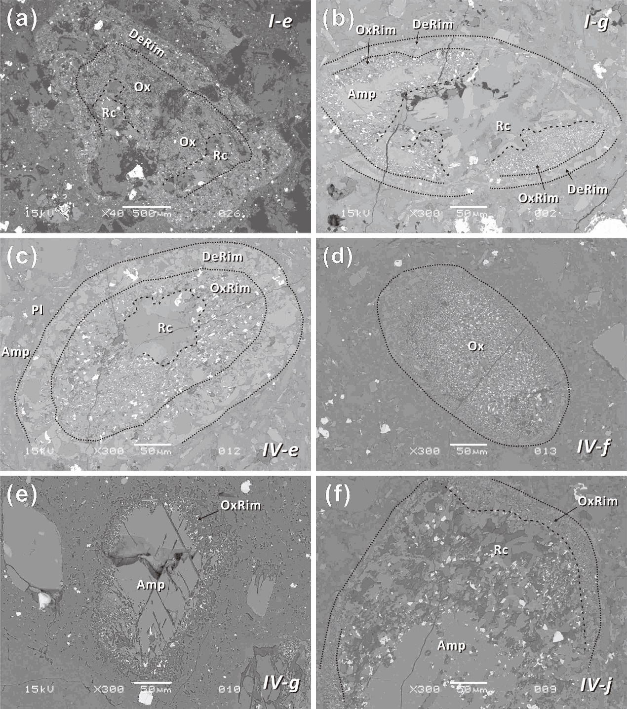
Fig. S2_Decomposition occurrences of amphibole phenocrysts (supplementary to Fig. 7): (a) decompression rim (DeRim) thermal oxidation (Ox) + recrystallization patches (Rc), I-e type; (b) decompression rim (DeRim) recrystallization (Rc) thermal oxidation rim (OxRim), I-g type; (c) magma resorption decompression rim (DeRim) thermal oxidation rim (OxRim) + recrystallization (Rc), IV-e type; (d) magma resorption thermally oxidized pseudomorph (Ox), IV-f type; (e) magma resorption oxidation rim (OxRim), IV-g type; (f) magma resorption recrystallization (Rc) thermally oxidized (OxRim), IV-j type.
- Equilibrium Test of Fe-Ti Oxide Pairs
Mg/Mn partitioning between titanomagnetite and ilmenite was measured to assess the applicability of Fe-Ti oxide geothermometric and oxygen barometric results (Bacon & Hirschmann 1988). The exchange reaction, Mg_{ill} + Mn_{mt} = Mn_{ill} + Mg_{mt}, yields the distribution coefficient K_{D} = (Mg/Mn)_{mt}/(Mg/Mn)_{ill}. The partitioning plot should show an approximately linear trend for homogeneous oxide pairs from volcanic rocks in equilibrium, as shown in Fig. S3. The majority of DT-01 data fall within the error envelope of the equilibrium line for volcanic rocks. Data plotted above the envelope resemble the distribution of mineral separates from intrusive layers/plutonic rocks, which is inconsistent with the lava host in this case. This implies that the Fe-Ti oxide pairs reached equilibrium within shallow magma bodies.
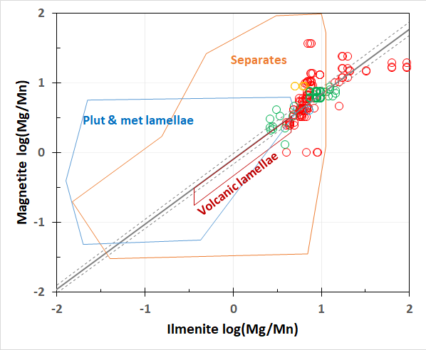
Fig. S3_Mg/Mn partitioning between titanomagnetite and ilmenite. Volcanic lamellae distribution is presented by the red polygon. Mineral separates (oxidized and exsolved) from plutonic rocks are presented by the orange polygon. Plutonic and metamorphic (oxidized and exsolved) lamellae are presented by the blue polygon. Symbols: Red circles – Lv4. Blue circles – Lv3. Orange circles – Lv2. Green circles – Lv1.

- Amphibole thermobarometer applicability
Amphibole thermobarometry is applicable to calcic amphiboles that crystallized from calc-alkaline and alkaline series magmas (Ridolfi et al. 2010; Ridolfi & Renzuli 2012). This study examined the applicability of the TVG amphiboles by comparing them with the predicted data range of the thermobarometric model proposed by Ridolfi et al. (2010).
1. For amphibole formula unit (apfu), the plot of the K number at the A site (^{A}K) versus the tetragonal Al number (^{[4]}Al) discriminates amphiboles from calc-alkaline and alkaline magmas (Ridolfi & Renzuli 2012). Amphiboles from DT-01 and amphibole-rich nodules fall within the calc-alkaline magma field (Fig. S4), consistent with those in the TVG.
2. On the plot of tetragonal Al number (^{[4]}Al) versus total Al number (Al_{T}), the Al# (=^{[6]}Al/Al_{T}, Al_{T} =^{[4]}Al+^{[6]}Al) of volcanic amphiboles ranges from 0 to 0.21 (Fig. S5). Al# for metamorphic amphiboles in the crust and mantle is above 0.21. The amphibole thermobarometer applies only to volcanic amphiboles. Most amphiboles from DT-01 and the amphibole-rich nodules fall within the volcanic origin (Fig. S5).
3. On the temperature versus pressure plot, amphiboles from DT-01 and amphibole-rich nodules fall within the stable range of calc-alkaline magma, bounded by dotted and dashed lines (Fig. S6). Solid lines mark magmatic SiO₂ proportions, and DT-01 amphiboles range from 52 to 76%, consistent with the amphibole chemometric result.
4. On the crystallization temperature versus oxygen fugacity plot, amphiboles from DT-01 and amphibole-rich nodules fall within the NNO 0~+2 range, which is occupied by calc-alkaline magmatic amphiboles (Fig. S7).
5. On the plot of water content in the melt versus crystallization temperature, most amphiboles from DT-01 and amphibole-rich nodules fall within the amphibole-stable field, bounded by the dotted and dashed lines (Fig. S8).

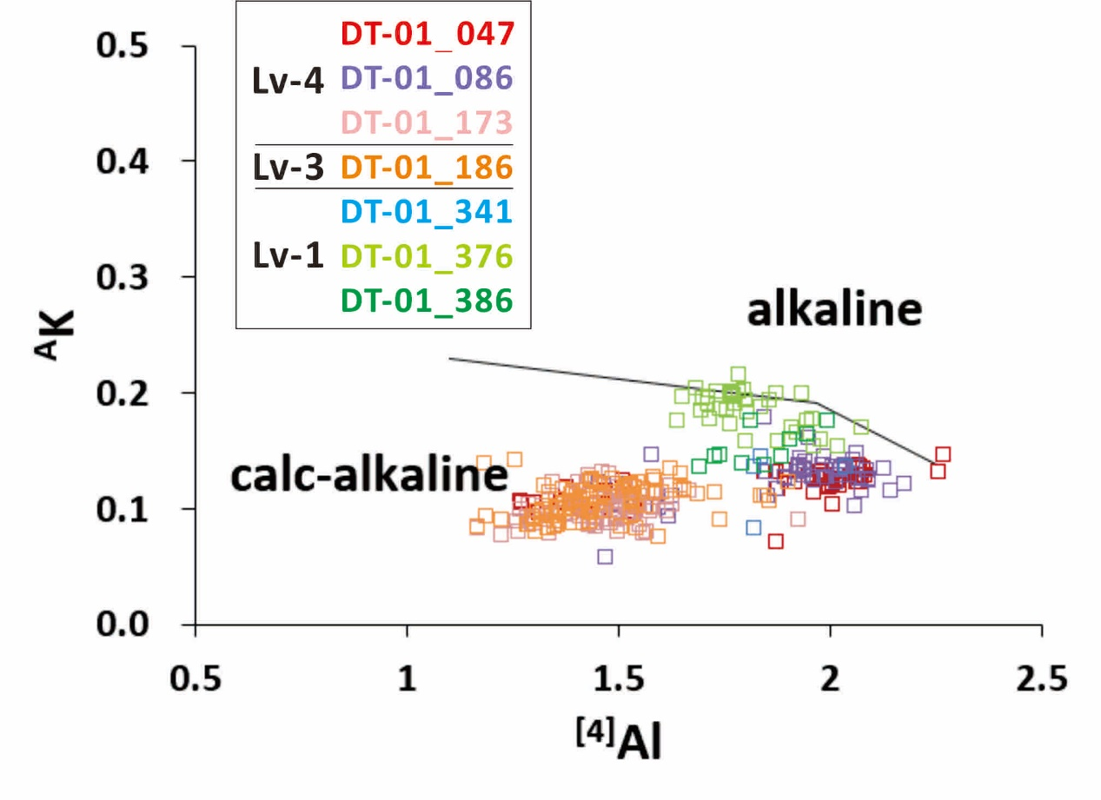
Fig. S4_Calc amphiboles in equilibrium with liquids of the calc-alkaline and alkaline series are separated by a compositional boundary. DT-01 amphiboles are plotted in the calc-alkaline field.
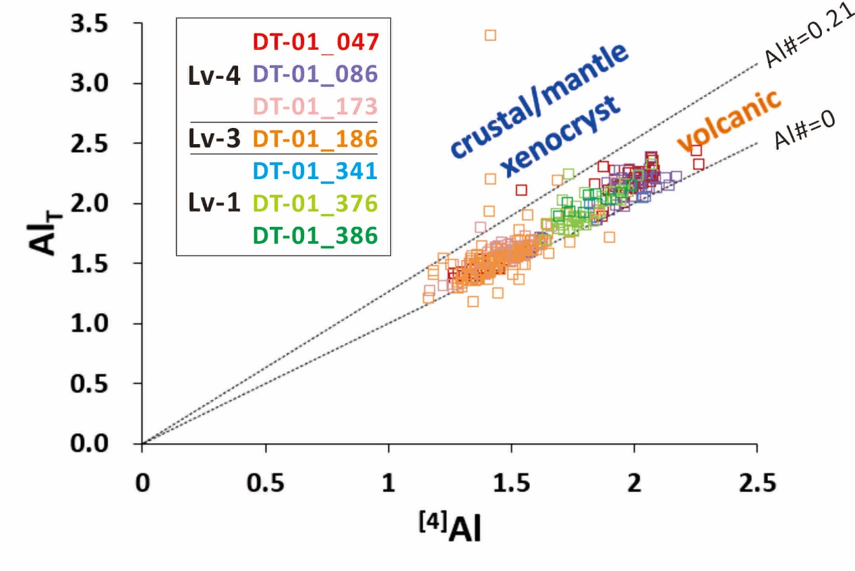
Fig. S5_The ^{[4]}Al versus Al_{T} diagram shows that most DT-01 amphiboles fall within the compositional field of volcanic amphiboles bounded by Al# = 0~0.21 (between the dotted lines).
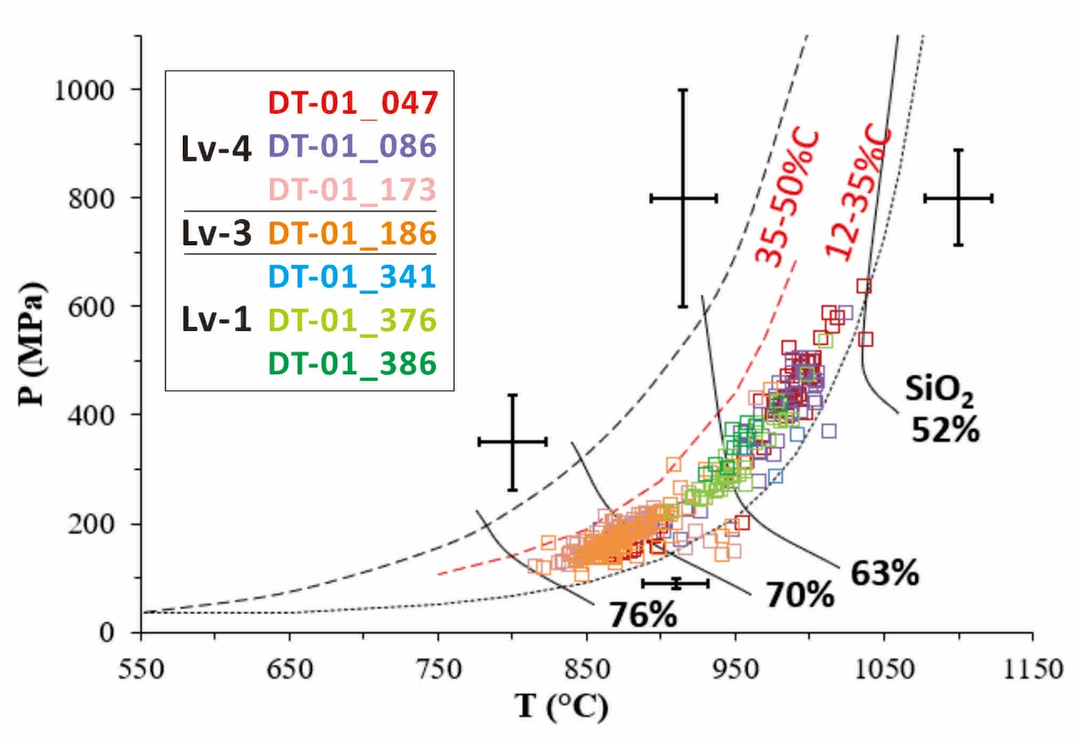
Fig. S6_P-T diagram presenting the amphibole stability field of calc-alkaline magma. Representative error bars indicate the accuracy of P (11-25%) and T (σ_{est} 22℃).
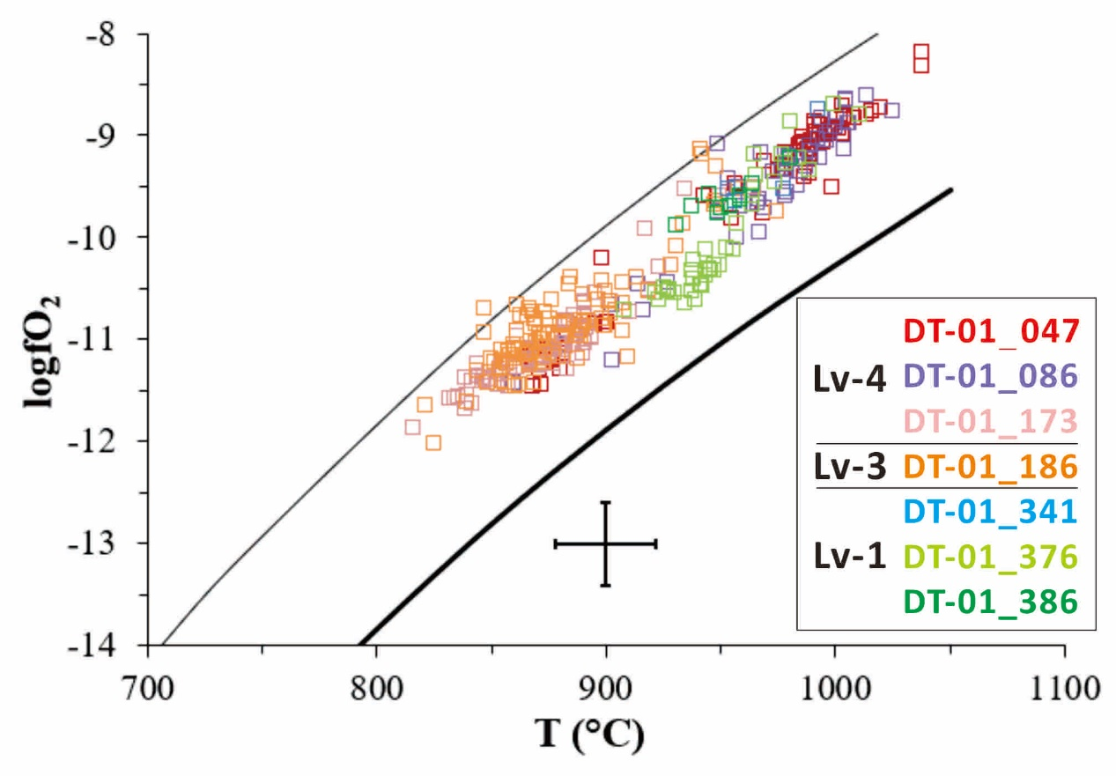
NNO+2
NNO
Fig. S7_The logfO₂-T diagram shows that DT-01 amphiboles fall within the stability field of calc-alkaline magmatic amphibole, bounded by the NNO and NNO+2 curves. Error bars represent the expected σ_{est} (22℃) and the maximum logfO₂ error (0.4 log unit).
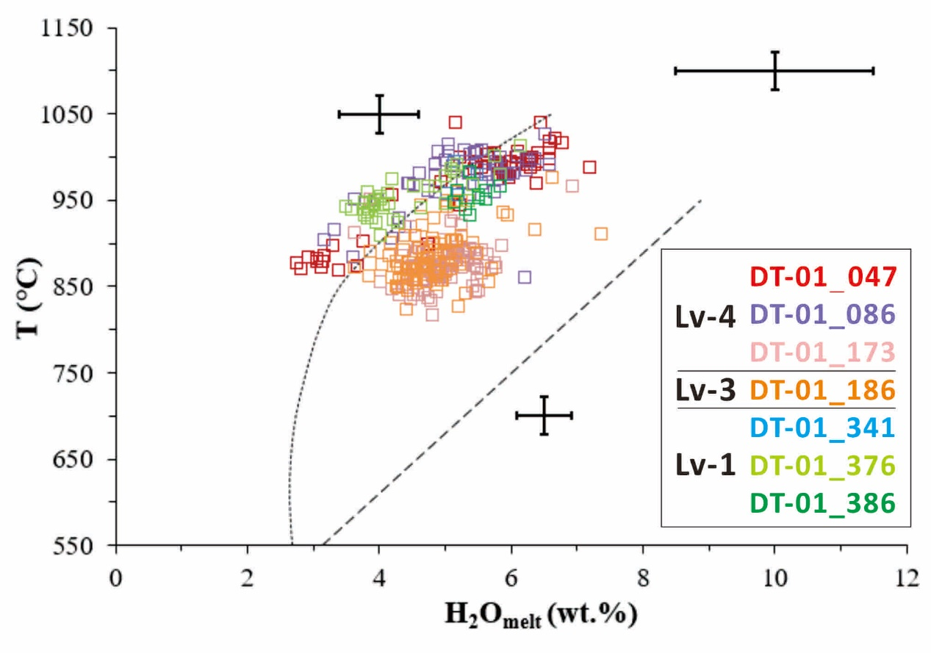
Fig. S8_T-H₂O_{melt} plot. Error bars indicate the maximum relative error (15%) and σ_{est} (0.4 wt%).

- ⁴⁰Ar/³⁹Ar dating for eruption ages
The groundmass 40Ar/39Ar age was obtained by incremental heating (Fig. S9a, c). Irradiated samples were loaded into Cu-planchettes in an ultra-high-vacuum sample chamber and incrementally heated by a defocused 30-W CO₂ Synrad Firestar laser beam scanning across the sample in preset patterns to release argon evenly. Each heating step was 50 s. After heating, reactive gases were removed using four SAES Zr-Al AP10 getters for 3 min. Ages were calculated using the corrected Steiger and Jager (1977) decay constant of 5.530 ± 0.097 x 10-10 1/yr (2σ), as reported by Min et al. (2000). For other constants used in the age calculations, refer to Koppers et al. (2003). Incremental heating plateau ages and isochron ages (Fig. S9b, d) were calculated as weighted means with 1/σ² as the weighting factor (Taylor 1997) and as YORK2 least-squares fits with corrected errors (York 1969).
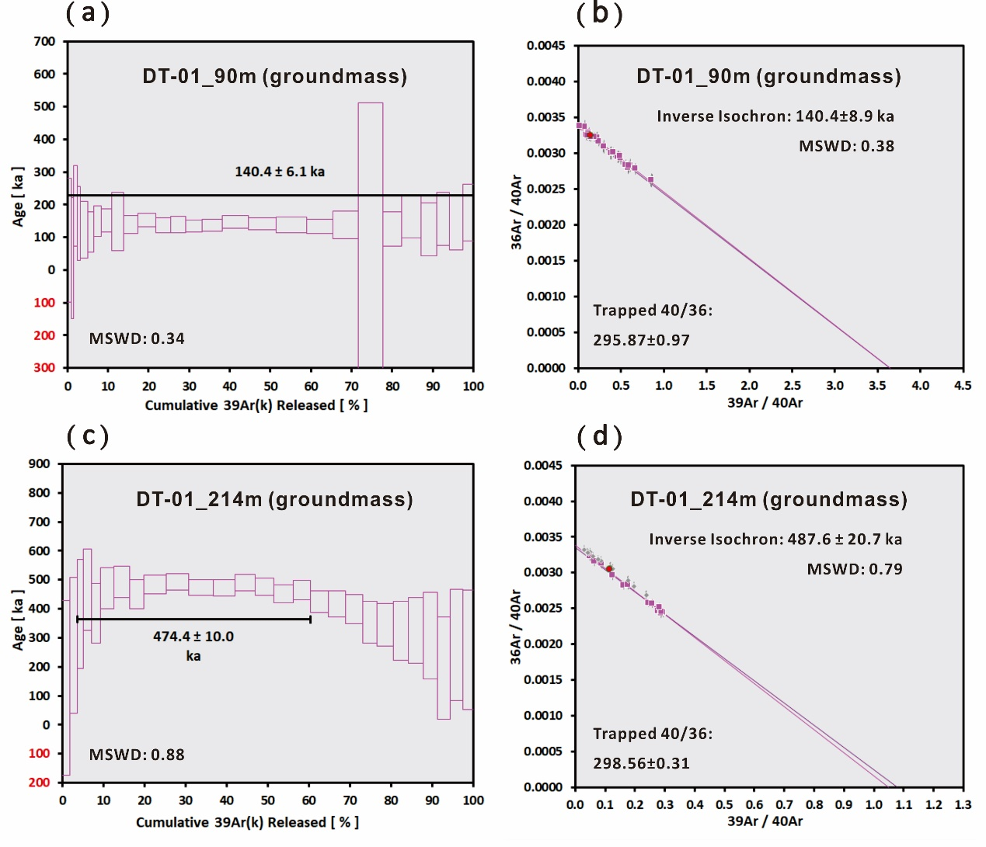
Fig. S9_Apparent plateau ages of the groundmass of the DT-01 samples (a) at 90 m and (c) at 214 m. ³⁶Ar/⁴⁰Ar-³⁹Ar/⁴⁰Ar inverse isochron ages for the groundmass of the DT-01 samples (b) at 90 m and (d) at 214 m.

References
Bacon CR, Hirschmann MM (1988) Mg/Mn partitioning as a test for equilibrium between coexisting Fe-Ti oxides. Am Mineral 73:57-61.
Chang SC, Chu MF, Wang JP, Lai YM, Song SR, Hemming SR, Ng SWP, Chow TD (2024) Volcanic activity around Taipei, Taiwan: new data and perspectives on the Tatun Volcano Group. Geoscience Lett 11:42.
Chu MF, Lai YM, Li Q, Chen WS, Song SR, Lee HY, Lin TH (2018) Magmatic pulses of the Tatun Volcano Group, northern Taiwan, revisited: Constraints from zircon U-Pb ages and Hf isotopes. J Asian Earth Sci 167:209-217.
Ignacio LARC, Lee YH, Jabagat KD, Iizuka Y, Lin CH, Hong GT (2026) Magma Storage and Eruptive History of the Mt. Qixing, Tatun Volcano Group, Taiwan: Insights from Petrology and Thermobarometry [Conference presentation abstract]. AOGS 2026 23rd annual meeting, Fukuoka, Japan.
Jabagat KD, Lee YH, Danišík M, Miggins D, Chu MF, Lai YM, Lo YC, Lee PT, Lin CH (2026) Late quaternary eruption history of the Tatun Volcano Group (Taiwan) – new constraints from zircon double-dating and 40Ar/39Ar dating of lava flows in Mt. Shamao. Tectonophysics 924(2026)231083.
Juang WS (1993) Diversity and origin of Quaternary basaltic magma series in northern Taiwan. Bull Natl Mus Nat Sci 4:125-166.
Juang WS, Bellon H (1984) The potassium-argon dating of andesites from Taiwan. Proc Geol Soc China 27:86-100.
Juang WS, Chen JC (1989) Geochronology and geochemistry of volcanic rocks in northern Taiwan. Bull Central Geol Surv 5:31-66.
Koppers A, Staudigel H, Wijbrans JR, Pringle M (2003) Short-lived and discontinuous intraplate volcanism in the South Pacific: hot spots or extensional volcanism? Geochem Geophys Geosyst 4:10.
Lee SF (1996) The study of the Chihsingshan Volcano Subgroup lava sequence in Tatun Volcano Group. Master thesis, Natl Taiwan Univ.
Min K, Mundil R, Renne PR, Ludwig KR (2000) A test for systematic errors in 40Ar/39Ar geochronology through comparison with U/Pb analysis of a 1.1-Ga rhyolite. Geochim Cosmochim Acta 64:73-98.
Pi JL, Lee YH, Jabagat KD, Miggins DP, Danišík M, Schmitt AK, Chu MF, Lai YM, Lo YC, Lee PT, Lin CH (2025) Eruptive history of Mt Huangzuei, Eastern Tatun Volcano Group, Taiwan, resolved by 40Ar/39Ar and zircon double-dating of lava flows. Geosci Lett 12:60.
Ridolfi F, Renzulli A (2012) Calcic amphiboles in calc-alkaline magmas: thermobarometric and chemometric empirical equations valid up to 1,130˚C and 2.2 Gpa. Contrib Mineral Petrol 163:877-895.
Ridolfi F, Renzulli A, Puerini M (2010) Stability and chemical equilibrium of amphibole in calc-alkaline magmas: An overview, new thermobarometric formulations and application to subduction-related volcanoes. Contrib Mineral Petrol 160:45-66.
Steiger RH, Jager E (1977) Subcommission on geochronology: convention on the use of decay constant in geo-and cosmochronology. Earth Planet Sci Lett 36:359-362.
Tayler JR (1997) An introduction to Error Analysis: The Study of Uncertainties in Physical Measurements. 327pp. Univ Sci Books, Mill Valley, Calif.
York D (1969) Least squares fitting of a straight line with correlated errors. Earth Planet Sci Lett 5:320-324.

