SUPPLEMENTAL INFORMATION
Supplemental Information: Delayed Gastric Emptying After Laparoscopic Left Hemicolectomy: Incidence, Clinical Course, and Operative-Field Extension
Fei Teng1,2†, Ming Lei1†, Chun-Yan Yuan3, Pu-hua Wang1, Yi-Ou Cao1*, Shao-Qun Liu1*

1Department of Gastrointestinal Surgery, Minhang Hospital, Fudan University, Shanghai, 201199, P. R. China.
2Department of General Surgery, People's Hospital of Daguan County, Daguan County, Yunnan Province, 657400, P. R. China.
3Department of Pathology, Minhang Hospital, Fudan University, Shanghai, 201199, P. R. China.

* Correspondence: liushaoqun@fudan.edu.cn;
yioucao_doctor@126.com

† Fei Teng, Ming Lei contributed equally to this work.

Supplemental Methods
DGE adjudication and diagnostic boundaries
DGE required a stomach-predominant symptom complex, intolerance of oral intake, or a need for decompression, together with objective evidence of delayed gastric emptying and exclusion of fixed mechanical obstruction. All 9 patients with DGE underwent computed tomography and an upper gastrointestinal contrast study on postoperative day 6; computed tomography showed no fixed mechanical obstruction and contrast imaging supported delayed gastric emptying. Imaging review included angulation at the Treitz region, a local transition point, vascular compression, and proximal dilatation. The available source summaries did not contain standardised measurements of duodenojejunal-flexure angle or proximal bowel calibre, so no patient-level frequency of mild angulation was inferred.
A fixed mechanical lesion was defined by a stable transition point, clear external or vascular compression, or persistent anatomical angulation. Diffuse POI referred to broadly delayed recovery of the stomach, small bowel, and colon. Occult functional obstruction at the Treitz region was conceived as a dynamic reduction in transit produced jointly by local inflammatory dysmotility, tissue oedema, and mild or intermittent angulation; it serves as an imaging and mechanistic framework for postoperative gastric retention.
Supplemental Tables
Table S1. Clinical definitions and analytical roles of key variables
Variable | Clinical definition | Analytical role
DGE | Persistent upper-GI symptoms, oral-intake intolerance, or decompression requirement; contrast evidence of delayed emptying; and CT exclusion of fixed mechanical obstruction | Primary outcome
DGE duration | From first fulfilment of the DGE criteria until decompression was no longer required and oral intake resumed | Days
Proximal tumour | Distal transverse colon near the splenic flexure, splenic flexure, or middle/upper descending colon | Anatomical classification
IMV root ligation | Division close to the IMV–splenic-vein confluence with full exposure posterolateral to the ligament of Treitz | Operative exposure
IMV high ligation | Division at the level of the inferior border of the ligament of Treitz | Operative exposure
IMV non-high ligation | Division >2 cm below the inferior border of the ligament of Treitz without disturbing the surrounding region | Operative exposure
Proximal–extended operative field | Proximal tumour plus splenic-flexure mobilisation, IMV root/high ligation, and Treitz-adjacent dissection | Composite exposure
Preoperative anxiety | GAD-7 score ≥10 on the day before surgery | Preoperative variable
Fluid balance, postoperative days 1–7 | Cumulative input minus output: net negative >1000 mL, within ±1000 mL, or net positive >1000 mL | Time-overlapping exploratory variable
Pathological T4 stage | Classified according to the AJCC 8th edition | Exploratory pathological exposure
The proximal–extended operative-field phenotype was analysed as the combination of proximal tumour location, splenic-flexure mobilisation, IMV root/high ligation, and Treitz-adjacent dissection. The source dataset contained only a cumulative postoperative-day 1–7 fluid-balance category; a separate day 1–3 exposure could not be reconstructed.

Table S2. Univariable Firth logistic regression for DGE
Variable | OR | 95% CI | P value
Age, per 10 years | 1.04 | 0.61–1.88 | 0.895
BMI, per 1 kg/m² | 0.95 | 0.77–1.16 | 0.647
Operating time, per 30 min | 1.39 | 0.48–4.08 | 0.543
Intraoperative blood loss, per 100 mL | 1.34 | 0.24–7.46 | 0.732
Preoperative albumin, per 5 g/L | 0.86 | 0.49–1.49 | 0.594
Maximum tumour diameter, per 2 cm | 1.38 | 0.71–2.32 | 0.322
Male sex | 1.06 | 0.29–4.50 | 0.935
Proximal–extended operative field | 10.93 | 1.37–1413.38 | 0.018
Type 2 diabetes mellitus | 1.04 | 0.24–3.73 | 0.953
Net-positive fluid balance >1000 mL, postoperative days 1–7 | 3.43 | 0.90–12.39 | 0.069
Preoperative anxiety | 1.16 | 0.27–4.17 | 0.825
Previous abdominal surgery | 1.58 | 0.42–5.67 | 0.482
Preoperative colonic obstruction | 2.66 | 0.62–9.64 | 0.173
AJCC stage III/IV | 1.57 | 0.44–5.92 | 0.483
The source dataset contained a categorical cumulative balance for postoperative days 1–7 rather than day-specific input and output, so a separate postoperative-day 1–3 exposure could not be reconstructed. The 7-day variable overlapped temporally with outcome ascertainment and was not interpreted causally. Confidence intervals were obtained from profile penalised likelihood.

Table S3. Focused exploratory multivariable Firth models
Analysis population | Variable | aOR | 95% CI | P value | N
Full cohort | Proximal–extended operative field | 14.75 | 1.79–1922.10 | 0.007 | 379
 | Pathological T4 stage | 14.01 | 3.59–77.11 | <0.001 | 379
Extended-field subgroup | Pathological T4 stage | 13.98 | 3.59–76.81 | <0.001 | 244
 | Age, per 10 years | 1.06 | 0.58–2.02 | 0.849 | 244
aOR, adjusted odds ratio; CI, confidence interval. Estimates were derived from Firth penalised-likelihood logistic regression. Extended-field status and pathological T4 stage were not nested: 48 of 83 patients with T4 disease and 196 of 296 patients with T0–T3 disease were in the extended-field group. With only 9 events, the very wide confidence interval for the extended-field estimate indicates substantial uncertainty in the magnitude of association; these estimates are hypothesis-generating rather than independent causal effects.

Table S4. Aggregated diagnostic evidence and characteristics of DGE events
Item | Result
Number of DGE events | 9
No fixed mechanical obstruction on CT, postoperative day 6 | 9/9
Upper-GI contrast study supporting delayed gastric emptying, postoperative day 6 | 9/9
DGE duration, days | 24 [18–26]; range 15–31
Proximal–extended operative field | 9/9
Pathological T4 stage | 7/9
DGE, delayed gastric emptying; CT, computed tomography; GI, gastrointestinal. Source imaging summaries confirmed exclusion of overt fixed obstruction but did not contain standardised measurements of duodenojejunal-flexure angulation or proximal bowel calibre; therefore, no frequency or quantitative estimate of mild Treitz-region angulation is reported.
Supplemental Figures
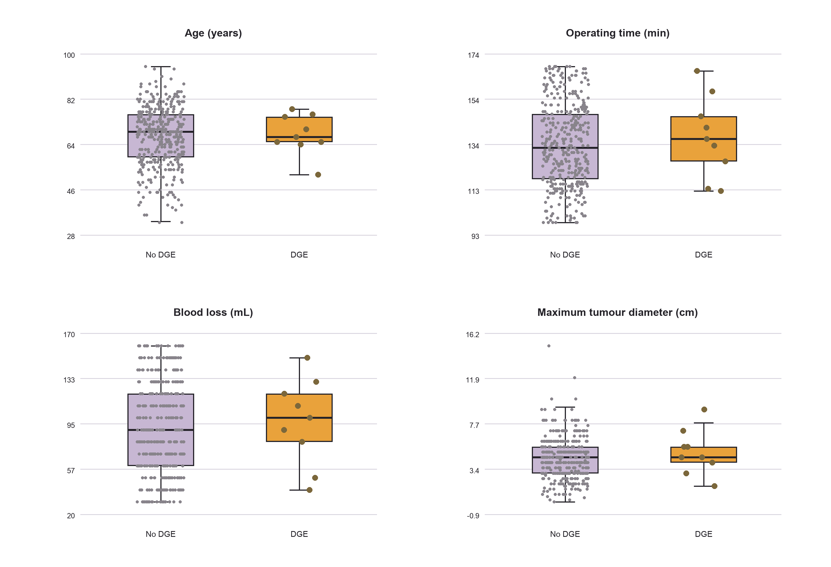
Figure S1. Distributions of continuous variables in patients without and with DGE. Boxes indicate interquartile ranges, horizontal lines medians, and points individual observations.

