Supplementary Information
Genome-Wide Association Mapping Identifies Candidate Loci and Genes for Agronomic Traits in the Barley Primary Gene Pool
Pilmo Sung¹, Mesfin Haile¹, Bich Saem Kim¹, Yuna Kang¹, Dong-Su Yu¹, Ho-Cheol Ko¹, Hee-Jong Woo¹, Nam-Jin Chung², Nayoung Ro¹*
¹ National Agrobiodiversity Center, National Institute of Agricultural Sciences, Rural Development Administration, Jeonju 54874, Republic of Korea
² Department of Crop Science and Biotechnology, Chonbuk National University, Jeonju 54896, Republic of Korea
*Corresponding author: Nayoung Ro
Email: nonanona@korea.kr

Contents
Supplementary Table S1. Information on the 137 barley accessions representing the primary gene pool used in this study.
Supplementary Table S2. Criteria and methods for evaluating continuous quantitative phenotypic traits in Hordeum accessions.
Supplementary Figure S1. Distribution of SNP density across barley chromosomal regions based on a 1-Mb window size.
Supplementary Table S1. Information on the 137 barley accessions representing the primary gene pool used in this study.
ID | Scientific name | IT No. | Temporart No. | Accession name | Country of origin
1 | H. spontaneum | 157394 |  | PI401379 | Iran
2 | H. vulgare | 206608 | K710125 | Musashino | Japan
3 | H. vulgare | 203778 | K706317 | Kuzzbegrannte Kulturgerste | Germany
4 | H. vulgare | 347399 | K264251 | UzRIPI 406 | China
5 | H. spontaneum | 115083 |  | PI220054 | Iraq
6 | H. vulgare | 331148 | K222756 | BGR 36872 | Bulgaria
7 | H. vulgare | 316304 | K254337 | 3-31 | Georgia
8 | H. vulgare | 246748 | K100435 | 72 | Kyrgyzstan
9 | H. vulgare | 246547 | K002604 | Jeonnam Wando Collection | Korea, South
10 | H. vulgare | 317064 | K247819 | 14-6 | Tajikistan
11 | H. spontaneum | 344019 | K230482 | PI 366431 | Afghanistan
12 | H. spontaneum |  | K163347 | HVS 457 | Armenia
13 | H. spontaneum | 218333 | K909144 | HOR10041 | Azerbaijan
14 | H. spontaneum |  | K909165 | HOR3553 | Bahrain
15 | H. spontaneum | 218343 | K909177 | HOR8266 | Cyprus
16 | H. spontaneum | 218342 | K909176 | HOR7426 | Germany
17 | H. spontaneum | 347576 | K163144 | HVS 254 | Egypt
18 | H. vulgare |  | K229708 | PI 356061 | Ethiopia
19 | H. vulgare | 115130 |  | PI415016 | Finland
20 | H. spontaneum |  | K241656 | PI 466613 | Iran
21 | H. spontaneum |  | K216396 | PI 219796 | Iraq
22 | H. spontaneum |  | K241480 | PI 466429 | Israel
23 | H. spontaneum |  | K909083 | GRA1034 | Italy
24 | H. spontaneum |  | K238461 | PI 420916 | Jordan
25 | H. spontaneum |  | K163348 | HVS 458 | Kazakhstan
26 | H. spontaneum |  | K241334 | PI 466262 | Lebanon
27 | H. spontaneum |  | K163289 | HVS 402 | Libya
28 | H. spontaneum | 218346 | K909190 | HOR9826 | Morocco
29 | H. spontaneum | 268971 | K163138 | HVS 245 | Pakistan
30 | H. spontaneum | 302825 | K163330 | HVS 444 | Russia
31 | H. spontaneum |  | K217379 | PI 283422 | Sweden
32 | H. spontaneum | 346320 | K239151 | PI 466056 | Syria
33 | H. spontaneum | 246532 | K909148 | HOR10404 | Tajikistan
34 | H. spontaneum | 218336 | K909159 | HOR2695 | Turkmenistan
35 | H. spontaneum | 346378 | K241699 | PI 466659 | Türkiye
36 | H. spontaneum |  | K909178 | HOR8496 | United States
37 | H. spontaneum | 218466 | K031731 | 47 | Uzbekistan
ID | Scientific name | IT No. | Temporart No. | Accession name | Country of origin
38 | H. vulgare | 303991 | K216414 | PI 220660 | Afghanistan
39 | H. vulgare | 311978 | K221586 | Bigo | Albania
40 | H. vulgare | 300957 | K210938 | PI 202035 | Argentina
41 | H. vulgare | 331420 | K220928 | PI 327866 | Armenia
42 | H. vulgare | 111937 |  | Mehltav Res. Barun | Antarctica
43 | H. vulgare | 108403 |  | Coast | Australia
44 | H. vulgare | 268617 | K709341 | QUANTUM | Austria
45 | H. vulgare | 17714 | K90690 | CI04312 | Azerbaijan
46 | H. vulgare | 19540 | K92516 | CI08287 | Belgium
47 | H. vulgare | 20378 | K93354 | CI15120 | Bosnia and Herzegovina
48 | H. vulgare | 277742 | K222762 | BGR 41077 | Belarus
49 | H. vulgare | 315330 | K241905 | PI 477765 | Bolivia
50 | H. vulgare | 294776 | K209683 | PI 168903 | Brazil
51 | H. vulgare | 302685 | K155726 | TKB 81c | Bhutan
52 | H. vulgare | 17532 | K90508 | Mensury | Canada
53 | H. vulgare | 140283 |  | Imperial | Switzerland
54 | H. vulgare | 285339 | K202257 | CIho 14286 | Chile
55 | H. vulgare | 111627 |  | A HOR1489/58 | China
56 | H. vulgare |  | K251860 | PI 573611 | Cameroon
57 | H. vulgare | 213346 | K802139 | i12640 | Colombia
58 | H. vulgare | 197298 |  | U0004858 | Czechoslovakia
59 | H. vulgare | 302399 | K045308 | Mari/Aths*2 | Cyprus
60 | H. vulgare | 315940 | K252677 | PI 61314 | Czech Republic
61 | H. vulgare | 18027 | K91003 | CI08790 | Germany
62 | H. vulgare | 111399 |  | Note Bolemia | Denmark
63 | H. vulgare | 17626 | K90602 | CI03365 | Algeria
64 | H. vulgare | 303937 | K210985 | Pelileo | Ecuador
65 | H. vulgare | 108261 |  | Giza120 | Egypt
66 | H. vulgare | 285401 | K202401 | CIho 14883 | Eritrea
67 | H. vulgare | 17639 | K90615 | CI03523 | Spain
68 | H. vulgare | 20371 | K93347 | CI14935 | Ethiopia
69 | H. vulgare | 20130 | K93106 | CI15721 | Europe
70 | H. vulgare | 115131 |  | PI415017 | Finland
71 | H. vulgare | 18013 | K90989 | Peragis 12 | France
72 | H. vulgare | 111311 |  | Maris Canon | United Kingdom
73 | H. vulgare | 295725 | K216891 | PI 264895 | Greece
74 | H. vulgare | 331555 | K210813 | PI 195318 | Guatemala
75 | H. vulgare | 316318 | K252600 | PI 591882 | Honduras
76 | H. vulgare | 295729 | K216912 | PI 264916 | Croatia
ID | Scientific name | IT No. | Temporart No. | Accession name | Country of origin
77 | H. vulgare | 18496 | K91472 | Slaski Ⅰ | Hungary
78 | H. vulgare | 295622 | K216508 | PI 224750 | Indonesia
79 | H. vulgare | 17665 | K90641 | CI03850 | India
80 | H. vulgare | 20364 | K93340 | Beorna | Iceland
81 | H. vulgare | 17398 | K90374 | CI7079 | Iran
82 | H. vulgare | 285384 | K202369 | CIho 1465 | Iraq
83 | H. vulgare | 307832 | K217338 | PI 282664 | Israel
84 | H. vulgare | 307683 | K216922 | PI 264926 | Italy
85 | H. vulgare | 108263 |  | Briggs | Jordan
86 | H. vulgare | 17175 | K90151 | Ibarakimugi | Japan
87 | H. vulgare | 308006 | K217835 | PI 296197 | Kazakhstan
88 | H. vulgare | 111280 |  | SYR-ICARDA-1985-11280(KEN) | Kenya
89 | H. vulgare | 145797 |  | CI08973 | Lebanon
90 | H. vulgare | 302401 | K045311 | Momtaz = (M126/CM67//As/Pro/3/Alanda) | Libya
91 | H. vulgare | 316464 | K253530 | PI 87404 | Lithuania
92 | H. vulgare | 108287 |  | Rabat 013 | Morocco
93 | H. vulgare | 285607 | K202954 | CIho 392 | Moldova
94 | H. vulgare | 108286 |  | SYR-ICARDA-1985-8286(MEX) | Mexico
95 | H. vulgare | 171466 |  | ICB104876 | Macedonia
96 | H. vulgare | 318218 | K242013 | PI 490393 | Mali
97 | H. vulgare | 306781 | K202348 | CIho 14401 | Myanmar
98 | H. vulgare | 111345 |  | CI15152 | Montenegro
99 | H. vulgare | 194747 |  | WIR1240 | Mongolia
100 | H. vulgare | 19702 | K92678 | Guilder | Netherlands
101 | H. vulgare | 313699 | K242464 | PI 54912 | Norway
102 | H. vulgare | 20261 | K93237 | CI08396 | Nepal
103 | H. vulgare | 302439 | K045406 | IG 32962 | Oman
104 | H. vulgare | 18403 | K91379 | CI11429 | Pakistan
105 | H. vulgare | 295769 | K217078 | PI 270663 | Peru
106 | H. vulgare | 197384 |  | U0005416 | Poland
107 | H. vulgare | 247409 | K170375 | PI 87781 | Korea, North
108 | H. vulgare | 320751 | K241856 | PI 467683 | Portugal
109 | H. vulgare | 303681 | K203578 | PI 122036 | Paraguay
110 | H. vulgare |  | K221506 | PI 328643 | Romania
111 | H. vulgare | 17302 | K90278 | CI5010 | Russia
112 | H. vulgare | 317031 | K252626 | PI 606309 | Saudi Arabia
113 | H. vulgare | 313325 | K238507 | PI 42891 | Sudan
114 | H. vulgare | 108415 |  | CI15090 | Serbia
ID | Scientific name | IT No. | Temporart No. | Accession name | Country of origin
115 | H. vulgare | 315222 | K253603 | PI 94854 | Soviet Union
116 | H. vulgare | 145964 |  | Wales | Slovakia
117 | H. vulgare | 308221 | K220706 | Adlesici | Slovenia
118 | H. vulgare | 285722 | K203283 | CIho 6540 | Sweden
119 | H. vulgare | 18055 | K91031 | CI08991 | Syria
120 | H. vulgare | 20235 | K93211 | CI14664 | Turkmenistan
121 | H. vulgare | 19589 | K92565 | CI15334 | Tunisia
122 | H. vulgare | 17997 | K90973 | CI08209 | Türkiye
123 | H. vulgare | 308255 | K220797 | PI 327733 | Ukraine
124 | H. vulgare | 188309 |  | Admire | United States
125 | H. vulgare | 302464 | K045481 | IG 123901 | Uzbekistan
126 | H. vulgare | 108386 |  | Ruble | Venezuela
127 | H. vulgare | 18325 | K91301 | CI10742 | Western Asia
128 | H. vulgare | 313310 | K238469 | PI 422225 | Yemen
129 | H. vulgare | 18265 | K91241 | Novi Sad 4084 | Yugoslavia
130 | H. vulgare | 318217 | K241996 | PI 48092 | South Africa
131 | H. vulgare | 285521 | K202759 | CIho 2342 | Zimbabwe
132 | H. vulgare | 315329 | K247523 | KOBO 060 | Bolivia
133 | H. vulgare |  | K269914 | Ji pi 2 hao | China
134 | H. vulgare | 203540 | 705135 | Keunalbori | Korea, South
135 | H. vulgare | 266646 | K175504 | Hopum | Korea, South
136 | H. vulgare | 218533 | K111340 | Gwangmaek | Korea, South
137 | H. vulgare | 318469 | K265828 | Heukbochal | Korea, South

Supplementary Table S2. Criteria and methods for evaluating continuous quantitative phenotypic traits in Hordeum accessions.
No. | Trait | Recording method | Measurement method
1 | Days to heading | Measured value | Date when 40% of the total tillers had headed
2 | Days to maturity | Measured value | Recorded as the maturity date when the first internode turned yellow
3 | Central spikelet awn length | Measured value | Measured from 2–3 spikelets in the central part of the spike at maturity
4 | Central spikelet glume length | Measured value | Measured from 2–3 spikelets in the central part of the spike at maturity
5 | Lateral spikelet awn length | Measured value | Measured from 2–3 spikelets in the central part of the spike at maturity
6 | Lateral spikelet glume length | Measured value | Measured from 2–3 spikelets in the central part of the spike at maturity
7 | Number of triple spikelets | Measured value | Number of triple spikelets per spike counted at heading
8 | Culm length | Measured value | Length from the ground surface to the spike neck after heading
9 | Spike length | Measured value | Spike length excluding awns at maturity
10 | Flag leaf area | Measured value | Flag leaves collected at the milk stage and analyzed by image analysis
11 | Flag leaf length | Measured value | Flag leaves collected at the milk stage and analyzed by image analysis
12 | Flag leaf width | Measured value | Flag leaves collected at the milk stage and analyzed by image analysis
13 | Flag leaf roundness | Measured value | Flag leaves collected at the milk stage and analyzed by image analysis
14 | 1,000-seed weight | Measured value | Weight of 1,000 dehulled grains harvested at maturity
15 | Seed area | Measured value | Seeds harvested at maturity and analyzed by image analysis
16 | Seed length | Measured value | Seeds harvested at maturity and analyzed by image analysis
17 | Seed width | Measured value | Seeds harvested at maturity and analyzed by image analysis
18 | Seed roundness | Measured value | Seeds harvested at maturity and analyzed by image analysis

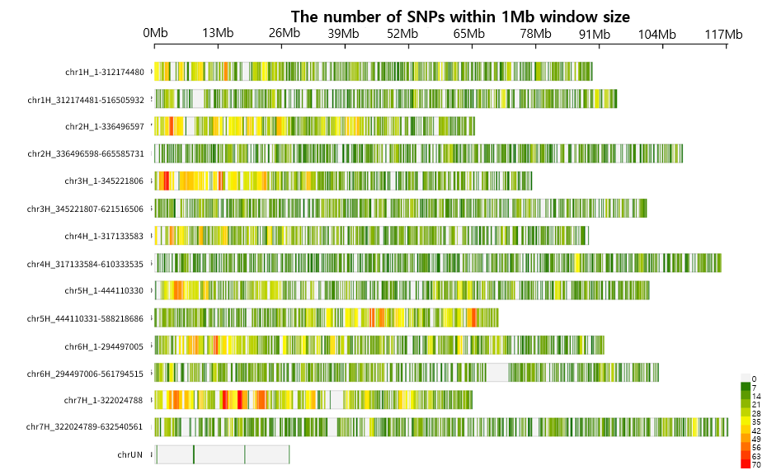
Supplementary Fig. S1. Distribution of SNP density across barley chromosomal regions based on a 1-Mb window size

