Supplementary Material
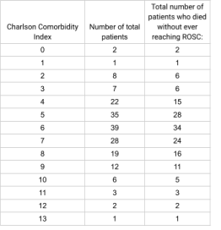
Table 1: Total number of patients who died without ever reaching ROSC

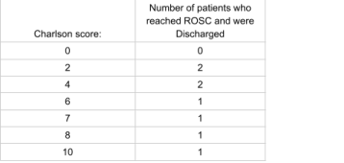

Table 2: Total number of patients who reached ROSC and were discharged
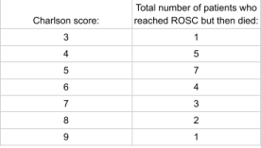
Table 3: Total number of patients who reached ROSC but then died

