Supplementary Information

Calibration-Free, Nanometer-Scale Single-Molecule Localization with MINFLUX and RASTMIN via Direct Minimum Fitting

Lucía F. Lopez¹, Florencia Edorna^{1,2}, Alan M. Szalai¹, Andrés Zelcer¹, Fernando D. Stefani^{1,2*}

¹ Centro de Investigaciones en Bionanociencias (CIBION), Consejo Nacional de Investigaciones Científicas y Técnicas (CONICET), Godoy Cruz 2390, C1425FQD Ciudad Autónoma de Buenos Aires, Argentina
² Departamento de Física, Facultad de Ciencias Exactas y Naturales, Universidad de Buenos Aires, Güiraldes 2620, C1428EHA Ciudad Autónoma de Buenos Aires, Argentina
*fernando.stefani@df.uba.ar

Supplementary Figures
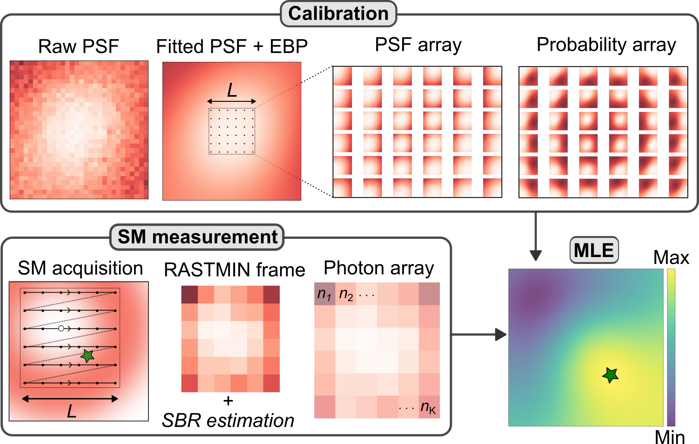

Figure S1. MLE pipeline in RASTMIN. Calibration step: Raw PSF acquisition and fitting followed by PSF array creation and corresponding probability array needed to build the Likelihood function. SM measurement step: SM (represented by a green star) acquisition, RASTMIN frame and corresponding photon array. MLE estimation step: Using the calibration, the acquired photon array and an estimation of the SBR from the measurement, the Likelihood function is built and the MLE is used to determine the SM position.

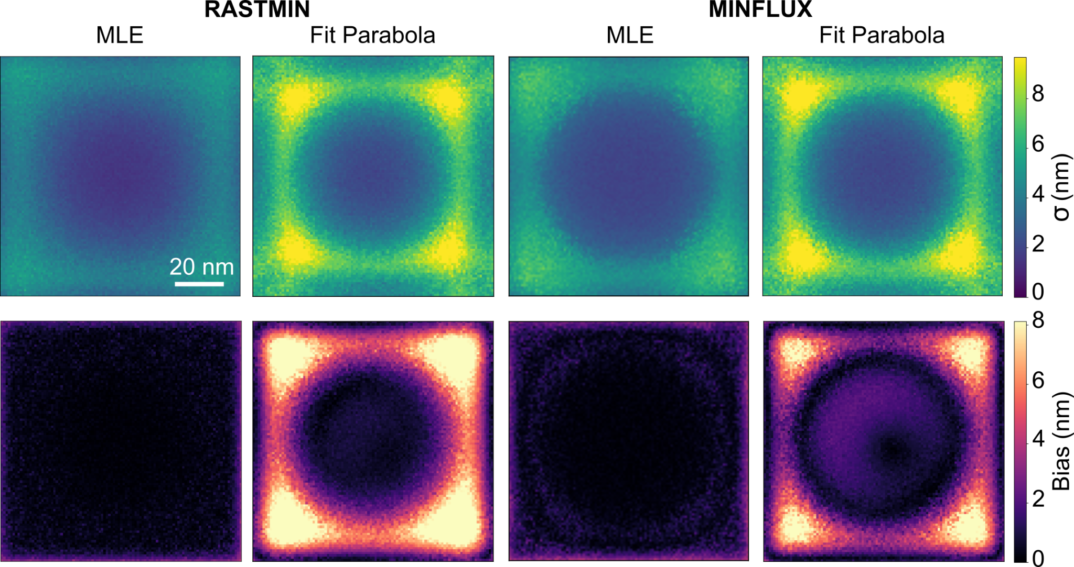

Figure S2. Localization precision and accuracy in RASTMIN and MINFLUX simulated experiments using MLE and the fitting approach using $I_{Parabola}$. Localization precision ($σ$) and accuracy ($Bias$) maps for the standard MLE and the fitting method using a parabola as the fitting function. Simulation parameters: $L =100 nm$, $K = 6× 6$ for RASTMIN and $K = 7$ for MINFLUX, $N = 1000$, $SBR =10$, $grid step =1 nm$. Scale bar: 20 nm (applies to all maps).

Supplementary Tables

Table S1: DNA origami with a single ATTO 647N
TAAAGACAAAGGCCGTAATAATTTTTTCAC
TACCTGAGAACAAAATAACTATATAAAGAACG
GCACCAACATGACAACTCGGTTTATCAGCTTG
AGTACATAATTGCTTTAATAATGGCGAACGTT
GTACCGACAGCCAGTACGCAAGACGTAAATGC
CAGGCAAACGAAACGTTGAAGGGACCAGAGCA
GAATTGAGGAGGTGAGCAGAGATAATCCAGAA
AAACTATCGATTTAGTGCGCGTAACCACCA
ATCAAGAACAAAAGAATTCCTGATGAAGGAGC
CCAAGAAGACCGTGTATAAAGCGTGAATAA
GTGAGCCTCCTCACAGCGTGCCAGGCGGTATG
TTAAAAATAACAACTATTTACAAATGCACGTA
GCCGCCACTGGGAAGGTCTGCCAGAATTCGCG
CTGCCAGCTGAAATGTAAAGCAGCGCTTTC
AATTTTATCAGATAGCAATAGCAATATCACCG
AACATAGCATAAAGAAGAATATACGAGCCGTC
AATTTACCCTGTTTAGGAATCATCCTTGAA
GTTGGGCGGTTGTGTATCACGACGGAGGTGTC
CTCAGAAAGGCGGATCGTTCCAGAGGCAGG
TTCGAGCTTTAGTTTGTGGGGCGCATGCAATG
AGAATTAAAACAGGGAGAAGGCTTCAATAGCA
CTGTTTCCCGAGATATGAGAGAGTTGCAGC
AAATGAATGAGCGCTGCATGATAGTTTATT
TAAATCCGAACCGAACAGGACGGCGACAGA
TGATGCAGGGAACAAATTAAGTAAACAAAC
AAATACCCGGGTATTTATCAACTCCCAATC
GCCAGGGTGCAAGGCGACGGCGGACGTCGGAT
TGATAATCGTTCTAGCCGCAAGGAAGTAGTAG
GAATAGCCTGTGTGAAGTGAGCCATAAACA
TTTTGCGGCAGTCACACCACGCTGGGATTTTA
CACTCCAGCTCCGTGGACAGCGCCCGTCAGCG
GACGAGAACATAACGCAGACGACGATCAAAAA
TCCCGTATCATCATAGATGATGTGGGTAAC
CAGTACCCCGCCACCTAGTAAATGAATTTT
GGAGCACTACCGAACGAAGAATACAAGAACTC
CATAGGCTAGGGGGTAGTAGAAAGGAGTACCT
GCAAGGCATCGGCATGGAGGTTGTAAGCGT
CAATCAATTAAACACCGTATCATATTAATTAA
GTTGATATCTCAGGAGTAAACAACTTTCAACA
ATGAATCGTGGGCGCCAAAGGGCGAAAAACCG
ACCGATTGCGCCACCCAGCCACCAATTCTGAA
TCTGGTCCAACAGTGCGACCAGACAGGAAA
TTAATTGGTACGGTGATCATACTTGCGGGA
TTGTCACACATTGACATTTCGGTCGTTTTGCT
GTCTCGTCCAGCGCATGCTCGTTAACTCAC
CAATCGTCACGCGTGGCGGGGAAGAGCGGG
CAGCAAATCAAATATCAACCACCATATCAGAT
AAGCGGTCGCCTAATGAATTGTTACCTGCATC
TAGCAATGGAGCGGGGAAAGGA
TAGTCAGCATCAATTCCCAATTAATATGAT
CAAGATTCCGAGGAATAAGCCCATTAGAGC
AGATTCACAACAAAGAAAACCCTCATTTCAAT
AACTTAAAACCGTGCAGCGATCGGACCCCGGT
AGGGTAGCCAGCGAAAGAATAGAAAGGAACAA
TCTTCGCCAGTGCCACATTTGCGATGCTGA
CCTTGCTTACATCGGGAAATTATTCAATTCGA
TTAGGTTGTTCATCAAAATTATTCAATCAATA
TCAGAGCCGATTAGGATGATACAGCCAGAGCC
ACGACGAGCCAACATAATATATCCTCCGGC
CCTGAGTATTGTTAAATTTAAATTCCGGAAAC
AATAAGAAAATCGGCTAATAATATCCAGTTAC
CAGTACAAACTACAACGTGCCCGTAACCTATTCCGGAACC
ATTTCATCAACAAGCAAACATGTTAACGTCAA
ATTGTATAAGTCAAATTATTTTAAGAGCTGAA
AGACGATCGCTGGCAAGCAGCACACCGGAA
AGCCGGGAACCAGCTGTTAAACCGCCAGCA
CAGTTTGGTCGAATTCTCACTGCCGCTGGTAA
AAACTCCAAGTTGATTCTACTAATTAAAAATT
CAGCAAAACGTTTGCCAACCACCAGAGTGTAC
AACTAAACTCCTTTTACGAGAAAATGTTTA
CAAATAAGAATTGAGTACGCAATATATGGTTT
TGTTTTTAGCGCTTAAATCGGAACCCTAAAGG
GATGGCAAGGTTATATTAATTACAGGCAGAGG
GAGGACAGATGAACGGTGCGATTTTTGAGGAC
ACCAGCGGCCACCAGATCTTTTGACTCCTC
GACAGGAATGGTTGCTTTTTGGGGTCGAGG
AGCTAAACTTCCTCGTGCCCACTACGTGAACC
GACGACGAAGAGACGATAACCTACCGCAAG
TTTAGAAGTTTTGAATCCCTAAAAAACCGTTG
AAACTAGTAGCTATTAATACTTAGGCAAGG
CCTGGGGTCACGCTGGCCCTTATAAATCAAAA
TACCTTTTCTGTAAATAGATTAAGAGGCGTTA
GAGCCCCCGGCCTTGGAGGCCAAGCAGAAG
AACATAAACTGAACACTTAGCAAATATAAAAG
CGTGGACTCCAACGTCAGGGTGGTTTTTCTTT
CTTCACCGCGTTGCGCGTAATCATGCGCGCCT
TTTTCCCCGTCAGATATTGCGTTTTGAGGA
GATTAAGATTTTCATTACCATTAGGAGAAAGG
AAGAGAAGACCACCCTACGATCTAAAGTTTTG
TGCCGTAACCGCCAGCCCAGAATCTATTAACA
AATAGATACTGATAGGGCTATTTTGATTAG
ACAACATTTACCTTATGTACAGCTCCATGT
GGGAGTTTTTTTCATCGACCTGACCAGGCG
CCCACGCTCACTGTTTGCGGCCTCCCCGGG
TAATAACACGTGGCGACGCTAGGGCGCTGGCA
CAAGCCCAGTATTAAGACGGGGTCACCACCCT
GAAGCCTTTCCTGTAGTCATATGTTGCGGGCC
AACATTATGACCCTGTTTTGAGAGAAATATGC
TGGTGCTGACTGGTGTCGGTGCCCTCCGCTCA
GTTTCAGCGGAGTGAGACAGCATAGGTGTA
TTGCCGTTTGTGGTGCGCCCTGCGCGCTTTCC
ATAACCGAAAATACGTTATCATCGGAGTAATC
AATCGCGTGAATTACTTTTTAATTTAGTTA
AACGCTCAAATCAAGTTTTGACGAGCACGTAT
AACGTGCTAGGAGGCCCCTACATTACATTGGC
CCGCCTGAGTTGGCATGAGTAACTGATTGT
GACAATATTATTAGACATAGATTAAGTAACAG
TTACCGATCCAGAGCTTACCAAGTAGAAAC
TCCCTTACGTCTGGTCGCCTCCGGTAGCTCTC
AATCAAAATCCAATAATCTGGAAGTAATGCCG
CAGAGCACAGATATAAGCGCATGCTGAATA
CAGTCTCTGATTTTGCGTTTAGTACCGCCACC
ATCAAGTTGCACCGTATGGCAACACGTAGAAA
CCCACAAGAAACGATTTTTTGAAGTACCGCAC
GGTCTGAGTACTTCTGGAATACCAGTTGAAAG
AGTGTAGCGTCCATCACTGAGTAGGTGGCACA
GAGCCTTGAGATTTGAATGCCAGTAAATTG
GAGAGGGCATGTCAACCAGCTTAGATGGGC
TCACCAGAAACCTGTTTGAGGAAGAATGCG
CTCAGAACAGGGAGGGAGGTGAATTAGCTATC
ACAAATTCACAAGAAAGTCTTTCCCCAGCTAC
GACTGGATAGCGTCCAAAAACGAAGTCATTTT
TTTAGAAGAACGCCACCCAAAACAGGCTGC
CCGGAGACAGCAAATATCAGCTCAGAAGATCG
GCCGCCAGATCAATAGAGCACCATAGAGATAA
TCTATCAGGGCGATGTAGAATCGAGGCGGT
TGAGTTTTATTTCGGATAAACACCGCCACC
TAACAACCAATAAACAGCCGTTGCGAACCT
GTGCACTCCCGGCAAACCGTCGGTGAGGTGGA
GCCTCCCTTCATTAAAAGGTAATTTTAAGA
CATTAACAATCAGGTCGGATTAGAATTCATCA
ACGGAAAACAGTATCCGCCATTACAGGAAG
TGGTAATTTAGCGTACATTTTCAGGGATAG
CTTATTAGTCACCAGTAAAATTCAATAACGGA
TTGTGAATATTACAGATAGTAATGACCATA
GCATCGTATTTCTGCTAGCTTTCAGGTGCCAT
ATACCCAAGCGGGAGGTTTTGTTTCAGCTAAT
AAGGAAAAGTTGCTATTATTTAAATAGATA
AAACAGAAGATAGCTTCGTCGCTATGCGTTAT
TCACCGACGGAACCAGTCAGAGCCAGTGCCTT
GATAGTTGCGCCGACACTAAAACGCAAGCGCGACCCAAAT
AAAAATCTATACCAGTCTGACCAACGGTCAAT
AAAATAAAAACAATGACGAACAAAGACATTCA
CTTATTACACGCGAGGCCTTTACACTGTCCAG
TTAAACAGTTCAGAAAGATAAGAGCTAACGGA
ATTAAATGTGAGCGAGATGAACGGGAAAGGGG
TTGGATTAAGACTACCCTTTTTTAGCCATATT
GTTGAGATATGGTTTATTCATCAACCTGATAA
GGGTAATAATAGCAGCGTTTTATTTATTTT
CAACGTAACGTTTACCCAAAAGGACGTTTTAA
ATAAATACATAAAGGATCAGTATTGGGAAG
CCAATAGCCCTCATACACCATCCTGCGAAC
CAATATTAAGCACTAATGCGCCGCTACAGGGC
TCATCGAGTTCTGACCTGAGAATCATGGAAAC
TACCGAGCAACAAGAGGCAACAGCTGATTGCC
CATCGTAGCTTTTTCAGTAATTTATTTAACAA
AAGAGTCCCATATCAAGAAACATATCTTTA
ATAAAACAGAAGGTTACCTTTGCCAAGGGTTA
ACCCTCAGAACGGCTAGGCGCAGACTTTGAAA
TACTTAGCCGGAACGACAGAGGCTTAAGAACT
CTCATAGAAGTTTTAAGGCTGACATAATCA
AGCAAATTAAAGCTAGCCTGAGAATATAAA
CTGACCTTATTAAATTCTAAAAATAACGGA
CTGTATGGGAATTTACAAGTGCCGCTGTAGCG
TACAACGTAATTGTAAACCATCGCCCACGC
GCGTACTACGGTACGCATTGCATAATAAAA
ATCACCCATGGAAATAGATTAAAGAGAGCCAG
AGTCCTGATTACCAGTGATAAATAACGCTGAG
TTCTAAGAGCAGTATGCCTGAACAGAAACCAT
TCACCGTAAAGTATAGGCCAGAATCAAACAAA
ATTCAACCAGAAAAGCTCAAAAATTTTGAGGG
CAGAGCCCCAAAGACTTTGGGAAATAATAA
CAATTCCAGGCAAAATTTTGCCCC
AACAGTAGCGCCTGTTAAACCAAGCCTTAAAT
CAGCATCATCCGCCGGGTCATACCTCGCGTCC
TTTGCCAGGGCTGACCATTTCAACTTCCATTA
GTTGAAAAGAAATCCGGAGGAAGTTTTAATCA
CCGGCGAATCACTTGCCGCAAATTCATCGCCA
TTGCGTATGCCAACGCCCTGTTCTGGGGGTTT
TTCGCCTGAATCAATAATTTATCAATGGTTTG
TCAGACGAAGACACCATCACCAATAAGTCAGA
CGACGGCTATTACGCTTGGTGTTCATCAAC
GCGGGCCGTTTTCACGGCGCGGTTCTGCATTA
CATTTTCGAAAAGGTAACCGCGCCATCCGGTA
GAGTAACAGCCTGTAGCCATGTACCGTAACAC
CAAAGAATTAGCAAAACATGTTTTATCTACAA
AAATCACCTTGAGCCAAAAAGGGCGTTACCAG
ACAATCGGGCGCCATTGGCCTCAGTTTTTTAA
CGAGAAAAGAATCATTAAGTAATTGAGAGAAT
TTTCATTCAGAGGCGTATAATCCATTATCA
CTAAAGGAATTGCGAACTTTTGCGGGATCGTC
AAGGTGGAAGCAAAGAACCAGATCAACTAA
GGAATTAAAAAAAGCATTGCAGTCACCTTG
CATACATGCCAGACGTCTCAGAACCGCCACCC
CGTTTTCCGGAAACGCGGAATATAAGACTC
GAGCAAGACAGCCATATTTTGCACTTATCATT
TGCGGATGTAGCTCAATTAAGCAAGTACCAAA
CACCCGCCTAATCAGTCTGGTAATGAACCCTT
CTTTCGAGGATTATACAAAGAGGCCTTGCCCT
GAACCTAAATAGTGATATGTGACAACGCTC
AATGGGATAGGTCACGCAGCTGGCTAATCGTA
AGGCTATCGAGAATCGTAACAACCTTGACCGT
ATACATATTCATTGACTTAATTTAGACGGG
TTGACAAGCGAGAGGACCACATCCGGAAGC
TCTGGCCTTATTTCAATGATAAATTTTCATTC
CGATAGCATGCCTTTAGATATTCAGGAAAGCG
TGCAGATAACACCAGATATTCATTAAACAAAG
TCTCCGTAATCCAATATAAGAGAGTCTGGA
GAGTAGATTCAAAGCGCGGATTGCATAAAAAC
CTGAACCTGAAAAATCGATTATTTTTGACGCT
ATTAATTTCTGGCCAAGCGGTCAGCTGAGAAG
AGTCGGGTGAGACGGTCCACTATTAAAGAA
AAACGCAATTGGCCTTGCGTCAGATCGAGAGG
ATTGTGTCTCTCCAAAGTCGCTGAGGCTTGCA
AGTGATGAAGGGTAAATACGGCTGTTGTAAAA
AATGCCAAGGTTTCTTGTGTCACTGGTCATAG
CATAAGGTCATTAAACCCGGAATCGGAACG
CATCCTCAAGCGGTGCGTTCAGCAGTGTAAAG
AAAGTAAGCCTGAATCCTAATTTGCCCATCCT
GGGACATTTAAAAGTTAATCAACAAGTTACAA
CCCGACTTAAGAACTGAATATCAGTACCATTA
TCGTCTTTGCTTTTGATTAGCGGGATAGCCCC
MODIFIED
CAACTCGGAAAGCGTAACCACCCCGAGTAATTT[ATTO542]
CAAAATAGAACCGGAACGAGTACTACGAAGTTT[ATTO647N]
[biotin]TTTAAGAGTCTGGTCACGCAGCTTGACGGGGAAAG
[biotin]TTTACATGAAAATAGGAACCATTCCACAGACAGCC
[biotin]TTTGCAGAACGGGCTTAATTAAATTTAAAATCATA
[biotin]TTTGCAAACAAAGGTCATTAATCGGTTTAAAGCCT
[biotin]TTTATTAATTGCCTGGCCCGGGTTGAGTGTTGTTC
[biotin]TTTAACGGGTATATATTCGAAAAAGGCTCCAAAAG

Table S2: Fitting parameter’s bounds
Function | Parameter | Lower bound | Upper bound
$$I_{Donut}$$ | $$A$$  $$x_{E}, y_{E}$$  $$d$$  B | 0  $$\frac{-FOV}{2}$$  60  $$-∞$$ | $$∞$$  $$\frac{FOV}{2}$$  1200  $$∞$$
$$I_{Parabola}$$ | $$A$$  $$x_{E}, y_{E}$$  $$σ$$  B | 0  $$\frac{-FOV}{2}$$  50  $$-∞$$ | $$∞$$  $$\frac{FOV}{2}$$  500  $$∞$$
$$I_{Anisotropic Donut}$$ | $$A$$  $$x_{E}, y_{E}$$  $$d_{x}^{}, d_{y}^{}$$  B  $$θ$$ | 0  $$\frac{-FOV}{2}$$  1  $$-∞$$  $$\frac{-π}{2}$$ | $$∞$$  $$\frac{FOV}{2}$$  1000  $$∞$$  $$\frac{π}{2}$$

