Supplementary information for
High-Selective CO Production via Carbonate Hydrogenation Mechanism over K-Ni/MgO Catalyst in Low Temperature CO₂ Hydrogenation at 350 ℃
Ruiqiang Liu¹, Jingqing Tian^{1*}, Chen Zhao^{1*}
¹Shanghai Key Laboratory of Green Chemistry and Chemical Processes, State Key Laboratory of Petroleum Molecular & Process Engineering, ECNU Engineering Center for Sustainable Carbon, School of Chemistry and Molecular Engineering, East China Normal University, Shanghai 200062, China
*Corresponding author E-mail: jqtian@chem.ecnu.edu.cn; czhao@chem.ecnu.edu.cn

Supplementary Methods
Materials
Polyvinylpyrrolidone (PVP, AR, 58000), potassium carbonate (K₂CO₃, AR) and sodium carbonate (K₂CO₃, AR) were purchased from Aladdin Chemical Reagent Company. magnesium nitrate hexahydrate (Mg (NO₃)₂·6H₂O, analytical reagent (AR)), nickel nitrate hexahydrate (Ni (NO₃)₂·6H₂O, AR), lithium nitrate (LiNO₃, AR), sodium nitrate (NaNO₃, AR), potassium nitrate (KNO₃, AR) and cesium nitrate (CsNO₃, AR) were purchased from Sinopharm Chemical Reagent Co., Ltd.
Catalyst Characterization
X-ray diffraction (XRD) patterns were characterized by a Rigaku Ultima X-ray diffractometer (35 kV, 25 mA, Cu Kα radiation, λ = 1.5406 Å).
Transmission Electron Microscopic (TEM), and energy dispersive spectroscopy (EDS) elemental mapping images were recorded on a JEOL JEM-2100Plus microscope at 200 kV. High resolution Cs-corrected high-angle annular dark-field-scanning transmission electron microscopy (HAADF-STEM) and corresponding energy dispersive X-ray (EDX) spectra were collected on a JEM ARM200F microscope operated at 200 kV. Scanning electron microscopy (SEM) observation was performed on afield-emission scanning electron microscope (Zeiss Supra 55) at an accelerating voltage of 2 kV and room temperature.
The C1s peak at 284.8 eV was used as a reference for binding energy calibration in X-ray photoelectron spectroscopy (XPS) on a Kratos Axis Ultra DLD equipment.
N₂ sorption measurements were conducted on a Quantachrome Autosorb-3B sorption analyzer. The specific surface area was calculated by the standard Brunauer-Emmett-Teller (BET) method and pore volume was obtained at the P/P₀=0.99.
H₂ temperature-programmed reduction (H₂-TPR) experiments were conducted on a Tianjin Xianquan TP5080 multifunctional adsorption instrument equipped with a thermal conductivity detector (TCD) to assess the reducibility of the sample. Typically, 0.1 g of the sample (40–60 mesh) was loaded into a quartz tubular reactor (6 mm inner diameter). The sample was first pretreated in a flow of pure N₂ (30 mL min⁻¹) at 300 °C for 1 h and subsequently allowed to cool to 30 °C. After the pretreatment, the gas stream was switched to 5% H₂/N₂ (30 mL min⁻¹), and the temperature was ramped from 30 to 800 °C at a rate of 10 °C min⁻¹ with monitoring H₂ consumption via a TCD.
CO₂ temperature-programmed desorption (CO₂-TPD) measurements were performed on a TP5080 multifunctional (Tianjin Xianquan Instrument Co., Ltd.) adsorption analyzer equipped with a TCD to evaluate the surface basicity of the catalysts. Typically, 0.1 g of the sample (40–60 mesh) was loaded into a quartz reactor and treated under a flowing pure He atmosphere (30 mL min⁻¹) at 500 °C for 1 h, ensuring complete decomposition of any carbonate species. After the sample was cooled to 30 °C in pure He, the gas was switched to pure CO₂ and held for 1 h to saturate the basic sites. Subsequently, the catalyst was purged with He (30 mL min⁻¹) for 30min to remove weakly adsorbed and physisorbed CO₂. Finally, the sample was heated to 800 °C at a ramp rate of 10 °C min⁻¹ in He flow, while the desorbed CO₂ was continuously monitored by the TCD.
CO temperature-programmed desorption (CO-TPD) and H₂ temperature-programmed desorption (H₂-TPD) were performed using the same experimental protocol as that employed for CO₂-TPD, with CO and H₂ serving as probe molecules to evaluate the adsorption properties of the catalyst surface toward CO and H₂, respectively.
In situ diffuse reflectance infrared Fourier transform spectroscopy (in-situ DRIFTS) measurements were conducted on a BRUKER TENSOR 27 FTIR spectrometer outfitted with an MCT detector and a Harrick in situ reaction cell. Initially, the catalysts were pre-reduced at 500 ℃ for 1 h in H₂ and then purged in Ar for 30min. Subsequently, the sample was cooled to 350 °C in Ar atmosphere, and the background spectrum was recorded. Finally, A CO₂/H₂ mixture (1/3,) was introduced at 15 mL min⁻¹, and spectra were collected (resolution of 4 cm⁻¹ coupled with 64 scans). Test samples for transient DRIFTS followed the same reduction procedure as standard in-situ DRIFTS experiments. Following reduction, the catalyst was stabilized at 350 °C under Ar, after which pure CO₂, Ar and H₂ were introduced sequentially while continuously recording spectra. This procedure enabled real-time tracking of the formation, evolution, and conversion of surface adsorbed species during the reaction process.
The CO adsorption DRIFTS was also performed on a BRUKER TENSOR 27 FTIR spectrometer. Typically, 30 mg of the catalyst was loaded into the in situ reaction chamber and reduced in H₂ (30 mL/min) at 500 °C for 1 h, followed by purging with Ar (30 mL/min) for 30min, and the temperature was dropped to 350°C. After collecting the background data, 5%CO/Ar (15 mL/min) were introduced, and the spectra were recorded over time until there was no obvious change of the signals.
Temperature-programmed surface reaction (TPSR) measurements were performed using a TP5080 multifunctional (Tianjin Xianquan Instrument Co., Ltd.) catalyst characterization system coupled with an online mass spectrometer (Pfeiffer MS instrument). Typically, 0.1 g of catalyst (40–60 mesh) was loaded into a quartz reactor and reduced under a H₂ flow (30 mL min⁻¹) at 500 °C for 1 h. After reduction, the catalyst was purged with He for 30 min and cooled to 350 °C. Alternate pulses were introduced for CO₂ and H₂ after the MS baseline reached stability. The transient evolution of gaseous species was monitored continuously by mass spectrometry, following H₂ (m/z = 2), CH₄ (m/z = 16), H₂O (m/z = 18), CO (m/z = 28), CO₂ (m/z = 44), and He (m/z = 4). This protocol enabled direct observation of the dynamic response of the catalyst surface to alternating reactant feeds.
¹³CO₂ isotope-tracer experiments were carried out on a TP5080 multifunctional (Tianjin Xianquan Instrument Co., Ltd.) catalyst characterization system coupled with an online quadrupole mass spectrometer (Pfeiffer Vacuum). Isotopically labeled ¹³CO₂ (>99 atom% ¹³C, Maotoo Gas Equipment (Shanghai) Co., Ltd., No. S16168) was used in place of ¹²CO₂ under otherwise identical reaction conditions. Typically, 0.1 g of catalyst (40–60 mesh) was loaded into a quartz reactor and reduced under flowing H₂ (30 mL min⁻¹) at 500 °C for 1 h. After reduction, the catalyst was purged with He for 30 min and subsequently cooled to 350 °C. Once a stable mass spectrometric baseline was established, pulses of a ¹³CO₂/H₂ mixture (1:3, v/v) were introduced into the reactor. The pulse sequence was repeated twice to ensure reproducibility. MS signals of H₂ (m/z=2), ¹²CO (m/z = 28), ¹³CO (m/z = 29), ¹²CO₂ (m/z = 44), ¹³CO₂ (m/z = 45), ¹²CH₄ (m/z = 16), ¹³CH₄ (m/z = 17), H₂O (m/z = 18) and He (m/z = 4) were continuously recorded.
Catalytic performance evaluation
The CO₂ conversion (C_{CO2}), CO/CH₄ selectivity (S_{CO}, S_{CH4}), and CO formation rate were calculated according to the following equations:
$${\text{C}}_{{\text{CO}}_{\text{2}}}=(n_{{CO}_{2}}^{in}\text{-}n_{{CO}_{2}}^{out})/n_{{CO}_{2}}^{in}×100\%$$
$${\text{S}}_{{\text{CH}}_{\text{4}}}=n_{{CH}_{4}}^{out}/(n_{{CO}_{2}}^{in}\text{-}n_{{CO}_{2}}^{out})×100\%$$
$${\text{S}}_{CO}=n_{CO}^{out}/(n_{{CO}_{2}}^{in}\text{-}n_{{CO}_{2}}^{out})×100\%$$
$$CO formation rate=\frac{\text{WHSV}\text{ × }{\text{X}}_{{\text{CO}}_{\text{2}}}}{{\text{V}}_{\text{m}}}\text{ × }{\text{C}}_{{\text{CO}}_{\text{2}}}\text{ × }{\text{S}}_{\text{CO}}$$
${\text{X}}_{{\text{CO}}_{\text{2}}}$represents the volume fraction of CO₂ in the reaction gas. V_{m} represents the molar volume of the gas.
The carbon balance is defined as:
$$Carbon balance =(n_{{CO}_{2}}^{out}\text{+}n_{CO}^{out}+n_{{CH}_{4}}^{out})/n_{{CO}_{2}}^{in}×100\%$$
The carbon balance of the system remained within the range of 97% to 100% in all tests.
Kinetic studies
Kinetic studies of Ni/MgO and M–Ni/MgO catalysts were carried out in the same fixed-bed reactor used for catalytic performance evaluation. Differential reaction conditions were maintained by controlling the CO₂ conversion within 5–15% through adjustment of the WHSV. The apparent energy activation (Ea) was determined from Arrhenius plots by linearly fitting the logarithm of the CO formation rate against the reciprocal of the absolute temperature, with E_{a} calculated from the slope of the resulting linear relationship.
Reaction orders with respect to CO₂ and H₂ were determined at 350 °C by systematically varying the partial pressure of the corresponding reactant while maintaining a constant total flow rate using N₂ as the balance gas. The reaction order was obtained from the slope of the linear regression between the CO formation rate and reactant partial pressure.

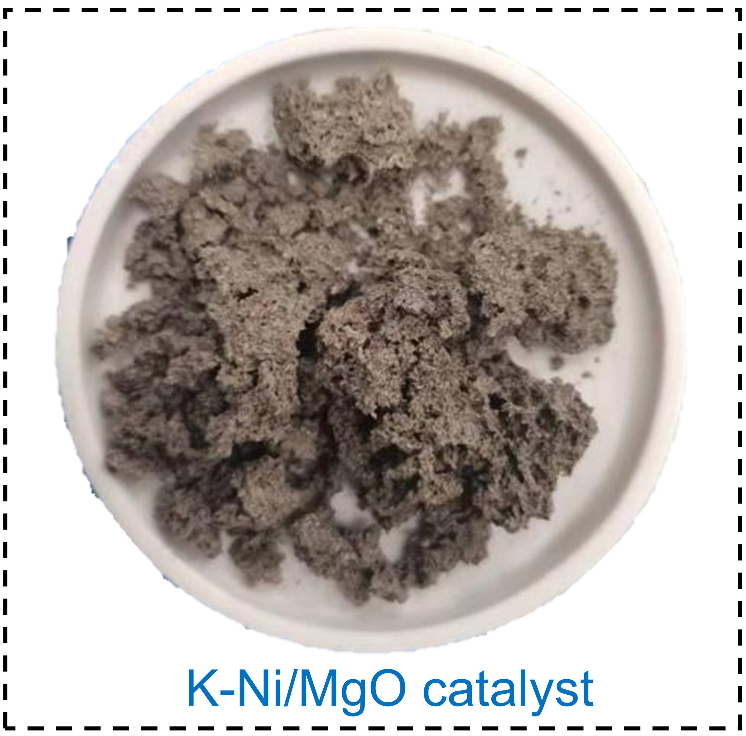
Figure S1. Photographs of the apparent morphology of K-Ni/MgO nanosheets catalyst.

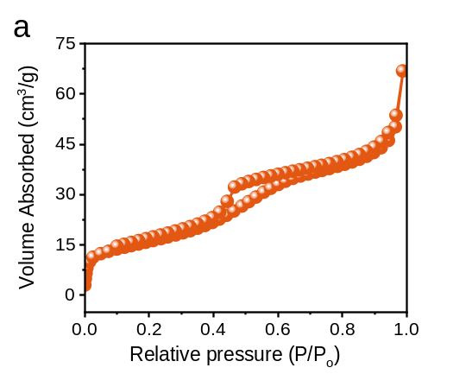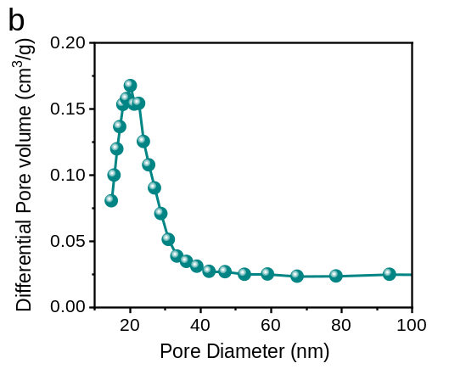
Figure S2. (a) N₂ adsorption-desorption isotherms and (b) pore size distribution calculated from the BJH desorption of K-Ni/MgO catalysts.

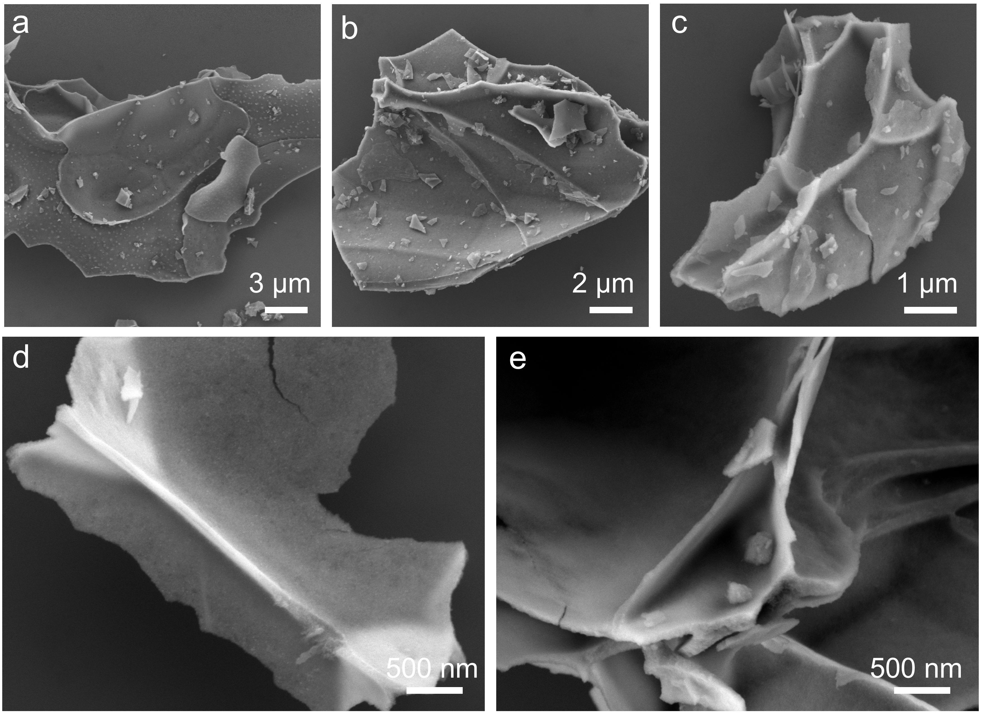
Figure S3. SEM images characterization of Ni/MgO nanosheets samples at different magnifications.

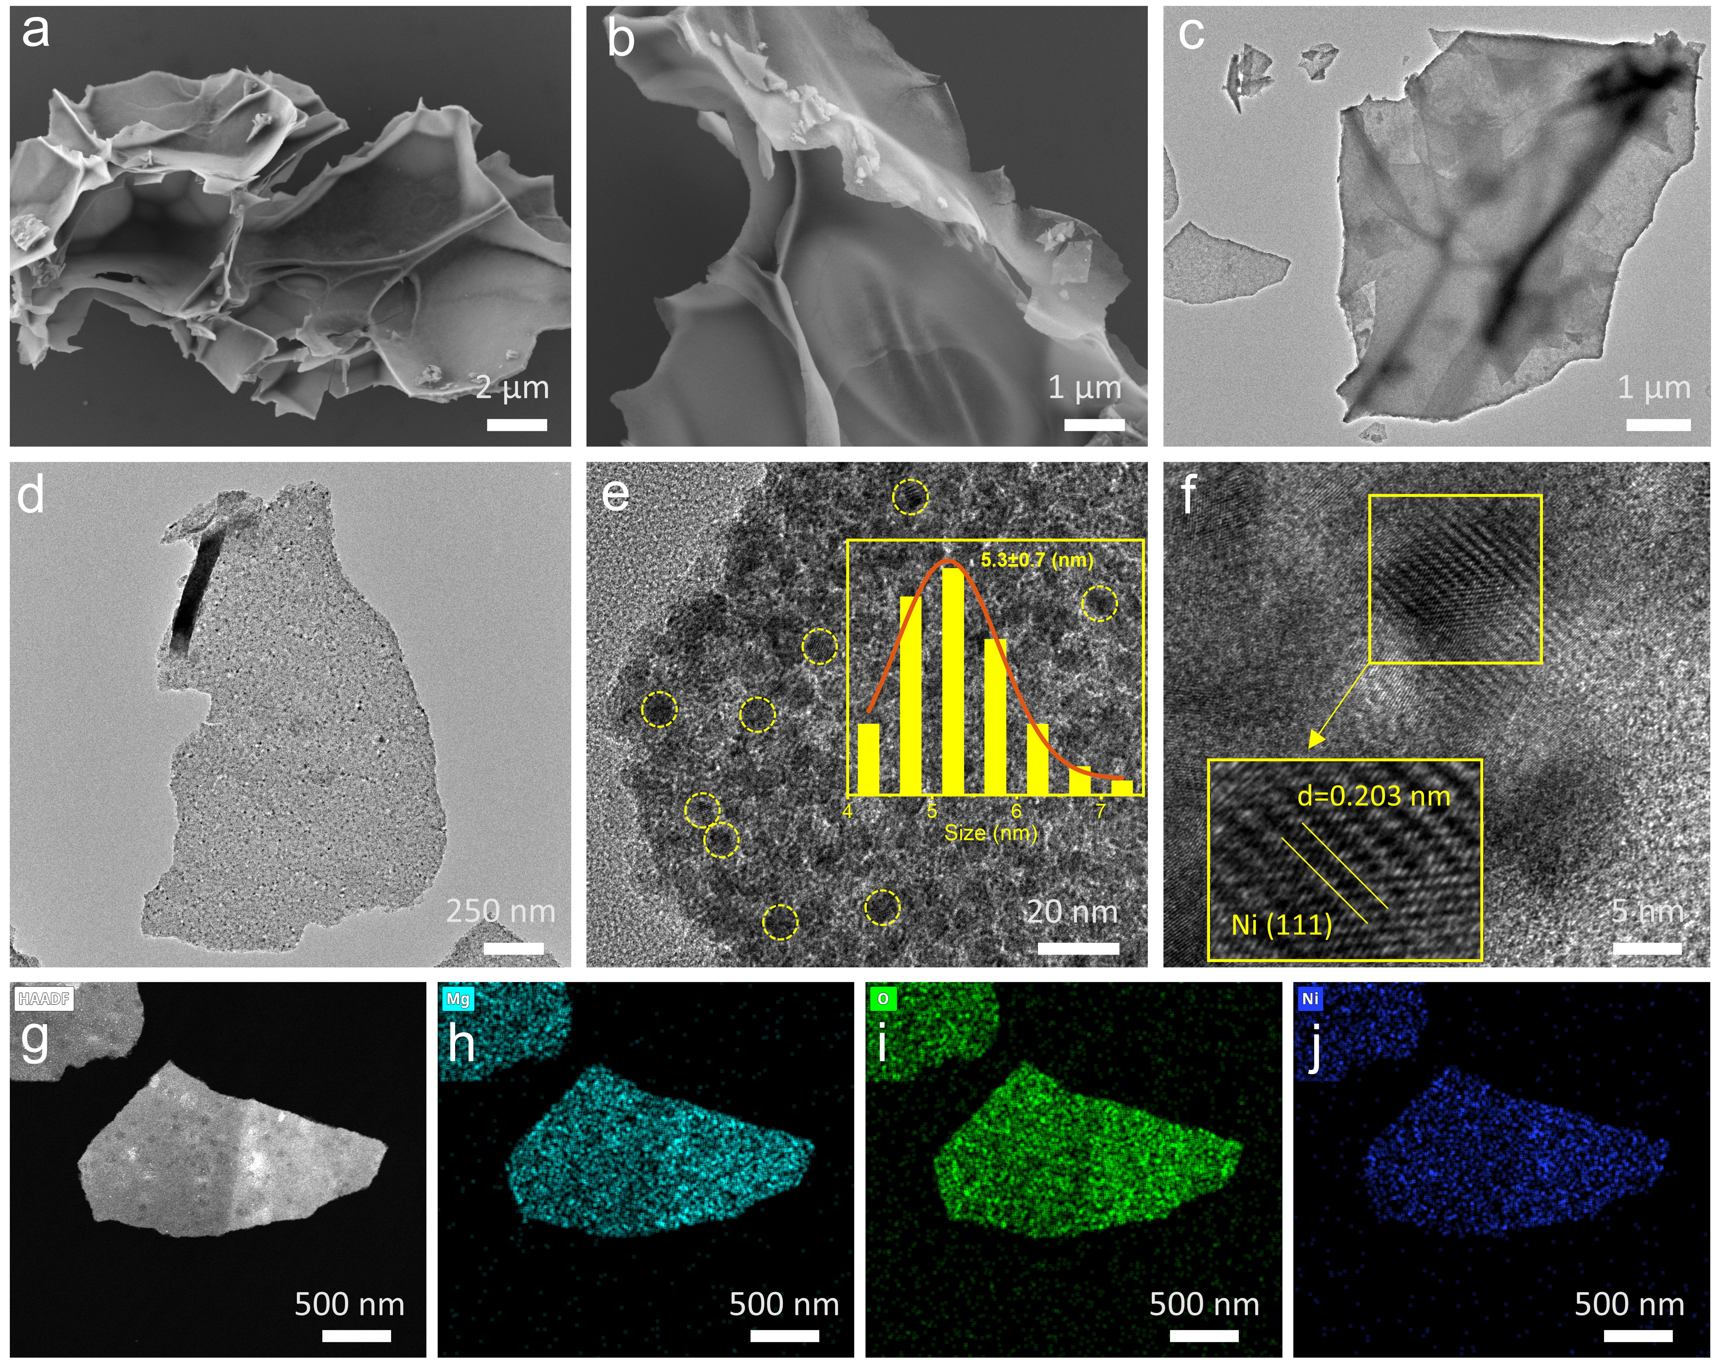
Figure S4. (a-b) SEM, (c-d) TEM, (e-f) HRTEM, (g-j) HAADF-STEM images and corresponding Mg, O and Ni elemental mappings images of the Ni/MgO catalyst.

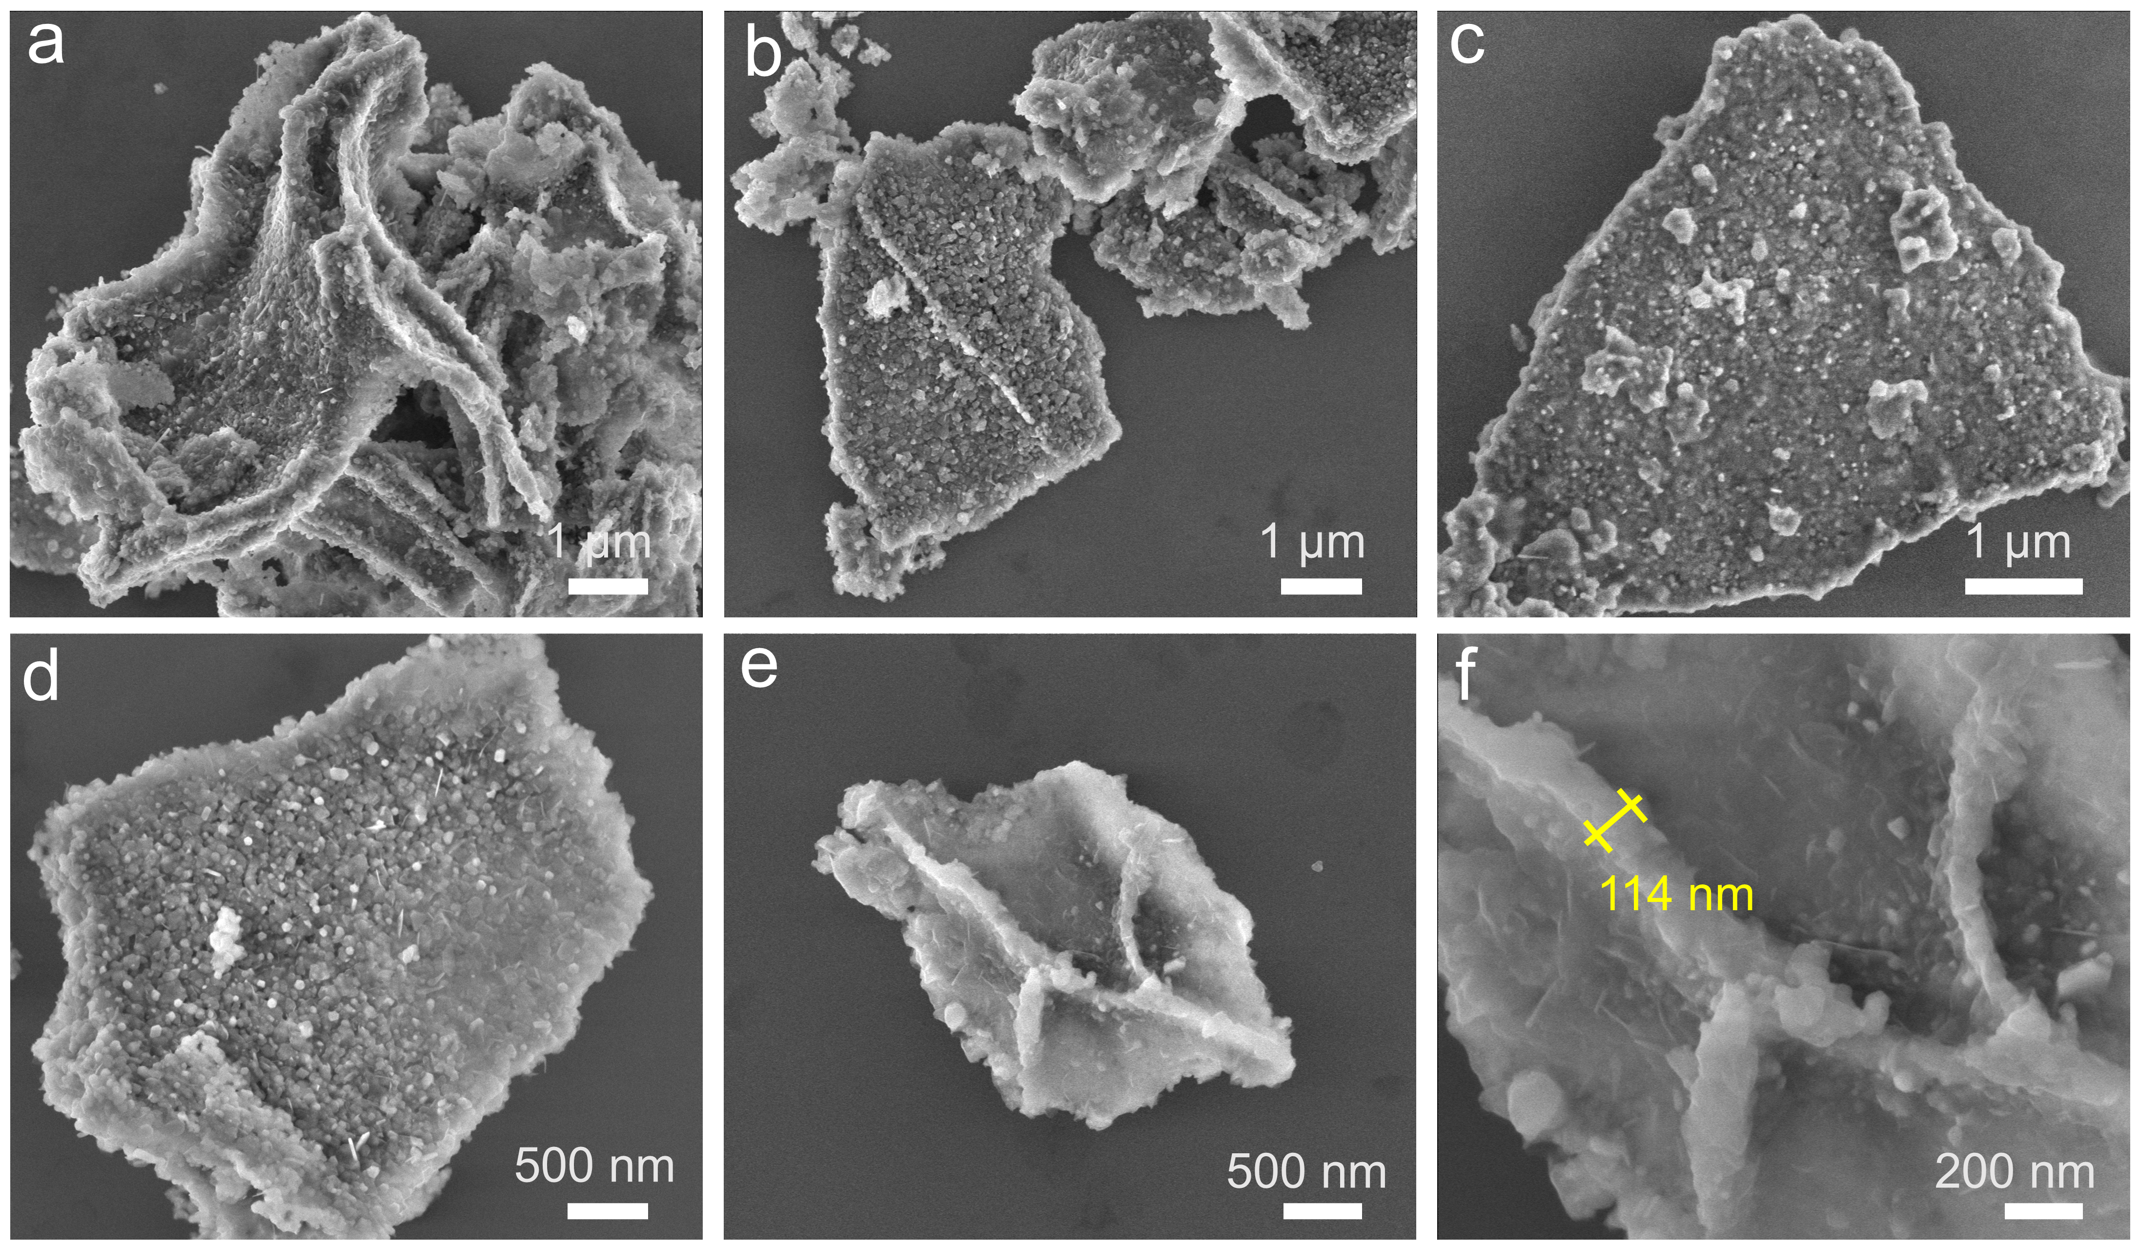
Figure S5. SEM images characterization of Ni/MgO nanosheets samples at different magnifications.

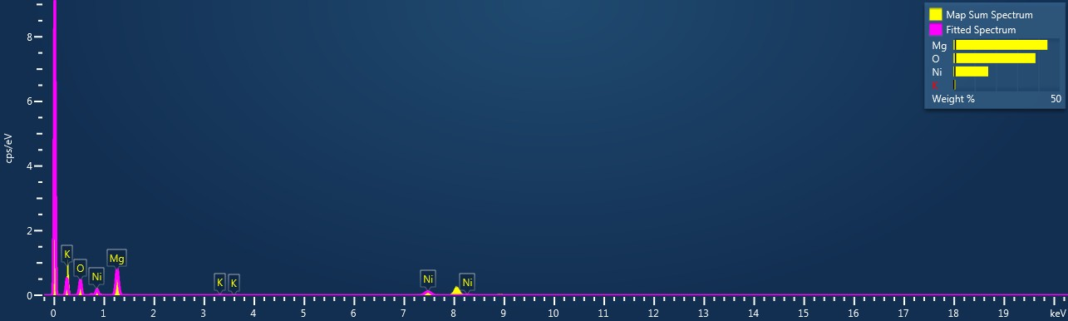
Figure S6. Energy-Dispersive X-ray Spectroscopy (EDS) spectrum of K-Ni/MgO catalyst in Figure 2h-k.

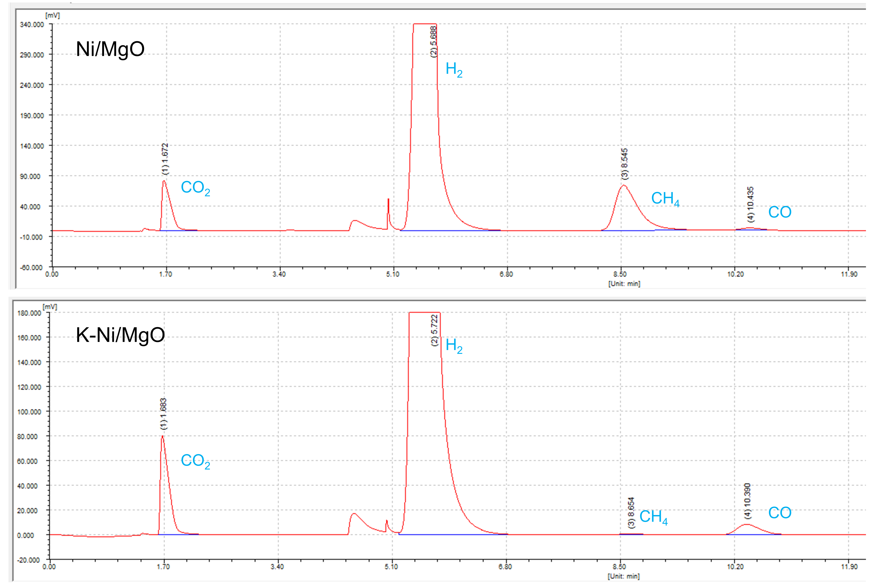
Figure S7. Typical GC-TCD chromatography profiles from CO₂ hydrogenation over Ni/MgO and K-Ni/MgO catalysts. Reaction conditions: 350 ℃, 24000 mL·g_{cat}⁻¹·h⁻¹ and H₂/CO₂=3.

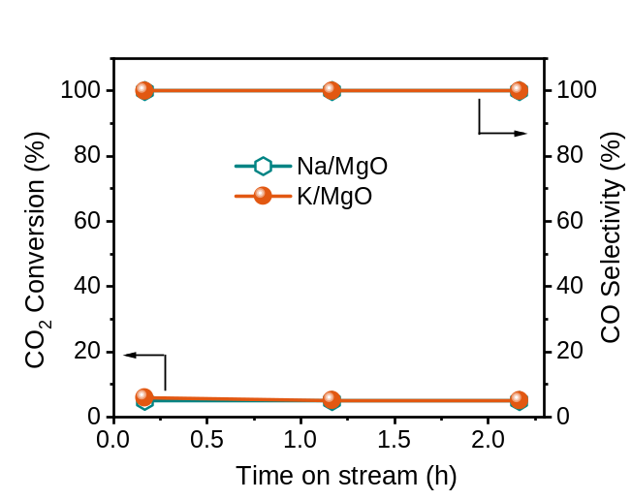
Figure S8. Catalytic performance of CO₂ hydrogenation reaction. CO₂ conversion and CO selectivity as a function of time on stream on Na/MgO and K/MgO catalysts. Reaction conditions: 350 ℃, 24000 mL·g_{cat}⁻¹·h⁻¹ and H₂/CO₂=3.

Note: Both Na/MgO and K/MgO catalysts exhibited low CO₂ conversion (＜6.0%) at 350 ℃.

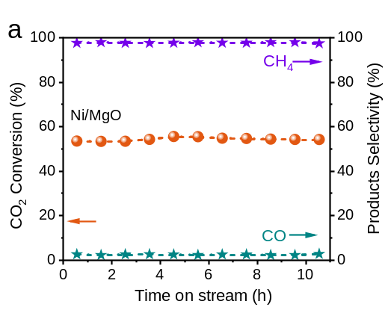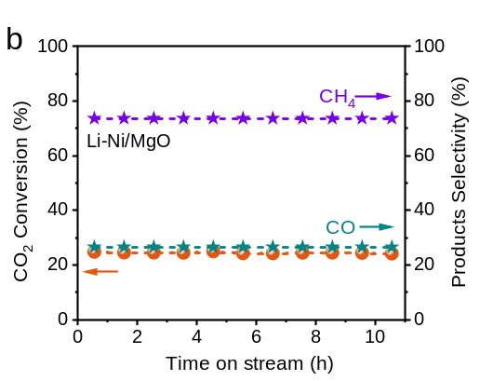
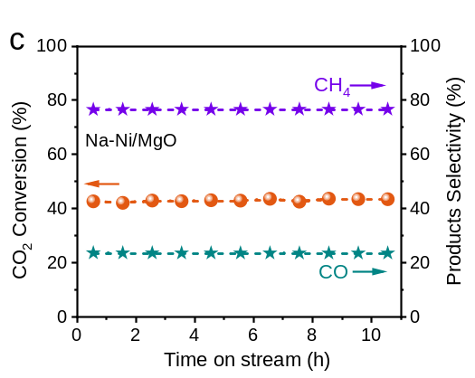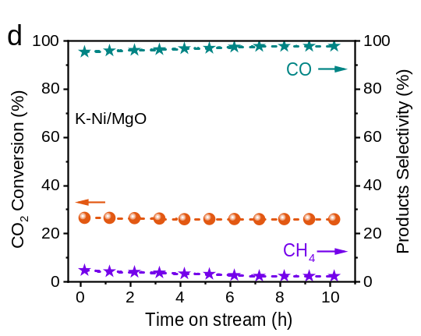
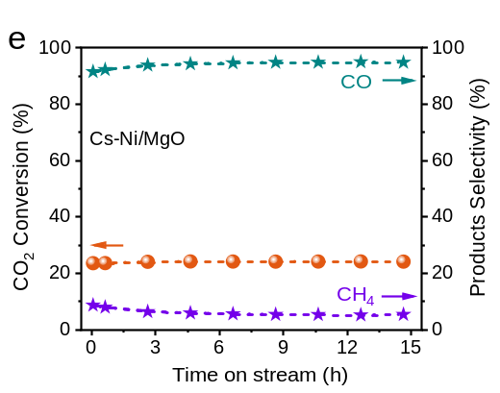
Figure S9. Catalytic performances of CO₂ hydrogenation reactions. CO₂ conversion and product selectivity as a function of time on stream on (a) Ni/MgO, (b) Li-Ni/MgO, (c) Na-Ni/MgO, (d) K-Ni/MgO and (e) Cs-Ni/MgO catalysts. Reaction conditions: 350 ℃, 24000 mL·g_{cat}⁻¹·h⁻¹ and H₂/CO₂=3.

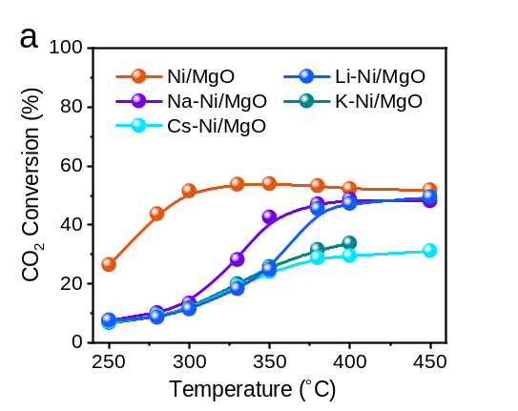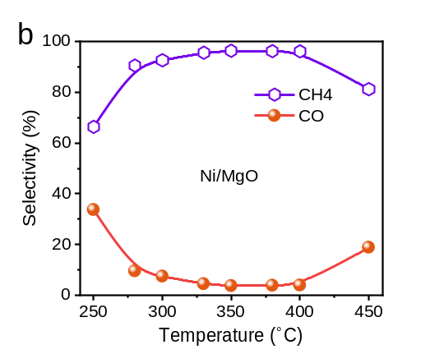
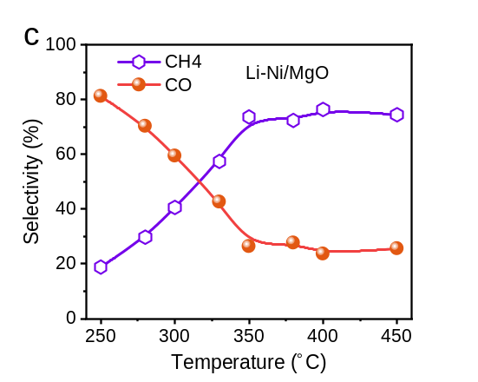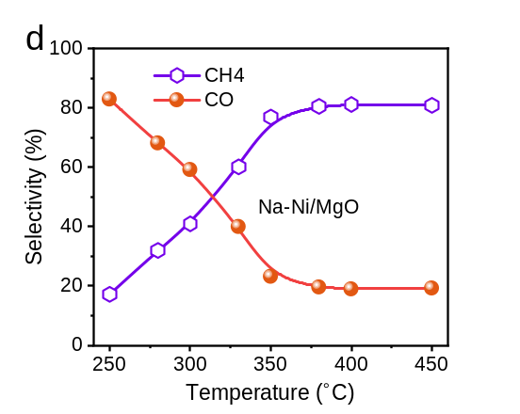
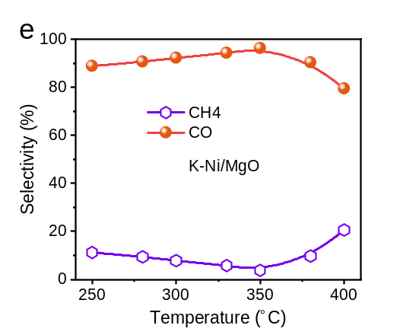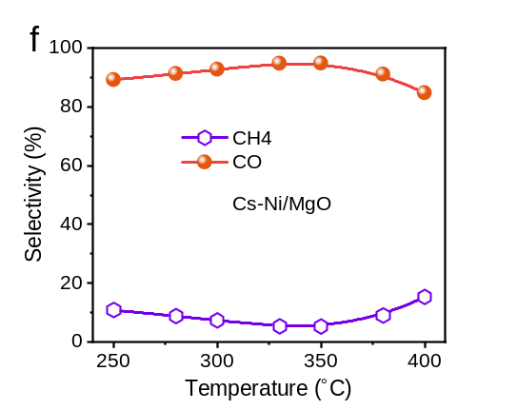
Figure S10. Effect of reaction temperatures on the catalytic performance. (a) CO₂ conversion as a function of temperature over Ni/MgO and M–Ni/MgO catalysts, product selectivity over (b) Ni/MgO, (c) Li–Ni/MgO, (d) Na–Ni/MgO, (e) K–Ni/MgO, and (f) Cs–Ni/MgO. Reaction conditions: 24000 mL·g_{cat}⁻¹·h⁻¹, H₂/CO₂=3.

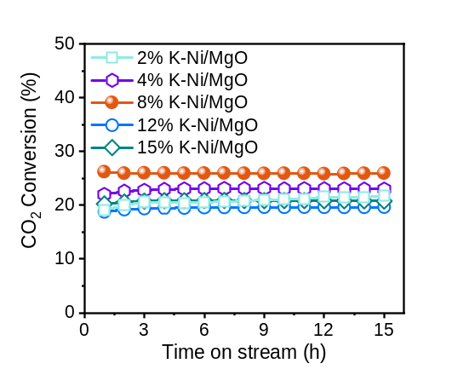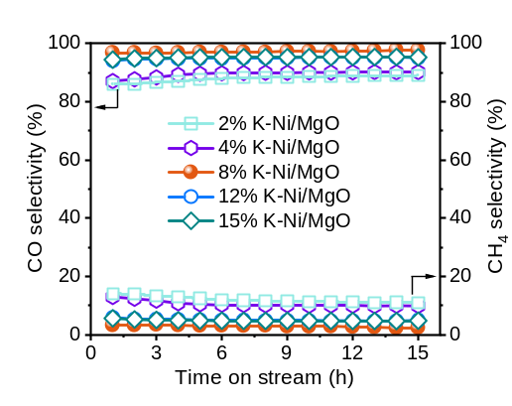
Figure S11. Effect of K loadings on the catalytic performances of CO₂ hydrogenation. (a) CO₂ conversion and (b) product selectivity over K–Ni/MgO with different K contents as a function of time on stream. Reaction conditions: 24000 mL·g_{cat}⁻¹·h⁻¹, H₂/CO₂=3 at 350℃.

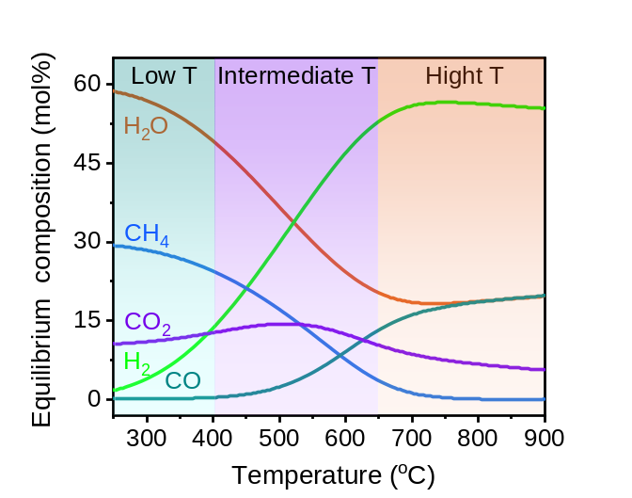
Figure S12. Thermodynamic equilibrium composition of CO₂ hydrogenation under 0.1 MPa with a H₂/CO₂ molar ratio of 3/1 at different temperatures (calculated using HSC Chemistry 6.0).

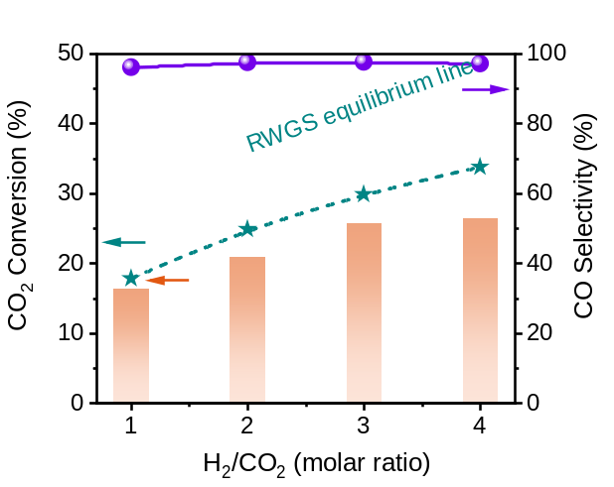
Figure S13. Effect of H₂/CO₂ ratio on CO₂ conversion and CO selectivity, reactions condition: 350 ℃, 24000 mL·g_{cat}⁻¹·h⁻¹.

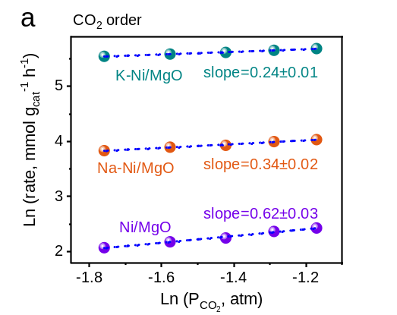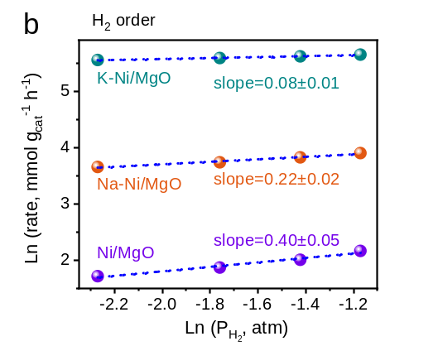
Figure S14. Kinetic orders of CO₂ hydrogenation on Ni/MgO, Na-Ni/MgO and K-Ni/MgO catalysts at 350 °C and 0.1 MPa with respect to CO₂ (a) and H₂ (b).

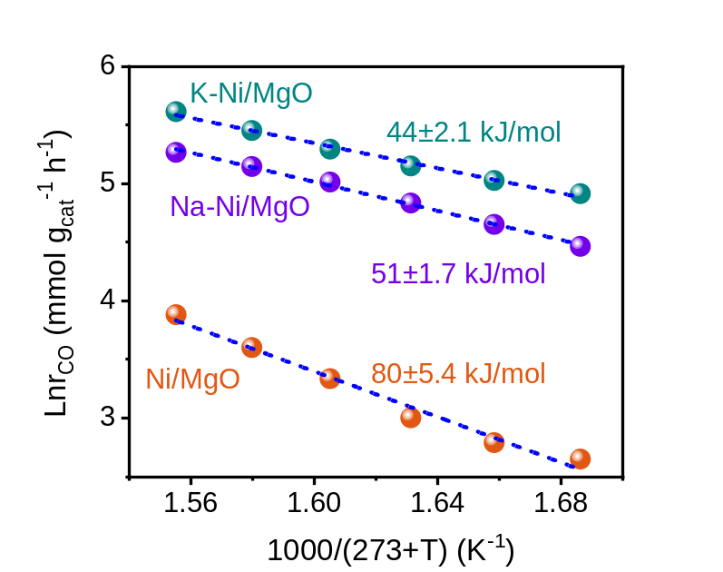
Figure S15. Arrhenius plots and calculated apparent activation energies (E_{a}) for CO₂ hydrogenation reactions over Ni/MgO, Na-Ni/MgO and K-Ni/MgO catalysts.

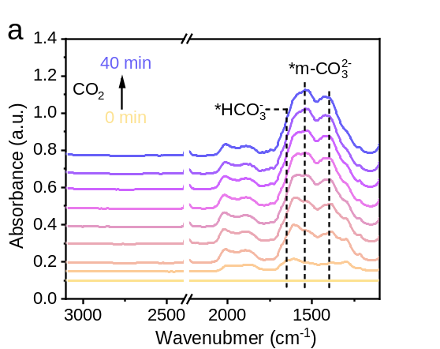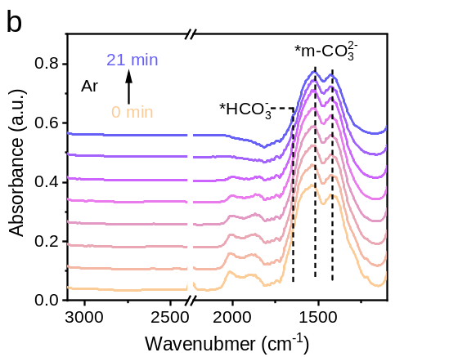
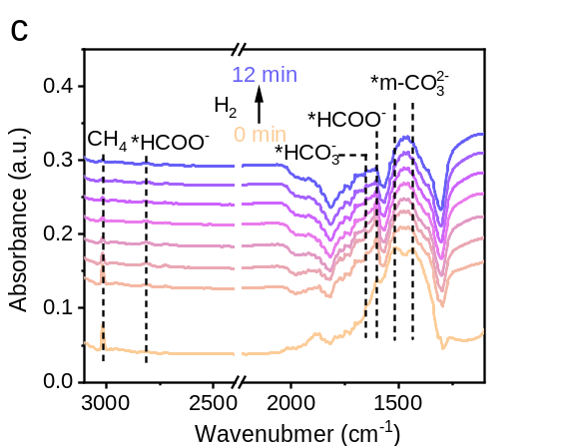
Figure S16. In situ DRIFTS spectra of the Ni/MgO catalyst during sequential gas-switching experiments at 350 °C. The catalyst was successively treated with CO₂ for 40 min (a), purged with Ar for 21 min (b), and exposed to H₂ for 12 min (c).

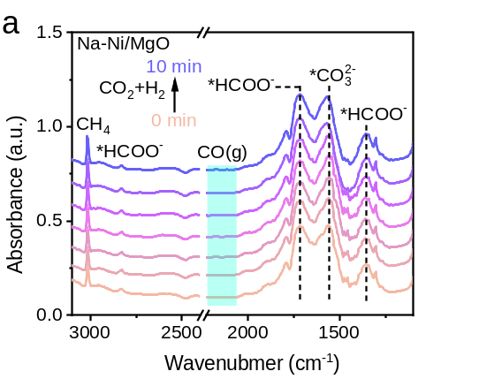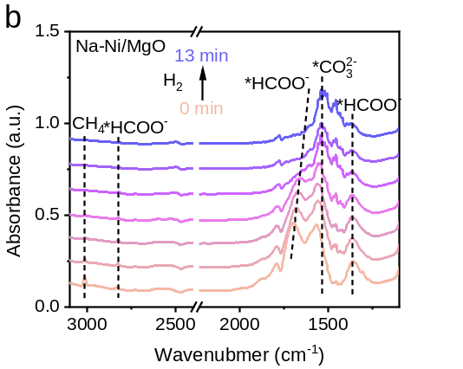
Figure S17. In situ DRIFTS spectra of the Na-Ni/MgO catalyst during sequential exposure to a CO₂/H₂ mixture (CO₂/H₂ = 1/3) and pure H₂ atmosphere at 350 °C. The catalyst was initially treated under a CO₂/H₂ mixture for 10 min (a), followed by switching the feed gas to pure H₂ for an additional 13 min (b).

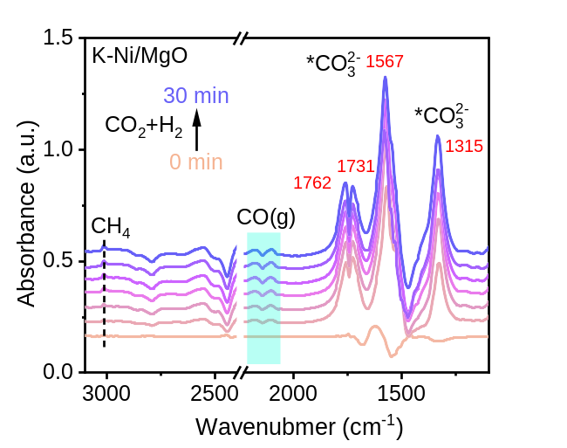
Figure S18. Repeated in situ DRIFTS spectra of the K-Ni/MgO catalyst exposed to a CO₂/H₂ mixture at 350 °C, demonstrating the reproducibility of the surface species evolution during CO₂ hydrogenation.

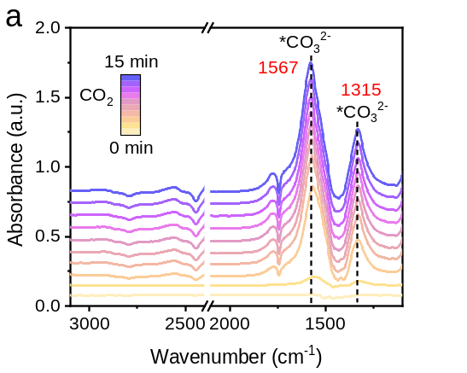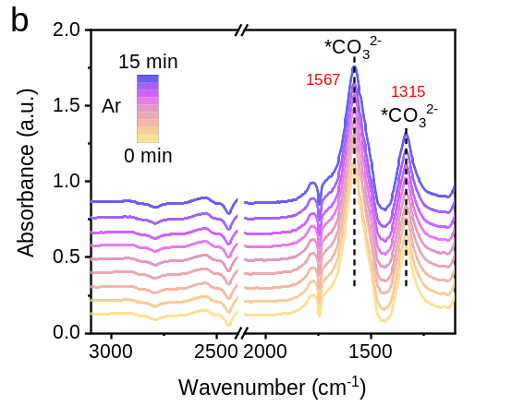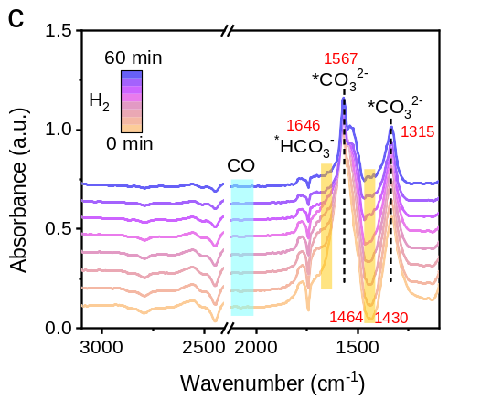
Figure S19. In situ DRIFTS spectra of the K-Ni/MgO catalyst during sequential gas-switching experiments at 350 °C. The catalyst was successively treated with CO₂ for 15 min (a), purged with Ar for 15 min (b), and exposed to H₂ for 60 min (c).

Table S1. Characteristic properties of elemental analysis and porosity of K-Ni/MgO nanosheet catalysts.
Catalyst | Ni content ª  (wt%) | S_{BET} ^{b}  (m²/g) | pore volume ^{c}  (cm³/g)
K-Ni/MgO | 19.6 | 56.33 | 0.195
^{a.} determined by ICP.
^{b.} BET specific surface areas.
^{c.} Total pore volume measured at a relative pressure (P/P₀) of 0.99.

Table S2. Comparison of the low-temperature (＜400℃) RWGS catalysts reported in the literature.
Catalysts | Temp.  (℃) | Gas composition | GHSV  (mL·g_{cat}⁻¹·h⁻¹) | CO formation rate  (mmol·g_{cat}⁻¹·h⁻¹) | CO₂ Conv.  (%) | CO Sel.  (%) | Ref.
Pt_{cluster}/PN-CeO₂ | 350 | 25 vol% CO₂, 75 vol% H₂ | 80000 | 163.8 | 18.4 | 100 | 1
Pt/CeO₂ | 350 |  | 72000 | 53 | 11 | 100 | 2
Pt/Fe₃O₄ | 350 |  | 72000 | 0.9 | 4 | 98 | 3
0.5Pt-MoO_{x}/Mo₂N | 350 |  | 300000 | 874.8 |  |  | 4
Pt NC /LOC | 380 |  | 60000 | 135 |  |  | 5
1wt% Pt/TiO₂ | 400 |  | 100000 | 103.2 | 25.2 | 100 | 6
0.5wt%Pt/MnO | 400 |  | 16000 | 37.5 |  | 97.7 | 7
Pt/CeO₂-AA-350 | 350 | CO₂/H₂/N₂=9/27/24 | 72000 | 94.5 | 20 | 98 | 8
1.9wt%Ru/TiO₂-500RT | 400 |  | 120000 | 57 | 12.1 | 100 | 9
Ru/Ti/Mn | 400 |  |  | 90 |  | 100 | 10
Pt-aCeO₂@SiO₂ | 400 |  | 12000 | 50.65 | 38.2 | 99 | 11
Pt1Fe1@SiO₂ | 350 | CO₂/H₂/Ar=  1:3:1 | 60000 | 106.1 | 20 | 99 | 12
Fe-Pt/CeO₂ | 350 | CO₂/H₂/Ar=  24/72/4 | 200000 | 445.5 | 21 | 99 | 13
RuCeFeO_{x} | 350 | CO₂/H₂/Ar=  48:48:4 | 300000 | 41 |  |  | 14
Pd1-FeO_{x} | 400 |  |  | 42 |  |  | 15
K-Ni/MgO | 350 | CO₂/H₂=1/3 | 192000 | 352.9 | 17.3 | 97 | This work

Table S3. The results of CO₂-TPD profiles over Ni/MgO, Na-Ni/MgO and K-Ni/MgO catalysts.
Catalysts | Weak basic site  mmol/g_{cat}  (< 150 °C) | Medium basic site  mmol/g_{cat}  (150-350 °C) | Total CO₂ desorbed  mmol/g_{cat}
Ni/MgO | 0.024 | 0.046 | 0.071
Na-Ni/MgO | 0.054 | 0.150 | 0.200
K-Ni/MgO | 0.131 | 0.179 | 0.310

Table S4. The results of H₂-TPD profiles over Ni/MgO, Na-Ni/MgO and K-Ni/MgO catalysts
Catalysts | Temperature (°C) / hydrogen desorbed  mmol/g_{cat} |  | Total H₂ desorbed  mmol/g_{cat}
Catalysts | Weak hydrogen binding | Medium hydrogen binding | Total H₂ desorbed  mmol/g_{cat}
Ni/MgO | 134/0.031 | 252/0.013 307/0.030 | 0.075
Na-Ni/MgO | 93/0.006 | 187/0.011 | 0.017
K-Ni/MgO | 122/0.019 | 245/0.022 356/0.004 | 0.045

Table S5. The results of CO-TPD for Ni/MgO, Na-Ni/MgO and K-Ni/MgO catalysts
Catalysts | Temperature (°C) / CO desorbed  mmol/g_{cat} |  | Total CO desorbed  mmol/g_{cat}
Catalysts | Weak | Medium | Total CO desorbed  mmol/g_{cat}
Ni/MgO | 164/0.0328 | 253/0.0283; 305/0.0507 | 0.112
Na-Ni/MgO | 116/0.0121 | 195/0.0419 | 0.054
K-Ni/MgO | 110/0.0045 | 224/0.0157 | 0.020

References
[1] Li, W. et al. Platinum and frustrated Lewis pairs on ceria as dual-active sites for efficient reverse water-gas shift reaction at low temperatures. Angew. Chem. Int. Edit. 135, e202305661 (2023).
[2] Zhao, Z. et al. Atomically dispersed Pt/CeO₂ catalyst with superior CO selectivity in reverse water gas shift reaction. Appl. Catal. B- Environ. 291, 120101-120110 (2021).
[3] Chen, H. et al. Dynamic phase transition of iron oxycarbide facilitated by Pt nanoparticles for promoting the reverse water gas shift reaction. ACS Catal. 11, 14586–14595 (2021).
[4] Liu, H. et al. Ptₙ–Oᵥ synergistic sites on MoO_{x}/γ-Mo₂N heterostructure for low-temperature reverse water–gas shift reaction. Nat. Commun. 13, 5800-5810 (2022).
[5] Zhang, R. et al. Synergism of ultrasmall Pt clusters and basic La₂O₂CO₃ supports boosts the reverse water gas reaction efficiency. Adv. Energy. Mater. 13, 2203806-2203813 (2023).
[6] Xie, Y. et al. Unraveling the cause of strong metal-support interaction formation: Disparities in metal nanoparticle anchoring mechanisms. Angew. Chem. Int. Edit. 64, e202505820 (2025).
[7] Szenti, I. et al. Pt/MnO interface induced defects for high reverse water gas shift activity. Angew. Chem. Int. Edit. 63, e202317343 (2024).
[8] Zhao, Z. et al. Atomically dispersed Pt/CeO₂ catalyst with superior CO selectivity in reverse water gas shift reaction. Appl. Catal. B-Environ. 291, 120101-120110 (2021).
[9] Li, J. et al. Tuning adsorbate-mediated strong metal-support interaction by oxygen vacancy: A case study in Ru/TiO₂. Angew. Chem. Int. Edit. 63, e202407025 (2024).
[10] Kang, H. et al. Generation of oxide surface patches promoting H-spillover in Ru/(TiO_{x})MnO catalysts enables CO₂ reduction to CO Nat. Catal. 6, 1062–1072, (2023).
[11] Lei, J. et al. Amorphous silica induced loose CeO₂ clusters with isolated Pt atoms for efficient reverse-water gas shift reaction. Angew. Chem. Int. Edit. 64, e202511913 (2025).
[12] Hansen, C. et al. Decoding the promotional effect of iron in bimetallic Pt–Fe-nanoparticles on the low temperature reverse water–gas shift reaction. J. Am. Chem. Soc. 146, 27555–27562 (2024).
[13] Wang, H. et al. Synergistic interactions of neighboring platinum and iron atoms enhance reverse water–gas shift reaction performance. J. Am. Chem. Soc. 145, 2264–2270 (2023).
[14] Jiang, H et al. Accelerating reverse water gas shift reaction through synergistic CO₂ and H₂ activation on Ru–Fe–(V_{O}-in-CeO₂) ternary catalytic centers. Nano. Letters 25, 3579–3587 (2025).
[15] Du, P. et al. Single-atom-driven dynamic carburization over Pd₁–FeO_{x} catalyst boosting CO₂ conversion. Chem 8, 3252–3262 (2022).

