Supporting Information for

A Novel Analytical Method for the Determination of 2-Ethylphenyl hydrazine Genotoxic Impurity in Etodolac Using Derivatization and UPLC/MS

Tayfun ÇEĞİL¹*, Alper YARDIMCI¹, M. Reşat ÖZBAŞ¹, Yusuf ÖZLÜ¹
¹Department of Analytical Research & Development, Ulkar Kimya, Tekirdağ, Türkiye

*Correspondence: tayfun.cegil@ulkarkimya.com.tr

Table of Contents
Page(s) | Content
S1 | Table of Contents
S2 | ¹H NMR Spectrum of hydrazone compound 3 (400 MHz, CDCl₃)
S3 | ¹³C NMR Spectrum of hydrazone compound 3 (101 MHz, CDCl₃)
S4 | ¹³C DEPT 135 Deg NMR Spectrum of hydrazone compound 3 (101 MHz, CDCl₃)
S5 | FTIR, ATR Spectrum of hydrazone compound 3
S6 | DSC thermogram of hydrazone compound 3
S7 | Mass Spectrum of hydrazone compound 3
S8 | Fragmentation mass cone voltage 5 of hydrazone compounds
S8 | Fragmentation mass cone voltage 25 of hydrazone compounds

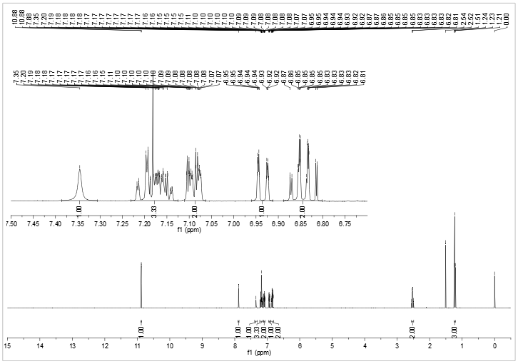
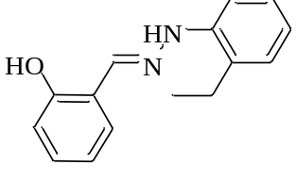
¹H NMR Spectrum of hydrazone compound 3 (400 MHz, CDCl₃)

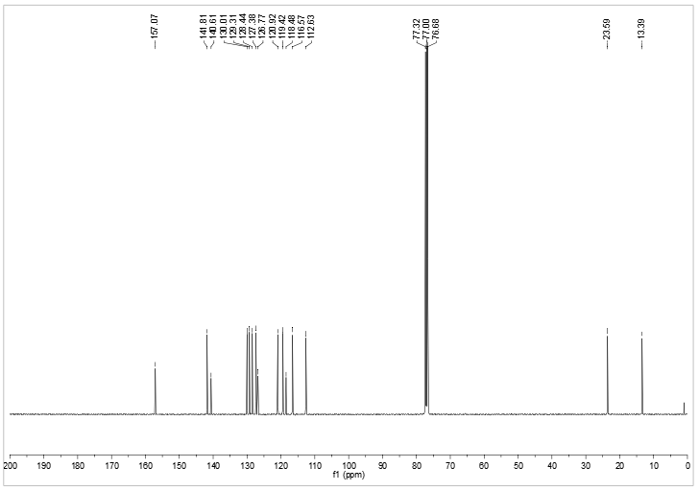
¹³C NMR Spectrum of hydrazone compound 3 (101 MHz, CDCl₃)
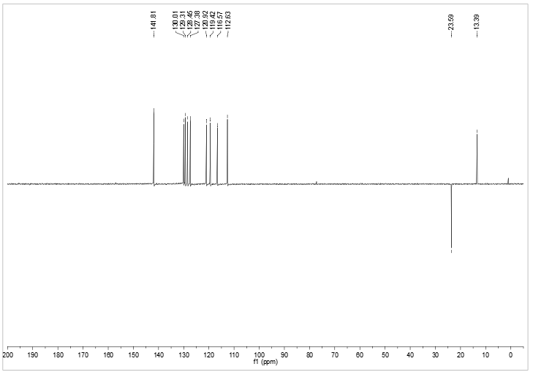
¹³C DEPT 135 Deg NMR Spectrum of hydrazone compound 3 (101 MHz, CDCl₃)

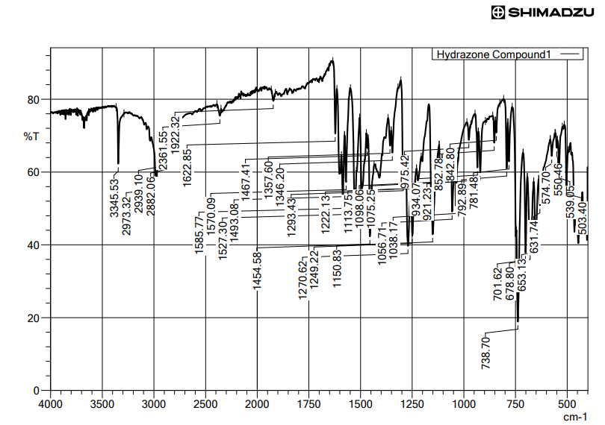
FTIR, ATR Spectrum of hydrazone compound 3
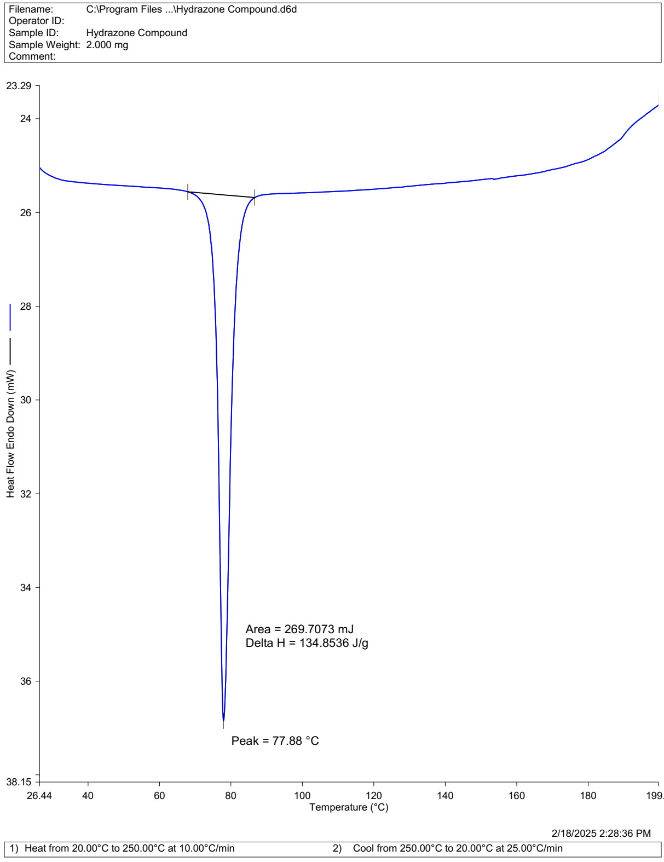
DSC thermogram of hydrazone compound 3

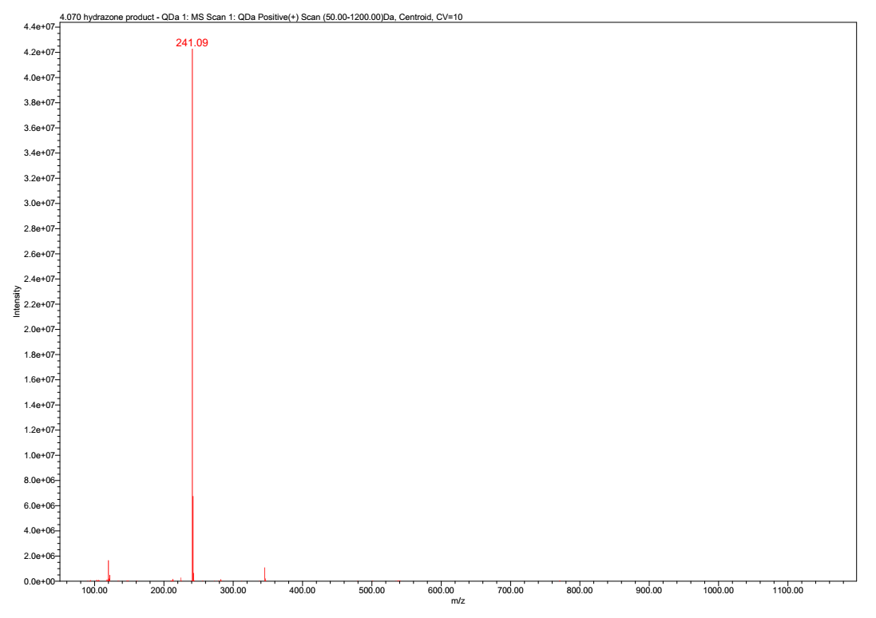
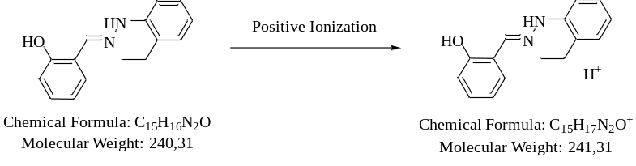
Mass Spectrum of hydrazone compound 3
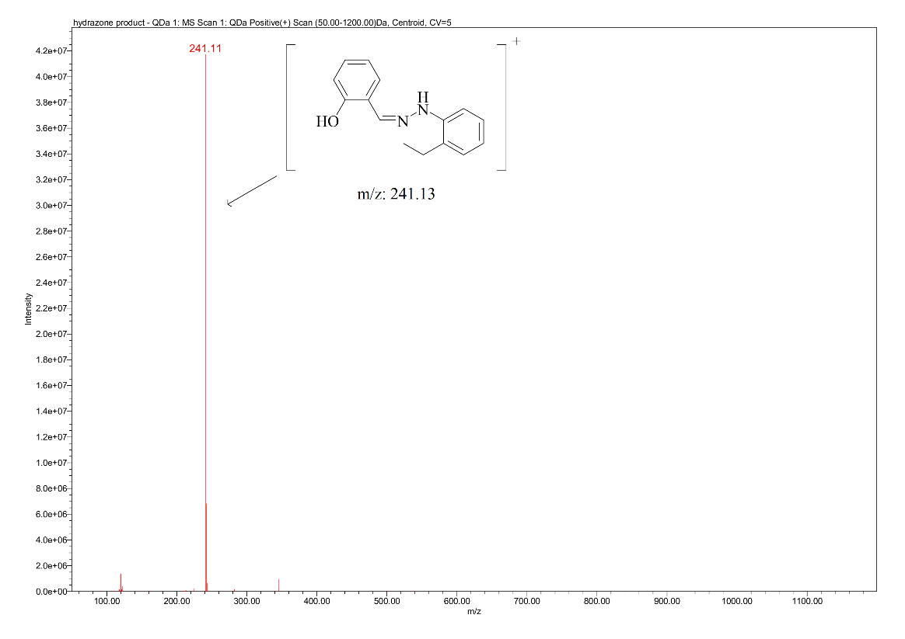
Fragmentation mass cone voltage 5 of hydrazone compounds
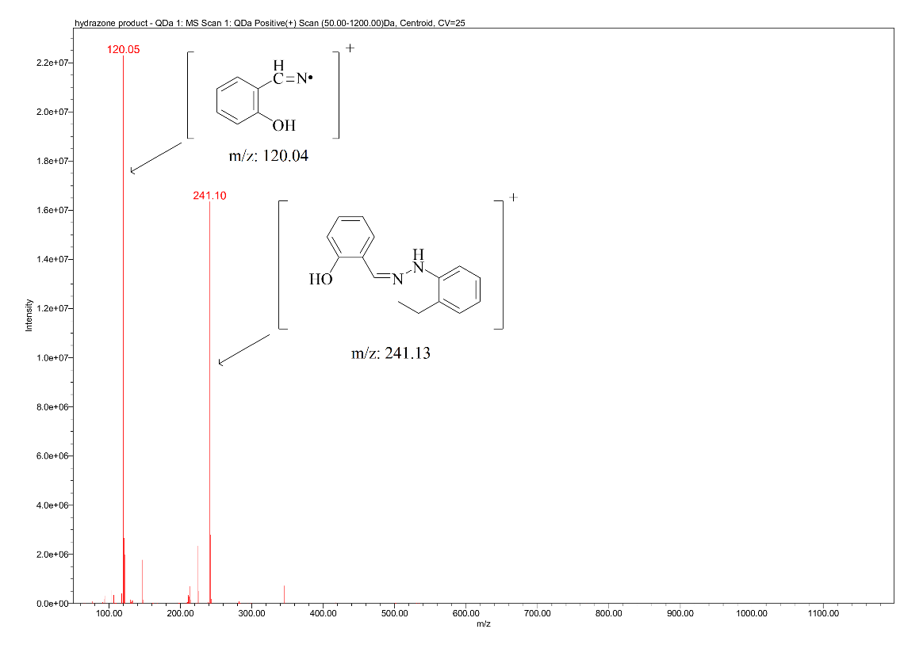
Fragmentation mass cone voltage 25 of hydrazone compound

