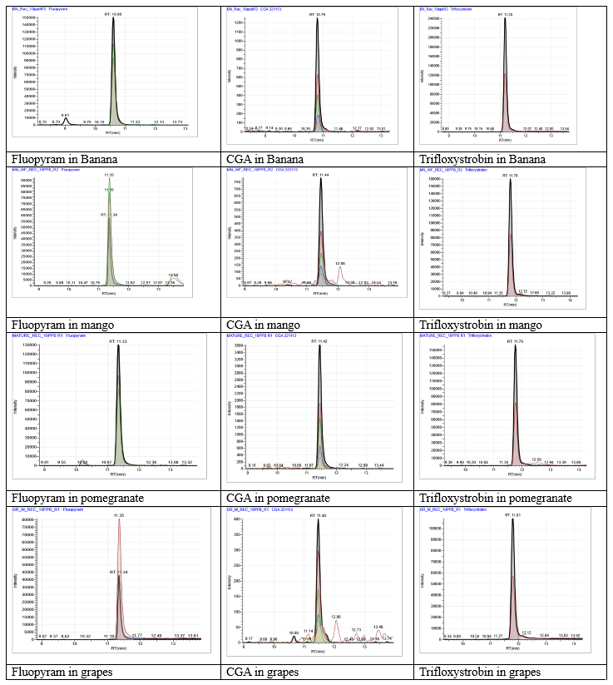

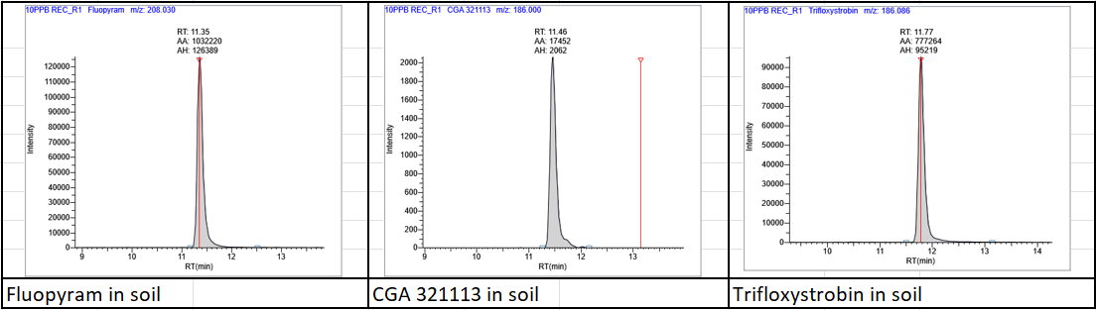
Figure S1. LC-MS/MS chromatogram of three analytes in different matrices at LOQ
Fluopyram |  |  | Trifloxystrobin |  |  | CGA 321113
Banana Whole Fruit
 | 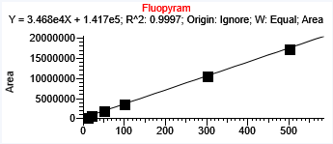 |  |  | 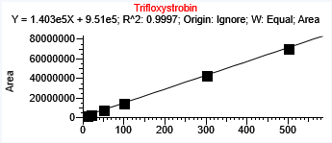 |  |  | 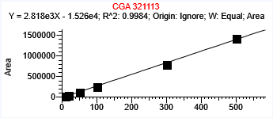
  Area | Conc
  10 | 376382
  20 | 770789
  50 | 1947708
  100 | 3657413
  300 | 10719294
  500 | 17367007
  Area | Conc
  10 | 1954191
  20 | 3487795
  50 | 8133908
  100 | 15261812
  300 | 43752462
  500 | 70645935
  Area | Conc
  10 | 21848
  20 | 53655
  50 | 123557
  100 | 263252
  300 | 789478
  500 | 1418403
Calibration of Fluopyram in banana |  |  | Calibration of Trifloxystrobin in banana |  |  | Calibration of CGA 321113 in banana
Banana Pulp
 | 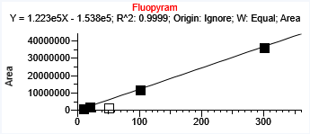 |  |  | 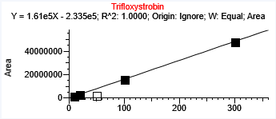 |  |  | 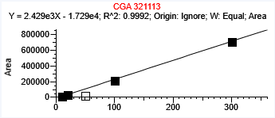
  Area | Conc
  10 | 1145758
  20 | 2119745
  100 | 12212491
  300 | 36513682
  Area | Conc
  10 | 1480741
  20 | 2798098
  100 | 2682390
  300 | 48029089
  Area | Conc
  10 | 13905
  20 | 33629
  100 | 212268
  300 | 715350
Calibration of Fluopyram in banana pulp |  |  | Calibration of Trifloxystrobin in banana pulp |  |  | Calibration of CGA 321113 in banana pulp

Pomegranate Whole Fruit
Fluopyram |  |  |  | Trifloxystrobin |  |  |  |  |  | CGA 321113
 | 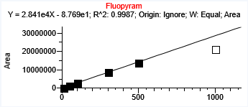 |  |  |  |  |  | 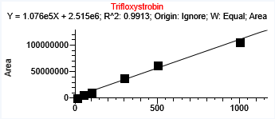 |  |  |  |  |  | 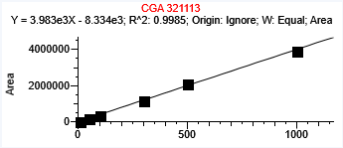
  Area | Conc
  10 | 238965
  50 | 1317262
  100 | 2839131
  300 | 8867531
  500 | 14008169
  Area | Conc
  10 | 1084932
  50 | 6209866
  100 | 11941346
  300 | 38012491
  500 | 62407929
  1000 | 10637957
  Area | Conc
  10 | 33517
  50 | 165438
  100 | 372170
  300 | 1158335
  500 | 2098930
  1000 | 3928276
Calibration of Fluopyram in pomegranate whole fruit |  |  |  | Calibration of Trifloxystrobin in pomegranate whole fruit |  |  |  |  |  | Calibration of CGA 321113 in pomegranate whole fruit
Pomegranate Aril
 | 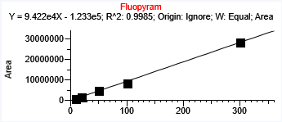 |  |  |  |  | 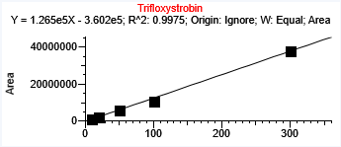 |  |  |  |  |  | 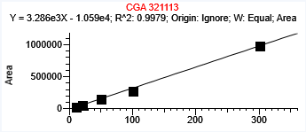
  Area | Conc
  10 | 963487
  20 | 196802
  50 | 481396
  100  300 | 851563  28346127
  Area | Conc
  10 | 1233756.
  20 | 2566379.
  50 | 6205969
  100 | 10952618
  300 | 37951773
  Area | Conc
  10 | 32340
  20 | 67427
  50 | 153165
  100 | 286799
  300 | 984454
Calibration of Fluopyram in pomegranate aril |  |  |  | Calibration of Trifloxystrobin in pomegranate aril |  |  |  |  |  | Calibration of CGA 321113 in pomegranate aril

Pomegranate Juice
 | 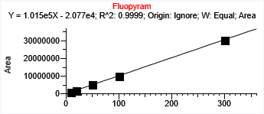  Calibration of Fluopyram in pomegranate juice |  |  | 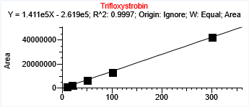  Calibration of Trifloxystrobin in pomegranate juice
  Conc | Area
  10 | 995996
  20 | 1977439
  50 | 5245174
  100 | 9931770
  300 | 30464063
  Conc | Area
  10 | 1349452
  20 | 2643887
  50 | 6874095
  100 | 13337638
  300 | 42210148

Area | Conc
10 | 34793
20 | 63891
50 | 164159
100 | 329452
300 | 1142146
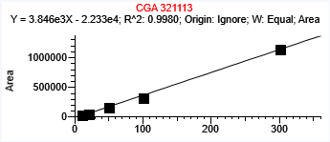 Calibration of CGA 321113 in pomegranate juice

Immature grape berries
 | 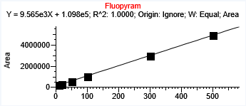 |  |  |  |  |  | 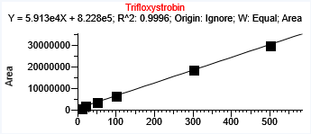 |  |  |  |  |  | 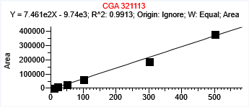
  Area | Conc
  10 | 209413
  20 | 310883
  50 | 578605
  100 | 1066686
  300 | 2966496
  500 | 4900159
  Area | Conc
  10 | 1043788
  20 | 2134346
  50 | 3780309
  100 | 6891716
  300 | 18843823
  500 | 30187920
  Area | Conc
  10 | 4675
  20 | 10541
  50 | 27412
  100 | 62673
  300 | 188923
  500 | 378508
Calibration of Fluopyram in immature grape berries |  |  |  | Calibration of Trifloxystrobininimmature grape berries |  |  |  |  |  | Calibration of CGA 321113 in immature grape berries
Mature grape berries
 | 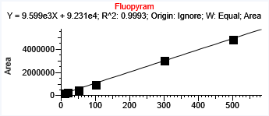 |  |  |  |  | 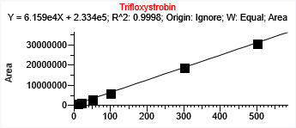 |  |  |  |  |  | 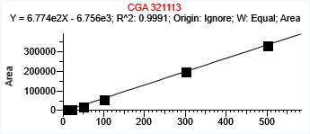
  Area | Conc
  10 | 240952
  20 | 305753
  50 | 522957
  100  300 | 989571  3027724
  500 | 4873944
  Area | Conc
  10 | 1028394
  20 | 1541694
  50 | 3138804
  100 | 6167582
  300 | 18930911
  500 | 30953193
  Area | Conc
  10 | 5232
  20 | 9086
  50 | 20882
  100 | 58218
  300 | 197731
  500 | 332158
Calibration of Fluopyram in mature grape berries |  |  |  | Calibration of Trifloxystrobininmature grape berries |  |  |  |  |  | Calibration of CGA 321113 in mature grape berries

Mango
 | 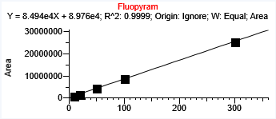 |  | 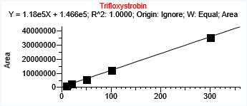
  Conc | Area
  10 | 873121
  20 | 1734820
  50 | 4338645
  100 | 8752684
  300 | 25521417
  Conc | Area
  10 | 1317979
  20 | 2559161
  50 | 5912393
  100 | 12047644.8
  300 | 35522830
Calibration of Fluopyram Calibration of Trifloxystrobinin
 | 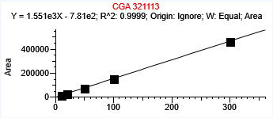
  Conc | Area
  10 | 16748.7
  20 | 31707.7
  50 | 74385.7
  100 | 152375.5
  300 | 465503.2
Calibration of CGA 321113
Mango Pulp
 |  | 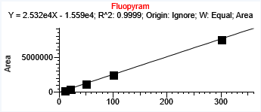  Calibration of Fluopyram |  |  | 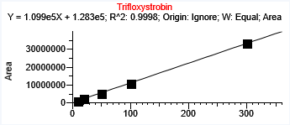  Calibration of Trifloxystrobin
  Conc | Area
  10 | 249203.3
  20 | 507939.9
  50 | 1256264
  100 | 2467455
  300 | 7592800
  Conc | Area
  10 | 1317360
  20 | 2539868.5
  50 | 5509960
  100 | 10826295
  300 | 33190618
 | 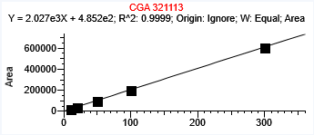
  Conc | Area
  10 | 20948.9
  20 | 42127.1
  50 | 98194
  100 | 205875
  300 | 608153
Calibration of CGA 321113
Soil
 |  | 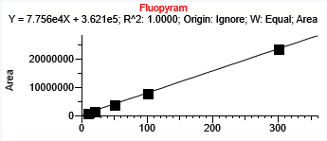  Calibration of Fluopyram  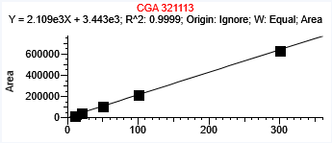 |  | 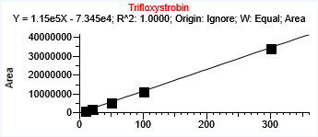  Calibration of Trifloxystrobin
  Conc | Area
  10 | 1122247
  20 | 1913441
  50 | 4263188
  100 | 8111329
  300 | 23628995
  Conc | Area
  10 | 21529
  20 | 45671
  50 | 110747
  100 | 216402
  300 | 635394
  Conc | Area
  10 | 1080956
  20 | 2218306
  50 | 5717060
  100 | 11373533
  300 | 34425269
Calibration of CGA 321113 in soil
Figure S2. Calibration curves for fluopyram, trifloxystrobin and CGA 32111 in the studied matrices

